Factors Report 20100104-20161230

**1. yanYD_Alpha_test1**

**截面指标累计曲线:**

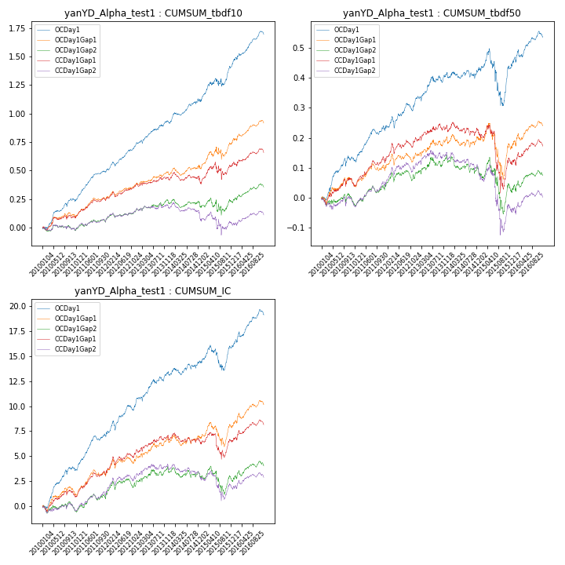

**因子换手率:** 41.09%

**截面指标_OCDay1:**

|  |  |  |  |  |  |  |  |  |
| --- | --- | --- | --- | --- | --- | --- | --- | --- |
| year | annret_tbdf10 | sharpe_tbdf10 | maxdd_tbdf10 | annret_tbdf50 | sharpe_tbdf50 | maxdd_tbdf50 | mean_IC | tstat_IC |
| 2010 | 0.25 | 4.5 | -0.03 | 0.13 | 3.59 | -0.03 | 0.02 | 4.78 |
| 2011 | 0.24 | 5.64 | -0.02 | 0.1 | 3.5 | -0.02 | 0.01 | 4.77 |
| 2012 | 0.26 | 5.66 | -0.04 | 0.1 | 3.04 | -0.04 | 0.02 | 4.26 |
| 2013 | 0.19 | 3.79 | -0.03 | 0.08 | 2.14 | -0.02 | 0.01 | 3.04 |
| 2014 | 0.19 | 3.35 | -0.03 | 0.02 | 0.56 | -0.03 | 0.0 | 1.45 |
| 2015 | 0.3 | 2.75 | -0.07 | 0.0 | 0.02 | -0.18 | 0.01 | 1.11 |
| 2016 | 0.28 | 5.04 | -0.03 | 0.1 | 2.72 | -0.02 | 0.01 | 3.94 |

**截面指标_CCDay1Gap1:**

|  |  |  |  |  |  |  |  |  |
| --- | --- | --- | --- | --- | --- | --- | --- | --- |
| year | annret_tbdf10 | sharpe_tbdf10 | maxdd_tbdf10 | annret_tbdf50 | sharpe_tbdf50 | maxdd_tbdf50 | mean_IC | tstat_IC |
| 2010 | 0.1 | 1.8 | -0.03 | 0.05 | 1.45 | -0.03 | 0.0 | 1.69 |
| 2011 | 0.14 | 2.99 | -0.03 | 0.07 | 2.36 | -0.02 | 0.01 | 2.96 |
| 2012 | 0.14 | 2.99 | -0.04 | 0.08 | 2.25 | -0.04 | 0.01 | 2.88 |
| 2013 | 0.06 | 1.2 | -0.02 | 0.04 | 0.97 | -0.02 | 0.01 | 1.7 |
| 2014 | -0.04 | -0.64 | -0.09 | -0.02 | -0.56 | -0.04 | -0.0 | -0.66 |
| 2015 | 0.15 | 1.17 | -0.15 | -0.1 | -1.07 | -0.21 | 0.0 | 0.07 |
| 2016 | 0.12 | 2.04 | -0.04 | 0.06 | 1.56 | -0.02 | 0.01 | 2.29 |

**风格暴露:**

|  |  |  |  |  |
| --- | --- | --- | --- | --- |
|  | long | short | corr_OCDay1 | corr_CCDay1Gap1 |
| momentum30 | -0.12 | 0.13 | 0.04 | 0.17 |
| logmktcap | 0.11 | -0.09 | -0.21 | -0.2 |
| liquidity10 | 0.01 | -0.01 | 0.11 | 0.18 |
| retvolatility30 | -0.24 | 0.24 | 0.2 | 0.23 |
| liquidity20 | -0.19 | 0.19 | 0.17 | 0.24 |
| momentum5 | 0.17 | -0.16 | -0.24 | -0.21 |
| momentum15 | 0.27 | -0.27 | -0.2 | -0.12 |
| liquidity5 | 0.14 | -0.14 | 0.07 | 0.14 |