Factors Report 20100104-20161230

**1. yanYD_0821_Alpha_GT_19_2**

**截面指标累计曲线:**

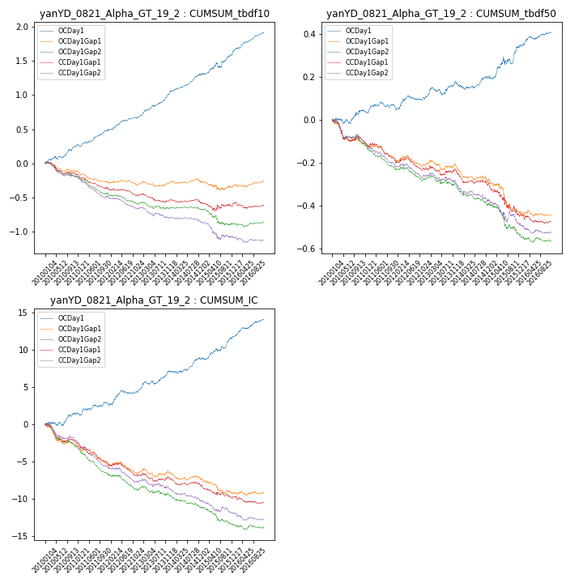

**因子换手率:** 58.55%

**截面指标_OCDay1:**

|  |  |  |  |  |  |  |  |  |
| --- | --- | --- | --- | --- | --- | --- | --- | --- |
| year | annret_tbdf10 | sharpe_tbdf10 | maxdd_tbdf10 | annret_tbdf50 | sharpe_tbdf50 | maxdd_tbdf50 | mean_IC | tstat_IC |
| 2010 | 0.25 | 3.36 | -0.05 | 0.04 | 1.16 | -0.02 | 0.01 | 1.66 |
| 2011 | 0.24 | 4.17 | -0.04 | 0.02 | 0.87 | -0.03 | 0.01 | 2.05 |
| 2012 | 0.2 | 3.6 | -0.02 | 0.04 | 1.54 | -0.02 | 0.01 | 2.35 |
| 2013 | 0.36 | 5.84 | -0.02 | 0.07 | 2.04 | -0.04 | 0.01 | 3.57 |
| 2014 | 0.27 | 4.76 | -0.02 | 0.03 | 0.95 | -0.03 | 0.01 | 2.57 |
| 2015 | 0.31 | 2.66 | -0.08 | 0.15 | 2.79 | -0.04 | 0.01 | 3.34 |
| 2016 | 0.32 | 5.76 | -0.02 | 0.06 | 2.64 | -0.01 | 0.01 | 4.2 |

**截面指标_CCDay1Gap1:**

|  |  |  |  |  |  |  |  |  |
| --- | --- | --- | --- | --- | --- | --- | --- | --- |
| year | annret_tbdf10 | sharpe_tbdf10 | maxdd_tbdf10 | annret_tbdf50 | sharpe_tbdf50 | maxdd_tbdf50 | mean_IC | tstat_IC |
| 2010 | -0.17 | -2.51 | -0.18 | -0.1 | -2.77 | -0.1 | -0.01 | -3.45 |
| 2011 | -0.18 | -3.49 | -0.2 | -0.08 | -3.48 | -0.08 | -0.01 | -4.27 |
| 2012 | -0.12 | -2.18 | -0.12 | -0.04 | -1.48 | -0.06 | -0.01 | -2.47 |
| 2013 | -0.08 | -1.31 | -0.13 | -0.02 | -0.56 | -0.05 | -0.0 | -0.65 |
| 2014 | -0.04 | -0.78 | -0.06 | -0.06 | -2.03 | -0.06 | -0.0 | -1.76 |
| 2015 | -0.03 | -0.3 | -0.12 | -0.15 | -2.61 | -0.15 | -0.01 | -2.15 |
| 2016 | 0.0 | 0.08 | -0.09 | -0.03 | -0.93 | -0.04 | -0.0 | -1.06 |

**风格暴露:**

|  |  |  |  |  |
| --- | --- | --- | --- | --- |
|  | long | short | corr_OCDay1 | corr_CCDay1Gap1 |
| momentum30 | 0.0 | 0.0 | -0.07 | -0.09 |
| logmktcap | -0.02 | 0.02 | -0.01 | -0.06 |
| liquidity10 | 0.05 | -0.04 | -0.09 | -0.0 |
| retvolatility30 | -0.01 | 0.02 | -0.08 | 0.05 |
| liquidity20 | -0.0 | 0.01 | -0.06 | 0.02 |
| momentum5 | 0.05 | -0.04 | 0.04 | -0.03 |
| momentum15 | 0.16 | -0.15 | -0.09 | -0.1 |
| liquidity5 | 0.07 | -0.06 | -0.1 | -0.05 |