Factors Report 20100104-20161230

**1. yanYD_0821_Alpha_GT_23_2**

**截面指标累计曲线:**

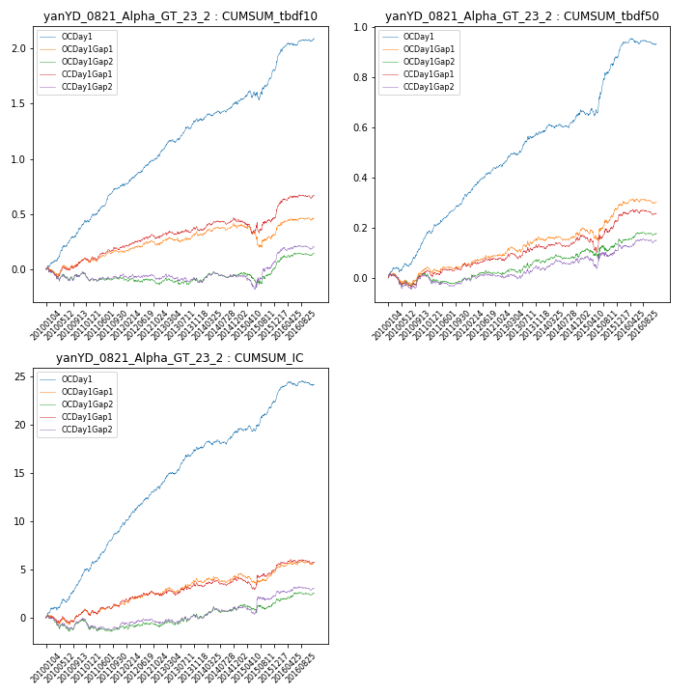

**因子换手率:** 49.0%

**截面指标_OCDay1:**

|  |  |  |  |  |  |  |  |  |
| --- | --- | --- | --- | --- | --- | --- | --- | --- |
| year | annret_tbdf10 | sharpe_tbdf10 | maxdd_tbdf10 | annret_tbdf50 | sharpe_tbdf50 | maxdd_tbdf50 | mean_IC | tstat_IC |
| 2010 | 0.43 | 6.35 | -0.01 | 0.17 | 5.43 | -0.02 | 0.02 | 6.11 |
| 2011 | 0.34 | 5.82 | -0.02 | 0.16 | 6.46 | -0.01 | 0.02 | 6.83 |
| 2012 | 0.3 | 5.24 | -0.03 | 0.13 | 5.16 | -0.01 | 0.02 | 5.59 |
| 2013 | 0.29 | 4.6 | -0.03 | 0.13 | 4.02 | -0.01 | 0.02 | 4.92 |
| 2014 | 0.15 | 2.89 | -0.03 | 0.08 | 2.83 | -0.02 | 0.01 | 2.65 |
| 2015 | 0.32 | 3.15 | -0.08 | 0.23 | 4.02 | -0.03 | 0.01 | 3.79 |
| 2016 | 0.27 | 4.18 | -0.02 | 0.05 | 2.08 | -0.03 | 0.01 | 2.77 |

**截面指标_CCDay1Gap1:**

|  |  |  |  |  |  |  |  |  |
| --- | --- | --- | --- | --- | --- | --- | --- | --- |
| year | annret_tbdf10 | sharpe_tbdf10 | maxdd_tbdf10 | annret_tbdf50 | sharpe_tbdf50 | maxdd_tbdf50 | mean_IC | tstat_IC |
| 2010 | 0.1 | 1.42 | -0.09 | 0.03 | 0.8 | -0.05 | 0.0 | 1.07 |
| 2011 | 0.11 | 2.05 | -0.04 | 0.03 | 1.29 | -0.03 | 0.0 | 1.61 |
| 2012 | 0.1 | 1.87 | -0.04 | 0.01 | 0.57 | -0.02 | 0.0 | 0.79 |
| 2013 | 0.05 | 0.83 | -0.04 | 0.05 | 1.59 | -0.02 | 0.0 | 1.34 |
| 2014 | 0.07 | 1.47 | -0.04 | 0.03 | 1.09 | -0.02 | 0.0 | 0.85 |
| 2015 | 0.05 | 0.47 | -0.12 | 0.08 | 1.38 | -0.07 | 0.0 | 1.09 |
| 2016 | 0.18 | 2.8 | -0.03 | 0.03 | 1.06 | -0.02 | 0.0 | 1.25 |

**风格暴露:**

|  |  |  |  |  |
| --- | --- | --- | --- | --- |
|  | long | short | corr_OCDay1 | corr_CCDay1Gap1 |
| momentum30 | -0.04 | 0.04 | -0.08 | -0.09 |
| logmktcap | -0.01 | 0.01 | 0.08 | 0.17 |
| liquidity10 | 0.01 | -0.01 | -0.13 | -0.17 |
| retvolatility30 | 0.02 | -0.01 | -0.11 | -0.14 |
| liquidity20 | 0.02 | -0.02 | -0.12 | -0.15 |
| momentum5 | -0.12 | 0.13 | 0.13 | 0.13 |
| momentum15 | -0.06 | 0.07 | -0.06 | -0.07 |
| liquidity5 | -0.0 | 0.0 | -0.13 | -0.17 |