Factors Report 20100104-20161230

**1. yanYD_0816_Alpha_test_1**

**截面指标累计曲线:**

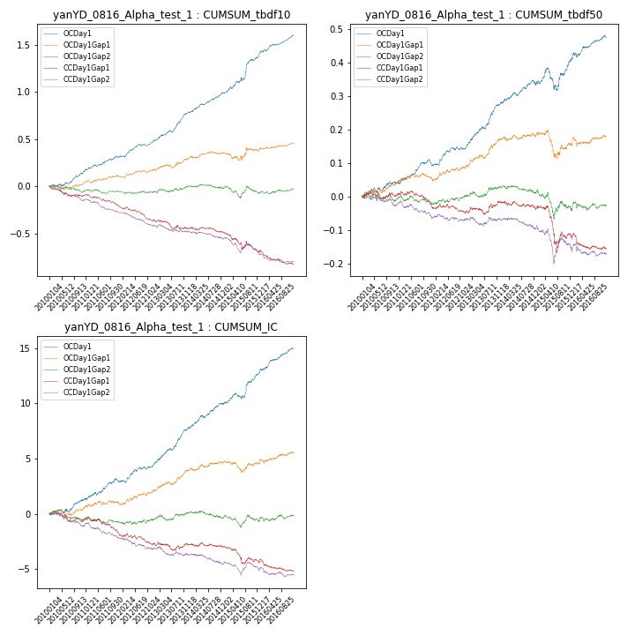

**因子换手率:** 56.97%

**截面指标_OCDay1:**

|  |  |  |  |  |  |  |  |  |
| --- | --- | --- | --- | --- | --- | --- | --- | --- |
| year | annret_tbdf10 | sharpe_tbdf10 | maxdd_tbdf10 | annret_tbdf50 | sharpe_tbdf50 | maxdd_tbdf50 | mean_IC | tstat_IC |
| 2010 | 0.16 | 3.03 | -0.02 | 0.04 | 1.58 | -0.01 | 0.01 | 2.11 |
| 2011 | 0.15 | 3.07 | -0.02 | 0.05 | 2.4 | -0.02 | 0.01 | 2.56 |
| 2012 | 0.18 | 4.05 | -0.02 | 0.06 | 2.78 | -0.01 | 0.01 | 2.88 |
| 2013 | 0.31 | 5.46 | -0.02 | 0.13 | 5.21 | -0.01 | 0.01 | 5.34 |
| 2014 | 0.21 | 4.48 | -0.01 | 0.06 | 2.47 | -0.02 | 0.01 | 3.86 |
| 2015 | 0.38 | 4.01 | -0.04 | 0.07 | 1.7 | -0.07 | 0.01 | 3.33 |
| 2016 | 0.23 | 4.8 | -0.01 | 0.07 | 2.63 | -0.02 | 0.01 | 4.19 |

**截面指标_CCDay1Gap1:**

|  |  |  |  |  |  |  |  |  |
| --- | --- | --- | --- | --- | --- | --- | --- | --- |
| year | annret_tbdf10 | sharpe_tbdf10 | maxdd_tbdf10 | annret_tbdf50 | sharpe_tbdf50 | maxdd_tbdf50 | mean_IC | tstat_IC |
| 2010 | -0.1 | -2.07 | -0.1 | 0.0 | 0.05 | -0.02 | -0.0 | -1.11 |
| 2011 | -0.11 | -2.63 | -0.12 | -0.03 | -1.57 | -0.05 | -0.01 | -2.52 |
| 2012 | -0.15 | -3.58 | -0.15 | -0.01 | -0.66 | -0.03 | -0.0 | -1.65 |
| 2013 | -0.1 | -1.67 | -0.09 | 0.03 | 1.12 | -0.02 | -0.0 | -0.14 |
| 2014 | -0.04 | -0.81 | -0.06 | -0.02 | -0.81 | -0.03 | -0.0 | -0.42 |
| 2015 | -0.2 | -1.91 | -0.19 | -0.08 | -1.61 | -0.12 | -0.01 | -1.65 |
| 2016 | -0.13 | -2.88 | -0.14 | -0.04 | -1.54 | -0.05 | -0.0 | -1.81 |

**风格暴露:**

|  |  |  |  |  |
| --- | --- | --- | --- | --- |
|  | long | short | corr_OCDay1 | corr_CCDay1Gap1 |
| momentum30 | 0.05 | -0.04 | -0.14 | -0.07 |
| logmktcap | -0.02 | 0.02 | -0.0 | 0.04 |
| liquidity10 | 0.05 | -0.05 | -0.13 | -0.06 |
| retvolatility30 | 0.0 | 0.0 | -0.09 | -0.02 |
| liquidity20 | 0.02 | -0.02 | -0.11 | -0.04 |
| momentum5 | 0.18 | -0.17 | -0.21 | -0.18 |
| momentum15 | 0.16 | -0.15 | -0.21 | -0.12 |
| liquidity5 | 0.08 | -0.08 | -0.14 | -0.01 |