Factors Report 20100104-20161230

**1. yanYD_0822_Alpha_GT_25_2**

**截面指标累计曲线:**

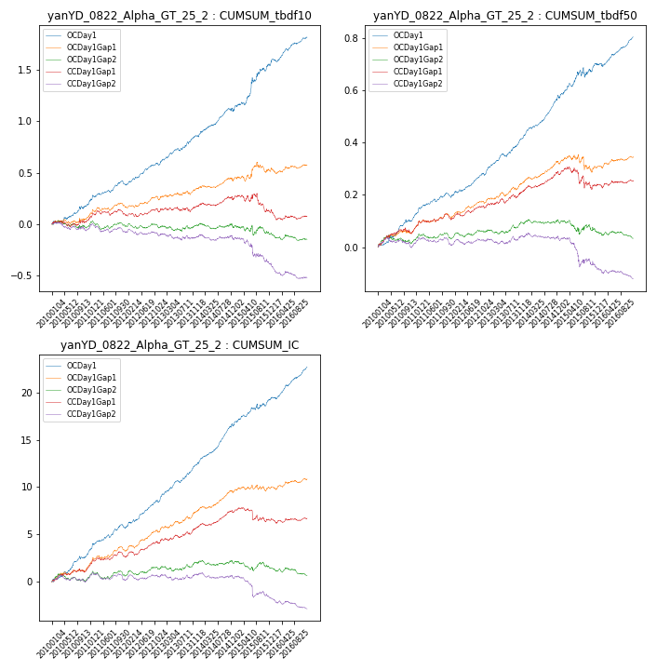

**因子换手率:** 49.51%

**截面指标_OCDay1:**

|  |  |  |  |  |  |  |  |  |
| --- | --- | --- | --- | --- | --- | --- | --- | --- |
| year | annret_tbdf10 | sharpe_tbdf10 | maxdd_tbdf10 | annret_tbdf50 | sharpe_tbdf50 | maxdd_tbdf50 | mean_IC | tstat_IC |
| 2010 | 0.19 | 2.96 | -0.02 | 0.12 | 4.69 | -0.01 | 0.01 | 4.77 |
| 2011 | 0.2 | 3.71 | -0.03 | 0.07 | 3.6 | -0.01 | 0.01 | 4.45 |
| 2012 | 0.22 | 4.56 | -0.02 | 0.11 | 5.32 | -0.01 | 0.01 | 5.7 |
| 2013 | 0.25 | 4.59 | -0.02 | 0.12 | 5.92 | -0.01 | 0.01 | 6.34 |
| 2014 | 0.25 | 4.26 | -0.03 | 0.15 | 6.71 | -0.01 | 0.02 | 7.42 |
| 2015 | 0.44 | 3.64 | -0.05 | 0.13 | 2.79 | -0.04 | 0.01 | 3.26 |
| 2016 | 0.27 | 5.04 | -0.03 | 0.1 | 5.02 | -0.01 | 0.01 | 6.62 |

**截面指标_CCDay1Gap1:**

|  |  |  |  |  |  |  |  |  |
| --- | --- | --- | --- | --- | --- | --- | --- | --- |
| year | annret_tbdf10 | sharpe_tbdf10 | maxdd_tbdf10 | annret_tbdf50 | sharpe_tbdf50 | maxdd_tbdf50 | mean_IC | tstat_IC |
| 2010 | 0.04 | 0.57 | -0.05 | 0.07 | 2.53 | -0.02 | 0.01 | 2.53 |
| 2011 | 0.06 | 1.03 | -0.05 | 0.04 | 1.76 | -0.02 | 0.0 | 2.14 |
| 2012 | 0.04 | 0.9 | -0.03 | 0.06 | 2.86 | -0.01 | 0.01 | 3.38 |
| 2013 | 0.04 | 0.66 | -0.05 | 0.06 | 2.33 | -0.02 | 0.01 | 2.43 |
| 2014 | 0.07 | 1.29 | -0.03 | 0.06 | 2.99 | -0.01 | 0.01 | 3.29 |
| 2015 | -0.14 | -1.28 | -0.18 | -0.04 | -0.87 | -0.08 | -0.0 | -1.04 |
| 2016 | -0.04 | -0.65 | -0.1 | 0.02 | 0.99 | -0.02 | 0.0 | 0.49 |

**风格暴露:**

|  |  |  |  |  |
| --- | --- | --- | --- | --- |
|  | long | short | corr_OCDay1 | corr_CCDay1Gap1 |
| momentum30 | -0.02 | 0.03 | -0.12 | 0.05 |
| logmktcap | -0.01 | 0.01 | -0.08 | -0.21 |
| liquidity10 | -0.09 | 0.1 | 0.11 | 0.23 |
| retvolatility30 | -0.1 | 0.11 | 0.09 | 0.24 |
| liquidity20 | -0.1 | 0.11 | 0.1 | 0.23 |
| momentum5 | 0.22 | -0.22 | -0.16 | -0.05 |
| momentum15 | -0.01 | 0.01 | -0.07 | 0.07 |
| liquidity5 | -0.0 | 0.01 | 0.1 | 0.25 |