Factors Report 20100104-20161230

**1. yanYD_0827_Alpha_GT_32_2**

**截面指标累计曲线:**

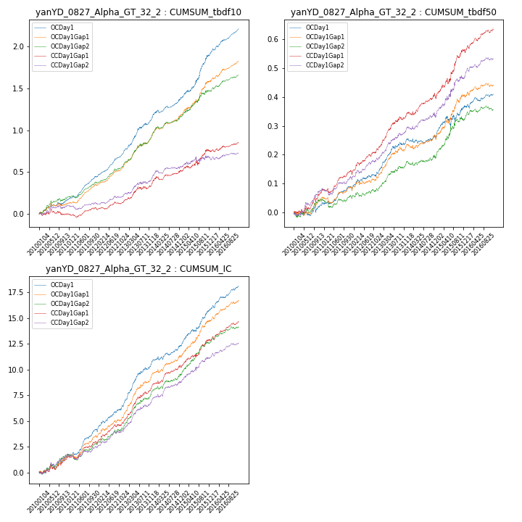

**因子换手率:** 29.83%

**截面指标_OCDay1:**

|  |  |  |  |  |  |  |  |  |
| --- | --- | --- | --- | --- | --- | --- | --- | --- |
| year | annret_tbdf10 | sharpe_tbdf10 | maxdd_tbdf10 | annret_tbdf50 | sharpe_tbdf50 | maxdd_tbdf50 | mean_IC | tstat_IC |
| 2010 | 0.18 | 2.93 | -0.03 | 0.04 | 1.32 | -0.02 | 0.01 | 2.79 |
| 2011 | 0.27 | 6.67 | -0.01 | 0.06 | 2.76 | -0.01 | 0.01 | 4.87 |
| 2012 | 0.31 | 7.57 | -0.01 | 0.06 | 2.39 | -0.02 | 0.01 | 4.63 |
| 2013 | 0.41 | 5.72 | -0.02 | 0.11 | 4.24 | -0.01 | 0.02 | 6.08 |
| 2014 | 0.23 | 4.2 | -0.03 | 0.01 | 0.23 | -0.02 | 0.01 | 2.85 |
| 2015 | 0.51 | 5.25 | -0.02 | 0.11 | 2.68 | -0.03 | 0.01 | 5.38 |
| 2016 | 0.31 | 6.44 | -0.02 | 0.04 | 1.85 | -0.01 | 0.01 | 4.85 |

**截面指标_CCDay1Gap1:**

|  |  |  |  |  |  |  |  |  |
| --- | --- | --- | --- | --- | --- | --- | --- | --- |
| year | annret_tbdf10 | sharpe_tbdf10 | maxdd_tbdf10 | annret_tbdf50 | sharpe_tbdf50 | maxdd_tbdf50 | mean_IC | tstat_IC |
| 2010 | 0.01 | 0.1 | -0.07 | 0.08 | 2.8 | -0.02 | 0.01 | 2.58 |
| 2011 | 0.06 | 1.33 | -0.04 | 0.07 | 3.03 | -0.01 | 0.01 | 2.83 |
| 2012 | 0.1 | 2.29 | -0.03 | 0.08 | 3.37 | -0.01 | 0.01 | 3.93 |
| 2013 | 0.22 | 3.01 | -0.03 | 0.12 | 4.67 | -0.01 | 0.01 | 5.62 |
| 2014 | 0.14 | 2.39 | -0.04 | 0.06 | 2.28 | -0.02 | 0.01 | 3.44 |
| 2015 | 0.24 | 2.35 | -0.06 | 0.16 | 3.79 | -0.02 | 0.01 | 4.04 |
| 2016 | 0.1 | 2.01 | -0.03 | 0.07 | 3.23 | -0.01 | 0.01 | 4.11 |

**风格暴露:**

|  |  |  |  |  |
| --- | --- | --- | --- | --- |
|  | long | short | corr_OCDay1 | corr_CCDay1Gap1 |
| momentum30 | 0.11 | -0.11 | -0.05 | 0.01 |
| logmktcap | -0.09 | 0.1 | 0.08 | 0.11 |
| liquidity10 | 0.21 | -0.2 | -0.17 | -0.13 |
| retvolatility30 | 0.11 | -0.1 | 0.04 | 0.0 |
| liquidity20 | 0.17 | -0.17 | -0.14 | -0.12 |
| momentum5 | 0.11 | -0.1 | -0.1 | -0.14 |
| momentum15 | 0.16 | -0.15 | -0.16 | -0.08 |
| liquidity5 | 0.21 | -0.21 | -0.17 | -0.14 |