Factors Report 20100104-20161230

**1. yanYD_0822_Alpha_GT_26_1**

**截面指标累计曲线:**

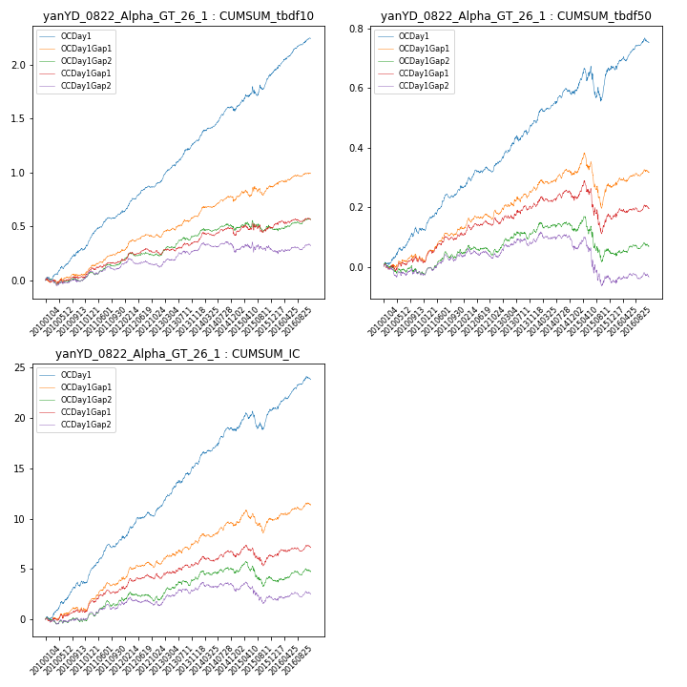

**因子换手率:** 46.68%

**截面指标_OCDay1:**

|  |  |  |  |  |  |  |  |  |
| --- | --- | --- | --- | --- | --- | --- | --- | --- |
| year | annret_tbdf10 | sharpe_tbdf10 | maxdd_tbdf10 | annret_tbdf50 | sharpe_tbdf50 | maxdd_tbdf50 | mean_IC | tstat_IC |
| 2010 | 0.29 | 4.47 | -0.02 | 0.13 | 3.85 | -0.02 | 0.01 | 4.8 |
| 2011 | 0.34 | 6.79 | -0.01 | 0.13 | 5.22 | -0.01 | 0.02 | 6.39 |
| 2012 | 0.28 | 5.59 | -0.02 | 0.09 | 3.31 | -0.02 | 0.01 | 4.38 |
| 2013 | 0.4 | 6.8 | -0.01 | 0.15 | 4.43 | -0.02 | 0.02 | 6.2 |
| 2014 | 0.29 | 5.18 | -0.04 | 0.1 | 3.48 | -0.02 | 0.01 | 4.87 |
| 2015 | 0.34 | 3.41 | -0.08 | 0.08 | 1.16 | -0.11 | 0.01 | 1.81 |
| 2016 | 0.32 | 6.26 | -0.01 | 0.09 | 3.23 | -0.02 | 0.01 | 4.75 |

**截面指标_CCDay1Gap1:**

|  |  |  |  |  |  |  |  |  |
| --- | --- | --- | --- | --- | --- | --- | --- | --- |
| year | annret_tbdf10 | sharpe_tbdf10 | maxdd_tbdf10 | annret_tbdf50 | sharpe_tbdf50 | maxdd_tbdf50 | mean_IC | tstat_IC |
| 2010 | 0.03 | 0.45 | -0.05 | 0.02 | 0.66 | -0.02 | 0.0 | 1.23 |
| 2011 | 0.16 | 3.1 | -0.02 | 0.08 | 3.15 | -0.01 | 0.01 | 3.47 |
| 2012 | 0.06 | 1.22 | -0.05 | 0.05 | 1.82 | -0.02 | 0.0 | 1.72 |
| 2013 | 0.11 | 2.15 | -0.02 | 0.06 | 1.91 | -0.01 | 0.01 | 2.21 |
| 2014 | 0.06 | 1.04 | -0.07 | 0.02 | 0.82 | -0.03 | 0.0 | 1.13 |
| 2015 | 0.07 | 0.7 | -0.09 | -0.07 | -0.99 | -0.17 | -0.0 | -0.12 |
| 2016 | 0.07 | 1.39 | -0.03 | 0.04 | 1.34 | -0.02 | 0.0 | 1.69 |

**风格暴露:**

|  |  |  |  |  |
| --- | --- | --- | --- | --- |
|  | long | short | corr_OCDay1 | corr_CCDay1Gap1 |
| momentum30 | -0.2 | 0.21 | 0.13 | 0.24 |
| logmktcap | 0.04 | -0.02 | -0.07 | -0.11 |
| liquidity10 | -0.03 | 0.04 | 0.03 | 0.13 |
| retvolatility30 | -0.18 | 0.19 | 0.05 | 0.14 |
| liquidity20 | -0.16 | 0.17 | 0.07 | 0.17 |
| momentum5 | 0.17 | -0.17 | -0.15 | -0.15 |
| momentum15 | 0.21 | -0.2 | -0.05 | 0.02 |
| liquidity5 | 0.08 | -0.06 | 0.0 | 0.07 |