Factors Report 20120104-20161230

**1. yanYD_0810_Alpha_GT_07**

**截面指标累计曲线:**

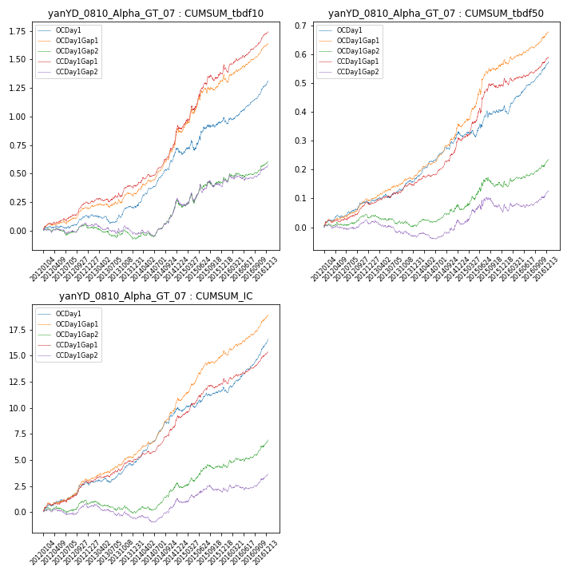

**因子换手率:** 49.25%

**截面指标_OCDay1:**

|  |  |  |  |  |  |  |  |  |
| --- | --- | --- | --- | --- | --- | --- | --- | --- |
| year | annret_tbdf10 | sharpe_tbdf10 | maxdd_tbdf10 | annret_tbdf50 | sharpe_tbdf50 | maxdd_tbdf50 | mean_IC | tstat_IC |
| 2012 | 0.13 | 2.39 | -0.02 | 0.09 | 3.86 | -0.01 | 0.01 | 4.04 |
| 2013 | 0.08 | 1.28 | -0.08 | 0.07 | 3.16 | -0.01 | 0.01 | 2.94 |
| 2014 | 0.51 | 7.0 | -0.02 | 0.17 | 6.81 | -0.01 | 0.02 | 8.02 |
| 2015 | 0.25 | 1.95 | -0.09 | 0.08 | 1.69 | -0.02 | 0.01 | 2.18 |
| 2016 | 0.35 | 5.3 | -0.06 | 0.17 | 5.79 | -0.03 | 0.02 | 6.87 |

**截面指标_CCDay1Gap1:**

|  |  |  |  |  |  |  |  |  |
| --- | --- | --- | --- | --- | --- | --- | --- | --- |
| year | annret_tbdf10 | sharpe_tbdf10 | maxdd_tbdf10 | annret_tbdf50 | sharpe_tbdf50 | maxdd_tbdf50 | mean_IC | tstat_IC |
| 2012 | 0.24 | 4.37 | -0.03 | 0.08 | 3.59 | -0.01 | 0.01 | 4.23 |
| 2013 | 0.15 | 2.19 | -0.03 | 0.07 | 2.88 | -0.01 | 0.01 | 3.37 |
| 2014 | 0.53 | 6.25 | -0.02 | 0.16 | 5.76 | -0.01 | 0.02 | 6.43 |
| 2015 | 0.47 | 3.93 | -0.05 | 0.19 | 3.82 | -0.02 | 0.01 | 4.23 |
| 2016 | 0.36 | 4.8 | -0.07 | 0.1 | 3.38 | -0.02 | 0.01 | 4.65 |

**风格暴露:**

|  |  |  |  |  |
| --- | --- | --- | --- | --- |
|  | long | short | corr_OCDay1 | corr_CCDay1Gap1 |
| momentum30 | -0.09 | 0.09 | 0.07 | 0.09 |
| logmktcap | -0.08 | 0.09 | 0.16 | 0.12 |
| liquidity10 | -0.07 | 0.08 | 0.03 | -0.03 |
| retvolatility30 | -0.14 | 0.14 | -0.12 | -0.16 |
| liquidity20 | -0.07 | 0.07 | 0.01 | -0.05 |
| momentum5 | -0.16 | 0.16 | 0.18 | 0.06 |
| momentum15 | -0.1 | 0.1 | 0.13 | 0.09 |
| liquidity5 | -0.08 | 0.09 | 0.03 | -0.06 |