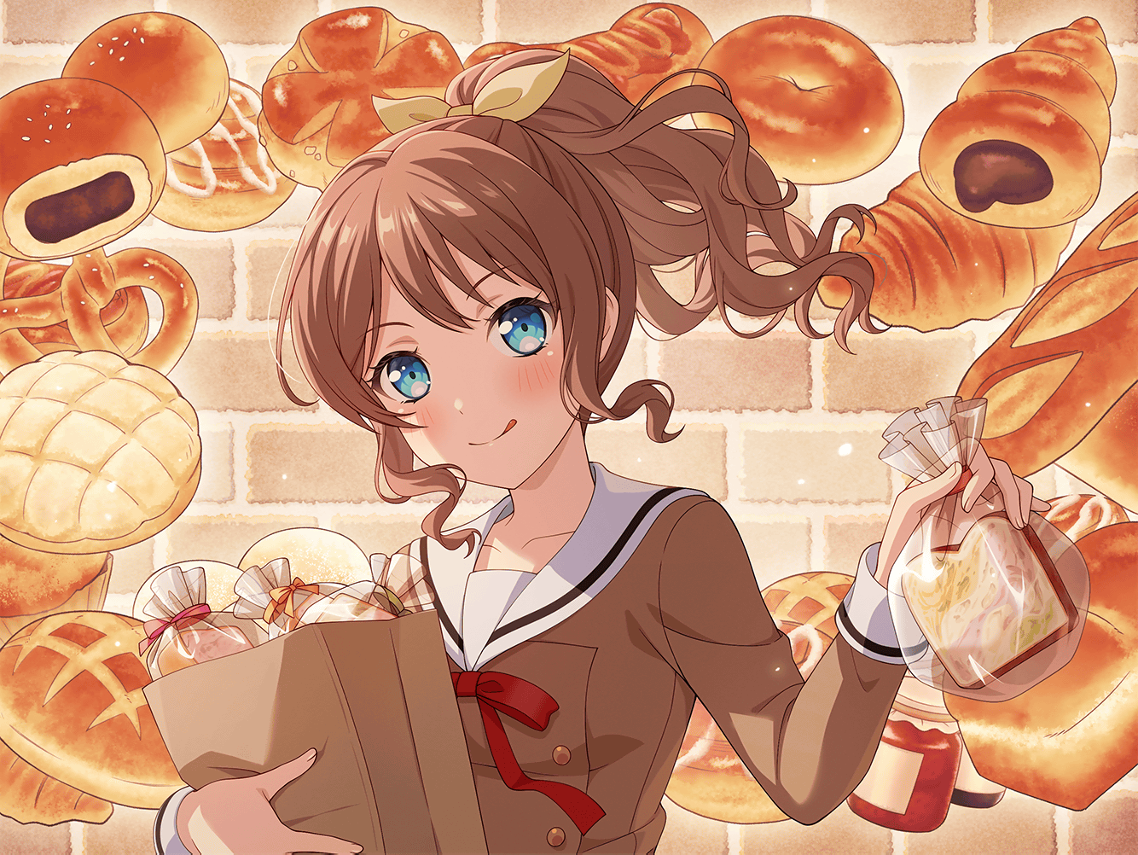

山吹 沙绫

SAAYA YAMABUKI



|  |  |  |  |  |  |
| --- | --- | --- | --- | --- | --- |
|  |  |  |  |  |  |



『你又这么 轻易地答应了……』