PA1 Report

B06901144

|  |  |  |  |  |  |  |  |  |
| --- | --- | --- | --- | --- | --- | --- | --- | --- |
| Input size | IS | | MS | | QS | | HS | |
|  | CPU Time(ms) | Memory  (KB) | CPU Time(ms) | Memory  (KB) | CPU Time(ms) | Memory  (KB) | CPU Time(ms) | Memory  (KB) |
| 4000.case2 | 0 | 12424 | 5.999 | 12424 | 11.998 | 12540 | 0 | 12424 |
| 4000.case3 | 12.999 | 12424 | 5 | 12424 | 7.999 | 12448 | 1 | 12424 |
| 4000.case1 | 3.999 | 12424 | 3.999 | 12424 | 0 | 12424 | 1 | 12424 |
| 16000.case2 | 0 | 12572 | 8 | 12572 | 153.976 | 13248 | 1 | 12575 |
| 16000.case3 | 120.982 | 12572 | 7.999 | 12572 | 120.982 | 12868 | 3 | 12572 |
| 16000.case1 | 57.991 | 12572 | 8.999 | 12572 | 1 | 12572 | 3 | 12572 |
| 32000.case2 | 0 | 12572 | 11.998 | 12760 | 615.906 | 14000 | 2 | 12572 |
| 32000.case3 | 461.93 | 12572 | 11.998 | 12760 | 454.931 | 13236 | 2 | 12572 |
| 32000.case1 | 230.964 | 12572 | 14.998 | 12760 | 1.999 | 12572 | 2 | 12572 |
| 1000000.case2 | 2 | 18592 | 388.94 | 22684 |  |  | 85.987 | 18592 |
| 1000000.case3 |  |  | 394.94 | 22684 |  |  | 84.987 | 18592 |
| 1000000.case1 |  |  | 450.932 | 22684 | 83.987 | 18592 | 155.976 | 18592 |

電機三 吳悠嘉

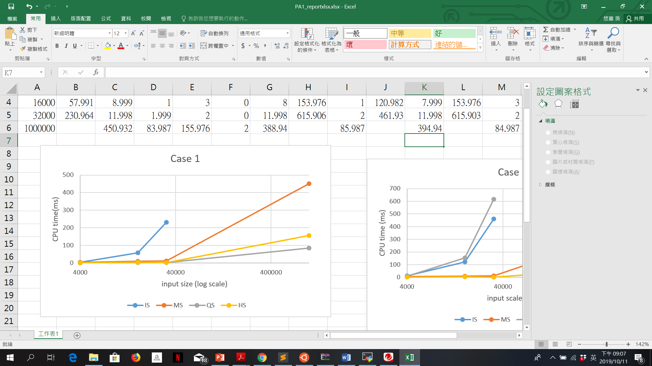 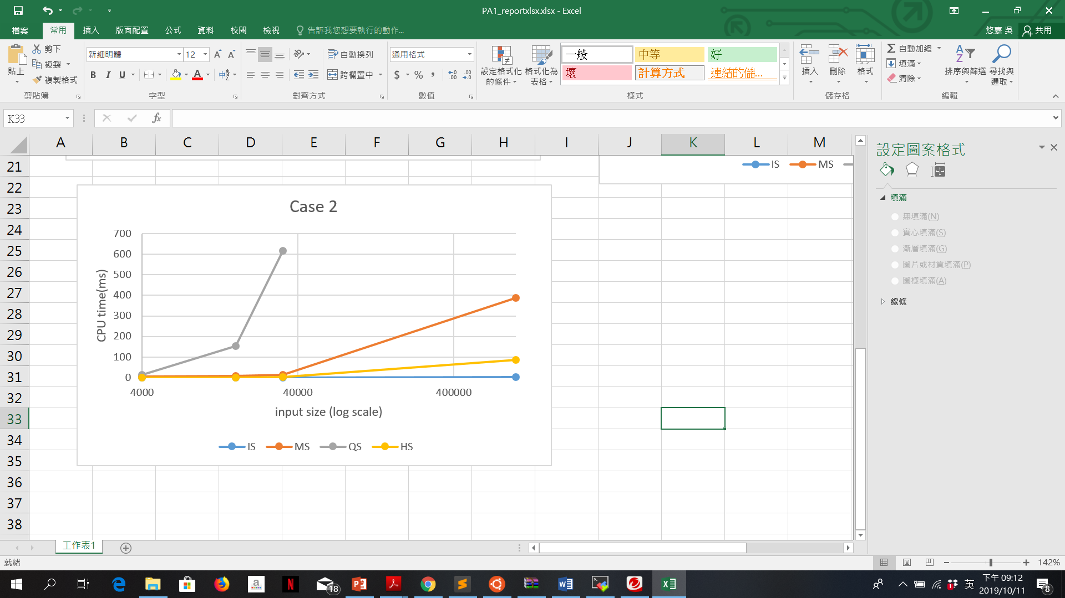

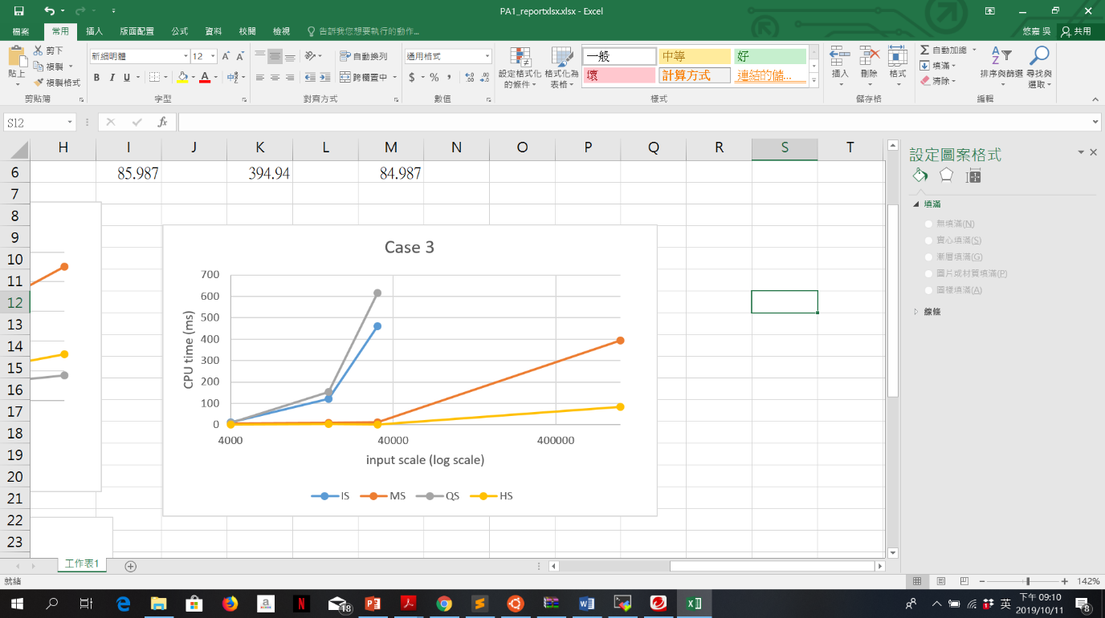In case1, the running time of QS is the shortest and IS is the longest. However, in case2, which is the sorted case, the running time of QS is the longest and IS costs almost 0ms in each input size. Then in case 3, QS is the slowest and IS is the second slowest.

In conclusion, QS is more proper in case1. When in a reverse order (case 3), HS will be more proper then others.