实验报告（Lab 3）
姓名：丘绎楦 学号：1820221050
实验：inter-VLAN Routing
Lab 3-1 VLANIF Configuration
Q3-1.1. Paste the screenshot of the created topology.
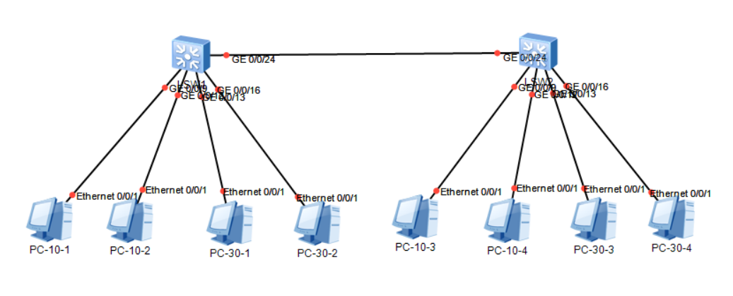
Q3-1.2. Paste the screenshot of the IP routing table on the switch LSW1.
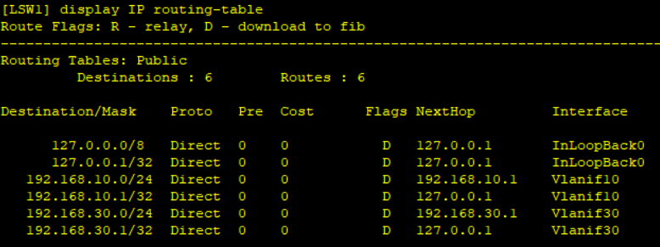
Q3-1.3. Can PC-10-1 and PC-10-3 ping each other? Please paste the screenshot of the ping result.
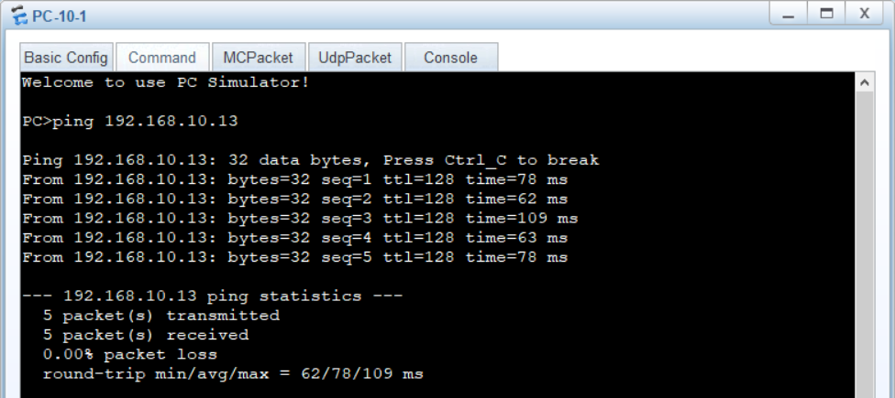
Q3-1.4. Can PC-30-1 and PC-30-3 ping each other? Please paste the screenshot of the ping result.
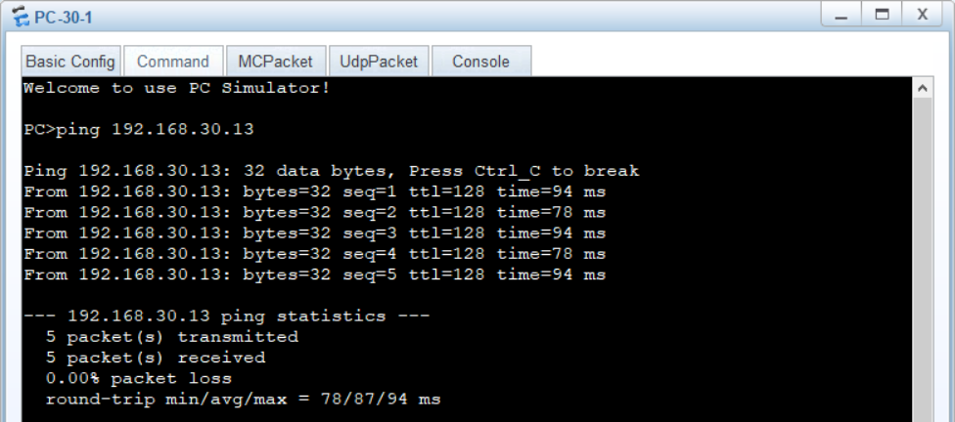
Q3-1.5. Can PC-10-1 and PC-30-3 ping each other? Please paste the screenshot of the ping result.
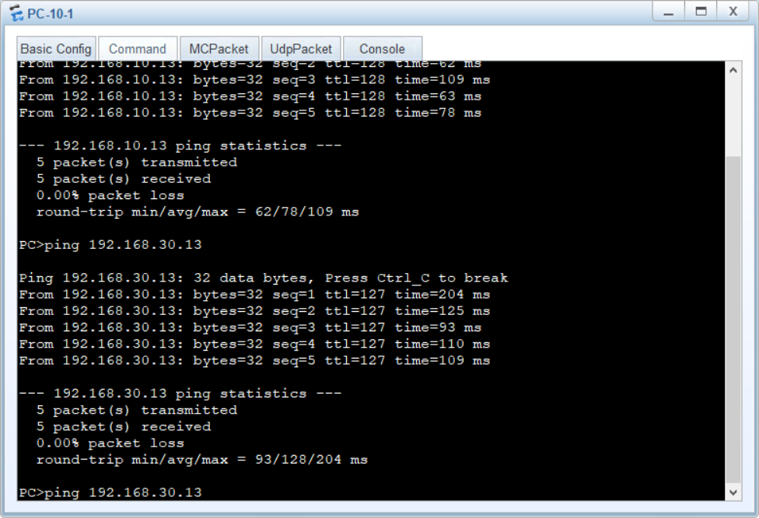
Q3-1.6. Please paste the screenshot of the result of command “tracert 192.168.30.13” issued from PC-10-1.
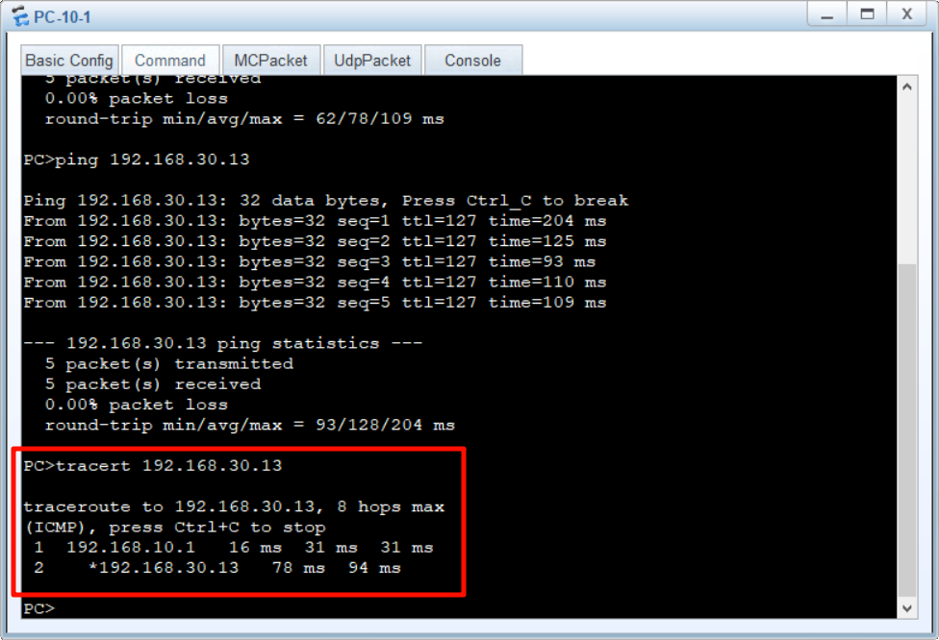
Q3-1.7. Analyze the captured ping traffics between the PC-10-1 and PC-10-3. What are the tagged VLAN IDs of the Ethernet frames leaving and entering the port? Please paste the screenshot of the all field information of the captured Ethernet frame.
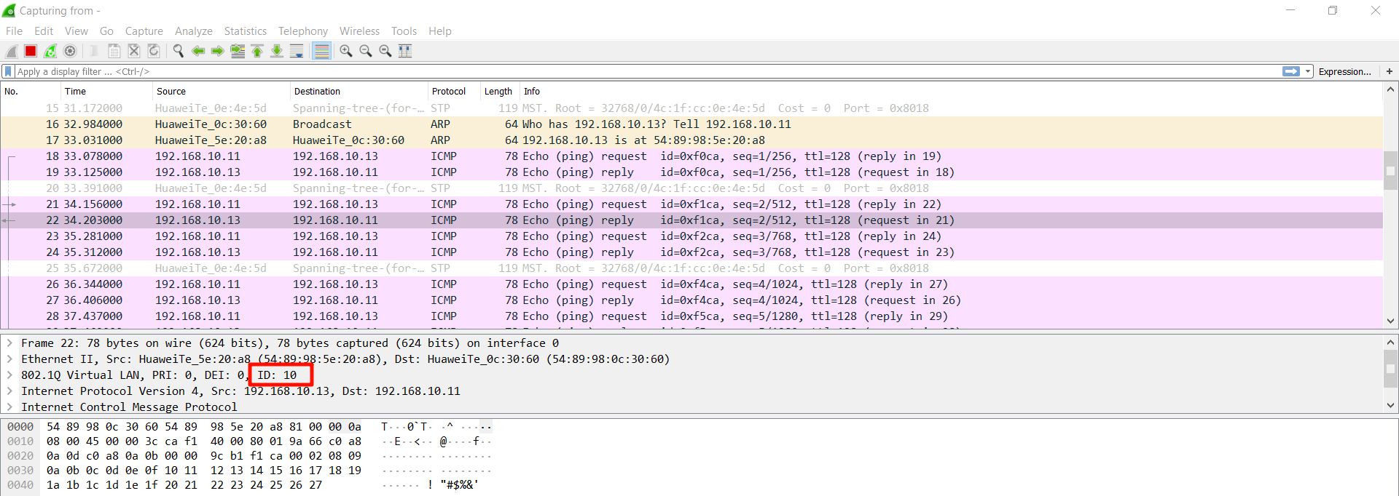
Q3-1.8. Analyze the captured ping traffics between the PC-10-1 and PC-30-3. What are the tagged VLAN IDs of the Ethernet frames leaving and entering the port? Please paste the screenshot of the all field information of the captured Ethernet frames.
