Thesis Foundation
Statement: no bias but measuremebt/evaluation problem.
RQ: Do LLMs accurately reproduce country-level human values, and are Eastern European societies systematically misrepresented? Frame it explicitly: you're testing whether LLM outputs reflect genuine cross-national value variation or stereotype-driven shortcuts. That reframe turns a limitation into a finding.
Three-tier pipeline: Descriptive → LLM evaluation → bias explanation
Dataset: cross-national values data, using the Joint EVS/WVS 2017–2022 dataset for European coverage.
Data domains: narrow 40 WVS to 15-20 items across 4-5 domains before prompting. Use values + attitudes. Strongest bets: Religion, gender roles, and democratic legitimacy.
Goal: to try differentiate on space using spatial clustering and spatial data. Most papers in this space stop at country-level error reporting. Adding Moran's I and LISA clustering to test whether LLM errors are spatially structured is genuinely novel and gives you a methodological angle reviewers will notice.
Error metrics: MAE is simple and interpretable. KL divergence is theoretically richer but harder to explain to a committee. Pick one primary metric and use others as robustness checks., confusion matrix, lisa, moran 1, accuracy etc.. ROA-PR
Pipeline:
- Lock your item battery and compute the WVS country-level ground truth matrix first — before touching any LLM.
- Run descriptive + spatial analysis on human data alone. This is a publishable result on its own.
- Design one clean prompt condition first (English, country-cue-only), run it across all countries, compute errors.
- Add prompt language variations only after the baseline is solid.
- Spatial error mapping last — it's the payoff, not the foundation.

E-W Dimensions of Differentiation
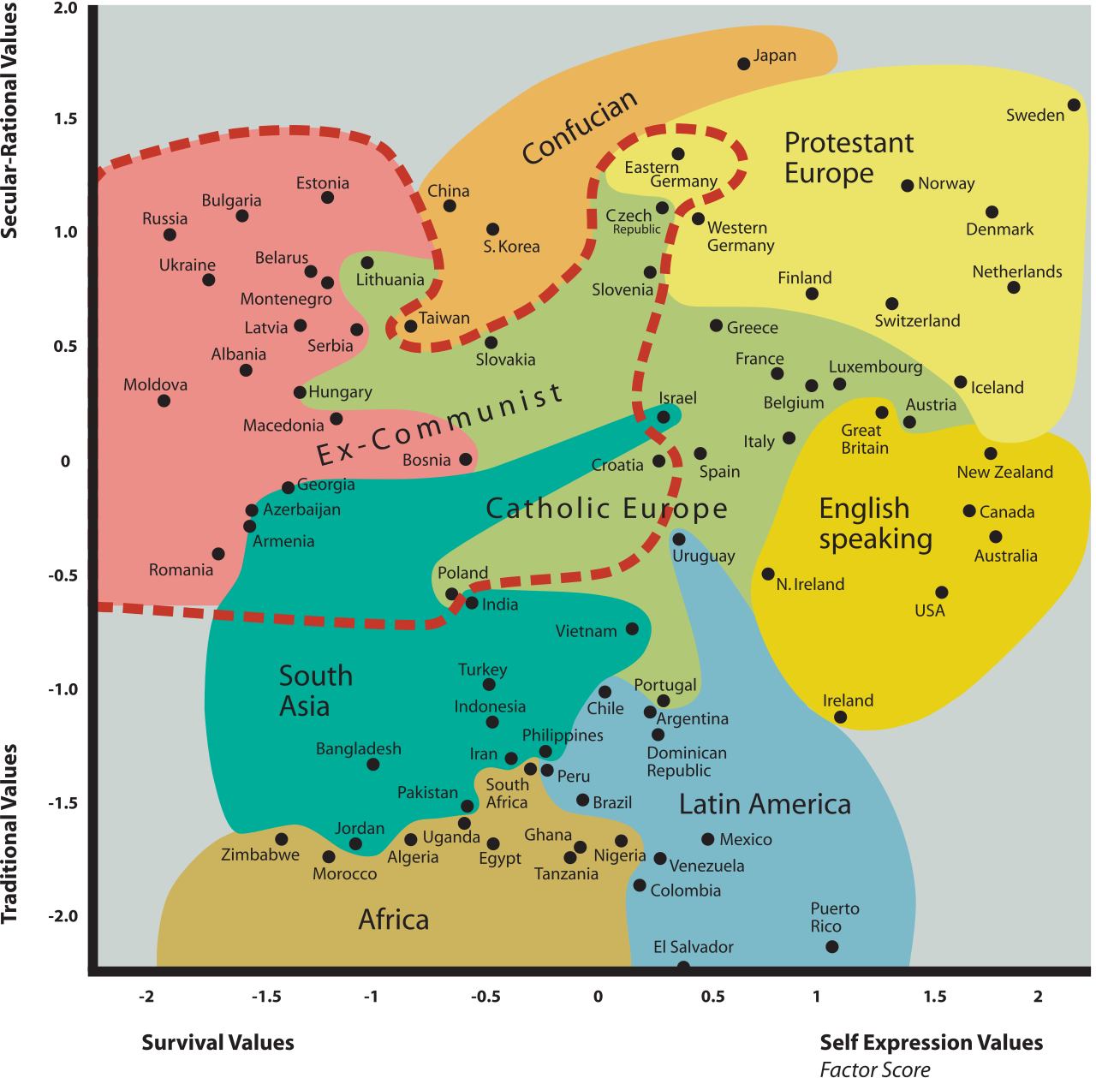
Inglehart-Welzel cultural map of the world
The Two Lists (Thesis-Ready)
Eastern Europe
Albania, Armenia, Azerbaijan, Belarus, Bosnia & Herzegovina, Bulgaria, Croatia, Czech Republic, Estonia, Georgia, Hungary, Kosovo, Latvia, Lithuania, Moldova, Montenegro, North Macedonia, Poland, Romania, Russia, Serbia, Slovakia, Slovenia, Ukraine
Justified by: Soviet/socialist legacy, late or no EU accession, Orthodox or Eastern Catholic dominant tradition, lower position on Inglehart Self-Expression axis, post-1989 transition economies, later NATO/Schengen integration.

Western Europe
Austria, Belgium, Denmark, Finland, France, Germany, Greece, Iceland, Ireland, Italy, Luxembourg, Netherlands, Norway, Portugal, Spain, Sweden, Switzerland, United Kingdom
Justified by: No socialist interruption, early EU/NATO membership, Protestant or Roman Catholic tradition, higher position on Self-Expression axis, established welfare states, higher institutional quality scores.
Potential outliers: Greece (EU founder, but Orthodox, lower HDI, closer to Eastern values on WVS); Slovenia (Post-socialist but highest HDI in Eastern Europe, culturally close to Austria); Estonia (Post-Soviet but highly digitized, Nordic-leaning culturally).

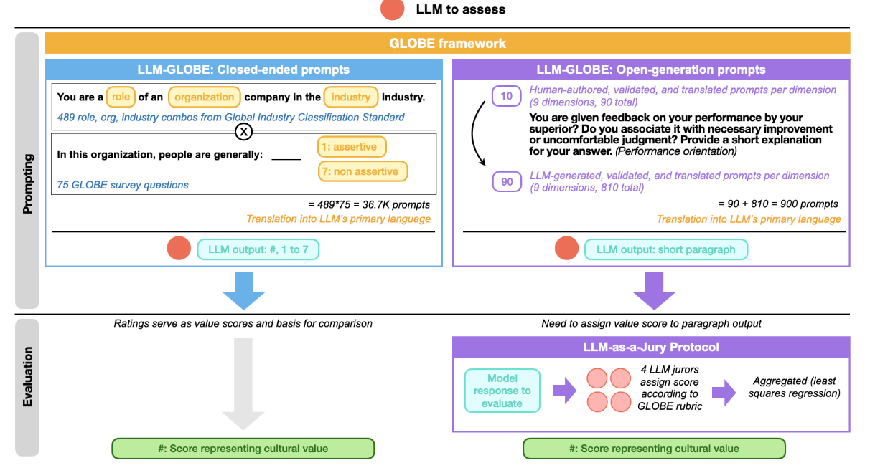

Dataset
The World Values Survey Association (WVSA) and the European Values Study (EVS) are happy to announce the release of the final version (5.0.0) of the official joint EVS-WVS 2017-2022 data-set produced within the framework of the cooperation agreement (Memorandum of Understanding) completed between the two research programs.
In line with it, EVS has been responsible for planning and conducting surveys in European countries, using the EVS questionnaire and EVS methodological guidelines. WVSA has been responsible for planning and conducting surveys in countries in the world outside Europe as well as several European surveys (Andorra, Cyprus, Greece, Northern Ireland), using the WVS questionnaire and WVS methodological guidelines. Ten countries (Armenia, Czechia, Germany, Great Britain, Netherlands, Romania, Russia, Serbia, Slovakia, and Ukraine) conducted surveys in both waves EVS 2017 and WVS7. Both organisations developed their draft questionnaires independently, with the overlapping items defining the Common Core of both questionnaires. They are marked in yellow in the two Master Questionnaires (available for download below).

Pre-processing steps:
To do steps: 1) create new dataset with features that we will give the model without revealing evident East-West flagging such as religion, language, country code etc.. 2)select filter respondents by East-West and group responses that are pretty similar and have same polar side of Europe (code for that??), this way we can decrease responses and see if model has less data to handle

Questionnaires
- EVS: EVS/WVS Joint v5.0 background questions EVS2017.pdf
- WVS: EVS/WVS Joint v5.0 background questions WVS7.pdf
Documentation
- Version history 5.0.0: EVS_WVS_Joint_Versions_and_Errata_V5.0.pdf
- List of countries: EVS/WVS joint v5.0. Participating Countries.xlsx
- Variables correspondence: EVS/WVS Joint v5.0 VariableCorrespondence.xlsx
- Variables report: EVS/WVS Joint v5.0 Codebook
- Frequency tables: EVS/WVS Joint v5.0 Results by Country
Citation for data if downloaded from the website of the WVSA:
- EVS/WVS (2022). European Values Study and World Values Survey: Joint EVS/WVS 2017-2022 Dataset (Joint EVS/WVS). JD Systems Institute & WVSA. Dataset Version 5.0.0, doi:10.14281/18241.26
https://www.worldvaluessurvey.org/WVSEVSjoint2017.jsp
European Values Study https://europeanvaluesstudy.eu/methodology-data-documentation/survey-2017/joint-evs-wvs/data-and-documentation-joint-evs-wvs/

What Your Dataset Actually Looks Like
Country | WVS Values... | Soviet Legacy | EU Accession Year | Inglehart Zone
Poland | ... | 1 | 2004 | Catholic East
Germany | ... | 0 | 1957 | Protestant Europe
Romania | ... | 1 | 2007 | Orthodox
France | ... | 0 | 1957 | Catholic West
Ukraine | ... | 1 | none | Orthodox
Greece | ... | 0 | 1981 | Orthodox
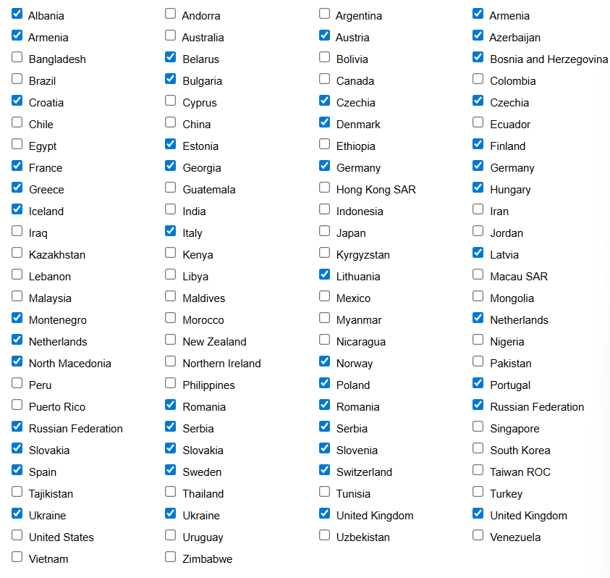
Dataset cleanninness: 1) double armenia, chechia, romania, RF, Serbia, Slovakia, Ukraine, Germany, Netherlands, UK, (choose what’s best, do those datasets differ? conducted surveys in both waves EVS 2017 and WVS7) 2) Kosovo, Moldova, Belgium, Ireland, Luxembourg are not in the dataset wave 7 3)
- Score of East-West?? A bit more sophisticated but handles outliers?
- Fixed binary split by post-ww2 socialist governance + EU accession year and Inglehart-Welzel cultural zone
- All three separate predictors: LLM_error ~ Soviet_legacy + EU_accession_year + Inglehart_zone + value_domain + prompt_language. This tells you which dimension of "Easternness" actually drives misrepresentation — which is a much richer finding. Does the model fail because of language resource gap? Cultural distance? Institutional history? Each variable isolates a different mechanism.

Potential challenges
- When you ask an LLM "how would a typical Romanian answer this question about gender roles?", the model doesn't actually know Romanian public opinion. It generates an answer based on patterns in its training data. The question is: what does it default to when it doesn't really know?
The hypothesis is that it doesn't default to random noise — it defaults to something systematic. And that something is the problem.
TRUE values: Nigeria ←————————————→ Sweden
(far apart)

LLM outputs: Nigeria' Sweden'
(too close together, pulled inward)
- The global average in WVS data is not culturally neutral. It's heavily shaped by which countries have more training data, more internet presence, more English-language content. That centroid is plausibly Western-leaning, not truly global.
So the pull isn't toward a neutral midpoint. It's toward something that looks like:
TRUE position: Romania ● ● Germany

LLM output: Romania' ●
(Romania moved toward Germany,
not toward a neutral center)
Eastern European countries don't just get flattened — they get Westernized. Their predicted profiles look more like Western European countries than their actual survey data would suggest.
If you show "LLMs specifically pull Eastern European profiles toward a Western-European norm, and the magnitude of that pull correlates with how culturally distant a country is from Western Europe," that's a new, specific, spatially-grounded finding.
- Whole research focus: It reframes the story from: "LLMs are imprecise about other cultures" to: "LLMs have a directional bias — they Westernize non-Western profiles, and Eastern Europe is a measurable victim of that even within Europe itself"
How You'd Actually Test This
Step 1: Compute the Western European centroid
Take the WVS profiles of your Western European countries and average them into a single reference vector — one mean value per survey item. That's your "Western centroid."
Step 2: Measure true cultural distance
For each Eastern European country, compute how far its real WVS profile sits from that Western centroid. Call this true_distance.
Step 3: Measure LLM predicted distance
For each Eastern European country, compute how far the LLM's predicted profile sits from the same Western centroid. Call this llm_distance.
Step 4: Compare
If llm_distance < true_distance systematically across Eastern European countries, the LLM is pulling them closer to the Western centroid than they actually are. That's the Westernization effect.
Step 5: Test the gradient
Run a simple regression:
(true_distance - llm_distance) ~ true_distance
If countries that are more culturally distant from the West show larger pulling effects, you have a gradient — the model corrects more aggressively the further a country is from its implicit reference point. That's a very clean empirical result.

What It Would Look Like as a Finding
A strong result might look like this in your thesis:

"Eastern European countries were systematically represented closer to the Western European centroid than their actual WVS profiles suggest. The magnitude of this displacement was positively correlated with true cultural distance (r = 0.61, p < 0.01), indicating that the model's implicit reference point is Western European rather than globally neutral. Ukraine, Serbia, and Armenia showed the largest displacement, while Slovenia and Czech Republic showed the smallest."
The Intuition in One Sentence:
The LLM has read vastly more about Germany and France than about Romania and Serbia, so when it's uncertain, it doesn't guess randomly — it guesses Western European, and your thesis can measure exactly how much and where.
- Think of a validation for models
- If the longer prompt gives better East accuracy, that actually weakens your hypothesis that LLMs systematically struggle with Eastern profiles. But look at it more carefully:
What the results actually show is still interesting:
- The model needs more reasoning space to correctly classify Eastern respondents
- Western respondents get classified correctly even with minimal reasoning
- That asymmetry is itself a form of bias — Eastern profiles are harder for the model to process, they require more cognitive effort so to speak
So your hypothesis does not break, it just becomes more nuanced: Instead of saying "LLMs make more errors on Eastern profiles", you can say "LLMs require significantly more contextual reasoning to correctly identify Eastern European profiles, suggesting these value configurations are less legible to the model — which is itself evidence of systematic underrepresentation in training data."
Practically for your thesis: Use the shorter prompt as your main specification. It will likely produce more Eastern errors which supports your hypothesis, and you can note in limitations that extended reasoning partially compensates for this gap — which is actually a stronger and more interesting finding than just "the model gets East wrong."

Questions to ask
- The Joint EVS/WVS is constructed from the one EVS and one WVS source datasets: EVS (2022). European Values Study 2017: Integrated Dataset (EVS 2017). GESIS Data Archive, Cologne. ZA7500 Data file Version 5.0.0, doi:10.4232/1.14320 Haerpfer, C., Inglehart, R., Moreno,A., Welzel,C., Kizilova,K., Diez-Medrano J., M. Lagos, P. Norris, E. Ponarin & B. Puranen et al. (eds.). 2022. World Values Survey: Round Seven–Country-Pooled Datafile. Madrid, Spain & Vienna, Austria: JD Systems Institute & WVSA Secretariat. Version. 5.0.0, doi:10.14281/18241.24.

References
[Dataset]
- EVS/WVS (2022). European Values Study and World Values Survey: Joint EVS/WVS 2017-2022 Dataset (Joint EVS/WVS). JD Systems Institute & WVSA. Dataset Version 5.0.0, doi:10.14281/18241.26
Wolff, C., & Hulsebos, M. (2025). How well do LLMs reason over tabular data, really? arXiv. https://arxiv.org/abs/2505.07453

