# Week 1

## quiz

1. What files do you need to open a shapefile  
a. .shp  
b. .shx  
c. .prj  
d. .dbf  
e. .prj

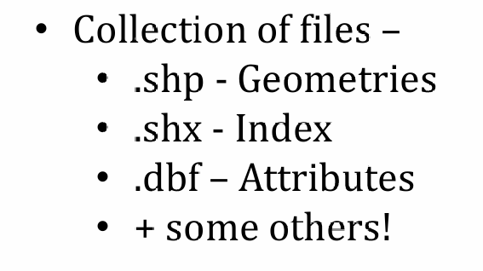  
2. When provided data what do you do first?  
a. Open it and look at it – in QGIS or excel  
3. What is wide data  
a. Data where any values are not repeated in the rows and each variable is a column  
4. What is long data  
a. Long table, where values do repeat (e.g. Borough name or borough code or year of  
observation)  
5. How did we change from one to the other  
a. Pivot table  
6. What are the benefits of a geodatabase  
a. Can store all data for your project in one file  
b. Both raster and vector can be stored within it  
c. Easy to share 1 file as opposed to many  
7. What is a thematic map  
a. Map of a “theme”  
b. Map of a column of data  
8. How do you join non spatial data to spatial data  
a. Using a unique field (e.g. ID)  
b. Through a join function or tool  
c. In QGIS you must export it to save it  
9. In R what is a package  
a. Collections of functions and data  
10. In R what is a function  
a. Code that is made into a command to make running the code easier for us, e.g.  
read_csv()  
b. Note packages are always a single work, e.g. tidyverse, functions always end with (),  
e.g. read_csv()  
11. In R what is an argument  
a. A specification within a function that controls how it works  
12. How does loading data in R and QGIS differ and what are the benefits  
a. R is object orientated  
b. R shows all the columns (e.g. geometry)  
c. QGIS shows you the polygons  
13. In R what does a %>% mean  
a. Then

# Week 2

## quiz

1. Why is it useful to use a project in R  
a. Stores all files and folders  
b. Removes need to access data from C drive.  
2. What are data structures  
a. How data is organised  
3. If you want to access a certain column and row in a data frame, how would you do it  
a. data.frame[row,column]  
b. Or use filter()and select()  
4. What does the c() function do?  
a. Combines things…for example df[c(2,3,6),2] means subset rows 2,3 and 2 from  
column 2  
5. Name some dplyr verbs and their function  
a. Filter()  
b. Select()  
c. Mutate()  
d. Summarise()  
e. Arrange()  
6. What happens when we combine `str_detect()` with filter.  
a. Str_detect() stands for string detect. You provide column(s) and the string you want  
to find. Filter() will then select the rows that match it..  
b. LondonMap<- EW %>%  
filter(str_detect(lad15cd, "^E09"))  
7. Given the following data what would group_by() do on the transmission column?  
ID Car Make Transmission Max speed  
1 Ford Fiesta Manual 75  
2 Ford Mustang Automatic 100  
3 Audi A1 Manual 60  
4 Peugeot 305 Manual 70  
a. It would do nothing much, aside from adding a group message  
8. What is group_by()? Followed by? Something like…  
a. group_by(Transmission)%>%  
b. summarise(Average=mean(`Max speed`)  
9. What does mutate() do?  
a. Adds a new column based on existing columns (e.g. adding two columns or dividing  
two columns etc)  
10. What does case_when() do and what must be used before it?  
a. Mutate() is always used before case_when() as there has to be a new column to  
store the data  
b. case_when() applies a condition to data (e.g. > 90) and then returns a set value or  
string (e.g. above average) in the new column made by mutate().

# Week 3

**Raster vs Vector**

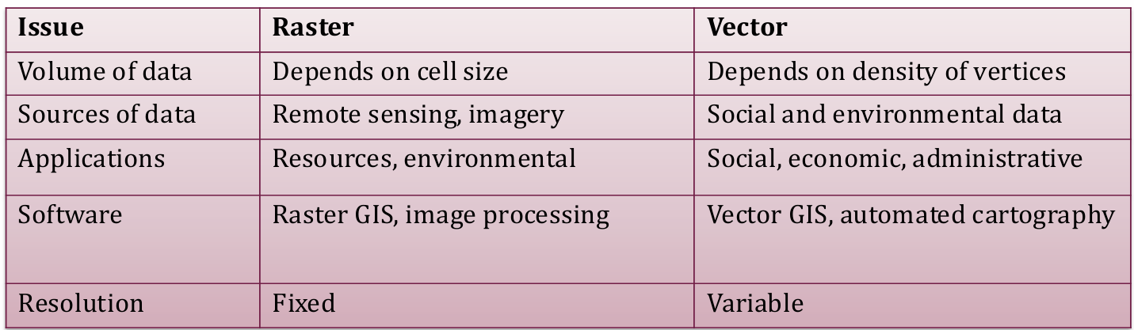

**3D into 2D – Projecting**

• Geographic coordinate reference system – 3D WHERE the place is on earth. It has **ANGULAR** units (degrees). BUT it will draw flat as your screen is flat.

• Projected coordinate reference system – HOW to draw that place on a FLAT surface. It has **LINEAR** units (e.g. metres)

• A Projected coordinate reference system **CONTAINS** a geographic coordinate reference system. It’s just a geographic one that is projected!

• Geographic CRS = treats data as sphere (angular units)

• Projected CRS = treats data as flat object (metric units)

**World Geodetic System (WGS 84)**

• Standard (3D) method of representing our solid surface (last revision established in 1984)

• Sphere divided into 360 parts called degrees (of longitude).

• Each degree has 60 minutes

• Each minute has 60 seconds

• 51°(degree) 30’ (min) 35.5140‘’ (secs) N – degree/minute/second (DMS)

• Example: 0° 7' 5.1312‘’ W

• Also commonly given as Decimal degrees (DD) – often seen on GPS

• Latitude (horizontal)

• Longitude (vertical)

**Mercator Projection**

• Invented for navigation purposes by Gerardus Mercator in 1569

• Bearings (angles) are preserved (particularly useful when navigating a ship with a compass!) = **constant true direction**

• Area and distance are not preserved – exaggerated at poles, downplay at equator

e.g.: Greenland 2.1 million square km. Africa 30.04 square km

**British National Grid (BNG)**

• BNG is a **local projected coordinate reference system**

• It has a local datum

• Measurements in metres.

• Point of origin is near the Isles of Scilly.

• Standard for all maps of Britain.

• Most countries have their own version

**Defining Spatial / Coordinate Reference Systems**

• One of the more commonly used sets of SRID (spatial reference identifier) values are maintained by the European Petroleum Survey Group (EPSG). For example: EPSG:4326 refers to the WGS 84 world geodetic system; EPSG:27700 refers to British National Grid

• Most EPSG identifiers will also have a Proj4 string. For example, the Proj4 string for EPSG:4326 is: +proj=longlat +ellps=WGS84 +datum=WGS84 +no_defs

• If you want to find an SRID code for a particular spatial reference system or its related Proj4 string, visit: http://spatialreference.org

# Week 4