1. 在Branch下拉菜单中选择New Branch
2. 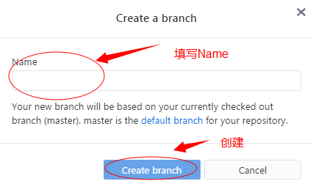
3. 创建完毕后会切换到创建的分支

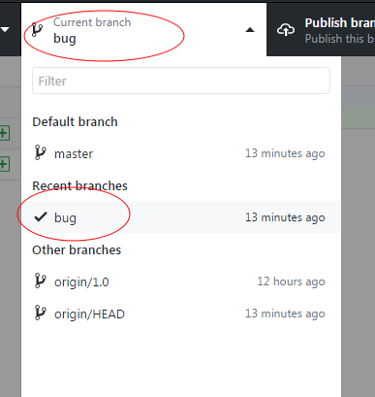

3.创建完毕后，在分支中修改代码，然后切换会主干master 然后点击merge 最后提交

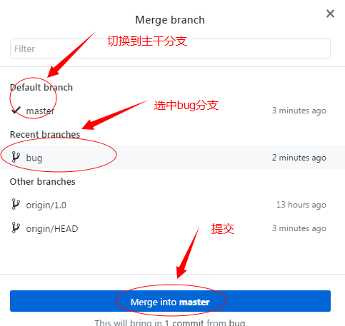

error: Your local changes to the following files would be overwritten by merge: 分支开发.docx Please commit your changes or stash them before you merge. Aborting