AI CHATBOT-DRIVEN PERSONALIZED MUSIC GENERATOR BASED ON EMOTION AND STYLE PREFERENCES
By
JASLYN LAU QIAN YU

A REPORT
SUBMITTED TO
Universiti Tunku Abdul Rahman
in partial fulfillment of the requirements
for the degree of
BACHELOR OF COMPUTER SCIENCE (HONOURS)
Faculty of Information and Communication Technology
(Kampar Campus)

JUNE 2026

ACKNOWLEDGEMENTS

I would like to express my sincere gratitude and appreciation to my supervisor, Ms Jennifer Ann a/p Felix Leo, for her valuable guidance, patience, and continuous support throughout the development of this project. Her advice, encouragement, and willingness to share her knowledge have greatly helped me in completing this Final Year Project.

Finally, I would like to express my heartfelt thanks to my parents and family for their love, care, and continuous encouragement. Their support has always been a source of motivation for me, and I am truly grateful for everything they have done throughout the completion of this project.

COPYRIGHT STATEMENT
Example

© 2026 Jaslyn Lau Qian Yu. All rights reserved.

This Final Year Project report is submitted in partial fulfillment of the requirements for the degree of Bachelor of Computer Science (Honours) at Universiti Tunku Abdul Rahman (UTAR). This Final Year Project report represents the work of the author, except where due acknowledgment has been made in the text. No part of this Final Year Project report may be reproduced, stored, or transmitted in any form or by any means, whether electronic, mechanical, photocopying, recording, or otherwise, without the prior written permission of the author or UTAR, in accordance with UTAR's Intellectual Property Policy.

ABSTRACT

This project focuses on the development of an AI chatbot-driven personalized music generator based on emotion and style preferences. The problem addressed in this project is the limitation of existing AI music generation systems in effectively mapping user emotions to musical features, producing personalized music output, and providing an intuitive input method for users. Existing systems often rely on predefined categories, generate repetitive outputs, and offer limited interaction, which reduces personalization and user satisfaction.
The proposed system integrates Natural Language Processing (NLP), emotion recognition, and symbolic music generation in a web-based system. The workflow involves collecting user input through a chatbot interface, detecting the emotional context of the input, and generating music output based on the detected emotion and user preferences. The development process includes requirement analysis, system design, prototype development, and preliminary testing.
The outcome of this project is a user-friendly music generation system that allows users to express emotions and style preferences through natural language. The generated music is provided in MIDI format with playback support. The novelty of this project lies in the integration of chatbot interaction, emotion-aware music generation, and web-based playback within a single prototype. Overall, this project demonstrates the potential of AI in creating more adaptive, accessible, and personalized music generation experiences.

Area of Study (Minimum 1 and Maximum 2): Artificial Intelligence (AI), Music Technology
Keywords (Minimum 5 and Maximum 10): AI Music Generation, Emotion Recognition, Chatbot, Natural Language Processing (NLP), Deep Learning, Transformer

TABLE OF CONTENTS

TITLE PAGE | i
ACKNOWLEDGEMENTS | ii
COPYRIGHT STATEMENT | iii
ABSTRACT | iv
TABLE OF CONTENTS | v
LIST OF FIGURES | ix
LIST OF TABLES | xii
LIST OF SYMBOLS | xiii
LIST OF ABBREVIATIONS | xiv
CHAPTER 1 INTRODUCTION | 1
1.1 Problem Statement and Motivation | 1
1.2 Objectives | 2
1.3 Project Scope | 3
1.4 Contributions | 3
1.5 Report Organization | 4
CHAPTER 2 LITERATURE REVIEW | 5
2.1 Artificial Intelligence Technique in Music Generation System  2.1.1 Rule-based System  2.1.2 Recurrent Neural Network (RNN)  2.1.3 Generative Adversarial Networks (GANs) | 5  5  6  7
2.1.4 Variational Autoencoders (VAEs) | 7
2.1.5 Transformer | 8
2.2 Emotion Recognition in Music Systems | 10
2.2.1 Emotion Representation Models | 10
2.2.1.1 Categorical Models | 10
2.2.1.2 Dimensional Models | 11
2.2.1.3 Hybrid Models | 12
2.2.2 Text-Based Emotion Recognition Techniques | 12
2.3 Conversational Agents in Natural Language Processing | 15
2.3.1 Rules-based Chatbots | 16
2.3.2 Generative Conversational Chatbot | 17
2.4 Existing AI-based Music Generation System & Platform | 17
2.4.1 Artificial Intelligence Virtual Artist (AIVA) | 17
2.4.2 Boomy | 19
2.4.3 Suno | 21
2.5 Summary | 24
CHAPTER 3 PROPOSED METHOD/APPROACH | 25
3.1 Methodology | 25
3.1.1 Methodology and General Work Procedures | 25
3.1.2 System Requirement | 26
3.1.3 User Requirements | 29
3.1.4 System Performance Definition | 29
3.1.5 Verification Plan | 30
3.2 System Design Diagram / Overview | 31
3.2.1 Overall System Flow | 31
3.2.2 Use Case Diagram | 32
3.3 Timeline | 32
CHAPTER 4 SYSTEM DESIGN | 34
4.1 System Architecture | 34
4.2 Chatbot Module | 35
4.3 Emotion Detection | 36
4.4 Music Parameter Mapping Model | 37
4.5 Music Generation Module | 37
4.6 Music Output and Playback Module | 39
4.7 REST API Design | 39
4.8 Web Design | 40
CHAPTER 5 SYSTEM IMPLEMENTATION | 42
5.1 Software Setup | 42
5.2 Setting and Configuration | 43
5.3 System Module Implementation | 45
5.3.1 Authentication Module | 45
5.3.2 Chatbot Module | 46
5.3.3 Emotion Detection Module | 48
5.3.4 History Management Module | 49
5.3.5 Music Generation Module | 51
5.3.5.1 Ruled-based Baseline Generator | 51
5.3.5.2 MIDI-GPT-based Generator | 52
5.3.5.3 Custom Music Transformer Generator | 53
5.4 System Operation | 54
5.4.1 Authentication Module | 54
5.4.2 Chatbot Module | 56
5.4.3 Generated Music History | 58
5.5 Implementation Issues and Challenges | 59
5.6 Concluding Remark | 60
CHAPTER 6 SYSTEM EVALUATION AND DICUSSION | 61
6.1 System Testing and Performance Metrics | 61
6.2 Custom Music Transformer | 66
6.2.1 Model Testing | 66
6.2.2 Model Validation | 67
6.3 MIDI-GPT Fine-tuning Result | 69
6.3.1 Model Testing | 70
6.3.2 Model Validation | 70
6.4 Comparison Between Custom Music Transformer and MIDI-GPT | 72
6.5 Objective Evaluation | 73
6.6 Conclusion Remark | 75
CHAPTER 7 CONCLUSION AND RECOMMENDATIONS | 76
7.1 Conclusion | 76
7.2 Recommendations | 77
REFERENCES | 78
APPENDIX A
A.1 Poster | A-1

LIST OF FIGURES

Figure Number | Title | Page
Figure 2.1 | Overview of Music Generation | 5
Figure 2.2 | Overview of Morpheus’ architecture | 6
Figure 2.3 | GAN Architecture | 7
Figure 2.4 | Music VAE Architecture | 8
Figure 2.5 | Transformer-based Model | 9
Figure 2.6 | Rusell's Circumplex Model | 11
Figure 2.7 | Overall Architecture of Multitask Learning Framework for Music Emotion Recognition | 12
Figure 2.8 | Overall AI Techniques of Emotion Recognition | 13
Figure 2.9 | General Chatbot Framework | 15
Figure 2.10 | Structure of a Rule-based Chatbot | 16
Figure 2.11 | Settings Dashboard of Music Creation | 18
Figure 2.12 | Editor | 18
Figure 2.13 | Sample of Music Composition | 18
Figure 2.14 | Interface of Style choosing in Boomy | 20
Figure 2.15 | Modify Interface of Boomy | 20
Figure 2.16 | Interface of Revenue | 20
Figure 2.17 | Chatbot of Music Creation | 22
Figure 2.18 | Music Library | 22
Figure 2.19 | Workspace of Suno | 22
Figure 3.1 | Agile Development Cycle | 25
Figure 3.2 | Overall System Flow | 31
Figure 3.3 | Use Case Diagram | 32
Figure 3.4 | FYP1 Timeline | 32
Figure 3.5 | FYP2 Timeline | 33
Figure 4.1 | System Architecture Diagram | 34
Figure 4.2 | Text-To_Music Prompt Processing Flow | 35
Figure 4.3 | Emotion Detection Module | 36
Figure 4.4 | Music Generation Module | 37
Figure 4.5 | Music Output and Playback Module | 39
Figure 4.6 | Flowchart of API call | 39
Figure 4.7 | Metadata Structure of Generated Music | 40
Figure 4.8 | System architecture diagram for saving generated music history | 41
Figure 5.1 | Environment Activation in VS Code | 42
Figure 5.2 | Create Project in Firebase | 43
Figure 5.3 | Get serviceAccountKey.json | 43
Figure 5.4 | Install LLaMA model | 44
Figure 5.5 | Pull service into local | 44
Figure 5.6 | Online Groq API and LLaMA Model Configuration | 44
Figure 5.7 | Firebase Web SDK Configuration | 45
Figure 5.8 | Firestore Security Rules Configuration | 45
Figure 5.9 | User Registration Function | 46
Figure 5.10 | User Login Function | 46
Figure 5.11 | Authentication State Checking Function | 47
Figure 5.12 | Password Reset Function | 47
Figure 5.13 | Chatbot API Endpoint | 48
Figure 5.14 | Match Emotion | 48
Figure 5.15 | Get Emotion | 49
Figure 5.16 | Valence and Arousal Calculation | 49
Figure 5.17 | Saving Generated Music History | 50
Figure 5.18 | Saving Generated Music History | 50
Figure 5.19 | Rule-based Baseline Generator | 52
Figure 5.20 | MIDI-GPT-based Generator | 53
Figure 5.21 | Custom Music Transformer Generator | 54
Figure 5.22 | User Registration Interface | 55
Figure 5.23 | User Login Interface | 55
Figure 5.24 | Password Reset Function | 56
Figure 5.25 | Chatbot Interaction Interface | 57
Figure 5.26 | Generated Music Result | 57
Figure 5.27 | Generated Music History Interface | 58
Figure 6.1 | Register with an invalid email or weak password | 62
Figure 6.2 | Register and login with valid account details | 62
Figure 6.3 | Reset password with email validation | 62
Figure 6.4 | Send music-related prompt to chatbot | 63
Figure 6.5 | Send prompt with emotion and instrument preference | 64
Figure 6.6 | Send empty message | 64
Figure 6.7 | Play and download generated output | 65
Figure 6.8 | View, regenerate and delete history record | 65
Figure 6.9 | Training and Validation Loss | 66
Figure 6.10 | Structural Token Validation Loss | 67
Figure 6.11 | Validation Token Accuracy | 68
Figure 6.12 | Validation Token Error Rate of the Custom Music Transformer Model | 69
Figure 6.13 | Perplexity and Test Loss | 70
Figure 6.14 | MIDI-GPT Fine-tuning Validation Loss Curve | 71

LIST OF TABLES

Table Number | Title | Page
Table 2.1 | Comparison Table of Existing AI Music Generation Platforms | 22
Table 3.1 | Specifications of Laptop | 27
Table 3.2 | Software Requirement | 27
Table 4.1 | Mapping Emotion | 37
Table 6.1 | Authentication Module Testing | 61
Table 6.2 | Chatbot Module Testing | 63
Table 6.3 | Playback, Download and History Module Testing | 64
Table 6.4 | Custom Music Transformer Training Result Summary | 67
Table 6.5 | MIDI-GPT Fine-tuning Result Summary | 70
Table 6.6 | Comparison Between Custom Music Transformer and MIDI-GPT | 72

LIST OF SYMBOLS

x̄ | mean
X_{i} | Ohm (resistance)
$N$ | Total numbers
$pos$ | Position of a token in the sequence
$i$ | Index of token or embedding dimension
$T$ | Temperature parameter in token generaration
d_model | Embedding dimension of the Transformer model

LIST OF ABBREVIATIONS

AI | Artificial Intelligence
ML | Machine Learning
DL | Deep Learning
NLP | Natural Language Processing
SVMs | Support Vector Machines
HMMs | Hidden Markov Models
RNN | Recurrent Neural Network
LSTM | Long Short-Term Memory
GRU | Gated Recurrent Unit
GANs | Generative Adversarial Network
VAEs | Variational Autoencoders
CNNs | Convolutional Neural Networks
MIR | Music Information Retrieval
TF-IDF | Term Frequency-Inverse Document Frequency
BOW | Bag-of-words
SENN | Semantic-Emotion Neural Network
BiLSTM | Bidirectional Long-Short Term Network
BERT | Bidirectional Encoder Representations from Transformers
RoBERTa | Robustly Optimized BERT approach
DeBERTa | Decoding-enhanced BERT with disentangled attention
RAD | Rapid Application Development

LIST OF SYMBOLS

x̄ | mean
X_{i} | Ohm (resistance)
$N$ | Total numbers
$pos$ | Position of a token in the sequence
$i$ | Index of token or embedding dimension
$T$ | Temperature parameter in token generaration
d_model | Embedding dimension of the Transformer model

Chapter 1
INTRODUCTION
1.1 Problem Statement and Motivation
Music is an important part of human life as it affects emotions, behaviour, and daily activities. However, traditional approaches of listening to music often require users to manually search for songs, create playlists or find existing recommendations. Nowadays, AI has been applied in the music industry to support the development of music generation and personalization. However, existing AI-based music generators still face some problems that cannot accurately target user satisfaction and requirements. The problem includes weak mapping between emotions and musical features, lack of creativity and repetitive outputs and difficulty in expressing user input.

i. Weak mapping between emotions and music features
Based on the current AI-based music generation system, they often provide simple emotional categories such as happy, sad or angry for users to choose. However, emotional expression is complex and multifaceted, which makes the input difficult for the model to capture. It will cause the result of music output that may not fulfil and align with the users’ needs and emotional state and reduce personalized and user satisfaction.

ii. Lack of creativity and repetitive outputs
Many AI-generated music systems tend to produce similar and repetitive output structures. This limitation causes a reduction in user satisfaction and engagement when delivering similar patterns to users. Also, affect users enjoy the personalized experience for using the system. In addition, when combining different instruments, that a problem in generating a smooth music fusion, resulting in an output that may be unnatural and less attractive.

iii. Difficulty in expressing user input
Users often struggle to present their emotions and preferences or desired music style input into the system to be understood. Without an intuitive way of communication, they cannot easily represent their requirements in simple words. It is difficult to generate a high-quality output for users, such as multiple instruments, good sound quality of music and music with emotional tones that fail to meet user expectations.
This project aims to develop an AI chatbot-driven personalized music generator that integrates emotion recognition and style modelling with a user-friendly system to address the existing limitations of AI-based music generators. The current systems are often limited to capturing human emotions, producing repetitive music outputs and lacking intuitive input methods for users to express their needs. The goal of the project is to make music creation more accessible, interesting and adaptive even for users without musical knowledge or technical skills.

1.2 Objectives
In this project, the main objectives are to design and develop an AI chatbot-driven music generator that integrates emotion recognition and style modelling to provide adaptive and user-friendly music creation.
- Evaluate AI-based music generation techniques and emotion representation methods relevant to personalized music generation
- Integrate emotion recognition and chatbot interaction and music generation into one system
- Develop a web-based prototype that enables personalized, adaptive music generation with music management features.

1.3 Project Scope
The scope of the project is to design and develop an AI chatbot-driven music generator in websites where users can generate music aligned with their emotions and style preferences. The main features and modules include:

- Chatbot Module
User can interact with the chatbot using natural language to describe the emotions and their requirements with style preferences such as “I want to feel calm before sleeping and generate relaxing music with jazz.” Also, the chatbot will support multi-turn dialogue to allow users to adjust and modify the music to increase interaction with the system.

- Emotion Recognition Module
The system applies NLP models to analyse user text input and extract emotional tone and intent. The input of emotions will be mapped to musical features like tempo, mode, pitch and instrument selection.

- Music Generation Module
A music generator will produce music compositions based on the user's input of emotions and selected style preferences. The system aims to generate multi-instrument and adaptive compositions rather than repetitive outputs.

- Music Output and Playback
The generated music will be saved in the music library that users can play, download or share. The basic editing controls, such as replay, regenerate and adjust style, will be included.

- Chat History
The user’s history will be saved in the database that users can regenerate and keep the chat history and finding.

- Login
Users able to create account and login into the website to generate the music.

1.4 Contributions
This project advances AI-based music generation in an interactive system with users in different ways. First, it integrates emotion recognition with style modelling to generate, which enables users aligning users' preferences, emotions and desired music style. Secondly, it uses a chatbot-driven interactive input method with an NLP technique, which provides users with an intuitive and user-friendly interface to input their requirements and emotions that solving the predefined categories problem. Furthermore, the system enhances personalized and creativity in music outputs by reducing repetitive patterns and generating smoother multi-instrument combinations, which enhances music quality and diversity outputs. Lastly, it provides a chance to produce music with a simple conversational input to generate playable MIDI music output for users without musical knowledge or expertise.

1.5 Report Organization
This report is organized into seven chapters. Chapter 1 introduces the project background, problem statement, objectives, project scope, contributions, and report organization. Chapter 2 reviews the related literature, including AI-based music generation, emotion recognition, conversational agents, symbolic music generation, and existing music generation platforms. Chapter 3 presents the system methodology and approach, including the system architecture, use case diagram, activity diagram, system workflow, and main system modules. Chapter 4 describes the system design, including the frontend and backend design, chatbot module, emotion detection module, emotion-to-music mapping module, music generation module, and Firebase-based data management design. Chapter 5 explains the system implementation, including the software setup, Firebase and Ollama configuration, module implementation, and system operation with screenshots. Chapter 6 presents the system evaluation and discussion, including model training results, MIDI-GPT fine-tuning results, system testing, output evaluation, and objective evaluation. Finally, Chapter 7 concludes the project and provides recommendations for future improvement.
Chapter 2
LITERATURE REVIEW

2.1 Artificial Intelligence Technique in Music Generation System
In the field of AI music generation techniques, researchers have explored various techniques to generate music, including rule-based systems, Recurrent Neural Networks (RNN), Long Short-term Memory, Generative Adversarial Networks (GAN), Variational Autoencoders (VAE), and Transformer model. These models can generate melodies, harmonies and full songs based on the user inputs.
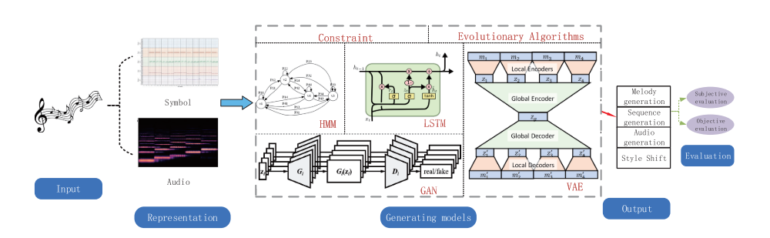
Figure 2.1 Overview of Music Generation

2.1.1 Rule-based System
Rule-based systems are among the traditional AI music generation methods used in practice. This generation system relies on predefined music theory rules, such as chord progression and harmonic constraints, incorporated into the logical engines to produce the music within the strict theoretical rules, as shown in (Figure 2.2). Experiments in Music Intelligence (EMI) was invented by David Cope in 1989 [6]. EMI analysed the structural patterns of the classical music sheets and used rule-based recombination to generate new compositions to imitate the styles. However, EMI produced music in structurally coherent music; it was restricted by the rules of training, which affected the lack of musical creativity.
The strength of rules-based systems offers to produce controllable melodies, rhythms and harmonies according to music theories. However, the limitation of this system is limited creativity, as the output music is fixed in the framework of the rules of music theory. Furthermore, it needs to create different rules for different music genre styles manually, which makes it less flexible [5].
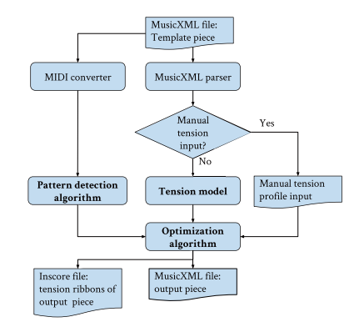
Figure 2.2 Overview of Morpheus’ architecture

2.1.2 Recurrent Neural Network (RNN)
The RNN architecture model is related to music generation. This architecture is used to capture the sequential data and learning temporal relationships between notes to predict the next notes based on previous notes using hidden layer states as the memory to store past learning information, which makes the music coherent in structure. However, the RNNs faced the vanishing gradient problem, which makes it difficult to learn the long-term dependencies in long music sequences, making it limited in music creation in various and difficult-to-control music styles [7]. To address this problem, the researchers propose the Long Short-Term Memory and Gated Recurrent Unit (GRU) to improve the long-term dependencies, which uses the memory gates to control the information to improve the quality and structure to generate music, but both will slow down training and demand more memory for long music sequences [8][9].

2.1.3 Generative Adversarial Networks（GANs）
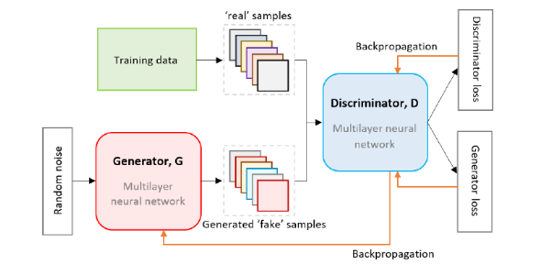
Figure 2.3 GAN Architecture

Furthermore, GANs model is also one of the techniques that was proposed in music generation [5] and designed in two neural networks – generator and discriminator to produce the music outputs. The generator gets the input data to produce music, and a discriminator that evaluates their quality to generate music of higher quality and more realistic sounds by differentiating the generated data as real or fake.
For the example, the researchers had proposed a model - MuseGAN that represented as symbolic-level generation that produce the music in multi-track with multi-instrument that designed in three models (jamming, composer, hybrid). As a result of the paper, the composer and hybrid model that performs better to handle inter-track interdependency that showed that multi-generation system is achievable [11]. Since the neural networks setup that helps in refining generated music to make more realistic and high-quality music that is more suitable for generating complex and diverse audio. Nevertheless, the challenges of GANs include training instability, model collapse and a weakness in capturing the structure and long-term dependencies.

2.1.4 Variational Autoencoders (VAEs)
VAE's architecture is a generative model separated into two components – encoder and decoder. The encoder compresses the components of music data, such as melody, harmonies, rhythms, styles and others into the latent space for capturing the attributes of data, then the decoder regenerates new melodies or musical sequences that were learned from the latent representation [12]. The models produce variations of musical compositions while maintaining similar stylistic characteristics. In the field of music generation, Roberts et al. proposed the MusicVAE model that used a hierarchical VAE architecture to generate music with long-term structure and diverse musical [13]. As a result, the VAE architecture model can produce diversity and creativity, suitable for style transfer. However, there are some limitations that VAEs need to challenge, which means that the generated music output can be lacking in musical coherence and performance compared to GANs and Transformer architectures.
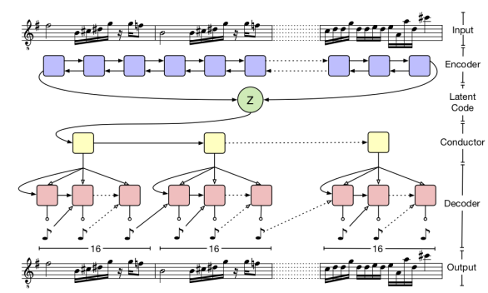
Figure 2.4 Music VAE Architecture

2.1.5 Transformer
The transformer architecture model has recently become a new benchmark in music generation. This model is designed with self-attention mechanisms that do not rely on sequential processing, who were introduced by Ashish Vaswani [14]. The transformer model allows for capturing both short and long-term range dependencies in parallel, generating complex and extended music pieces with high performance.
From the studies, the Music Transformer proposed by researchers [15], the model demonstrated the ability to produce long-term structure, dynamic phrasing, and expressive timing. Also, it had strong performance in generating coherent and expressive musical compositions. Based on its scalability and flexibility, the Transformer system is trending for use in AI-driven music generation.
Furthermore, researchers proposed the Multitrack Music Transformer (MMT), designed for symbolic multi-track MIDI music generation. This architecture introduced a compact representation that supports diverse instruments with short sequences and reduces memory usage to achieve strong inter-track coherence and fast inference through self-attention mechanisms. As a result, it showed that MMT achieves comparable performance to existing models while providing faster inference and lower computational cost. Also, the attention mechanism showed that the model captures beats, harmonic relationships and rhythmic patterns in music.
Therefore, compared to the earlier models such as RNN, VAE, and GAN, MMT provides better scalability and performance, improved long-term dependency modelling and coherent multi-track music. This project is inspired by the Multitrack Music Transformer (MMT) architecture, as it provides a useful reference for generating structured multi-instrument symbolic music while remaining practical for implementation.
In addition, MIDI-GPT is reviewed as a related transformer-based symbolic music generation model. It is designed for controllable multitrack MIDI composition and can generate music based on attributes such as instrument type, note density, polyphony level, and note duration [16]. This is relevant to the proposed system because the detected emotion can be mapped into structured music conditions before being passed to the generation module. Therefore, MIDI-GPT provides a practical reference for integrating a pretrained transformer-based MIDI generation model into the final web application.
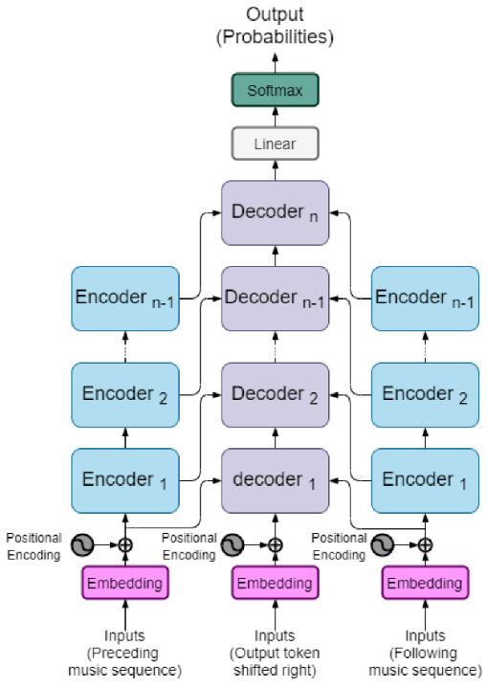
Figure 2.5 Transformer-based Model

2.2 Emotion Recognition in Music Systems
The fusion of emotion and music enriches the music palette, enabling listeners to have a deeper immersion and more effective communication of messages to the public. Music and emotion have a strong connection, which can become a powerful media of expression by using musical elements such as tempo, harmony and rhythm. Thus, emotion recognition plays an important role in AI-driven music generation that can act as media of emotional expression or information to the public.

2.2.1 Emotion Representation Models
Emotion recognition in the music system requires a clear framework for categorizing and translating emotional states into a structured format that enables the system to understand and process. That model is separated into categorical, dimensional and hybrid modes.

2.2.1.1 Categorical Models
Categorical models are represented as discrete labels corresponding to specific emotions. Ekman’s model is one of the categorical models that defines six universals (happiness, sadness, anger, fear, surprise and disgust) [18]. In the term "music system," this type of model provides a simple mapping, such as happiness being represented by fast tempos, major scales, and bright timbres.
The studies had proposed that the Geneva Emotional Music Scale (GEMS) model is specifically designed to represent emotions evoked by music. GEMS model includes emotion categories such as nostalgia, power, sadness and others that can describe expression in a more specific way compared to Ekman’s model [19].
A key strength of categorical models is that they provide an intuitive way to express users straightforwardly, and that the emotions are represented in clear and easily labelled. This feature makes users describe emotion using familiar terms for classification tasks. However, this model's limitation is that it fails to represent complex emotions, such as bittersweetness, which cannot be easily captured in complex emotional variations in a limited set of discrete categories because it oversimplifies [20][21].

2.2.1.2 Dimensional Models
Dimensional models represent emotion on a continuous scale, allowing for a flexible and nuanced analysis. For example, Russell’s Circumplex Model, which places the emotions in valence (positive-negative) and arousal (high-low) groups (Figure 2.2.1.1) [22].
For instance, the emotion “happy” is represented as high tension and positive energy, placed at positive valence and high arousal, with a fast tempo, major keys, and a bright timbre. These models are powerful in music generations because they enable dynamic adaptation of musical features. Valance represents harmony and scales mode, while arousal aligns as tempo, rhythms and loudness. A key strength of these models is easily capturing complex and mixed emotions with a strong computability in 2D or 3D coordinate space to represent emotions. In contrast, there are some limitations that dimensional models have, including that different emotions may share similar valence and arousal value in the coordinate space, which makes it difficult to clearly distinguish between specific emotional states.
For example:
- Happy → fast tempo, major scale, bright timbres (e.g., guitar, piano).
- Sad → slow tempo, minor scale, soft timbres (e.g., cello, violin).
- Energetic/Angry → strong percussion, distorted or heavy sounds.
- Calm/Relaxed → smooth harmonies, ambient textures, low tempo.
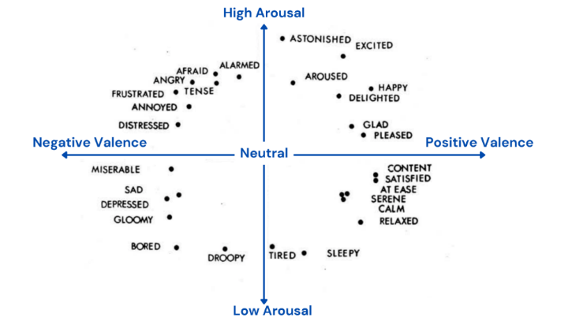
Figure 2.6 Rusell's Circumplex Model

2.2.1.3 Hybrid Models
Hybrid Models combine categorical and dimensional approaches to better capture emotion in music by combining their strengths to address the limitation of reliance on a single framework. In this paper [23], the researchers proposed a multitask learning framework that predicts both discrete emotion categories and dimensional values to improve generalization across different types of datasets. It provides a more balanced and flexible representation of emotions in AI-driven music systems to generate personalized and emotional, and adaptive compositions.
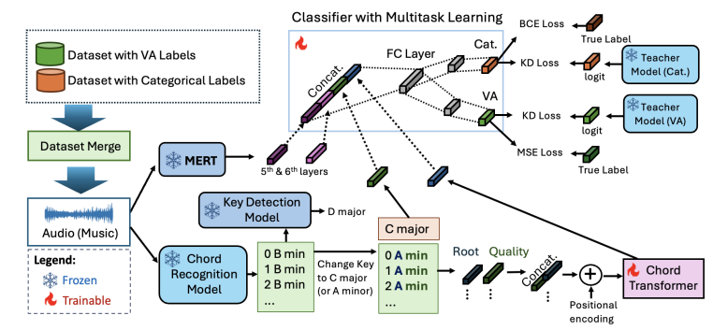
Figure 2.7 Overall Architecture of Multitask Learning Framework for Music Emotion Recognition

Thus, the comparison between the hybrid and dimensional emotion models indicates that the dimensional emotion model is better suited to capturing complex emotional states and improving the mapping of emotion to musical features.

2.2.2 Text-Based Emotion Recognition Techniques
Emotion recognition has become a part of component in AI-driven music generation systems. It acts as a bridge for communicating with the system using natural language to express their idea and emotions and translate them into the system with musical attributes for music creation. Nowadays, there are various AI techniques for emotion recognition.
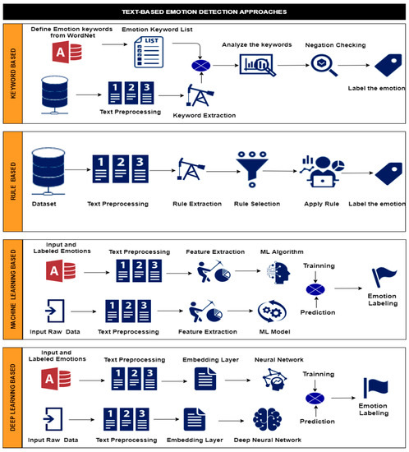
Figure 2.8 Overall AI Techniques of Emotion Recognition

Machine Learning
In machine learning models, the models collect the data from the emotion dataset, generating data and preprocessing data for data cleaning to get the keywords from the textual of users. Machine Learning included some algorithms such as SVM, Random Forest and Naïve Bayes to classify emotion from the textual input by users. These models rely on handcrafted textual features such as Term Frequency-Inverse Document Frequency (TF-IDF) or Bag-of-words (BOW). According to research by Kharde and Sonawane [25], using the SVM and Naïve Bayes to analyse the posts of text in Twitter shows that both models have a high accuracy detection in the research and use lexical-based and syntactic features to predict sentiment and emotional tone. ML models learn the statistical relationships between words and emotions from labelled data, compared with lexical-based models, and perform more flexibility and adaptability. However, these models are limited to capturing in-context information and long-range dependencies in text and are restricted in analysing complex information and implicit emotional cues. Also, the researchers compared the classifier average performance between ML and DL and found that ML models’ performance is weaker than DL models: SVM: 74.13% compared to the CNN, which achieved in 80.63%, and LSTM performed in 85% [26].

Deep Learning
Deep learning models enabling to learn representations directly from raw text. Recently, RNN and LSTM networks have been widely used to capture sequential dependencies in language, which LSTMs can capture better than BOW models based as the emotional meaning depends on the relationship between clauses. The Convolutional Neural Networks (CNNs) originally designed for the image recognition field were adapted for text classification tasks, detecting emotionally charged phrases or local word patterns [26][27]. In the research of [27], proposed Semantic-Emotion Neural Network (SENN) that builder in CNN and a bidirectional Long-Short Term Network (BiLSTM) is possible on emotion recognition in high result compared to others. Nevertheless, LSTMs and CNNs models require large amounts of labelled data, which is often costly and time-consuming to obtain for emotion-specific datasets. Furthermore, they struggle to capture long-range dependencies in lengthy or complex.

Transformer
Transformer is the most recent development technique for text-based applications in emotion recognition, which uses a self-attention mechanism [14] that allows for capturing short-term and long-term dependencies in text without relying on sequential processing. This feature makes the models effective in detecting subtle and complex emotions in natural language with assigned NLP.
The most popular transformer is Bidirectional Encoder Representations from Transformers (BERT), which learns contextual word representations by considering sentence context. It has shown strong performance in emotion classification but requires large-scale pretraining and computational resources. Robustly Optimized BERT approach (RoBERTa) enhanced the accuracy result by removing next-sentence prediction and optimizing training strategies, but needs to increase model size, making it less efficient for real-time applications compared to basic model BERT [29]. Furthermore, Decoding-enhanced BERT with disentangled attention (DeBERTa) was designed with a disentangled attention that separates content and positional representations during the process. This design improves the model to capture the relationship between words and their positions in a sentence. The study of [30] shows that DeBERTa had performed a high accuracy result (84.97%) in the emotion classification task on the benchmark dataset.

2.3 Conversational Agents in Natural Language Processing
Chatbots give an interface to users to communicate with the system using natural language, which improves human and computer interaction. Nowadays, this technology has been widely used across different industries such as education, healthcare, customer service and entertainment. Users can intuitively communicate with systems that omit the complexity of interacting with digital systems to enhance user experience by using natural language [32].
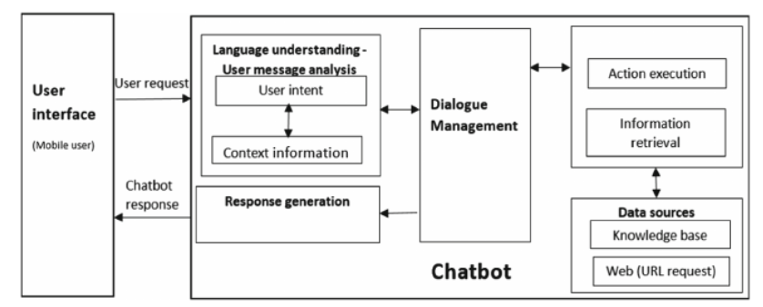
Figure 2.9 General Chatbot Framework

2.3.1 Rules-based Chatbots
Rules-based chatbots rely on predefined data, keyword matching or decision trees to respond to user inputs. They are working as if, then logic rules with determination to produce fixed responses whenever the rule is triggered. As the model was designed, it always performed with accurate results for users. If it works in a music system that approaches by asking users to select predefined emotional categories like happy, sad or calm. For example, the ELIZA chatbot, which is designed to detect keywords and generate responses based on a script template [34]. However, these types of systems are limited because they cannot handle complex or unexpected queries and need to define new rules for adding more responses to maintain natural conversation when users' input fails to match the information within the database [34].
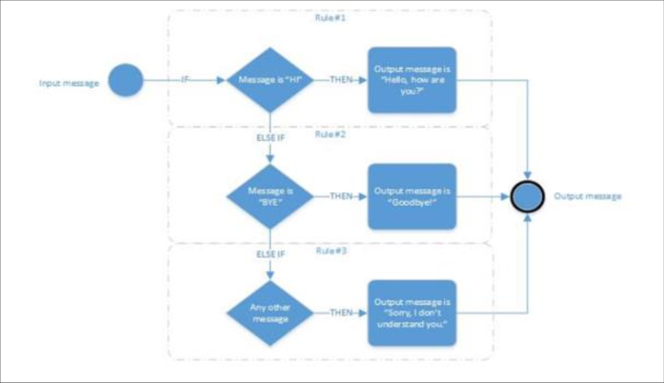
Figure 2.10 Structure of a Rule-based Chatbot

2.3.2 Generative Conversational Chatbots
Recently, the conversational agent’s model has been designed with advancements in natural language processing and machine learning, which is enhanced by Large-Language Models (LLMs) such as ChatGPT and Gemini. Those models are trained in large-scale text datasets and dialogues that can provide flexibility, understanding context and emotion expressed by users for natural language. Compared to rule-based chatbot models, LLM-driven chatbots need to be trained on large text data and dialogues, which allow them to understand context and emotional tone.
Research has shown that LLM can have a strong performance in natural language processing tasks using few-shot or zero-shot learning, enabling them to conform to new tasks without numerous task-specific learning [35]. However, the limitation of LLM requires high computational resources and may generate inaccurate or contextually inconsistent output responses in certain situations. As a result, compared to the rule-based systems model, LLM models provide stronger contextual understanding and natural language generation capabilities, making them suitable for applications in the music generation system.
Furthermore, an LLM-driven chatbot supports multi-turn dialogue and conversational memory that enables users to iteratively optimise generated music [36]. This feature allows users to continuously interact with the system to gradually adjust music performance such as emotional tone, style and instrument preferences [37]. So that the system can translate the adjustment into structured parameters that the backend music generator can execute, which provides a personalised creation experience to users.

2.4 Existing AI-based Music Generation System & Platform

2.4.1 Artificial Intelligence Virtual Artist (AIVA)
AIVA is an AI music generation system designed for professional composition, published by a Luxembourg company [38]. It is usually used for film, advertising and video game soundtracks. It uses the deep learning models trained on the large datasets of classical and symphonic music to achieve high-quality music generation. It primarily generates symbolic music (MIDI), which is then rendered into audio using high-quality sound libraries.
AIVA provides label tags for users to choose the emotion, music styles, and chord progression for users to create music with default settings of AIVA. From (Figure 2.11), users can select the style that they want, such as tempo, expressive performance, emotion, dynamic range and harmony to generate the music based on the requirements they selected. Users can also edit the music composition or update the MIDI file in the editor to make edits like cutting, making accents and changing the key signature manually, just like making music in the music maker application, which provides high editability to users for making creation (Figure 2.12). Furthermore, it provides a sample of different types of styles or chord progressions for users to choose (Figure 2.13).
Strength:
- Clearly and friendly user interface and user experience for the user.
- Users can modify the effects of style, tempo, key signature and others.
- Users can upload the MIDI file to make customised music.
- Provide high-quality composition
- Users can arrange the output of the music in the editor if they are not satisfied or change the style manually.
Weakness:
- Limited styles to generate music composition, it excels at classical and symphonic music but is not as strong at producing modern music.
- Limited user interaction that is primarily for selecting present parameters, which is restricted to matching the complex description of users needed.
- Free users are limited to downloading files and creating music for a duration.
- Limited emotional understanding, although users can select an emotion label in the creation site, it cannot recognise more complex emotions.
- Need some musical theory knowledge when editing in the editor for creation.

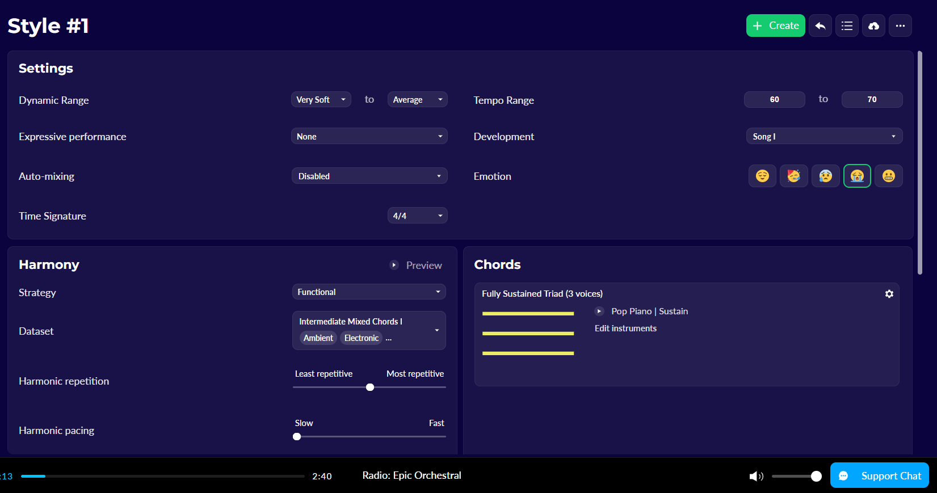
Figure 2.11 Settings Dashboard of Music Creation

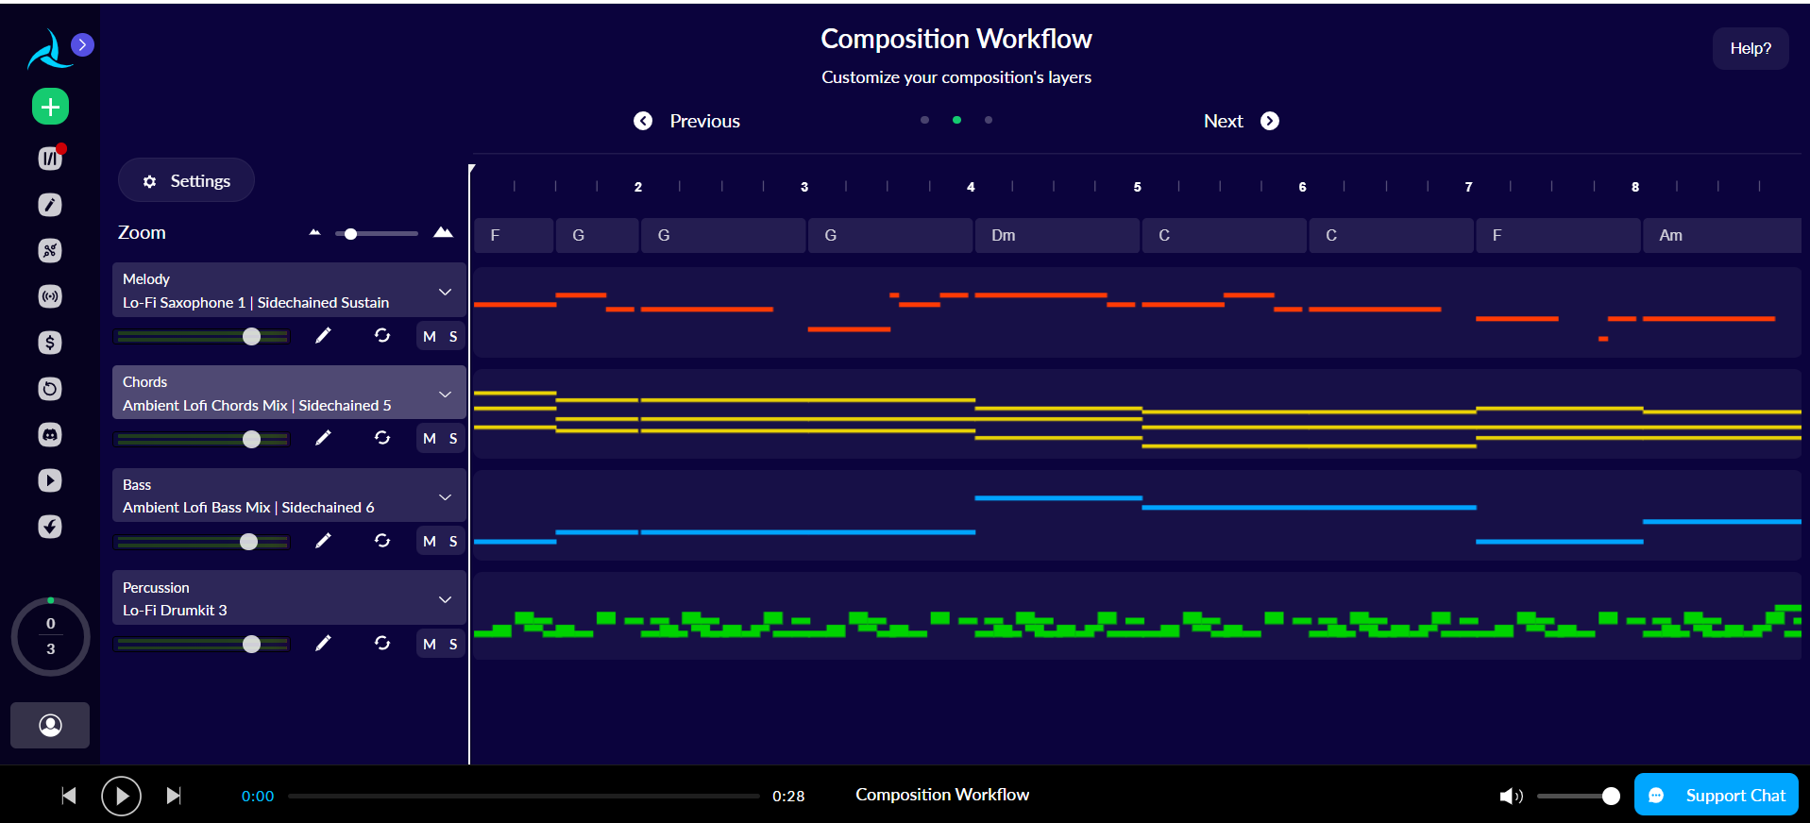
Figure 2.12 Editor

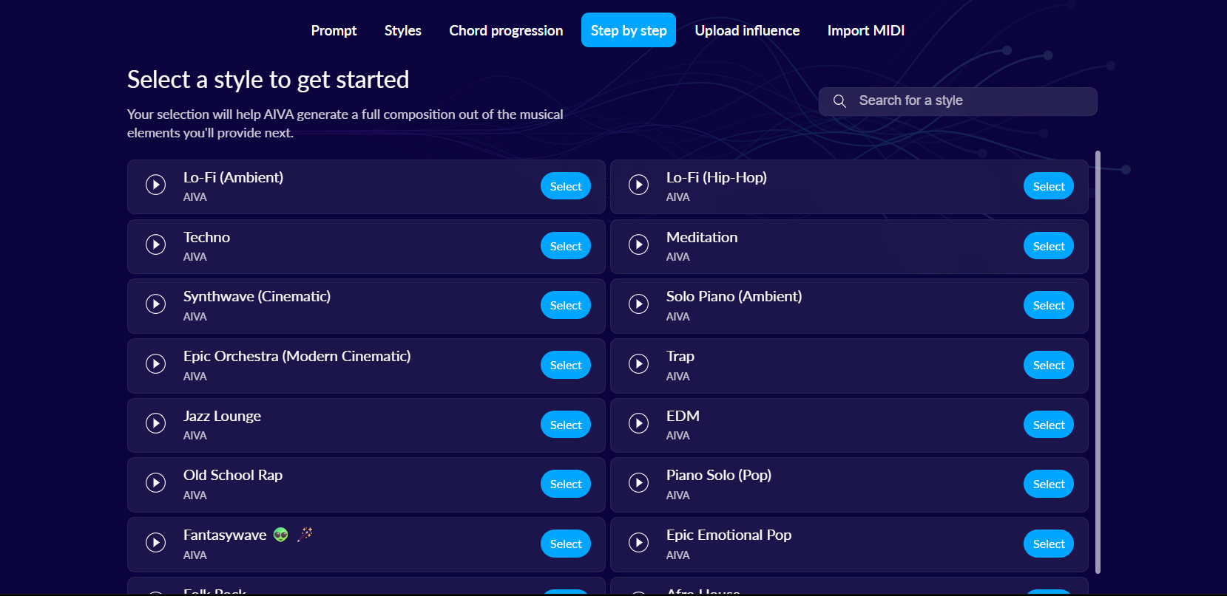
Figure 2.13 Sample of Music Composition

2.4.2 Boomy
Boomy was published in 2019 that specifically targeting users without music creation experience and content creators to create music easily and quickly [39]. It provides more accessibility and rapid composition with selected predefined styles in a few seconds to create music through the music generative system (Figure 2.14). It provides an intuitive interface with styles, instruments and effects that users can customise their music by adjusting elements that they want (Figure 2.15).
Furthermore, Boomy is integrated with music distribution platforms such as Spotify, Apple Music and YouTube that enabling users to publish their compositions on these platforms for commercial release to gain some revenue (Figure 2.16).
Strength:
- Fast to produce music in seconds, making it efficient for users.
- Highly user-friendly for beginners and non-musicians.
- Provides customization options to give users creative control despite limited expertise.
- Provide a platform for creators to publish their compositions on the platform to earn.
Weakness:
- Limited emotional mapping that may not capture user moods generated out of the ascent of the music performance styles by users’ expectations.
- Restricted flexibility in producing complex multi-instrument arrangements.
- Lack custom synthesizer programming, reducing flexibility for users.
- No conversational interaction, users interacting with a simple, click-based user interface, which limited personalized music based on music preferences.
- Free users are limited to song saving in the library
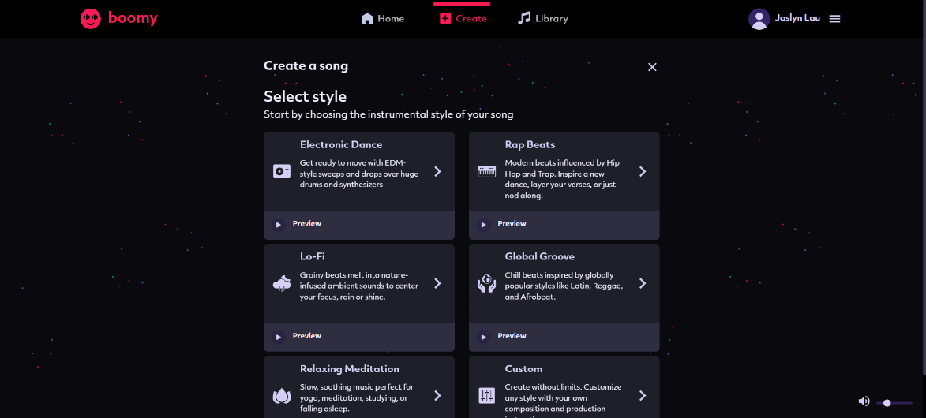
Figure 2.14 Interface of Style choosing in Boomy

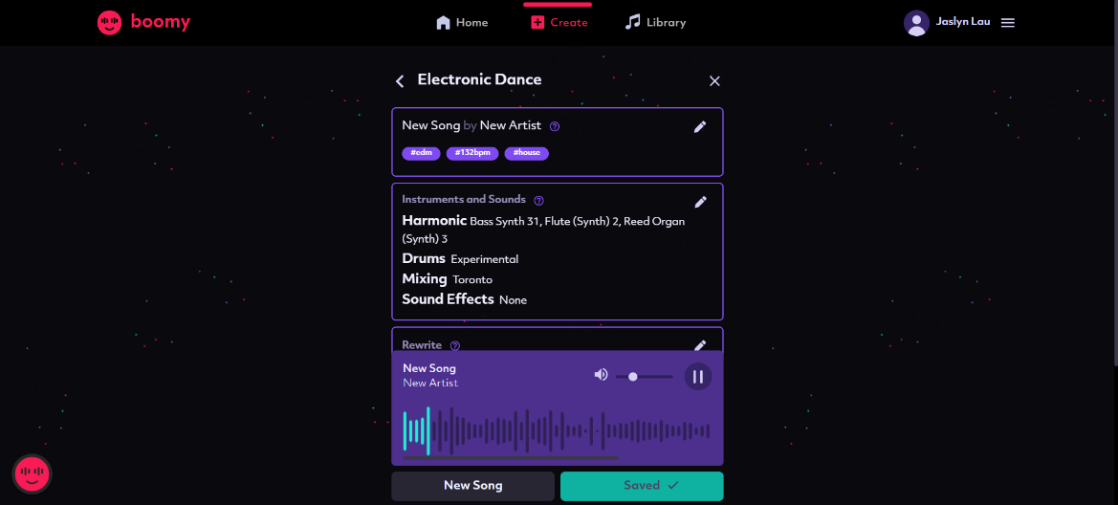
Figure 2.15 Modify Interface of Boomy

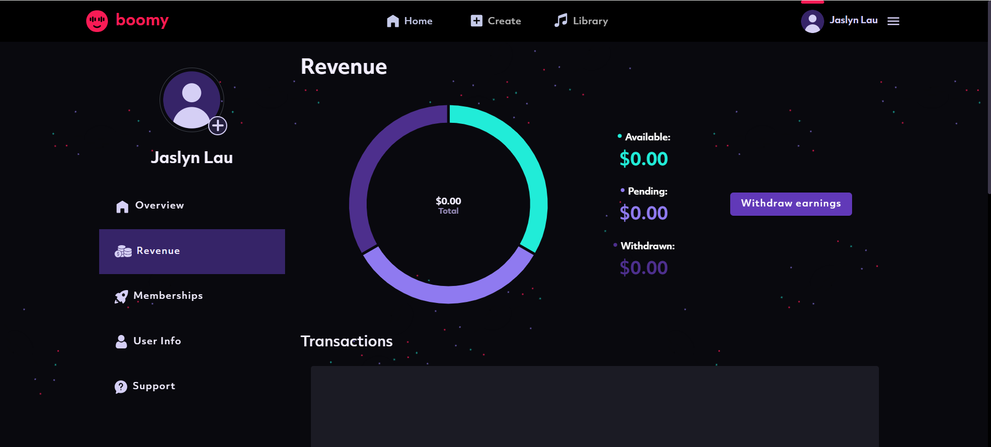
Figure 2.16 Interface of Revenue

2.4.3 Suno
Suno is an AI music generation platform launched in 2023 that enables users to generate complete music, enabling users to make music creations without a music background. It enables users to use text prompts for description, including lyrics, genre, vocals and instrumental and provides tags for users to select genre output (Figure 2.17) [40].
Suno also provides an intuitive interface that enables users to select different genres or styles of music when users have input the description, and it is designed like Spotify, where creators can publish or share their compositions or songs on this platform (Figure 2.18). Furthermore, it integrates with Microsoft Copilot, so that users can interact with Suno in a chatbot, making the music creation process more natural and accessible. These features improve the interaction between the system and users, which can better meet users’ requirements and expectations. However, the interaction remains limited to a single turn prompt, which cannot have multi-conversation with the system to adjust music.
Strength:
- Supported chatbot-style interaction with users who describe more details user requirements.
- Provide natural language prompts that improve usability compared to a parameter-based system.
- Provides end-to-end song generation with vocals, lyrics and instruments.
- Fast and accessible for music creation, with generating different melodies for choosing.
- Enables users to publish and share their compositions on the platform.
Weakness:
- Limited ability of conversational, only supports single turn prompts, cannot make multi-conversational.
- Limited to adjusting the elements for music creation, relying more on predefined models, reducing flexibility for custom composition styles.
- Generated compositions still fall short of professional composition tools in terms of melodic fluidity, lyrical coherence and repetitiveness.
- Music quality remains inconsistent, and sound quality is unclear.
- Limits on the number and duration of music creation for free users
- Need to subscribe to unlock the studio for music editing

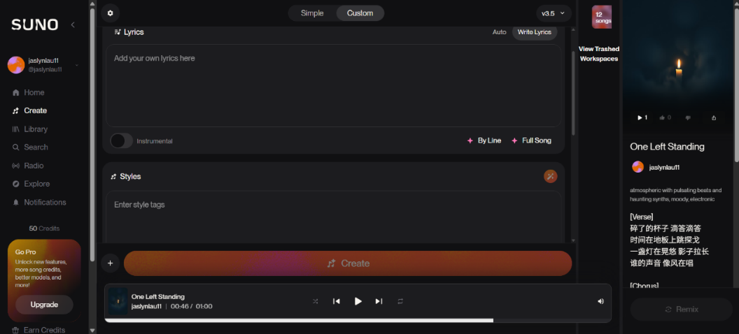
Figure 2.17 Chatbot of Music Creation

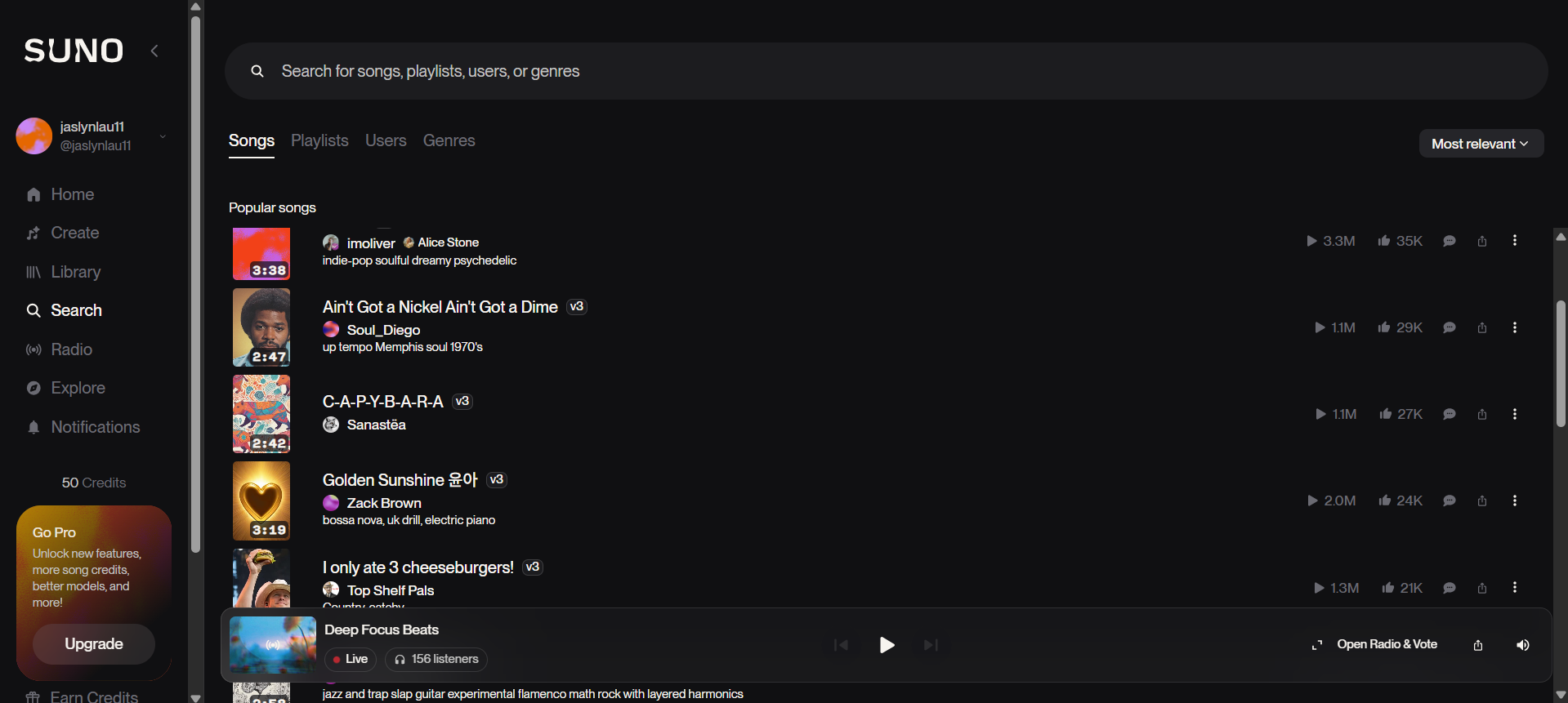
Figure 2.18 Music Library

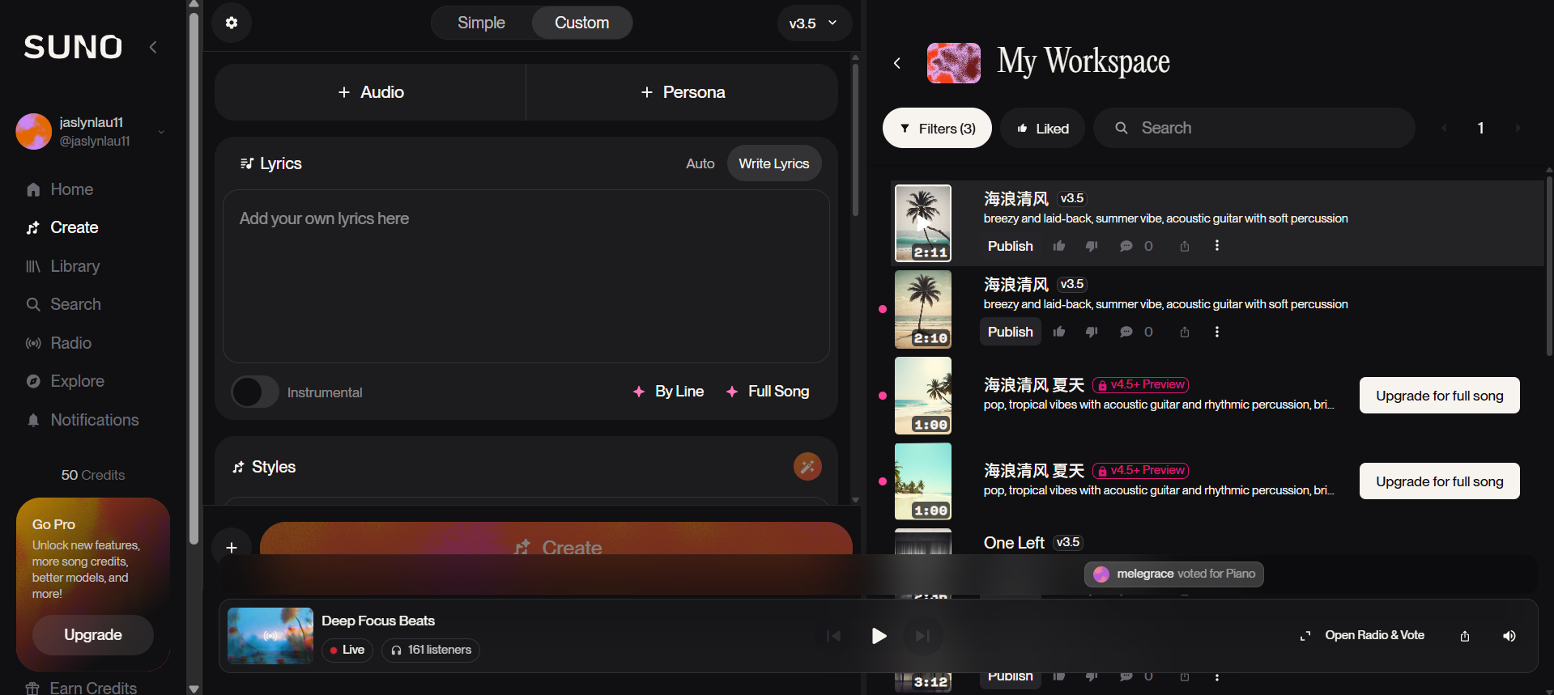
Figure 2.19 Workspace of Suno

Table 2.1 Comparison Table of Existing AI Music Generation Platforms
Features | AIVA | Boomy | Suno
Representation | Symbolic | Audio | Audio
Design of User Interface | Simple, clear interface. Allow MIDI editing | Simple and user-friendly, but when making music creation, it displayed like a mobile-based | Intuitive with a similar Spotify interface with chatbot support.
Responsiveness / Accessibility | Responsive in mobile view | Responsive in mobile view. | Responsive in mobile view, also published with a mobile application
User Roles | Targeted at professionals (film, ads, game composers) | Targeted at beginners and casual creators | Targeted at general users with or without a music background
Emotion Mapping | No. Only style selecting | No. Only style selecting | Only style selecting, but can write input in the lyrics box to express emotion to generate output.
Music Editing / Customization | Editable MIDI files, users can manually adjust tempo, harmony, key, and chord. | Limited customization (styles and instruments only). | Limited flexibility and relies heavily on predefined models.
Conversation / Interaction | No chatbot, only a selection of parameters | No chatbot with direct style and element selection | Chatbot-based input, but only single-turn conversation

2.5 Summary
In conclusion, the literature reviewed in this chapter is closely related to the development of the proposed AI chatbot-driven personalized music generator. The review of AI music generation techniques shows that Transformer-based symbolic music generation is more suitable for this project because it is able to model longer musical dependencies and generate more structured music output compared to RNN-, LSTM-, GAN-, and VAE-based approaches. This supports the use of a Transformer-based model in the proposed system.

The literature on emotion recognition also supports the direction of this project. Among the reviewed emotion representation methods, the dimensional approach using valence and arousal provides a more flexible way to describe emotional states than simple categorical labels. This is relevant to the proposed system because the project aims to interpret user emotion from text input and map it into music-related conditions. In addition, the review of conversational agents shows that chatbot-based interaction is more suitable than rigid rule-based input because it allows users to describe their needs in natural language. Finally, the review of existing music generation platforms highlights that many current systems still provide limited personalization, weak emotion alignment, and insufficient conversational support. These limitations directly justify the need for the proposed system and confirm the relevance of the selected project direction.

Chapter 3
SYSTEM METHODOLOGY/APPROACH
In this chapter, the methods employed in the development of the project are described. It has listed the system requirements, including hardware and software specifications, and presents the methodological steps followed throughout the development process.

3.1 Methodology

3.1.1 Methodology and General Work Procedures
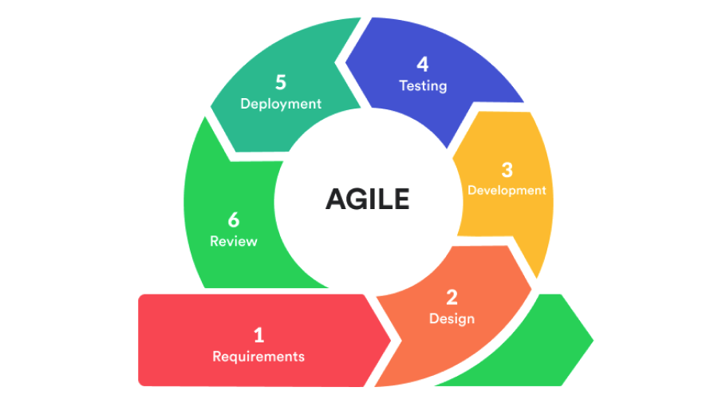
Figure 3.1 Agile Development Cycle

This project adopted an Agile Development Methodology using an iterative and incremental approach. Agile is suitable for this project because the development of an AI chatbot-driven personalized music generation system involves multiple interdependent modules that require one-by-one development, testing and refinement rather than a single-pass implementation. Furthermore, starting the module flow, these modules included symbolic music dataset preparation, tokenization, transformer-based music model training, and web-based user interface integration. Since the quality of generated symbolic music could not be guaranteed in the first development cycle, repeated experimentation was required to refine the tokenization settings and design, model configurations, training parameters, and generation strategies. Thus, the Agile approach was suitable in the project because it encouraged continuous improvement, modular development, and repeated testing throughout the project life cycle.
The development process was divided into several iterative stages:
- Requirements
In this phase, the idea of developing an AI-music generator is defined after the problem statement, objectives, and scope of the project. Literature reviews are carried out on related systems such as emotion recognition, music generation models and chatbot models and datasets suitable for using the selected music representations are conducted to define the system requirements.

- Design
In this phase, the overall system structure workflow is designed. This includes the design of the chatbot interaction flow, emotion input processing, music generation pipeline with the tokenization and training, system architecture and user interface.

- Development
In this phase, the proposed system is developed based on the design specifications. This includes dataset preparation, music representation, tokenization the dataset, building a Transformer-based music model for training, emotion mapping to the music generation, chatbot integration and user interface development.

- Testing
In this phase, the developed system is tested to ensure that each module functions correctly and meets the project objectives. The generated music output, chatbot interaction, and system usability are evaluated for performance and quality.

- Deployment
In this phase, all developed modules are integrated into a complete prototype system. The chatbot, music generation model and related to the emotion mapping and user interface are connected and deployed in a working environment to demonstrate the overall system functionality.
- Review
In this phase, the system is checked based on testing results to identify limitations. Refinements and improvements are made to enhance the system performance and output quality, related to the user requirements and user experience.

3.1.2 System Requirement

3.1.2.1 Hardware
The hardware involved in this project is a laptop computer, which serves as the primary platform for system development, model training, system integration, and testing. It is used to support dataset preprocessing, music generation, chatbot integration, and user interface development. The specifications of the laptop used in this project are shown in Table 3.1:
Table 3.1 Specifications of Laptop
Description | Specifications
Model | Acer Nitro AN515-58
Processor | 12th Gen Intel(R) Core (TM) i5-12450H, 2500 Mhz, 8 Core(s), 12 Logical Processor(s)
Operating System | Windows 11
Graphic | NVIDIA GeForce RTX 3050 Laptop GPU
Memory | 16GB DDR4-3200 MHz
Storage | 512GB Micron 3400 NVMe SSD

3.1.2.2 Software
The software will be used in this project:
Table 3.2 Software Requirement
Components | Tools | Description
Tools | Visual Studio Code | A lightweight source code editor with support for multiple programming languages for debugging, testing and integration
Tools | Google Colaboratory (Colab) | Used as training and testing models due to the free cloud GPU.
Programming Languages | Python | Used as the main programming language for implementing the backend system, emotion processing module, and music generation module.
Programming Languages | JavaScript | Enabling interactive and dynamic content on the website.
Programming Languages | Hypertext Markup Language (HTML) | Standard markup language for creating web pages and describing the structure of web content.
Programming Languages | Cascading Style Sheets (CSS) | The stylesheet language is used to design to present the appearance of the website.
Libraries & Frameworks | PyTorch | Main code editor during the development process for debugging, testing and integration
Libraries & Frameworks | miditok | Used for tokenizing symbolic music data and decoding generated token sequences back into MIDI format.
Libraries & Frameworks | pyfluidsynth | Used to render MIDI output into WAV audio for direct playback on the website
Libraries & Frameworks | mido | Read and process MIDI files during analysis and duration checking.
Libraries & Frameworks | Ollama | Open-source frameworks for conversational AI chatbots.
Libraries & Frameworks | Firebase | Store users’ data
Dataset | Lakh MIDI Dataset | Multi-instrument dataset used in the project
Dataset | POP909 | Multi-instrument dataset used in the project

3.1.3 User Requirements
The system is designed to meet the following user requirements:

1. Users should be able to register and log in to the system using an email and password.
2. Users should be able to input music requests through the chatbot interface.
3. Users should be able to describe emotion, style, instrument preference, and music requirements in natural language.
4. The system should be able to detect the emotional context of the user input.
5. The system should be able to map the detected emotion into suitable music generation conditions.
6. The system should be able to generate music based on the user input and detected emotion.
7. The system should produce generated music output in MIDI format.
8. Users should be able to listen to the generated music through the web interface.
9. Users should be able to download the generated MIDI or WAV output.
10. Users should be able to view previous generated music records and chatbot history.
11. Users should be able to regenerate music using previous prompts or updated preferences.
12. Users should be able to delete generated music records from their history.

3.1.4 System Performance Definition
Several key factors were considered when defining the system performance. The system should be able to receive natural language input from the chatbot interface and identify the emotional context of the user’s request. The detected emotion and user requirements should be passed correctly to the emotion-to-music mapping module so that suitable music conditions, such as tempo, note density, velocity and instrument preference, can be produced.
Furthermore, the music generation module should be able to produce playable symbolic music output. The generated music should be saved in MIDI format and, when available, rendered into WAV format for browser playback. In addition, the generated music should show basic musical consistency in terms of note progression, instrument arrangement and overall structure to improve the listening experience.
Besides that, the system should be reliable and usable during normal operation. The chatbot interface, emotion detection module, music generation module, Firebase services and playback functions should work together consistently. The system should also provide a user-friendly interface so that users without technical or musical knowledge can describe their music ideas, generate music, listen to the result and manage previous outputs conveniently.

3.1.5 Verification Plan
The proposed system is intended to make sure that each module functions correctly and that the overall system will be able to generate music successfully. The system will be verified using different user input cases involving different emotions and instrument preferences. For example, users can input the emotion, such as happy piano music and sad strings, which will be used to test whether the chatbot, emotion detection module, and music generation module can operate correctly and function properly.
The verification process focuses on whether the system can receive user input, detect the emotion, generate music successfully, and provide the generated music results through the user interface. The generated MIDI and WAV outputs will also be tested to ensure that they can be played and downloaded properly. In addition, the system will also be checked for overall reliability and usability to confirm that all modules can work together consistently and provide correct results during operation.

3.2 System Design Diagram / Overview
This section describes the overall design of the proposed system and explains how the main components work together to generate music based on the user’s emotion and style preferences. Furthermore, the system design has covered the overall system flow, the main system components, the data preprocessing flow and the connection between the chatbot interface, music generation module and playback component.
The purpose of the system design is to allow users to describe their emotional requirements and instrument preferences in human language with the user input to the chatbot, then analysis the requirements to produce a musical output and playback delivery. The flow ensures that the user's request can be processed clearly and converted into a suitable music output.

3.2.1 Overall System Flow
The system flow in the project will be: User Login / Register → Chatbot Interface → User Music Prompt → Prompt Analysis → Emotion Detection and Preference Extraction → Emotion-to-Music Mapping → Music Generation Module → Generated MIDI/WAV Output → Save Metadata and Files to Firebase → Playback, Download and View History
The process begins when the user registers or logs in to the web application. After authentication, the user enters a music requirement through the chatbot interface. The input is passed to the chatbot module and analysed to identify the user’s emotion, style, instrument preference and other music requirements. If emotion or preference information is detected, the system performs emotion detection and preference extraction. If no clear emotion or preference is found, the system assigns a neutral emotion or asks the user for clarification. The extracted information is then mapped into structured music conditions before being forwarded to the music generation module. The generated result is saved as a MIDI file and may also be rendered into WAV format for browser playback. The generated metadata and files are then stored in Firebase, allowing the user to play, download and view the generated music history.
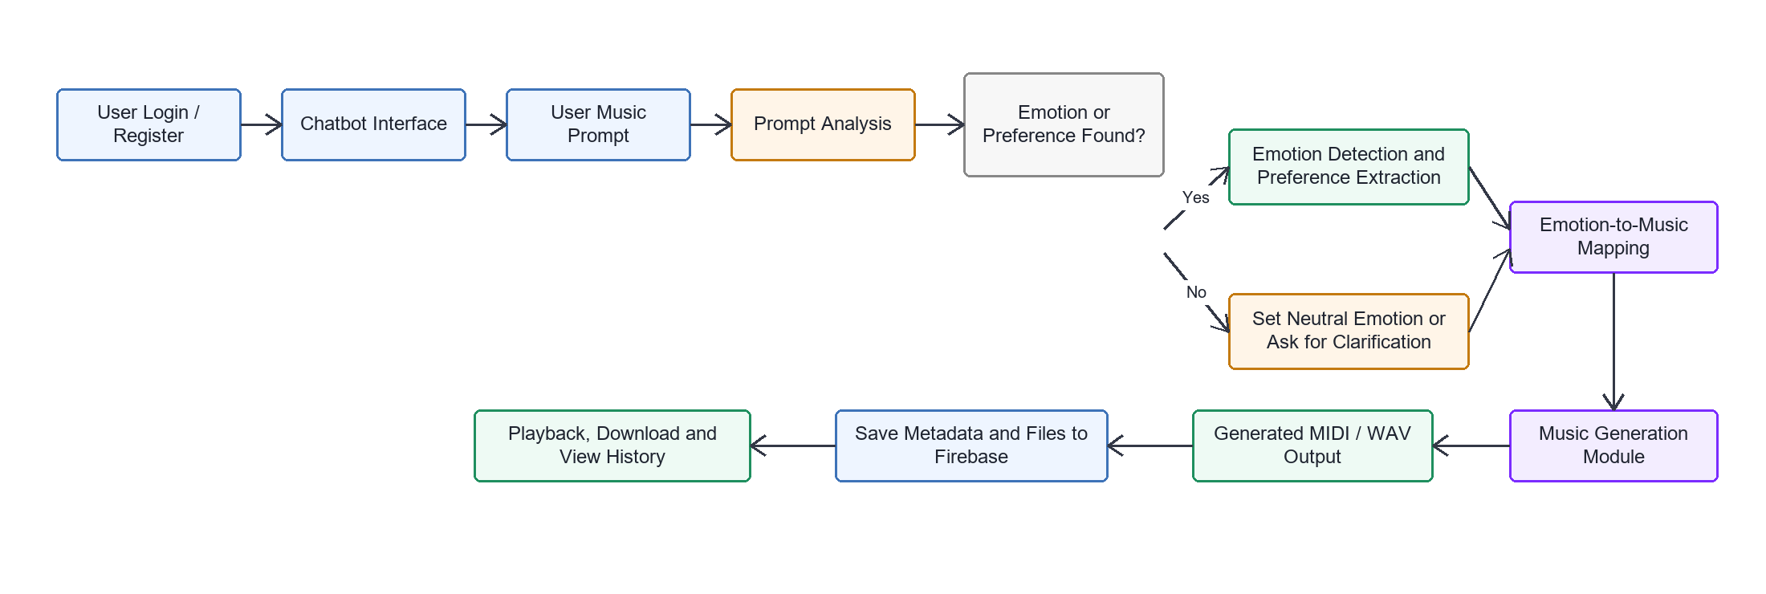
Figure 3.2 Overall System Flow
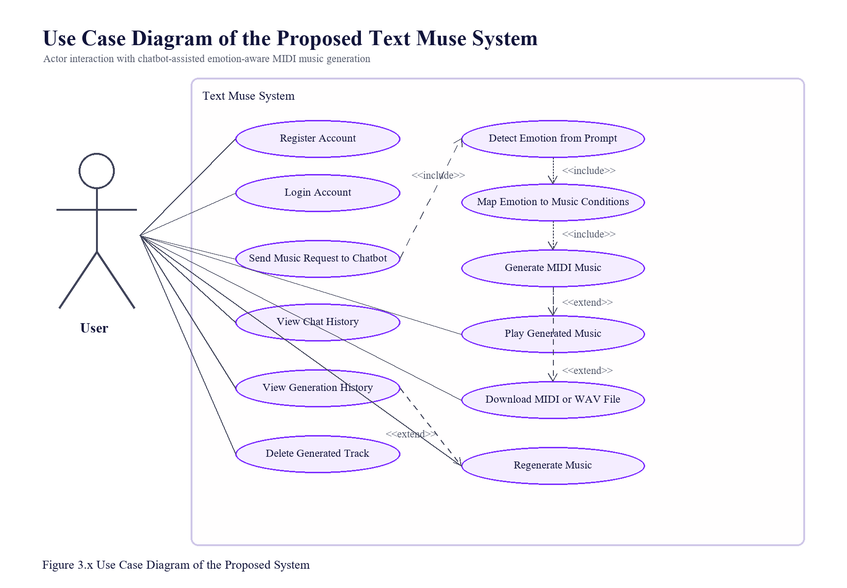

3.2.2 Use Case Diagram
Figure 3.3 Use Case Diagram

3.3 Timeline
The project timeline was planned according to the main development tasks and milestones of the FYP2 semester. The work focused on refining the FYP1 prototype and integrating the chatbot, emotion detection, emotion-to-music mapping, music generation, Firebase authentication, storage, playback, download and history management functions into a complete web-based system. The timeline also covered model-related work, including the custom Music Transformer, MIDI-GPT integration and rule-based fallback generator. In the final stage, system testing, result evaluation, report writing and documentation were completed to ensure that the proposed system met the project objectives.
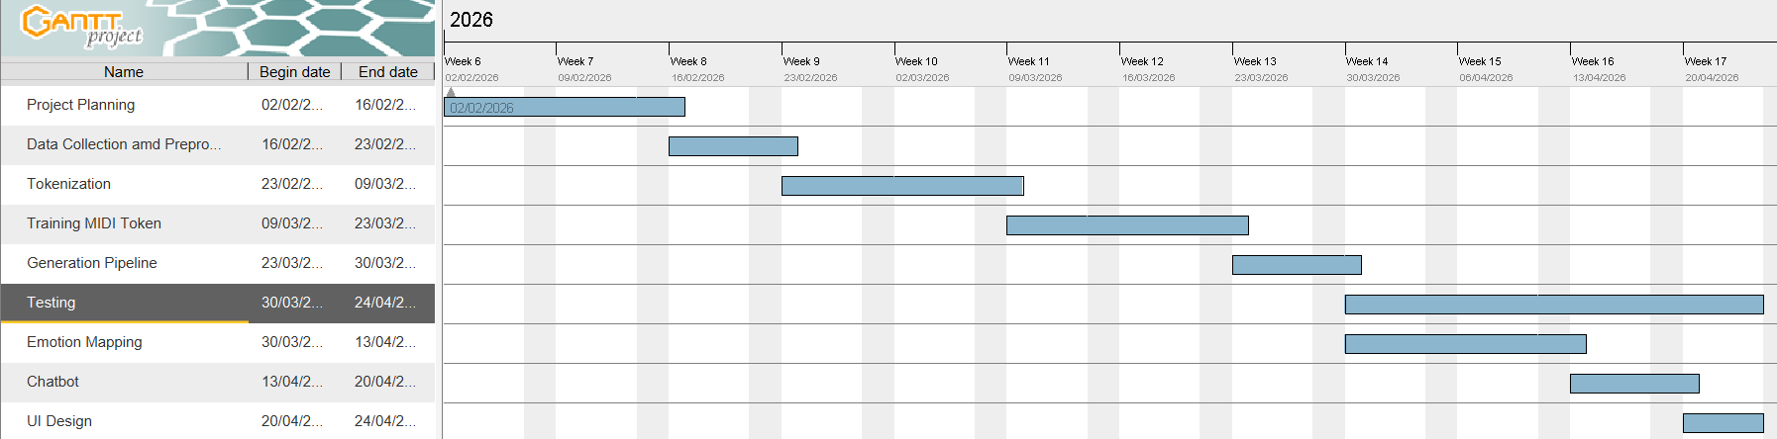
Figure 3.4 FYP1 Timeline

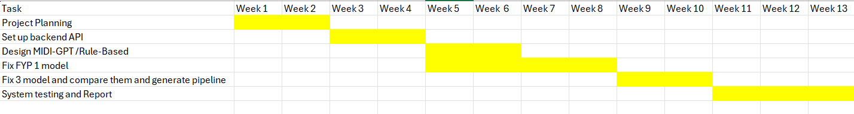
Figure 3.5 FYP2 Timeline
Chapter 4
SYSTEM DESIGN
This chapter presents the system design of the proposed project system. The design focused on the structure, workflow, database, user interface and major system components involved in generating music from user text input. The system is designed as a web-based application that allows users to register, login, enter text prompts, generate MIDI- based music, preview the output and view their generation history.

4.1 System Architecture
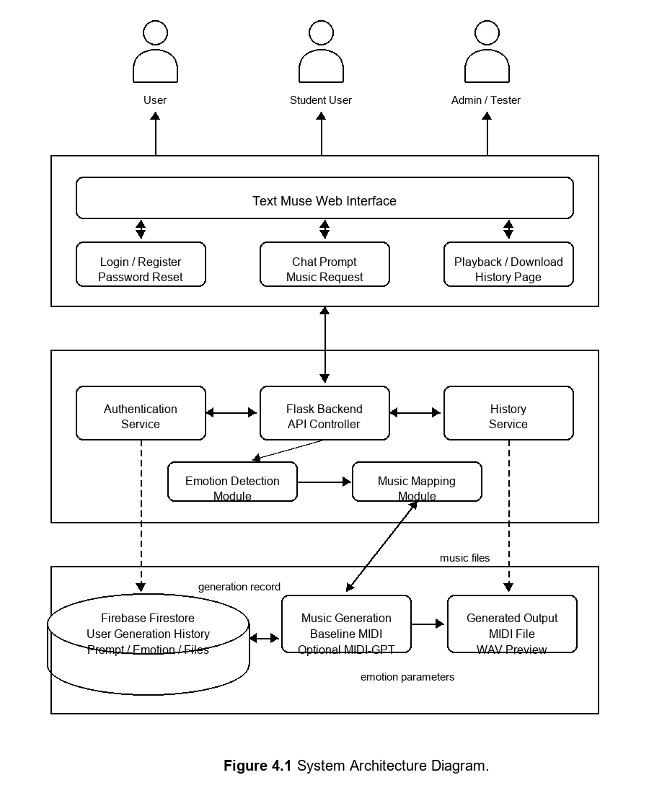
Figure 4.1 System Architecture Diagram

4.2 Chatbot Module
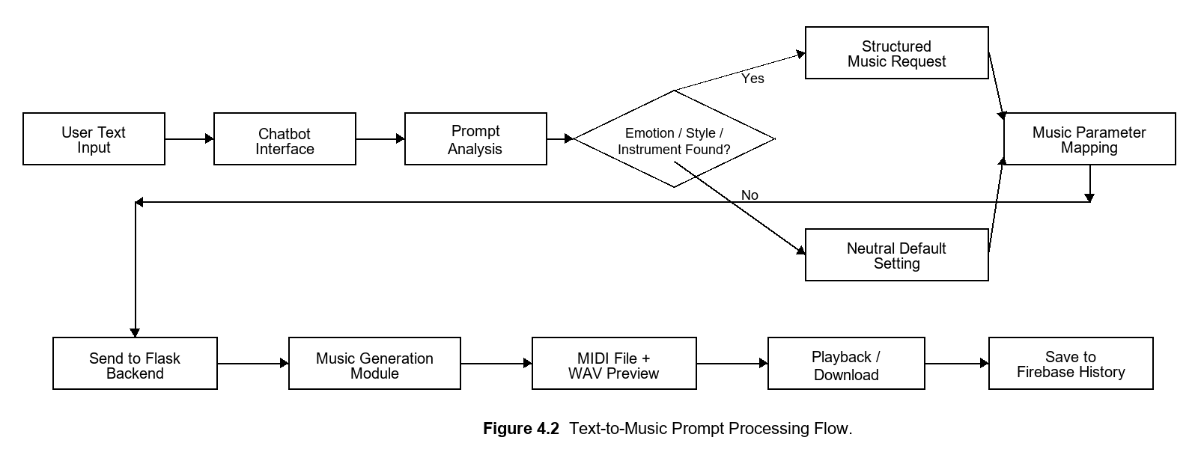
Figure 4.2 Text-To_Music Prompt Processing Flow

Figure 4.2 shows the flowchart of the chatbot interaction model. The system first receives a user message from the chatbot interface. The message is then sent to the Flask backend through the /api/chat endpoint. Next, the chatbot module determines whether the message is a general conversation or a music related request by checking music-related keywords.
If the message is related to music generation, the system processes the message with the emotion detection pipeline. The detected emotion, valence, arousal, suggested tempo range, velocity range, density level, preferred instruments, and emotion control token are added as context for the chatbot. The chatbot then sends the conversation history, system prompt, and contextualized user message from the Flask backend to the Groq API. The Groq API uses the online LLaMA 3.3 model to generate a natural language response.
The Groq API uses the online LLaMA 3.3 model to generate a natural language response. When the Groq API successfully processes the request, the response is returned to the Flask backend and displayed in the chatbot interface. If the Groq API is unavailable or returns an error, the system displays an error message, and the chatbot request cannot be completed.

4.3 Emotion Detection
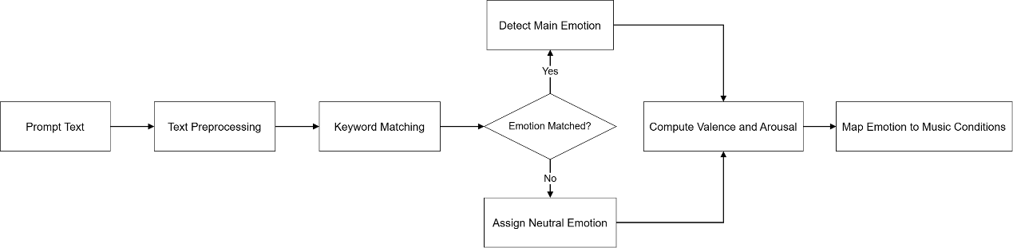
Figure 4.3 Emotion Detection Module
The emotion detection model focuses on identifying the emotional meaning of the user’s text input. Unlike the chatbot interaction model, while generating conversational replies, this model produces structured emotion results that can be used for music generation.
The model uses a keyword-based approach. The input text is first pre-processed by converting it into a standard format. After preprocessing, the system compares the text with a predefined emotion keyword dictionary. Each emotion category contains a list of related keywords that represent a specific emotional state.
If the keyword is matched, the system stores the matched emotion categories and selects the main emotion based on the predefined emotion priority. If no matched, the system assigns neutral as the default emotion. This ensures that the system can still continue the music generation process even when the prompt does not contain clear emotional words.
The model also calculated the average valence and arousal values based on match emotion categories. Then, the values are passed to the emotion-to-music mapping module to convert.
The average valence and arousal calculated formula:
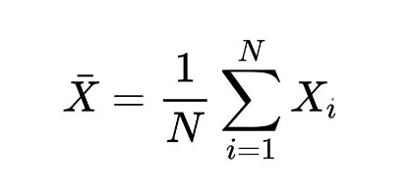
Equation 4.1 Valence & Arousal Average

Where:
- x̄ means the average
- X_{i} represents the value of each matched emotion,
- $N$ is the number of matched emotions.

4.4 Music Parameter Mapping Model
Table 4.1 Mapping Emotion
Emotion | Tempo Range | Velocity Range | Density Level | Music Characteristic
Happy | 110-140 BPM | 80-110 | Medium high | Bright and lively
Sad | 60-90 BPM | 40-75 | Low | Soft and melancholic
Relaxed | 70-100 BPM | 45-80 | Low medium | Calm and smooth
Energetic | 130-170 BPM | 90-120 | High | Strong and active
Neutral | 85-110 BPM | 60-90 | Medium | Balanced

4.5 Music Generation Module
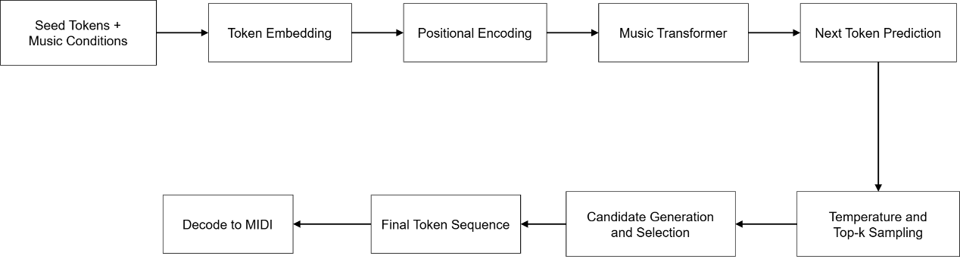
Figure 4.4 Music Generation Module

The music generation module is the core component of the proposed system. It receives the user input and detects emotion to produce the music output. The project uses a Transformer-based symbolic music generation model, which generates the sequence of tokens in an autoregressive manner, which means the model predicts the next token based on the sequence of previously generated tokens.
First, it starts with cleaning the dataset, in the requirement that the notes of the data cannot be below 20, and the track of the dataset should have 2 above tracks. Then, the model first converts each token into an embedding representation. Positional encoding is then added so that the model can preserve the sequence order of tokens.
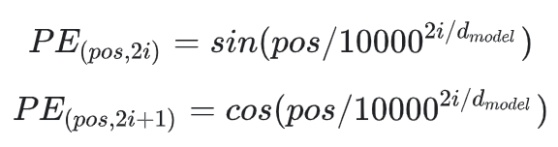
Equation 4.2 Positional Encoding
Where:
- $pos$ = token position
- $i$ = embedding index
- $d_{model}$ = embedding dimension
The final input to the Transformer is the sum of token embeddings and positional encoding:
$$X=Embedding(tokens)+PE$$
This allows the model to process symbolic music events while preserving their sequence structure.
After the training, it will move to the generation, the model predicts the next-token logits. To control diversity, temperature scaling is applied:
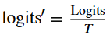
Equation 4.3 Temperature scaling equation
Where:
- $T$ = temperature
- lower $T$ = more conservative output
- higher $T$ = more diverse output
After temperature scaling, top-k sampling is used to select the next token from the most likely candidates represented as:
$$p=softmax(topk(logits'))$$
and the next token is sampled from this probability distribution. This helps balance randomness and controllability in symbolic music generation.
To improve the output quality, the system generates multiple candidate outputs and compared before selecting the result. The final token sequence is then decoded into MIDI format. Overall, this module is able to convert user requirements and emotions into an actual symbolic music output

4.6 Music Output and Playback Module
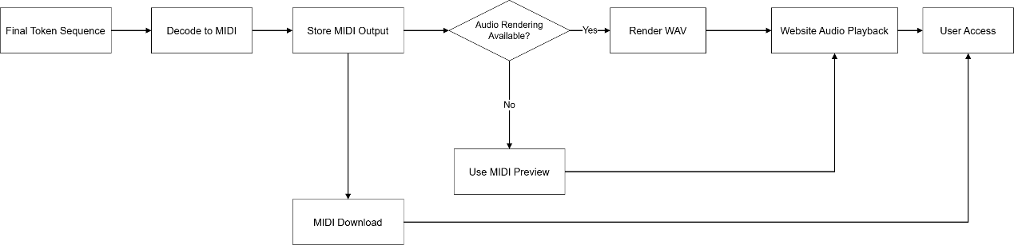
Figure 4.5 Music Output and Playback Module

After the music generation, the music output and playback module converts the generated symbolic result into a form back to the interface that can be accessed by the user. The generated token sequence is decoded into MIDI format. The system supports rendering the MIDI files into WAV format for direct playback through the interface using SoundFont and an audio synthesis library. This module also manages playback and download of generated outputs. The purpose is to ensure that the user can immediately evaluate and access the generated music result conveniently to enhance the user experience.

4.7 REST API Design
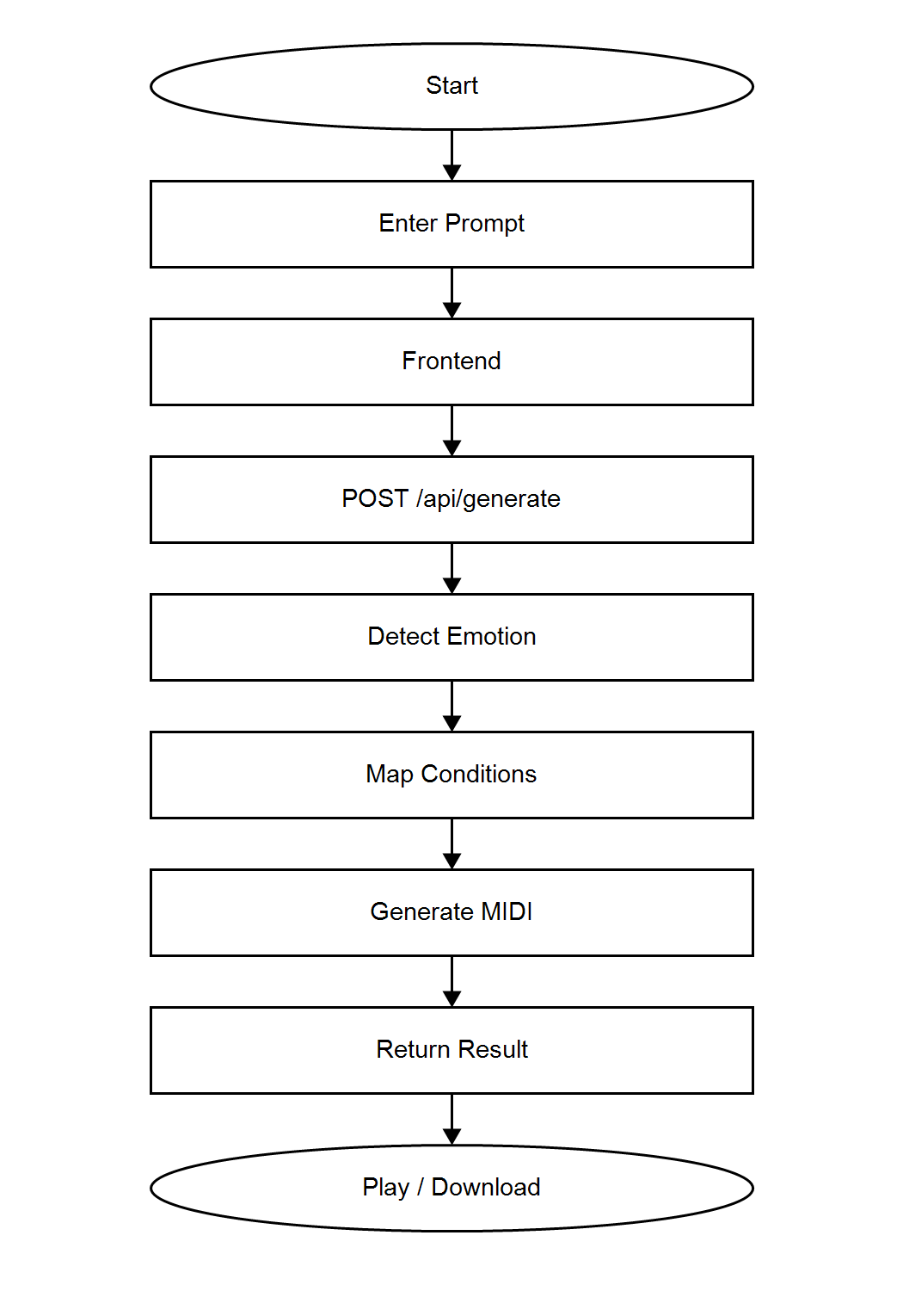
Figure 4.6 Flowchart of API call
The REST API acts as the communication layer between the web application frontend and the backend services. It is implemented using Flask and is responsible for receiving user requests, processing the required functions, and returning responses in JSON format.
The main point used for music generation is /api/generate. When the user submits a text prompt, the frontend sends the prompt together with the selected music conditions to the backed. The backend will validate the request, process the emotion-related parameters, and passes the extracted conditions to the emotion-related parameters, and passes the extracted conditions to the music generation service. The generated MIDI file and optional audio file are then returned to the frontend for playback and download.

4.8 Web Design
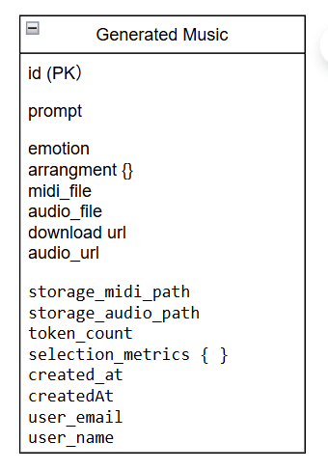
Figure 4.7 Metadata Structure of Generated Music

To utilize the functionality, the user must create an account and log in to the system. This is required because the application stores each user’s generated music and chatbot conversation history separately. The user can enter a text prompt describing the desired music including emotion, style, instruments, and arrangement. The system then processes the prompt and generates a MIDI file with an optional WAV audio preview. Figure 4.9 shows the metadata structure of the application. The metadata of each generated music record is stored in Cloud Firestore the user’s generation collection, while the generated MIDI and WAV files are stored in Firebases Storage. The metadata includes the prompt, detected emotion, arrangement information and others. Therefore, the application requires an internet connection to authenticate users, save generation records, and retrieve stored files. When music generation is requested, the frontend sends the prompt to the Flask RESTful API though the /api/generate endpoint. The backend processes the prompt, detects emotion, maps emotions to music conditions and generates the MIDI output. The generated result and related metadata are then returned to the frontend. The user can play the audio preview, view the piano-roll visualization or download the MIDI and WAV files.
The application also provides a history page for managing previously generated music. Users can replay saved audio files, download their generated music. Users can replay saved audio files and reuse previous prompts. Chatbot conversations are stored separately under the user’s chatHistory collection. This separation allows music generation records and chatbot history to be managed independently.
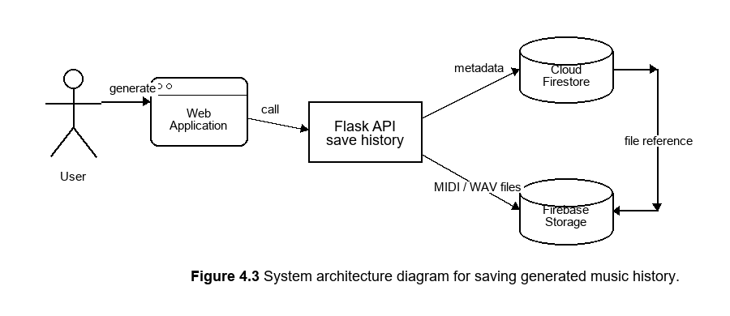
Figure 4.8 System architecture diagram for saving generated music history

Chapter 5
SYSTEM IMPLEMENTATION

5.1 Software Setup
Open the Project in Visual Studio Code
The web application was developed using Visual Studio Code. The project was organized into separate directories for the frontend, backend, chatbot, emotion processing and music generation modules.

Create Python Virtual Environment
To create the virtual environment to isolate the project dependencies from other Python projects. Activate the virtual environment using .\.venv\Scripts\Activate.ps1.
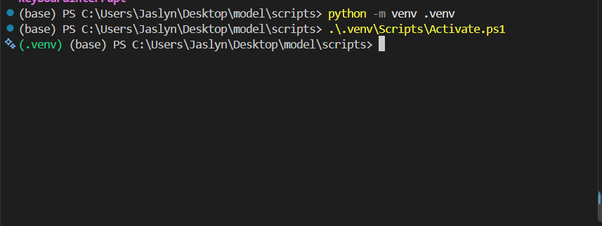
Figure 5.1 Environment Activation in VS Code

Create Firebase Project
Next, go to the Firebase console to create a Firebase project, and follow the instructions to set up the project as shown in Figure 5.2. The Firebase configuration values were copied into the firebase-config.js file to initialize Firebase Authentication, Cloud Firestore, and Firebase Storage in the front end.
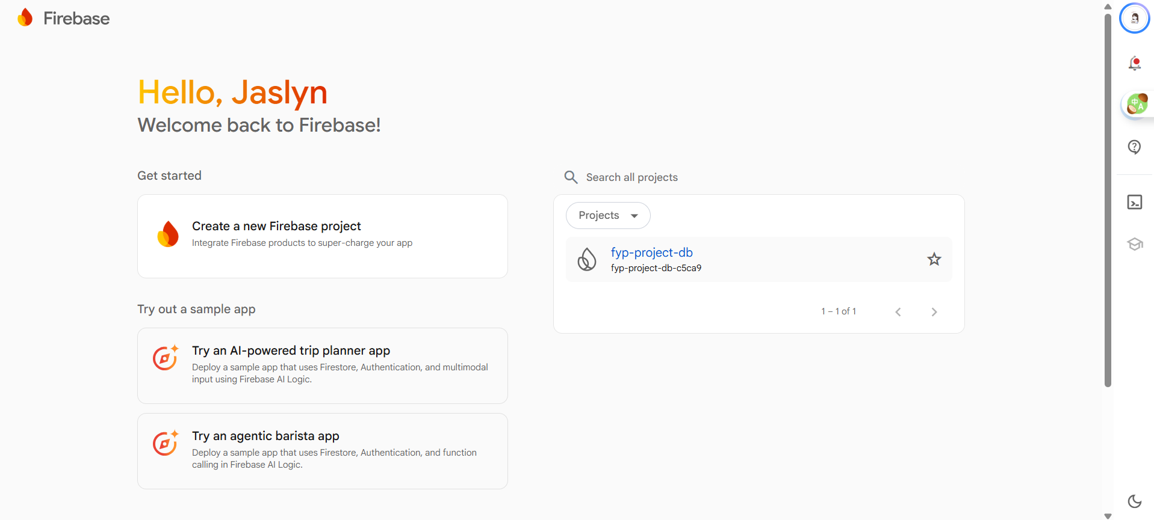
Figure 5.2 Create Project in Firebase
The Firebase Web SDK was configured in the frontend to support Firebase Authentication, Cloud Firestore, and Firebase Storage. The backend was configured with Firebase Admin SDK to verify user tokens and access Firebase services as shown in Figure 5.3.
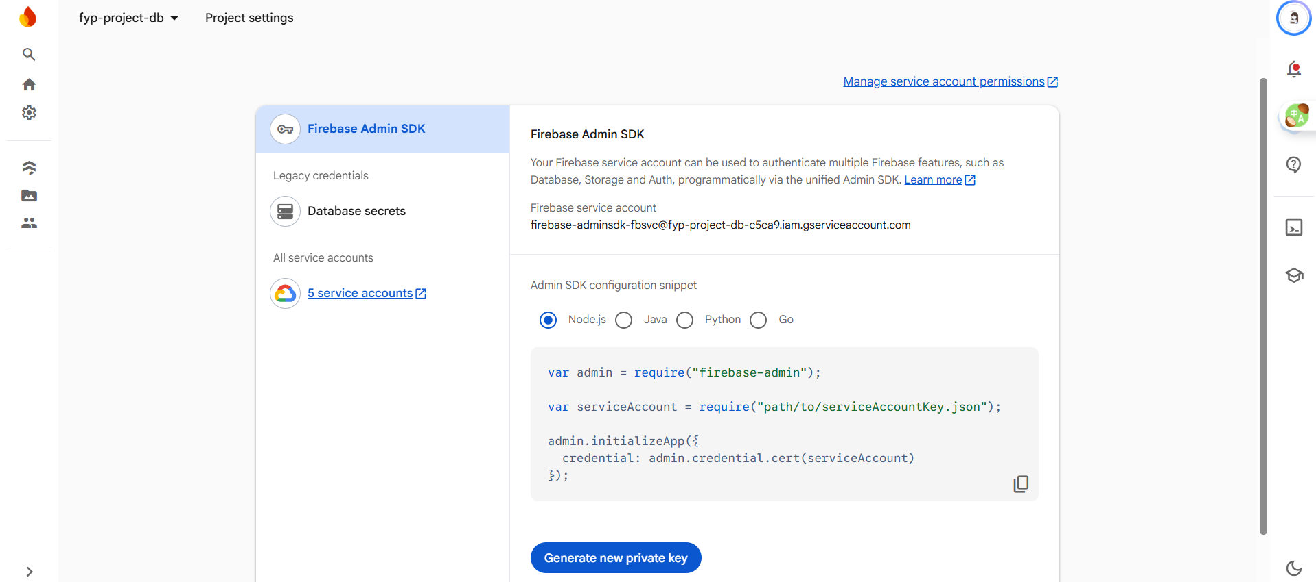
Figure 5.3 Get serviceAccountKey.json

Install Ollama
Then, install a suitable Llama model on the Ollama website, as shown in Figure 5.4, and pull into local system to run the local chatbot service, and download the LLaMA 3 model used to generate chatbot responses
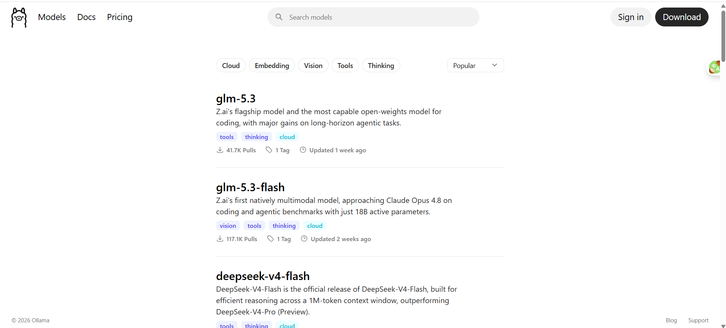
Figure 5.4 Install LLaMA model


Figure 5.5 Pull service into local

5.2 Setting and Configuration
Configure LLaMa API
The project uses a .env file to store the Groq API key, online LLaMA model name, and chatbot provider configuration. This prevents sensitive credentials from being hardcoded in the source code and makes the system easier to maintain. The backend loads these values at runtime and connects the Flask application to the Groq API, which provides online access to the LLaMA model, as shown in Figure 5.6.
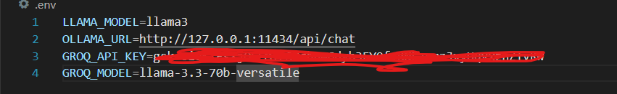
Figure 5.6 Online Groq API and LLaMA Model Configuration
Configure Firebase SDK
The Firebase Web SDK is configured to connect the web application with Firebase services. The configuration initializes Firebase Authentication, Firestore, and Storage, which are used for user authentication, data management, and generated music storage.
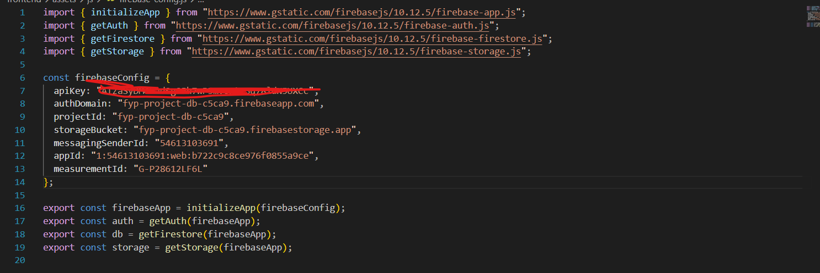
Figure 5.7 Firebase Web SDK Configuration

Configuration Firestore Security Rules
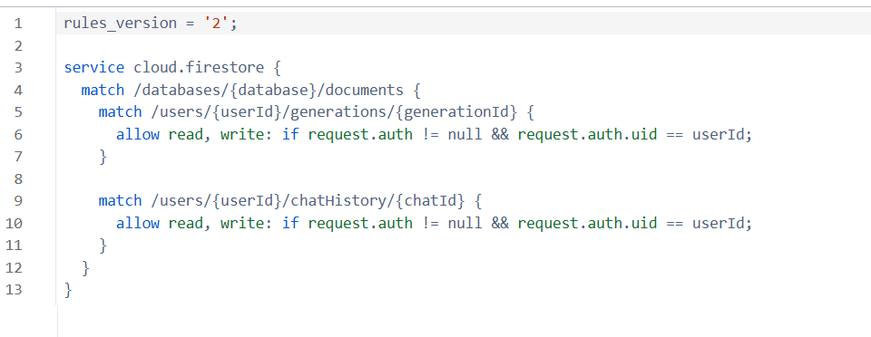
Figure 5.8 Firestore Security Rules Configuration

5.3 System Module Implementation

5.3.1 Authentication Module
Figure 5.9 shows the registration function used in the system. The `createUserWithEmailAndPassword()` function creates a new user account using the email and password entered by the user. After the account is created successfully, the `updateProfile()` function stores the username as the user’s display name. The user is then redirected to the main page of the web application.
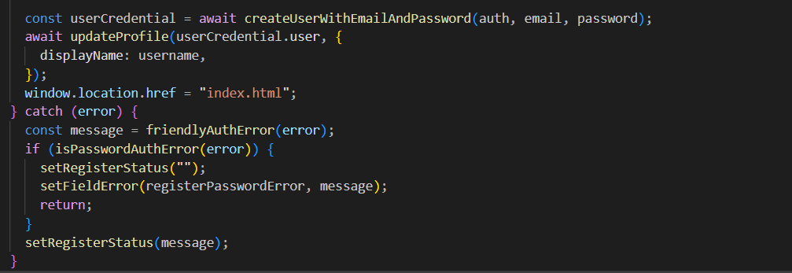
Figure 5.9 User Registration Function
Figure 5.10 shows the login function used in the system. The `signInWithEmailAndPassword()` function verifies the user’s email and password through Firebase Authentication. If the login is successful, the user is redirected to the main application page. If an error occurs, the system displays a friendly error message to guide the user.
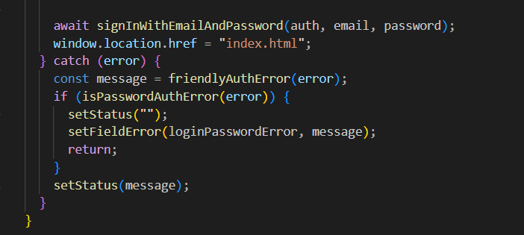
Figure 5.10 User Login Function
Figure 5.11 shows the authentication state checking function. The `onAuthStateChanged()` function monitors whether a user is already logged in. If an authenticated user session exists, the system displays the logged-in account information and allows the user to continue using the application.
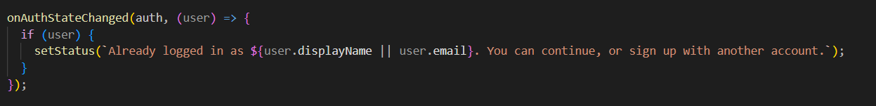
Figure 5.11 Authentication State Checking Function
Figure 5.12 shows the password reset function. When the user forgets the password, the system first checks whether the email field is empty and whether the email format is valid. If the email is valid, the `sendPasswordResetEmail()` function sends a password reset link to the user’s email address. This allows users to recover their account without creating a new account.
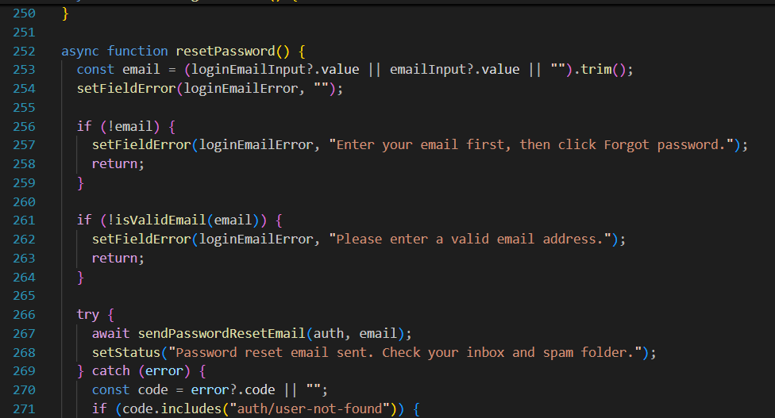
Figure 5.12 Password Reset Function

5.3.2 Chatbot Module
Figure 5.13 shows the chatbot API endpoint implemented in the Flask backend. The `/api/chat` endpoint receives a JSON request from the frontend and extracts the user message from the payload. If the message is empty, the system returns an error response to inform the frontend that a message is required. Otherwise, the backend imports the `chat_with_llama()` function from the chatbot module and passes the payload to it for response generation. The generated chatbot response is then returned to the frontend in JSON format. Error handling is also included to return proper error messages when the chatbot request fails.
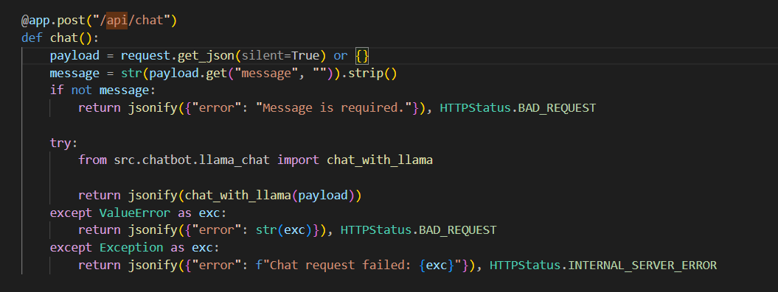
Figure 5.13 Chatbot API Endpoint.

5.3.3 Emotion Detection Module
Figures 5.14 to 5.16 show the script of the emotion detection module. The `match_emotion()` function compares the user input with the predefined emotion keyword dictionary and stores all matched emotion categories. The `get_emotion()` function then selects the main emotion based on the predefined priority order. If no emotion is matched, the system returns neutral as the default emotion. The `get_valence_arousal()` function calculates the average valence and arousal values from the matched emotions. Finally, the `detect_emotion()` function combines the matched emotions, main emotion, valence, and arousal values into a structured result for the music generation process.
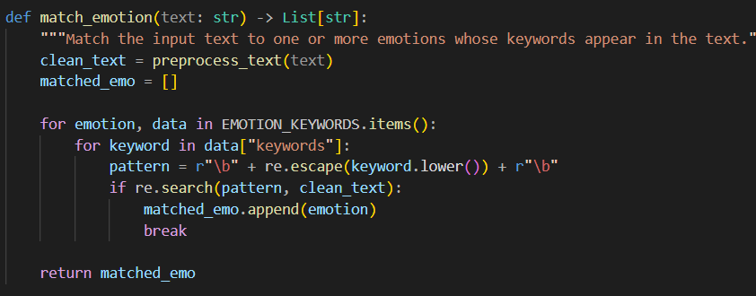
Figure 5.14 Match Emotion
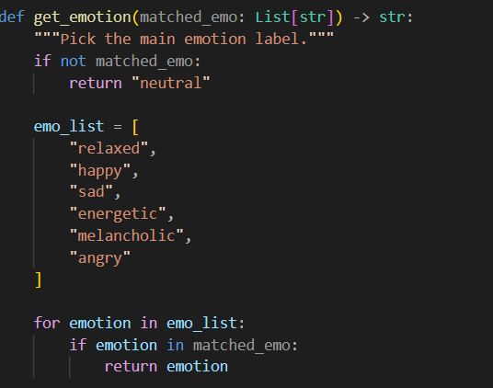
Figure 5.15 Get Emotion
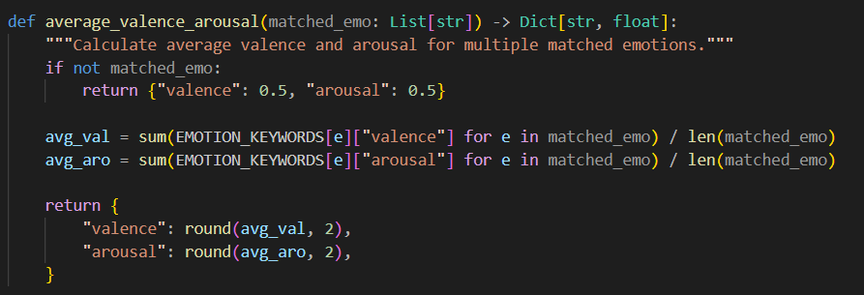
Figure 5.16 Valence and Arousal Calculation

5.3.4 History Management Module
Figure 5.17 shows the function used to save generated music history. After a music track is generated, the system stores the prompt, detected emotion, arrangement, generated MIDI file, WAV preview file, download URLs, storage paths, and creation time in Cloud Firestore. The records are saved under the `users/{uid}/generations` collection so that each user can access only their own generated music history.
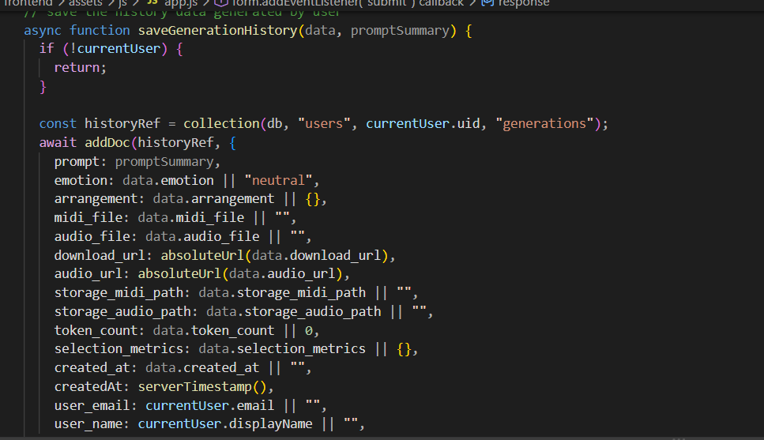
Figure 5.17 Saving Generated Music History
Figure 5.18 shows the function used to save chatbot history. The system stores the user message, chatbot reply, prompt summary, detected emotion, conversation state, and creation time in the `users/{uid}/chatHistory` collection. This allows users to review previous conversations and reuse earlier music ideas.
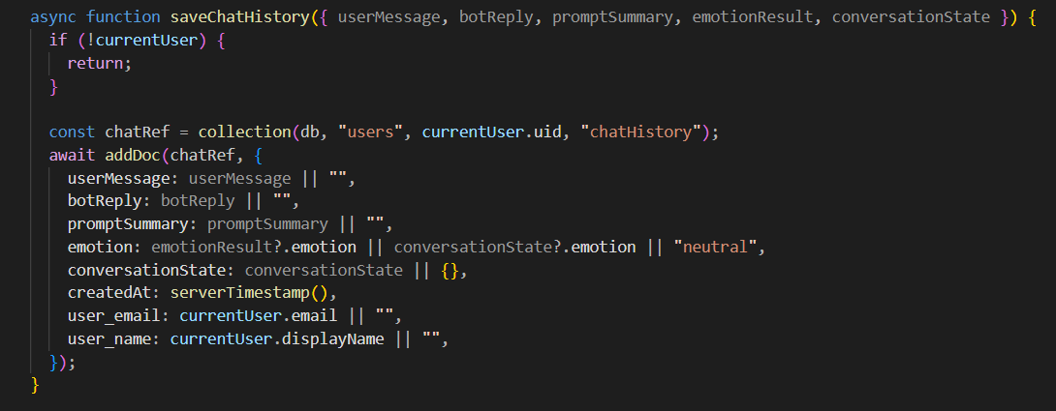
Figure 5.18 Saving Chatbot History

5.3.5 Music Generation Module
The music generation module was implemented with three generation approaches to support comparison and system reliability. The first approach is a rule-based baseline generator, which generates MIDI output using predefined musical rules and emotion-based conditions. The second approach is a custom Music Transformer generator, which represents the transformer-based generation model developed in an earlier stage of the project. The third approach is a MIDI-GPT-based generator, which integrates a pre-trained symbolic music generation model as the main generation method in the final web application.
In the final system, MIDI-GPT is used as the default generation method, while the rule-based baseline generator is used as a fallback method when the model checkpoint or runtime is unavailable. The standalone Music Transformer generator is included for comparison and evaluation purposes because it represents the earlier transformer-based implementation of the project.

5.3.5.1 Rule-based Baseline Generator
The rule-based baseline generator creates MIDI output using predefined musical rules and the emotion-based conditions generated by the system. As shown in Figure 5.19, the generator first creates a tempo track based on the selected BPM. If the user selects a single-instrument mode, the system builds a lead track using the selected instrument, scale, root note, number of bars, and detected emotion. If the user selects custom instruments, the system builds multiple tracks, such as lead, harmony, bass, and pad tracks, based on the requested instruments.
The generator can also add a drum track when the drum option is enabled. After the tracks are prepared, the system writes them into a MIDI file and renders an audio preview when available. Since this generator does not require a trained checkpoint, it is more stable and suitable as a fallback method.

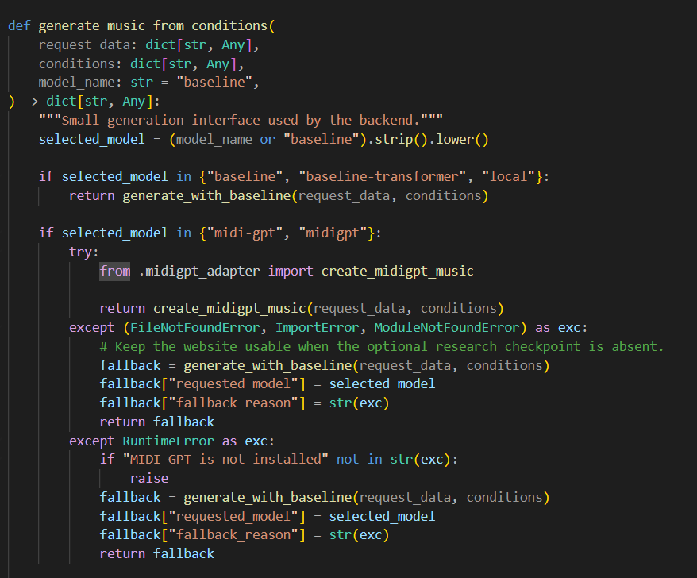
Figure 5.19 Rule-based Baseline Generator

5.3.5.2 MIDI-GPT-based Generator
The MIDI-GPT-based generator is the main generation method used in the final system. It integrates a pre-trained symbolic music generation model to generate MIDI output from the processed music conditions. The detected emotion, tempo, density, and instrument preferences are used to guide the generation process. Compared with the standalone Music Transformer generator, MIDI-GPT provides a more practical integration path for the final web application.
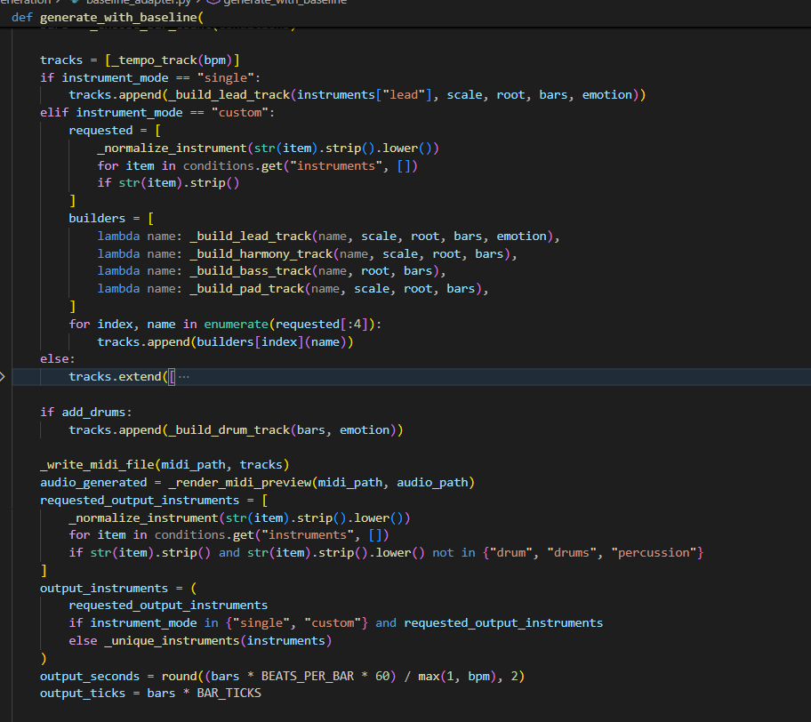
Figure 5.20 MIDI-GPT-based Generator

5.3.5.3 Custom Music Transformer Generator
The custom Music Transformer generator was developed during the earlier stage of the project. As shown in Figure 5.21, the model uses a transformer encoder architecture. The input token IDs are first converted into token embeddings and combined with positional encoding so that the model can understand the order of the symbolic music tokens. The embedded sequence is then passed into transformer encoder layers with a causal mask, which prevents the model from using future tokens during generation.

The output of the transformer is passed through a linear layer to predict the next music token from the vocabulary. The generated token sequence is later decoded into MIDI output. This model represents the original transformer-based approach of the project. However, it was not selected as the default generator in the final web application because its generated output was less stable during integration testing. Therefore, it is included as a comparison model.
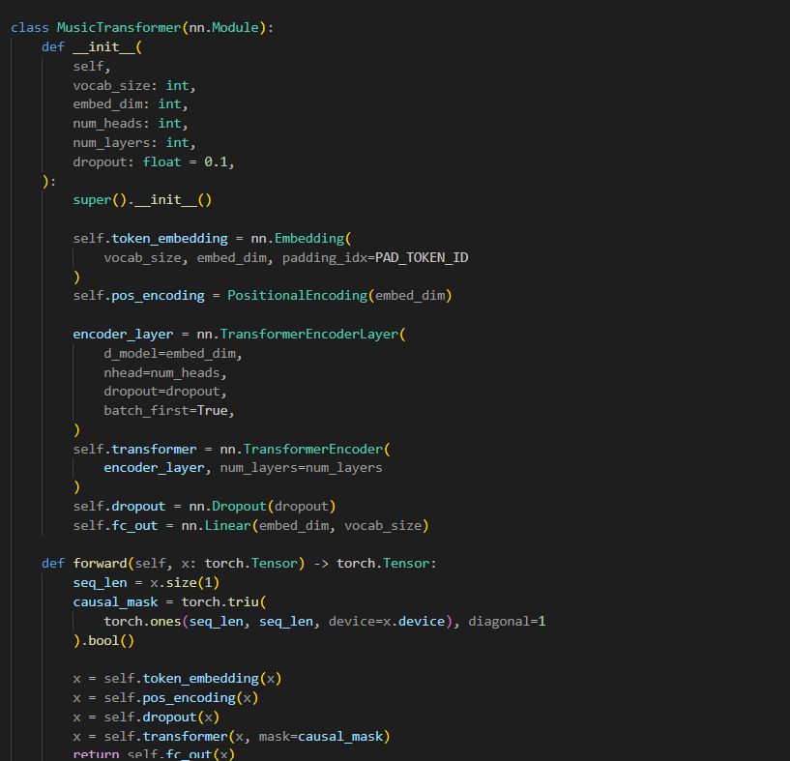Figure 5.21 Custom Music Transformer Generator

5.4 System Operation

5.4.1 User Registration and Login
Figure 5.22 shows the user registration and login interfaces of the system. Before using the main functions of the web application, the user must create an account or log in using an existing account. A new user can register by entering a username, email address, and password. The registration information is verified through Firebase Authentication. Once the account is created successfully, the username is stored as the user’s display name, and the user is redirected to the main page of the application.
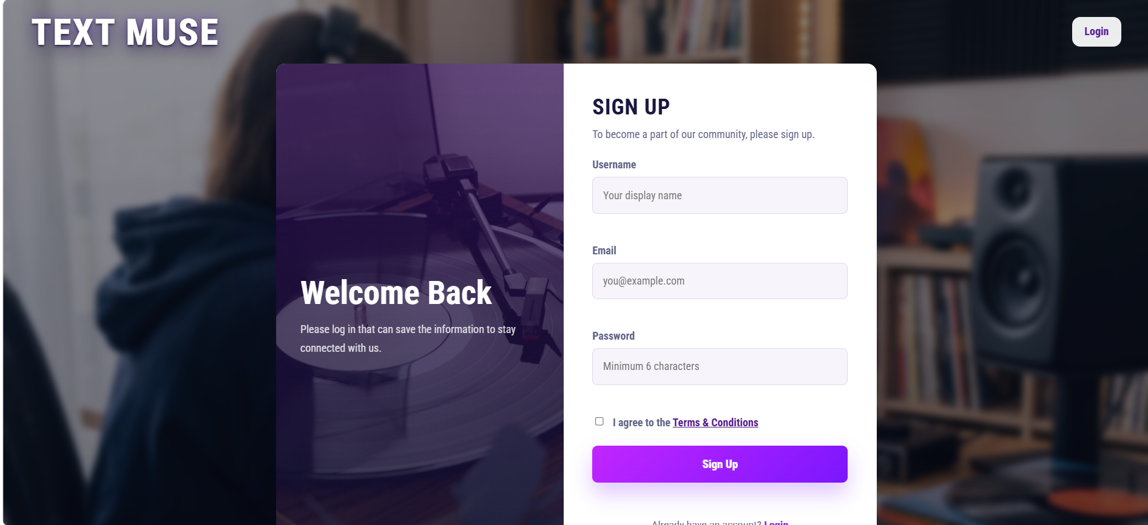
Figure 5.22 User Registration Interface

For existing users, the login function allows the user to sign in using the registered email address and password. If the login details are correct, Firebase Authentication returns an authenticated user session, and the system redirects the user to the main music generation interface. If the login fails, the system displays an error message to guide the user. This prevents unauthorised users from accessing the music generation and history management functions.

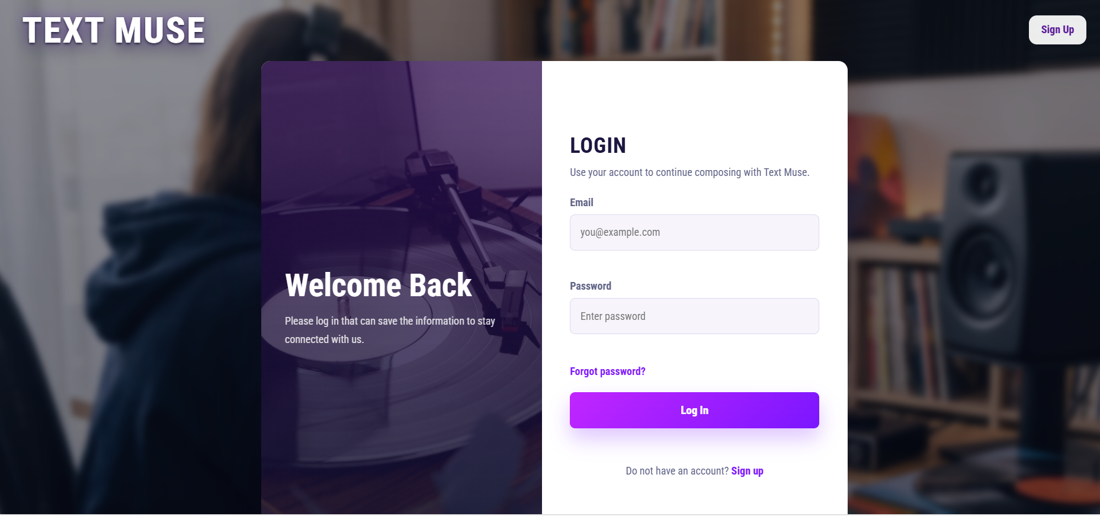
Figure 5.23 User Login Interface

The system also provides a password reset function. If the user forgets the password, the user can enter the registered email address and request a password reset email. Firebase Authentication sends a reset link to the user’s email address, allowing the user to recover the account without creating a new one. This improves the usability and accessibility of the system.
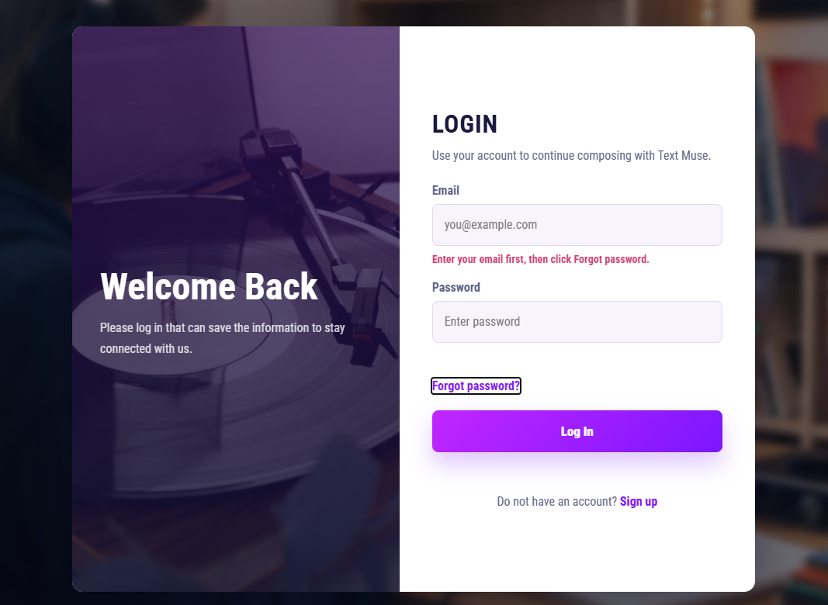
Figure 5.24 Password Reset Function

5.4.2 Chatbot Interaction
Figure 5.25 shows the chatbot interaction interface of the system. The chatbot is designed to help users communicate with the music generation system in a natural way. Instead of requiring the user to manually select every music parameter, the user can type a text message or music request into the chatbot input field. For example, the user may request a relaxing piano melody, a sad background track, or an energetic music piece.
When the user submits a message, the frontend sends the message to the Flask backend through the chatbot API endpoint. The backend passes the message payload to the chatbot module, which prepares the conversation history and music-related context. The chatbot module then communicates with the local Ollama API, where the LLaMA 3 model generates a natural language response. The response is returned to the frontend and displayed in the chatbot interface.
The chatbot also helps refine the user’s music idea before generation. If the message contains music-related intent, the system can include emotion and music condition information, such as detected emotion, valence, arousal, preferred instruments, and style preferences. This allows the chatbot to provide more relevant responses for music generation. Through this interaction, the user can describe the desired mood and style more clearly before generating the final output.
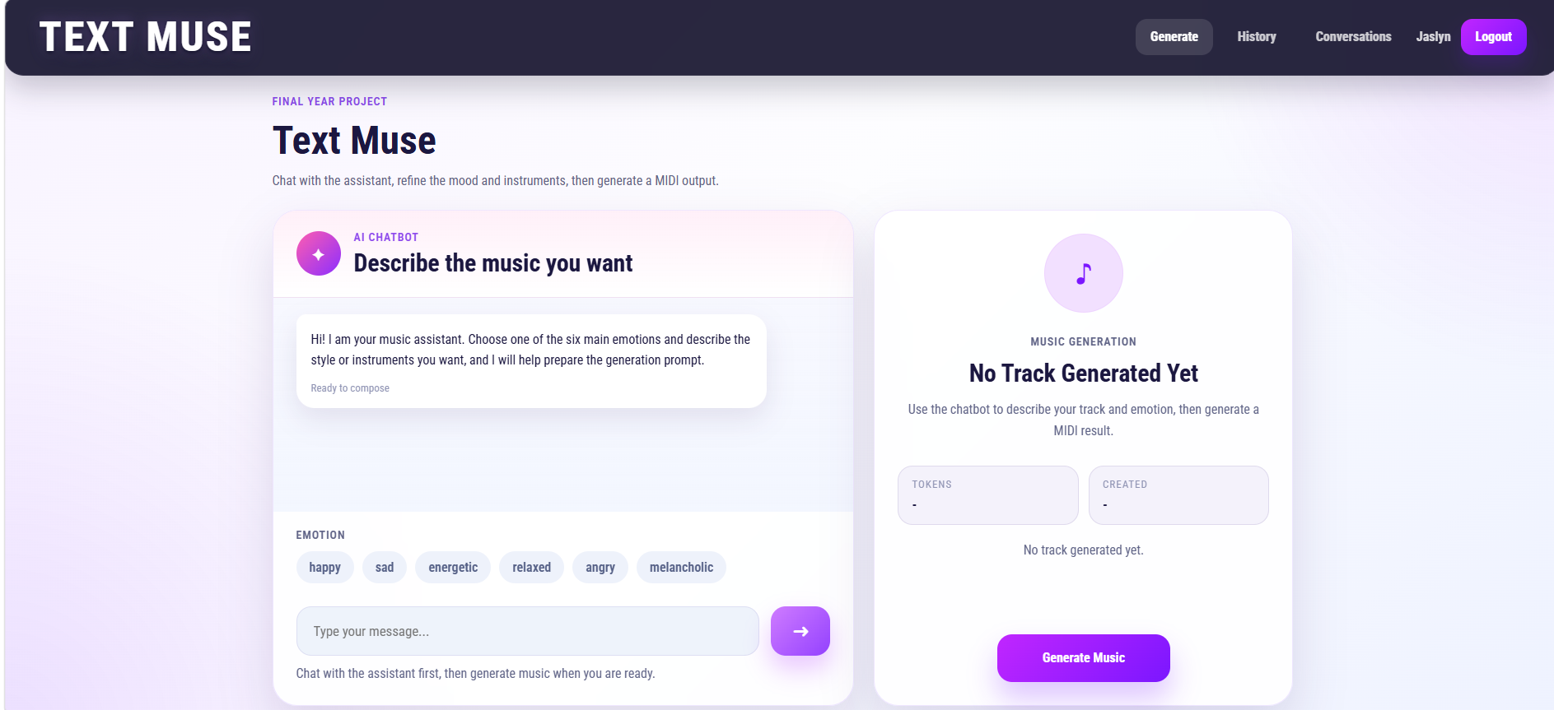
Figure 5.25 Chatbot Interaction Interface
Then, the user's input will generate the dialogue to the user as shown in Figure 5.26:
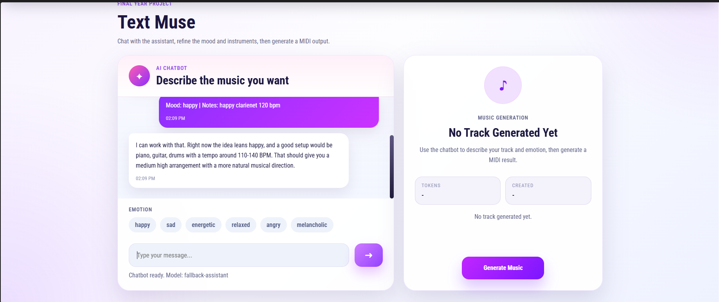
Figure 5.26 Generated Music Result

5.4.3 Generated Music History
Figure 5.27 shows the generated music history page. After a music track is generated, the system saves the generated record under the authenticated user’s account. The saved record includes important metadata such as the original prompt, detected emotion, generated MIDI file, WAV preview file, download URLs, storage paths, and creation time. The generated files are stored in Firebase Storage, while the related metadata is stored in Cloud Firestore.
The history page allows the user to view all previously generated music records. Each record is displayed with its prompt, emotion label, and available actions. The user can replay previous generated music, download the MIDI or WAV file, regenerate music from the same prompt, or delete records that are no longer needed. This makes the system more practical because users do not need to generate music again from scratch every time.
The generated music history function also supports creative continuity. A user may generate several music ideas and later compare the results to choose the most suitable one. By saving generated outputs automatically, the system helps users manage their music creation process more effectively.
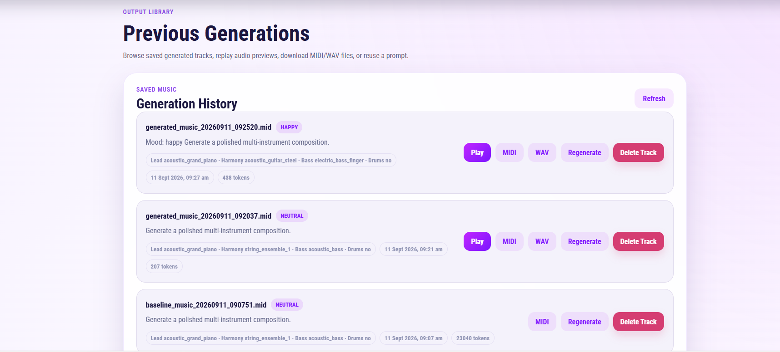
Figure 5.27 Generated Music History Interface

5.5 Implementation of Issues and Challenges
One of the main implementation challenges was connecting the emotion analysis module with the music generation module. The system does not generate music directly from the raw user prompt only. Instead, the user prompt must first be processed by the emotion detection module to identify the main emotion, valence, and arousal values. These emotion results are then passed to the emotion-to-music mapping module, where they are converted into music generation conditions such as tempo range, velocity range, density level, preferred instruments, and emotion control token. Therefore, the challenge was to design a clear data flow so that the emotional meaning of the text prompt could be converted into usable music parameters for generation.
Another challenge was deciding how the music generation module should use these mapped conditions. Different generation approaches handle control conditions differently. The rule-based baseline generator can directly use the mapped tempo, instruments, density, and emotion values because its output is generated based on predefined musical rules. However, transformer-based generation is less direct because the model generates symbolic music tokens, and the emotion conditions must be converted into a suitable prompt or control input before generation. This made the connection between emotion analysis and transformer-based music generation more difficult.
The custom Music Transformer generator developed during the earlier stage of the project also introduced stability issues. Although it represents the original transformer-based direction of the project, its generated MIDI output was sometimes inconsistent and sensitive to generation parameters. Some outputs did not produce a musically stable melody or were difficult to control using the detected emotion. Because of this, it was not selected as the default generator in the final web application and was kept mainly for comparison and evaluation.
The integration of MIDI-GPT was another important challenge. Since MIDI-GPT is a pre-trained symbolic music generation model, the system had to prepare the detected emotion and mapped music conditions into a form that could guide the generation process. The backend needed to pass information such as emotion, arousal, valence, tempo, density, and instrument preferences to the MIDI-GPT adapter. This required an additional adapter layer so that the web application could connect the emotion-processing pipeline with the MIDI-GPT generation process.
A further challenge was maintaining system reliability when the transformer-based generator was unavailable. The MIDI-GPT generator depends on the correct checkpoint, required libraries, and runtime environment. If the checkpoint is missing or the runtime fails, the system may not be able to generate music using MIDI-GPT. To solve this issue, the music generation service includes a fallback mechanism. When MIDI-GPT cannot run successfully, the system automatically switches to the rule-based baseline generator. This ensures that the user can still receive a playable MIDI output.
Overall, the main challenge in the music generation module was not only generating MIDI files, but also connecting emotion analysis, music condition mapping, and transformer-based symbolic music generation into one complete workflow. These challenges were addressed by separating the system into clear modules, using mapped emotion conditions as generation control input, integrating MIDI-GPT through an adapter, and including a baseline generator as a fallback method.

5.6 Concluding Remark
This chapter presented the implementation of the proposed emotion-aware text-to-MIDI music generation web application. The software setup, system configuration, module implementation, system operation, and implementation issues were discussed. The system was implemented using a web frontend, Flask backend, Firebase services, an online LLaMA 3.3 chatbot accessed through the Groq API, and music generation modules.
The implemented system allows users to register and log in, interact with a chatbot, generate emotion-aware MIDI music from text prompts, play the generated music in the browser, download MIDI and WAV files, and manage generated music and chatbot history. The use of Firebase Authentication, Cloud Firestore, and Firebase Storage supports user account management and data storage, while the Flask backend connects the frontend with the chatbot and music generation services.
Although several challenges were encountered, especially in transformer-based music generation stability, Firebase configuration, Ollama availability, and WAV rendering, the final system was able to provide a complete workflow for emotion-aware music generation. The next chapter evaluates the system through functional testing, music generation comparison, performance testing, and user acceptance evaluation.

Chapter 6
SYSTEM EVALUATION AND DICUSSION

6.1 System Testing and Performance Metrics
Authentication Module Testing
Table 6.1 Authentication Module Testing
Test Case Description | Input | Expected Result | Actual Result
Register with an invalid email or weak password | Username: Jaslyn  Email: test123  Password: 123 | The system displays a friendly error message and prevents account creation | Achieved the expected result
Register and login with valid account details | Username: Jaslyn  Email: test11@utar.my  Password: Test123@ | The system creates the account, updates the display name, logs in the user and redirects to the main page | Achieved the expected result
Reset password with email validation | Email: test@utar.my | The system validates the email field and sends a password reset email when the email is valid | Achieved the expected result

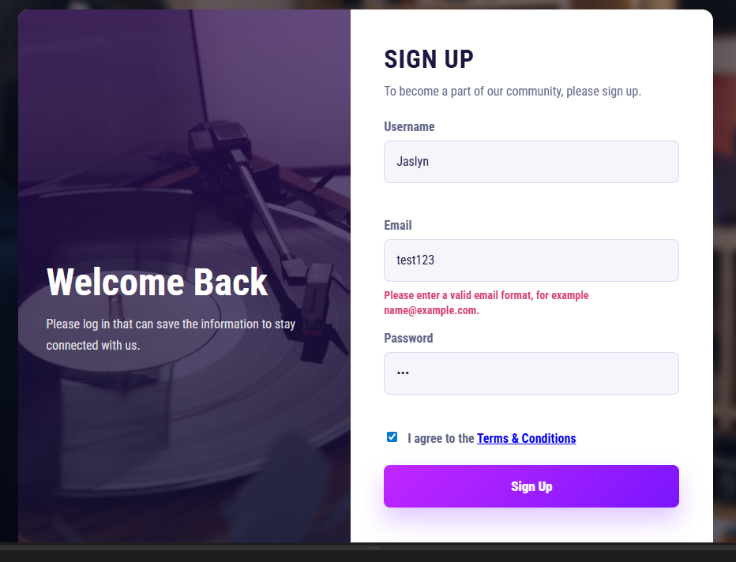
Figure 6.1 Register with an invalid email or weak password
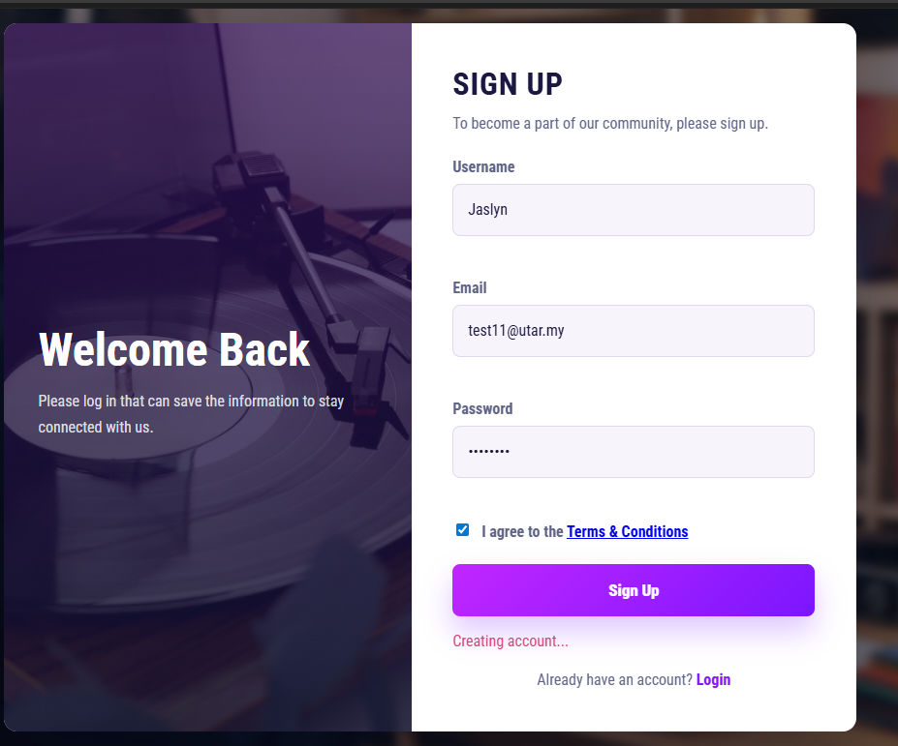
Figure 6.2 Register and login with valid account details
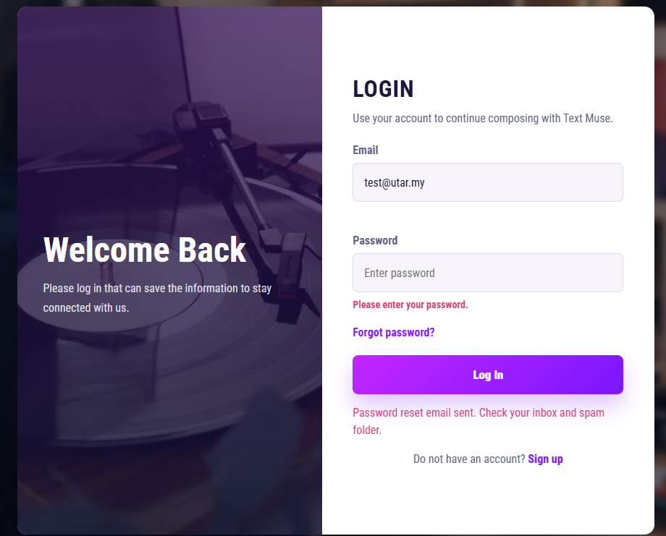
Figure 6.3 Reset password with email validation

Chatbot Module Testing
Table 6.2 Chatbot Module Testing
Test Case Description | Input | Expected Result | Actual Result
Send music-related prompt to chatbot | “Generate a relaxing piano piece” | The chatbot receives the prompt and returns a music-related response | Achieved the expected result
Send prompt with emotion and instrument preference | “Generate a happy clarinet music at 120 bpm” | The system identifies the music request and returns a response based on the emotion and preference | Achieved the expected result
Send empty message | Empty input field | The system does not process the request and displays or returns a message required error | Achieved the expected result

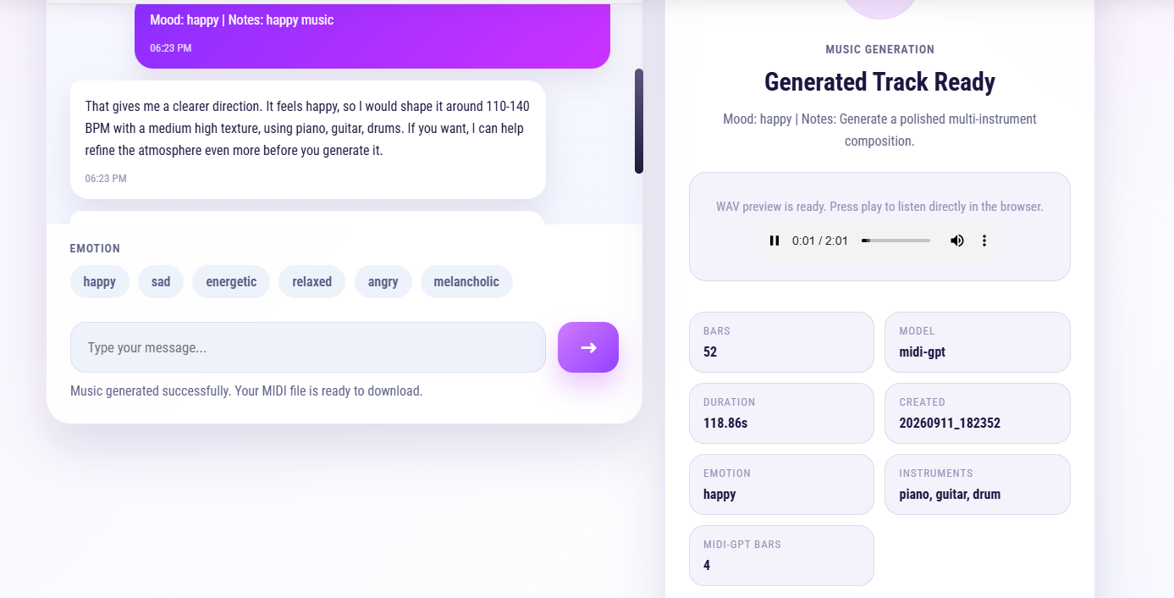
Figure 6.4 Send music-related prompt to chatbot
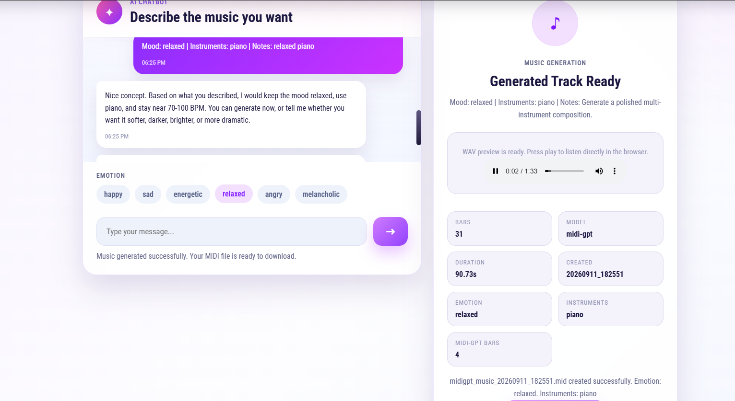
Figure 6.5 Send prompt with emotion and instrument preference
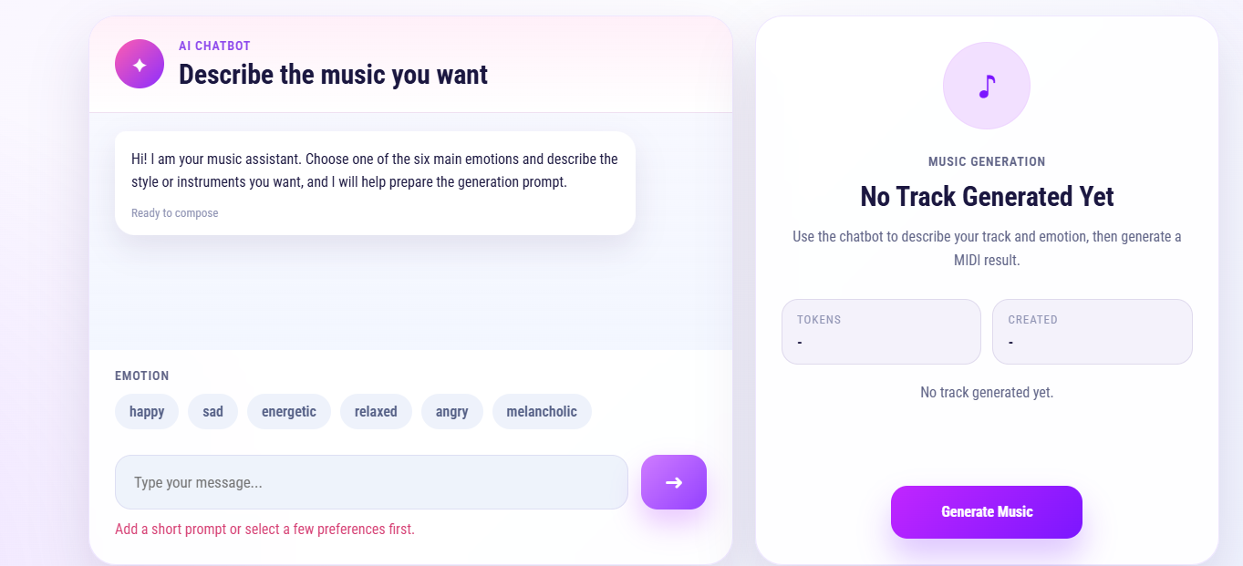
Figure 6.6 Send empty message

Playback, Download and History Module Testing
Table 6.3 Playback, Download and History Module Testing
Test Case Description | Input | Expected Result | Actual Result
Play and download generated output | Click Play, MIDI or WAV button after music generation | The system plays the generated output and allows the user to download the available MIDI or WAV file | Achieved the expected result
View, regenerate and delete history record | Open the generation history page and select regenerate or delete | The system displays saved generation records and allows the user to regenerate or delete a selected track | Achieved the expected result

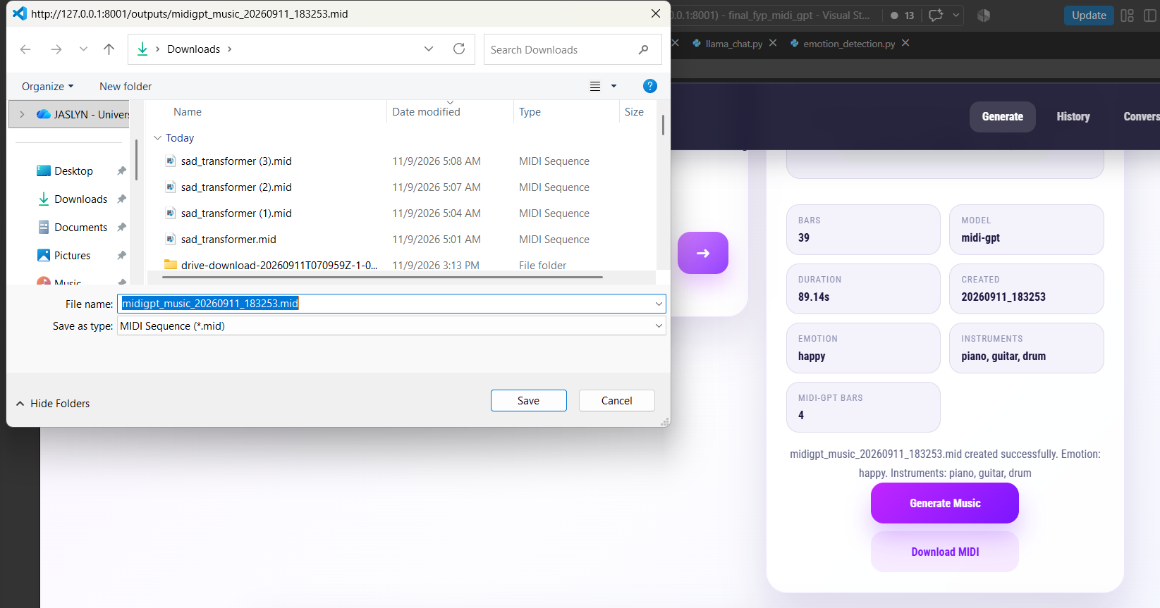
Figure 6.7 Play and download generated output
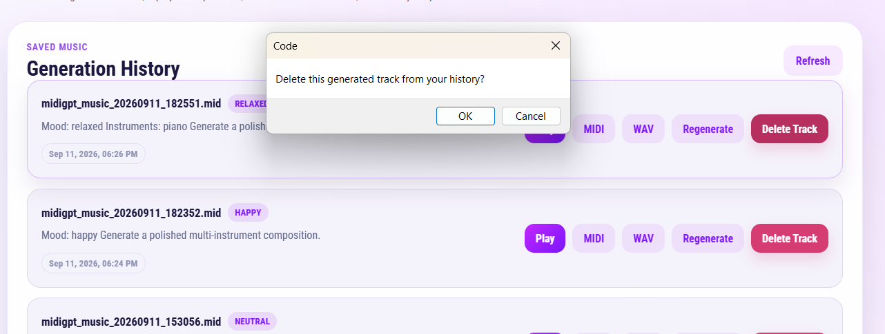
Figure 6.8 View, regenerate and delete history record

6.2 Custom Music Transformer

6.2.1 Model Testing
The custom Music Transformer model was trained using tokenized MIDI data to evaluate the transformer-based music generation approach developed in the earlier stage of the project. The model used a bar-aware training process and was evaluated using cross-entropy loss, structural-token validation loss, validation token accuracy, and token error rate.
Figure 6.9 shows the training and validation loss of the custom Music Transformer model across 100 epochs. At the beginning of training, the training loss was relatively high at approximately 2.0, while the validation loss was around 1.6. This indicates that the model initially had difficulty predicting the next symbolic music token accurately. However, both losses decreased rapidly during the early epochs, showing that the model was able to learn basic MIDI token patterns from the training data.
After the early training stage, the loss continued to decrease more gradually. By the final epoch, the training loss was reduced to around 0.6, while the validation loss decreased to around 0.63. The small gap between training loss and validation loss suggests that the model was able to generalize reasonably well to the validation data instead of only memorising the training set.
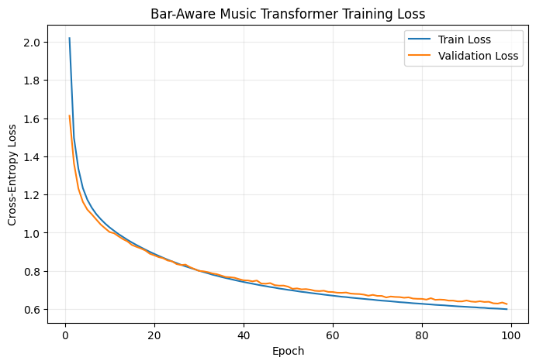
Figure 6.9 Training and Validation Loss

Table 6.4 Custom Music Transformer Training Result Summary
Metric | Initial Result | Final Result
Training Loss | ≈ 2.00 | ≈ 0.60
Validation Loss | ≈ 1.60 | ≈ 0.63
Structural-Token Validation Loss | ≈ 0.56 | ≈ 0.15
Validation Token Accuracy | ≈ 49% | ≈ 80%
Token Error Rate | ≈ 51% | ≈ 20%
Learning Rate | 1 × 10⁻⁴ | 1 × 10⁻⁴

6.2.2 Model Validation
To further validate the training result, structural-token validation loss, validation token accuracy, and token error rate were analysed. Figure 6.10 shows the structural-token validation loss. The loss decreased sharply during the first few epochs, from around 0.56 to below 0.30, and then continued to decrease gradually until it reached approximately 0.15 near the final epoch. This shows that the model improved in predicting structural music tokens, which are important for maintaining the organisation of the MIDI sequence.
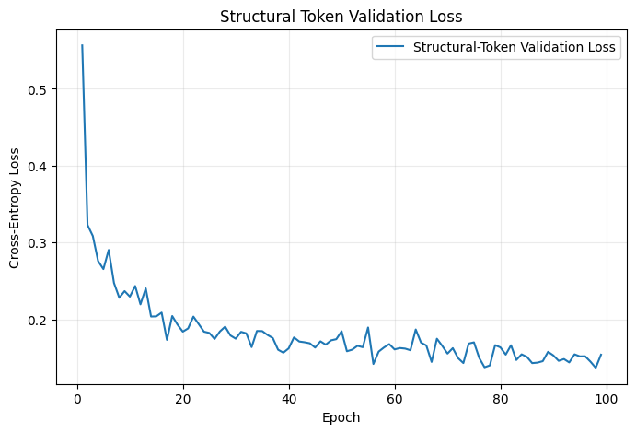
Figure 6.10 Structural Token Validation Loss
Figure 6.11 shows the validation token accuracy of the model. The accuracy increased from approximately 49% at the beginning of training to around 80% near the final epoch. This indicates that the model became more accurate in predicting the next token in the symbolic MIDI sequence. The improvement was more significant during the early epochs and became more gradual after the model had learned the main token patterns.
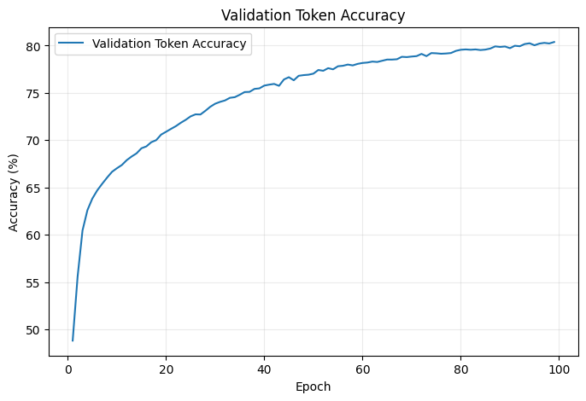
Figure 6.11 Validation Token Accuracy

Figure 6.12 shows the validation token error rate. The token error rate decreased from approximately 51% to around 20%. This result supports the validation accuracy graph, as the model made fewer token prediction errors as training progressed. The decreasing error rate shows that the model became more reliable in predicting MIDI token sequences.
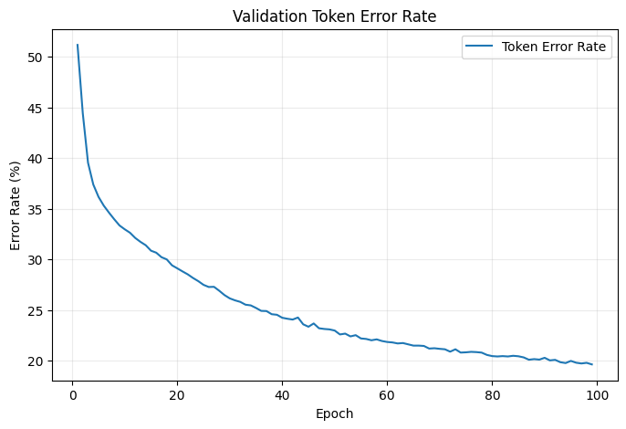
Figure 6.12 Validation Token Error Rate of the Custom Music Transformer Model.

These results show that increasing the model capacity to a 384-dimensional embedding size with 6 attention heads and 6 transformer layers improved the model’s ability to learn MIDI token sequences. However, lower validation loss and higher token accuracy do not always guarantee musically stable generated output. Therefore, the final system also considers practical generation quality, emotion controllability, and integration stability.

6.3 MIDI-GPT Fine-tuning Result
The MIDI-GPT-based generator was evaluated through a fine-tuning experiment to determine its suitability for the final emotion-aware music generation system. The experiment used the `exp1_lakh_full` setting with a learning rate of 1.00E-05, weight decay of 0.01, warmup steps of 200, batch size of 4, and gradient accumulation steps of 2. Therefore, the effective batch size was 8. The model was trained for 5 epochs with evaluation performed every 1000 steps.

Table 6.5 shows the summary of the MIDI-GPT fine-tuning experiment. The best validation loss achieved was 0.6657 at evaluation check 3, which occurred at training step 1499. The last recorded validation loss was 0.6745. The mean training loss was 0.6675, while the last training loss was 0.6274. These results show that the MIDI-GPT model maintained a relatively low validation loss during fine-tuning.

6.3.1 Model Testing
Figure 6.13 shows the test loss and perplexity result. Test loss measures how well the model predicts unseen token sequences, while perplexity provides another indication of prediction uncertainty. A lower test loss and lower perplexity indicate better predictive performance on the test set.
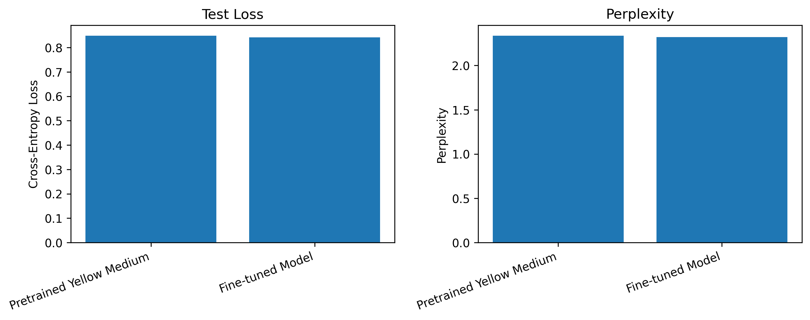
Figure 6.13 Perplexity and Test Loss

6.3.2 Model Validation
Figure 6.14 shows the epoch-level result summary of the MIDI-GPT fine-tuning experiment. In the first epoch, the mean training loss was 0.6577, while the minimum training loss reached 0.2181. The mean validation loss was 0.7228, with the minimum validation loss reaching 0.7000. The last recorded validation loss for the epoch was 0.7318, and the best validation loss so far was 0.7000. This shows that the MIDI-GPT model was able to produce a relatively low validation loss during the early stage of fine-tuning.
Table 6.5 MIDI-GPT Fine-tuning Result Summary
Parameter | Value
Experiment Name | exp1_lakh_full
Learning Rate | 1.00 × 10⁻⁵
Weight Decay | 0.01
Warmup Steps | 200
Number of Epochs | 5
Batch Size | 4
Gradient Accumulation Steps | 2
Effective Batch Size | 8
Evaluation Steps | 1,000
Validation Batch Limit | 20
Best Validation Loss | 0.6657
Best Evaluation Check | 3
Best Training Step | 1,499
Last Validation Loss | 0.6745
Mean Training Loss | 0.6675
Last Training Loss | 0.6274

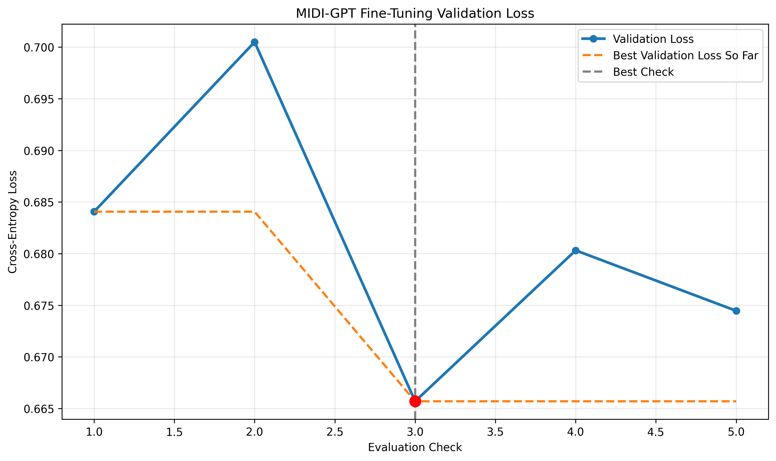
Figure 6.14 MIDI-GPT Fine-tuning Validation Loss Curve.
Although the fine-tuning result shows promising validation performance, validation loss alone cannot fully represent the quality of generated music. Therefore, the final system also considers MIDI playability, output stability, emotion controllability, and integration reliability. Based on these considerations, the MIDI-GPT-based generator was used as the main generation method in the final web application, while the rule-based baseline generator was retained as a fallback method.

6.4 Comparison Between Custom Music Transformer and MIDI-GPT
This section compares the two transformer-based music generation approaches used in this project: the custom Music Transformer model and the MIDI-GPT-based generator. The custom Music Transformer model represents the original transformer-based model developed during the earlier stage of the project, while MIDI-GPT represents the pre-trained transformer-based symbolic music generation model integrated into the final web application.
Table 6.6 shows the comparison between the two transformer-based music generation approaches.
Table 6.6 Comparison Between Custom Music Transformer and MIDI-GPT
Criteria | Custom Music Transformer | MIDI-GPT-Based Generator
Model Type | Custom Transformer model | Pre-trained Transformer-based symbolic music model
Training Approach | Trained from scratch using tokenized MIDI data | Fine-tuned and integrated using a pre-trained checkpoint
Model Size | Smaller custom model | Larger model with 87.6 million parameters
Model Structure | 384 embedding size, 6 attention heads, 6 layers | 768 embedding size, 12 attention heads, 12 layers
Maximum Sequence Length | 1,024 | 2,048
Evaluation Metrics | Training loss, validation loss, token accuracy, token error rate | Validation loss, test loss, perplexity
Validation Performance | Validation loss decreased to approximately 0.63 | Best validation loss of 0.6657
Emotion Control | Emotion control requires additional mapping or conditioning | Supports integration with an emotion-conditioning adapter
Integration Suitability | Less stable during web application integration | More suitable for final web application integration
Final System Role | Comparison model | Main music generation method

Based on the comparison, both approaches are transformer-based and can generate symbolic music. The custom Music Transformer model showed clear improvement during training, as the training loss and validation loss decreased and validation token accuracy increased. However, the generated MIDI output was less stable during system integration and was harder to control using emotion-based conditions.
MIDI-GPT was selected as the main generation method because it uses a pre-trained symbolic music model and provides a more practical integration path for the final web application. Although MIDI-GPT is larger and more difficult to fine-tune due to its computational requirements, it can be connected to the emotion-to-music mapping module through an adapter. Therefore, it was more suitable for the final system. The rule-based baseline generator was retained only as a fallback method to maintain system reliability when the transformer-based generator is unavailable.

6.5 Objective Evaluation
- Web-based Text-to-MIDI Music Generation
The objective of developing a web-based music generation system was successfully achieved. The final system allows users to enter text prompts through the web interface and generate MIDI music based on the prompt. The generated output can be played directly in the browser and downloaded as MIDI or WAV files. This shows that the system provides a complete text-to-music generation workflow.

- Emotion-aware Music Generation
The objective of integrating emotion awareness into the music generation process was achieved. The system analyses the user’s text prompt using the emotion detection module and identifies the main emotion, valence, and arousal values. These emotion results are then converted into music conditions such as tempo range, velocity range, density level, and preferred instruments. The mapped conditions are passed to the music generation module to guide the generated output.

- Transformer-based Music Generation
The objective of applying a transformer-based music generation approach was achieved. The custom Music Transformer model was developed and evaluated as the earlier transformer-based implementation of the project. In addition, MIDI-GPT was integrated as the main transformer-based symbolic music generation model in the final web application. Although the custom Music Transformer model was not used as the default generator due to output stability issues, it was still included for comparison and evaluation.

- Chatbot-assisted Prompt Interaction
The objective of providing chatbot-assisted interaction was achieved. The chatbot module allows users to describe their music ideas in natural language and receive responses from the system. The chatbot uses the online LLaMA 3.3 model through the Groq API to generate replies and assist users in refining their desired emotions, styles, and instrument preferences before music generation.

- User Account and History Management
The objective of providing user account and history management was successfully achieved. Firebase Authentication allows users to register, log in, and reset their password. Cloud Firestore and Firebase Storage are used to store generated music metadata, chatbot history, MIDI files, and WAV files. Users can review previous generated music, download saved files, regenerate music from previous prompts, and delete records when needed.

In summary, the system successfully meets its core objectives of web-based music generation, emotion-aware control, transformer-based generation, chatbot-assisted interaction, and Firebase-based history management. However, some limitations remain in terms of generation stability, fine-grained emotion controllability, and runtime dependency for transformer-based generation.

6.6 Conclusion Remark
This chapter presented the evaluation and discussion of the proposed website system. The evaluation included functional testing of the web application, training result analysis of the custom Music Transformer model, and fine-tuning result discussion of the MIDI-GPT-based generator. The functional testing showed that the main system modules, including authentication, chatbot interaction, emotion detection and mapping, music generation, playback, download and history management, were able to operate correctly.
The model evaluation showed that the custom Music Transformer was able to learn symbolic MIDI token patterns, while MIDI-GPT provided a more practical generation approach for the final web application. Although the system achieved the main project objectives, some limitations remain in terms of generation stability, fine-grained emotion controllability and runtime dependency. These limitations are further discussed in the recommendation section in Chapter 7.

Chapter 7
CONCLUSION AND RECOMMENDATIONS

7.1 Conclusion
This project developed an AI chatbot-driven personalised music generation system based on emotion and style preferences. The system allows users to describe their desired music through a chatbot interface, where the input is processed to detect emotion and extract music-related preferences. The detected emotion is then mapped into structured music conditions, which are used to guide the MIDI music generation process.
The final system was implemented as a web-based application with Firebase Authentication, Cloud Firestore, Firebase Storage, a Flask backend, a online LLaMa-based chatbot through the Groq API and music generation modules. MIDI-GPT was used as the main MIDI generation approach, while a rule-based baseline generator was included as a fallback method to improve system reliability. The system also supports playback, download, regeneration, deletion, and history management for generated music outputs.
The evaluation showed that the main system functions were able to operate correctly, including user authentication, chatbot interaction, emotion detection, emotion-to-music mapping, music generation, playback, download and history retrieval. The custom Music Transformer model developed in the earlier stage of the project showed that transformer-based models could learn symbolic MIDI token patterns, while MIDI-GPT provided a more practical approach for integration into the final web application.
Overall, the project achieved its main objectives by developing a working prototype that connects chatbot interaction, emotion-aware processing and symbolic music generation. Although limitations remain in terms of generation stability, fine-grained emotion control and runtime dependency, the system demonstrates the feasibility of using chatbot-based interaction and emotion mapping to support personalised MIDI music generation.

7.2 Recommendations
To improve the system, several enhancements can be made. The current emotion detection module relies on predefined keywords, which may not fully understand the context of a user’s prompt. Therefore, integrating a trained NLP or transformer-based emotion classification model can improve emotion-recognition accuracy. The music generation module can also be further optimized to produce more stable and musically structured outputs, especially in terms of melody continuity and song length. The transformer-based music generation model may require high computational resources and longer processing time. Therefore, future development can investigate model optimization techniques and lightweight models to improve performance. The emotion-mapping module can also be extended by supporting more detailed control, such as key signature, note density and others. Since the chatbot uses the online Groq API, future improvements should also consider API availability, network latency, usage limits, and response time. In addition, Voice communication could be added by using speech-to-text for user input and text-to-speech for chatbot responses. Further user testing can be conducted to evaluate the generated music quality, emotional relevance, generation time, and overall user satisfaction. Firebase security rules should also be reviewed to protect user accounts, chatbot history, metadata, and generated MIDI or WAV files.

REFERENCES
[1] P. N. Juslin and J. A. Sloboda, Eds., Handbook of Music and Emotion: Theory, Research, Applications. Oxford, U.K.: Oxford Univ. Press, 2010. Available: https://books.google.com.my/books?hl=en&lr=&id=ZtwUDAAAQBAJ&oi=fnd&pg=PR9&dq=Handbook+of+Music+and+Emotion:+Theory‌
[2] M. Zhang, “Advancing deep learning for expressive music composition and performance modeling,” Scientific Reports, vol. 15, no. 1, Dec. 2025, doi: 10.1038/s41598-025-13064-6.
[3] A. Dash and K. Agres, “AI-Based Affective Music Generation Systems: A Review of Methods and Challenges,” ACM Computing Surveys, vol. 56, no. 11, Jul. 2024, doi: 10.1145/3672554.
[4] Y. Zhu, J. Baca, B. Rekabdar, and R. Rawassizadeh, “A Survey of AI Music Generation Tools and Models,” Aug. 2023, [Online]. Available: http://arxiv.org/abs/2308.12982
[5] L. Wang, Z. Zhao, H. Liu, J. Pang, Y. Qin, and Q. Wu, “A Review of Intelligent Music Generation Systems,” Nov. 2023, [Online]. Available: http://arxiv.org/abs/2211.09124
[6] D. Cope, “Experiments in musical intelligence (EMI): Non‐linear linguistic‐based composition,” Interface, vol. 18, no. 1–2, pp. 117–139, Jan. 1989, doi: https://doi.org/10.1080/09298218908570541.
[7] S. Hochreiter, “The Vanishing Gradient Problem During Learning Recurrent Neural Nets and Problem Solutions,” International Journal of Uncertainty, Fuzziness and Knowledge-Based Systems, vol. 06, no. 02, pp. 107–116, Apr. 1998, doi: https://doi.org/10.1142/s0218488598000094.
[8] S. S. Patil et al., “Music Generation Using RNN-LSTM with GRU,” 2023 International Conference on Integration of Computational Intelligent System (ICICIS), pp. 1–5, Nov. 2023, doi: https://doi.org/10.1109/icicis56802.2023.10430293.
[9] GeeksforGeeks, “RNN vs LSTM vs GRU vs Transformers,” GeeksforGeeks, Jan. 06, 2025. https://www.geeksforgeeks.org/deep-learning/rnn-vs-lstm-vs-gru-vs-transformers/
[10] C. Little, M. Elliot, R. Allmendinger, and S. S. Samani, “Generative Adversarial Networks for Synthetic Data Generation: A Comparative Study,” arXiv.org, Dec. 03, 2021. https://arxiv.org/abs/2112.01925
[11] H.-W. Dong, W.-Y. Hsiao, L.-C. Yang, and Y.-H. Yang, “MuseGAN: Multi-track Sequential Generative Adversarial Networks for Symbolic Music Generation and Accompaniment,” Nov. 2017, [Online]. Available: http://arxiv.org/abs/1709.06298
[12] D. P. Kingma and M. Welling, “Auto-Encoding Variational Bayes,” arXiv (Cornell University), Dec. 2013, doi: https://doi.org/10.48550/arxiv.1312.6114.
[13] A. Roberts, J. Engel, C. Raffel, C. Hawthorne, and D. Eck, “A Hierarchical Latent Vector Model for Learning Long-Term Structure in Music,” arXiv (Cornell University), Jan. 2018, doi: https://doi.org/10.48550/arxiv.1803.05428.
[14] A. Vaswani et al., “Attention Is All You Need,” Cornell University, Jun. 12, 2017. https://arxiv.org/abs/1706.03762
[15] C.-Z. A. Huang et al., “Music Transformer,” Dec. 2018, [Online]. Available: http://arxiv.org/abs/1809.04281
[16] P. Pasquier, J. Ens, N. Fradet, P. Triana, D. Rizzotti, J.-B. Rolland, and M. Safi, “MIDI-GPT: A Controllable Generative Model for Computer-Assisted Multitrack Music Composition,” arXiv preprint arXiv:2501.17011, 2025. [Online]. Available: https://arxiv.org/abs/2501.17011
[17] J.-L. Hsu and S.-J. Chang, “Generating Music Transition by Using a Transformer-Based Model,” Electronics, vol. 10, no. 18, p. 2276, Sep. 2021, doi: https://doi.org/10.3390/electronics10182276
[18] P. Ekman, “An Argument For Basic Emotions,” 1992. Available: https://www.paulekman.com/wp-content/uploads/2013/07/An-Argument-For-Basic-Emotions.pdf
[19] D. C. Rubin and J. M. Talarico, “A comparison of dimensional models of emotion: Evidence from emotions, prototypical events, autobiographical memories, and words,” Memory, vol. 17, no. 8, pp. 802–808, Nov. 2009, doi: https://doi.org/10.1080/09658210903130764.
[20] Y. Song, S. Dixon, M. T. Pearce, and A. R. Halpern, “Perceived and Induced Emotion Responses to Popular Music,” An Interdisciplinary Journal, vol. 33, no. 4, pp. 472–492, 2016, doi: 10.2307/26417432
[21] A. Aljanaki, Y.-H. Yang, and M. Soleymani, “Developing a benchmark for emotional analysis of music,” PLOS ONE, vol. 12, no. 3, p. e0173392, Mar. 2017, doi: https://doi.org/10.1371/journal.pone.0173392
[22] R. Liyanarachchi, A. Joshi, and E. Meijering, “A Survey on Multimodal Music Emotion Recognition,” Apr. 2025, [Online]. Available: http://arxiv.org/abs/2504.18799
[23] J. Kang and D. Herremans, “Towards Unified Music Emotion Recognition across Dimensional and Categorical Models,” Apr. 2025, [Online]. Available: http://arxiv.org/abs/2502.03979
[24] S. Kusal, S. Patil, K. Kotecha, R. Aluvalu, and V. Varadarajan, “AI Based Emotion Detection for Textual Big Data: Techniques and Contribution,” Big Data and Cognitive Computing, vol. 5, no. 3, p. 43, Sep. 2021, doi: https://doi.org/10.3390/bdcc5030043
[25] V. Kharde and S. Sonawane, “Sentiment Analysis of Twitter Data: A Survey of Techniques,” International Journal of Computer Applications, vol. 139, no. 11, pp. 975–8887, 2016, Available: https://arxiv.org/pdf/1601.06971
[26] Abdullah Al Maruf, F. Khanam, Md. Mahmudul Haque, Zakaria Masud Jiyad, Firoj Mridha, and Z. Aung, “Challenges and Opportunities of Text-based Emotion Detection: A Survey,” IEEE access, pp. 1–1, Jan. 2024, doi: https://doi.org/10.1109/access.2024.3356357
‌[27] Y. Kim, “Convolutional Neural Networks for Sentence Classification,” arXiv.org, 2014. https://arxiv.org/abs/1408.5882
[28] E. Batbaatar, M. Li, and K. H. Ryu, “Semantic-Emotion Neural Network for Emotion Recognition from Text,” IEEE Access, vol. 7, pp. 111866–111878, 2019, doi: 10.1109/ACCESS.2019.2934529
[29] Y. Liu et al., “RoBERTa: A Robustly Optimized BERT Pretraining Approach,” Jul. 2019, [Online]. Available: http://arxiv.org/abs/1907.11692
[30] P. He, X. Liu, J. Gao, and W. Chen, “DeBERTa: Decoding-enhanced BERT with Disentangled Attention,” Oct. 2021, [Online]. Available: http://arxiv.org/abs/2006.03654
[31] E. Boitel, A. Mohasseb, and E. Haig, “MIST: Multimodal emotion recognition using DeBERTa for text, Semi-CNN for speech, ResNet-50 for facial, and 3D-CNN for motion analysis,” Expert Systems with Applications, vol. 270, p. 126236, Jan. 2025, doi: https://doi.org/10.1016/j.eswa.2024.126236.
[32] A. Følstad and P. B. Brandtzæg, “Chatbots and the new world of HCI,” interactions, vol. 24, no. 4, pp. 38–42, Jun. 2017, doi: https://doi.org/10.1145/3085558.
[33] E. Adamopoulou and L. Moussiades, “An Overview of Chatbot Technology,” IFIP Advances in Information and Communication Technology, vol. 584, no. 1, pp. 373–383, May 2020, doi: https://doi.org/10.1007/978-3-030-49186-4_31.
[34] C. C. Nwokedi and C. A. Nwafor, “Enhancing customer service and user experience through the use of machine learning powered intelligent chatbots,” World Journal of Advanced Research and Reviews, vol. 23, no. 2, pp. 181–191, Aug. 2024, doi: https://doi.org/10.30574/wjarr.2024.23.2.2307.
[35] T. Brown et al., “Language Models Are Few-Shot Learners,” ArXiv (Cornell University), vol. 4, May 2020, doi: https://doi.org/10.48550/arxiv.2005.14165.
[36] Yi, Z., Xu, Z., & Shen, Y. (n.d.). A Survey on Recent Advances in LLM-Based Multi-turn Dialogue Systems. In Journal of the ACM (Vol. 37).
https://doi.org/10.48550/arXiv.2402.18013
[37] Doh, S., Choi, K., Kwon, D., Kim, T., & Nam, J. (2024). Music Discovery Dialogue Generation Using Human Intent Analysis and Large Language Models. http://arxiv.org/abs/2411.07439
[38] Aiva, “AIVA - the AI composing emotional soundtrack music,” www.aiva.ai, 2024. https://www.aiva.ai/
[39] “Boomy - Make Instant Music with Artificial Intelligence,” boomy.com. https://boomy.com/
[40] Suno, “Suno,” suno.com, 2025. https://suno.com/

APPENDIX-A

POSTER

