**缺陷检测**

* 高层次抽象概念，注重语义信息，轻纹理信息，局部和整体关系明确，有明确的语义边界。
* 低层次抽象概念，轻语义信息，重纹理信息，局部和整体关系模糊，无明确的语义边界
* 对于缺陷检测而言，真的需要非常深的网络吗？
* 在算力和数据的限制条件下，怎么充分的利用卷积神经网络？
* 在工业应用中，原始图像是非常大，而缺陷非常小，无法进行重采样，将图像缩的很小，若太小，就无法查看到缺陷特征。
* 缺陷检测其实更偏向于纹理信息（底层特征）。
* **加强底层特征在最后决策中的比重**🡪

1. 在每个Stage的内部使用Denseblock复用特征形成层级内的高速通路
2. 将每个Stage的输出降采样后直接拼接到最后的输出形成层级间的高速通路

* 通常选择分类、分割和目标检测进行缺陷检测任务🡪

1. 分类任务：缺陷在原图中有较大的比例（30%）；将图像分块，在每块中进行分类
2. 分割任务：适应于语义信息较弱的缺陷检测，例如划痕，针对划痕缺陷检测，最好是利用分割网络，但是分割网络数据标注成本很高
3. 检测任务：

不论是采用何种方法进行缺陷检测，但是都应该采用分类指标进行性能评估

* 分割和检测的结果无法直接应用到缺陷检测中，因此🡪

1. 使用阈值将分割、检测的结果直接转化为分类结果：
2. 缺陷的面积、周长
3. 检测框的置信度

* 在训练模型的直接使用多任务框架，分类作为主任务，检测和分割作为辅助任务
* 直接使用分类模型，检测框和分割的标注作为attention模块导入
* 将传统算法结果和深度学习结果进行融合
* 将传统算法作为图片预处理前置到深度学习算法
* 将传统算法作为attention模块引入卷积神经网络
* M(x)注意力掩码产生方式🡪

1. 卷积神经网络自学习得到
2. 传统算法产生掩码，如Canny算法
3. 通过辅助子任务产生掩码，如分割结果

* 在每个Stage使用attention，比全局范围内使用attention更好
* **工业中缺陷检测的难点：**

1. 确定检测方法（分类，分割，检测）
2. 使用模型过拟合少量标记样本，在训练集上可视化
3. 使用少量样本+大量无标记样本、使用半监督学习训练，在验证集上可视化、测试
4. 更有针对性的收集大量带标签的样本
5. 在工业项目中，存在大量无标签数据，因此，采用半监督的学习方法（mean Teacher）
6. 缺陷检测也可采用由粗到精的检测策略

CLBP :

Z.H. Guo, L. Zhang, D. Zhang, A completed modeling of local binary pattern operator for texture classification, IEEE Transactions on Image Processing 19 (2010) 1657–1663

**论文阅读**

1. **Weimer D, Scholz-Reiter B, Shpitalni M (2016) Design of deep convolutional neural network architectures for automated feature extraction in industrial inspection. CIRP Ann Manuf Technol 65(1): 417–420**

The paper proposed a novel deep CNN architecture to detect defects, which taked all types of defect free and defective samples together as the input. This model is a 12-class classifier: 6 defect free classes and 6 defective classes.

1. **Jager M, Knoll C, Hamprecht FA (2008) Weakly supervised learning of a classifier for unusual event detection. IEEE Trans Image Process 17(9):1700–1708**

benchmark dataset:

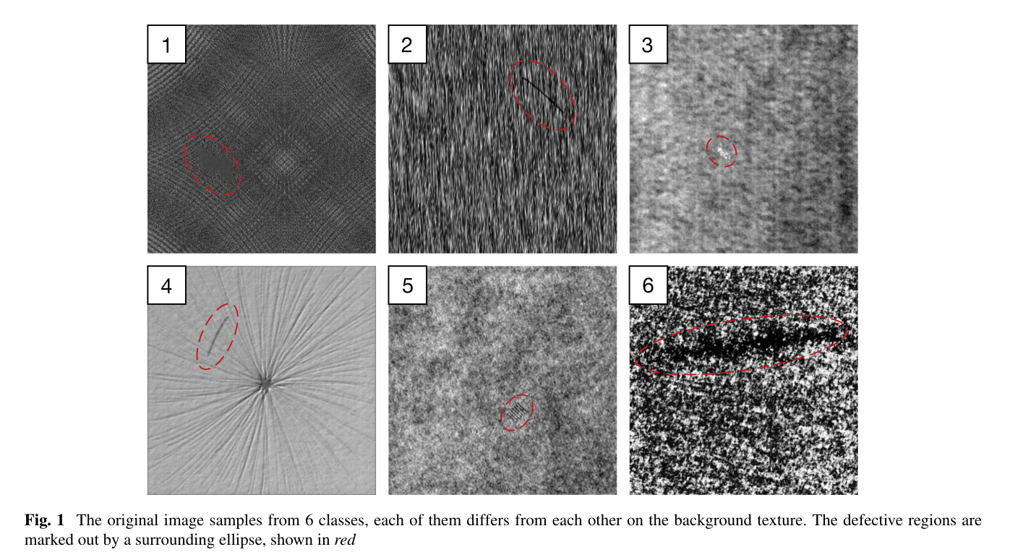

The DAGM dataset which is shown in Fig. 1 contains image samples of 6 classes with size 512 × 512 pixel. Each class consists of 1000 defect free images and 150 defective ones with only one labeled defect region each on the texture background. This dataset is highly challenging mainly for two reasons:

* the defective background texture in the same class varies a lot
* some of the defect regions are very small and some are very similar to the backgroud texture.

1. **A fast and robust convolutional neural network-based defect**

在进行缺陷检测时，首先确定缺陷的类别，然后回归确定缺陷位置。

* The global frame classification part learns to classify the image samples into the correct class based on their background texture features. The subframe detection part is developed to decide whether each of the samples contains defective regions or not based on the output of the first part. The two parts are quite similar in architecture and they are strung together for the defect detection forming the whole network.

利用神经网络进行分类时，最终利用全连接层产生的结果是当前图像处于每个类型的概率值；

利用神经网络进行缺陷检测时，其输出结果是二维值，表示该图片是否存在缺陷。

* The global frame classification part works in conjunction with the sub-frame detection part for the purpose of defect detection. Given an image, **the first part decides** which class this sample belongs to. **Then**, this image is divided into 49 blocks and they are fed into one of the sub-networks belonging to the second part according to the output of the first part. If any of the blocks is detected as defective, then the whole image is labelled defective.
* the second part takes image blocks of size 128×128 pixel extracted from the original 512×512 pixel images as the input. The extraction is performed by the sliding-window method depicted in Fig. 3. The sliding window has a size of 128×128 pixel and moves along the rows and columns over the whole image with a 64 pixel stride.

将原始图像进行分块，当其中一块检测结果中存在缺陷，则该图像存在缺陷。***分块预测***

在分类过程中，当分类的类别背景纹理具有很大的区分度时，即使少量的样本也不会出现过拟合现象，在缺陷检测过程中，由于缺陷图像较少，且缺陷区域较小，因此为了防止在缺陷检测中的过拟合现象，需要进行数据增强，增强缺陷图像数量，缓解非缺陷图像和缺陷图像间样本的数量差异。

图像增强，是为了防止过拟合现象。

缺陷检测过程中，需要考虑尺度变化、变形等重要因素。

在缺陷检测结果中，需要预测缺陷的位置以及大小等信息，这对产品的质量评估具有很重要的意义。

1. **Defects Based on Improved YOLO Detection Network Detection Network**

现有的缺陷检测算法主要是利用机器学习算法，包括图像预处理、特征提取和分类。

The YOLO network divides the input image into S × S grids. Meanwhile, the convolutional layers are designed to extract the defect features. For each grid, the network determines whether the grid contains defects and identifies the defect categories according to the extracted defect features.

利用卷积层代替Max pooling层

max pooling layers can be replaced by convolution layers with stride of 2 without loss in accuracy on several image recognition benchmarks.

* **Multi-scale input：**When training our network, we changed the fixed 416 *416 input resolution to a variable input resolution. We set a set of selectable input resolutions {224, 256 ,416, 448}, and the network changes the input size every 10 iterations.
* **Batch Normalization:** Our network utilizes Batch Normalization to normalize the data for each batch.(**批量归一化**)
* **Multi-scale features:** feature maps of different scales are jointly connected to predict the classification information and bounding boxes, which reduce the loss of information in defect images.
* **Data augmentation:** data augmentation can expand the data set and increase the diversity of the training data. Data augmentation can also reduce overfitting. Before we train the network, we performed sharpness augmentation and contrast augmentation on some of the defect images. During the training process, we randomly scaled and cropped the defect images.