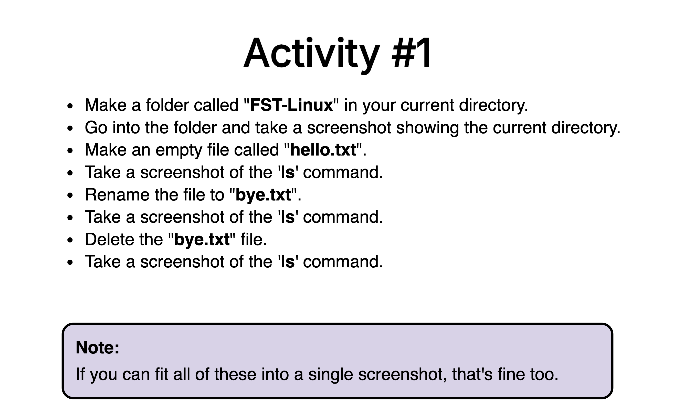

Solution:

addepalliyamini@Addepallis-MBP ~ % mkdir FST-Linux

addepalliyamini@Addepallis-MBP ~ % ls -lrt

drwxr-xr-x 2 addepalliyamini staff 64 Dec 24 09:21 FST-Linux

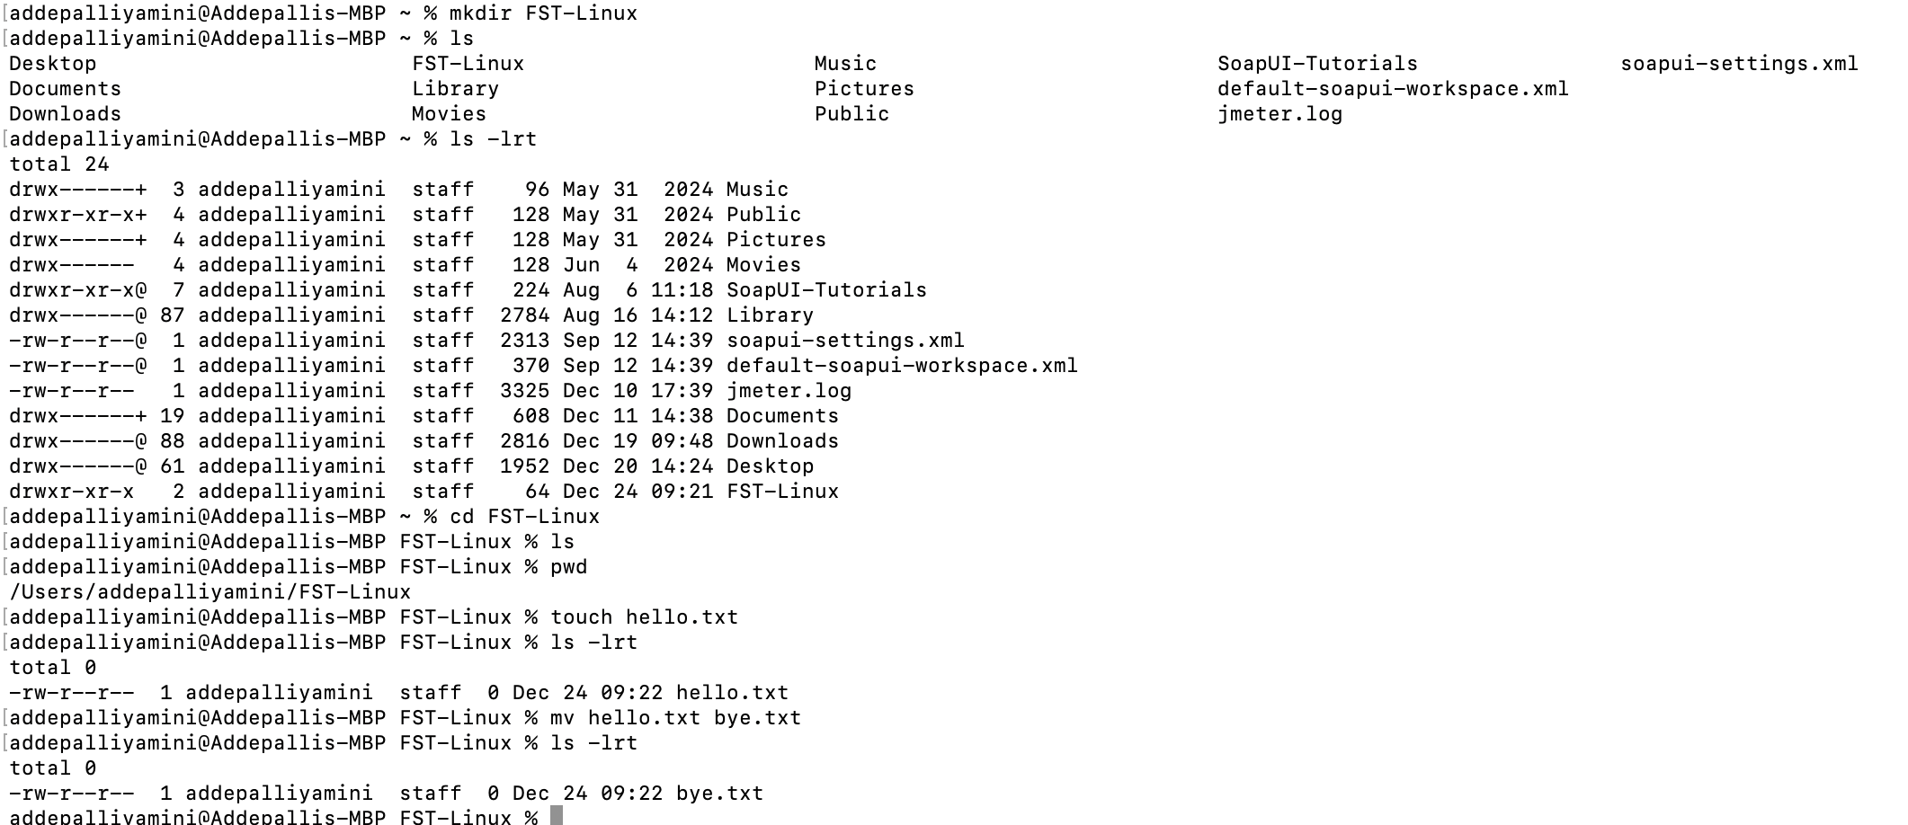

\*\*\*\*\*\*\*\*\*\*\*\*\*\*\*\*\*\*\*\*\*\*\*\*\*\*\*\*\*\*\*\*\*\*\*\*\*\*\*\*\*\*\*\*\*\*\*\*\*\*\*\*\*\*\*\*\*\*\*\*\*\*\*\*\*\*\*\*\*\*\*\*\*\*\*\*\*\*\*\*\*\*

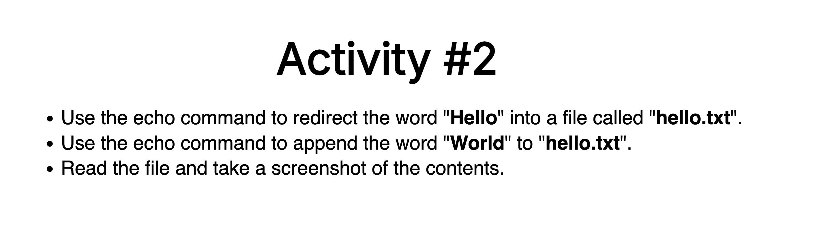

Solution:

addepalliyamini@Addepallis-MBP FST-Linux % echo "Hello" >hello.txt

addepalliyamini@Addepallis-MBP FST-Linux % echo "World" >> hello.txt

addepalliyamini@Addepallis-MBP FST-Linux % cat hello.txt

Hello

World

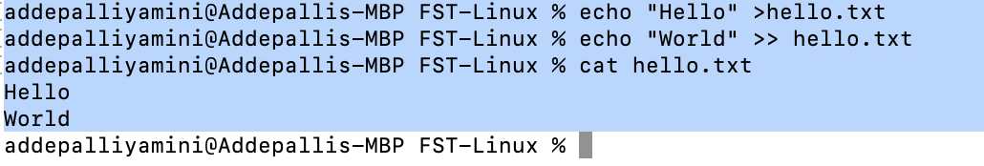

\*\*\*\*\*\*\*\*\*\*\*\*\*\*\*\*\*\*\*\*\*\*\*\*\*\*\*\*\*\*\*\*\*\*\*\*\*\*\*\*\*\*\*\*\*\*\*\*\*\*\*\*\*\*\*\*\*\*\*\*\*\*\*\*\*\*\*\*\*\*\*\*\*\*\*\*\*\*\*\*\*\*

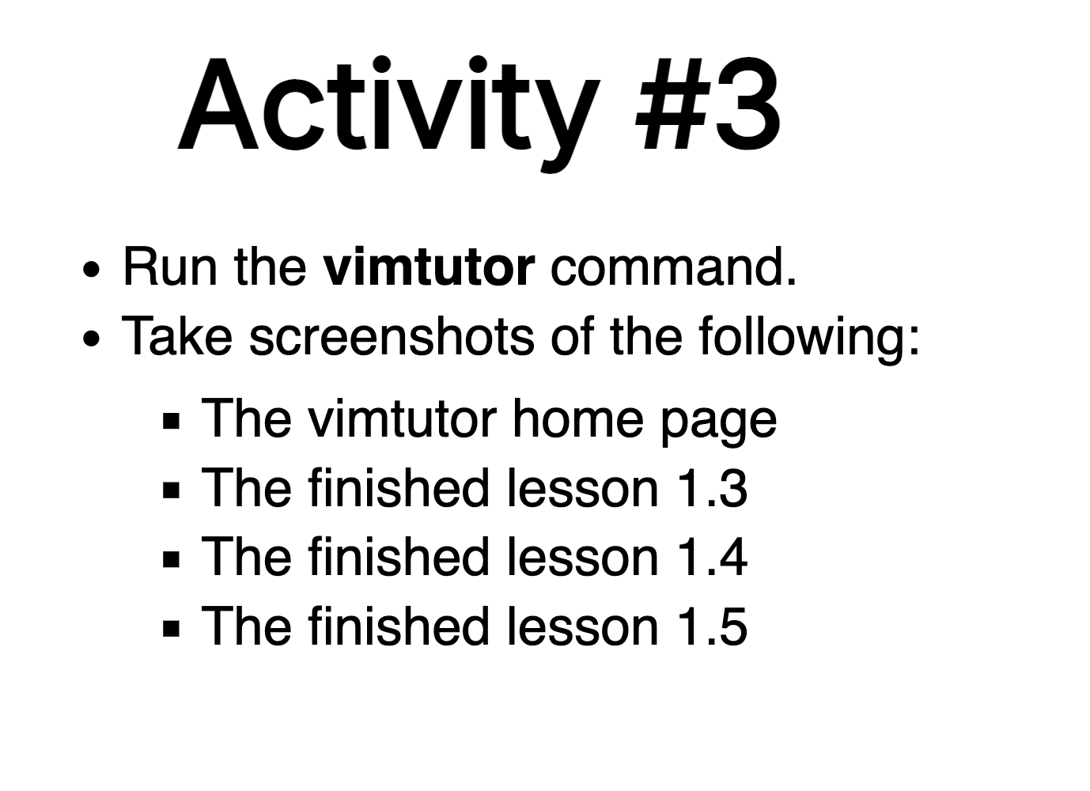

Solution:

Note: As I am using MAC OS, not installed vim separately

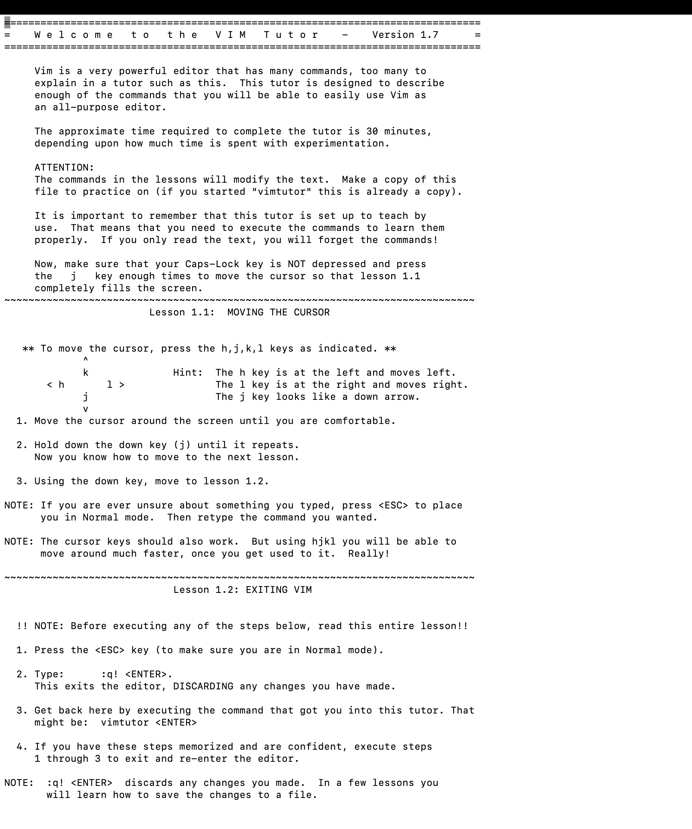

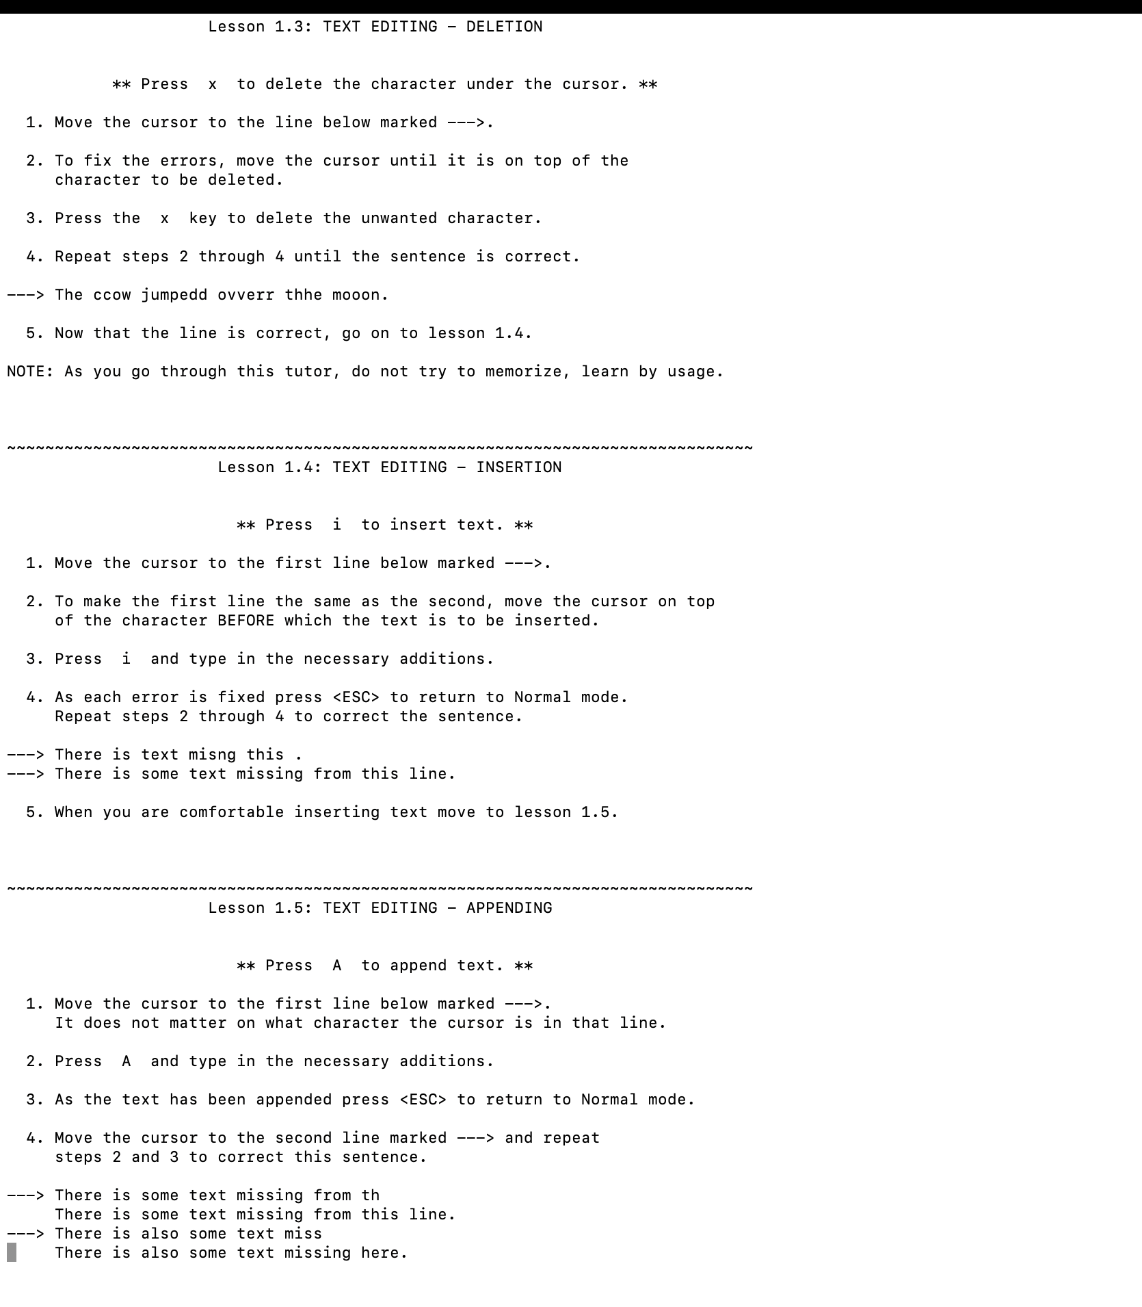

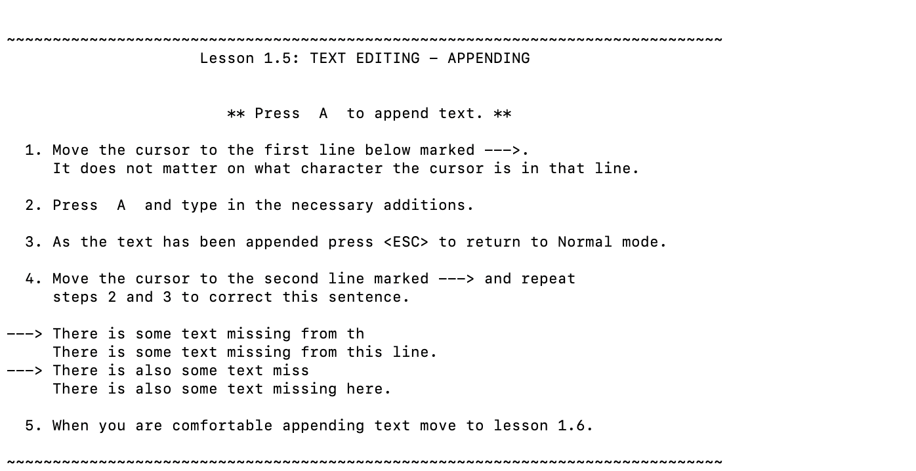

\*\*\*\*\*\*\*\*\*\*\*\*\*\*\*\*\*\*\*\*\*\*\*\*\*\*\*\*\*\*\*\*\*\*\*\*\*\*\*\*\*\*\*\*\*\*\*\*\*\*\*\*\*\*\*\*\*\*\*\*\*\*\*\*\*\*\*\*\*\*\*\*\*\*\*\*\*\*\*\*\*\*

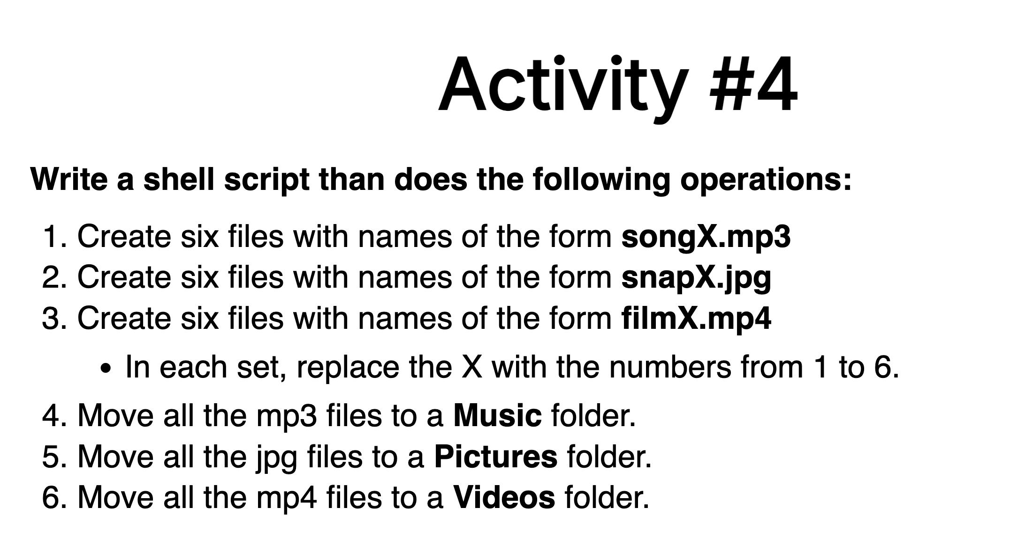

addepalliyamini@Addepallis-MBP Activity4 % pwd

/Users/addepalliyamini/FST-Linux/Activity4

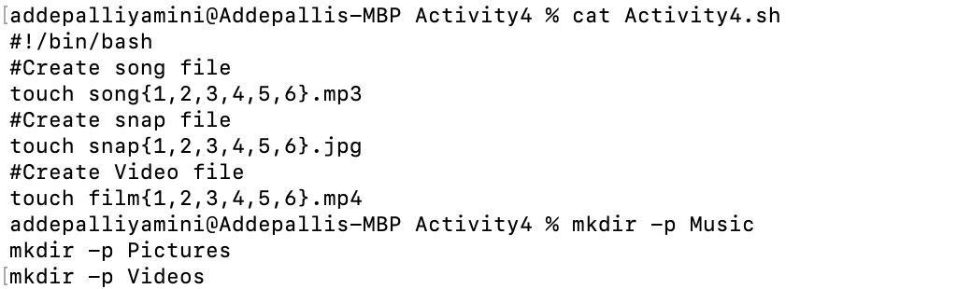

addepalliyamini@Addepallis-MBP Activity4 % cat Activity4.sh

#!/bin/bash

#Create song file

touch song{1,2,3,4,5,6}.mp3

#Create snap file

touch snap{1,2,3,4,5,6}.jpg

#Create Video file

touch film{1,2,3,4,5,6}.mp4

addepalliyamini@Addepallis-MBP Activity4 %

mkdir -p Music

mkdir -p Pictures

mkdir -p Videos

