**ourcommons prototype features**

Made by Alexander Breeze

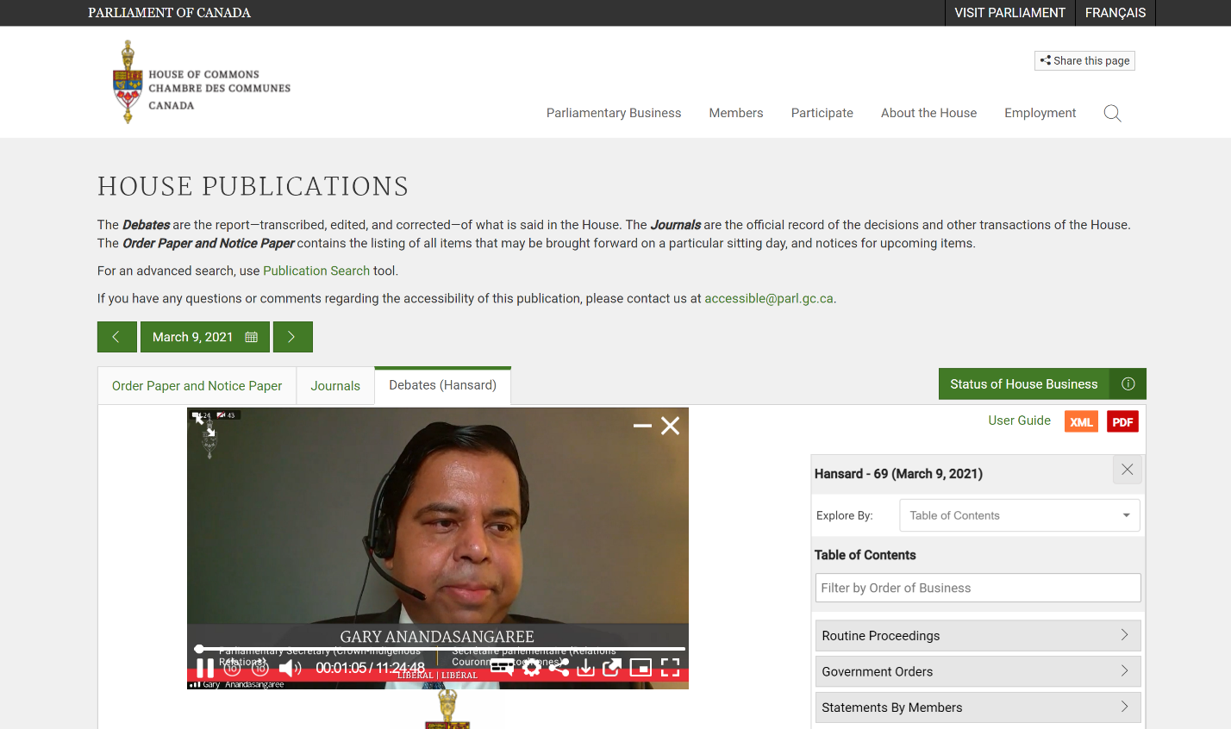

Image: ourcommons prototype with video player loaded in default lightbox position

The general website is a fairly simple mockup, designed to house the video player. The right column was complicated to make, due to its nature of resizing and sticking when the user scrolls. The left column contains “View this Video” links which, when clicked, activate the video player at the correct video position. The entire player is custom, coded from scratch, with the exception of the M3U8 video conversion handled by the video.js plugin and the sub-plugin videojs-contrib-quality.

The video player loads automatically and autoplays if the browser allows it. Normally browsers do not allow things to autoplay if they have sound, however they allow it if there is previous user interaction with the domain. In this case the video is only loaded when the user clicks a link, so the videos almost always autolay.

The video player is composed of a muted video player and a hidden audio player, to allow for selecting separate audio and video+cc streams with different languages. To handle audio drift a function occasionally changes audio speed slightly, ensuring audio is always fluidly synced with video.

FEATURES:

Video progress bar: updates based on video position, controls playback position.

Time text: says current video progress (12:45:13/12:50:55). Displays time numerically.

Play/pause button: controls playback, changes icon based on state. Can also be accessed via spacebar, k, or by clicking on the main part of the video player.

Skip +- 10 seconds: moves video. Can also be accessed via right/left arrow keys.

Volume: controls audio volume. Click to mute/unmute, move mouse over to reveal volume slider and move time text out of the way. Volume slider updates video volume in real time, allowing for easy selection while video is playing. Volume icon has 5 symbols: null, muted, low, med, high. Setting volume to 0 also sets muted icon. Unmuting sets volume back to where it was before it was muted. Can also be accessed via m (mute), up/down arrow keys (volume +/-).

Subtitles: opens subtitles/audio menu, to select languages for video and audio streams. Changing one does not affect the other, i.e. changing the audio does not impede video playback or vice versa. Can also be accessed via c, which either sets subtitles to same language as audio, disables them, or opens the menu if audio is floor.

Settings: opens settings menu, containing speed and quality options. Quality options are hardcoded (min and max bitrates), video will display best stream within allowed bitrates. If no streams are allowed, displays default stream. Speed controls change video speed. Can also be accessed via +, -, which change speed by 0.25X, displays current speed in the top-right corner of the video player, and greys all speed options except any that correspond with current speed.

Download/share icons do nothing.

Close video: use X button in top right, deletes video player. Clicking on a link reopens the player at a new time, saves viewing mode, lightbox size/position, audio/cc/volume selections. Clicking on a link while an existing video player is running causes it to be replaced by a neew player at the link-specified video position.

Move: click and drag on lightbox to move it anywhere on the screen. Position is saved when exiting this mode, so lightbox will be in the same place when it is reselected.

Resize: click and drag on lightbox resize button (top left) to change the size. size is saved when exiting this mode, so lightbox will be the same size when it is reselected. Size minimum is based on control layout, to avoid controls overlapping.

Open in ParlVU: links to ParlVU version of video

TOOLTIPS have been added for most controls. Fullscreen, play/pause, lightbox/minibox/minimize buttons can change tooltips based on current state.

Four viewing modes:

Fullscreen: activates fullscreen, updates icon. Icon is updated automatically, so it works even if user exits fullscreen with esc key. Can also be accessed via f.

Miniplayer: changes video player to a small, embedded player with compact controls at bottom of right bar

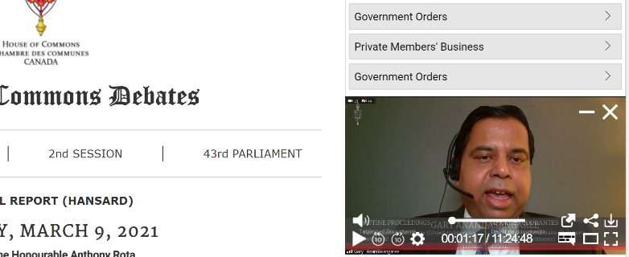

Lightbox: default player, large box on screen. Can be moved and resized. Does not impede access to other parts of website, except those parts directly underneath it.

Minimized player: access with (-) icon in top right. Acts like miniplayer, but no video and more compact controls. Disables quality and cc options. Note the controls in the fourth-from-the-right column, which are added to go back to previous selection (miniplayer/lightbox) and to close video.

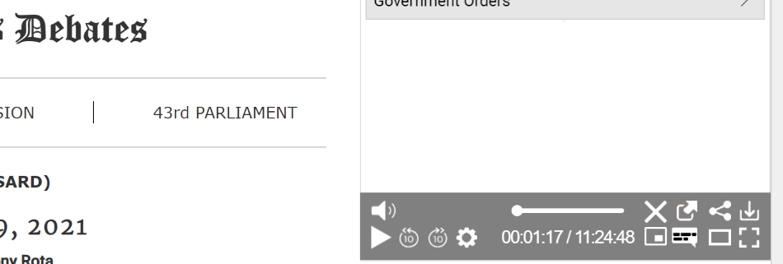

NOTE: any viewing mode can be accessed from any other viewing mode with a single click. When switching back to lightbox mode, the lightbox size and position will always be saved. If the window resizes and the lightbox is lost, it will automatically return to view.

Mobile player:

To access mobile mode, for touchscreens such as phones and tablets:

Right-click, inspect element, toggle device emulation (ctrl+shift+m), and refresh the page

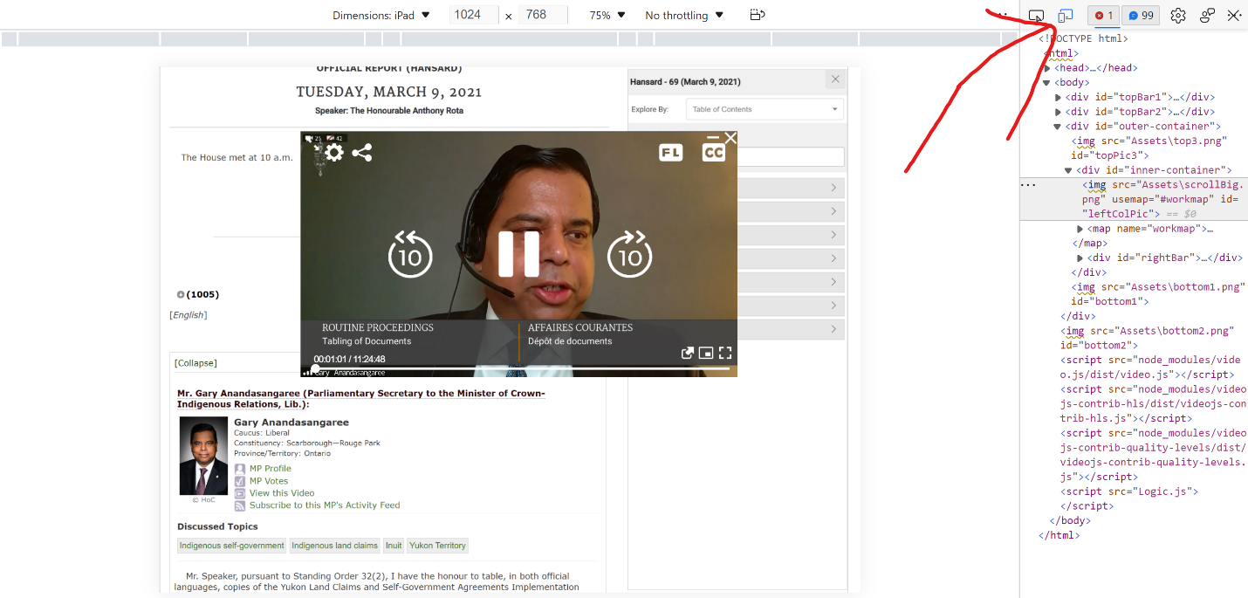

NOTE: you MUST refresh page when swapping between mobile and non-mobile modes. Look at the video controls to see which mode you are in.

No audio controls, as the device handles that directly. No download.

Play/pause, skip+-10 icons are much larger, centered. Fullscreen works like normal, share still does nothing. Settings has one less quality/speed option.

Audio and cc languages have 2 separate menus, audio icon changes depended on language selection, subtitles icon changes depending audio only mode.

    

Controls disappear after 3 seconds, reappear when screen is tapped