CSCE 3530 Final Network Project Report
Small Office Network Built in Proxmox
Student Name: Zion Welsh
Course: CSCE 3530 - Introduction to Computer Networks
Date: July 2026
This report documents the design, configuration, and testing of a small office-style network using virtual machines in Proxmox. The project includes a router/firewall VM, an internal server VM, and two Ubuntu Desktop client VMs. The network was tested for routing, NAT, DHCP, DNS, HTTP, SSH, and general connectivity.

Project Overview
The goal of this project was to create a functional small office network in a virtual lab environment. Proxmox was used as the virtualization platform. The network separates the outside/home network from the internal project network using a Router-Firewall-VM. The internal Server-VM provides DHCP, DNS, and Apache web services to two Ubuntu Desktop client machines.

Objectives of the Project
- Build a virtualized office network using Proxmox.
- Configure a router/firewall VM with two interfaces, routing, and NAT.
- Configure a server VM to provide DHCP, DNS, and HTTP web services.
- Configure two client VMs to receive addressing automatically through DHCP.
- Verify connectivity with ping, DNS lookup, HTTP/curl testing, and traceroute.
- Document the final design with screenshots and explanations.

Network Design Explanation
The network uses two Proxmox bridges. The outside bridge, vmbr0, connects the router VM to the home network. The internal bridge, vmbr10, connects the router VM, server VM, and client VMs together on the private 192.168.10.0/24 subnet. The router acts as the default gateway for the internal subnet and performs NAT so internal clients can reach the internet.
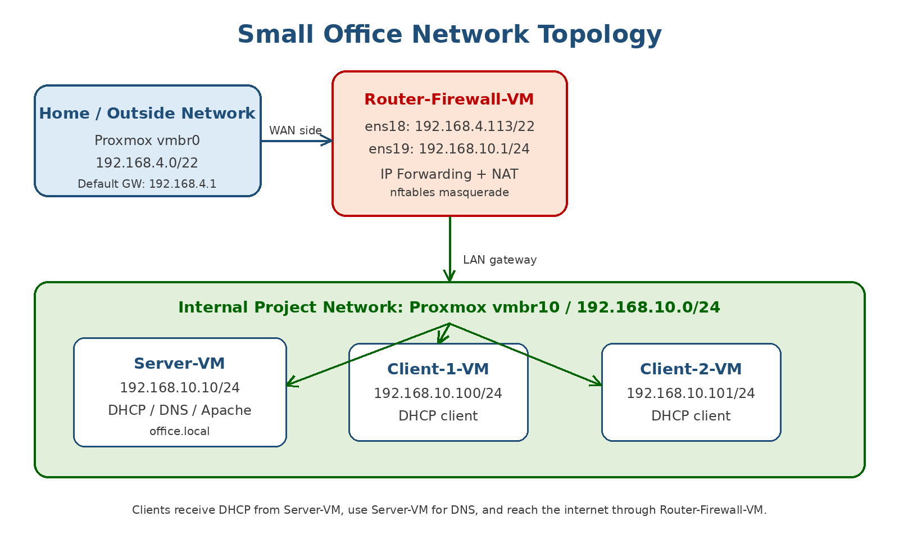
Figure 1. Network topology diagram showing the router, server, clients, subnet, and IP addressing.
The Proxmox inventory confirms the project was implemented using separate virtual machines for the Router-Firewall-VM, Server-VM, Client-1-VM, and Client-2-VM. Keeping each network role in its own VM helped simulate a small office network with a dedicated router/firewall, internal server, and client systems.
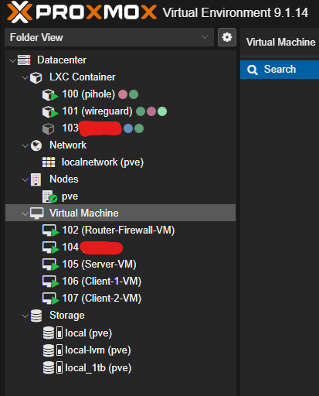
Figure 2. Proxmox VM inventory showing the project virtual machines used for the network lab.
Device | Interface | IP Address | Purpose
Router-Firewall-VM | ens18 | 192.168.4.113/22 | Outside/home network on vmbr0
Router-Firewall-VM | ens19 | 192.168.10.1/24 | Internal gateway on vmbr10
Server-VM | ens18 | 192.168.10.10/24 | DHCP, DNS, Apache web server
Client-1-VM | ens18 | 192.168.10.100/24 | DHCP client
Client-2-VM | ens18 | 192.168.10.101/24 | DHCP client

Description of Networking Protocols Used
Protocol / Service | Use in This Project
DHCP | The Server-VM assigns automatic IP addresses, gateway, DNS, and domain information to the client VMs.
DNS | BIND9 on the Server-VM resolves internal names such as www.office.local and router.office.local.
HTTP | Apache on the Server-VM hosts an internal web page available at http://www.office.local.
NAT | nftables masquerading on the Router-Firewall-VM allows internal clients to reach outside networks.
ICMP | Ping was used to confirm connectivity between clients, server, router, and the internet.
Traceroute | Traceroute confirmed that client traffic exits the internal network through the router at 192.168.10.1.
SSH | SSH was enabled so each VM could be managed from the Windows terminal through the router jump host.

Device Configurations

Router-Firewall-VM
The Router-Firewall-VM has two virtual network adapters. ens18 connects to vmbr0 and received an outside network address of 192.168.4.113/22. ens19 connects to vmbr10 and uses the internal gateway address 192.168.10.1/24. The router was configured with IPv4 forwarding and nftables NAT/forwarding rules.
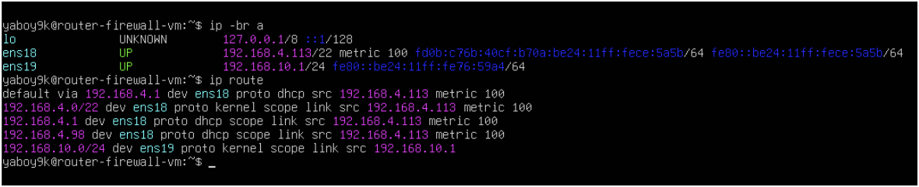
Figure 3. Router-Firewall-VM interface and route configuration.

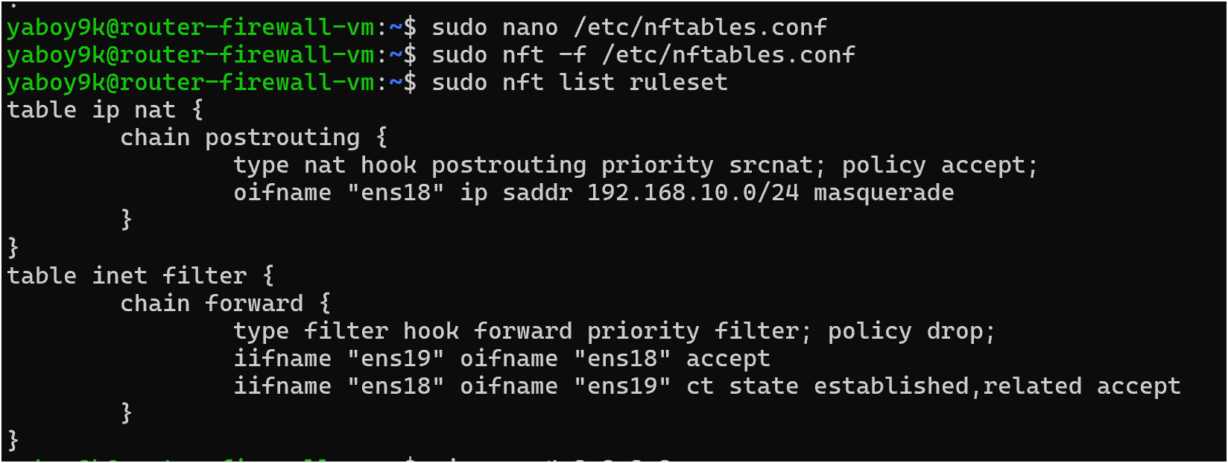
Figure 4. nftables NAT and forwarding rules on the Router-Firewall-VM.
Important router commands used:
ip -br a
ip route
sysctl net.ipv4.ip_forward
sudo nft list ruleset

Server-VM
The Server-VM was configured with a static address of 192.168.10.10/24, default gateway 192.168.10.1, and internal services for DHCP, DNS, and Apache HTTP. The server successfully reached both the router and the internet through the Router-Firewall-VM.
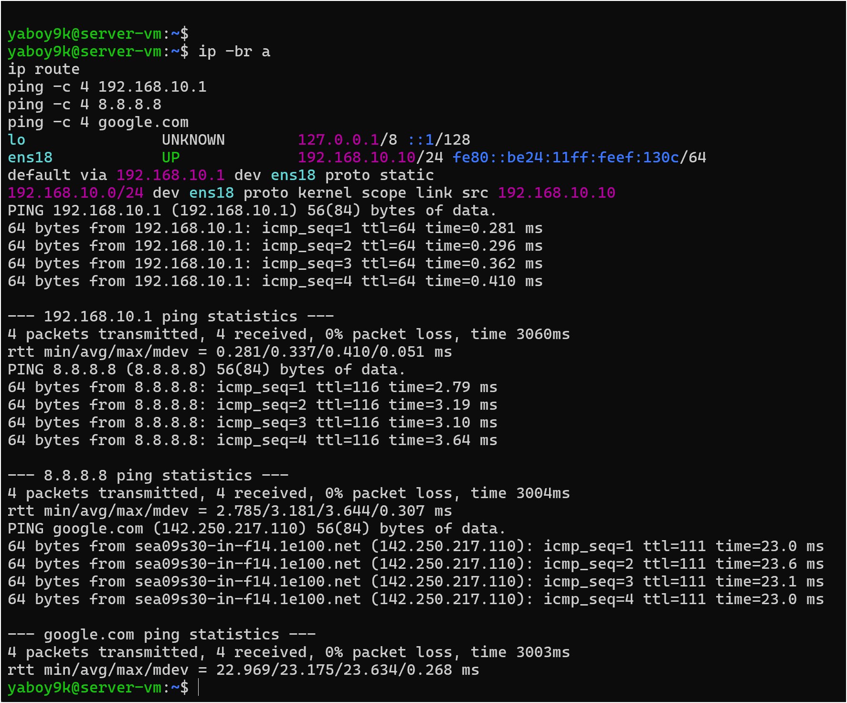
Figure 5. Server-VM IP configuration, default route, and connectivity tests.

DHCP Configuration
ISC DHCP Server was configured to listen on ens18 and provide addresses in the 192.168.10.100-192.168.10.200 range. It also provides the default gateway 192.168.10.1 and DNS server 192.168.10.10 to clients.
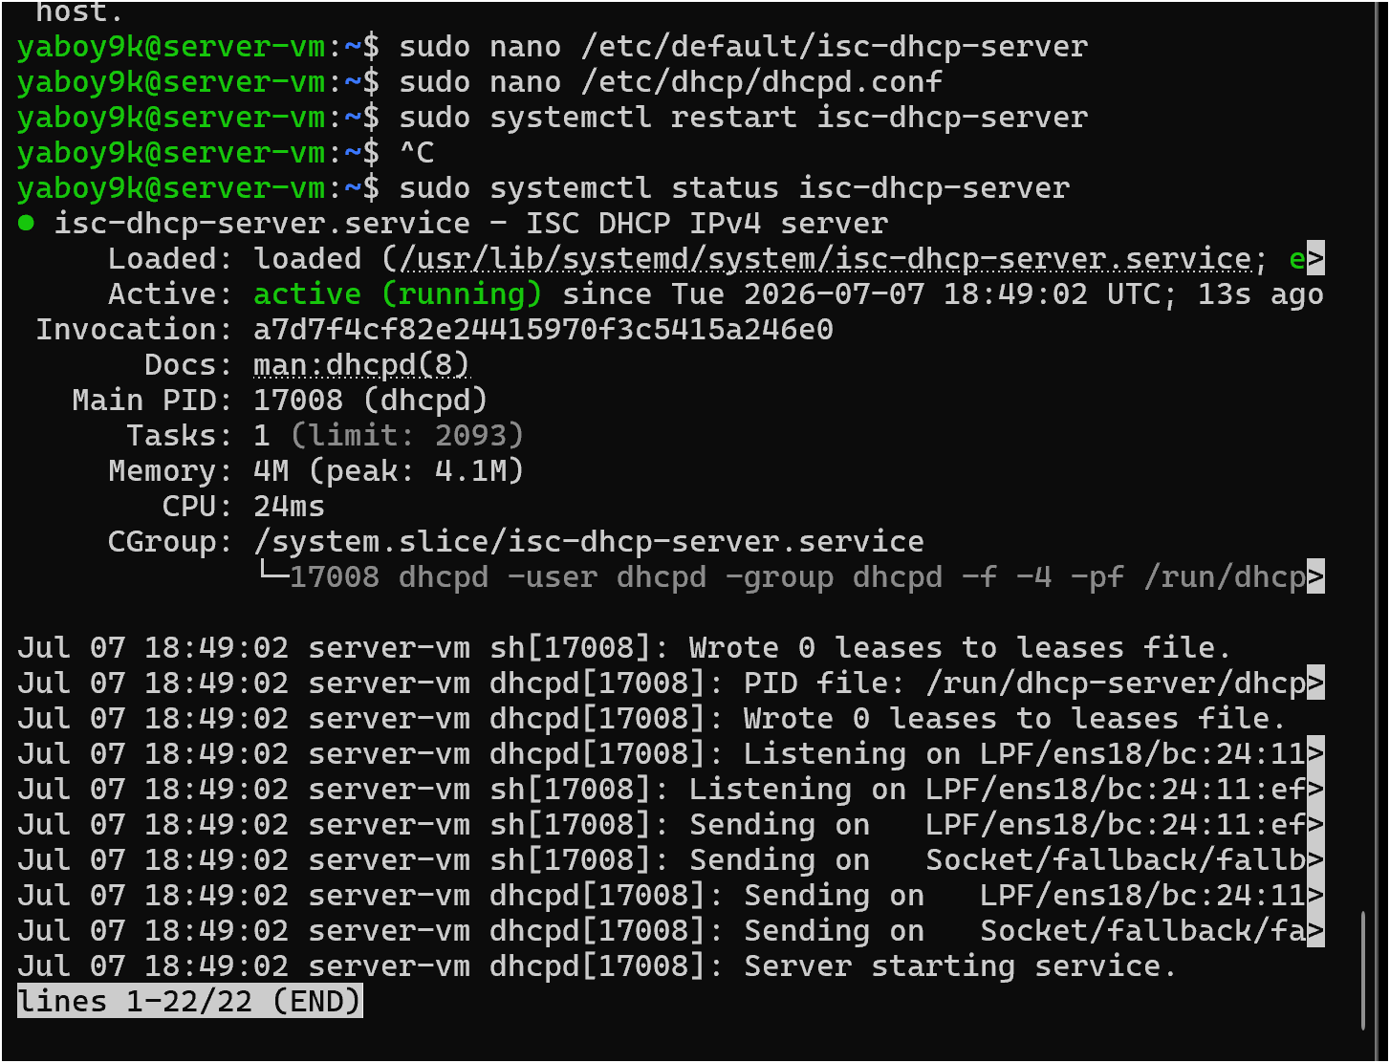
Figure 6. ISC DHCP Server service running on the Server-VM.
DHCP configuration summary:
- Subnet: 192.168.10.0/24
- DHCP range: 192.168.10.100 - 192.168.10.200
- Router/default gateway: 192.168.10.1
- DNS server: 192.168.10.10
- Domain: office.local

DNS Configuration
BIND9 was configured as the internal DNS server for the office.local domain. The zone includes records for www.office.local, server.office.local, and router.office.local.
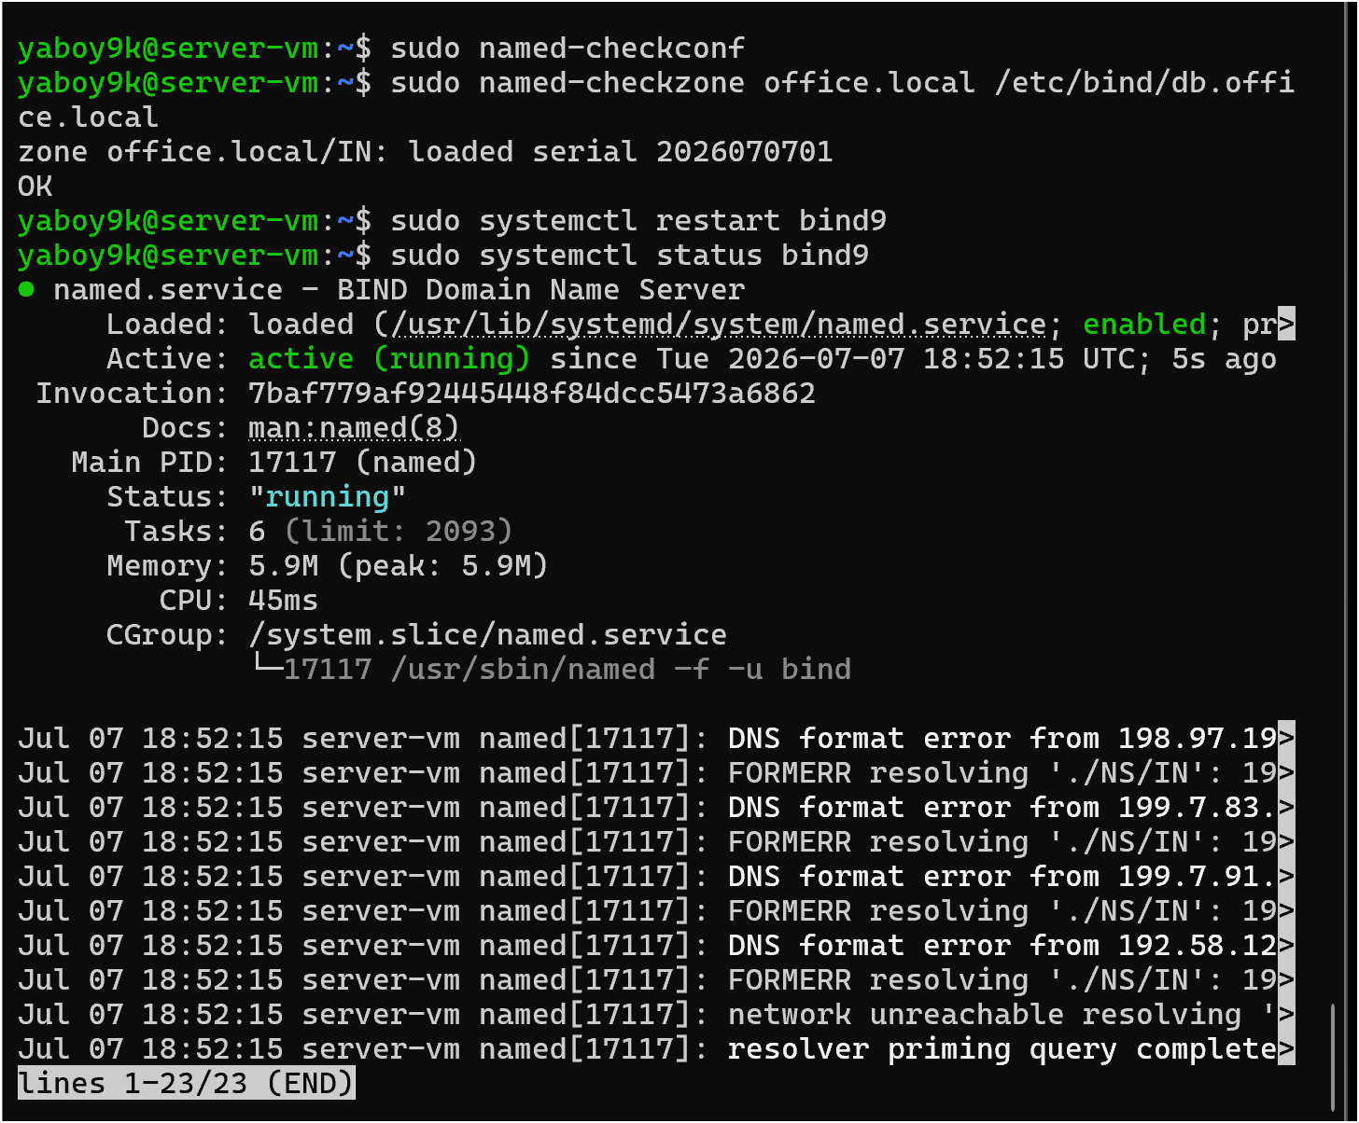
Figure 7. BIND9 DNS service running and zone file check passing.
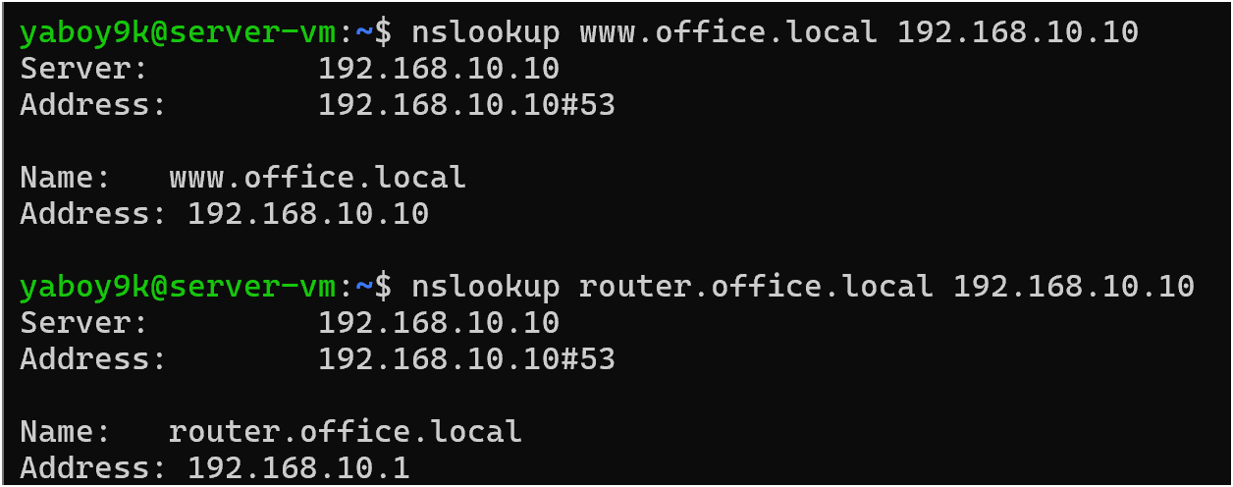
Figure 8. DNS lookups resolving www.office.local and router.office.local using the Server-VM.

HTTP / Apache Configuration
Apache was installed on the Server-VM and used to host a simple internal web page. The page is reachable by IP address and by the DNS name www.office.local after DNS was configured.
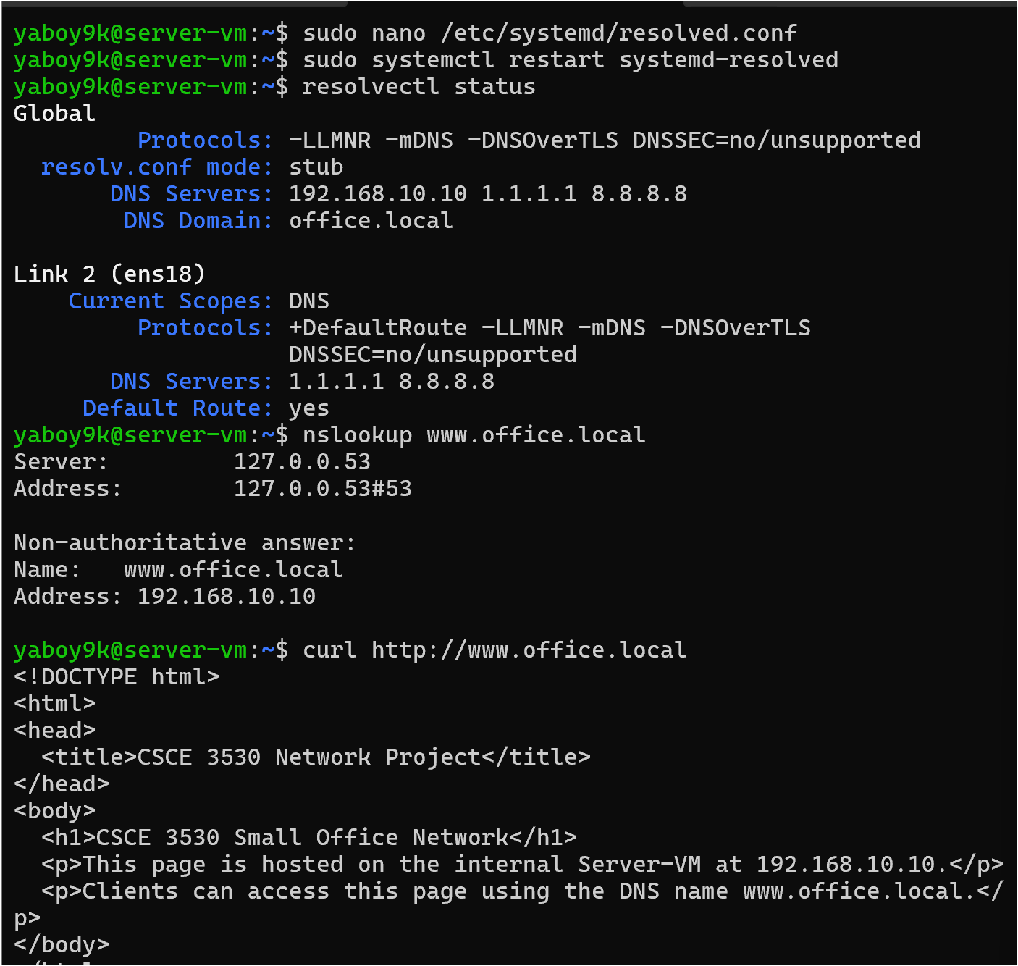
Figure 9. Server-VM resolver configuration and successful HTTP test using www.office.local.

DHCP Lease Verification
The DHCP lease file verifies that the Server-VM issued addresses to both client systems. Client-1-VM received 192.168.10.100 and Client-2-VM received 192.168.10.101.
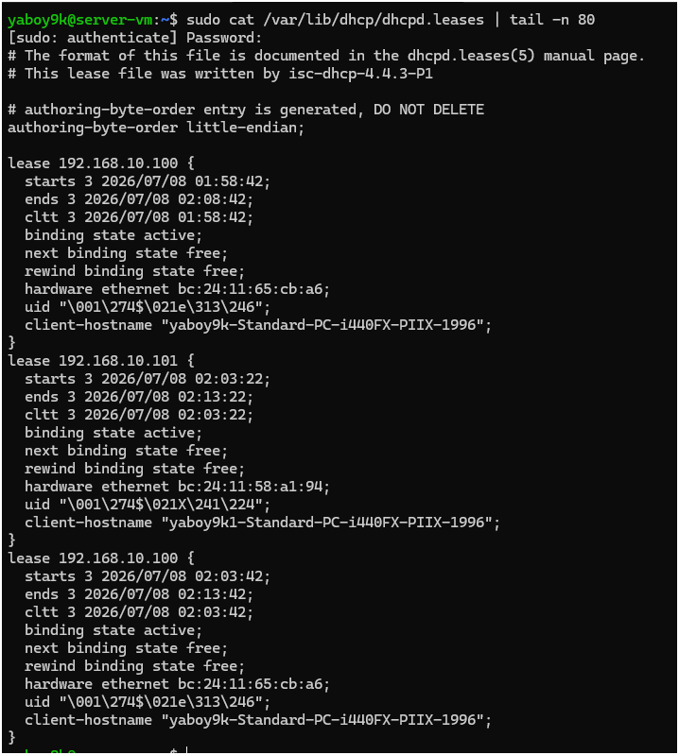
Figure 10. DHCP lease file showing active leases for Client-1-VM and Client-2-VM.

Network Testing and Results

Client-1-VM Testing
Client-1-VM received its IP address automatically through DHCP. It used 192.168.10.1 as the default gateway and 192.168.10.10 as the DNS server. The client was able to ping the router, ping the server, reach the internet, resolve www.office.local, access the web page, and traceroute through the router.
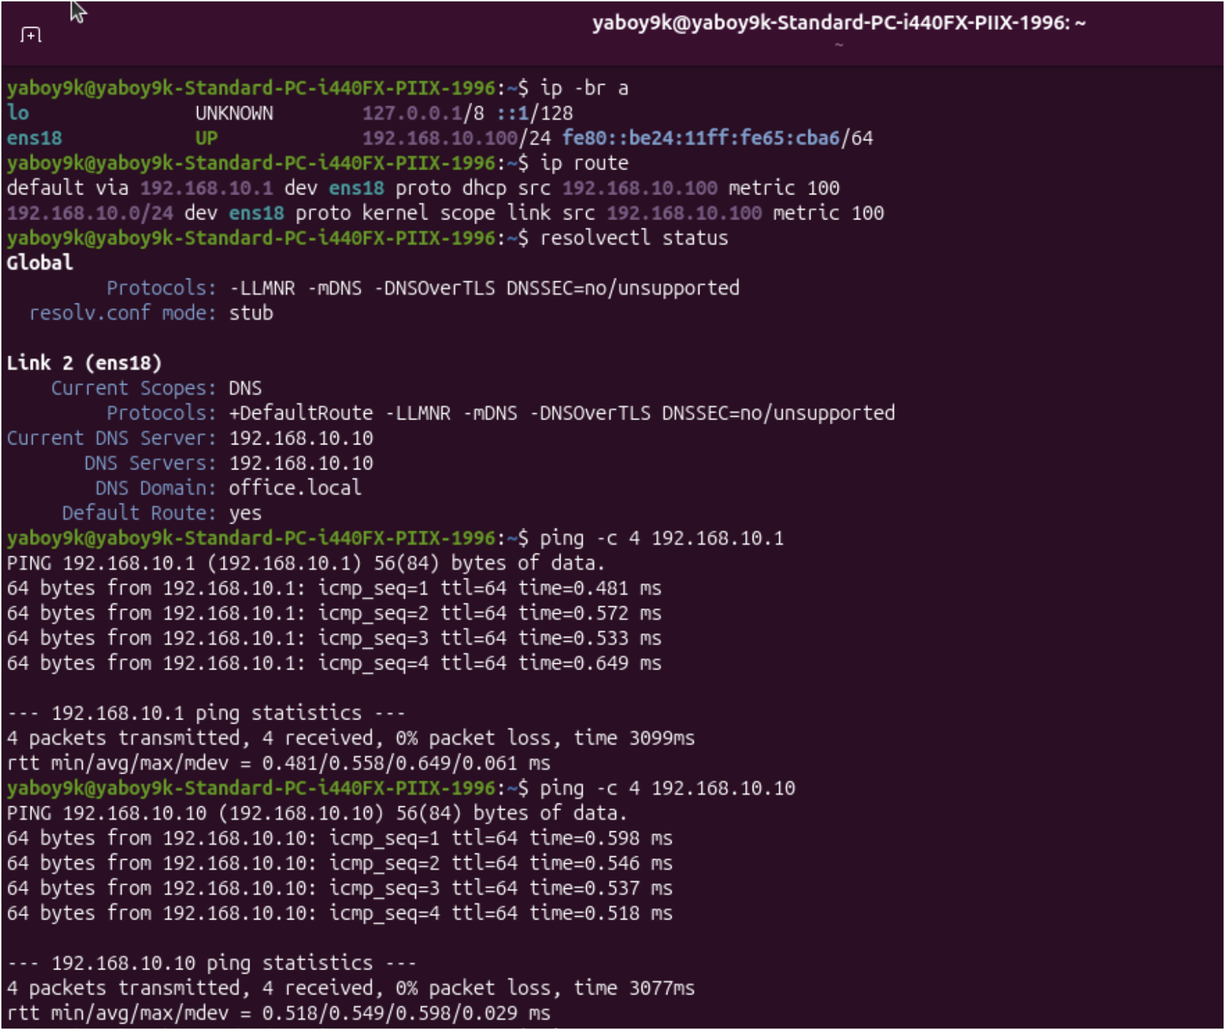
Figure 11. Client-1-VM DHCP addressing, DNS configuration, and internal ping tests.
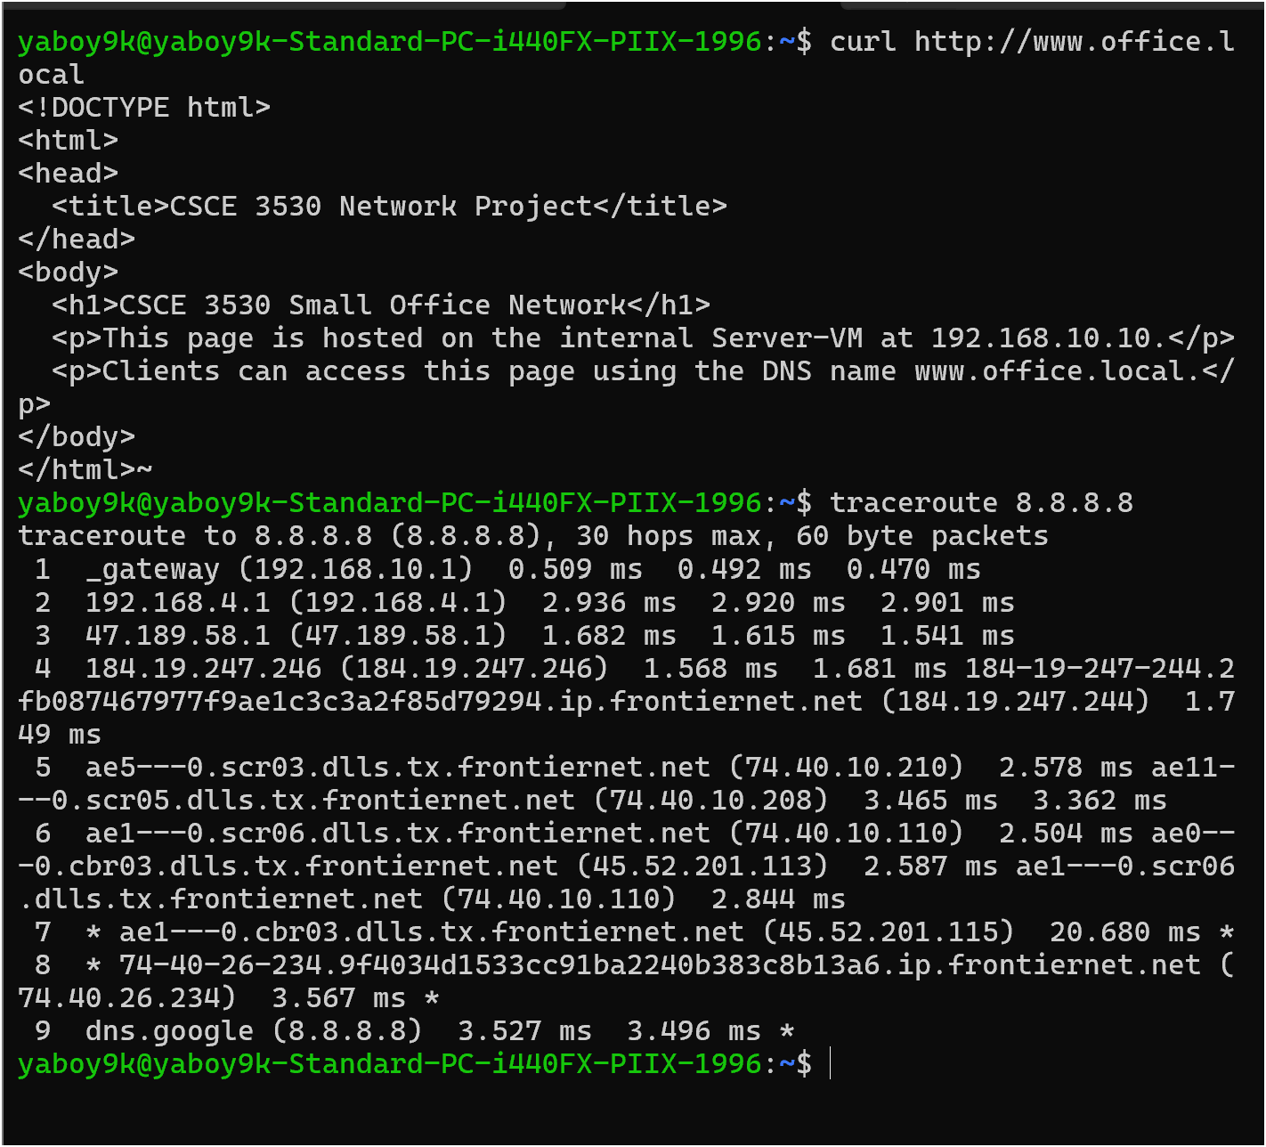
Figure 12. Client-1-VM HTTP test and traceroute showing first hop through 192.168.10.1.

Client-2-VM Testing
Client-2-VM also received its IP configuration automatically from DHCP. It received 192.168.10.101/24, used 192.168.10.1 as the gateway, and used 192.168.10.10 for DNS. The same internal, DNS, HTTP, and internet routing tests were successful.
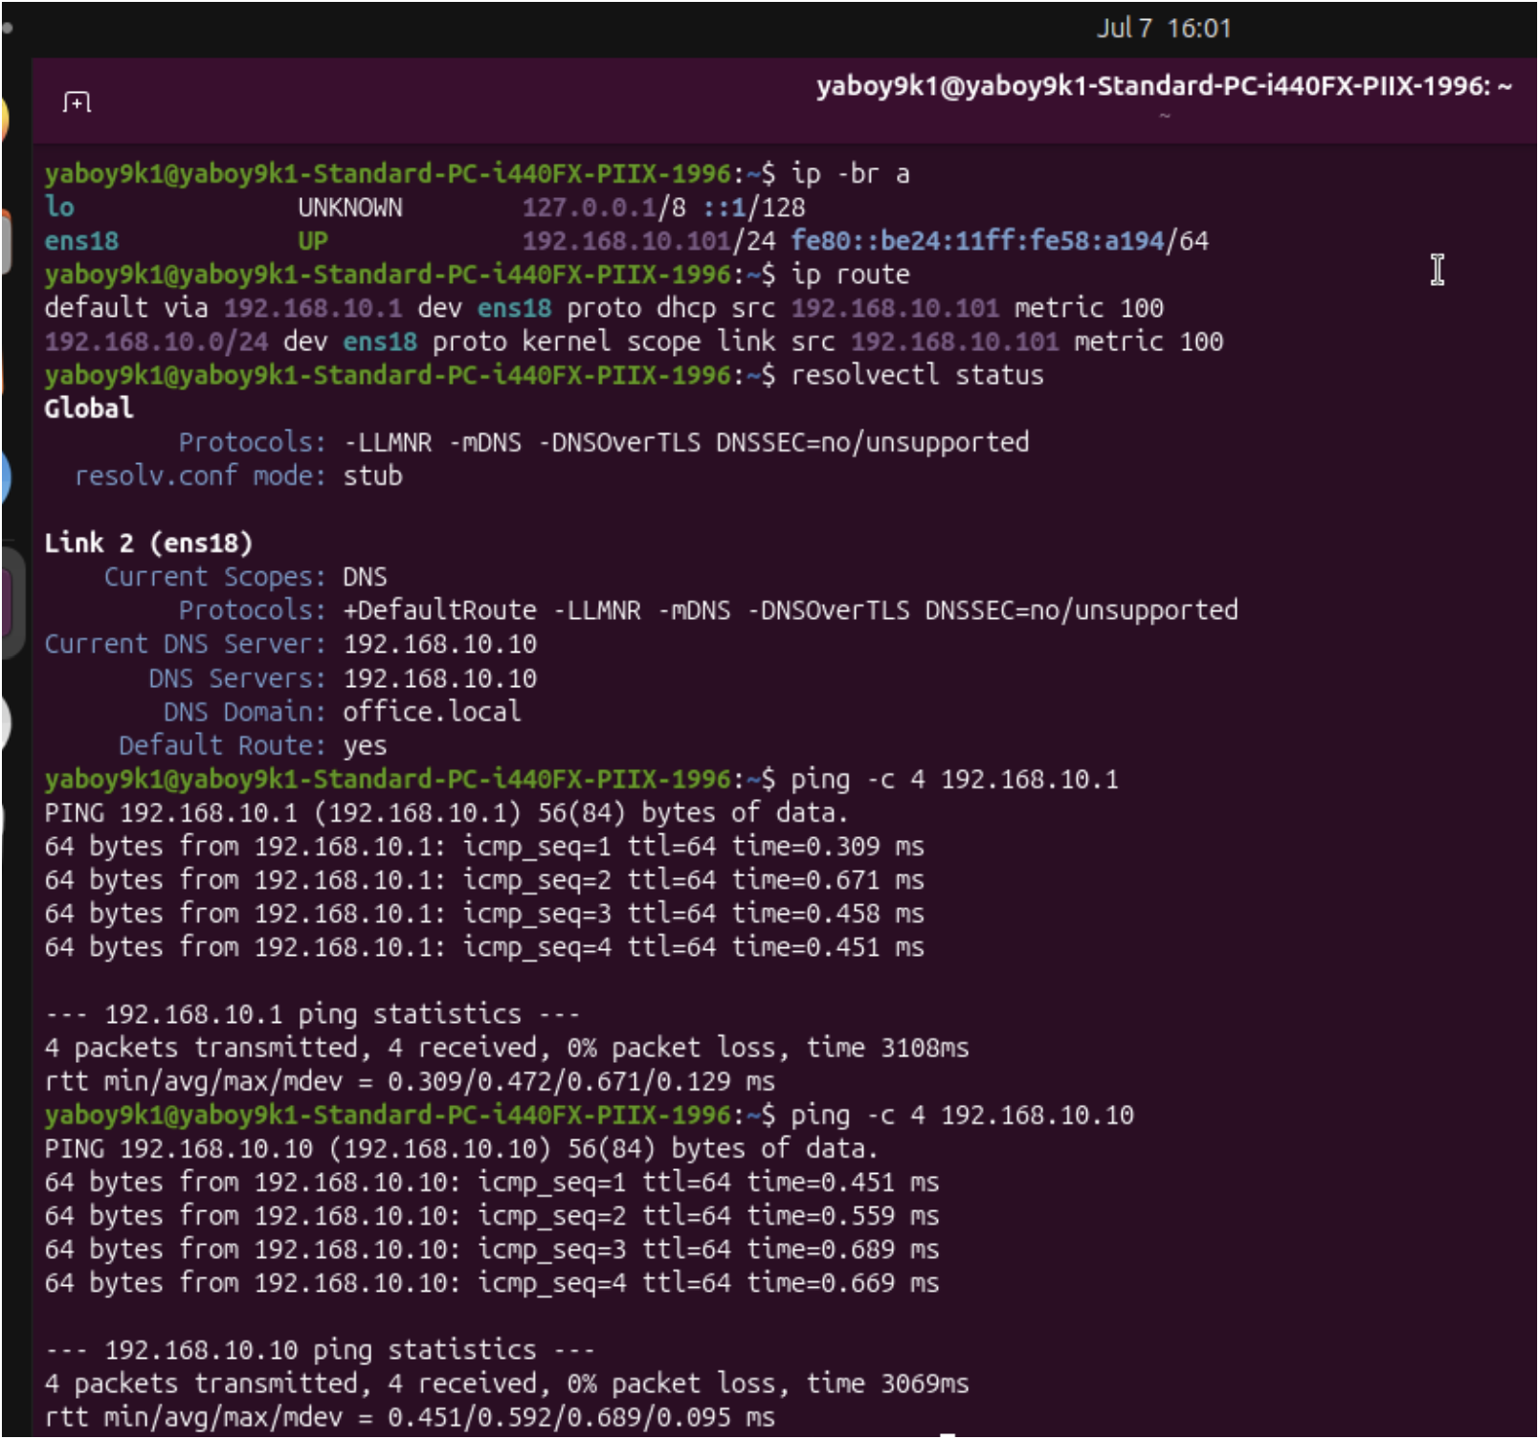
Figure 13. Client-2-VM DHCP addressing, DNS configuration, and internal ping tests.
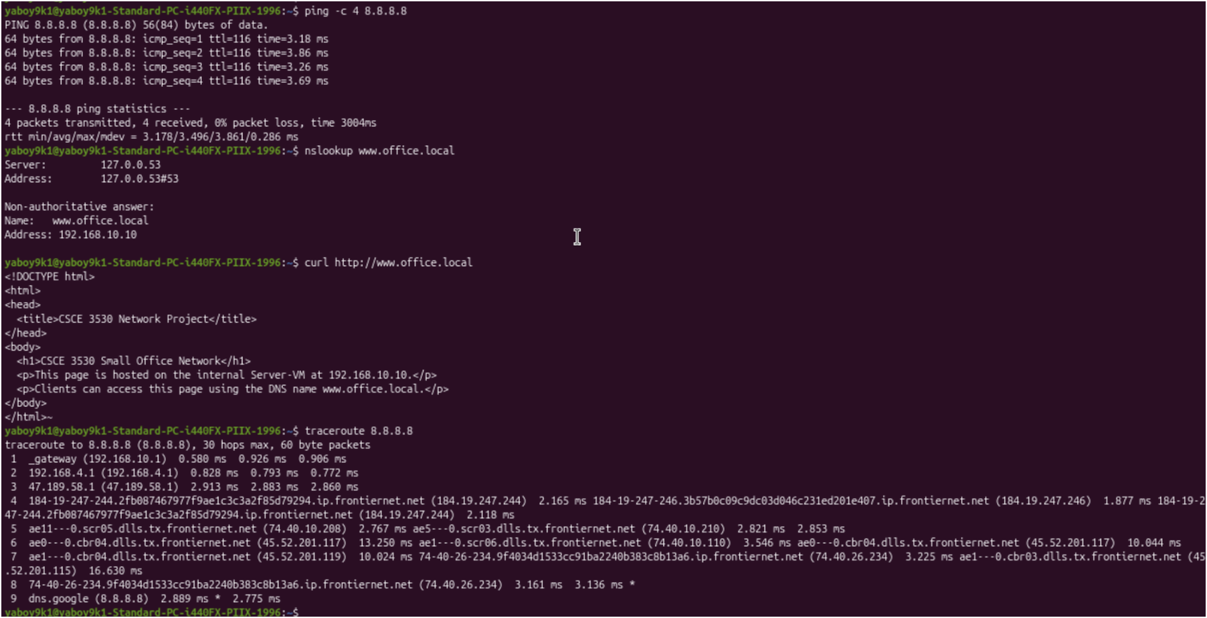
Figure 14. Client-2-VM internet ping, DNS lookup, HTTP test, and traceroute.

Verification Results Summary
Test | Result
Router has outside and inside interfaces | Successful
Router can reach the internet | Successful
IPv4 forwarding enabled on router | Successful
nftables NAT/masquerade configured | Successful
Server can ping router and internet | Successful
DHCP server running | Successful
DNS server running | Successful
Apache web server running | Successful
Client-1 received DHCP address | Successful
Client-2 received DHCP address | Successful
Clients resolve www.office.local | Successful
Clients access internal web page | Successful
Clients traceroute through router | Successful

Challenges Faced and Solutions
Challenge | Solution
No DHCP on the internal network at first | The internal vmbr10 network did not have a DHCP server yet, so the router internal interface was configured manually as 192.168.10.1/24. Later, the Server-VM provided DHCP for the client VMs.
Clients needed a DNS server for office.local | BIND9 was installed and configured on the Server-VM. The clients received 192.168.10.10 as their DNS server through DHCP.
Server initially could not resolve www.office.local locally | systemd-resolved was configured to use 192.168.10.10 and the office.local search domain. After restarting systemd-resolved, curl and nslookup worked using the DNS name.
curl and traceroute were missing on client VM | The missing packages were installed with apt, and the HTTP/traceroute tests were then repeated successfully.
Internal clients needed internet access | IPv4 forwarding and nftables NAT were configured on the Router-Firewall-VM so traffic from 192.168.10.0/24 could exit through ens18.

Conclusion
The final network was successfully built and tested in Proxmox. The Router-Firewall-VM provided routing, forwarding, and NAT for the internal network. The Server-VM provided DHCP, DNS, and Apache web services. Both Ubuntu Desktop client VMs received DHCP addresses, used the Server-VM for DNS, accessed the internal web server using www.office.local, and reached the internet through the router/firewall VM. The test results confirm that the small office network design is functional and correctly configured.

Submission Checklist
- Final report includes project title, student name, overview, objectives, network design, protocols, configurations, testing, challenges, and conclusion.
- Network topology diagram is included.
- Proxmox VM inventory screenshot is included to document the virtual lab environment.
- Configuration screenshots are included and labeled.
- Testing screenshots are included and labeled.
- Client DHCP leases are verified from the Server-VM.

