Xây Dựng Ứng Dụng Theo Mô hình MVC:

-----------------------------

..\MVCSample\WebContent

- login.jsp

- welcome.jsp

..\MVCSample\SRC

- controller\CheckLoginServlet.java

- model:

+ bean: Wife.java

+ bo: CheckLoginBO.java

+ dao: CheckLoginDAO.java

login.jsp:

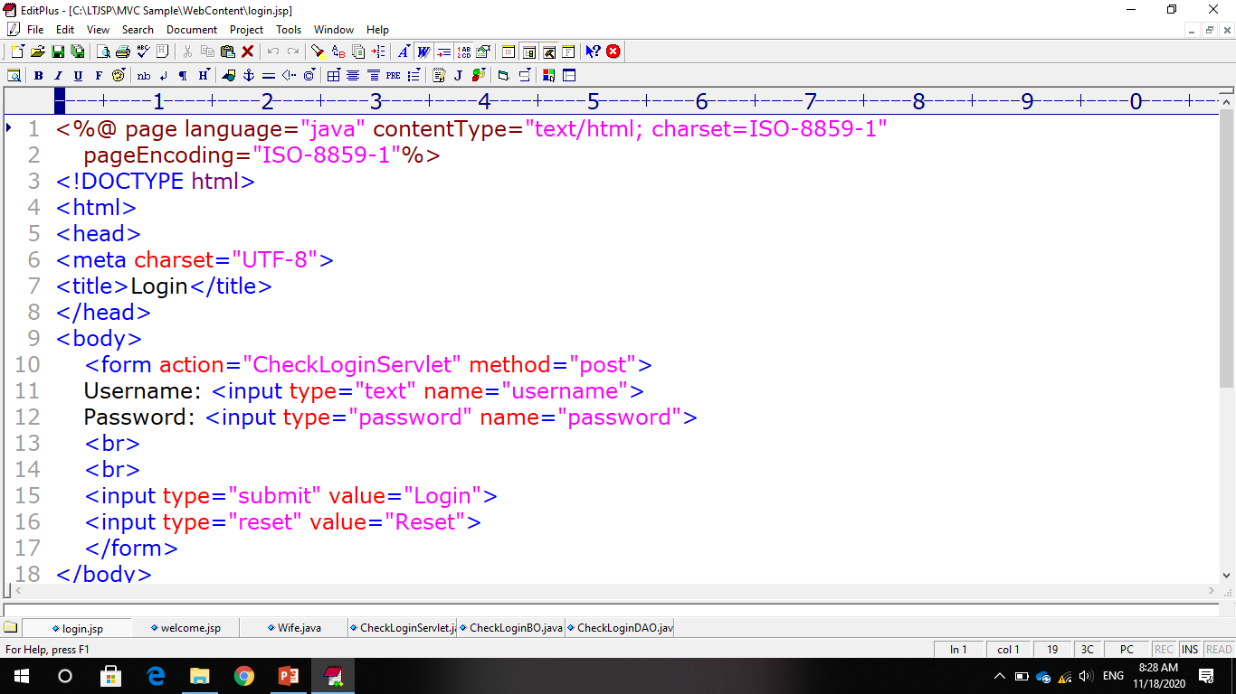

CheckLoginServlet.java:

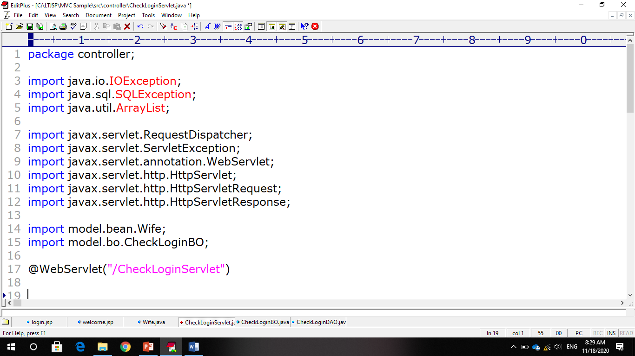

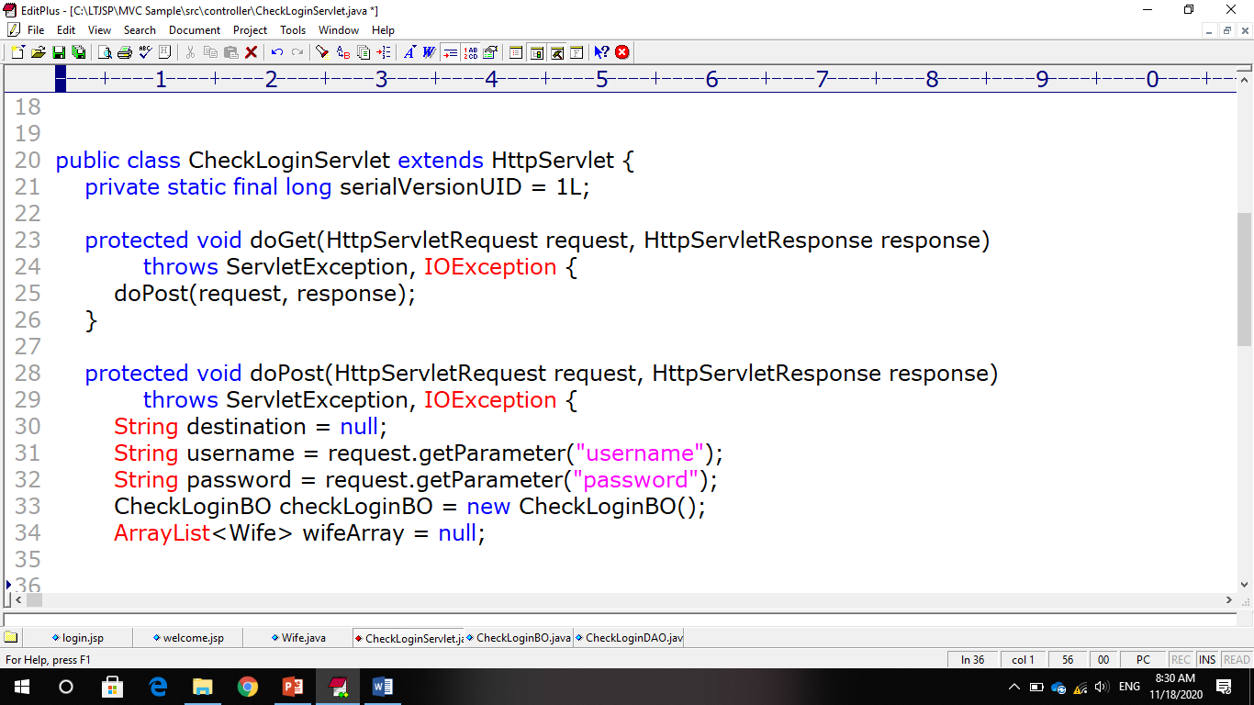

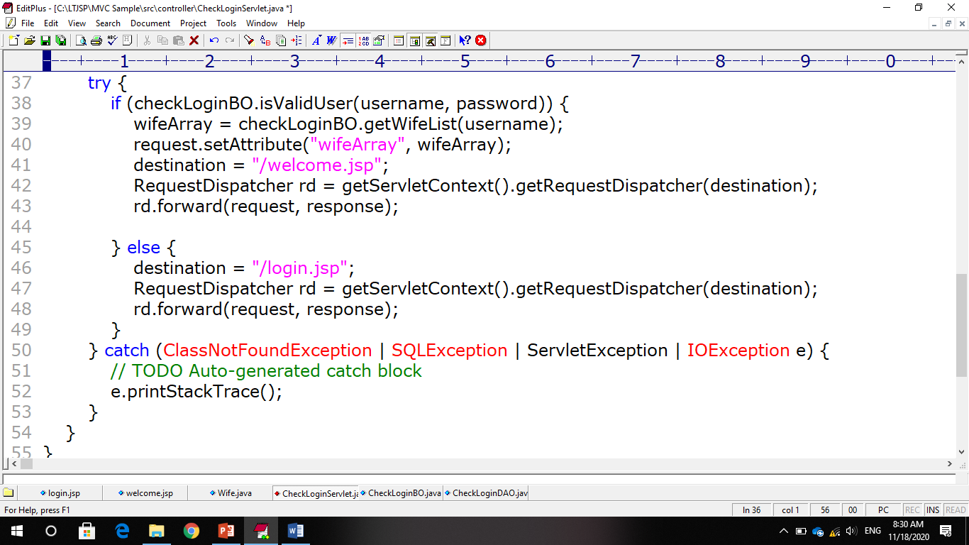

CheckLoginBO:

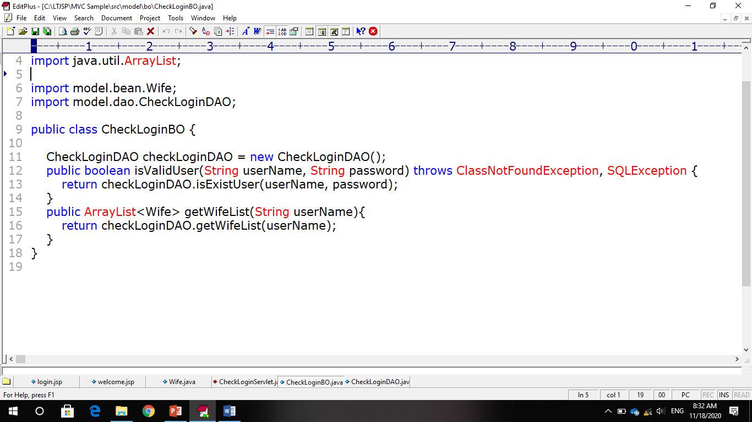

CheckLoginDAO:

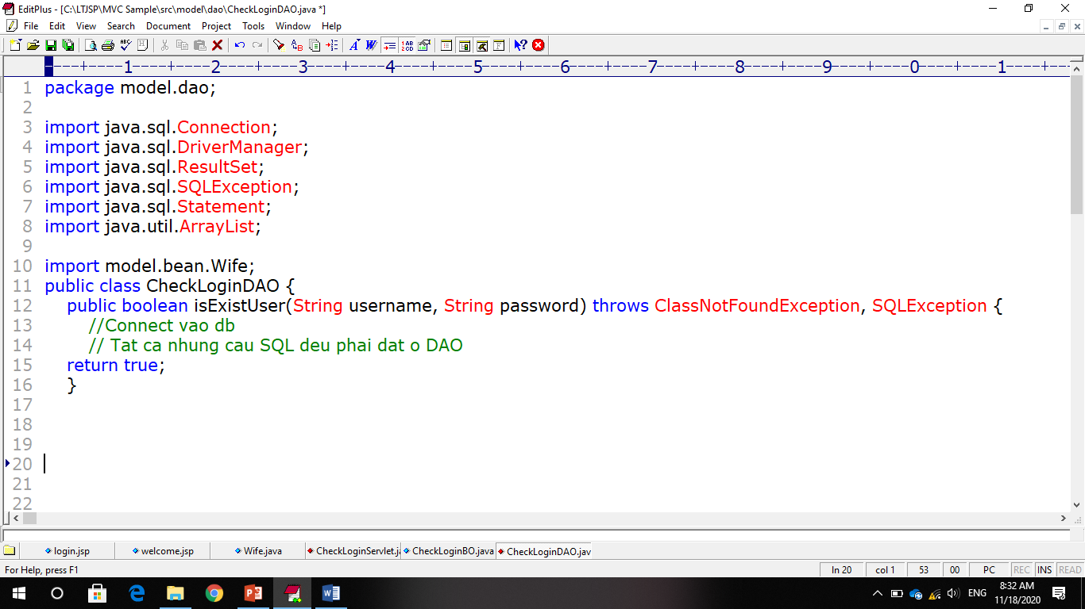

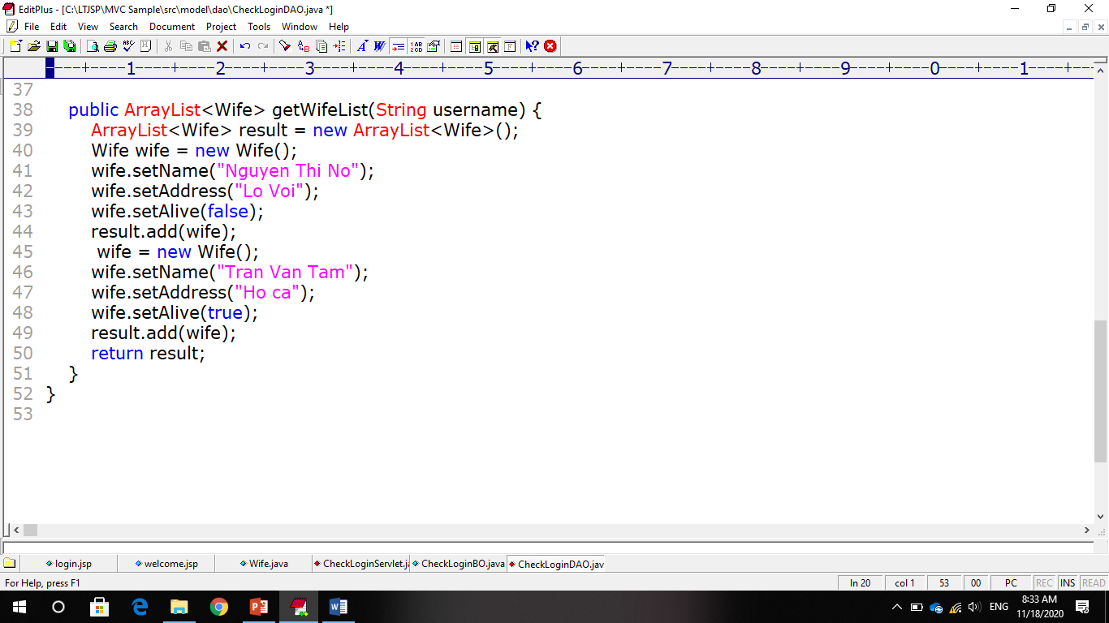

Bean\Wife.java:

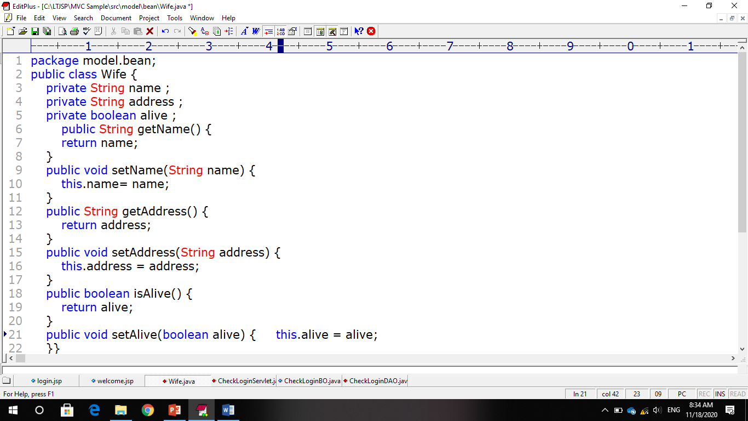

welcome.jsp:



