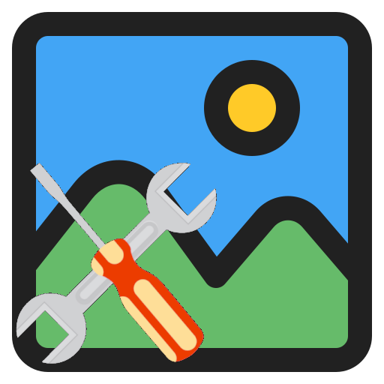

YaIPS

ReadMe file for developers

Based on version V1.00 from August 21, 2026

Version history

28.08.2026 RR: First version.

Table of contents
1. About this manual 3
2. Third-party libraries used 3
2.1 FLTK GUI toolkit 3
2.2 Ccap Camera CAPture 3
3. Description of the package's directories 4
4. Notes on the compiler used 4

1. About this manual

In this manual, I would like to provide guidance to help you better understand the application and the source code.
I assume that you have at least looked through the user manual.
I also assume that you have some basic knowledge of image processing and its concepts.
It is also important that you have read and understood the chapter “About images and image channels” in the user manual. This chapter describes the structure of the images used in YaIPS.

2. Third-party libraries used

YaIPS uses several third-party libraries. The include files and libraries required for compilation are located in the “Third-party-libraries” subdirectory of the application.
It is therefore not necessary to download the source code for the third-party libraries. However, it will broaden your horizons if you at least take a look at the websites for these packages.

2.1 FLTK GUI toolkit

The Fast Light Tool Kit (FLTK) is a cross-platform C++ GUI toolkit for UNIX®/Linux® (X11 or Wayland), Microsoft® Windows®, and macOS®. FLTK provides modern GUI functionality without bloat and supports 3D graphics via OpenGL® and its built-in GLUT emulation. It was originally developed by Mr. Bill Spitzak and is currently maintained by a small group of developers across the world with a central repository on GitHub.

https://www.fltk.org/
https://github.com/fltk/fltk/

2.2 Ccap Camera CAPture

A high-performance, lightweight cross-platform camera capture library with hardware-accelerated pixel format conversion, supporting both camera capture and video file playback (Windows/macOS). On Windows, ccap now fully supports both DirectShow and Media Foundation, with DirectShow remaining the default for strong virtual-camera compatibility.

https://ccap.work/
https://github.com/wysaid/CameraCapture

3. Description of the package's directories

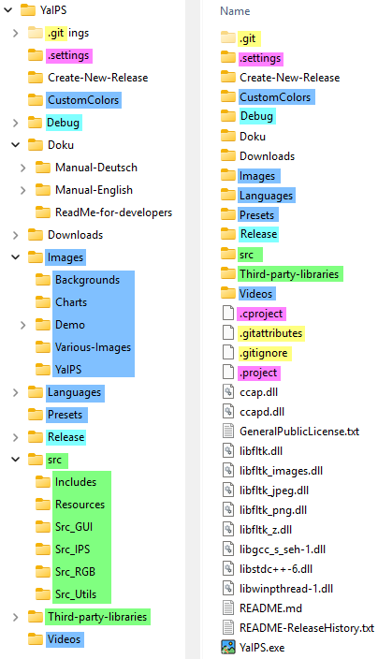
This is a screenshot of my development environment.
The colors have the following meanings:
Used by Git. Is not important for you.
Used by Eclipse IDE. Is not important for you.
Compilation leftovers.
Source files and files required for compilation.
Additional files for the ready-made application package.

The “Create-New-Release” directory contains Windows batch files and the command-line tools needed to generate release files. The .zip files for the release and the source code are stored in the “Downloads” directory.

In addition to the application's .exe file, the root directory contains all the necessary DLL files.

4. Notes on the compiler used

To compile ‘Ya3dag_LanguageExtract’, I use the Eclipse IDE and the “MinGW-W64-builds-5.0.0” compiler.

