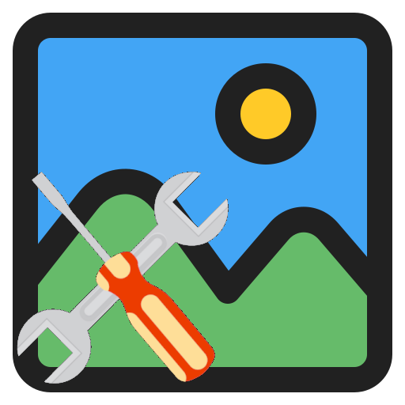

YaIPS

Manual

Based on version V1.02 from October 07, 2026

Version history

22.06.2026 RR: First version.
16.09.2026 RR: Adding the changes for version 1.01
07.10.2026 RR: Adding the changes for version 1.02

Table of contents
1. Introduction 4
1.1 About YaIPS 4
1.2 What can YaIPS do? 4
1.3 About images and image channels 5
1.4 User Interface Overview 6
1.4.1 Main window 6
1.4.2 Dialogs 6
1.4.3 Tool Window 6
1.4.4 General information about windows and dialogs 7
2. The main window 8
2.1 Left area 8
2.1.1 Menu bar 8
2.1.2 Display settings 10
2.1.3 Information Area 11
2.2 Middle area 12
2.3 Right area 12
3. Dialogs 13
3.1 Settings 13
3.2 Calibration 13
3.3 Custom Colors 14
4. Tool window 15
4.1 Groups of Tool Windows 16
4.2 Source 17
4.2.1 Camera 17
Operating mode area camera 18
Operating mode line scan camera 19
Operating mode height camera 20
4.2.2 New Image 21
4.2.3 Image Viewer 21
4.2.4 Video Player 22
4.3 Processing 23
4.3.1 Filter 23
4.3.2 Color 25
4.3.3 Geometry 28
4.3.4 Calculation 30
4.3.5 Correlation 32
4.3.6 Objects 35
4.3.7 Other 37
4.4 Output 39
4.4.1 Video writer 39
4.5 Inspection 40
4.5.1 Reference image 41
4.5.2 Color Testing 42
4.5.3 Position correction 43
4.5.4 Edges 44
4.5.5 Compare 45
4.6 Other 46
4.6.1 Overlay 46

1. Introduction

1.1 About YaIPS

YaIPS is an abbreviation for "Yet another Image Processing Software". Literally translated, this means "Yet another image processing software" and humorously alludes to the fact that there are many such programs.

Unlike image editing (which visually alters an image, e.g. retouching, color correction), image processing involves analyzing or automatically evaluating an image (e.g. measurement, object recognition). While the two terms sound similar, they pursue entirely different goals.

Industrial image processing uses cameras and software to automatically detect features, defects, or properties of products – usually directly on a production line. The goal is to monitor and control manufacturing processes or to inspect finished products.
For further information on industrial image processing, lighting, optics, or cameras, it's worth taking a look at the Vision Doctor website. These topics are explained clearly there in both German and English.
YaIPS is a program that allows you to playfully explore the algorithms and methods used in image processing.
Particular emphasis was placed on
- to make the results of each processing visible,
- to keep the operation simple and intuitive.

YaIPS is therefore ideally suited for trying out and understanding image processing.

I wish you much joy and many exciting insights while working with YaIPS.

1.2 What can YaIPS do?

- Image analysis
Color channel display, false color representation, 3D representation, measurement of color values, color histograms, horizontal or vertical brightness profiles, measuring distances.
- Import/generate images
from camera, file, video player, or generate images in defined sizes.
- Image processing
filtering images, modifying color, geometric corrections, image processing, correlation, object extraction, …
- Output images.
Save images as .jpg, .png or .tga. Create videos.
- Inspect images
Take a reference image, measure or correct color, correct position, measure distances, compare image parts.
- Other
Overlay images, shapes or text (can also be used to create posters or shareable images).

1.3 About images and image channels

An image is a matrix of pixels, the total number of which is calculated as width × height. The pixel depth determines how many bytes are stored per pixel.

- Width
The width of an image indicates how many pixels are arranged horizontally next to each other. It therefore determines the number of pixels per line.
- Height
The height of an image describes how many pixels are stacked vertically on top of each other.
It indicates the number of pixels per column.
- Pixel Depth
Pixel depth indicates how many bits or bytes are stored per pixel. It determines how many different values a pixel can assume—that is, how many colors or shades of gray can be represented.
YaIPS uses images with 1 to 4 bytes per pixel. The bytes are also referred to as image channels. Each byte can have one of 256 possible values.
The alpha channel is an additional channel (transparency) that describes how transparent a pixel is.
The pixel depths used by YaIPS are:
Number of  bytes | Abbreviation | Remark
1 | BW | Black-and-white, 256 shades of gray
2 | BW+A | Black-and-white + 1 byte alpha (transparency)
3 | RGB | Red, Green, Blue, 3×8 bits = 16.7 million colors
4 | RGB+A | 3 bytes color + 1 byte alpha (transparency)

Multiplying the width, height, and pixel depth gives the image size in bytes. These three parameters directly influence storage requirements, image quality, and processing effort.
Example calculation for a 1920 × 1080 RGB image:
1920 × 1080 × 3 = 2,073,600 bytes or 1.977 megabytes.

1.4 User Interface Overview

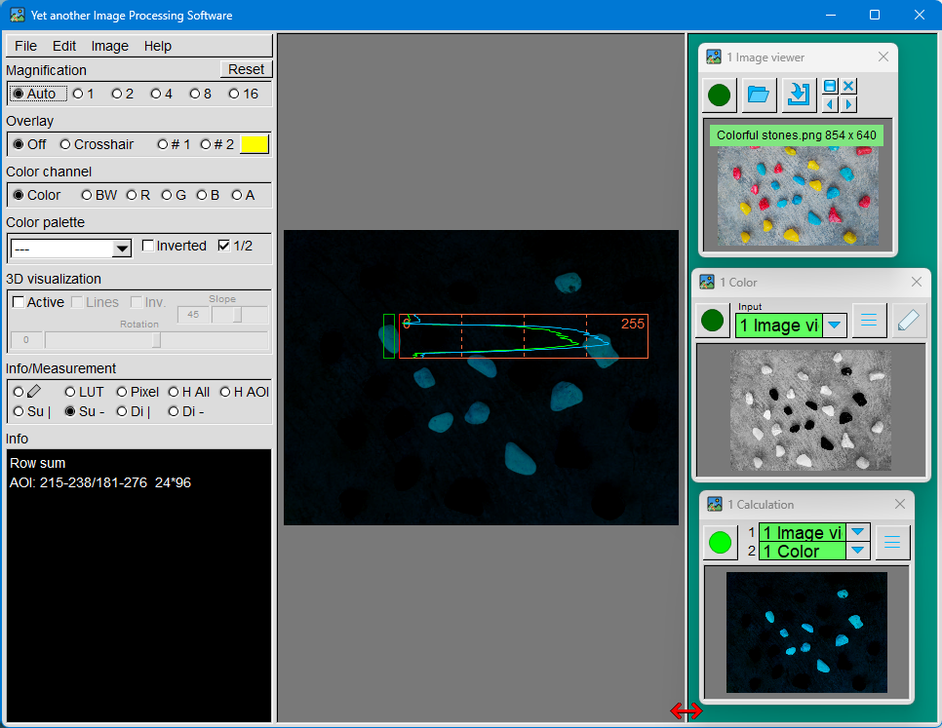

The user interface consists of several windows and dialogs that work together.

1.4.1 Main window
The main window is the central element of the user interface. It is divided into three areas:
- Left area: This contains the menu bar as well as numerous functions to display, change or analyze the image in the middle area.
- Middle area: The current image is displayed in this area.
- Right area: This area is used to place the tool windows.

1.4.2 Dialogs
There are various dialogs for settings, calibrations, or custom colors. These affect either the main window or individual tool windows.

1.4.3 Tool Window
Tool windows are responsible for the actual image processing.
- Each tool window can create or further process images.
- Tool windows can be linked together to perform multi-stage processing steps.
- The output image of a tool window can be displayed in the main window.
- Most tool windows have their own parameter dialog, through which the respective processing is set.

1.4.4 General information about windows and dialogs
  - Modal vs. Non-modal Dialogs
A modal dialog must be closed before you can continue working in the application.
A non-modal dialog remains open without blocking the main window or other non-modal dialogs. You can therefore continue working while the dialog remains open.
In YaIPS, many non-modal dialogs can be open simultaneously, but only one modal dialog can be open at a time.
  - Keyboard focus
At any given time, exactly one dialog box has keyboard focus. Keyboard input is therefore always directed to this window.
The focus dialog is indicated by the highlighted title bar.
  - Window positions and settings
All windows remember their position on the screen and their settings. These are automatically restored the next time the program is started.
  - Closing a Dialog
All dialogs can be closed either by clicking the “X” in the upper right corner with the mouse or by pressing the Escape key.
  - Help text
Help text is available for input fields, radio buttons and other GUI elements.
It appears automatically when the mouse remains briefly over the respective element.
  - Numeric input field
If the mouse pointer is over a numeric input field, turning the mouse wheel changes the value. If these changes do not affect the least significant digit of the number, pressing the “Ctrl” key at the same time will change the value in smaller increments.
  - Color Button
A color button is used to set a color. It is easily recognizable because the button itself is colored.
Right-clicking with the mouse opens the color selection dialog, where a new color can be chosen.
Left-clicking with the mouse opens a context menu. The current color can be changed there.
- to the clipboard or
- from the clipboard.
- If a histogram is selected in the info area of the main dialog, the color determined there can be applied directly as the button color.
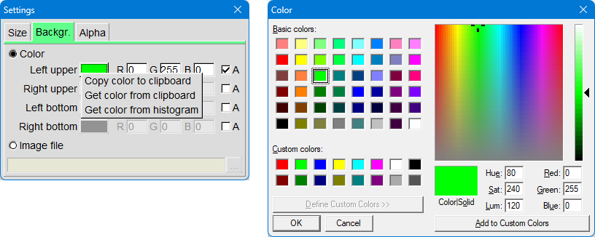

2. The main window

2.1 Left area
The menu bar is located at the top. This will be described in detail later.
Below are settings that directly affect the image in the middle section or extract information from this image. These functions will also be explained in detail later.
The information area displays various details about the currently shown image. Depending on the selected information or measurement function, lookup-tables, brightness histograms, or other image-related data may also appear here.

2.1.1 Menu bar
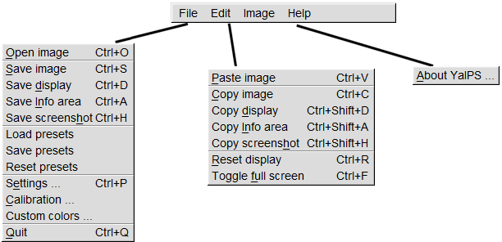
File
- Open
An image is loaded from a file and displayed in the middle area.
Supported formats: PNG, JPEG, JPG, TGA, BMP, GIF, PSD, HDR, PIC, PPM, PGM.
Alternatively, you can drag & drop an image file from Windows Explorer directly into the middle area.
- Save
The following content can be saved as an image:
  - the currently displayed image in the middle area
  - the entire middle area
  - the information area
  - a screenshot of the entire main window
Supported storage formats: PNG, JPG, TGA (PNG and TGA support images with an alpha channel).
- Presets
A preset (preset) is a file that saves
all current settings.
- Loading:
When loading a preset, all currently open tool windows are closed first.
The windows and settings saved in the preset, as well as the clipboard, are then restored.
- Save:
All current settings of the main window and the tool windows are saved in a file with the extension “.prefs”.
In addition to the state of the tool windows (position, size, open/closed), the clipboard contents are also saved.
- Reset:
All tool windows will be closed, and all settings will be reset.
Note:
The “Images\YaIPS\Clipboard” subdirectory is used as the clipboard. Pasted images, text or other tool window-specific data are stored here.
When a preset is saved, the clipboard contents are copied to a subdirectory of “Presets\.Clipboard”. This subdirectory has the same name as the saved preset.
- Dialogs
The dialogs for settings, calibration, etc. will be described later.
- Exit
The application will be terminated.
Edit
- Insert
An image from the clipboard is loaded and displayed in the middle area.
- Copying
The following content will be saved to the clipboard:
  - the currently displayed image in the middle area
  - the entire middle area
  - the information area
  - a screenshot of the entire main window
Copying does not support an alpha channel.
Note: Pressing Alt + Print Screen saves a copy of a window – including the title bar and borders – to the clipboard.
- Reset display
All settings in the left area of the main window will be reset to their default values.
The image in the middle area will then be displayed without any visualization changes – exactly as it was originally loaded.
- Switch to full screen mode
This function toggles between full-screen mode and windowed mode.
The main window will then either fill the entire screen or be displayed as a normal application window.
Image
This submenu opens one of the tool windows. This will be described in detail later.
Help
Currently, only the “About YaIPS" dialog can be opened.
This window displays the current program version and the open-source-projects used.

2.1.2 Display settings
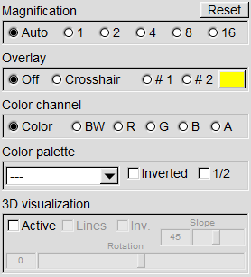
These settings directly affect the display of the image in the middle area.
Reset
This button resets all display settings to their default values.
Magnification
The magnification determines how large the image is displayed in the central area. With the Auto setting, the image size automatically adjusts to the available display area.
Overlay
Lines or a grid can be overlaid on the image.
The color of the lines can be freely adjusted.
Such guidelines are particularly useful when setting up cameras or aligning objects.
Color Channel
This setting determines which image channels are used for display:
- Color: All color channels of the image are used – the image appears in full color representation, or in the case of black-and-white images, only in black-and-white.
- BW: A color image is converted into a black-and-white image.
- Individual color channels (R, G, B): The currently selected channel is displayed as a black-and-white image.
- A (Alpha channel): If an alpha channel is present, it is displayed as a black-and-white image. If no alpha channel is present, the normal image is displayed instead.
Color Palette
Here you can select a color palette – also called a Look-Up-Table (LUT). Each input value of a color channel is converted into a new value using a table.
A color palette consists of three separate tables. One each for the red channel, the green channel, and the blue channel.
For black-and-white images: The image is colored by the LUT, as the tables generate new color values.
For color images: Each color channel is modified individually by its respective table. This means: Red is adjusted via the red table, green via the green table, and so on.
If Invert is enabled, the colors of the image in the middle area are reversed. Light areas become dark, and dark areas become light.
When 1/2 is enabled, the brightness values of the image are halved. This makes the image appear darker, and overlaid graphics (e.g. lines, grids, AOI-markers) are more visible.

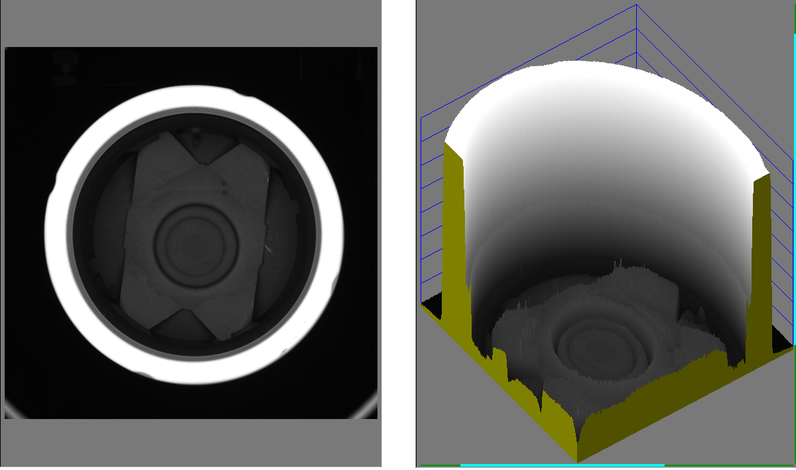
3D visualization
In 3D -visualization, the value of the selected color channel is interpreted as height information and displayed as a height image.

If the color channel is activated, a color image is automatically converted first into a black-and-white image to create a clear height reference.

The viewing angle and tilt of the 3D-view can be changed directly in the image by holding down the left mouse button and moving the mouse.

2.1.3 Information Area
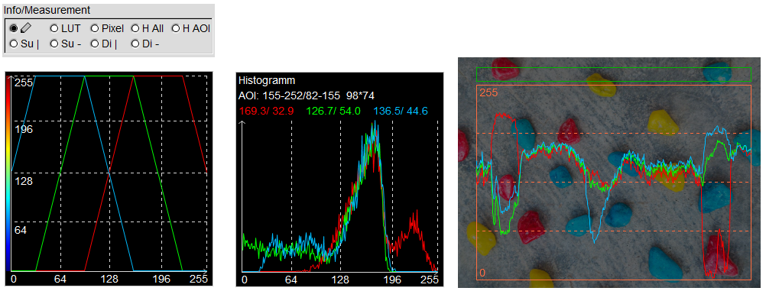
Depending on the selected setting, various information can be displayed in the info area or on the image in the middle area, for example:
- the current LUT
- Pixel values under the mouse pointer
- Brightness histograms
- Row -or column totals within a rectangle
- Distances between points
For some of these functions, an AOI-rectangle (Area of Interest) is displayed in the image. This rectangle can be moved or resized with the mouse.
When the pen icon is activated, information about the current image is displayed, and the learning mode of certain tool windows is supported.
Some tool windows themselves have a pen icon. In these windows, AOIs can be adjusted directly with the mouse while in learning mode. If such a tool window is active in the main window, AOIs can also be modified directly in the large image area – provided that:
- The corresponding option field is activated.
- and the pen icon is green

2.2 Middle area
This area displays images. These can appear in three ways:
- They are loaded from a file.
- They are inserted from the clipboard using Ctrl + V.
- An image file can be dragged & dropped directly from Windows Explorer into the middle area.
- They originate from a tool window whose green dot has been activated. In this case, the output image from that window is displayed here.
The image size can be changed in two ways:
- Via the zoom options in the left panel.
- By rotating the mouse wheel directly over the image.
If an image is enlarged, the visible area can be moved by holding down the left mouse button and moving the mouse.
For certain functions, an AOI (Area of Interest) appears in the middle area.
- This AOI can be repositioned and resized using the mouse.
- In the image at the beginning of chapter "1.4 User Interface Overview", a row sum is calculated from the AOI area (green rectangle), i.e., the average of all pixels in each row. The result is displayed to the right of the AOI.

2.3 Right area
Tool windows are located here. Each tool window can create or process images.
- The output image that a tool creates or modifies is displayed directly in the respective tool window.
- The input images required for processing are selected from the already open tool windows.
Clicking the dark green dot in the top left of the tool window displays the output image in the main window. The dot then turns light green to indicate that this image is active in the main window.
In the example at the beginning of chapter “1.4 Overview of the user interface”, the following happens:
- In the Image Viewer tool window, an image is loaded from a file and displayed.
- The Color tool window extracts the red color channel from this and displays it as a separate image.
- The Calculation tool window then performs a subtraction: It subtracts the output image of color from the output image of the image viewer.
This subtraction makes the blue stones in the original image stand out particularly clearly.
Note: The boundary between the right and middle areas can be moved with the mouse (see red double arrow in the example).
Note: The tool windows located within the right area are moved along when the main window is moved or when the boundary between the right and middle areas is moved.
Their position relative to the upper-left corner of the right area remains unchanged.

3. Dialogs

The dialogs described in this section are opened via the "File" menu bar.
These dialogs affect either the main window or individual tool windows.

3.1 Settings
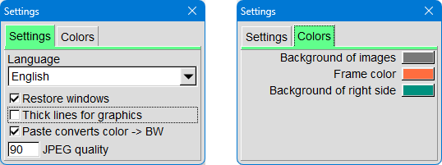
These settings primarily affect the main window.
The screenshots usually provide a good overview. Additional information appears when the mouse remains briefly over the respective interface element – the corresponding help text is then displayed.

3.2 Calibration
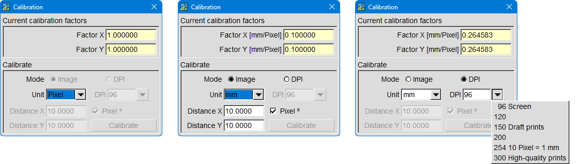
This dialog manages the calibration for the entire application. It uses a base unit such as pixels, mm, cm, or inches. Many functions — such as distance measurements or size specifications — use this calibration to convert pixel values into real-world units.

Camera calibration
Calibration can be performed either with a camera or an image. For this to work, a measuring object (e.g. a ruler) must be visible in the image; a known distance is measured against this object.

- Positioning measuring objects
- Click the green dot in the camera window
to display the camera image in the main window.
- Place the measuring device in front of the camera.
- The distance to be measured should be as horizontal as possible.
- An overlay can be activated in the main window for alignment
purposes.
- In the calibration dialog
- Select "Image" mode.
- Specify the unit (mm, cm or inch).
- Enter the known distance in "Distance X".
- Perform measurement in the image
- In the main window, under Info/Measurement, select "Distance -".
- Move the edges of the measurement window in the image so that they
exactly cover the defined distance.
- Calculate calibration
- In the calibration dialog, click on "Calibrate".
- The calibration factors are now being calculated.
- For area scan cameras with square pixels, one measurement is
sufficient.
- For non-square pixels, line scan camera simulation, or height camera
simulation, both horizontal and vertical measurements are required.

Specify a resolution
This method is useful, for example, if you want to create images with a defined size and resolution in the "New Image" tool window.

- calibration dialog
- Select the "DPI" mode (dots per inch).
- Select a DPI preset or enter a value.
- In the "New Image" tool window
- select a DIN size or enter the desired size manually.
- Click "Apply".

3.3 Custom Colors
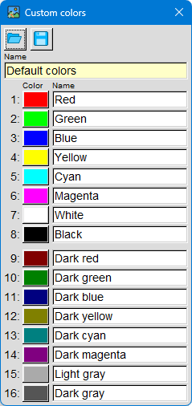
This dialog allows you to create, save, and reload
color sets of up to 16 colors each. You can also assign a name to each color.

The last loaded color combination is automatically used in the color selection dialog of a color button.

This allows, for example, a company's corporate design colors to be created and managed centrally.

4. Tool window
Tool windows are responsible for the actual image processing.
- Each tool window can create or process images.
- Many tool windows can be open in multiple instances simultaneously. They will then have a number displayed in the title bar.
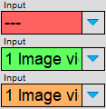
- Tool windows can be linked together to perform multi-stage processing steps.
To link a tool window, select one of the other open tool windows as input image using the pull down button.
The status of the selected window is indicated by the color of the name field:
Red — No tool window has been selected yet.
Green — The selected tool window is open and has an output image.
Orange — The window is either not open or it is not providing an output image.

- The output image of a tool window can be displayed in the main window.
Clicking the dark green dot in the upper left corner of the tool window also displays the output image in the main window. The dot then turns light green to indicate that this image is active in the main window.
- Copy output image to the clipboard
Pressing Ctrl + C saves a copy of the output image to the clipboard.

- Most tool windows have their own parameter dialog, which is used to configure the respective processing settings.
If the tool window has keyboard focus, the parameter dialog can be opened using the Ctrl + P keys.

- Pen-icon and learning mode
Some tool windows have a pen-icon.
Clicking this button switches between learning mode and evaluation mode.
In learning mode, the pencil icon is green.
AOIs can now be adjusted directly in the tool window using the mouse. If the source image is displayed in the main window and the pen-icon is also activated in the info area there, the AOIs can also be changed directly in the main window using the mouse.

- Load from file
This button is used, for example, to load images from files.
- The tool windows located within the right area are moved along when the main window is moved or when the boundary between the right and middle areas is moved.
Their position relative to the upper-left corner of the right area remains unchanged.

4.1 Groups of Tool Windows
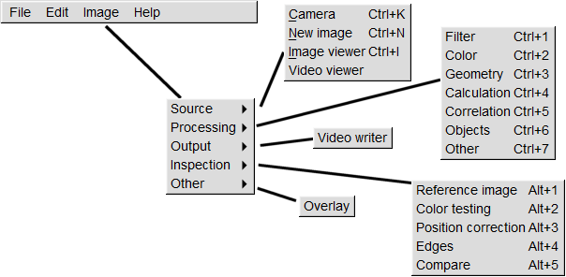
Tool windows are divided into different groups according to their common properties.
Here's an overview:
- Source
  - Image sources generate new images. They form the starting point of every processing chain. Images can be captured by USB -cameras, loaded from files, or generated, for example.
  - These tools do not have an input image.
- Processing
  - Processing tools manipulate one or more input images. Typical processing operations include: filtering, color correction, geometric adjustments, image processing...
  - The result is displayed as the output image in the window and can be used by other tool windows.
- Output
  - Output tools output an input image, for example, to a file or to a display.
  - They always have an input image.
  - Some generate an output image, but this cannot be further processed.
- Inspection
  - Inspection tools are used to analyze and compare images.
Typical tasks include: capturing a reference image, measuring or correcting colors, correcting position, measuring distances or comparing image parts.
  - The most important element is the reference image, such as a camera image of an object.
Other tools compare specific features of new images with the reference image to detect or compensate for deviations.
- Other
Other tools contain functions that do not fit into any of the tool groups mentioned so far.

4.2 Source

Image sources generate new images. They form the starting point of every processing chain. Images can be captured by USB -cameras, loaded from files, or generated, for example.
These tools do not have an input image.

4.2.1 Camera
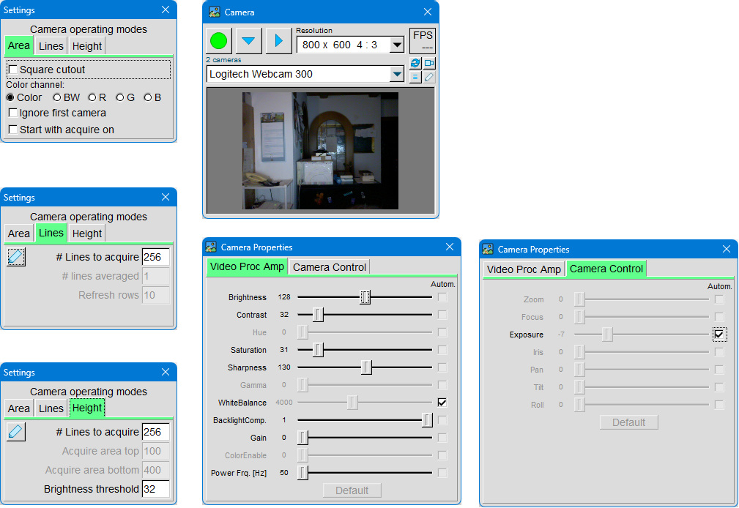
Images can be captured by webcams and other cameras with UVC (USB Video Class) support.
In the tool window, select one of the cameras and a suitable resolution.
In addition to single-image capture, continuous recording is also possible. If a camera is removed or reconnected, the available devices can be re-searched.
In the parameter dialog, select one of Three operating modes: area, lines or height (details follow later in the relevant section).
The Camera Settings dialog allows you to adjust various camera parameters, as the name suggests. These settings are retained even after restarting the application.

Operating mode area camera
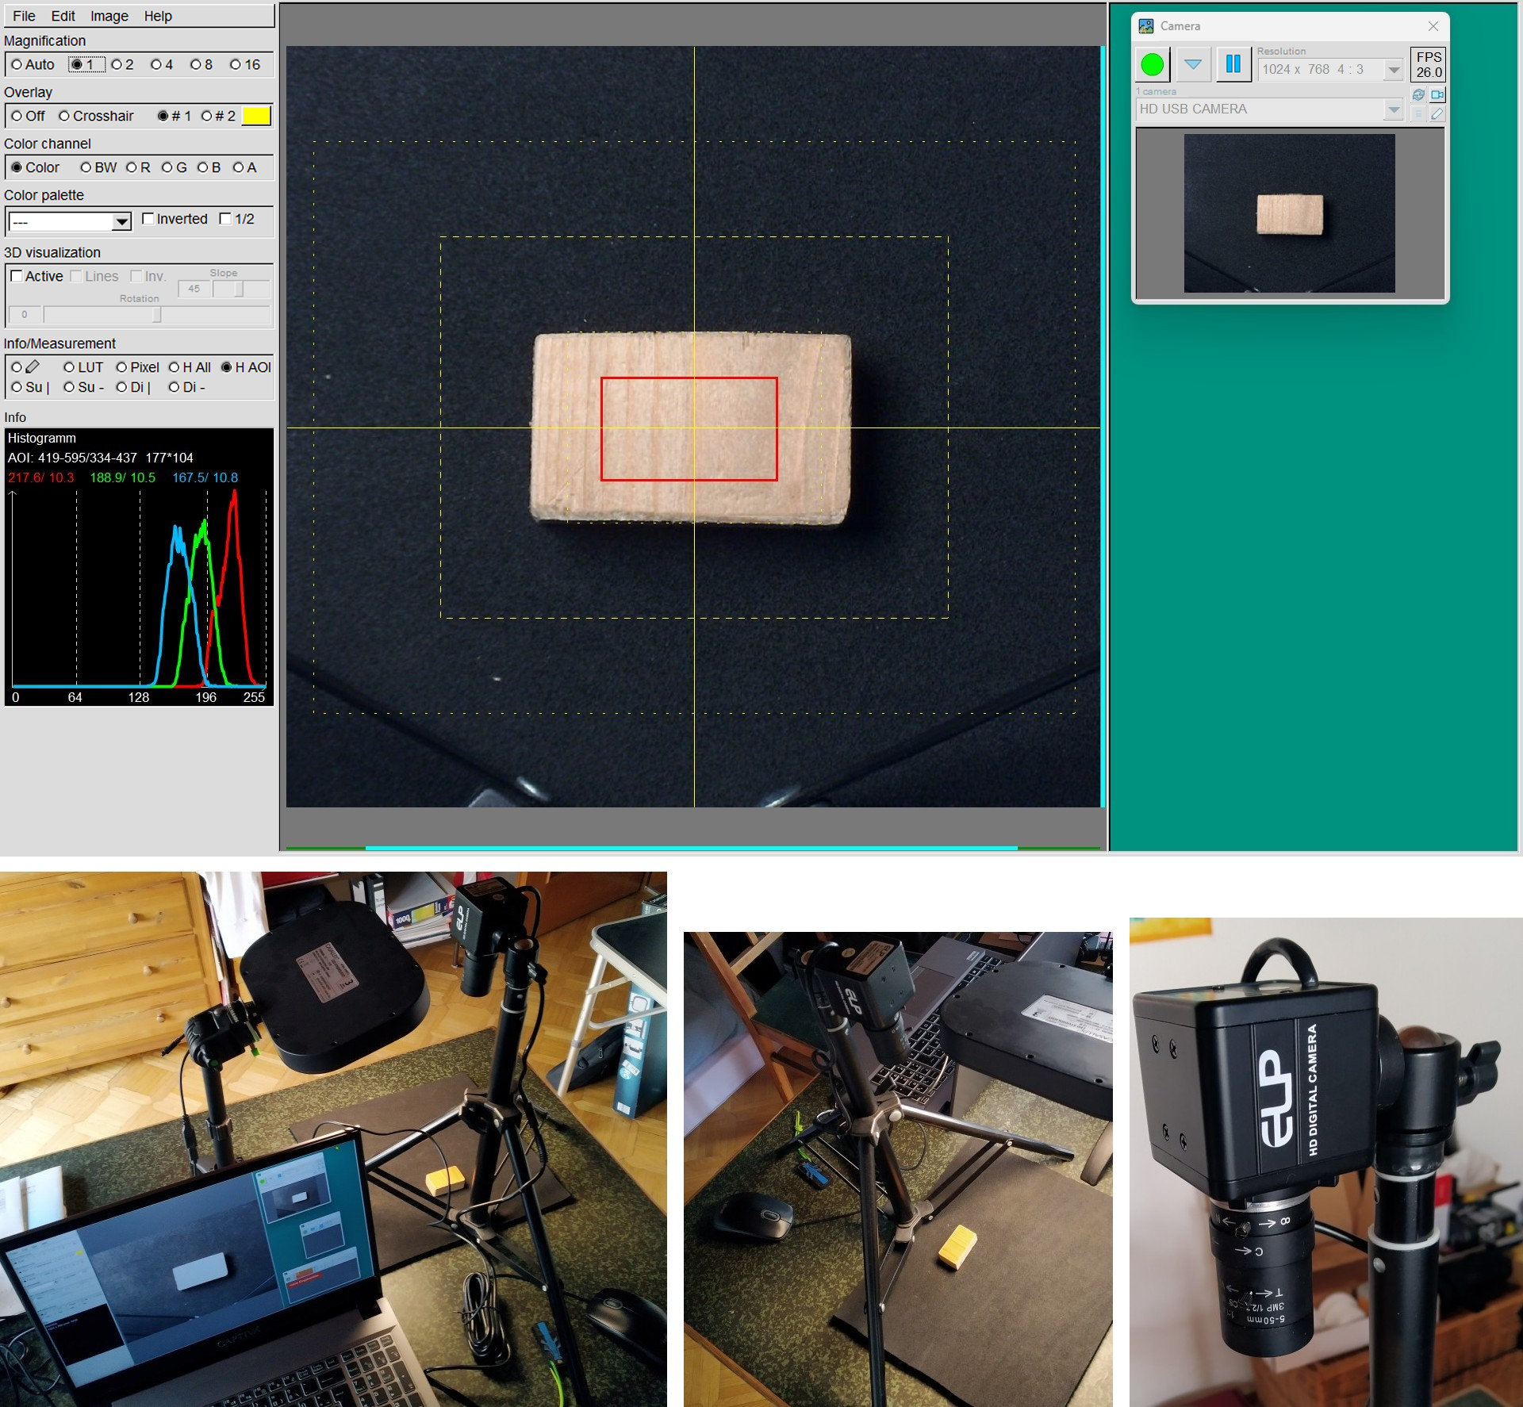
In area scan mode, standard camera images are captured. Almost all webcams are area scan cameras: The rectangular sensor delivers a two-dimensional image of the scene viewed through the lens.
A normal webcam is suitable for getting started. Even better is a camera with adjustable focal length and focus.
Using a tripod and appropriate lighting, stable and reproducible images can be produced, which are ideal for image processing experiments.

Operating mode line scan camera
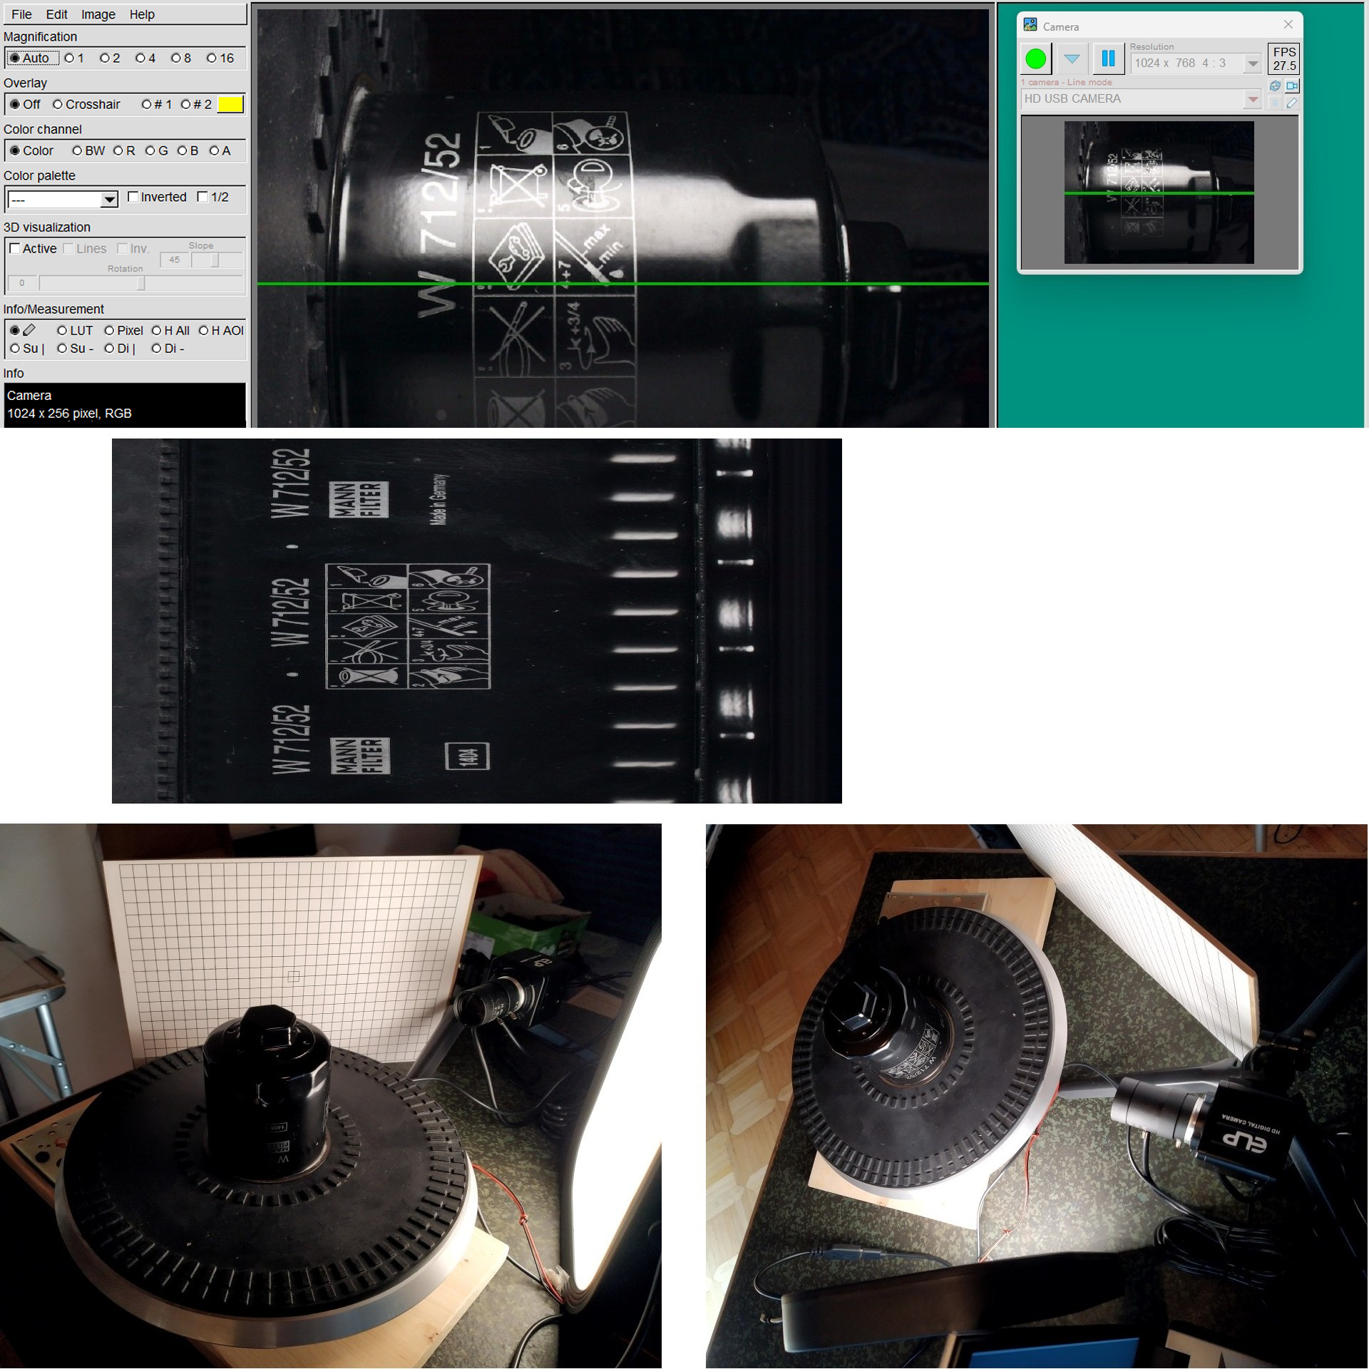
A line scan camera is a special type of camera that doesn't capture a complete image at once, but rather a single line of pixels. This line is captured very rapidly in succession as the object moves in front of the camera or as the camera moves past the object. A complete image is then created from many individual lines. It is used, for example, for scanning continuous materials or for unwinding round parts.
In line scan mode, YaIPS simulates a real line scan camera by using only a single pixel line from the image of an area scan camera. From many of these lines, a complete image is then assembled line by line.
The top image shows how the camera position and focus are set in the area scan camera's learning mode. The middle image shows a shot taken in evaluation mode. Here, the unfolding of a round object is shown – that is, the "unrolled" representation of the surface created by the rotation.
The bottom images show the setup used. A turntable platter serves as a rotating mechanism that spins smoothly thanks to a small electric motor.

Operating mode height camera
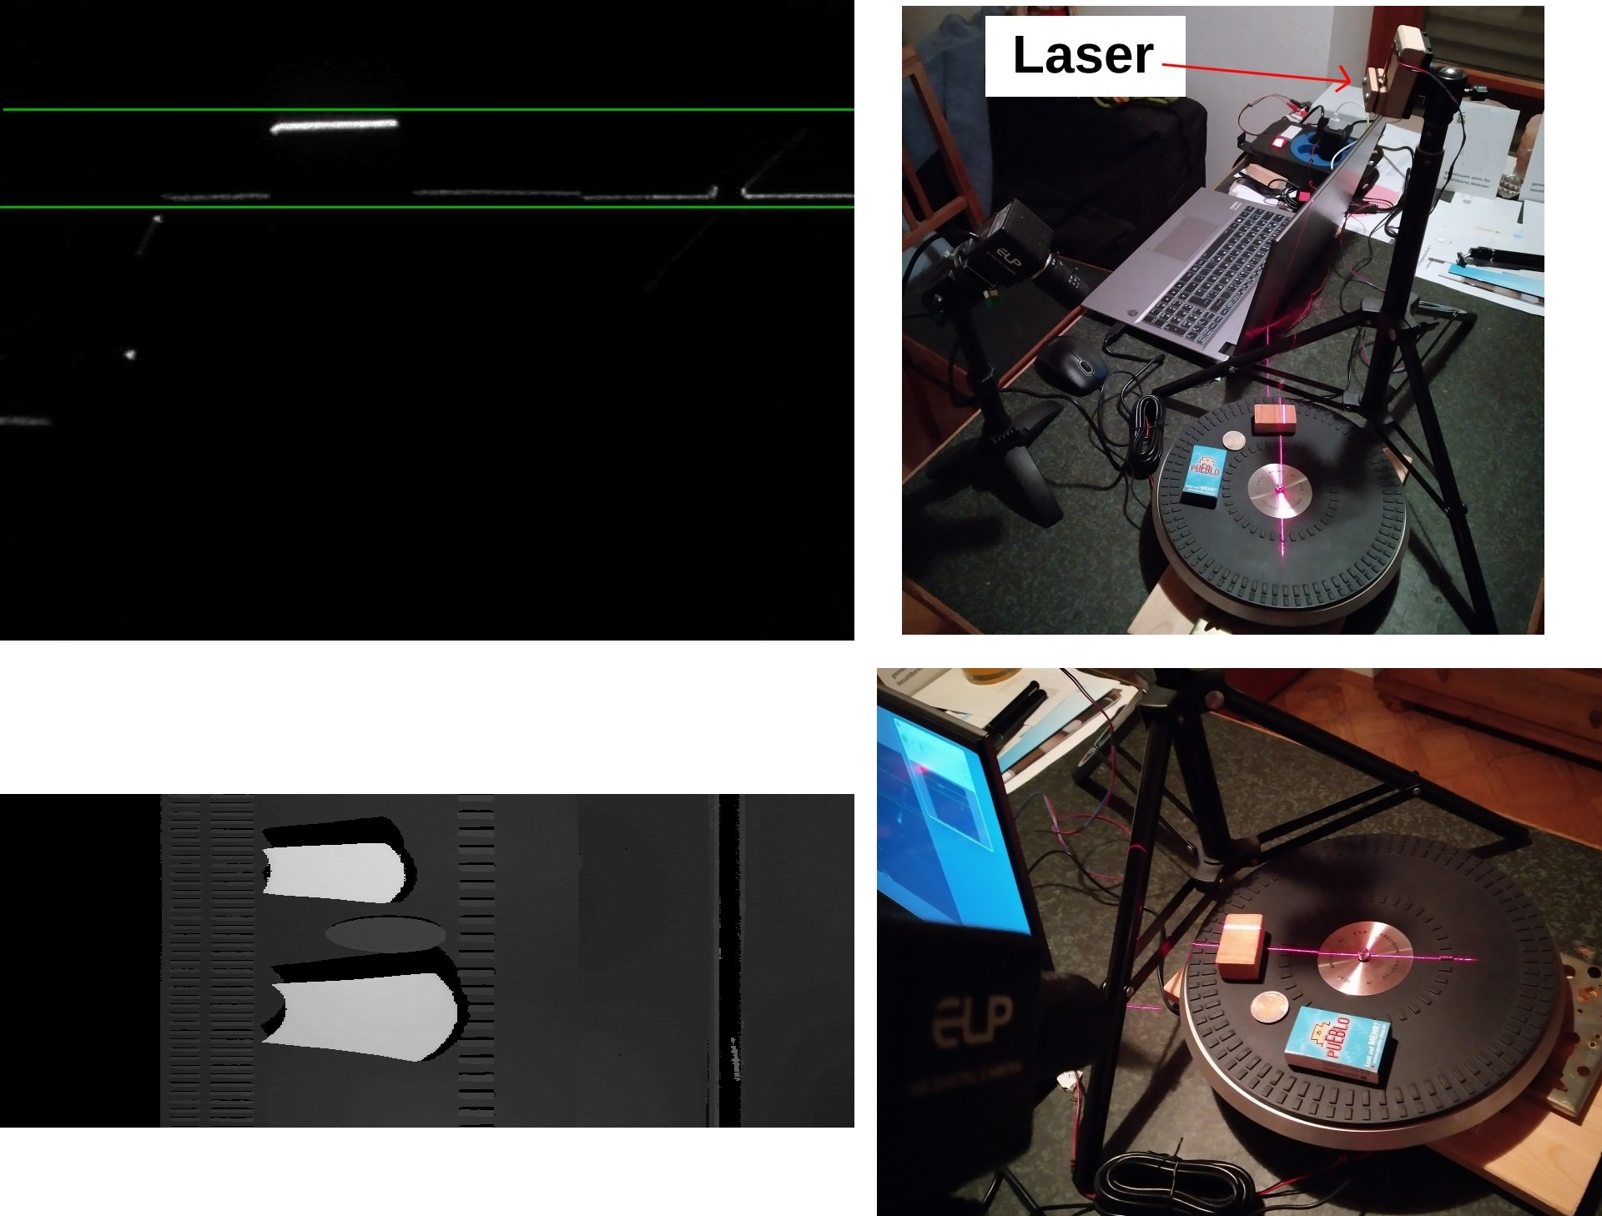
In height camera mode, YaIPS simulates a typical laser triangulation measurement. A laser line is projected onto the object, and an area scan camera captures the resulting profile. The object's shape distorts the laser line – this distortion is analyzed to obtain height information. To generate a complete height image, many individual laser profiles must be captured and combined into a single image. This requires either the object to move (e.g. rotate) or the sensor to be moved along the object.
The image in the upper left shows the camera setup in learning mode. The laser profile must be horizontal in the camera image. The lower green line marks the lowest point, and the upper green line marks the highest point of the object.
In evaluation mode, the brightest point between the two lines is searched for each image column. If it is closer to the lower line, the pixel is displayed darker. If it is closer to the upper line, the pixel is displayed brighter. This creates a height image in which the height of an object can be directly determined by its brightness (bottom left image).
The setup is shown on the right. A turntable platter serves as the rotating device and is turned smoothly by a small electric motor. The lases used is PICO 70105094 line laser module (purchased from Reichelt Elektronik).

4.2.2 New Image
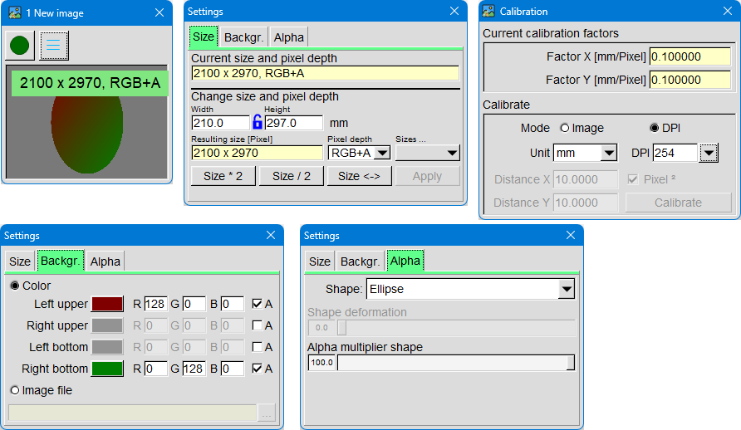
This tool window allows you to create images of freely selectable sizes. The program uses the unit of measurement and conversion factors from the calibration dialog to correctly convert the desired size into pixels.
After entering the desired image size and pixel depth, a new image is created by clicking "Apply". The size is automatically converted to pixels. Instead of manual input, a predefined size can also be selected.
The generated image can be filled with a single color, a gradient, or an image from a file.
If an image with an alpha channel is created, an alpha mask can also be defined.

4.2.3 Image Viewer
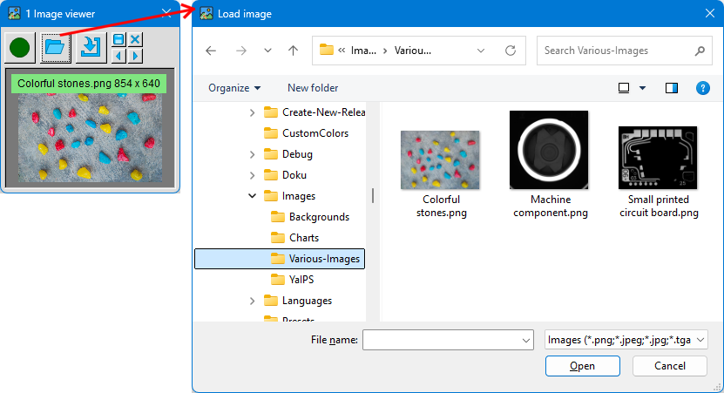
The image viewer loads images from the hard drive and displays them in the tool window. Alternatively, you can drag & drop an image file from Windows Explorer directly into the image area or paste an image from the clipboard using Ctrl+V.
You can easily switch between the next and previous image in the file directory using the arrow keys. Additional buttons are available to move the currently displayed image to the middle area of the main window, save the output image to the hard drive, or delete it completely.

4.2.4 Video Player
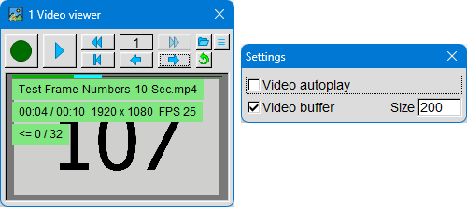
The video player, as the name suggests, plays videos. The last opened file is automatically reloaded the next time the window is opened. If the corresponding option is enabled in the settings, playback begins immediately after loading.
Videos are loaded using the “Load” button or via drag & drop using Windows Explorer.
The double arrow keys change the playback speed. Use the right/left arrow keys to skip forward or backward in the video: During playback, the skip is 10 seconds; during pause, it skips one frame at a time. If the video buffer is enabled, you can also rewind one frame. If the Ctrl key is pressed at the same time, the video skips forward 1 minute; if the Shift key is pressed, it skips forward 10 minutes.
A progress bar is located at the top of the screen. When the video buffer is active, the already played portion is displayed in green. With the video buffer enabled, the end of the played portion is highlighted in light blue. These frames are cached and can be played backward step by step during the pause.
The information in the image area displays the file name, the total length of the video, the elapsed time, the image size in pixels, and the frame rate. If the video buffer is enabled, an additional line appears indicating the buffer size in frames and the number of frames rewound.

4.3 Processing

Processing tools process one or more input images. Typical processing operations include: filtering, color correction, geometric adjustments, image processing…
The result is displayed as the output image in the window and can be used by other tool windows.

4.3.1 Filter
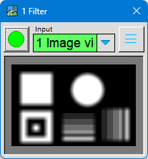
In image processing, a filter is a computational method used to selectively modify an image in order to highlight specific information or reduce noise. You can think of a filter as a tool that "edits" an image, similar to a tool in photo editing – only mathematically and automatically.
A filter changes the pixel values of an image. This usually involves examining the pixels surrounding a point and calculating a new value from them. In this way, certain characteristics of the image can be enhanced or reduced.
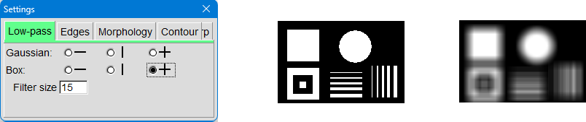
A low-pass filter, also known as a smoothing filter, makes an image appear smoother by reducing minor disturbances. Typical examples are the average value filter and the Gaussian filter. They blend the pixels of a given area, causing the image to appear blurred.
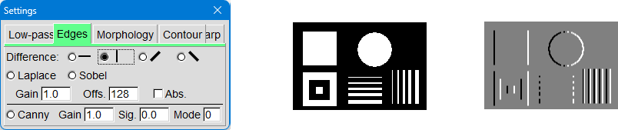
An edge filter highlights transitions between light and dark. Well-known variations include differential filters, Sobel filters, and Canny filters. They show where strong changes in brightness occur in the image – ideal for edge detection or object recognition.
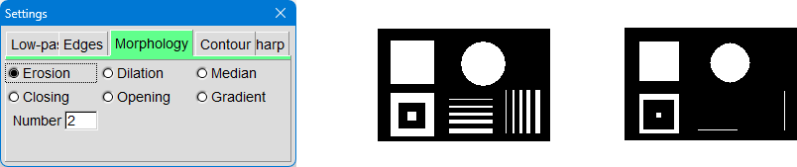
Morphological filters are image operations that modify the shape of objects in an image by selectively adding or removing pixels.
The most important basic operations are erosion (making objects smaller) and dilation (making objects larger).
Combining these steps creates opening and closing operations, which, for example, remove small imperfections or fill gaps.
In morphological operations, a pixel is always considered together with its
immediate neighbors.
In erosion, the darkest pixel in this neighborhood is the result. In dilation, the brightest pixel is used. With the median filter, the pixel whose brightness lies in the middle of all neighboring pixels is obtained.
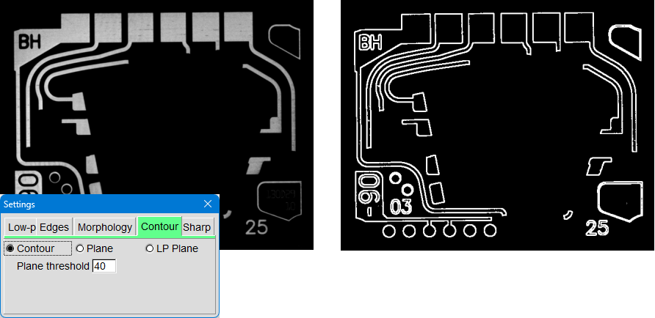
A contour filter checks how much a pixel differs from its immediate neighbors. If the brightness difference to at least one neighboring pixel is greater than the level -threshold, this pixel is classified as a contour; if the difference is smaller, it is considered a plane. Such filters are also suitable for tolerant image comparisons, where small differences are ignored, but significant deviations are reliably detected.
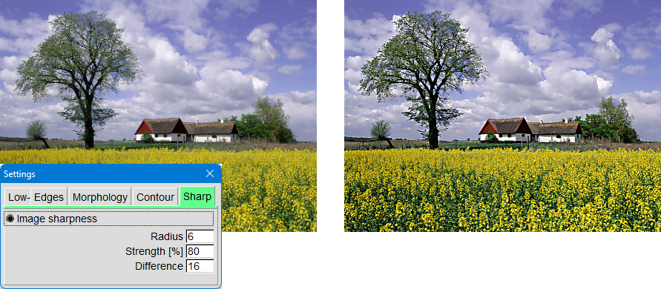
A sharpening filter enhances details by emphasizing edges. The image appears clearer because differences between pixels are more pronounced.

4.3.2 Color
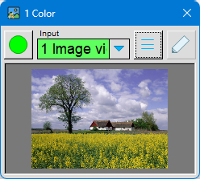
Color filters modify the color values of a pixel to selectively adjust or analyze images. Lookup tables (LUTs) are frequently used for this purpose, allowing for very fast and efficient conversion of color channels. Matrix operations can be used to combine the individual color channels of a pixel, for example, to change hues or emphasize specific color ranges.
Furthermore, color images can be converted to black-and-white images or back again, and IHS color space transformations can be performed, in which intensity, hue and saturation are processed separately.
Color filters are used to emphasize or suppress certain colors so that objects are easier to recognize and interference is reduced by -considering only relevant color or contrast ranges.
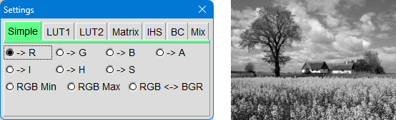
This tool extracts individual color channels from a color image, for example, red, green, blue, or the components of an IHS conversion (intensity, hue, saturation). Additionally, the minimum and maximum values of the RGB pixels can be determined. An RGB to BGR conversion is also possible, in which the order of the color channels is reversed.

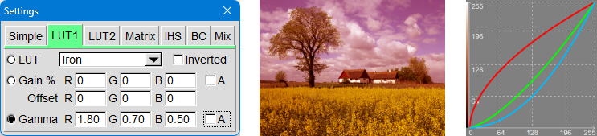
With this tool, you can select a predefined lookup -table (LUT), as described under Color Palette in section 2.1.2. Additionally, you can lighten or darken the colors and apply gamma correction. Provided the output image is large enough, the resulting lookup table is displayed as a graphic, allowing you to see the effect of the color transformation immediately.
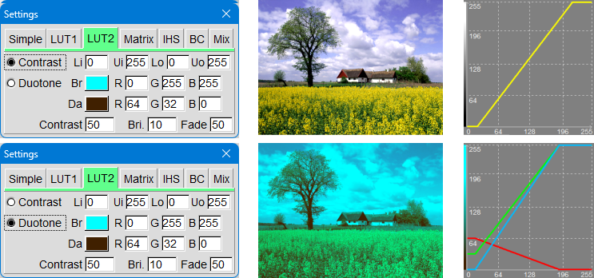
The “Contrast” setting allows you to define contrast ranges by specifying which brightness or color values should be considered light or dark areas.
The “Duotone” effect filter converts an image so that it consists of only two colors: a dark one and a light one. The dark color is used for shadows, and the light color for highlights. All intermediate values are simply blended between these two colors. This creates a clean, graphic two-color look reminiscent of posters or screen prints.
For color images, the conversion of the individual RGB channels can be combined with the conversion of a black-and-white image.
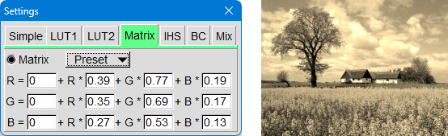
Color matrices are used to selectively alter the colors of images, for example, to give them a specific tint, style, or duotone look. Each pixel of the image is mathematically recalculated: The original RGB-values of a pixel are multiplied by a 3×3-matrix that determines how strongly red, green, and blue are mixed.
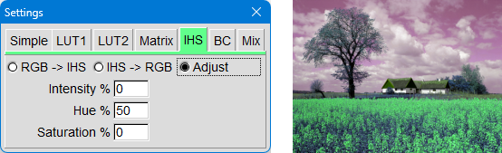
IHS is an alternative color space in which pixel values have a different meaning than in the standard RGB model. IHS breaks down an image into intensity (pixel brightness), hue (the specific color), and saturation (how saturated the color is).
Here, you can convert between RGB and IHS or selectively modify individual components.
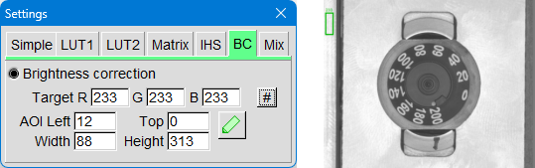
Brightness correction of an image is useful when the lighting changes over time – for example, due to the aging of a light source or fluctuating environmental conditions. To do this, a measurement window is placed in the image on a spot that is clearly visible in every captured image and always in the same position. This area should be as bright as possible so that changes can be reliably detected.
For all subsequent captures, the brightness is adjusted so that the measured value in the measurement window corresponds to the desired target value. In this way, the image brightness remains constant over many captures, even if the actual lighting changes.
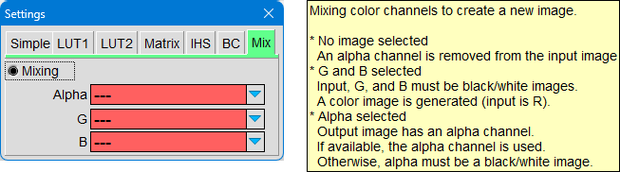

This tool lets you edit the alpha channel of an image. You can remove an existing alpha channel, add a new one, or replace an existing one. This allows you to precisely control which areas of the image should be transparent or opaque.
Additionally, the tool offers the option of combining multiple black-and-white images into a single color image. Each black-and-white image is used as a separate color channel – for example, one for red, one for green, and one for blue. In this way, a complete RGB image is created from separate channels.

4.3.3 Geometry
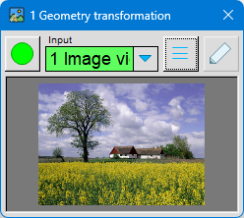
Geometry here refers to all functions that change the shape or orientation of an image.
In this tool window, you can scale the image, rotate, flip, or move it. More complex adjustments, such as lens correction (e.g. to remove distortion), are also possible. Additionally, you can select a specific area of the image and extract it as a separate sub-image.

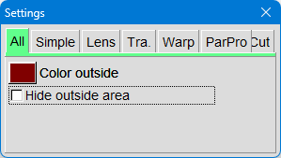
These parameters are used when an image is rotated, distorted, or otherwise geometrically transformed. This inevitably creates areas that lie outside the original image. Any replacement color can be assigned to these areas to prevent "empty" or undefined pixels.
Alternatively, this outer area can also be hidden using an alpha mask. In this case, the newly created image areas are displayed transparently, so that they can later be easily overlaid on other images or further processed.
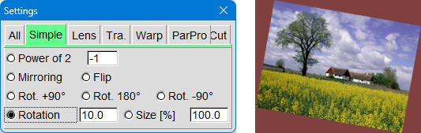

These basic geometric functions allow you to easily resize or rotate an image.
These operations are fundamental geometric editing techniques and are frequently used to align images or adapt them to a desired format.
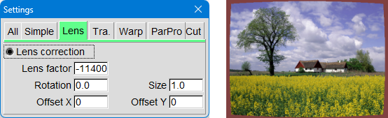
The lens factor corrects an optical distortion known as pincushion distortion. This distortion is often caused by certain lenses and results in the image appearing "stretched" towards the edges. By adjusting this factor, this distortion can be compensated for, restoring the image to a natural geometry.
In addition, further corrections can be made using the same parameters: The image can be resized, the rotation corrected, or a lateral offset compensated. This allows for the reliable correction of typical imaging errors caused by the camera lens or positioning.
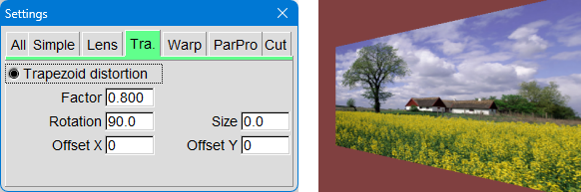
The trapezoidal distortion tool is used both to distort images and to correct skew in an image.
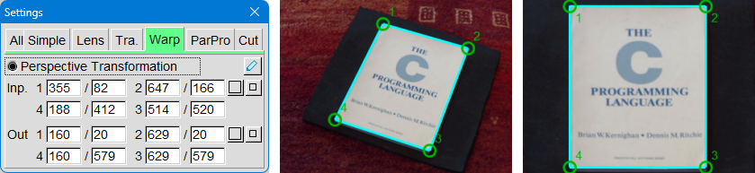
Warp (perspective transformation) is a simple way to correct distortions in an image. In learning mode (green pen-icon), use the mouse to drag 4 points to the corners of a rectangular object. In evaluation mode (blue pen-icon), move the 4 points so that the object is displayed without distortion.
The buttons with a square on them reset the 4 points.
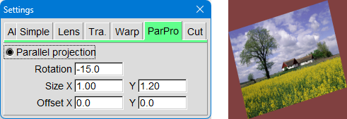
Parallel projection is another method of geometric manipulation. In addition to rotation or translation operations, you can adjust the image size separately for the X and Y directions.
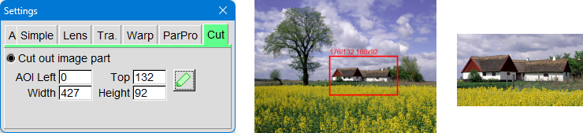
In learning mode, an area within the image is defined. In evaluation mode, this previously defined area is extracted from the image and used as the output image.

4.3.4 Calculation
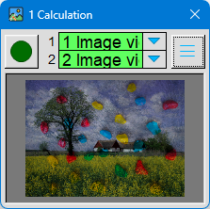
The calculation combines functions that process two image sources. The pixel values of the two images can be directly combined – for example, by adding, subtracting, or multiplying.
The output image always adopts the size of the first input image. All subsequent input images are automatically adjusted.
Additionally, various methods are available to blend the two images together. These blending methods determine how strongly each of the two images is visible in the final result.
One special mode is shading. This allows you to balance differences in shading or brightness within an image. This is particularly helpful if an image is unevenly lit or if certain areas appear too dark or too bright. Shading ensures that the entire image has a more uniform appearance.
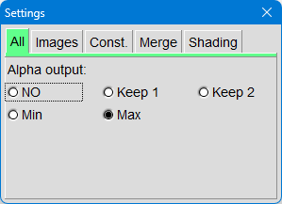
If neither image has an alpha channel, then the output image also lacks an alpha channel – it remains completely opaque.
If only one of the input images has an alpha channel, this can be applied to the output image.
If both input images have an alpha channel, a minimum or maximum calculation can be performed. In this process, either the smaller or the larger alpha value from the two images is selected for each pixel and applied to the output image.
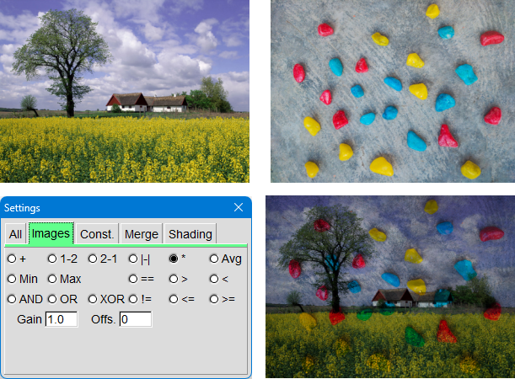
Here, two images are combined. In this example, the two images above are multiplied together so that their pixel values are combined to create a new output image.
After each calculation, the output image can be further adjusted: The gain setting allows you to selectively lighten or darken the result, while the offset adds a fixed brightness value to shift the overall image to be brighter or darker.
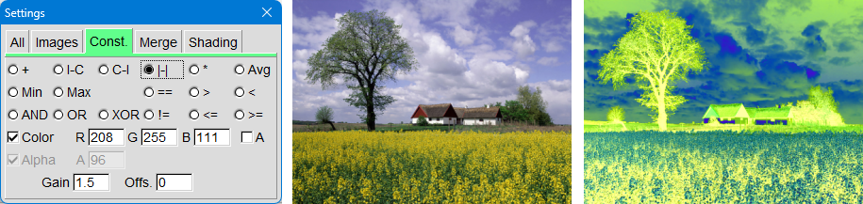
Here, the input image is combined with a constant. You can choose to combine the color channels, the alpha channel, or both.
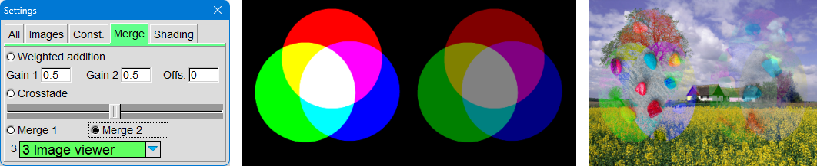
Here, the first two input images are blended together. How strongly each of the two images is visible in the result depends on the third image (the middle image). The brightness of this middle image determines the blending ratio.
Bright areas in the third image cause more of the second image
to be visible. Dark areas cause more of the first image to be visible.
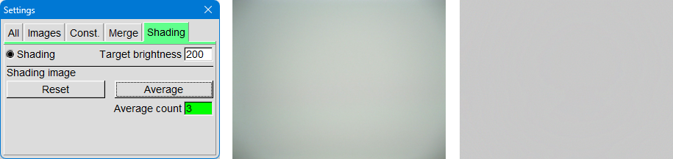
The middle image shows a camera snapshot of a white surface. Darkening is visible in the corners – typical effects caused by the lens or uneven lighting.
The shading -function is used to compensate for such differences in brightness, so that the image later appears uniformly bright everywhere.
Procedure for using the shading -function:
- The first input image 1 is the camera image.
To set up the shading, a white sheet of paper is placed under the camera.
- Input image 2 must be an image viewer.
It is used to temporarily store the so-called shading image.
- Pressing Reset deletes the current shading -image.
Pressing the Average button for the first time saves input image 1 as the new shading image.
- To compensate for minor irregularities in the paper, the paper can be repositioned.
By pressing Average again, the new camera image is averaged with the previous shading image. This process can be repeated several times – typically 4 to 8 times.
- The output image is finally a shading corrected camera image.
If the paper is removed and a bright object is held in front of the camera, the corners will be just as bright as the center of the image.

4.3.5 Correlation
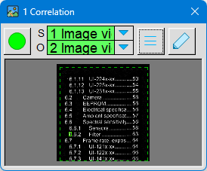
In image processing, correlation means comparing two images or two patterns to find out how similar they are at a specific point.
Correlation checks: "Does this small pattern (object) fit in this place in the image (scene)?"
The pattern is moved across the image, and a value is calculated at each position indicating how well the two elements match.
High similarity → high correlation value
Low similarity → low correlation value.
The cross-difference correlation used here is a really simple
type of this method: It measures how much two image regions differ from each other.
This is done by calculating the difference in pixel values between the object and the scene.
For each pixel: Difference = |Pixel Scene − Pixel Object|
Then all the differences are added up.
- Small sum → Image and pattern are similar
- Large sum → Image and pattern are different
The less the pixels differ, the better the pattern fits in that position.
Cross-difference correlation is fast, simple, and works well when the lighting is stable.
Note: Correlation can be very computationally intensive for large scenes or very large object images because a large number of pixels need to be compared.
Therefore, it is often advisable to reduce the image size before correlation. This reduces the number of pixels that need to be compared, and the calculation runs significantly faster without severely impacting the result.
The images for the following correlation examples are located in the “Demo\Correlation” subdirectory of the application.
The raw data of the scene – a labeled sheet of paper – was previously prepared by background elimination. This involves applying a small Gaussian filter and a large Gaussian filter and subtracting their results from each other, thus largely removing the background.
objects were then cut out from this cleaned-up scene image and saved as small individual images.
Note: Objects can be quickly replaced by drag & drop them from the
File Manager directly onto the image viewer for objects.
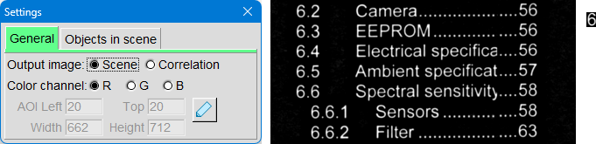
The middle image shows a section of the scene, the right image shows the corresponding object.
The object image must always be black-and-white for the correlation to work correctly. The scene image, on the other hand, can be black-and-white or color. If it is a color image, only the selected color channel will be used for the correlation.
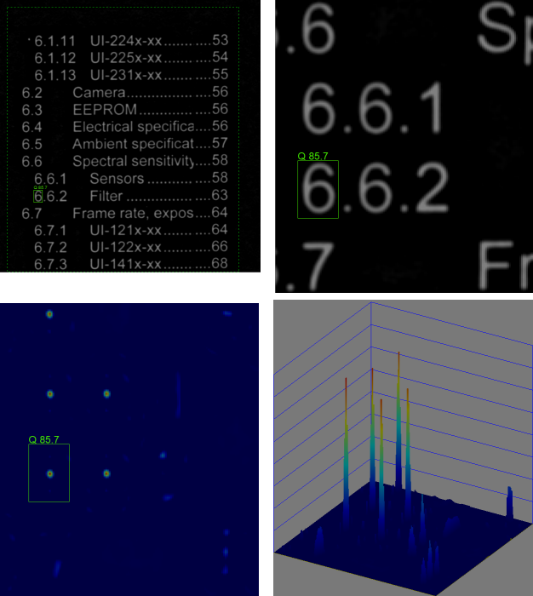
If "Scene" is selected as the output image, the scene is displayed along with the superimposed result of the correlation. The rectangle marks the position of the best match. The correlation value ranges from 0 (no match) to 100 (optimal match).

If "Correlation" is selected as the output image, a processed image of the correlation qualities appears. Areas with good agreement are light, areas with poor agreement are dark. This is particularly easy to see in the main window when a color palette is selected and the 3D visualization is activated.
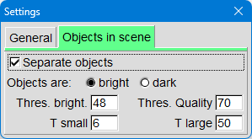
If appropriate, objects in the
scene can be isolated first. This speeds up the correlation process because only the areas where objects are actually suspected are examined. Isolation is also necessary when multiple objects in a scene need to be correlated simultaneously.
Simple binarization is used for pixel isolation. All pixels that are lighter or darker than the set binarization threshold are classified as objects. Additional size thresholds allow for the differentiation of genuine objects from disturbances such as dirt or debris.

Another setting is the quality threshold. It defines the value above which a correlation quality is rated as "good".
- Values above this threshold are displayed in green.
- Values below appear yellow to pink.
- Very poor results are marked in red.
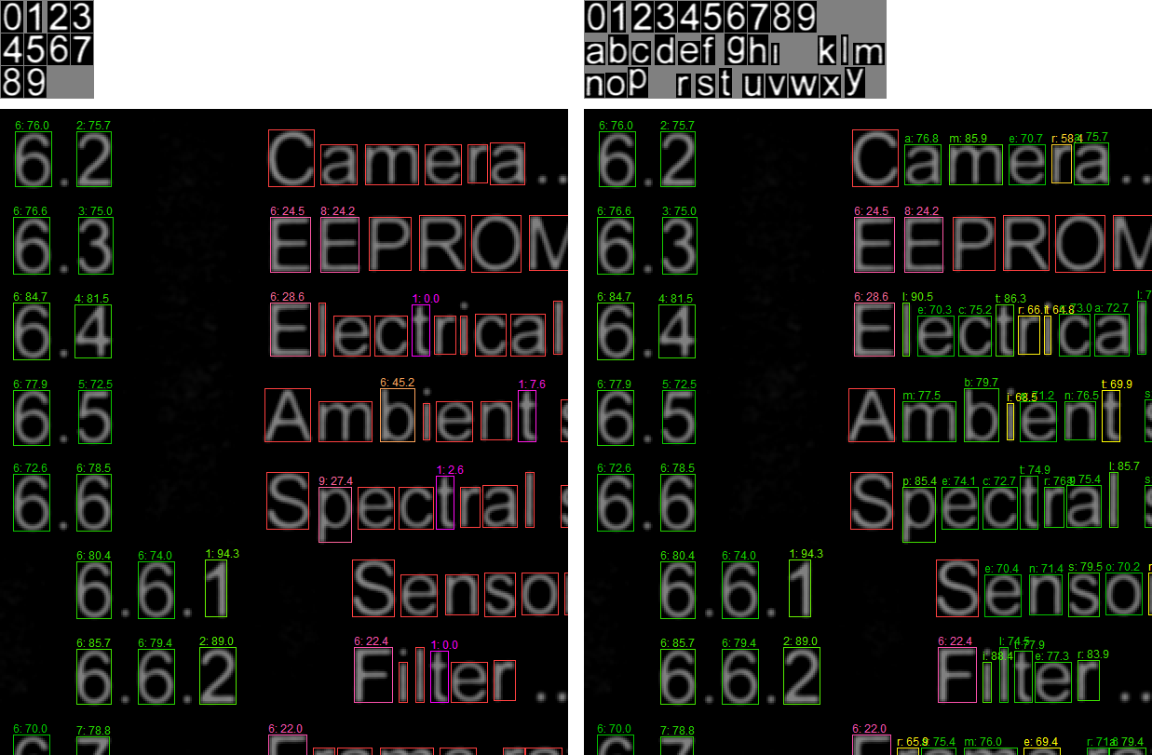
A single object image can store multiple individual objects. For this to work, the objects in the image must be clearly distinguishable from one another, and a text file with labels must exist that has the same base name as the object image.
This technique can be used to implement a simple text recognition.
Isolate objects within the object image.
The following conditions apply in order for the software to recognize the individual objects:
- The objects must be surrounded by border pixels.
- Object rows must be separated by image rows that consist exclusively of border pixels.
- Within such a row, the objects must additionally be separated from each other by columns of border pixels.
- The pixel in the top left corner of the object image must always be a border pixel. The value of this pixel is used as a reference to identify border pixels.Structure of the associated text file (labels):
The text file must
- The first line contains the text “Crcdf-Options”.
- Comment lines begin with “//”.
- Each object should have a line with "Label:". The text to the right of this will later be used when displaying the correlation results.
Important:
The number of objects in the object image must exactly match the number of labels in the text file. Only then can the objects be correctly assigned.

4.3.6 Objects
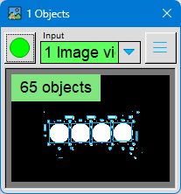
Separating objects from the background is a fundamental task in image processing. A prerequisite for this is that the objects are clearly distinguishable from the background. If this is not the case, a suitable background color or appropriate lighting can help.

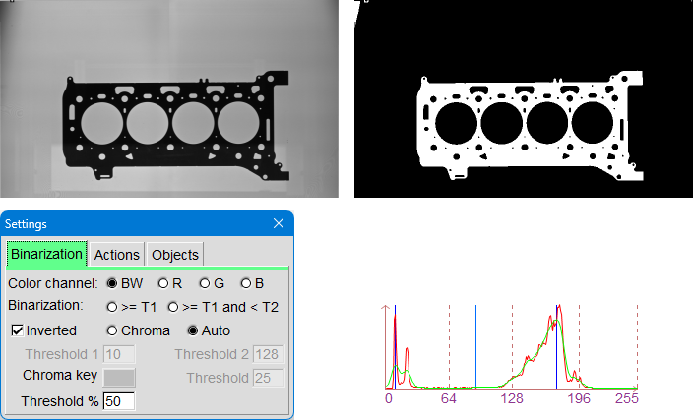
Binarization converts the image into so-called RLCs (Run Length Codes). RLCs are a compact representation of image lines and can be processed much faster than normal grayscale or color images.
In addition to binarization with one or two brightness thresholds, a color can also be used as a criterion.
With the "Auto" setting, the binarization threshold is automatically determined via histogram analysis. For this to work, the image's brightness histogram must have two clearly separated maxima. The automatically calculated threshold is then a percentage value between these two maxima.
In the example above, you can see a backlit engine block gasket on the left and the binarization on the right.
The graphic shows:
- The brightness histogram is shown in red.
- Green is a smoothed version of this histogram.
- The identified maxima and the derived threshold are marked in blue.
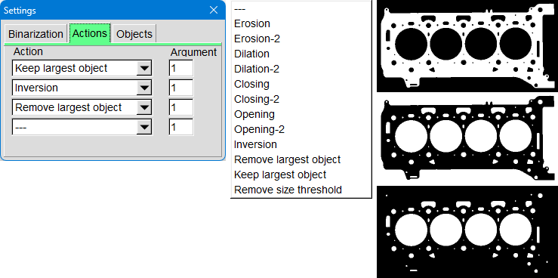
Once the image has been binarized, various actions can be performed on the RLCs, such as removing holes, noise pixels, or small unwanted objects. The images above show the processing steps used to identify the holes in the seal.

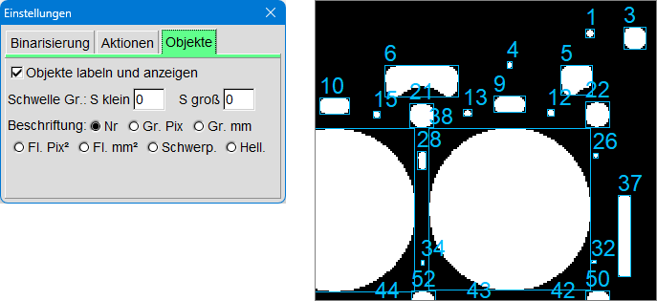
After the RLCs have been created, they are labeled. This involves grouping contiguous image lines into objects. Information about each object is also calculated, for example:
- Position and size of the enclosing rectangle
- Number of binarized pixels → Area
- The object's center of gravity
- or other features

4.3.7 Other
This tool window contains various image processing functions that cannot be assigned to any of the existing categories. It therefore serves as a collection area for other processing steps that do not fit into any of the defined groups.
FIFO
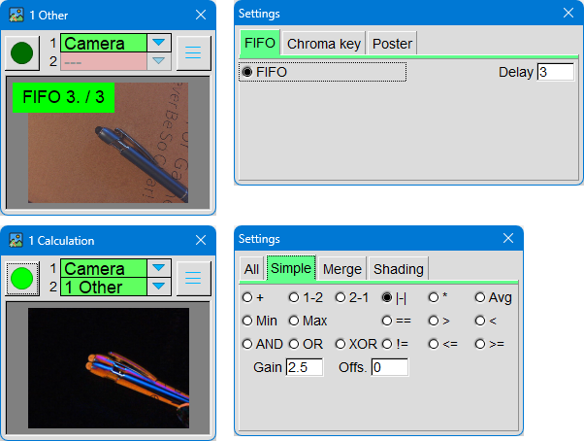
FIFO (First In – First Out) outputs incoming images with a time delay. In the example shown, this simulates motion detection.
A camera focuses on a ballpoint pen. The current camera image is compared with a time-delayed image from the FIFO by subtracting them from each other.
If something moves in the image, this movement becomes clearly visible in the difference image because the pixel values differ between the current and the older image.
Chroma key
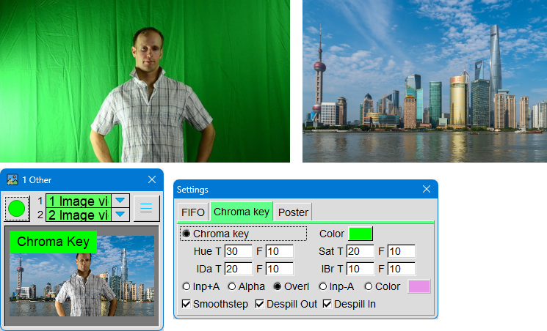
The chroma key technique separates the foreground from a solid-colored background. It's important that the background color doesn't appear in the foreground, otherwise the separation won't work reliably.
In addition to the background color, threshold values for hue, saturation, and brightness must be set. This allows you to precisely define which pixels are considered the background. Furthermore, various output formats and options for optimizing the transition between foreground and background are available.
Note: When the input image is displayed in the main window and 'H AOI' is selected as the measurement, a measurement window can be moved to a location on the background. The color measured there can be directly applied via the context menu of the 'Color' button using 'Get Color from Histogram'.
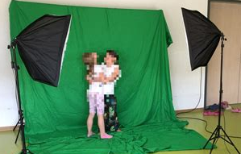
Here you can see a simple green screen setup.
If only small objects are in the foreground – for example, model cars – the entire setup can be made more compact.

Poster
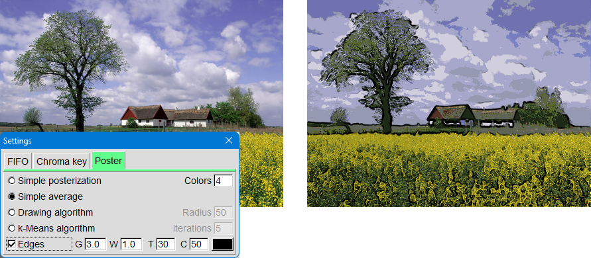
When converting an image into a poster, the algorithm transforms the many subtle color gradations into a few large blocks of color. This eliminates soft transitions, and the image appears clearer, more graphic, and more striking – just like a typical poster.
- In posterization, colors are divided into a few levels.
- Each pixel is assigned to one of these levels.
- This results in hard edges and large areas of solid color.
- The image looks less like a photograph and more like a graphic.
In addition, the edges can be emphasized.

4.4 Output

Output tools output an input image, for example, to a file or to a display.
They always have an input image. Some generate an output image, but this cannot be processed further.

4.4.1 Video writer
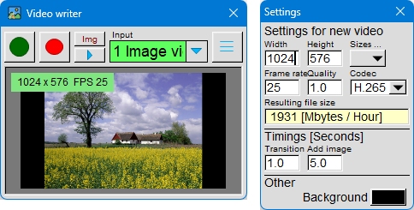
This tool can be used to create videos. Before recording starts, all relevant video settings should be configured and the recording mode selected.
The 'Image' recording mode is intended for single images, e.g. from an image viewer. For each new image, frames are appended to the video for the set duration 'Add Image'. A crossfade is created between the images for the
'Transition' duration.
The 'Video' recording mode is intended for camera images. Each new camera image is immediately added to the video as a frame.

4.5 Inspection

Industrial image processing uses cameras and software to automatically detect features, defects, or characteristics of products – usually directly on a production line. The goal is to monitor and control manufacturing processes or to inspect finished products.

The inspection tools shown demonstrate how such tests can be carried out. Typical tasks include:
- Take a reference image
- Measure or correct colors
- Position correction
- Measuring distances
- Compare image parts
The reference image – for example, a camera image of a flawless object – serves as the basis. Other tools compare the features of new images with this reference image to detect deviations, make errors visible, or compensate for changes in position.
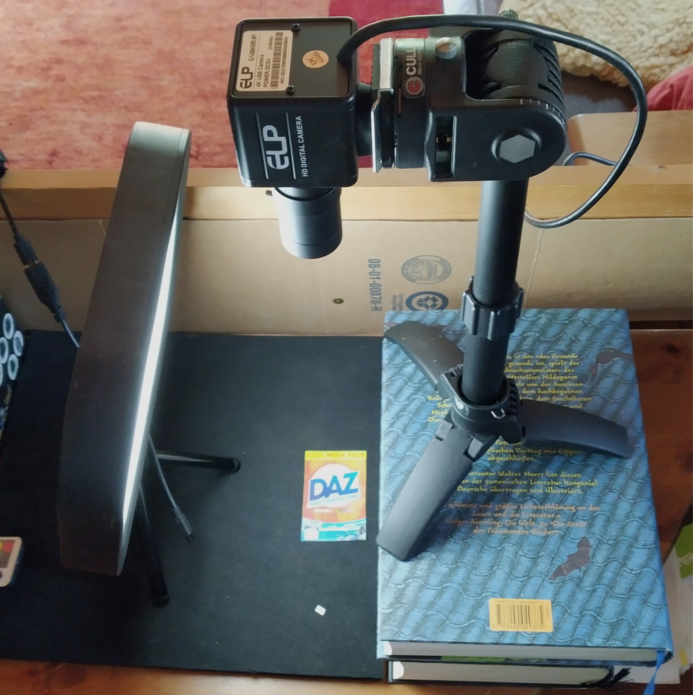
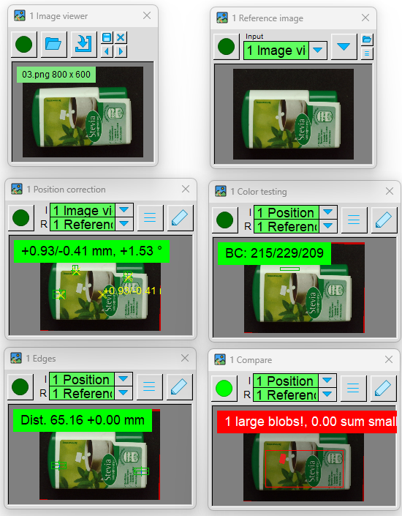
The images show the setup used and the tool windows that were used in the following descriptions.
Images of a small can were taken with the camera and saved in the application's ‘Images\Demo\Inspection-1’ subdirectory. These examples can be easily opened with an image viewer, allowing you to follow the operation of the inspection tools step by step.

4.5.1 Reference image
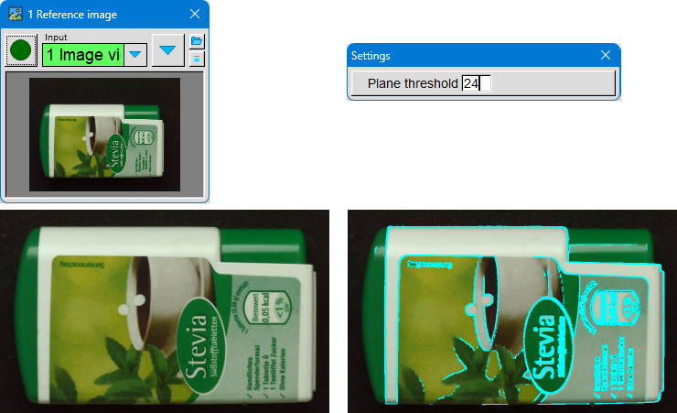
In industrial image processing, a reference image serves as a benchmark. It shows a product as it should appear – flawless, correctly positioned, and properly lit. All subsequently captured images are compared to this reference image to reliably detect deviations, errors, or changes.
A reference image is the "target version" of a product against which all subsequent images are checked.
For the reference image to work reliably, several points must be correct:
- Uniform lighting No shadows, no reflections, no overexposure. The lighting must be reproducible later.
- Clean, flawless object The reference image must not contain any scratches, dust, fingerprints or production defects.
- Stable position The object must be positioned exactly as it will be later inspected – same position, same orientation.
- Steady camera settings Focus, exposure time, aperture, white balance must be set correctly and remain unchanged later.
- High-contrast contours edges, and shapes should be clearly recognizable so that image processing can reliably find them.
- Stable environment No changing light sources, no movement in the background, no vibrations.
A reference image can be generated in two ways: Either an input image is used – for example, from a camera or an image viewer – or a stored image is loaded.
Next, the contour areas in the image are marked. This is done by examining the neighboring pixels of each pixel:
- If the brightness difference to all neighbors is smaller than the set "Plane threshold", the pixel is low-pass filtered.
- If the difference is greater, the pixel is classified as a contour and remains unchanged.
Additionally, a contour bit is set in the alpha channel of the reference image. This contour bit is used by the image comparison tool to improve comparisons in the contour area.
When the parameter dialog is open, the detected contour areas are visibly marked in the image.

4.5.2 Color Testing
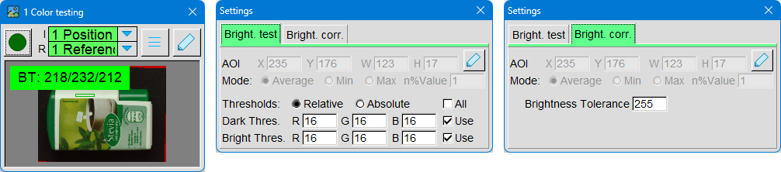
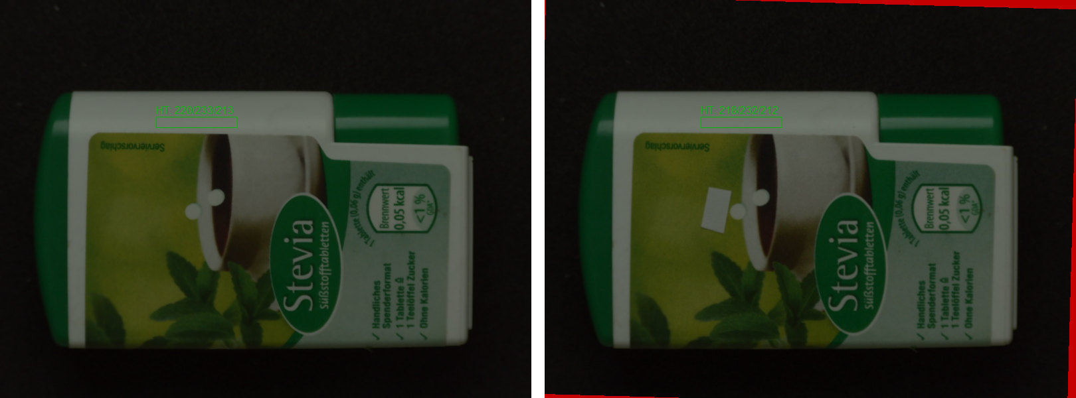
In learning mode, the reference image is displayed. The AOI (Area of Interest) is overlaid on the image area whose color or brightness is to be measured.
The measurement is performed either as the average of all pixels within the AOI or as the average of the darkest or brightest n% of pixels.
This allows you to control whether the entire area is evaluated or only particularly bright or dark parts of the image.
Brightness test
In evaluation mode, the brightness of the input image is compared with the brightness in the reference image.
- If the difference is within the error tolerance, the image is considered OK. The measured value is highlighted in green.
- If the difference is outside the tolerance range, the image is faulty. The measured value is highlighted in red.
The brightness test is well suited for checking the presence of parts or for color or brightness control in production processes.
Brightness correction
In evaluation mode, the input image is adjusted so that the brightness in the AOI corresponds to the value of the reference image.
- If the difference is within tolerance, the image is OK (green).
- If the difference is greater than the tolerance, the image is marked as faulty (red).
Brightness correction is particularly suitable for compensating for changes in lighting, e.g. due to aging of LEDs, slight fluctuations in light color or changes in light intensity.
Practical setup: Place a bright reference area in a corner of the camera image and position the AOI on it. As the LED lighting ages, both brightness and color tone change – both can be compensated for by the correction.

4.5.3 Position correction
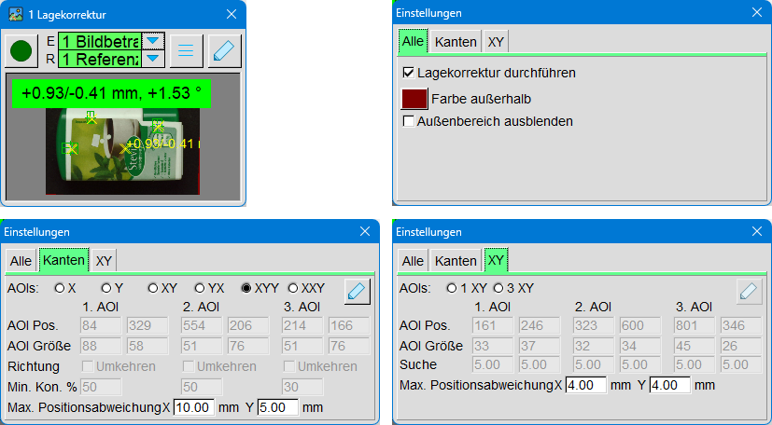
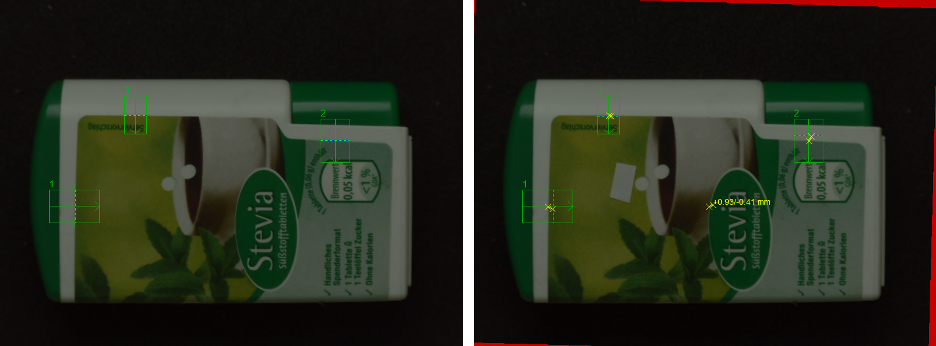
This inspection tool corrects the position of a part in the input image so that the object in the output image has the same position as in the reference image.
- Without position correction, only the extent to which the object deviates from its position in the reference image is measured.
- Position correction shifts the input image accordingly so that the object is back in its target position.
Areas that fall out of the image due to this shift are either colored in or can be hidden using an alpha mask.
The position-corrected output image can then be further processed by other inspection tools.
Edge mode
In edge mode, horizontal or vertical edges are searched for. The search direction is indicated by an arrow in the AOI.
- In learning mode, the AOI is placed on a suitable edge. The intensity of this edge is saved.
- In evaluation mode, the system searches in the direction of the arrow for the first edge whose intensity corresponds at least to the set minimum edge contrast.
This allows the position of an object to be reliably determined based on a clear edge.
XY mode
In XY mode, the algorithm searches for areas of the image that differ significantly from their surroundings.
- In learning mode, the AOI is applied to such a prominent part of the image. The tool displays a quality indicator. the higher this value, the better suited the area is for position correction.
- The dashed frame around the AOI indicates the search area. This area should be as small as possible to ensure fast and stable position correction.
XY mode is particularly well-suited for objects with distinctive
structures that consist of more than a single edge.

4.5.4 Edges
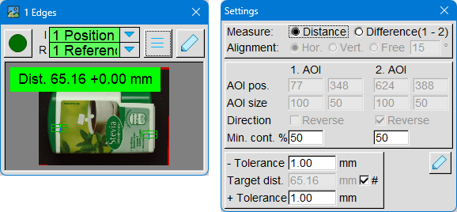
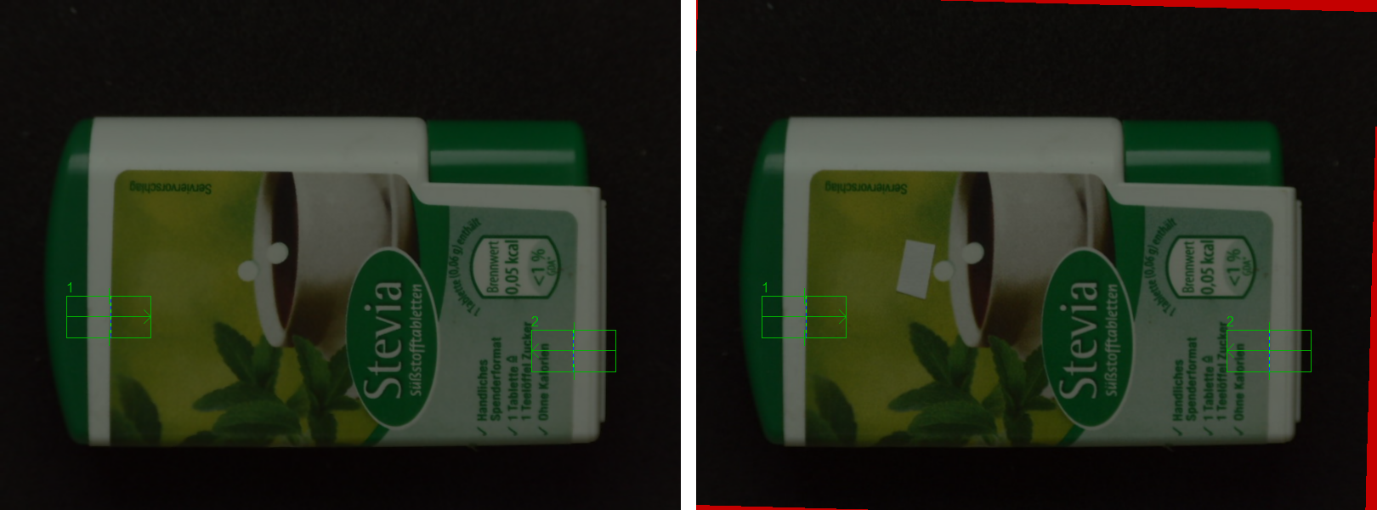
This tool measures distances between edges. To do this, the AOIs are placed on the desired edges. The search direction is indicated by an arrow within the AOI.
- In learning mode, the AOI is placed on a suitable edge. The intensity of this edge is saved.
- In evaluation mode, the system searches in the direction of the arrow for the first edge whose intensity corresponds at least to the set minimum edge contrast.
Difference
Here, the difference between the two edge positions is used as the measurement. The value can be positive or negative. This setting is particularly well-suited for measuring offsets, i.e., when you want to know whether an edge has been shifted to the left or right.
Distance
Here, the absolute value of the difference is used – always a positive value. This setting is well-suited for size measurements where only the distance between two edges is important.

4.5.5 Compare
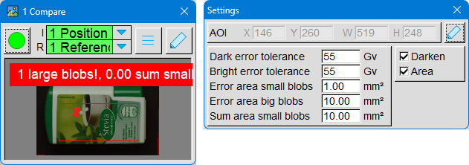
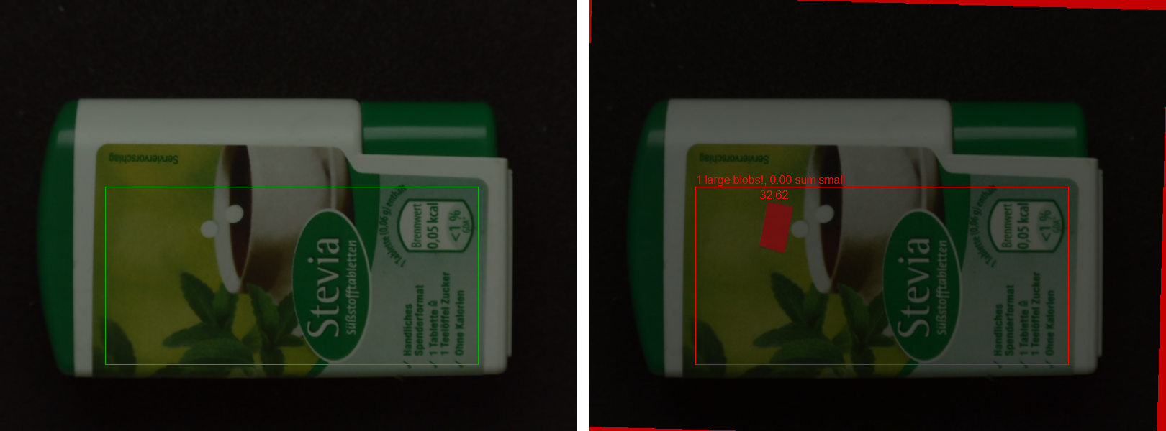
This tool compares the image content between the input image and the reference image. The comparison only takes place within the AOI.
For each pixel, it is checked whether its brightness in the input image differs more from the reference image than the set brightness tolerance.
- Pixels with excessive deviation are considered defective.
- Associated defective pixels are grouped together as blobs.
The blobs are color-coded according to their size:
- Subliminal blobs → blue
- Small blobs → green
- Large blobs → red
The image comparison is considered faulty if:
- at least one large blob is present or
- the sum of the areas of all small blobs is above the set threshold.
To make the graphic more visible, the output image can be darkened. Additionally, the areas of smaller and larger blobs can be displayed.
This tool is used for surface inspection, print control, and other quality control tasks.
Professional systems often use an additional inspection mask. A separate image is used to mark precisely the areas to be inspected. This allows the system to define which image regions are relevant and which can be ignored.

4.6 Other

Other tools contain functions that do not fit into any of the tool groups mentioned so far.

4.6.1 Overlay
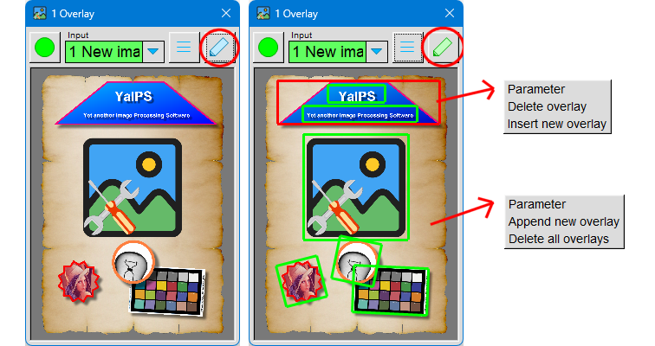
This tool allows you to overlay other images, shapes, or text onto an image source. The output image always has the same size as the image source.
If "New Image" is used as the image source, a poster with a defined size and resolution — such as DIN A4 at 150 dpi — can be generated, along with the calibration. If a camera is used as the image source, text or logos can be superimposed on the camera's live image.
Up to 16 overlays can be defined.
Operation in learning mode and closed parameter dialog:
- Left mouse button: Move or resize overlay.
- Right mouse button over an overlay:
  - Open parameter dialog of this overlay
  - Delete overlay
  - Insert new overlay
- Right mouse button over the background:
  - Open parameter dialog
  - Add a new overlay at the end
  - Delete all overlays
- Mouse wheel:
  - Holding Ctrl down: Rotate overlay by 1°
  - Holding Shift down: Rotate overlay by 15°
- Dragging an image file onto an overlay: If the overlay has an image as its background, this image will be replaced.
- Dragging the image file onto the background: A new overlay will be inserted at the end of the list.

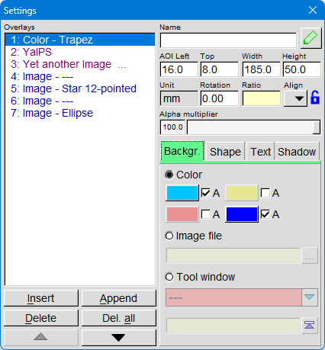
The left half of the parameter dialog contains a list of all overlays. They are drawn in the order of the list – the last overlay is always on top and therefore visible, while earlier overlays can be covered by later ones.
You can edit the currently selected overlay using the buttons at the bottom:
- Move overlay
- Delete overlay
- Insert a new overlay in front
- Append new overlay afterwards
If the Ctrl-key is pressed when creating new overlays, they will be created as a copy of the selected one.
In the upper right part of the dialog, you can make further adjustments to the overlay:
- Change position and size
- a name (this will then appear as text in the list)
- Rotate the superposition
- the overlay at the image edges
- Lock the aspect ratio to prevent the shape from being distorted when scaling
- Set transparency​
In the lower right part of the parameter dialog, there are several tabs that can be used to edit different properties of an overlay.
Background: In this tab, you select what is used as the background of the overlay: color, image file, or tool window.
For image file and tool window, the size is also displayed. Using the adjacent button, you can directly apply this image size as the size of the overlay.
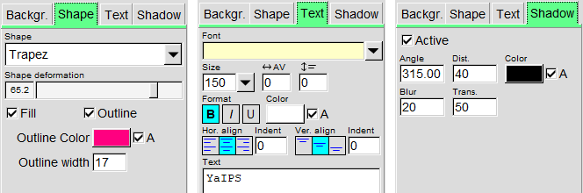
Shape: Here you can select one of the available shapes. The shape will be placed over the background. Optionally, a colored outline can be added.
Text: In this tab, you can enter text that will be displayed in the overlay. Besides font and font size, numerous other settings are available, such as alignment, line spacing, color, and transparency.
Shadows: Each overlay can have a shadow. The following properties can be set:
- Direction of the shadow
- Color
- Blur
- transparency
This allows overlays to be visually highlighted or rendered in a more three-dimensional way.

