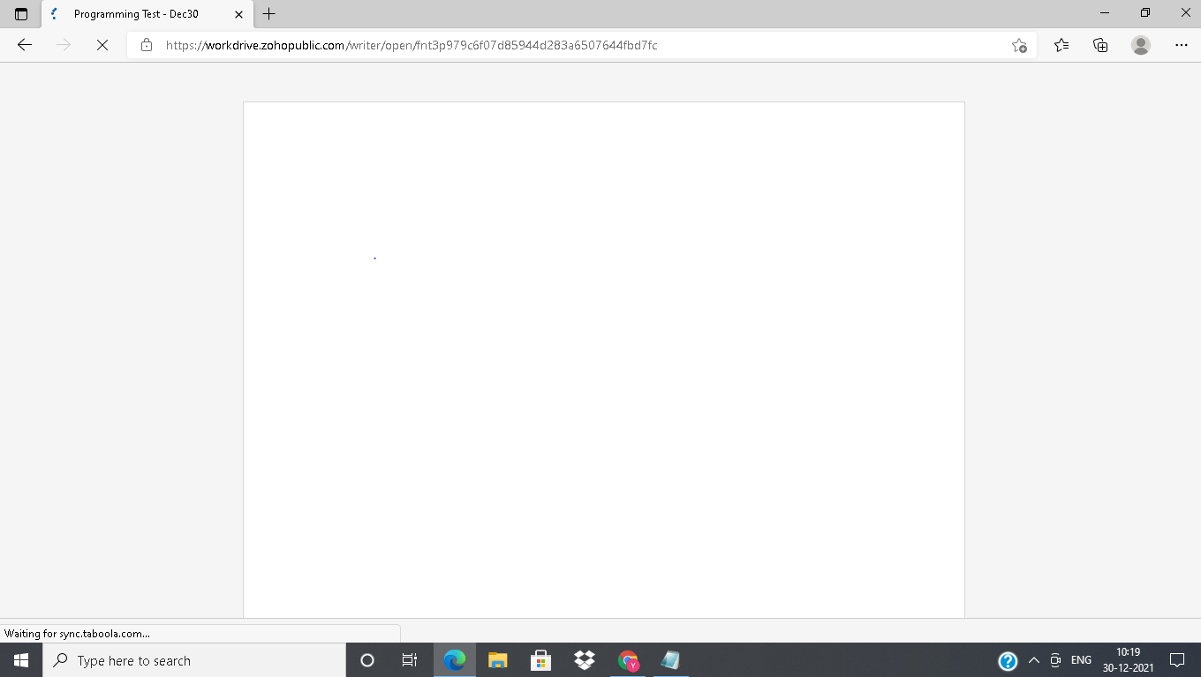

Got programming link after 10.20 so it become delay to complete programming.

Program:

#include <stdio.h>

#include<string.h>

int main()

{

char str[]="WELCOME";

int len,mid,i,j;

len=strlen(str);

mid=len/2;

printf("%d",mid);

printf("%d",len);

printf("\n");

for(i=0;i<len;i++)

{

for(j=i+1;j<len;j++)

{

printf(" ");

}

for(j=mid;j<(mid+i);j++)

{

printf("%c",str[j]);

}

for(j=0;(i>=mid)&&(j<i-mid);j++)

{

printf("%c",str[j]);

}

printf("\n");

}

}