

This is the text that’s written inside the background color.

Under the div tag with id(wrapper)

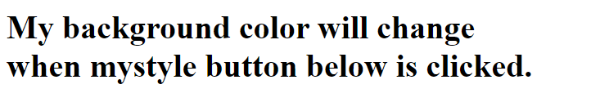

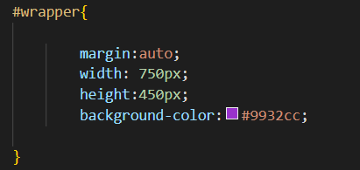

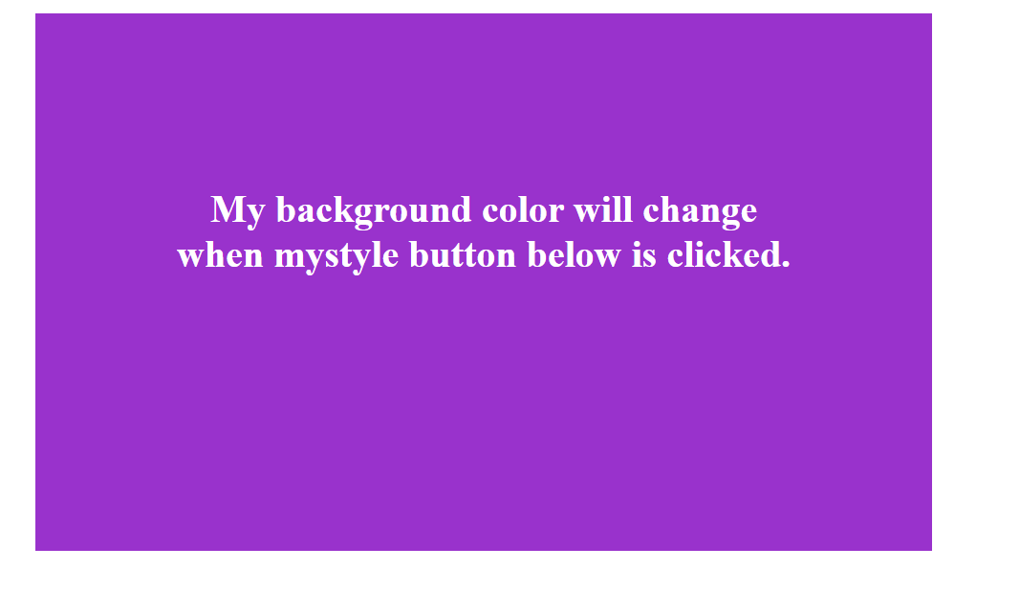



This is the button that will help us to change the color by clicking it.



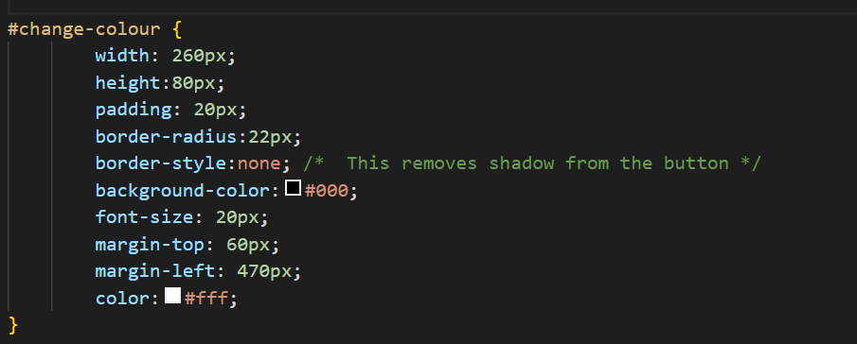



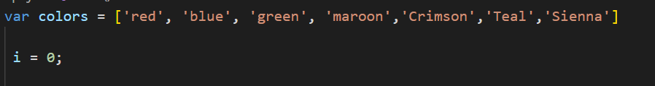

It is used to let the button “Click Me” to change the background color.

Variable ‘colors’ is an array that holds the values: red, blue, green maroon, crimson, teal and sienna.

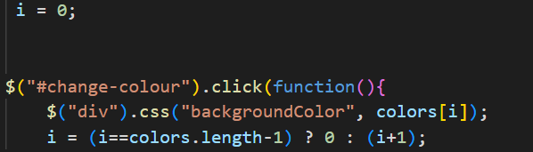

$ identifies the ‘change-color’ id.

Under ‘click’, there is a function that contains:

$ identifies the ‘div’ then adds the CSS that is ‘backgroundColor’ that will be set according to what the array’s index is.

After changing its color, the value of variable i’s value will change.

Here the value of i is in ternary operator.

Colors length-1 is total number of elements in the array – 1.

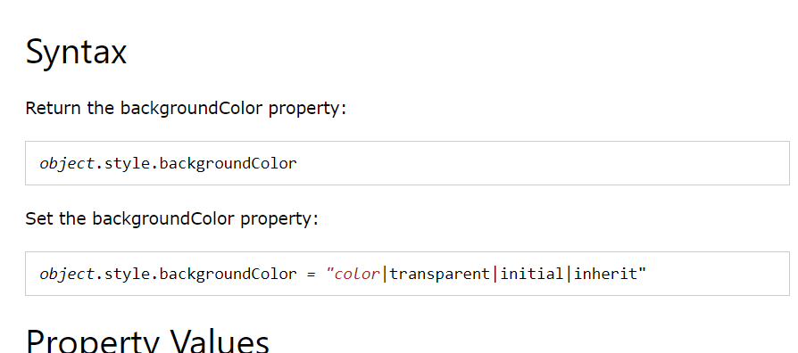

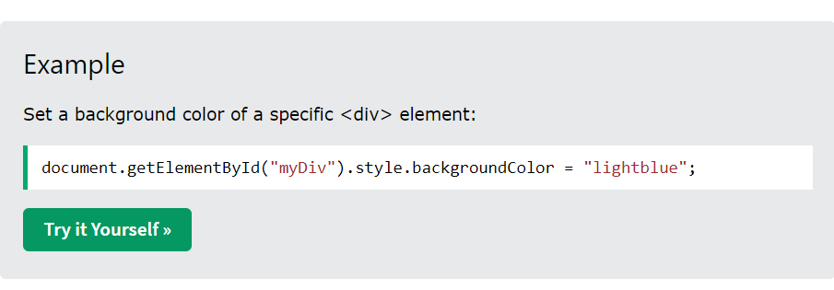

#1 Modified code

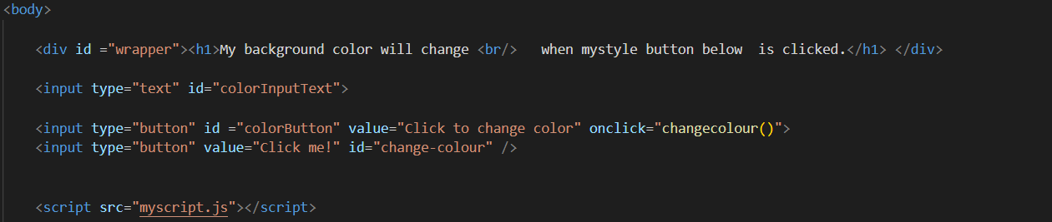

Here we created a texbox using a input type text. And a new button

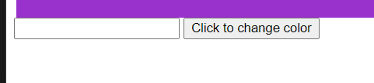

On click this button will begin a function called changecolour()

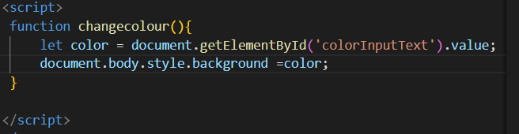

After the function changecolour has been called, it will declare a variable called color with its value from the document whose id is ‘colorInputText’, so if it is red then the value of color variable will also be red.

Then the background style of body in document will be changed to red

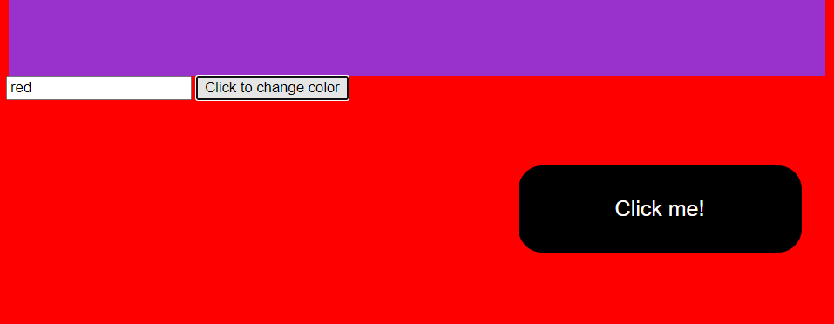

#2 Modified Code

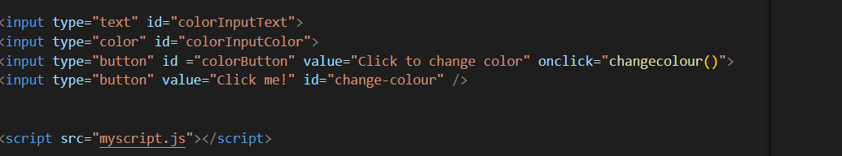

Instead of putting the colour by text we can use input type color to choose the color and display it in the div tag wrapper

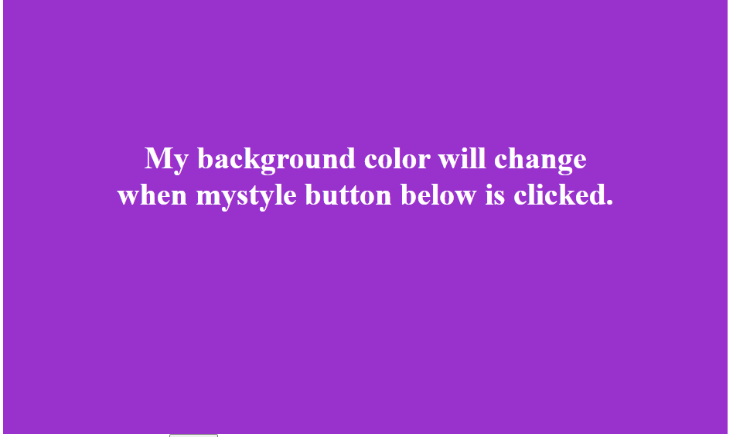

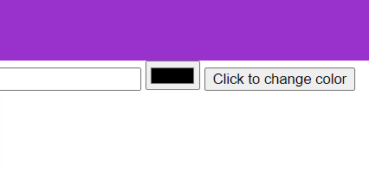

We have change the colour of the #wrapper using:

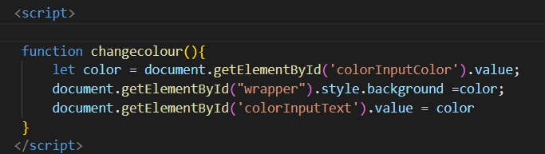

Here again changecolour function will be called when the button is clicked.



When changecolour is called the variable color is declared with its value as the value given in the element with id as colorInputColor

Then the wrapper will take the color

And also the textbox will also display its value which is the color