Workbook 2: Object Orientated Programming Inheritance, Polymorphism and Overriding.

Please complete the tasks in this workbook.

For any code created a screen shot should be provided in this document and the code file saved as a .py file.
Each section or task will need its own code file.

When complete save it as a PDF file with the following naming convention and then submit:
oop2_<student number>_<student name>.pdf

For example:

oop2_123456_fred_blogs.pdf

Task 1

Extending our person Class from the previous worksheet.

A college has many students.
Each student will have their own record.
Some new software has been installed but it is not quite complete and is missing a way of displaying a student record. You have been asked to rectify this and add some more functionality.
The Following code has been provided:
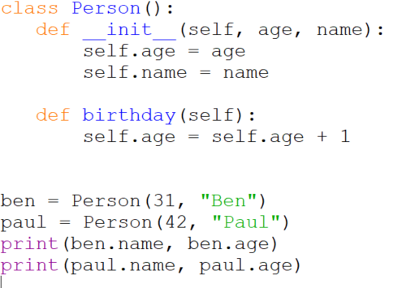

This shows a class, called Person, it’s constructor (this will be explained in the next lesson) used to setup the object and a single method, birthday(), to adjust the birthday value.

Some example code is also provided on how to use the class.
You will need to copy the above code into the IDE of your choice and make sure it works before attempting the tasks below.

Task 1.A:
Produce a design on paper to enable the Person class to be a super class along with classes that create student and staff objects.

1.A Answer:
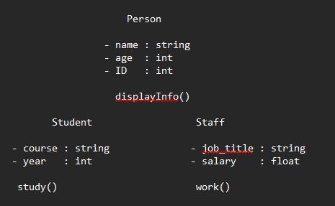

Task 1.B
Convert this design into software and show the output below along with a copy of the software.

1.B Answer:
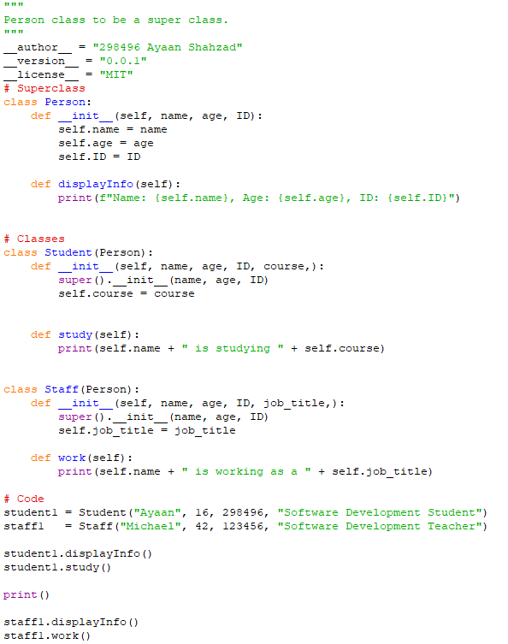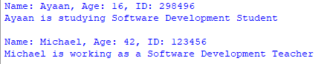

Task 1.C
On the previous worksheet you were asked to create a method to save data to a file.
Can you now create a class that will handle this process along with being able to read CSV data from a file and use it to create records for students and staff.

1.C Answer:
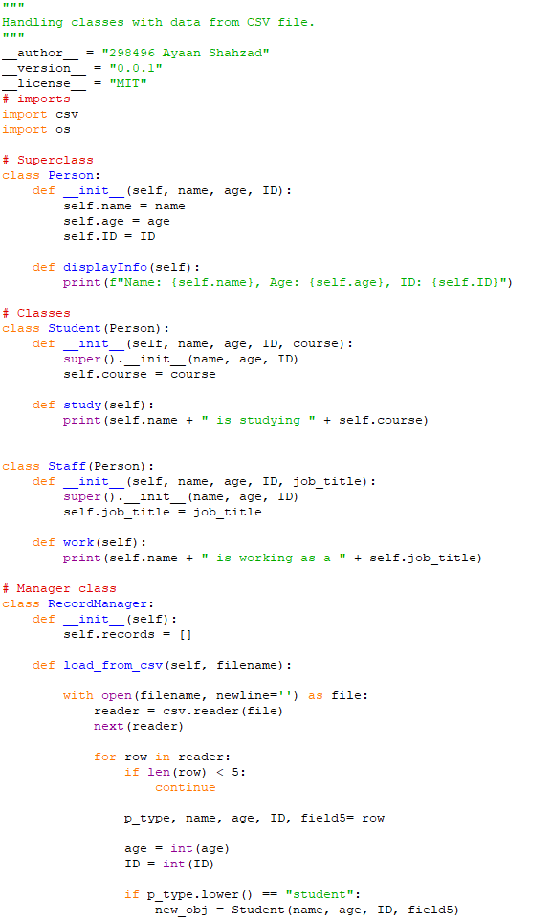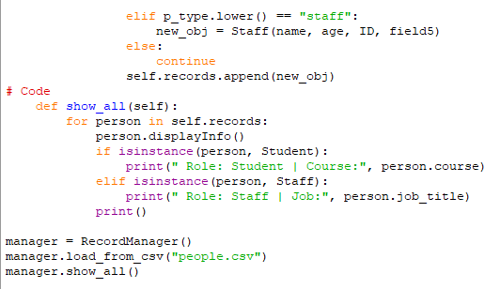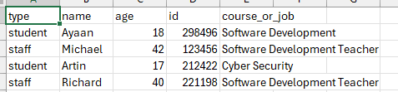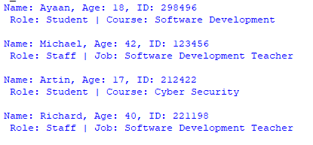

Task 2:

Pizza Code Express

Read the attached Pizza Code assignment.
Produce two separate versions of it:
- One in the procedural paradigm
- One in the OOP paradigm
Along with your solution answer the following questions:
- What is a Paradigm in respect to Programming? (Provide some examples.) Programming paradigms are different ways or styles in which a given program or programming language can be organized. Each paradigm consists of certain structures, features, and opinions about how common programming problems should be tackled.
- Which have you found better (OOP or Procedural) to write your solution in? OOP
- Why? Because I could split the program into different classes, like pizzas, orders, and the menu. This made it easier to keep track of everything and made the code less messy compared to just writing it all as functions. It also makes it easier to add new features later.

Task 2 Answer:

- 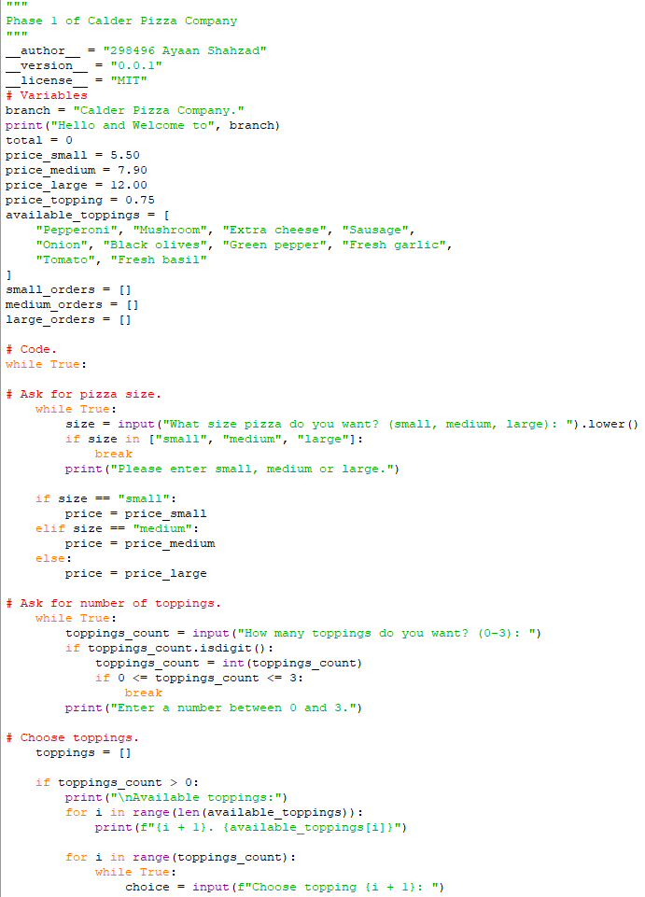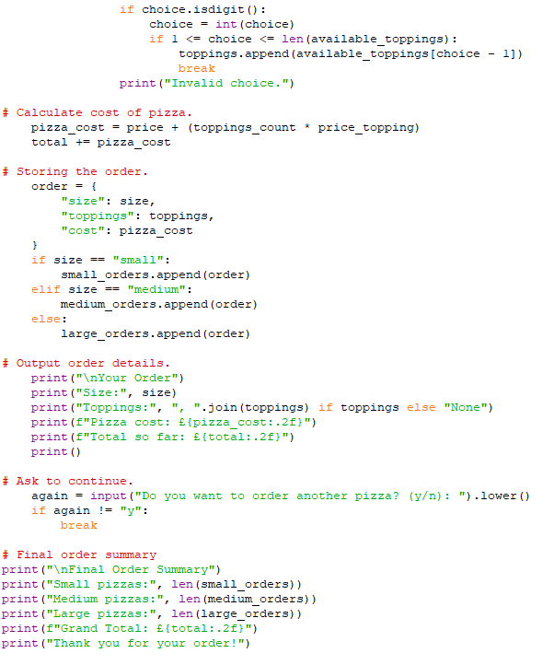 Procedural paradigm.
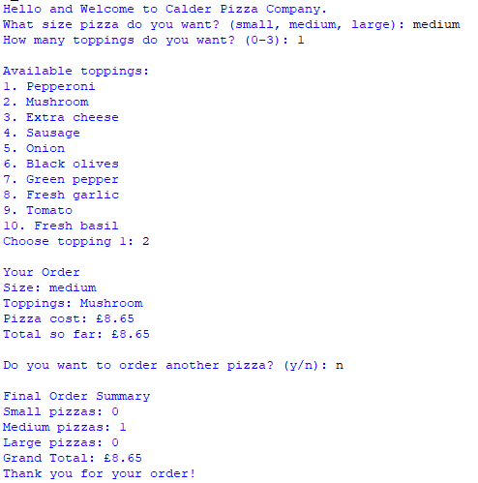
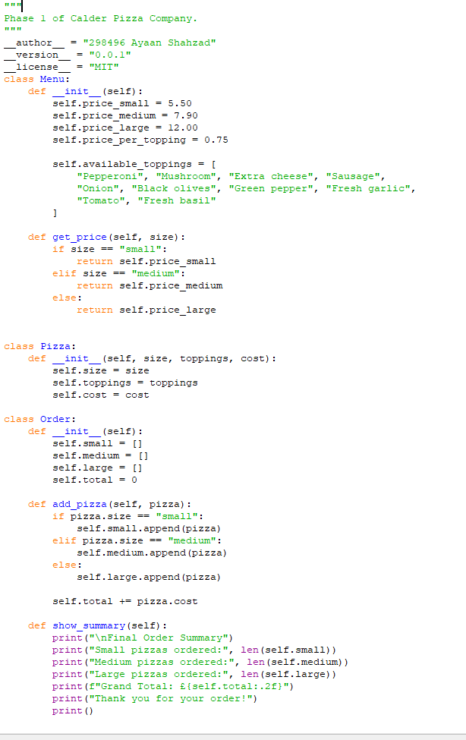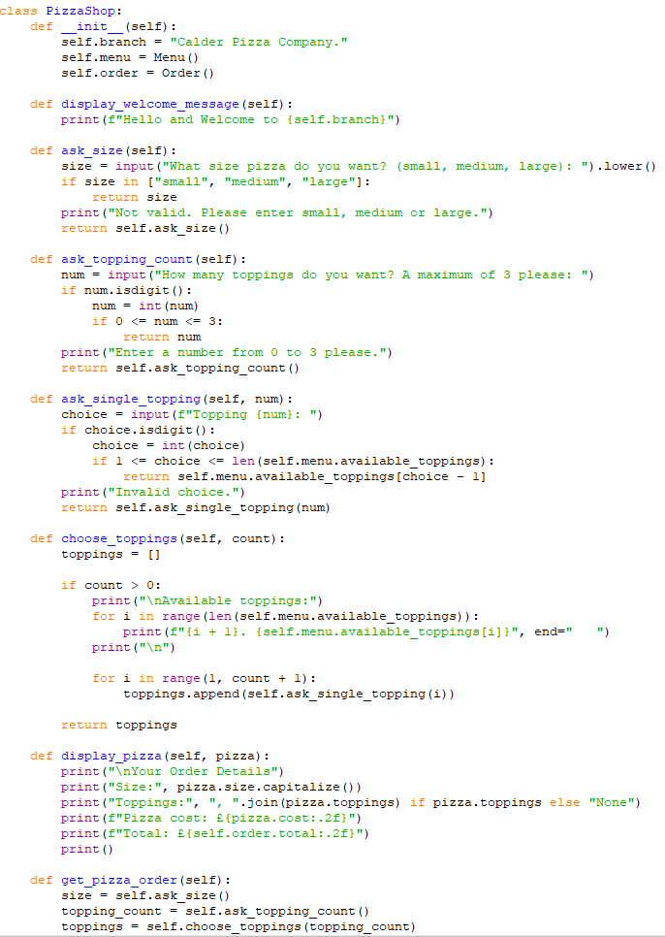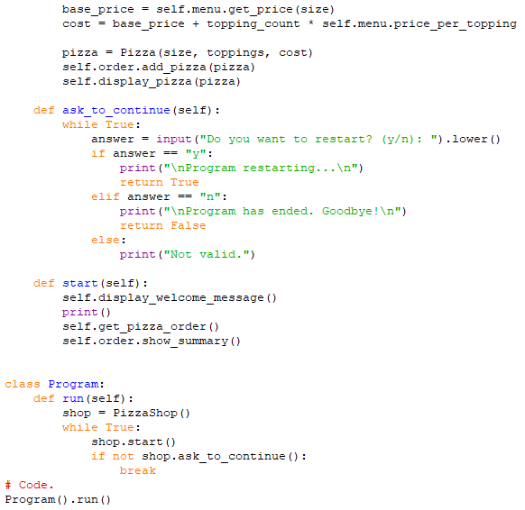

OOP paradigm.

