Report

# Features Implemented

The case study that I have chosen is the draw app. My partner and I both agreed to do 3 tools each. The three tools that I did were the eraser tool, star tool and the spirograph tool. The eraser tool erases the drawing on the canvas by drawing a white thick line. The star tool that draws stars. The spirograph tool makes a spirograph. My partner did the rectTool, ellipseTool, and triangleTool which make rectangles, ellipses and triangles. He also made a stamp tool which creates rounded squares and rectangles.

Eraser tool:

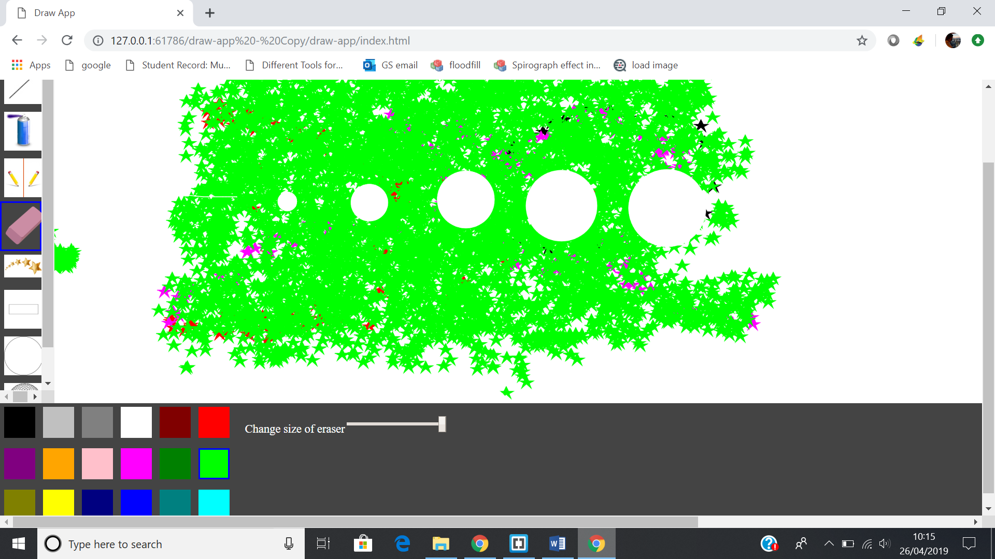

Star Tool:

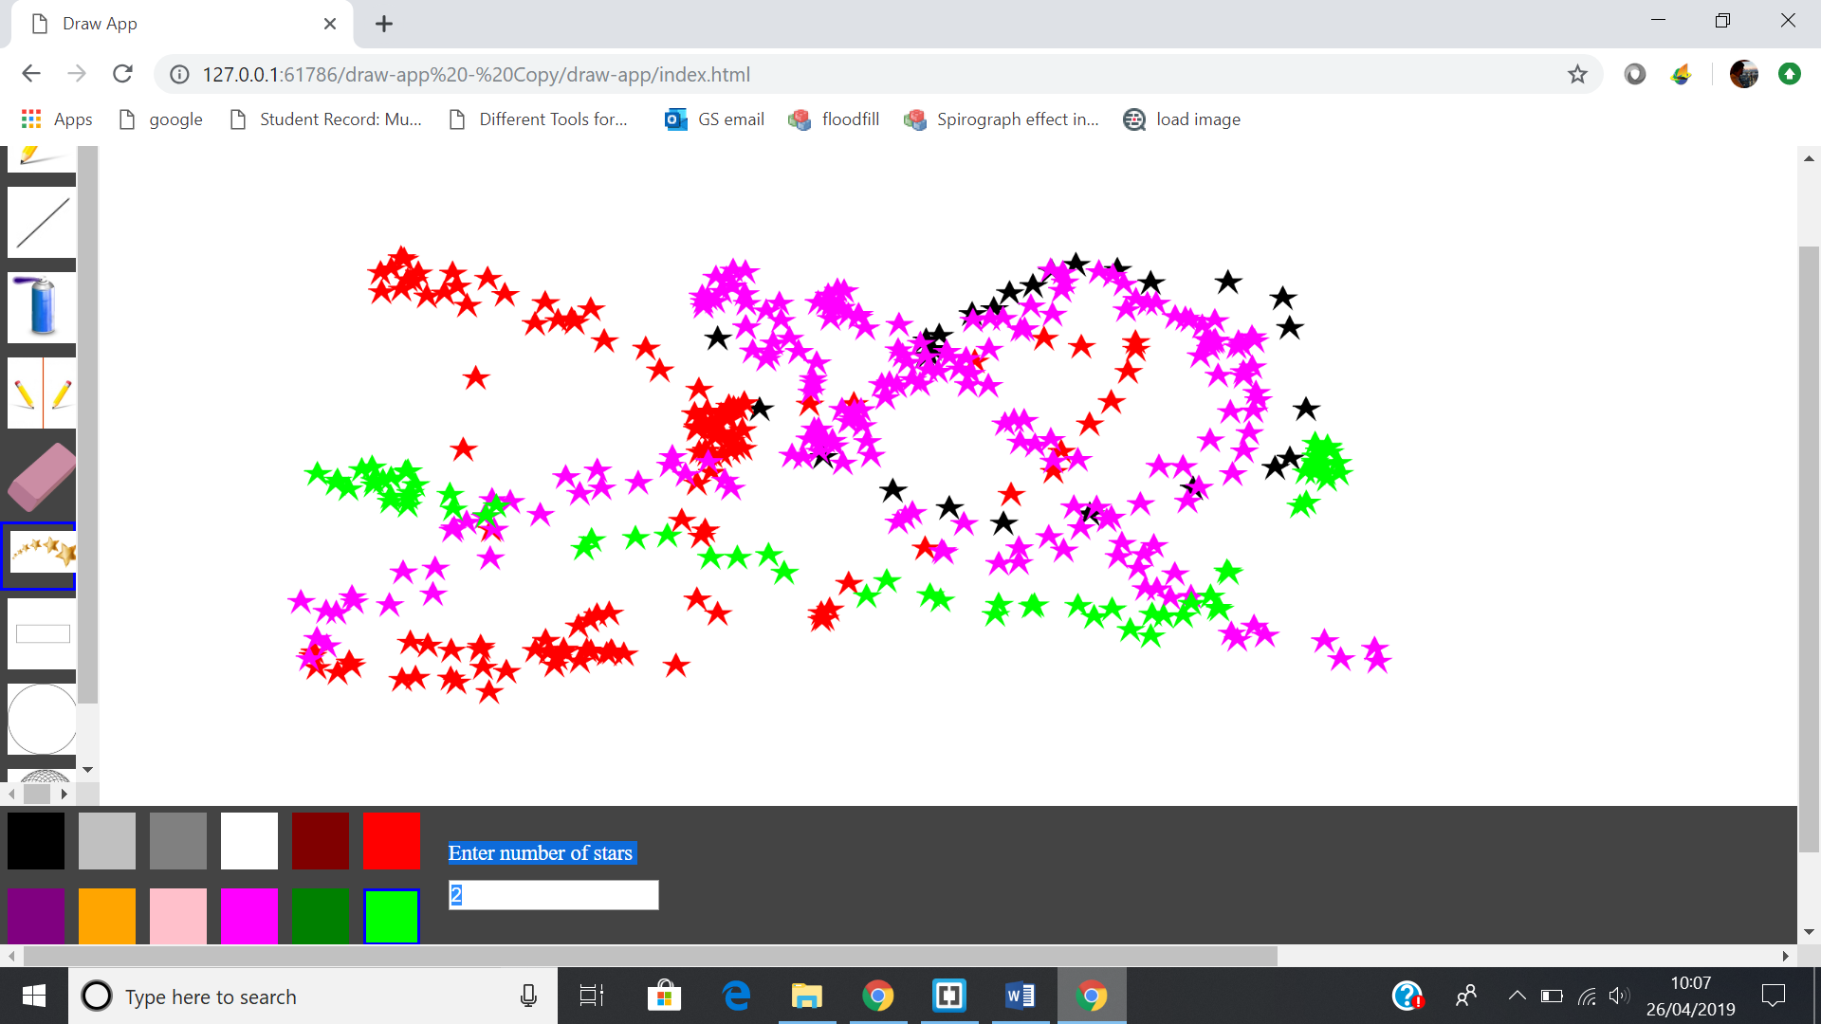

Spirograph tool:

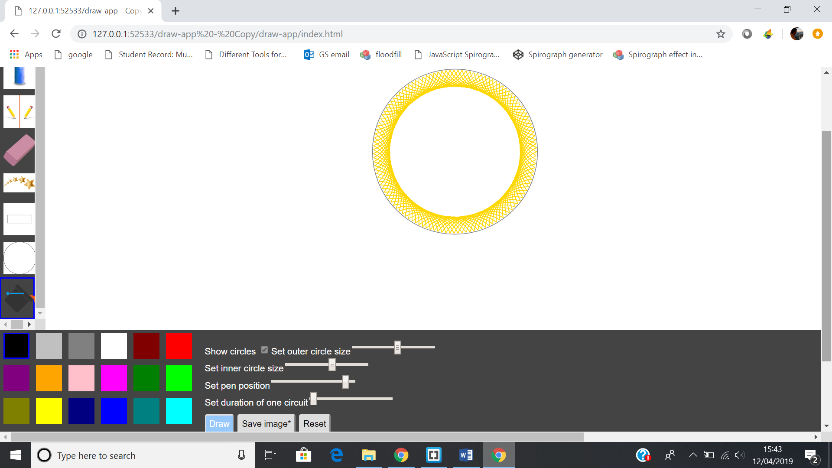

rectTool:

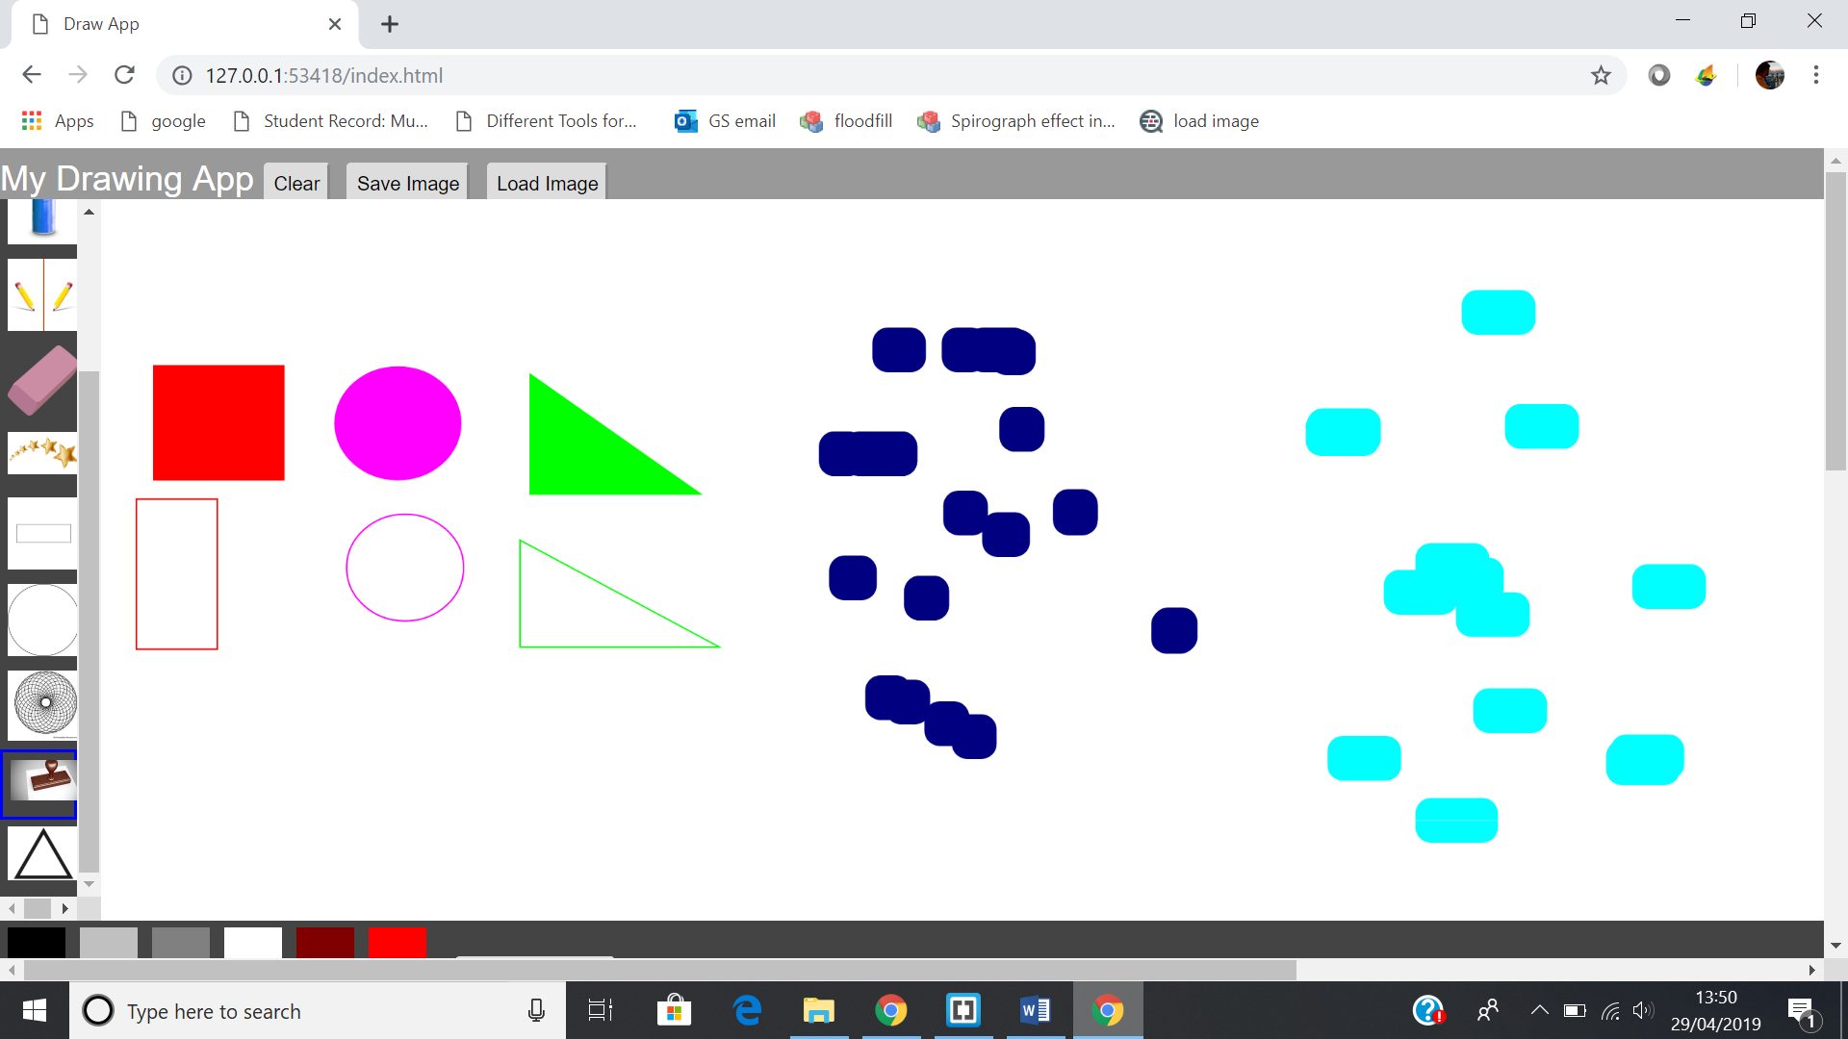

ellipseTool:



triangleTool:



stamp:



# Planning and coordinated development

We used google docs to plan what tools we would do and when we should complete the tools by.

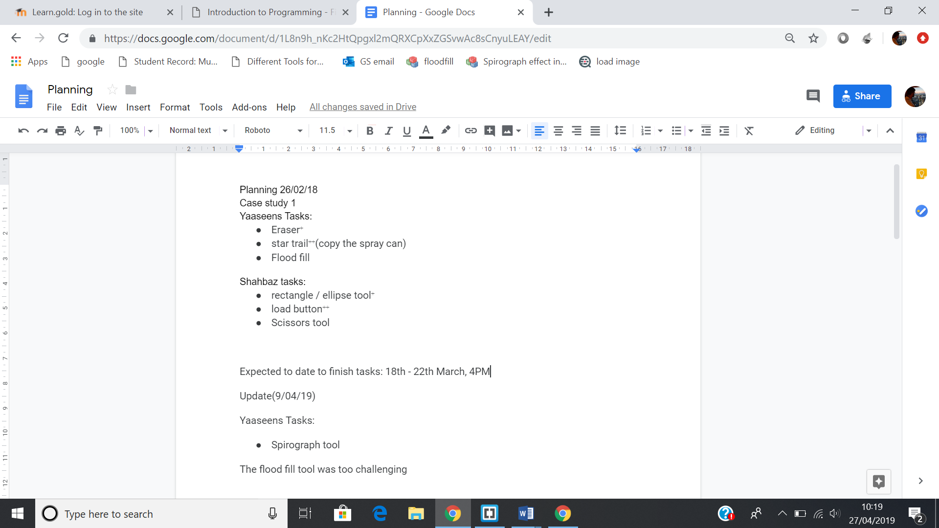

We each had a list with the tasks we were meant to complete. We decided to complete our first two tasks by 22th of March because that was when the work-in-progress peer review deadline was. After attempting the flood fill tool, I realised it was going to take too long as I was finding it too challenging, so I started on the spirograph tool instead. We also communicated on Whatsapp to check on each other’s development and emailed our code to each to check if everything was going as planned or if we needed help.

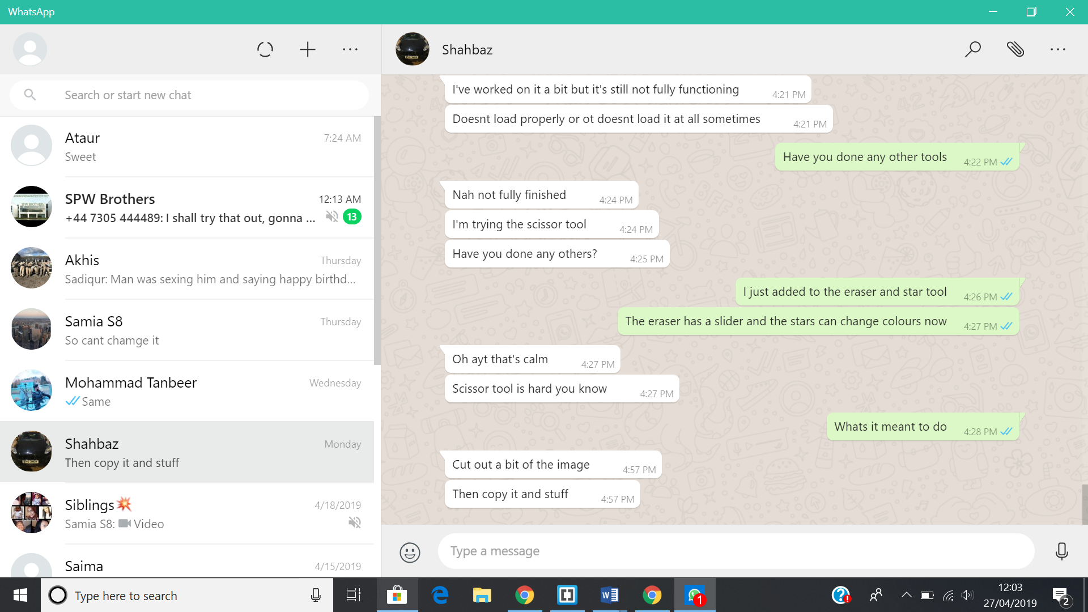

Email:

# 

# Structure of code

I structed my code in the same fashion as the other tools. All the tools were saved in different files, the name was decided and the icon for that tool was set. Global variables, if any, were declared after that. The draw function is then coded after that and if there were any other functions the tool required such as the populate options tool then it always came after the draw function

# Coding Techniques

One coding technique which I never used before is using html in JavaScript by using html ()

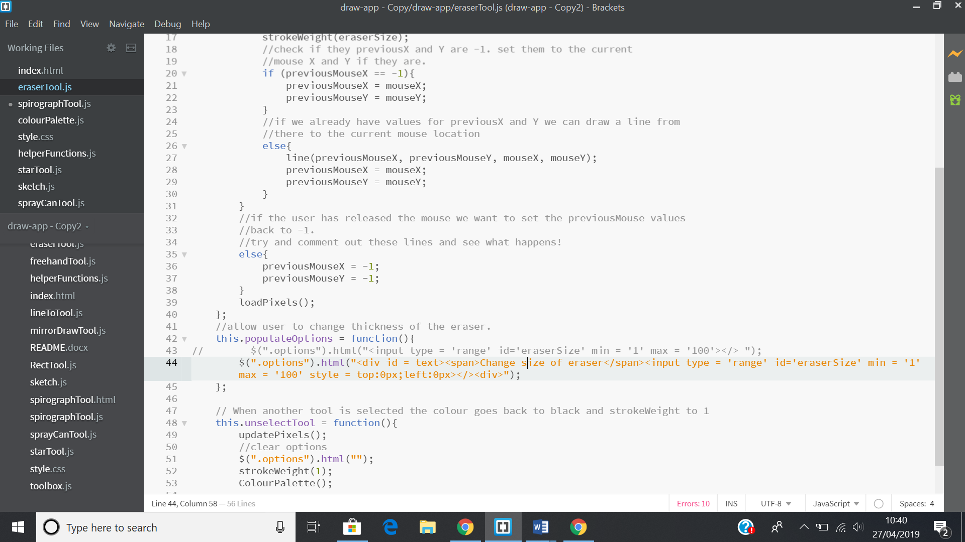

Line 44

Another technique is using camel case on variables. This makes it easier to read variables that contain more than one word like previousMouse rather having it all lower case. I also use indentation correctly to make the code look neater and easier to debug. As well as this, I used console log as way to check if my code was working correctly and if it was not then I would put console log in certain places to check if certain variables were changing the way I wanted them to or if they were even being used by the program at all. One example of this is when I was using the star tool and I had to allow the user to enter the number if stars that they wanted to use. Program was not accepting users input because when they user inputted the number of stars they wanted, it saved as a string and not number. The way I figured this out was by using console log to check the data type.

# Challenges faced

A challenged that I faced was with the colour switching when I selected another tool from the eraser or star tool. The problem was that if I am using the colour red then selected the eraser or star tool and then go back to another tool. The colour black would be selected as well as the previous colour. If you look at (20/03/19) screenshot 4 you can see two colours are selected. This was because I called colourPalette. The reason why I called colourPalette was because if I didn’t, then after clicking another tool from the eraser tool, no colour would show up. This was because in the eraser tool I used fill (255) which was white so after using the eraser if I used the freehand tool, it would draw in white. Look at (27/02/19) screenshot 2. I managed to fix this problem with star tool because I didn’t use fill so there was no need to call colourPalette but with the eraser tool because I use fill I have call colourPalette otherwise the selected colour will be white without the user knowing.

Another problem which I faced was putting a limit on the star tool. I successfully managed to put a limit on the star tool so that they could not go above 5 stars and if they typed in letters, it would not be accepted, and they would get an alert. However, for some reason the letter “e” was accepted. (12/03/19) screenshot 11. I think the reason the letter “e” was accepted was because it can be used mathematically so the program accepted as a number. I managed to fix this problem by checking if their input is a number by using parseInt. (19/03/19) Screenshot 12

Time was also an issue when there was a bug that we had to fix, we would send each other the codes and try to work out what the problem was. Sometimes this would take longer than expected. An example of this would be the colourPalette (20/03/19) screenshot 4. Time running out meant that we had to stick to a fewer tools but make sure that they were perfect and had no bugs.

# Implementation decisions justified

The reason I added a slider in the eraser tool and input box in the star tool was to make the program more interactive for the user. The user would find it more comfortable if they choose the size of the slider and be more accurate as to what they want to erase to a better degree of accuracy. The reason I added a limit to the number of stars the user could use was because they chose a number too high the stars would bunch up together and it would look closer to a square and the computer would slow down as well. It would get boring quickly if I did not add these extra features. As well as this, it was a challenge to me to see if I was able to successfully implement this the way I envisioned it in my head and I did. For the spirograph tool, I didn’t have a lot of control with the way it turned since majority of the code was taken from the internet. The parts that I did change were the sliders that determine the design of the spirograph. I put them in the options area so that when the user selects another tool, it should disappear. A feature that we added was the shapes tools. This tool was necessary as many users like to have perfect shapes and they can select a size that they like. We wanted to add in a normal triangle shape, but we had problems trying to construct the code for it. To make these tools, we looked at our older codes and have altered the code to make the shapes. This made it easier to work with and if there were any problems, they usually occurred in all three, so we were able to fix them all at once.

# Self-evaluation

One thing I would improve on would be fixing the bugs in my code like the colour switching. I also would like to add more complex tools like the blur or flood fill tool. I attempted both tools but found it too challenging to code, so I decided to do the spirograph tool. I would improve more on the spirograph tool making it so that when you press the clear or save button, the spirograph would either reset or the spirograph would save along with the rest of the canvas. But to do this I would have to draw the spirograph on the original canvas. As well as coding, managing my time so that I could complete the tasks I set out to do since this was an issue.

# Bibliography

<https://www.w3schools.com/jsref/prop_number_value.asp>

<https://www.w3schools.com/jsref/tryit.asp?filename=tryjsref_number_max2>

<https://www.w3schools.com/Js/js_popup.asp>

<https://www.w3resource.com/javascript-exercises/javascript-math-exercise-38.php>

<https://www.w3schools.com/howto/tryit.asp?filename=tryhow_css_rangeslider>

<https://bl.ocks.org/johnburnmurdoch/309de23b678aba316f3b3d802a67967f>