RESULTS

Ammonia Level Indication

- Ammonia level Normal

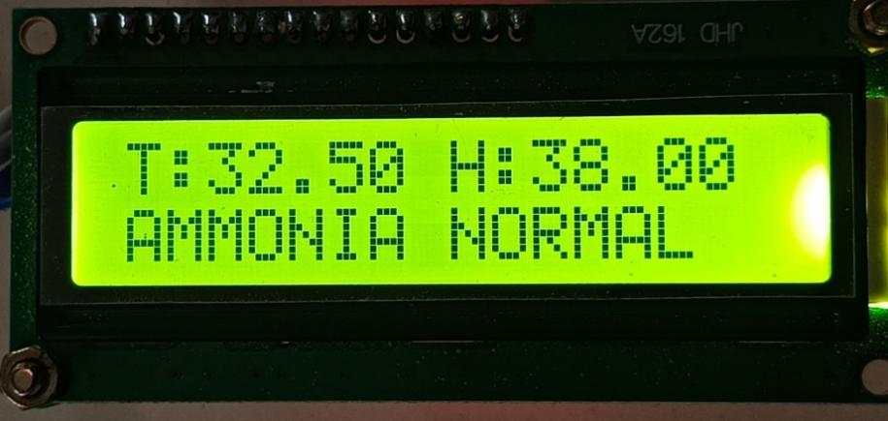

- Ammonai Level High

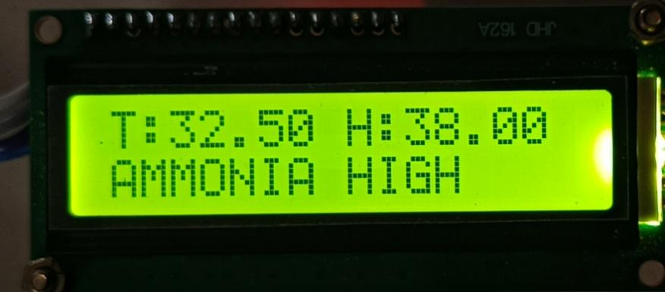

Dashboard View

- Ammonia Level View On Mobile Dashboard

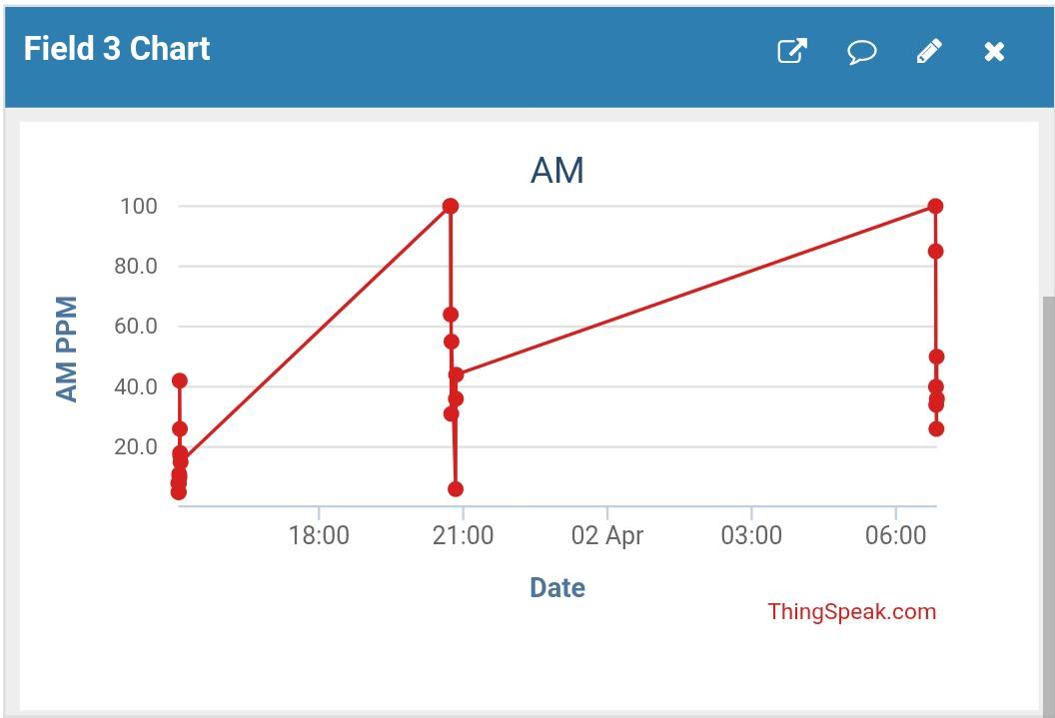

- Temperature Level View On Mobile Dashboard

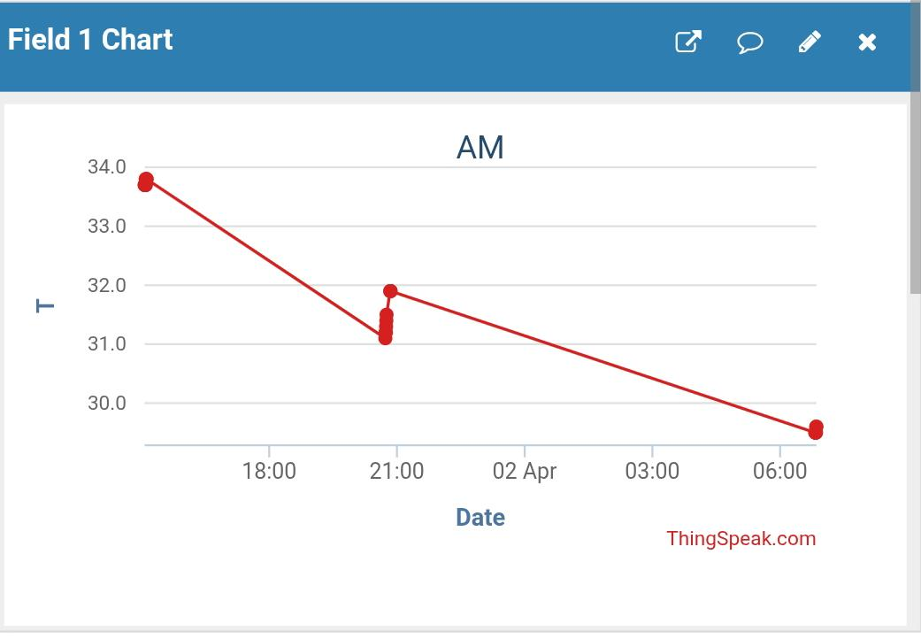

- Humidity level View On Mobile Dashboard

