**Project4 Task1 Write-up: App for Worldwide Country Holidays**

**3a) Names and Andrew ID:** Pawanjeet Singh (pawanjes), Yashvi Thakkar (ypt)

**3b) Name of API:** CALENDARIFIC

**3c) URL of API Documentation:** <https://calendarific.com/api-documentation>

**3d) Short Description:**Our application will prompt the user for a country name, year, and month. It will then search Calendarific to display all the holidays in that country for that particular year and month (all holiday types like national, local, religious or observance).

**3e)** **Screenshot of console output from 1b. –** Extract some piece of data and print it to the console.

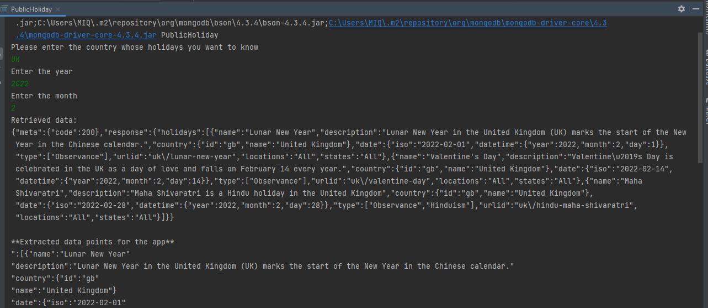

**3f) Screenshot of the console output from section 2c. -** Print all strings contained in these documents to the console.

