What is a container ?
A container is a standard unit of software that packages up code and all its dependencies, so the application runs quickly and reliably from one computing environment to another.
A Docker container image is a lightweight, standalone, executable package of software that includes everything needed to run an application: code, runtime, system tools, system libraries and settings.
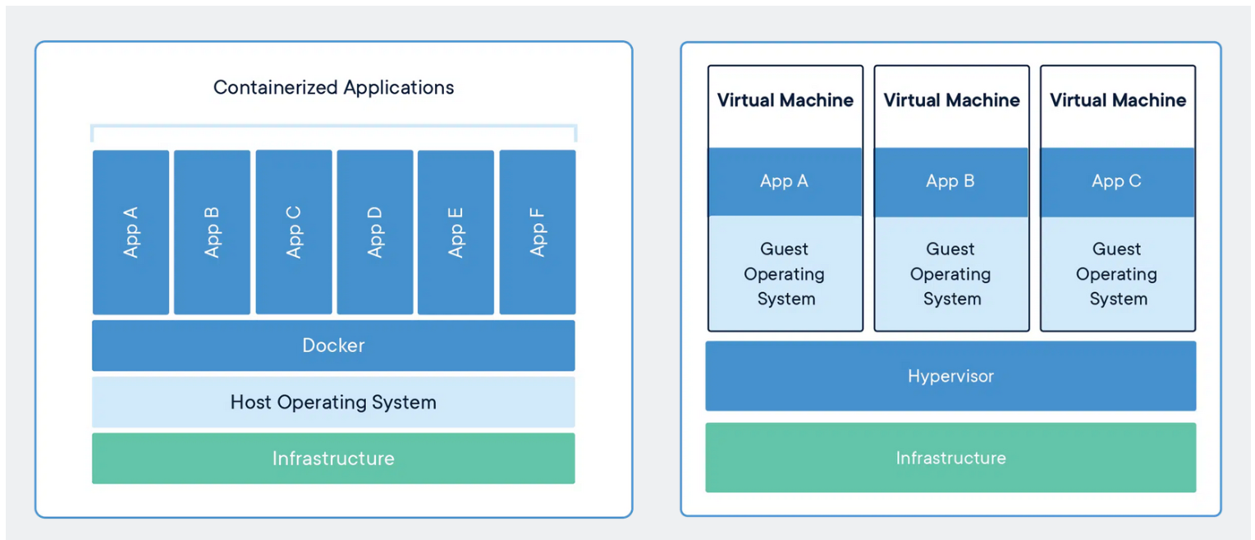

Containers and virtual machines are both technologies used to isolate applications and their dependencies, but they have some key differences:
1. Resource Utilization: Containers share the host operating system kernel, making them lighter and faster than VMs. VMs have a full-fledged OS and hypervisor, making them more resource-intensive.
2. Portability: Containers are designed to be portable and can run on any system with a compatible host operating system. VMs are less portable as they need a compatible hypervisor to run.
3. Security: VMs provide a higher level of security as each VM has its own operating system and can be isolated from the host and other VMs. Containers provide less isolation, as they share the host operating system.
4. Management: Managing containers is typically easier than managing VMs, as containers are designed to be lightweight and fast-moving.

Why are containers light weight ?
Containers are lightweight because they use a technology called containerization, which allows them to share the host operating system's kernel and libraries, while still providing isolation for the application and its dependencies. This results in a smaller footprint compared to traditional virtual machines, as the containers do not need to include a full operating system. Additionally, Docker containers are designed to be minimal, only including what is necessary for the application to run, further reducing their size.

Let's try to understand this with an example:

Below is the screenshot of official ubuntu base image which you can use for your container. It's just ~ 22 MB, isn't it very small ? on a contrary if you look at official ubuntu VM image it will be close to ~ 2.3 GB. So the container base image is almost 100 times less than VM image.

Files and Folders in containers base images:
/bin: contains binary executable files, such as the ls, cp, and ps commands.
/sbin: contains system binary executable files, such as the init and shutdown commands.
/etc: contains configuration files for various system services.
/lib: contains library files that are used by the binary executables.
/usr: contains user-related files and utilities, such as applications, libraries, and documentation.
/var: contains variable data, such as log files, spool files, and temporary files.
/root: is the home directory of the root user.

Files and Folders that containers use from host operating system
The host's file system: Docker containers can access the host file system using bind mounts, which allow the container to read and write files in the host file system.
Networking stack: The host's networking stack is used to provide network connectivity to the container. Docker containers can be connected to the host's network directly or through a virtual network.
System calls: The host's kernel handles system calls from the container, which is how the container accesses the host's resources, such as CPU, memory, and I/O.
Namespaces: Docker containers use Linux namespaces to create isolated environments for the container's processes. Namespaces provide isolation for resources such as the file system, process ID, and network.
Control groups (cgroups): Docker containers use cgroups to limit and control the amount of resources, such as CPU, memory, and I/O, that a container can access.
It's important to note that while a container uses resources from the host operating system, it is still isolated from the host and other containers, so changes to the container do not affect the host or other containers.

What is Docker?
Docker is a containerization platform that provides easy way to containerize your applications, which means, using Docker you can build container images, run the images to create containers and also push these containers to container registries such as Docker Hub, Quay.io and so on.
In simple words, you can understand as containerization is a concept or technology and Docker Implements Containerization.
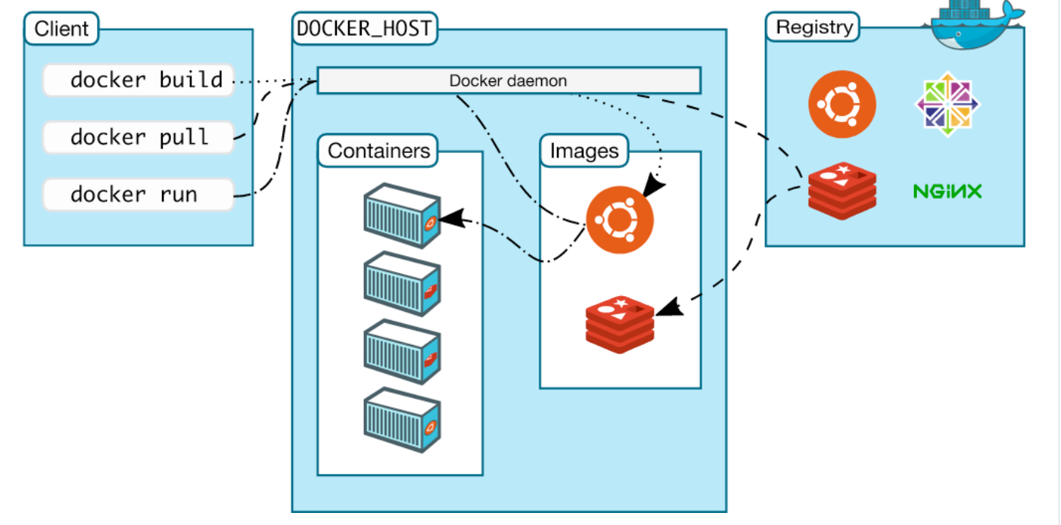
The above picture , clearly indicates that Docker Deamon is brain of Docker. If Docker Deamon is killed, stops working for some reasons, Docker is brain dead: p (sarcasm intended).

Docker LifeCycle:
We can use the above Image as reference to understand the lifecycle of Docker.
There are three important things,
docker build -> builds docker images from Dockerfile
docker run -> runs container from docker images
docker push -> push the container image to public/private regestries to share the docker images.
Understanding the terminology (Inspired from Docker Docs)
Docker daemon
The Docker daemon (dockerd) listens for Docker API requests and manages Docker objects such as images, containers, networks, and volumes. A daemon can also communicate with other daemons to manage Docker services.
Docker client
The Docker client (docker) is the primary way that many Docker users interact with Docker. When you use commands such as docker run, the client sends these commands to dockerd, which carries them out. The docker command uses the Docker API. The Docker client can communicate with more than one daemon.
Docker Desktop
Docker Desktop is an easy-to-install application for your Mac, Windows or Linux environment that enables you to build and share containerized applications and microservices. Docker Desktop includes the Docker daemon (dockerd), the Docker client (docker), Docker Compose, Docker Content Trust, Kubernetes, and Credential Helper. For more information, see Docker Desktop.

Docker registries
A Docker registry stores Docker images. Docker Hub is a public registry that anyone can use, and Docker is configured to look for images on Docker Hub by default. You can even run your own private registry.

When you use the docker pull or docker run commands, the required images are pulled from your configured registry. When you use the docker push command, your image is pushed to your configured registry. Docker objects

When you use Docker, you are creating and using images, containers, networks, volumes, plugins, and other objects. This section is a brief overview of some of those objects.

Dockerfile
Dockerfile is a file where you provide the steps to build your Docker Image.
Images
An image is a read-only template with instructions for creating a Docker container. Often, an image is based on another image, with some additional customization. For example, you may build an image which is based on the ubuntu image, but installs the Apache web server and your application, as well as the configuration details needed to make your application run.
You might create your own images or you might only use those created by others and published in a registry. To build your own image, you create a Dockerfile with a simple syntax for defining the steps needed to create the image and run it. Each instruction in a Dockerfile creates a layer in the image. When you change the Dockerfile and rebuild the image, only those layers which have changed are rebuilt. This is part of what makes images so lightweight, small, and fast, when compared to other virtualization technologies.
INSTALL DOCKER:
A very detailed instructions to install Docker are provide in the below link
https://docs.docker.com/get-docker/
For Demo,
You can create an Ubuntu EC2 Instance on AWS and run the below commands to install docker.
sudo apt update
sudo apt install docker.io -y
Start Docker and Grant Access:
A very common mistake that many beginners do is, After they install docker using the sudo access, they miss the step to Start the Docker daemon and grant acess to the user they want to use to interact with docker and run docker commands.

Always ensure the docker daemon is up and running.
A easy way to verify your Docker installation is by running the below command
docker run hello-world
If the output says:

docker: Got permission denied while trying to connect to the Docker daemon socket at unix:///var/run/docker.sock: Post "http://%2Fvar%2Frun%2Fdocker.sock/v1.24/containers/create": dial unix /var/run/docker.sock: connect: permission denied.
See 'docker run --help'.
This can mean two things,

Docker deamon is not running.
Your user does not have access to run docker commands.
Start Docker daemon
You use the below command to verify if the docker daemon is actually started and Active

sudo systemctl status docker
If you notice that the docker daemon is not running, you can start the daemon using the below command
sudo systemctl start docker
Grant Access to your user to run docker commands
To grant access to your user to run the docker command, you should add the user to the Docker Linux group. Docker group is create by default when docker is installed.
sudo usermod -aG docker ubuntu
In the above command ubuntu is the name of the user, you can change the username appropriately.

NOTE: : You need to logout and login back for the changes to be reflected.
Docker is Installed, up and running 🥳🥳
Use the same command again, to verify that docker is up and running.
docker run hello-world
Login to Docker [Create an account with https://hub.docker.com/]
docker login
Login with your Docker ID to push and pull images from Docker Hub. If you don't have a Docker ID, head over to https://hub.docker.com to create one.
Username: abhishekf5
Password:
WARNING! Your password will be stored unencrypted in /home/ubuntu/.docker/config.json.
Configure a credential helper to remove this warning. See
https://docs.docker.com/engine/reference/commandline/login/#credentials-store

Login Succeeded
Build your first Docker Image
docker build -t abhishekf5/my-first-docker-image:latest .
Output of the above command

e:latest
Verify Docker Image is created
docker images
Output
REPOSITORY TAG IMAGE ID CREATED SIZE
abhishekf5/my-first-docker-image latest 960d37536dcd 26 seconds ago 467MB
ubuntu latest 58db3edaf2be 13 days ago 77.8MB
hello-world latest feb5d9fea6a5 16 months ago 13.3kB
Run your First Docker Container
docker run -it abhishekf5/my-first-docker-image
Output
Hello World
Push the Image to DockerHub and share it with the world
docker push abhishekf5/my-first-docker-image
----------------------------------------------------------------------------------------------------------------------------
Docker Commands
Some of the most commonly used docker commands are
docker images
Lists docker images on the host machine.

docker build
Builds image from Dockerfile.
docker run
Runs a Docker container.
There are many arguments which you can pass to this command for example,
docker run -d -> Run container in background and print container ID docker run -p -> Port mapping
use docker run --help to look into more arguments.
docker ps
Lists running containers on the host machine.
docker stop
Stops running container.
docker start
Starts a stopped container.
docker rm
Removes a stopped container.
docker rmi
Removes an image from the host machine.
docker pull
Downloads an image from the configured registry.
docker push
Uploads an image to the configured registry.
docker exec
Run a command in a running container.
docker network
Manage Docker networks such as creating and removing networks, and connecting containers to networks.
Docker Networking:
Networking allows containers to communicate with each other and with the host system. Containers run isolated from the host system and need a way to communicate with each other and with the host system.
By default, Docker provides two network drivers for you, the bridge and the overlay drivers.
docker network ls
NETWORK ID NAME DRIVER
xxxxxxxxxxxx none null
xxxxxxxxxxxx host host
xxxxxxxxxxxx bridge bridge
Bridge Networking:
The default network mode in Docker. It creates a private network between the host and containers, allowing containers to communicate with each other and with the host system.
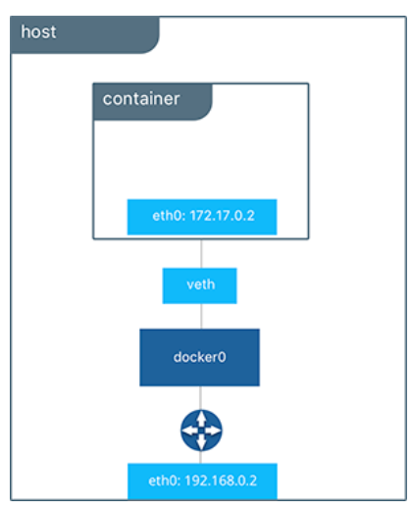
If you want to secure your containers and isolate them from the default bridge network you can also create your own bridge network.
docker network create -d bridge my_bridge
Now, if you list the docker networks, you will see a new network.
docker network ls

NETWORK ID NAME DRIVER
xxxxxxxxxxxx bridge bridge
xxxxxxxxxxxx my_bridge bridge
xxxxxxxxxxxx none null
xxxxxxxxxxxx host host
This new network can be attached to the containers, when you run these containers.
docker run -d --net=my_bridge --name db training/postgres
This way, you can run multiple containers on a single host platform where one container is attached to the default network and the other is attached to the my_bridge network.
These containers are completely isolated with their private networks and cannot talk to each other.
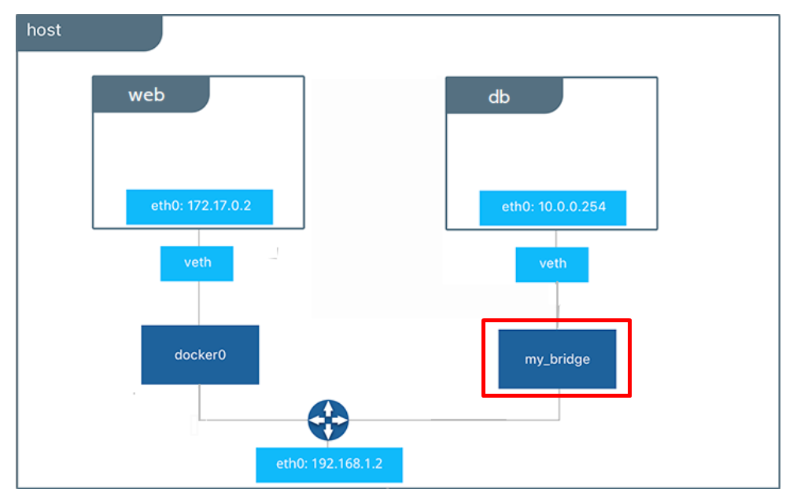
However, you can at any point of time, attach the first container to my_bridge network and enable communication
docker network connect my_bridge web
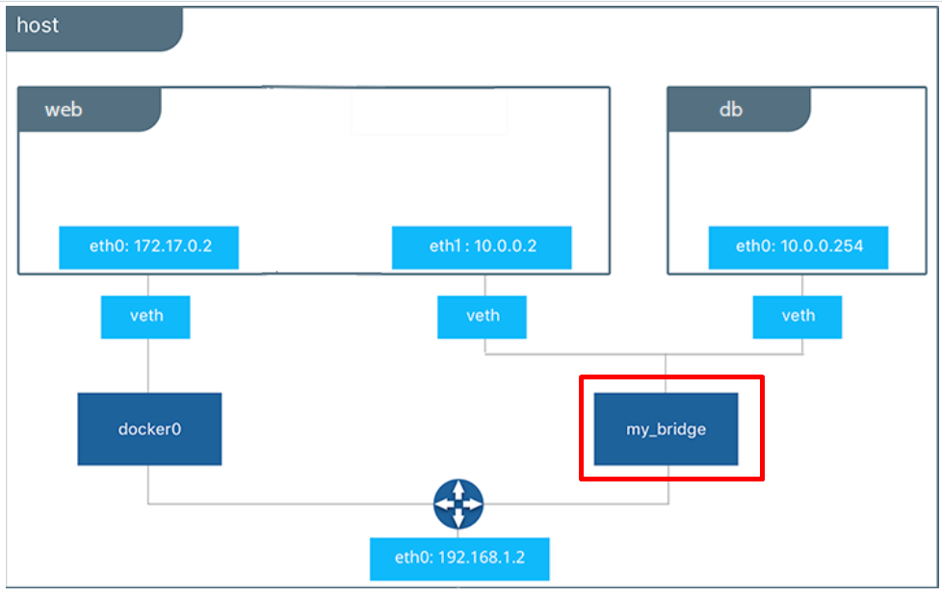
Host Networking:
This mode allows containers to share the host system's network stack, providing direct access to the host system's network.
To attach a host network to a Docker container, you can use the --network="host" option when running a docker run command. When you use this option, the container has access to the host's network stack, and shares the host's network namespace. This means that the container will use the same IP address and network configuration as the host.
Here's an example of how to run a Docker container with the host network:
docker run --network="host" <image_name> <command>
Keep in mind that when you use the host network, the container is less isolated from the host system, and has access to all of the host's network resources. This can be a security risk, so use the host network with caution.
Additionally, not all Docker image and command combinations are compatible with the host network, so it's important to check the image documentation or run the image with the --network="bridge" option (the default network mode) first to see if there are any compatibility issues.
Overlay Networking:
This mode enables communication between containers across multiple Docker host machines, allowing containers to be connected to a single network even when they are running on different hosts.
Macvlan Networking
This mode allows a container to appear on the network as a physical host rather than as a container.

Docker Volumes:
Problem Statement
It is a very common requirement to persist the data in a Docker container beyond the lifetime of the container. However, the file system of a Docker container is deleted/removed when the container dies.
Solution
There are 2 different ways how docker solves this problem.
- Volumes
- Bind Directory on a host as a Mount
Volumes
Volumes aims to solve the same problem by providing a way to store data on the host file system, separate from the container's file system, so that the data can persist even if the container is deleted and recreated.
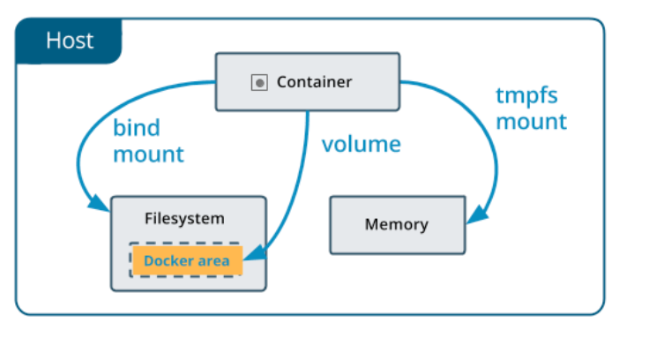
Volumes can be created and managed using the docker volume command. You can create a new volume using the following command:
docker volume create <volume_name>
Once a volume is created, you can mount it to a container using the -v or --mount option when running a docker run command.
For example:
docker run -it -v <volume_name>:/data <image_name> /bin/bash
This command will mount the volume <volume_name> to the /data directory in the container. Any data written to the /data directory inside the container will be persisted in the volume on the host file system

Bind Directory on a host as a Mount:
Bind mounts also aims to solve the same problem but in a complete different way.
Using this way, user can mount a directory from the host file system into a container. Bind mounts have the same behavior as volumes, but are specified using a host path instead of a volume name.
For example,
docker run -it -v <host_path>:<container_path> <image_name> /bin/bash
Key Differences between Volumes and Bind Directory on a host as a Mount
Volumes are managed, created, mounted and deleted using the Docker API. However, Volumes are more flexible than bind mounts, as they can be managed and backed up separately from the host file system, and can be moved between containers and hosts.
In a nutshell, Bind Directory on a host as a Mount are appropriate for simple use cases where you need to mount a directory from the host file system into a container, while volumes are better suited for more complex use cases where you need more control over the data being persisted in the container.

Docker compose:
https://github.com/docker/awesome-compose
