Cluster:
In cloud computing, a cluster refers to a group of interconnected computers, or nodes, that work together as a single, unified system. This unified system provides enhanced performance, scalability, and reliability compared to a single computer.
Key Concepts:
- Nodes:
Individual computers or servers within the cluster.
- Interconnected:
Nodes are connected through high-speed networks, allowing them to communicate and share data.
- Single System Image:
From a user's perspective, the cluster appears as a single, powerful computer.
- Parallel Processing:
Clusters enable parallel processing, where tasks are divided and processed concurrently across multiple nodes, improving performance.
- Fault Tolerance:
Clusters can be designed to be fault-tolerant, meaning that if one node fails, the others can continue working, ensuring uninterrupted service.
Benefits of using clusters in cloud computing:
- Scalability:
Clusters can easily scale up or down to meet changing demands by adding or removing nodes.
- Performance:
Distributing workloads across multiple nodes can significantly improve processing speed and responsiveness.
- Reliability:
Redundancy through multiple nodes makes the system more resilient to failures and ensures high availability.
- Cost-effectiveness:
Clustering can be a cost-effective way to achieve high performance and reliability compared to relying on a single, powerful machine,
Docker & Kubernetes different:
Docker is a simple container platform.
Kubernetes is a container orchestration platform.
Container is ephemeral in nature (short life)

Docker doesn't
* Auto healing, auto starting without user intervention
* Autoscaling when load on application increase
Docker is single host,
No enterprise level support for load balancing, auto heal, apu gateway, firewall etc

Kubernetes
is by default a cluster that is , control plane and nodes. Auto scaling - either manually through yaml replica edition or HPA horizontal pod autoscaler(when load reaches threshold) *Auto healing - when there is damage, Kubernetes control or fix the damage. One pod/container goes down. Using auto healing , even before pod goes down, whenever Api server receives a signal container is going down it will rollout a new pod is created. Enterprise support - load balancing support, firewall support by CNCF . Lots of enhancement , development integration support for different tools, load balancer, Prometheus monitoring tools
container orchestration platform:
automates the deployment, scaling, and management of containerized applications. These platforms handle tasks like scheduling containers, distributing workloads, ensuring high availability, and monitoring application health, simplifying the complexities of running containerized software at scale.
Here's a more detailed explanation:
What it does:
- Automates Deployment:
Container orchestration platforms take the manual effort out of deploying applications by automating the process of creating, configuring, and starting containers.
- Scales Applications:
They can automatically adjust the number of running containers based on demand, ensuring applications can handle traffic spikes and scale down when resources are not needed.
- Manages Resources:
Orchestration platforms allocate resources (CPU, memory, etc.) to containers, ensuring efficient utilization and preventing resource conflicts.
- Ensures High Availability:
By monitoring container health and automatically replacing failed containers, these platforms maintain application availability and prevent downtime.
- Simplifies Networking:
They handle container networking, making it easier for containers to communicate with each other and with external services.
Key Components:
- Container Runtime: This is the software that actually runs containers (e.g., Docker, containerd).
- Scheduler: Determines where containers are placed on the available infrastructure.
- Control Plane: Provides the user interface and APIs for managing the platform.
- API Server: Exposes the orchestration platform's functionality through an API.
- etcd: A distributed key-value store used to maintain the state of the cluster.
Popular Platforms:
- Kubernetes:
A widely used open-source platform created by Google, known for its rich features and scalability.
- Docker Swarm:
Docker's native container orchestration solution, offering simplicity and integration with Docker tools.
- Apache Mesos/Marathon:
A platform designed for large-scale deployments, known for its ability to manage tens of thousands of machines.
- Red Hat OpenShift:
A commercial Kubernetes distribution that offers additional features and management tools.
Benefits of using container orchestration:
- Increased Agility: Faster deployment cycles and easier updates.
- Improved Resource Utilization: Containers share resources efficiently, reducing costs.
- Enhanced Scalability: Applications can easily scale up or down to meet demand.
- Reduced Complexity: Automation simplifies the management of containerized applications.
- Greater Reliability: Automated failover and health checks ensure high availability.

KUBERNETES ARCHITECTUR:

Control plane components are - api server, etcd, scheduler, controller manager, ccm _ cloud controller manager.
- Control Plane (Master Node) →
1) API Server (exposes to external world)
2) Scheduler (Scheduling pods or resources in K8s) Receives information from API server
3) etcd: Backup service (key value store)
4) Controller Manager Example: Replica Set
5) CCM (Cloud Controller Manager) - No need for on-premice
Data plane:
Node components - kubelet, kube proxy, container runtime
Container runtime is equivalent to containerd in docker
Kubelet is responsible for running and ensuring pod is always running.
Kubelete interacts with container-runtime to i e cri-o(Container Runtime Interface) or containerd to run the container inside pod. If pod is not running & kubelet will inform kube_apiserver.
Kube-proxy - provides, networking, ipaddresses and load balancing for the pod to communicate, Implements iptables..
---------------------------------------------------------K8s Production system----------------------------------------------
Kubernetes is open-source, but there is certain distribution that provide support and build for providing user experience to its customers.
Distribution provides additional wrapper, plugin and command line tools.
distribution: Open shift, rancher,tanzu, eks, aks, gke ,etc, they are used in production,But at the end of day solution is same.
Most used cluster management tool is kops and then kubeadm.
Kops stands for Kubernetes operations * Installation, upgradation, configuration and deletion are part of lifecycle of Kubernetes cluster

Pods:( running specification for the container)
Pods is one /group of containers , but most of the time pods is single container , and there are some cases if you have used side car container / init container which are needed to share the config file/ user file to other container and use to main container , so that situation , these containers are group into one pods
Kubernetes allow shared networking and shared storage for multi container pod. Since localhost communication happens within the pod.
IPaddress are generated for pod from range of podCIDR.
Pod is a wrapper around container.
Kubeproxy generates the ip address for pod( cluster ip address).
Deployment:
Pod has running specification and can have multiple container.
Side car container for service mesh. Service mesh is established by sidecar proxy.
Deployment is capable of providing capabilities like autohealing and autoscaling. Deployment will create an intermediate resource called replica set and then replica set will create/rollout pod replicas..
So end of the day we are creating pods.
Since replica set is Kubernetes controller , it will implement autohealing and ensure that there are always two replicas of pods running.
A Controller ensure desired state matches the current state in Kubernetes.

KUBERNETES SERVICES:
For each deployment you will create a service in the world of Kubernetes.
So what is ideal pod numbers/count of replicas is decided by number of concurrent users trying to access the application and no. Of user or load a single pod can handle.
When a pod replica dies, a new pod replaces with new ip adress as a feature of auto healing
Service created on top of development and it acts as load balancer. Instead of accessing the ips of every single pod, service is used instead.
Service using the kube-proxy will forward the request to underlying pod based on label and selectors, load balancing them out at the same time.
Service keep tracks of pods based on labels and selectors instead of ip adress, since ip adress are bound to change.
Service also expose your application to the external world, for end user to use the application.
Config Maps:
A Kubernetes ConfigMap is an API object used to store non-confidential configuration data in key-value pairs. Its primary purpose is to decouple configuration details from the application code and container images, enhancing the flexibility, reusability, and portability of applications within a Kubernetes cluster.
Key characteristics and uses of ConfigMaps:
Storage of non-confidential data:
ConfigMaps are designed for storing general configuration settings, such as environment variables, command-line arguments, or entire configuration files, that do not require high-level security. For sensitive information like passwords or API keys, Kubernetes Secrets should be used instead.
Decoupling configuration:
By externalizing configuration data into ConfigMaps, you can update application settings without needing to rebuild or redeploy container images. This simplifies management and allows for environment-specific configurations (e.g., development, testing, production) to be easily applied.
Consumption by Pods:
Pods can consume ConfigMap data in several ways:
As environment variables: Key-value pairs from a ConfigMap can be injected directly into a container as environment variables.
As mounted volumes: ConfigMap data can be mounted as files within a Pod's volume, allowing applications to read configuration from files.
As command-line arguments: ConfigMap values can be used as arguments when starting a container.
Flexibility and Portability:
ConfigMaps enable applications to be more environment-agnostic, as the specific configuration can be provided at deployment time, making them easily portable across different Kubernetes setups.
Immutability (optional):
ConfigMaps can be made immutable, preventing accidental modifications and ensuring configuration stability. Changes to an immutable ConfigMap require deletion and recreation.

Secret:
In Kubernetes, a Secret is an object designed to store and manage sensitive information required by applications running within the cluster. This sensitive data can include passwords, API keys, OAuth tokens, SSH keys, or other credentials.
The primary purpose of using Secrets is to prevent the embedding of sensitive data directly within Pod definitions, container images, or configuration files, which could lead to accidental exposure and security vulnerabilities. By abstracting this information into a Secret object, Kubernetes provides a more secure and manageable way to handle sensitive data.
Type Of secret:
Opaque: used for storing arbitrary, user-defined data as key-value pairs.
kubernetes.io/tls: This type is designed to store TLS certificates and their corresponding private keys, commonly used for securing communication
kubernetes.io/basic-auth: This Secret type is specifically for storing credentials (username and password) used for basic HTTP authentication.
kubernetes.io/ssh-auth: Used for storing SSH private keys, enabling secure shell authentication to external systems from within Kubernetes Pods.

kubernetes.io/dockerconfigjson:These types are used to store credentials for accessing Docker registries, allowing Kubernetes to pull images from private repositories.
Key characteristics and functionalities of Kubernetes Secrets:
- Storage of Sensitive Data:
Secrets hold sensitive data as key-value pairs. The values are typically base64 encoded, which provides a level of obfuscation but is not encryption. True security relies on encryption at rest and robust access controls.
- Separation from Application Code:
Secrets enable the separation of sensitive information from application code and configuration, improving security and maintainability.
- Integration with Pods:
Secrets can be consumed by Pods in various ways:
  - Mounted as Volumes: Secrets can be mounted as data volumes within a Pod, making the sensitive data available as files in the container's filesystem.
  - Exposed as Environment Variables: Sensitive data from a Secret can be injected into a container's environment variables.

Difference between ConfigMap & Secret ?
ConfigMaps and Secrets are both Kubernetes objects used to store configuration data for applications, but they differ primarily in their intended use and security characteristics.
ConfigMap:
- Purpose:
Stores non-sensitive configuration data, such as environment variables, application settings, or configuration files.
- Security:
Data is stored in plain text and is not encrypted at rest. It is suitable for information that does not require confidentiality.
- Usage:
Can be consumed by Pods as environment variables, command-line arguments, or mounted as files within a volume.
Secret:
- Purpose:
Stores sensitive data, such as passwords, API keys, TLS certificates, or other credentials.
- Security:
Data is base64-encoded and encrypted at rest within etcd. While base64 encoding is not encryption, Kubernetes adds encryption at rest for Secrets.
- Usage:
Similar to ConfigMaps, Secrets can be consumed by Pods as environment variables or mounted as files within a volume. They offer an additional layer of security for sensitive information.

Using a Volume Mount for reading a ConfigMap in Kubernetes offers several advantages over using environment variables:
- Dynamic Updates:
Changes to a ConfigMap mounted as a volume are automatically reflected in the running Pod without requiring a restart. This enables dynamic configuration updates and reduces downtime for applications that can consume file-based configuration. In contrast, changes to ConfigMaps used to set environment variables require the Pod to be recreated or restarted for the changes to take effect.
- Handling Large Configurations:
Volume mounts are more suitable for ConfigMaps containing a large number of key-value pairs or multi-line configurations, such as entire configuration files (e.g., nginx.conf). Each key-value pair in a mounted ConfigMap becomes a separate file within the mounted directory, allowing applications to read them as regular files. Environment variables are better suited for smaller, simpler configurations.
- Application Compatibility:
Many applications are designed to read their configuration from files on the local filesystem. Mounting a ConfigMap as a volume allows these applications to consume the configuration directly without modification, preserving their expected behavior.

- Security and Access Control:
While both methods have security considerations, volume mounts can offer a more controlled way to expose sensitive data stored in ConfigMaps (or Secrets). When mounted, the data is typically accessed by the application as files, and permissions can be managed at the filesystem level. Environment variables are accessible to any process within the Pod, which can sometimes be a broader exposure.
- Flexibility for File-Based Configuration:
If an application expects specific configuration files (e.g., a .properties file, a .yaml file), mounting a ConfigMap as a volume allows you to present the ConfigMap's data as these specific files, maintaining the application's expected file structure.
Volumes:
Kubernetes volumes provide a way for containers in a pod to access and share data via the filesystem. There are different kinds of volume that you can use for different purposes, such as:
- populating a configuration file based on a ConfigMap or a Secret
- providing some temporary scratch space for a pod
- sharing a filesystem between two different containers in the same pod
- sharing a filesystem between two different pods (even if those Pods run on different nodes)
- durably storing data so that it stays available even if the Pod restarts or is replaced
- passing configuration information to an app running in a container, based on details of the Pod the container is in (for example: telling a sidecar container what namespace the Pod is running in)
- providing read-only access to data in a different container image
Data sharing can be between different local processes within a container, or between different containers, or between Pods.

Why volumes are important
- Data persistence: On-disk files in a container are ephemeral, which presents some problems for non-trivial applications when running in containers. One problem occurs when a container crashes or is stopped, the container state is not saved so all of the files that were created or modified during the lifetime of the container are lost. After a crash, kubelet restarts the container with a clean state.
- Shared storage: Another problem occurs when multiple containers are running in a Pod and need to share files. It can be challenging to set up and access a shared filesystem across all of the containers.

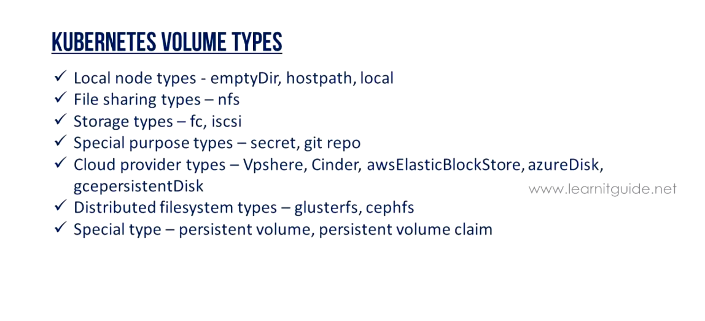
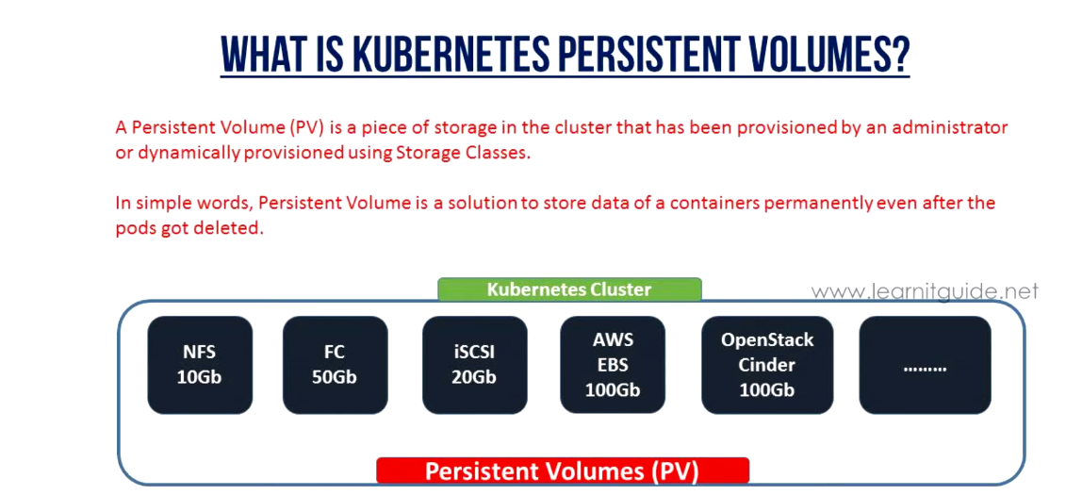
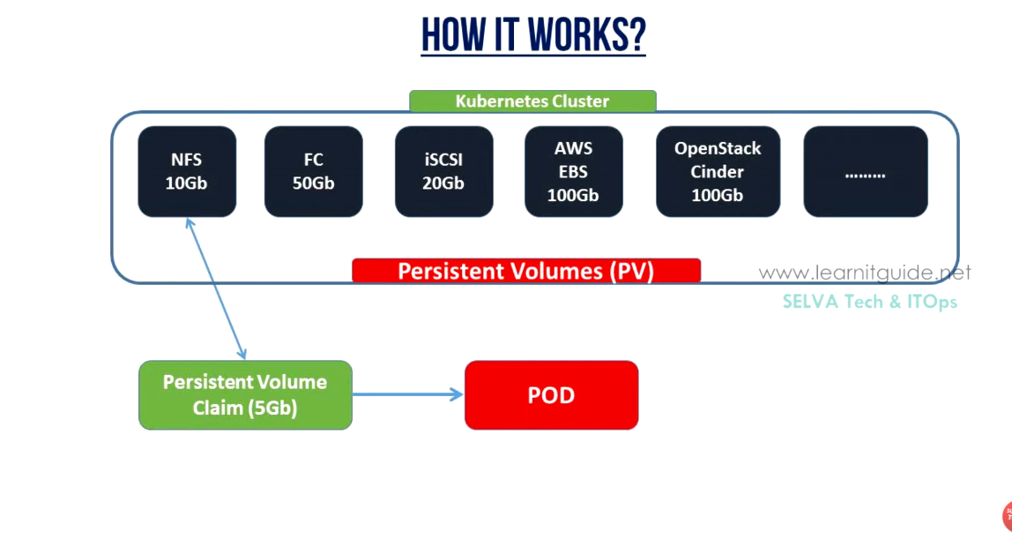
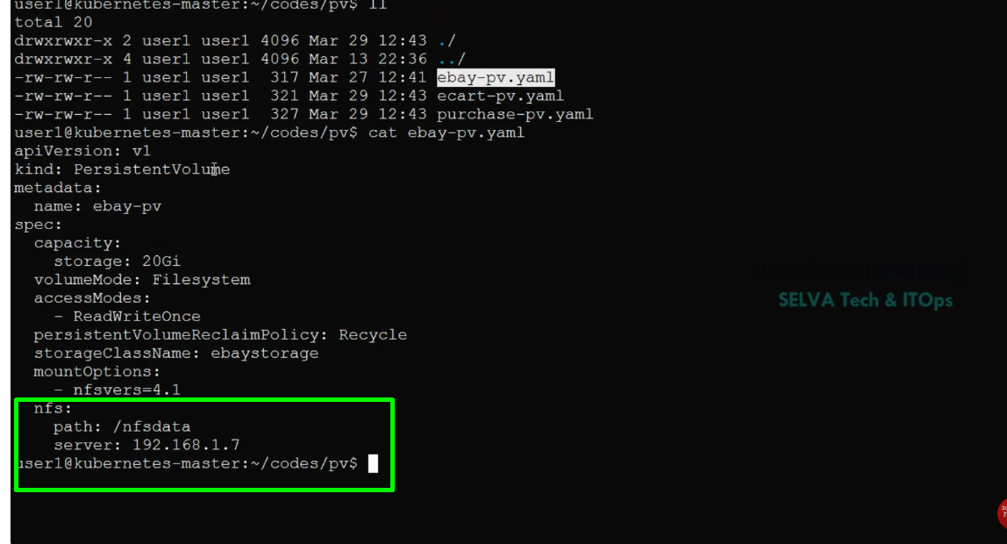
A Kubernetes Persistent Volume (PV) represents a piece of storage in a Kubernetes cluster that has been provisioned for use by applications. Unlike ephemeral volumes, which are tied to the lifecycle of a Pod, a PV's lifecycle is independent, meaning data stored on a PV persists even if the Pod using it is deleted or recreated.
Key characteristics of Kubernetes Persistent Volumes:
- Cluster Resource:
PVs are resources within the Kubernetes cluster, similar to nodes, and are managed by the cluster administrator.
- Decoupled Lifecycle:
The data on a PV remains available regardless of the lifecycle of the application, container, Pod, Node, or even the cluster itself.
- Abstraction of Storage Details:
PVs abstract the underlying storage implementation details (e.g., NFS, iSCSI, cloud provider-specific storage like AWS EBS or EFS) from the application developer.
- PersistentVolumeClaim (PVC):
Pods access PVs indirectly through PersistentVolumeClaims (PVCs). A PVC is a request for storage by a user, specifying requirements like storage capacity and access modes. Kubernetes then binds a suitable PV to the PVC.
- Access Modes:
PVs define how the volume can be mounted, such as ReadWriteOnce (only one node can mount it for read/write), ReadOnlyMany (multiple nodes can mount it for read-only), and ReadWriteMany (multiple nodes can mount it for read/write).
- Reclaim Policies:
PVs have reclaim policies (e.g., Retain, Recycle, Delete) that determine what happens to the underlying storage when the associated PVC is deleted.

Prometheus:
https://github.com/iam-veeramalla/observability-zero-to-hero/blob/main/day-2/readme.md

