What is Kubernetes Volumes?
Kubernetes Volumes are used to store data that should be accessible across all your containers running in a pod based on the requirement.

What are the types of Kubernetes Volumes?
Kubernetes supports many kind of storage types, these are determined by how it is created and assigned to pods.

Local Node Types - emptyDIR, hostpath, local
File Sharing types - nfs
Storage types - fc, iscsi
Special Purpose Types - Secret, Git repo
Cloud Provider types - Vsphere, Cinder, awsElasticBlockStore, azureDisk, gcepersistentDisk
Distributed filesystem types - glusterfs, cephfs
Special type - persistent volume, persistent volume claim

Note:
1. emptyDIR - Its a type of storage types that writes data only in memory till the pods running. So you data will be erased when the pod is deleted. So its not a persistent kind of types.
2. hostpath, local, fc and other types are persistent kind only, but volume wont be available across the nodes.
it will be available only on local nodes. So we may need to setup something shared volume using traditional storage mount across all the nodes.
3. Persistent volume type volumes can be accessible across all the nodes.

How to use kubernetes volumes to pod and containers?
Use an option "Volumes" along with name and types as below in a deployment file for the entire PODS and use the "volumeMounts"
along with mountPath where the volume to be mounted for the container.
we must use the volume name unique and exactly as specified in specification for the containers.
If not you will end up with error.

How to assign single volume to specific container in a pod?

spec:
volumes:
- name: volume
hostPath:
path: /mnt/data
containers:
- name: container1-nginx
image: nginx
volumeMounts:
- name: volume
mountPath: "/var/nginx-data"
- name: container2-tomcat
image: tomcat

How to share same volume to all containers within a pod?
In order to share a same volume to all containers running in a pod, we must use volumemounts option in all containers.
spec:
volumes:
- name: volume
hostPath:
path: /mnt/data
containers:
- name: container1-nginx
image: nginx
volumeMounts:
- name: volume
mountPath: "/var/nginx-data"
- name: container2-tomcat
image: tomcat
volumeMounts:
- name: volume
mountPath: "/var/tomcat-data"

How to assign dedicated volumes to each container in a pod?
In order to assign a dedicated volumes to each containers running in a pod, we must use volumes and
volumemounts option in all containers accordingly as per the example given below.
spec:
volumes:
- name: volume1
hostPath:
path: /mnt/data1
- name: volume2
hostPath:
path: /mnt/data2
containers:
- name: container1-nginx
image: nginx
volumeMounts:
- name: volume1
mountPath: "/var/nginx-data"
- name: container2-tomcat
image: tomcat
volumeMounts:
- name: volume2
mountPath: "/var/tomcat-data"

How to assign shared volume across all pods running on different worker nodes?

Why do we actually need this setup is, so far we have seen volumes that is used only on single pod running on one worker node.
so your data wont be available when pod is rescheduled to other node since your hostpath you have used is local directory.

If you want your data to be available for all worker nodes, we must have shared volumes concepts to overcome such situation.
We can use a special type ie PersistentVolume and PersistentVolumeClaim or our traditional approach that mount a shared volume from storage
and use that mounted path in the deployment file.

PV:
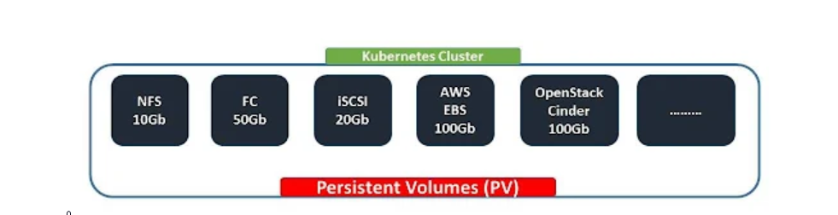
A PersistentVolume (PV) is a piece of storage in the cluster that has been provisioned by an administrator or
dynamically provisioned using Storage Classes.
In simple words, Kubernetes Persistent Volumes is a solution to store data of our containers permanently even after the pods got deleted.

What is Kubernetes Persistent Volumes Claim?
A PersistentVolumeClaim (PVC) is a claim request for some storage space by users.
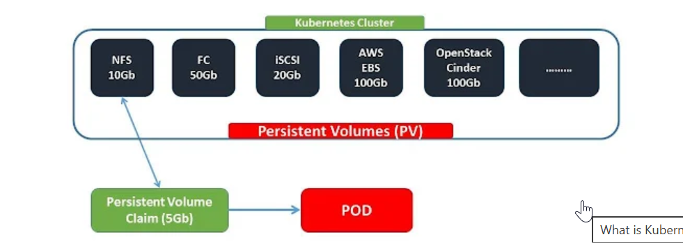
How it is different from other kubernetes volume types?
Lets say you have multiple pod running on different nodes and you used hostpath volume type. Your data written by pod 1 running on worker node 1 will be resides only on worker node 1 and that cannot be access by pod 2 running on worker node 2. similarly pod 1 cannot access data written by pod 2 on worker node 2. right?. Since hostpath is a type that writes data only on your local node directory. Its not kind of a shared volume.
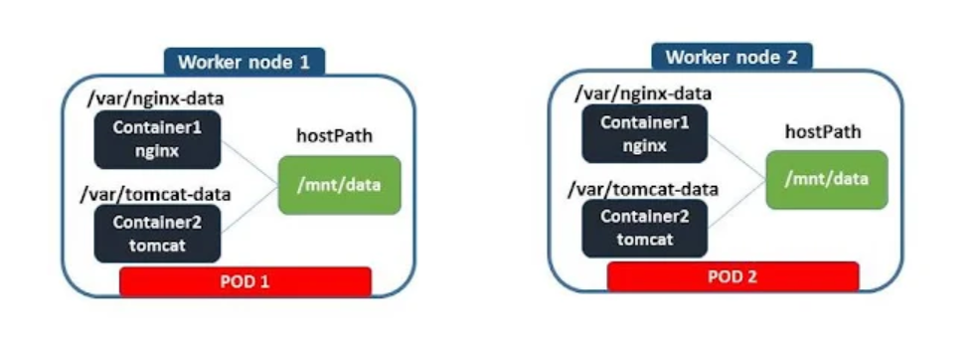
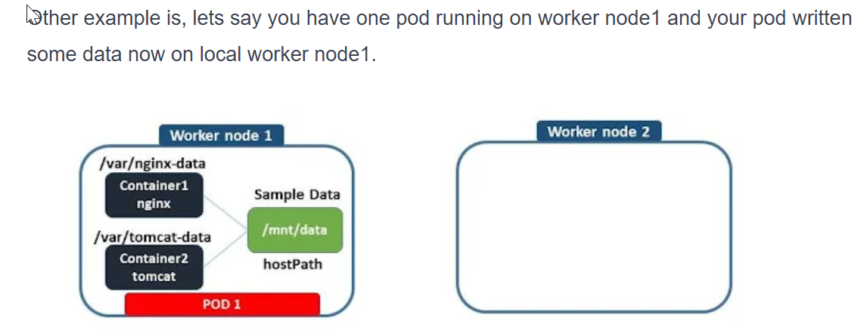
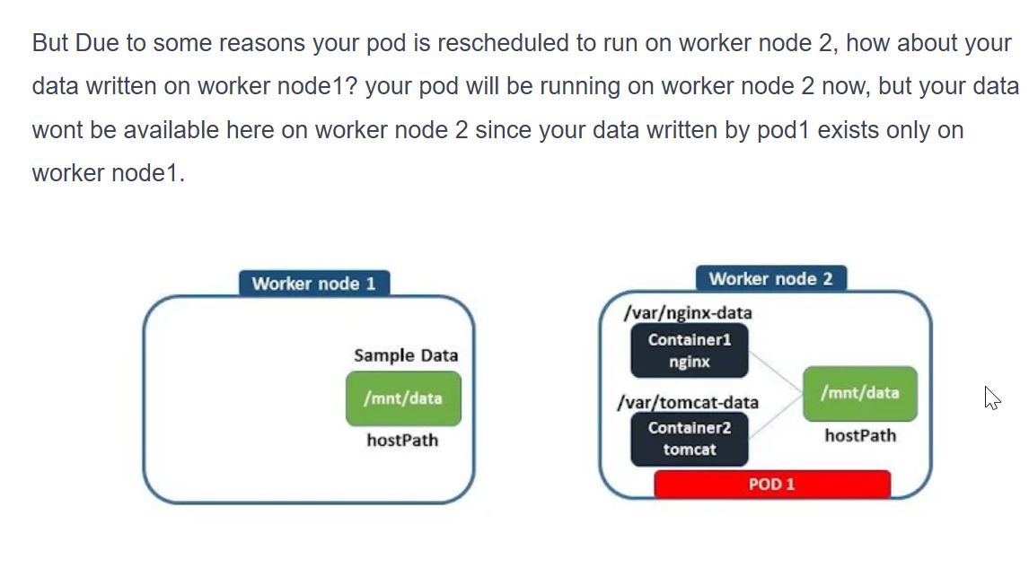
So we must have shared volume that should be accessible across all worker nodes only when pods need it. In this case, persistent volume and persistent volume claim can be used at the kubernetes cluster level.
But there is a traditional method to have shared volume across worker nodes at operating system level by mounting some volume through nfs, fc, iscsi on all worker nodes that can share the same volume.
Before I explain you how to create persistent volume and persistent volume claim, Let me explain you What is actually happening in persistent volume and how it works?
In a legacy infrastructure environment, when you need additional storage space to your server, you will reach out to the storage administrator for the space. So there would be a storage administrator who allocates some storage space from storage device to your server as you requested.
Similarly, in kubernetes. Persistent volume is a resource type through which you can get your storage space allocated to your kubernetes cluster. Let's say you got some 10G persistent volume allocated to your kubernetes cluster.

Obviously that should be through any one of the kubernetes volume types. Might be through iscsi, fc, nfs, or any other cloud providers. From which you can claim some space you want for your pod using persistent volume claim.

Let's say you want 5gb for your pod. You can use persistent volume claim to request 5gb space from your persistent volume. Now you persistent volume will allocates the space you requested using persistent volume when it is find suitable, now you can use that volume claim in your deployment.
Persistent Volume supports three types of Reclaim Policy - Retain, Delete and Recycle and also it supports different access modes which are ReadWriteOnce, ReadOnlyMany and ReadWriteMany.
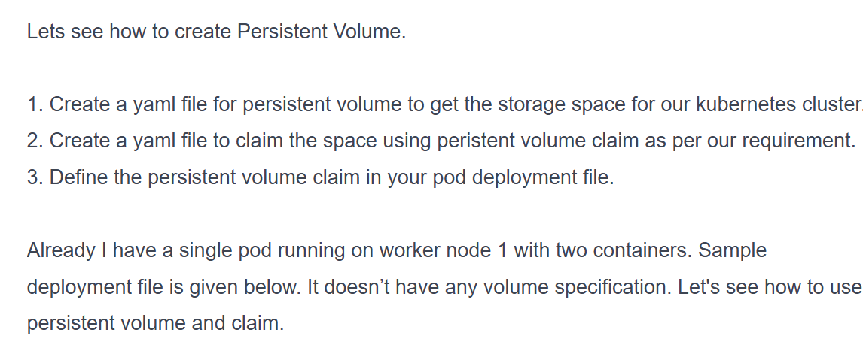

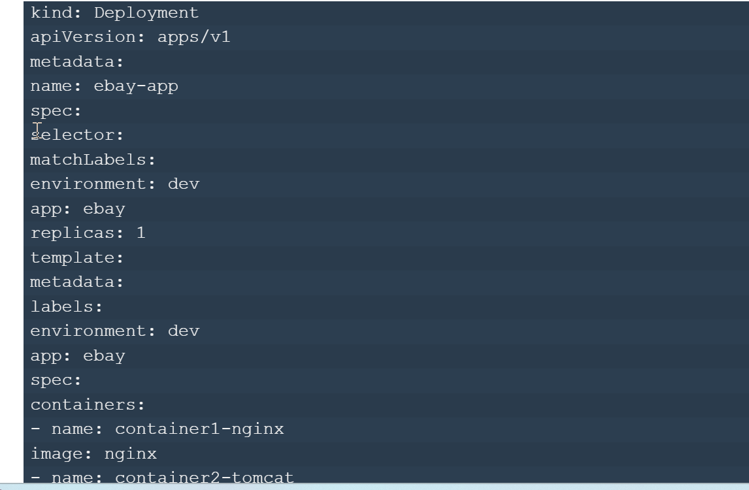
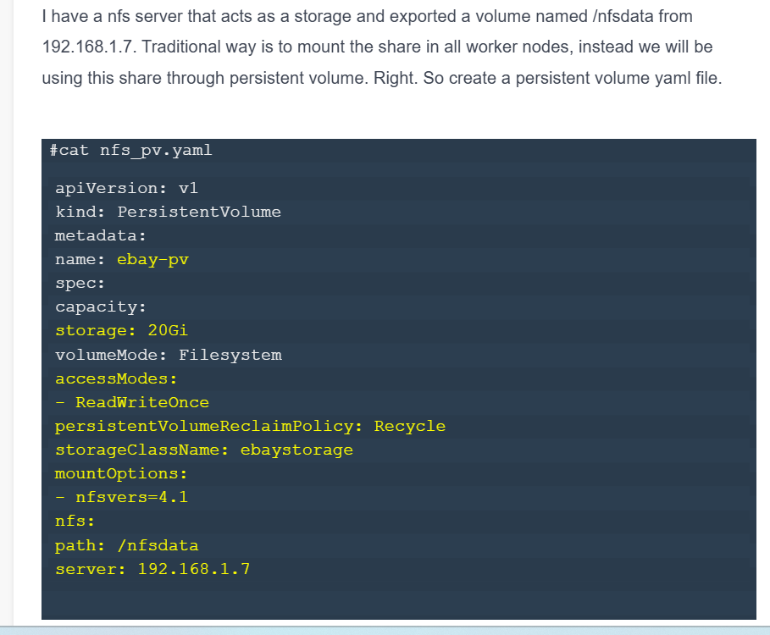
create persistent volume claim:
apiVersion: v1
kind: PersistentVolumeClaim
metadata:
name: myclaim
spec:
storageClassName: ebaystorage
accessModes:
- ReadWriteOnce
resources:
requests:
storage: 20G
Claim can be given from kubernetes cluster only when it finds suitable any Storageclassname and accessmode are same as specified in this claim file, if any persistent volume doesn’t have these storageclassname or accessmode, then persistent volume claim will not be processed.

