**HANDSON -1**

**Filename:** *App.js*

import React from 'react';

function App() {

  return (

    <div>

      <h1>Welcome to the first session of React</h1>

    </div>

  );

}

export default App;

**OUTPUT SCREENSHOTS :**

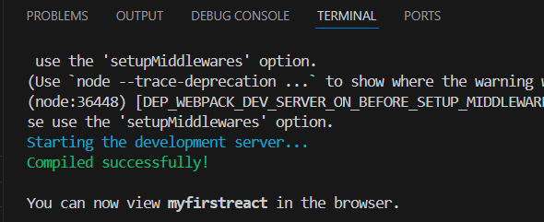

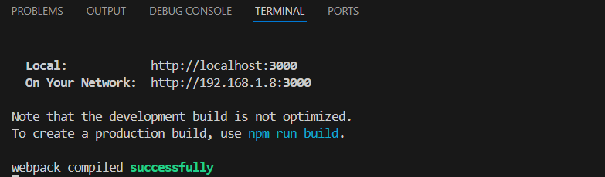

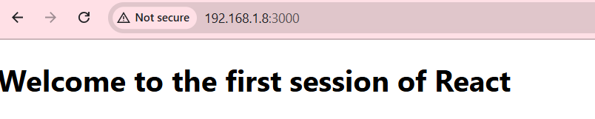

**HANDSON – 2**

**Filename:** *Home.js*

import React, { Component } from 'react';

class Home extends Component {

  render() {

    return (

      <div>

        <h2>Welcome to the Home page of Student Management Portal</h2>

      </div>

    ); } }

export default Home;

**Filename:** *About.js*

import React, { Component } from 'react';

class About extends Component {

  render() {

    return (

      <div>

        <h2>Welcome to the About page of the Student Management Portal</h2>

      </div>

    ); } }

export default About;

**Filename:** *Contact.js*

import React, { Component } from 'react';

class Contact extends Component {

  render() {

    return (

      <div>

        <h2>Welcome to the Contact page of the Student Management Portal</h2>

      </div>

    ); } }

export default Contact;

**Filename:** *App.js*

import React from 'react';

import './App.css';

import Home from './Components/Home';

import About from './Components/About';

import Contact from './Components/Contact';

function App() {

  return (

    <div className="App">

      <h1>Student Management Portal</h1>

      <Home />

      <About />

      <Contact />

    </div>

  );

}

export default App;

**OUTPUT SCREENSHOTS :**

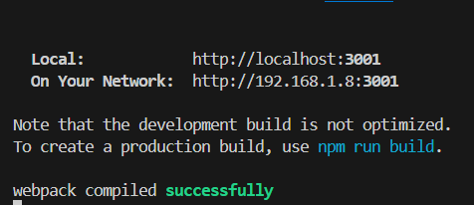

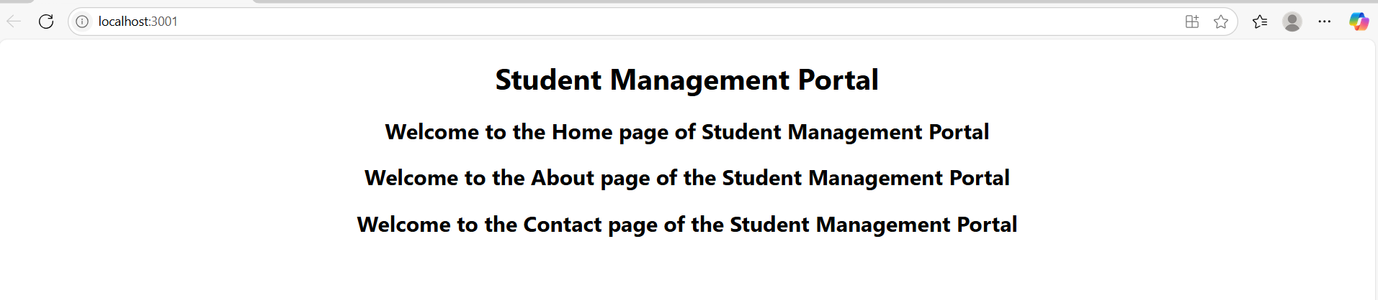

**HANDSON – 3**

**Filename:** *CalculateScore.js*

import React from 'react';

import '../Stylesheets/mystyle.css';

function CalculateScore() {

  const name = "John Doe";

  const school = "Green Valley High School";

  const total = 480;

  const goal = 5;

  const average = total / goal;

  return (

    <div className="score-card">

      <h2>Score Calculator</h2>

      <p><strong>Name:</strong> {name}</p>

      <p><strong>School:</strong> {school}</p>

      <p><strong>Total Marks:</strong> {total}</p>

      <p><strong>Number of Subjects (Goal):</strong> {goal}</p>

      <p><strong>Average Score:</strong> {average}</p>

    </div>

  );

}

export default CalculateScore;

**Filename:** *App.js*

import React from 'react';

import './App.css';

import CalculateScore from './Components/CalculateScore';

function App() {

  return (

    <div className="App"> <CalculateScore /> </div>

  ); }

export default App;

**Filename:** *mystyle.css*

.score-card {

  background-color: #f9f9f9;

  padding: 20px;

  margin: 30px auto;

  width: 60%;

  border: 2px solid #ccc;

  border-radius: 10px;

  font-family: Arial, sans-serif;

  box-shadow: 2px 2px 10px #aaa;

}

.score-card h2 {

  color: #2c3e50;

  text-align: center;

}

.score-card p {

  font-size: 18px;

  line-height: 1.6;

}

**OUTPUT SCREENSHOTS :**

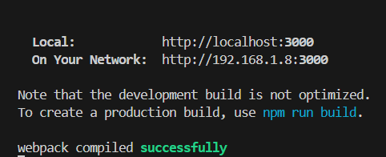

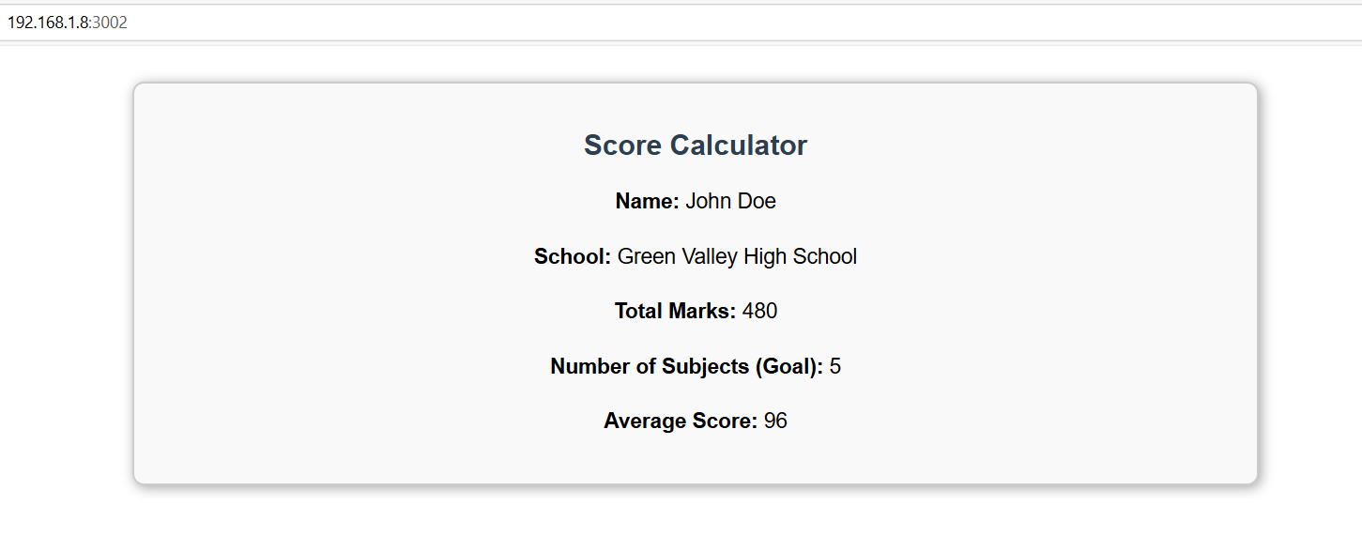

**HANDSON – 4**

**Filename:** *Post.js*

import React from 'react';

class Post extends React.Component {

  render() {

    const { title, body } = this.props;

    return (

      <div className="post">

        <h2>{title}</h2>

        <p>{body}</p>

        <hr />

      </div>

    );

  }

}

export default Post;

**Filename:** *Posts.js*

import React from 'react';

import Post from './Post';

class Posts extends React.Component {

  constructor(props) {

    super(props);

    this.state = {

      posts: [],

      error: null

    };

}

  loadPosts = () => {

    fetch('https://jsonplaceholder.typicode.com/posts')

      .then(res => {

        if (!res.ok) {

          throw new Error('Failed to fetch posts');

        }

        return res.json();

      })

      .then(data => { this.setState({ posts: data }); })

      .catch(error => { this.setState({ error });});

};

  componentDidMount() {

    this.loadPosts();

  }

  componentDidCatch(error, info) {

    alert('Something went wrong: ' + error.message);

  }

  render() {

    const { posts, error } = this.state;

    if (error) {

      return <h2>Error: {error.message}</h2>;

    }

    return (

      <div>

        <h1>Blog Posts</h1>

        {posts.slice(0, 10).map(post => (

          <Post key={post.id} title={post.title} body={post.body} />

        ))}

      </div>

    ); } }

export default Posts;

**Filename:** *App.js*

import React from 'react';

import './App.css';

import Posts from './Posts';

function App() {

  return (

    <div className="App">

      <Posts />

    </div>

  );

}

export default App;

**OUTPUT SCREENSHOTS :**

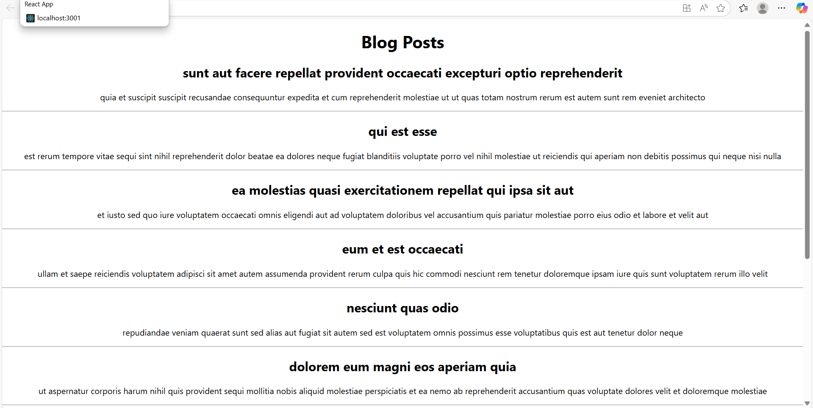

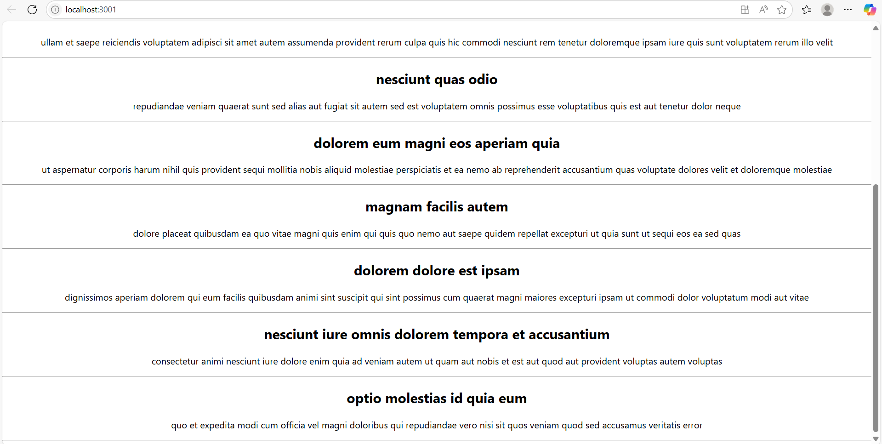

**HANDSON – 5**

**Filename:** *App.js*

import React from 'react';

import CohortDetails from './CohortDetails';

function App() {

  return (

    <div style={{ padding: '20px' }}>

      <h1>My Cohorts</h1>

      <CohortDetails

        name="React Basics"

        status="ongoing"

        startDate="2025-07-01"

        endDate="2025-08-01"

      />

      <CohortDetails

        name="Advanced React"

        status="completed"

        startDate="2025-05-01"

        endDate="2025-06-01"

      />

    </div>

  );

}

export default App;

**Filename:** *CohortDetails.js*

import React from 'react';

import styles from './CohortDetails.module.css';

const CohortDetails = ({ name, status, startDate, endDate }) => {

  const headingStyle = {

    color: status.toLowerCase() === 'ongoing' ? 'green' : 'blue',

  };

  return (

    <div className={styles.box}>

      <h3 style={headingStyle}>{name}</h3>

      <dl>

        <dt>Status:</dt>

        <dd>{status}</dd>

        <dt>Start Date:</dt>

        <dd>{startDate}</dd>

        <dt>End Date:</dt>

        <dd>{endDate}</dd>

      </dl>

    </div>

  );

};

export default CohortDetails;

**Filename:** *CohortDetails.module.css*

.box {

  width: 300px;

  display: inline-block;

  margin: 10px;

  padding: 10px 20px;

  border: 1px solid black;

  border-radius: 10px;

}

dt {

  font-weight: 500;

}

**OUTPUT SCREENSHOTS :**

