**9) REACT-HOL**

**Filename :** *ListOfPlayers.js*

import React from 'react';

const ListOfPlayers = () => {

const players = [

{ name: 'Virat Kohli', score: 83 },

{ name: 'Rohit Sharma', score: 65 },

{ name: 'Jasprit Bumrah', score: 45 },

{ name: 'KL Rahul', score: 72 },

{ name: 'Hardik Pandya', score: 68 },

{ name: 'Ravindra Jadeja', score: 76 },

{ name: 'Shubman Gill', score: 59 },

{ name: 'Rishabh Pant', score: 91 },

{ name: 'Suryakumar Yadav', score: 55 },

{ name: 'Mohammed Shami', score: 37 },

{ name: 'Ishan Kishan', score: 88 }

];

const belowSeventy = players.filter(p => p.score < 70);

return (

<div>

<h2>List of Players (All)</h2>

<ul>

{players.map((p, idx) => (

<li key={idx}> {p.name} - Score: {p.score} </li> ))}

</ul>

<h3>Players with Score Below 70</h3>

{belowSeventy.length === 0 ? ( <p>None</p> ) : (

<ul>

{belowSeventy.map((p, idx) => (

<li key={idx}>

{p.name} - Score: {p.score}

</li>))} </ul>)}

</div> ); };

export default ListOfPlayers;

**Filename :** *IndianPlayers.js*

import React from 'react';

const IndianPlayers = () => {

const indianPlayers = [

'Rohit Sharma',

'Shubman Gill',

'Virat Kohli',

'KL Rahul',

'Hardik Pandya',

'Rishabh Pant'

];

const [player1, player2, player3, player4, player5, player6] = indianPlayers;

const oddTeam = [player1, player3, player5];

const evenTeam = [player2, player4, player6];

const T20players = ['Suryakumar Yadav', 'Jasprit Bumrah'];

const RanjiTrophyPlayers = ['Mayank Agarwal', 'Devdutt Padikkal'];

const mergedPlayers = [...T20players, ...RanjiTrophyPlayers];

return (

<div> <h2>Indian Players</h2>

<div> <h3>Odd Team Players</h3>

<ul>

{oddTeam.map((p, i) => ( <li key={i}>{p}</li> ))}

</ul> </div>

<div> <h3>Even Team Players</h3>

<ul>

{evenTeam.map((p, i) => ( <li key={i}>{p}</li> ))}

</ul> </div>

<div> <h3>Merged Players (T20 + Ranji Trophy)</h3>

<ul>

{mergedPlayers.map((p, i) => ( <li key={i}>{p}</li> ))}

</ul> </div>

</div>

); };

export default IndianPlayers;

**Filename :** *App.js*

import React from 'react';

import './index.css';

import ListOfPlayers from './components/ListOfPlayers';

import IndianPlayers from './components/IndianPlayers';

function App() {

const flag = true; // set to false to show IndianPlayers instead

return (

<div style={{ padding: '20px', fontFamily: 'Arial, sans-serif' }}>

<h1>Cricket App</h1>

{flag ? <ListOfPlayers /> : <IndianPlayers />}

</div>

); }

export default App;

**Filename :** *index.js*

import React from 'react';

import ReactDOM from 'react-dom/client';

import App from './App';

const root = ReactDOM.createRoot(document.getElementById('root'));

root.render(<App />);

**Filename :** *index.css*

*body {*

*margin: 0;*

*background-color: #f4f7fa;*

*}*

*h1 {*

*color: #1f4e79;*

*margin-bottom: 10px;*

*}*

*h2 {*

*color: #2d566b;*

*margin-top: 1rem;*

*}*

*h3 {*

*margin-bottom: 5px;*

*}*

*ul {*

*padding-left: 1rem;*

*}*

**OUTPUT SCREENSHOTS :**

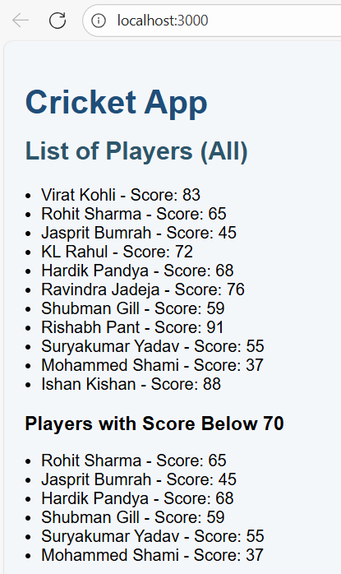

**10) REACT-HOL**

**Filename :** *App.js*

import React from 'react';

import './index.css';

const OfficeCard = ({ office }) => {

const { name, rent, address, imageUrl } = office;

const rentStyle = { color: rent < 60000 ? 'red' : 'green', fontWeight: 'bold' };

return (

<div className="office-card">

<h2>{name}</h2>

<img src={imageUrl} alt={name} className="office-image" />

<p><strong>Address:</strong> {address}</p>

<p><strong>Rent:</strong> <span style={rentStyle}>₹{rent.toLocaleString()}</span></p>

</div>

); };

function App() {

const featuredOffice = {

name: 'Central Business Hub',

rent: 75000,

address: '123 Corporate Avenue, Mumbai',

imageUrl: 'https://via.placeholder.com/300x200?text=Office+Space'

};

const offices = [

{ name: 'Central Business Hub', rent: 75000, address: '123 Corporate Avenue, Mumbai', imageUrl: 'https://via.placeholder.com/300x200?text=Central+Hub' },

{ name: 'Startup Space', rent: 45000, address: '45 Innovation Street, Bengaluru', imageUrl: 'https://via.placeholder.com/300x200?text=Startup+Space' },

{ name: 'Premium Tower', rent: 120000, address: '10 Skyline Road, Delhi', imageUrl: 'https://via.placeholder.com/300x200?text=Premium+Tower' },

{ name: 'CoWork Corner', rent: 58000, address: '88 Tech Park, Chennai', imageUrl: 'https://via.placeholder.com/300x200?text=CoWork+Corner' } ];

return (

<div className="app-container">

<header>

<h1>Office Space Rental Portal</h1>

<p>Compare and choose your ideal office.</p>

</header>

<section>

<h2>Featured Office</h2>

<OfficeCard office={featuredOffice} />

</section>

<section>

<h2>Available Offices</h2>

<div className="office-list">

{offices.map((off, idx) => <OfficeCard key={idx} office={off} />)}

</div> </section> </div>

); }

export default App;

**Filename :** *index.css*

body {

margin: 0;

font-family: Arial, sans-serif;

background: #f0f4f9;

color: #333;

}

.app-container {

max-width: 1000px;

margin: auto;

padding: 24px;

}

header {

text-align: center;

margin-bottom: 32px;

}

h1 {

margin: 0;

color: #1e3a8a; }

h2 {

margin-top: 24px;

color: #2d4f7c;

}

.office-list {

display: flex;

flex-wrap: wrap;

gap: 16px;

margin-top: 8px; }

.office-card {

background: white;

border: 1px solid #ccc;

border-radius: 10px;

padding: 16px;

width: 320px;

box-shadow: 2px 4px 12px rgba(0,0,0,0.08); }

.office-image {

width: 100%;

height: auto;

border-radius: 6px;

margin-bottom: 8px; }

**Filename :** *index.js*

import React from 'react';

import ReactDOM from 'react-dom/client';

import App from './App';

const root = ReactDOM.createRoot(document.getElementById('root'));

root.render(<App />);

**OUTPUT SCREENSHOTS :**

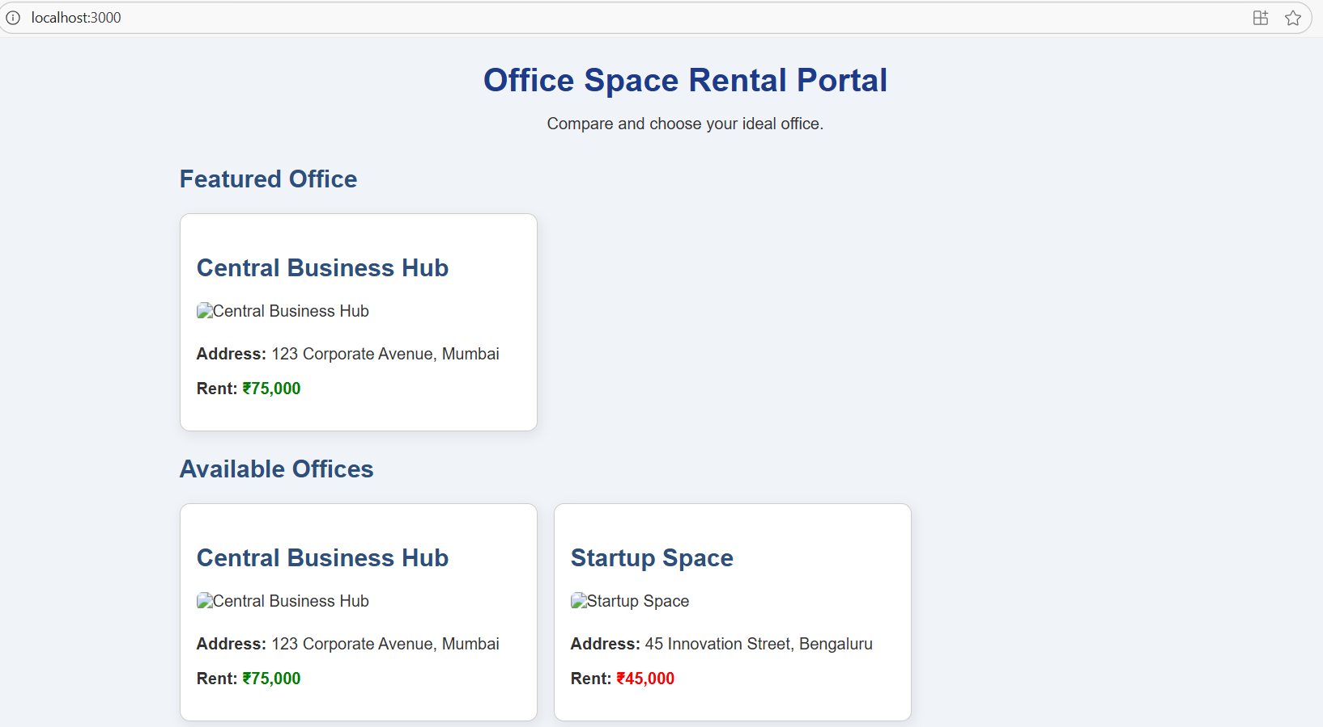 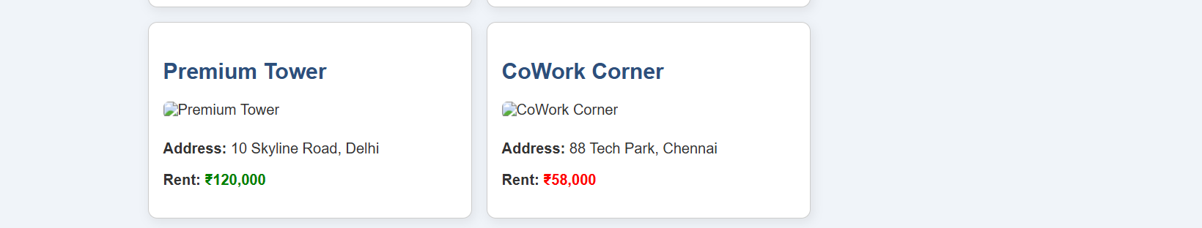

**11) REACT-HOL**

**Filename :** *App.js*

import React from 'react';

import './index.css';

import CounterWithHello from './CounterWithHello';

import WelcomeButton from './WelcomeButton';

import ClickLogger from './ClickLogger';

import CurrencyConvertor from './CurrencyConvertor';

function App() {

  return (

    <div style={{ padding: '24px', fontFamily: 'Arial, sans-serif' }}>

      <h1>Event Examples App</h1>

      <section style={{ marginBottom: '32px' }}>

        <h2>1. Counter with Multiple Methods</h2>

        <CounterWithHello />

      </section>

      <section style={{ marginBottom: '32px' }}>

        <h2>2. Say Welcome Button</h2>

        <WelcomeButton />

      </section>

      <section style={{ marginBottom: '32px' }}>

        <h2>3. Synthetic Event (OnPress equivalent)</h2>

        <ClickLogger />

      </section>

      <section style={{ marginBottom: '32px' }}>

        <h2>4. Currency Convertor (INR to EUR)</h2>

        <CurrencyConvertor />

      </section> </div>

  ); }

export default App;

**Filename :** *CounterWithHello.js*

import React, { useState } from 'react';

const CounterWithHello = () => {

  const [count, setCount] = useState(0);

  const increment = () => {

    setCount(prev => prev + 1);  };

  const sayHello = () => { alert('Hello! This is a static message.');  };

  const handleIncrease = () => {

    increment();

    sayHello();  };

  const handleDecrease = () => {

    setCount(prev => prev - 1);  };

  return (

    <div> <p>  Counter: <strong>{count}</strong> </p>

      <button onClick={handleIncrease} style={{ marginRight: 8 }}> Increase </button>

      <button onClick={handleDecrease}>Decrease</button>

    </div>  ); };

export default CounterWithHello;

**Filename :** *WelcomeButton.js*

import React from 'react';

const WelcomeButton = () => {

  const say = message => {

    alert(`Message received: ${message}`); };

  return (

    <div>  <button onClick={() => say('welcome')}>Say Welcome</button> </div>

  ); };

export default WelcomeButton;

**Filename :** *ClickLogger.js*

import React from 'react';

const ClickLogger = () => {

  const handlePress = event => {

    // synthetic event equivalent of onPress is onClick in web

    alert('I was clicked');

  };

  return (

    <div>

      <button onClick={handlePress}>Click Me (OnPress)</button>

    </div> );

};

export default ClickLogger;

**Filename :** *CurrencyConvertor.js*

import React, { useState } from 'react';

const CurrencyConvertor = () => {

  const [inr, setInr] = useState('');

  const [euro, setEuro] = useState(null);

  const RATE = 90;

  const handleSubmit = e => {

    e.preventDefault();

    const inrValue = parseFloat(inr);

    if (isNaN(inrValue)) {

      alert('Please enter a valid number for INR');

      return; }

    const converted = inrValue / RATE;

    setEuro(converted.toFixed(2));  };

  return (

    <div> <form onSubmit={handleSubmit}>

        <div style={{ marginBottom: 8 }}>

          <label>

            INR:{' '}

            <input type="text"  value={inr}

              onChange={e => setInr(e.target.value)}

              placeholder="Enter amount in INR"  />

          </label> </div>

        <button type="submit">Convert to EUR</button>

      </form>

      {euro !== null && (

        <p> ₹{parseFloat(inr).toLocaleString()} = €{euro} </p>    )}

    </div>

); };

export default CurrencyConvertor;

**Filename :** *index.js*

import React from 'react';

import ReactDOM from 'react-dom/client';

import App from './App';

const root = ReactDOM.createRoot(document.getElementById('root'));

root.render(<App />);

**Filename :** *index.css*

body {

  margin: 0;

  font-family: Arial, sans-serif;

  background: #f5f7fa;

  color: #222;

}

h1 {

  color: #1f4e79;

}

section {

  background: white;

  padding: 16px;

  margin-bottom: 16px;

  border-radius: 6px;

  box-shadow: 0 2px 8px rgba(0,0,0,0.05);

}

button {

  padding: 8px 14px;

  border: none;

  border-radius: 4px;

  cursor: pointer; }

button:hover {

  opacity: 0.*9;*

*}*

**OUTPUT SCREENSHOTS:**

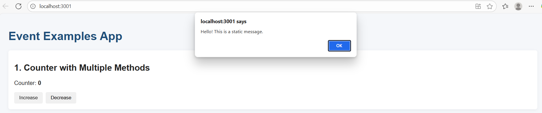

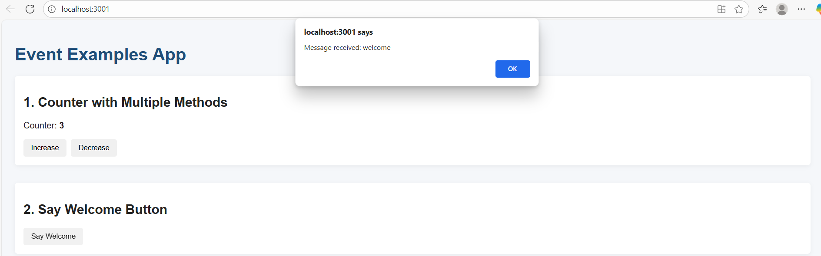

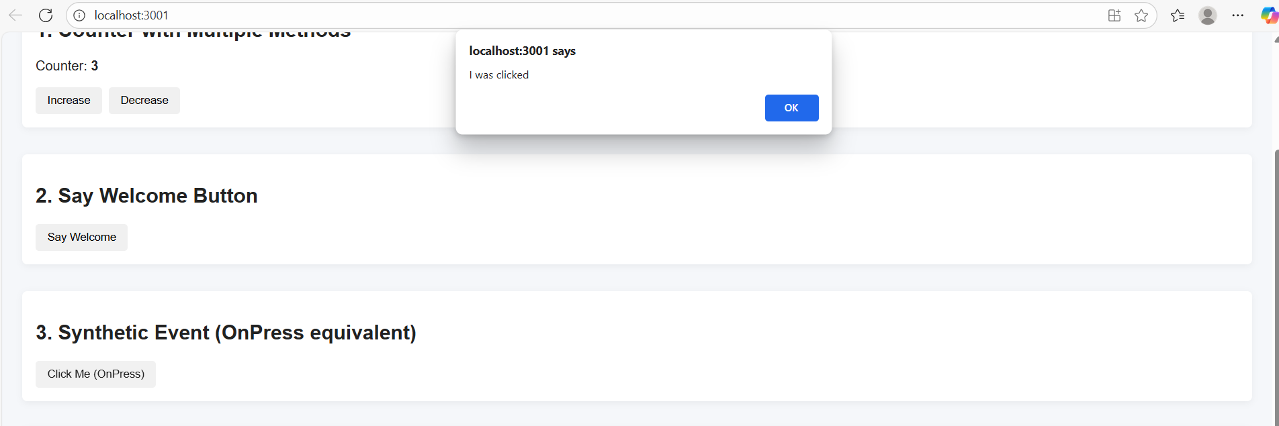

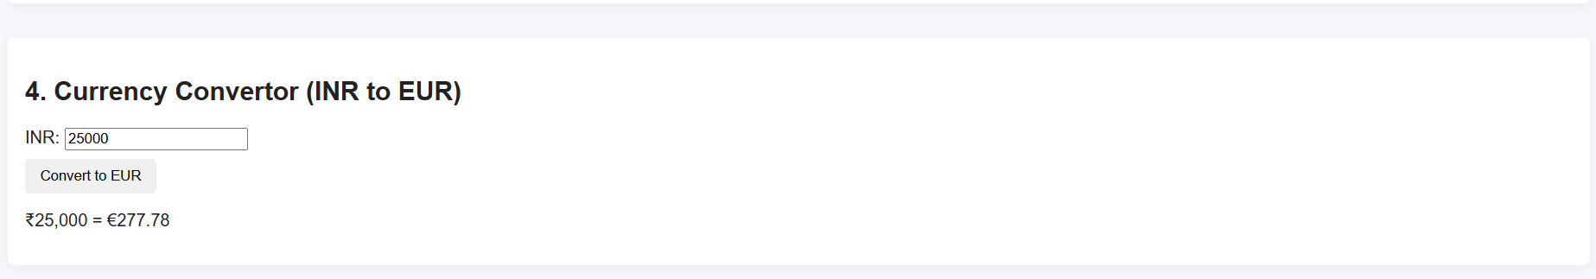

**12) REACT-HOL**

**Filename :** *index.js*

import React from 'react';

import ReactDOM from 'react-dom/client';

import App from './App';

import './index.css';

const root = ReactDOM.createRoot(document.getElementById('root'));

root.render(<App />);

**Filename :** *App.js*

import React, { useState } from 'react';

import FlightList from './FlightList';

function App() {

  const [isLoggedIn, setIsLoggedIn] = useState(false);

  const [username, setUsername] = useState('');

  const handleLogin = () => {

    const name = prompt('Enter your name to login:', 'John Doe');

    if (name) {

      setUsername(name);

      setIsLoggedIn(true);

    } };

  const handleLogout = () => {

    setIsLoggedIn(false);

    setUsername('');

  };

  return (

    <div className="app-container">

      <header>

        <h1>Flight Ticket Booking</h1>

        <div className="auth-row">

          {isLoggedIn ? (   <>

              <span className="welcome">Welcome, {username}</span>

              <button onClick={handleLogout}>Logout</button>

            </>  ) : (

            <button onClick={handleLogin}>Login</button>

          )}

        </div>

        <hr />

      </header>

      {isLoggedIn ? (

        <div>

          <h2>User Dashboard</h2>

          <p>You can book tickets below.</p>

        </div>  ) : (

        <div>

          <h2>Guest View</h2>

          <p>Please login to enable booking.</p>

        </div> )}

      <FlightList isLoggedIn={isLoggedIn} />

    </div>  ); }

export default App;

**Filename :** *FlightList.js*

import React from 'react';

import FlightCard from './FlightCard';

const FlightList = ({ isLoggedIn }) => {

  const flights = [

    {

      id: 1,

      airline: 'Air India',

      from: 'Mumbai',

      to: 'Delhi',

      departure: '2025-08-10 09:00',

      arrival: '2025-08-10 11:15',

      price: 4500

    }, {

      id: 2,

      airline: 'IndiGo',

      from: 'Bengaluru',

      to: 'Chennai',

      departure: '2025-08-11 14:30',

      arrival: '2025-08-11 15:45',

      price: 3200 }, {

      id: 3,

      airline: 'SpiceJet',

      from: 'Kolkata',

      to: 'Hyderabad',

      departure: '2025-08-12 07:20',

      arrival: '2025-08-12 09:50',

      price: 5600

    }  ];

  return (

    <div>

      <h2>Available Flights</h2>

      <div className="flight-list">

        {flights.map(f => (

          <FlightCard key={f.id} flight={f} isLoggedIn={isLoggedIn} />

        ))}    </div>    </div>  ); };

export default FlightList;

**Filename :** *FlightCard.js*

import React from 'react';

const FlightCard = ({ flight, isLoggedIn }) => {

  const handleBook = () => {

    alert(`Ticket booked on ${flight.airline} from ${flight.from} to ${flight.to} for ₹${flight.price}`);

  };

  return (

    <div className="flight-card">

      <h3>{flight.airline}</h3>

      <p> <strong>Route:</strong> {flight.from} → {flight.to} </p>

      <p>  <strong>Departure:</strong> {flight.departure}     </p>

      <p><strong>Arrival:</strong> {flight.arrival}      </p>

      <p> <strong>Price:</strong> ₹{flight.price.toLocaleString()}   </p>

      <button onClick={handleBook} disabled={!isLoggedIn}>

        {isLoggedIn ? 'Book Ticket' : 'Login to Book'}

      </button>

    </div>

  ); };

export default FlightCard;

**Filename :** *index.css*

body {

  margin: 0;

  font-family: Arial, sans-serif;

  background: #eef2f7;

  color: #222; }

.app-container {

  max-width: 900px;

  margin: auto;

  padding: 20px; }

header {

  display: flex;

  flex-direction: column;

  gap: 8px; }

.auth-row {

  display: flex;

  justify-content: flex-end;

  align-items: center;

  gap: 10px;

  margin-bottom: 4px; }

button {

  padding: 8px 14px;

  border: none;

  background: #1f6fb2;

  color: white;

  border-radius: 4px;

  cursor: pointer; }

button:disabled {

  background: #999;

  cursor: not-allowed; }

.flight-list {

  display: flex;

  flex-wrap: wrap;

  gap: 16px;

  margin-top: 12px; }

.flight-card {

  background: white;

  border: 1px solid #ccc;

  padding: 14px;

  border-radius: 8px;

  width: 280px;

  box-shadow: 0 2px 6px rgba(0,0,0,0.08); }

.flight-card h3 {

  margin-top: 0;

}

.welcome {

  margin-right: auto;

  font-weight: 600; }

**OUTPUT SCREENSHOTS:**

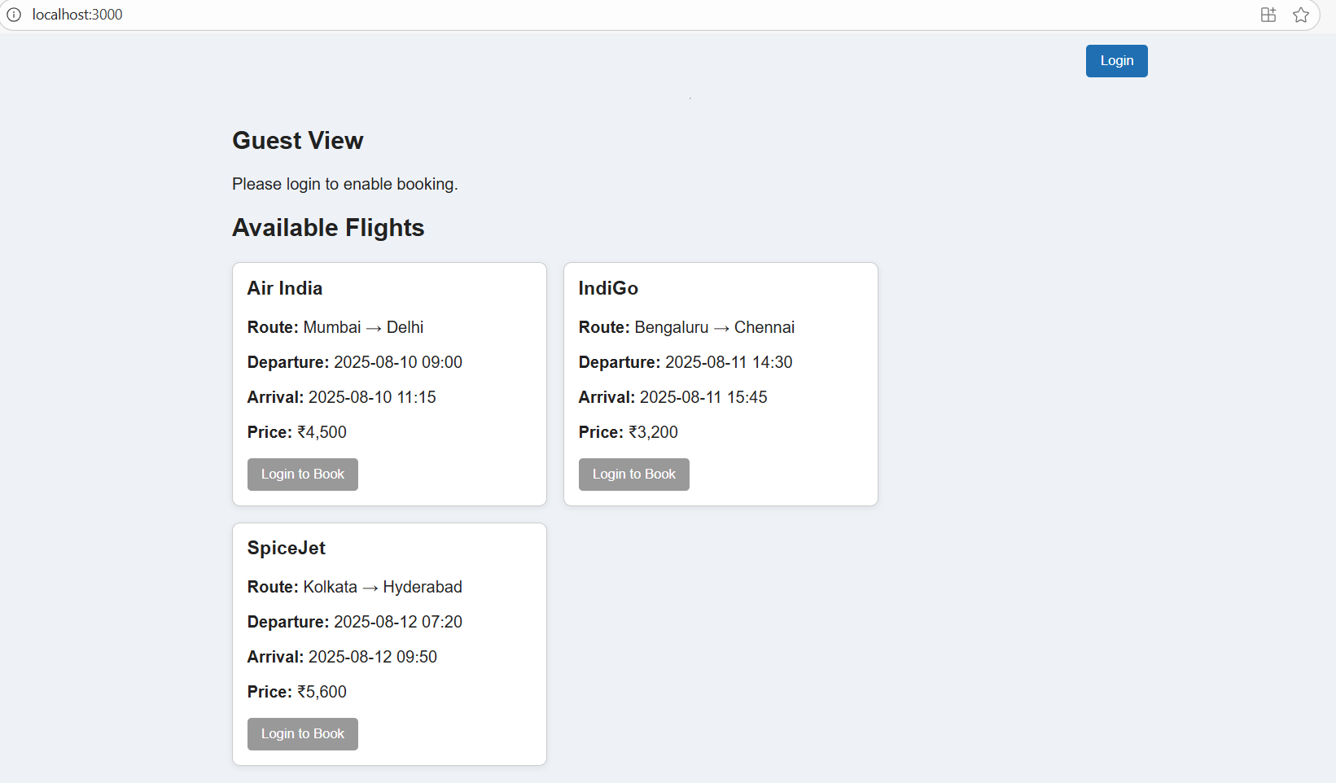 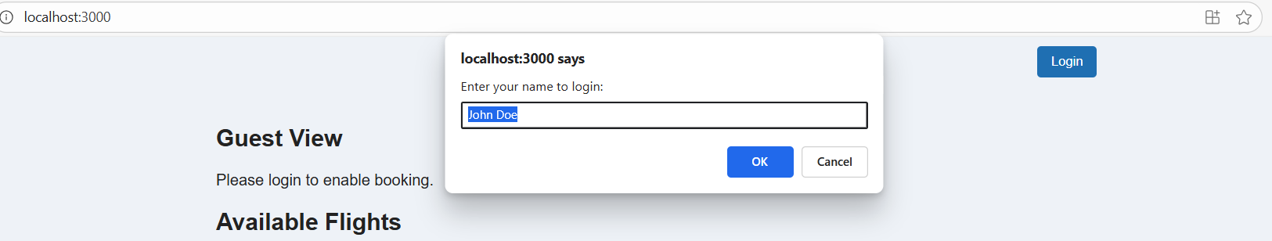 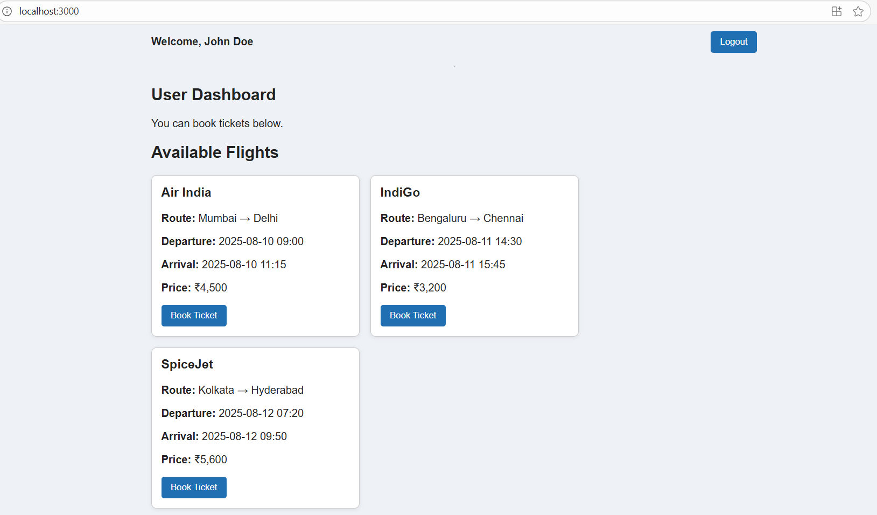

**13) REACT-HOL**

**Filename :** *withLoading.js*

import React from 'react';

export function withLoading(Component) {

  return function WithLoadingWrapper({ isLoading, ...props }) {

    if (isLoading) {

      return <div style={{ fontStyle: 'italic' }}>Loading...</div>;

    }

    return <Component {...props} />;

  }; }

**Filename :** *BookDetails.js*

import React from 'react';

import PropTypes from 'prop-types';

const BookDetails = ({ books }) => {

  return (

    <div className="column">

      <h2>Book Details</h2>

      {books && books.length > 0 ? (

        books.map((b, idx) => (

          <div key={idx} className="item">

            <div className="title">{b.title || 'Untitled Book'}</div>

            <div className="sub">{b.value !== undefined ? b.value : 'N/A'}</div>

          </div>

        ))   ) : (   <p>No books to show.</p> )}

    </div> ); };

BookDetails.propTypes = {

  books: PropTypes.arrayOf(

    PropTypes.shape({

      title: PropTypes.string,

      value: PropTypes.oneOfType([PropTypes.number, PropTypes.string]),    }) ), };

BookDetails.defaultProps = {

  books: [], };

export default BookDetails;

**Filename :** *BlogDetails.js*

import React from 'react';

import PropTypes from 'prop-types';

const BlogDetails = ({ blogs }) => {

  return (

    <div className="column">

      <h2>Blog Details</h2>

      {blogs && blogs.length > 0 ? (

        blogs.map((b, idx) => (

          <div key={idx} className="item">

            <div className="heading">{b.heading || 'Untitled'}</div>

            <div className="author">{b.author && <strong>{b.author}</strong>}</div>

            <div className="content">{b.content || ''}</div>

          </div>

  ))   ) : (

        <p>No blog entries.</p>   )}

    </div> ); };

BlogDetails.propTypes = {

  blogs: PropTypes.arrayOf(

    PropTypes.shape({

      heading: PropTypes.string,

      author: PropTypes.string,

      content: PropTypes.string,

    })

), };

BlogDetails.defaultProps = {

  blogs: [],

};

export default BlogDetails;

**Filename :** *CourseDetails.js*

import React from 'react';

import PropTypes from 'prop-types';

const CourseDetails = ({ courses }) => {

  if (!courses || courses.length === 0) {

    return (

      <div className="column">

        <h2>Course Details</h2>

        <p>No courses available.</p>

      </div>

    );  }

  return (

    <div className="column">

      <h2>Course Details</h2>

      {courses.map((c, idx) => (

        <div key={idx} className="item">

          <div className="title">{c.name || 'Untitled Course'}</div>

          <div className="sub">{c.date || 'TBD'}</div>

        </div>

      ))}

    </div>

  ); };

CourseDetails.propTypes = {

  courses: PropTypes.arrayOf(

    PropTypes.shape({

      name: PropTypes.string,

      date: PropTypes.string,

    })  ), };

CourseDetails.defaultProps = {

  courses: [], };

export default CourseDetails;

**Filename :** *App.js*

import React from 'react';

import './App.css';

import CourseDetails from './components/CourseDetails';

import BookDetails from './components/BookDetails';

import BlogDetails from './components/BlogDetails';

function App() {

  const courses = [

    { name: 'Angular', date: '4/5/2021' },

    { name: 'React', date: '6/3/2021' }, ];

  const books = [

    { title: 'Master React', value: 670 },

    { title: 'Deep Dive into Angular 11', value: 800 },

    { title: 'Mongo Essentials', value: 450 },  ];

  const blogs = [

    {heading: 'React Learning',

      author: 'Stephen Biz',

      content: 'Welcome to learning React!',  },

    { heading: 'Installation',

      author: 'Schewzdiener',

      content: 'You can install React from npm.', },  ];

  return (

    <div className="App">

      <div className="three-columns">

        <CourseDetails courses={courses} />

        <BookDetails books={books} />

        <BlogDetails blogs={blogs} />

      </div>

    </div>

  ); }

export default App;

**Filename :** *App.css*

.App {font-family: system-ui, -apple-system, BlinkMacSystemFont, 'Segoe UI', Roboto, Oxygen,

    Ubuntu, Cantarell, 'Open Sans', 'Helvetica Neue', Arial, sans-serif;

  padding: 2rem; }

.three-columns {  display: flex;

  gap: 2rem;

  align-items: flex-start;

  justify-content: center; }

.column { width: 250px;

  position: relative;

  padding-left: 1rem; }

.column:not(:first-child)::before { content: '';

  position: absolute;

  left: 0;

  top: 0;

  bottom: 0;

  width: 6px;

  background: #007f0e; /* dark green */

  border-radius: 2px; }

h2 {  font-size: 1.75rem;

  margin-bottom: 1rem;

  font-weight: 700; }

.item {

  margin-bottom: 1rem; }

.title,

.heading { font-size: 1.25rem;

  font-weight: 600; }

.sub { font-size: 1rem;

  margin-top: 4px; }

.author { font-size: 0.9rem;

  margin-top: 4px;}

.content {  font-size: 0.9rem;

  margin-top: 8px; }

**OUTPUT SCREENSHOTS:**

