

Predictive Modeling and Data Engineering Pipelines for

Maternal Health Risk Stratification in Low-Resource Public Health Frameworks
Project Report
Student Name: Yabets Desalegn
Student ID: GSE9850/18
Course: Data Management and Engineering
Date: August 24, 2026

Dataset Source: UCI Machine Learning Repository / Kaggle Maternal Health Risk Data Set (drmbsharma), 1,014 records, 3-class risk stratification

Abstract
Maternal morbidity and mortality remain critical public health concerns, particularly in low-resource settings where continuous clinical monitoring is limited. This project develops and evaluates a machine learning pipeline for classifying pregnant women into three maternal health risk categories low, mid, and high risk. using six routinely collectible vital signs (age, systolic and diastolic blood pressure, blood glucose, body temperature, and heart rate) sourced from an IoT-based monitoring dataset (UCI Machine Learning Repository / Kaggle, 1,014 records). Three engineered clinical features (pulse pressure, mean arterial pressure, and a systolic-diastolic ratio) and one demographic feature (maternal age group) were added to the raw feature set. Seven supervised algorithms Logistic Regression, Decision Tree, K-Nearest Neighbors, Support Vector Machine, Random Forest, Gradient Boosting, and a Multi-Layer Perceptron neural network were trained inside leakage-safe preprocessing pipelines, tuned exhaustively via GridSearchCV with stratified 5-fold cross-validation, and selected strictly on cross-validated macro F1 score prior to a single, untouched evaluation on a held-out 20% test set (203 records).
Random Forest was selected as the final model (cross-validated macro F1 = 0.834) and achieved a held-out test accuracy of 84.7%, a macro F1 score of 0.851, and a one-vs-rest macro ROC-AUC of 0.953. A Friedman test provided evidence of differences in cross-validated performance across the seven models (p = 0.00013), although this comparison is interpreted as supportive rather than independently confirmatory because the same cross-validation framework was used for hyperparameter selection and comparison. Blood glucose concentration was consistently identified as the dominant predictive feature by both permutation importance and the model's built-in feature importance. Mid-risk cases were the most difficult to classify, most often confused with low-risk cases, while high-risk cases were separated with high reliability (96% recall). The final model, all comparison tables, and all figures were saved as reproducible artifacts. The project concludes that ensemble tree-based methods substantially outperform linear and distance-based baselines on this task, while noting that the dataset's modest size, single-country origin, and lack of external clinical validation limit the model to a research prototype rather than a deployable clinical decision-support tool.
Table of Contents
Abstract
1. Introduction 1
1.1 Statement of the Problem 1
1.2 Objectives 1
1.3 Research Questions 1
2. Related Works 2
2.1 Foundational IoT Risk-Factor Review (Ahmed et al., 2020) 2
2.2 The Original Dataset Study (Ahmed and Kashem, 2020) 2
2.3 Deep Hybrid ANN-Random Forest Model (Togunwa et al., 2023) 2
2.4 Early Prediction with Traditional ML (Assaduzzaman et al., 2023) 2
2.5 Positioning of This Project 2
3. Methodology 3
3.1 Overall Architecture 3
3.2 Why Cross-Validation-Only Model Selection 3
3.3 Algorithms Used 3
3.4 Preprocessing and Leakage Prevention 4
3.5 Evaluation Metrics 4
3.6 Statistical Comparison 4
3.7 Reproducibility 4
4. Data Preparation 5
4.1 Data Source and Integrity Verification 5
4.2 Data Quality Audit 5
4.3 Target Class Distribution 5
4.4 Descriptive Statistics 6
4.5 Feature Engineering 7
4.6 Train/Test Split 7
5. Experimental Results and Analysis 8
5.1 Baseline Model 8
5.2 Hyperparameter Tuning (All Seven Models) 8
5.3 Held-Out Test Set Comparison (All Seven Tuned Models) 9
5.3.1 An Important Methodological Observation 9
5.4 Selected Model: Detailed Evaluation (Random Forest) 10
5.5 Per-Class Performance Across All Models 13
5.6 Statistical Significance of Model Differences 13
5.7 Feature Importance (RQ4) 14
5.8 Diagnostics for the MLP Neural Network 16
5.9 Generalization: Learning Curves (RQ5) 16
5.10 Error Analysis 18
5.11 Descriptive/Unsupervised Analysis: PCA and K-Means 18
6. Concluding Remarks 21
6.1 Summary of Findings 21
6.1.1 Answers to the Research Questions 21
6.2 Major Strengths 22
6.3 Major Weaknesses and Limitations 23
6.4 Suggested Way Forward 23
References 24
Annex 25
A1. Software Environment and Package Versions 25
A2. Best Hyperparameters per Model 25
A3. Final Model Metadata 25
A4. Final Pipeline Validation Checks 25
A5. Live Demonstration Example 26
A6. Data Dictionary 26
A7. Complete Figure Index ( not only document but created by notebook also) 26

1. Introduction

1.1 Statement of the Problem
Reducing maternal mortality remains one of the most persistent challenges in global public health and is directly tied to Sustainable Development Goal 3. In low-resource settings, pregnant women frequently lack access to continuous clinical supervision, meaning that early indicators of pregnancy-related risk abnormal blood pressure, elevated blood glucose, irregular heart rate, or fever often go undetected until a crisis emerges. The proliferation of low-cost Internet of Things (IoT) sensing devices has made it possible to collect basic vital signs from pregnant women in remote or under-resourced areas, but converting these raw measurements into an actionable, interpretable risk classification still requires a robust predictive modeling pipeline. Manually interpreting combinations of six or more vital signs is difficult for non-specialist health workers, motivating the use of machine learning to automate risk stratification into clinically meaningful categories.

1.2 Objectives
The project pursues the following objectives:
- To build a reproducible, leakage-safe data engineering pipeline that cleans, audits, and engineers features from raw maternal vital-sign data.
- To train and rigorously compare seven machine learning and deep-learning-style algorithms (Logistic Regression, Decision Tree, KNN, SVM, Random Forest, Gradient Boosting, and an MLP neural network) for three-class maternal risk classification.
- To select a final model using methodologically sound practices cross-validation-only model selection followed by a single held-out test evaluation rather than test-set-driven model shopping.
- To interpret the selected model using multiple complementary techniques (native feature importance, permutation importance, learning curves, and error analysis) to identify which clinical factors drive risk predictions.
- To critically assess the strengths, weaknesses, and responsible-use boundaries of the resulting system for low-resource public health deployment.

1.3 Research Questions
This report is organized around six explicit research questions that structure the remainder of the analysis:
- RQ1 (Predictive accuracy): How accurately can the seven algorithms classify maternal risk level from six raw clinical/IoT features?
- RQ2 (Model comparison): Which model performs best, and is the difference statistically significant or within noise?
- RQ3 (Class imbalance): How does class imbalance across low/mid/high risk affect per-class recall, and does macro-averaging change the ranking versus plain accuracy?
- RQ4 (Feature contribution): Which raw and engineered features contribute most to predictions, and is this consistent across importance methods?
- RQ5 (Generalization): Do the learning curves and CV-vs-test comparison show overfitting, underfitting, or a model that would likely improve with more data?
- RQ6 (Limitations and responsible use): What are the limitations of this dataset and model for real-world, low-resource clinical deployment, and what human oversight would be required?

2. Related Works
This project builds directly on a well-established line of research applying machine learning to IoT-collected maternal health data. Four directly relevant prior works are summarized below.

2.1 Foundational IoT Risk-Factor Review (Ahmed et al., 2020)
Ahmed, Kashem, Rahman, and Khatun [1] first reviewed and analyzed maternal health risk factors collected via an IoT-based remote monitoring system, motivating the use of low-cost wearable sensing in resource-limited regions and establishing the risk-factor taxonomy (blood pressure, blood glucose, body temperature, heart rate, and age) that later informed the dataset used in this project.

2.2 The Original Dataset Study (Ahmed and Kashem, 2020)
Ahmed and Kashem [2] introduced the specific IoT-based Risk Level Prediction Model for maternal health care in the context of Bangladesh, collecting the 1,014-record dataset used directly in this project from hospitals, maternity clinics, and IoT devices across Dhaka. Their reported class distribution 406 low-risk, 336 mid-risk, and 272 high-risk records matches exactly what this project's dataset-integrity validation confirmed, providing strong evidence that this project used the authentic, unaltered source data.

2.3 Deep Hybrid ANN-Random Forest Model (Togunwa et al., 2023)
Togunwa, Babatunde, and Abdullah [3] proposed a deep hybrid model combining an Artificial Neural Network with a Random Forest classifier for maternal health risk classification, reporting that ensemble tree-based approaches captured non-linear interactions between vital signs more effectively than purely linear or purely neural approaches. This project's own finding that Random Forest and Gradient Boosting substantially outperformed both Logistic Regression and the MLP neural network on the same class of features is directly consistent with their conclusion.

2.4 Early Prediction with Traditional ML (Assaduzzaman et al., 2023)
Assaduzzaman, Al Mamun, and Hasan [4] compared several traditional machine learning techniques for early prediction of maternal health risk factors, reinforcing that tree-based and ensemble methods generally provide a strong balance of accuracy and interpretability for this problem class, which motivated this project's decision to tune and compare tree-based models alongside linear, distance-based, kernel-based, and neural approaches rather than relying on a single algorithm family.

2.5 Positioning of This Project
While the works above establish that ensemble and tree-based methods are generally effective on this dataset, none of the reviewed works reports a model-selection protocol that separates cross-validated model selection from held-out test evaluation, nor do they report a formal statistical significance test (e.g., a Friedman test) across all candidate models, nor do they combine two independent feature-importance methods (native impurity-based importance and permutation importance) to cross-check which features are genuinely predictive versus artifacts of a single method. This project addresses those gaps directly, described in the Methodology section that follows.

3. Methodology

3.1 Overall Architecture
The project follows a linear, auditable pipeline: raw data ingestion and integrity verification -> data quality audit -> exploratory data analysis -> feature engineering and ordinal target encoding -> stratified train/test split -> leakage-safe preprocessing embedded in per-model pipelines -> exhaustive hyperparameter tuning of all seven candidate models via GridSearchCV under stratified 5-fold cross-validation -> model selection strictly on cross-validated macro F1 -> a single, untouched evaluation of the selected model on the held-out test set -> multi-method interpretation (feature importance, permutation importance, learning curves, statistical comparison, error analysis, and an unsupervised PCA/K-Means check) -> refitting the selected model on the full dataset -> saving all artifacts (model, metadata, tables, and figures) for reproducibility.
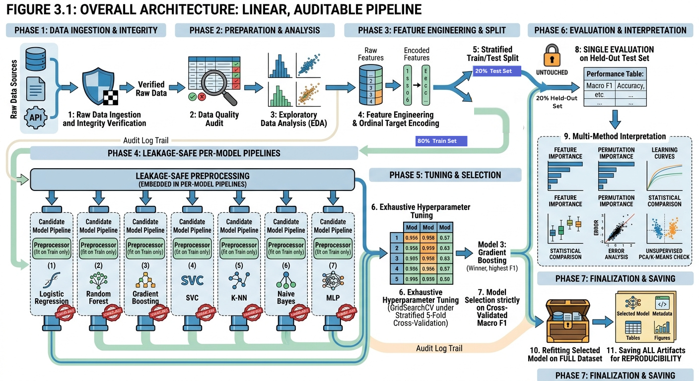
Figure 1: Overall Project Architecture

3.2 Why Cross-Validation-Only Model Selection
A methodologically important design decision in this project is that the final model is chosen using only cross-validated performance on the training set (via GridSearchCV's internal scoring), never by comparing candidate models on the test set. The test set is touched exactly once, to report the honest, unbiased performance of the already-selected model. This avoids a subtle but real form of test-set leakage in which the test set implicitly influences which model is reported as "best."

3.3 Algorithms Used
Seven algorithms from scikit-learn were trained and tuned:
- Logistic Regression: a linear baseline classifier, included for interpretability and as a lower-bound reference.
- Decision Tree: a single interpretable rule-based classifier, tuned over maximum depth, minimum leaf size, and class weighting.
- K-Nearest Neighbors (KNN): a non-parametric, distance-based classifier, tuned over neighborhood size, weighting scheme, and distance metric power.
- Support Vector Machine (SVM): a kernel-based classifier using a radial basis function kernel, tuned over the regularization parameter C, gamma, and class weighting.
- Random Forest: a bagging ensemble of decision trees, tuned over tree count, maximum depth, minimum leaf size, and feature sampling strategy.
- Gradient Boosting: a sequential boosting ensemble, tuned over learning rate, tree count, and maximum depth.
- Multi-Layer Perceptron (MLP) Neural Network: a feed-forward neural network, tuned over hidden-layer architecture, activation function, and regularization strength.

3.4 Preprocessing and Leakage Prevention
All preprocessing (missing-value imputation and, where required, feature scaling) is embedded inside each model's own scikit-learn Pipeline object rather than applied once to the whole dataset. This guarantees that preprocessing statistics (such as the mean and standard deviation used for scaling) are recomputed independently on each cross-validation training fold, so no information from a validation or test fold ever leaks into model fitting.

3.5 Evaluation Metrics
Because all three risk classes are clinically important and the classes are moderately imbalanced (40.0% low, 33.1% mid, 26.8% high), macro-averaged metrics were prioritized over plain accuracy throughout. The primary model-selection metric was macro F1. Secondary metrics tracked for every model included accuracy, balanced accuracy, macro precision, macro recall, weighted F1, one-vs-rest macro and weighted ROC-AUC, and macro average precision.

3.6 Statistical Comparison
To determine whether the seven models' cross-validated performances differed by more than chance, a Friedman test was applied to the matched per-fold macro F1 scores across all seven models (five folds each), which is more appropriate than a series of pairwise tests when comparing more than two models simultaneously.

3.7 Reproducibility
All experiments used a fixed random seed (random_state = 42) for the train/test split, cross-validation folds, and all stochastic model components. The exact library versions used in this run are reported in the Annex (Table A1) for reproducibility.

4. Data Preparation

4.1 Data Source and Integrity Verification
The dataset used is the Maternal Health Risk Data Set, originally collected by Ahmed and Kashem [2] from hospitals, maternity clinics, and IoT devices in Dhaka, Bangladesh, and distributed via the UCI Machine Learning Repository and Kaggle. Before any analysis, the notebook explicitly validated that the loaded file contained the expected 1,014 rows and all three target classes (low risk, mid risk, high risk); the notebook is designed to stop immediately rather than silently continue if this check fails, since an earlier attempt to source this data (from a mismatched file with only 808 rows and two classes) was caught by this same safeguard during development.

4.2 Data Quality Audit
Check | Value
Raw rows | 1,014
Raw columns | 7
Missing values | 0
Exact duplicate measurement rows | 562
Table 1: Data quality audit summary
No missing values were present in any column. A notable data characteristic is that 562 of the 1,014 rows (55.4%) are exact duplicates on all seven columns. These duplicate rows were deliberately retained rather than removed, because the dataset provides no patient or encounter identifier that would confirm they are erroneous re-entries rather than genuinely different patients who happen to share identical, coarsely-rounded vital-sign readings (blood pressure and heart rate in this dataset are recorded only in round numbers). Removing them would be an unverifiable assumption and was avoided in favor of transparently documenting the limitation instead; this decision is revisited in the Concluding Remarks.

4.3 Target Class Distribution
Risk Level | Count | Percent
Low risk | 406 | 40.04%
Mid risk | 336 | 33.14%
High risk | 272 | 26.82%
Table 2: RiskLevel class distribution
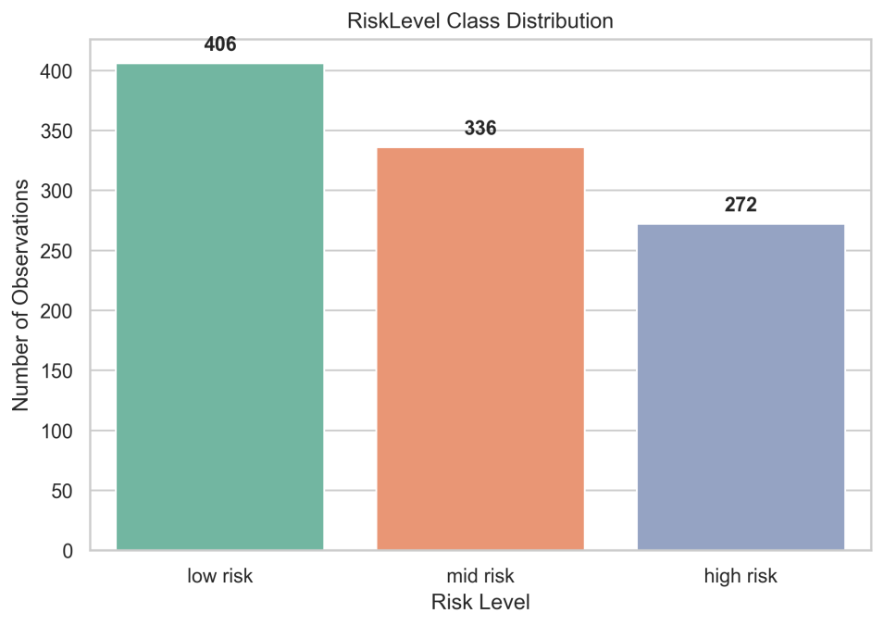
Figure 2: Distribution of the three RiskLevel classes across the 1,014-record dataset.

4.4 Descriptive Statistics
Variable | Mean | Std | Min | 25% | Median | 75% | Max
Age | 29.87 | 13.47 | 10 | 19 | 26 | 39 | 70
SystolicBP | 113.20 | 18.40 | 70 | 100 | 120 | 120 | 160
DiastolicBP | 76.46 | 13.89 | 49 | 65 | 80 | 90 | 100
BS (mmol/L) | 8.73 | 3.29 | 6.0 | 6.9 | 7.5 | 8.0 | 19.0
BodyTemp | 98.67 | 1.37 | 98.0 | 98.0 | 98.0 | 98.0 | 103.0
HeartRate | 74.30 | 8.09 | 7 | 70 | 76 | 80 | 90
Table 3: Descriptive statistics for the six raw numeric variables
Age, blood glucose (BS), and systolic blood pressure show visibly higher means and greater dispersion among high-risk cases than low-risk cases, consistent with established clinical risk factors for pregnancy complications (hypertension and hyperglycemia). Body temperature is heavily concentrated at 98.0 degrees for the majority of records across all three risk groups, suggesting it functions more as a threshold flag (elevated at 100-103 for a minority of cases) than a continuously informative variable.
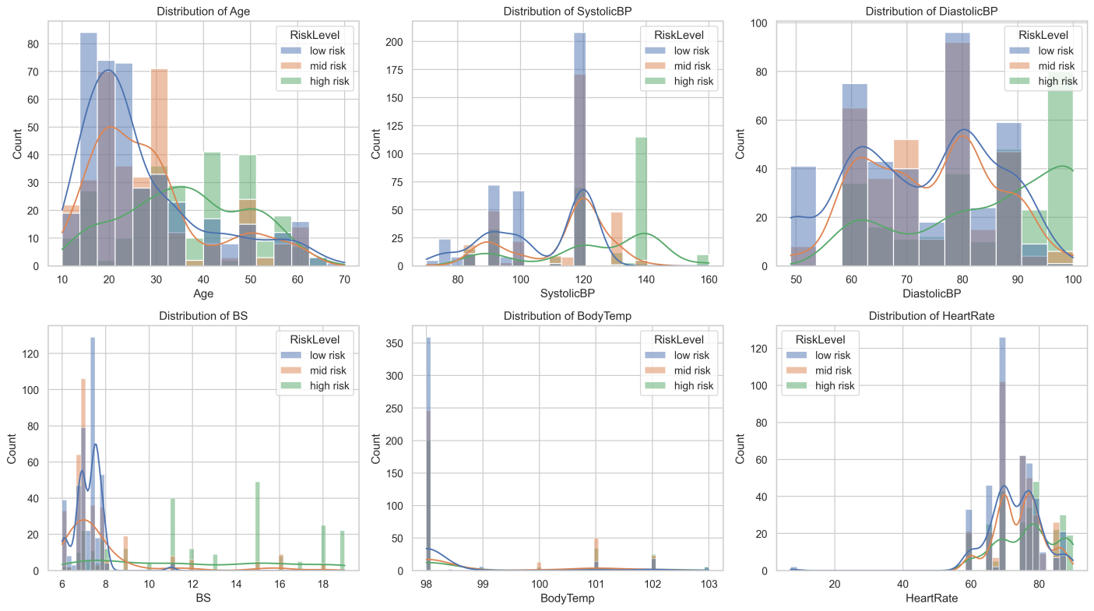
Figure 3: Distribution of each of the six raw numeric features across the full dataset.

4.5 Feature Engineering
Three clinically motivated derived features and one demographic feature were added to the six raw features:
- Pulse Pressure = SystolicBP - DiastolicBP, a recognized cardiovascular risk indicator.
- Mean Arterial Pressure (MAP) = DiastolicBP + (Pulse Pressure / 3), a standard clinical composite blood-pressure measure.
- Systolic-Diastolic Ratio = SystolicBP / DiastolicBP.
- AgeGroup (one-hot encoded as AgeGroup_adult and AgeGroup_advanced_maternal_age, with adolescent as the implicit baseline) bins reflecting recognized maternal age risk categories (under 20, 20-34, and 35+).
After feature engineering, the analysis feature set contained 11 columns: Age, SystolicBP, DiastolicBP, BS, BodyTemp, HeartRate, PulsePressure, MeanArterialPressure, SystolicDiastolicRatio, AgeGroup_adult, and AgeGroup_advanced_maternal_age. The target variable was ordinally encoded as low risk = 0, mid risk = 1, high risk = 2 (rather than using an unordered/alphabetical encoding), preserving the natural clinical ordering of risk severity.

4.6 Train/Test Split
The data was split into 80% training (811 records) and 20% held-out testing (203 records) using stratified sampling on the target class, ensuring the class proportions in both splits closely matched the full dataset.
Risk Level | Train Count | Test Count | Train % | Test %
Low risk | 325 | 81 | 40.07% | 39.90%
Mid risk | 269 | 67 | 33.17% | 33.00%
High risk | 217 | 55 | 26.76% | 27.09%
Table 4: Train/test split class distribution

5. Experimental Results and Analysis

5.1 Baseline Model
An untuned Logistic Regression model (with balanced class weighting) was evaluated first as a baseline reference point before any hyperparameter tuning was performed.

Metric | Value
Accuracy | 0.6502
Balanced Accuracy | 0.6576
Precision (macro) | 0.6442
Recall (macro) | 0.6576
F1 (macro) | 0.6493
F1 (weighted) | 0.6437
ROC-AUC (OvR macro) | 0.8171
Average Precision (macro) | 0.6719
Table 5: Baseline (untuned Logistic Regression) test-set performance
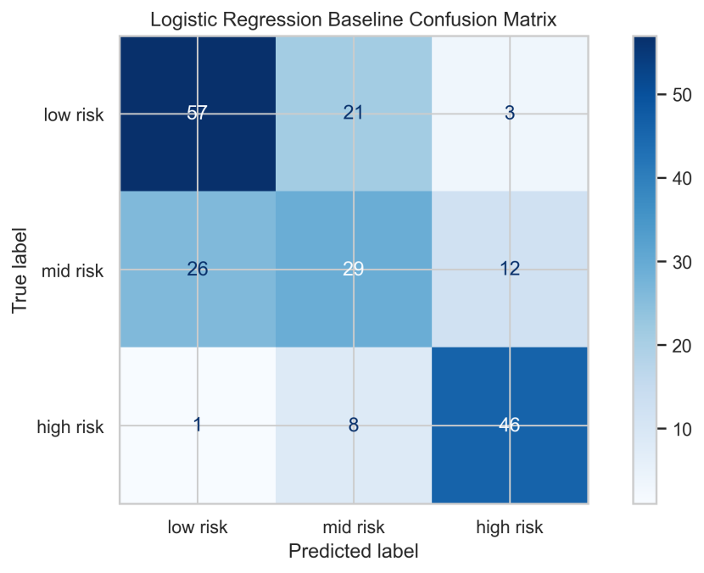
Figure 4: Baseline (untuned Logistic Regression) test-set performance

5.2 Hyperparameter Tuning (All Seven Models)
Every one of the seven candidate models was tuned exhaustively via GridSearchCV under identical stratified 5-fold cross-validation, using macro F1 as the scoring criterion. Tuning all seven models (rather than only the best-performing untuned subset) avoids selection bias against models that start with weak default hyperparameters but tune well.
Model | Best CV Macro F1 | Configurations Evaluated | Tuning Time (s)
Random Forest | 0.8338 | 48 | 35.66
Gradient Boosting | 0.8208 | 36 | 12.02
Decision Tree | 0.8120 | 24 | 0.47
KNN | 0.8057 | 20 | 0.45
SVM | 0.6895 | 12 | 1.29
MLP Neural Network | 0.6585 | 8 | 1.48
Logistic Regression | 0.6180 | 6 | 7.29
Table 6: Hyperparameter tuning results, ranked by best cross-validated macro F1
Random Forest achieved the highest cross-validated macro F1 (0.8338) and was therefore selected as the final model, in accordance with the cross-validation-only selection protocol described in Section 3.2, before the test set was consulted at all.

5.3 Held-Out Test Set Comparison (All Seven Tuned Models)

Model | Accuracy | Bal. Acc. | F1 Macro | F1 Weighted | ROC-AUC Macro | Avg Precision
Decision Tree | 0.8522 | 0.8615 | 0.8562 | 0.8512 | 0.9345 | 0.8704
KNN | 0.8473 | 0.8565 | 0.8521 | 0.8464 | 0.9460 | 0.8985
Random Forest (selected) | 0.8473 | 0.8565 | 0.8514 | 0.8461 | 0.9533 | 0.9211
Gradient Boosting | 0.8227 | 0.8333 | 0.8279 | 0.8211 | 0.9363 | 0.8908
SVM | 0.7685 | 0.7747 | 0.7683 | 0.7627 | 0.8772 | 0.7873
MLP Neural Network | 0.6749 | 0.6713 | 0.6541 | 0.6494 | 0.8221 | 0.7048
Logistic Regression | 0.6552 | 0.6525 | 0.6431 | 0.6417 | 0.8165 | 0.6843
Table 7: Test-set performance of all seven tuned models (n = 203), ranked by test macro F1
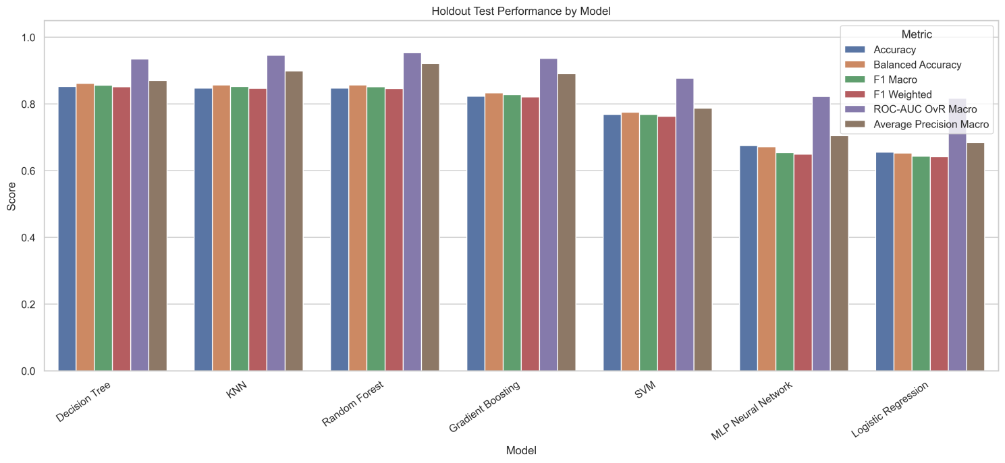
Figure 5: Bar chart comparison of held-out test metrics across all seven tuned models.

5.3.1 An Important Methodological Observation
On the held-out test set specifically, Decision Tree (F1 = 0.8562) and KNN (F1 = 0.8521) numerically edge out Random Forest (F1 = 0.8514) by a small margin. This is worth stating plainly rather than hiding: had model selection been performed by comparing test-set scores directly, Decision Tree would have been chosen instead. Random Forest was nonetheless selected because it had the strongest cross-validated macro F1 (0.8338 vs. 0.8120 for Decision Tree) across five folds of the training data, which is a more stable and less noise-prone estimate than a single 203-record test set can provide. Random Forest also achieved the best ROC-AUC (0.9533) and average precision (0.9211) on the test set, indicating stronger class-discrimination and ranking performance, even where its point-prediction F1 was marginally lower than Decision Tree's. This divergence between the CV-selected winner and the test-set winner illustrates realistic variance at this dataset size and is discussed further in Section 5.9 (Generalization) and Section 6.

5.4 Selected Model: Detailed Evaluation (Random Forest)
Class | Precision | Recall | F1-score | Support
Low risk | 0.86 | 0.81 | 0.84 | 81
Mid risk | 0.80 | 0.79 | 0.80 | 67
High risk | 0.88 | 0.96 | 0.92 | 55
Accuracy |  |  | 0.85 | 203
Macro avg | 0.85 | 0.86 | 0.85 | 203
Weighted avg | 0.85 | 0.85 | 0.85 | 203
Table 8: Final classification report for the selected model (Random Forest) on the held-out test set
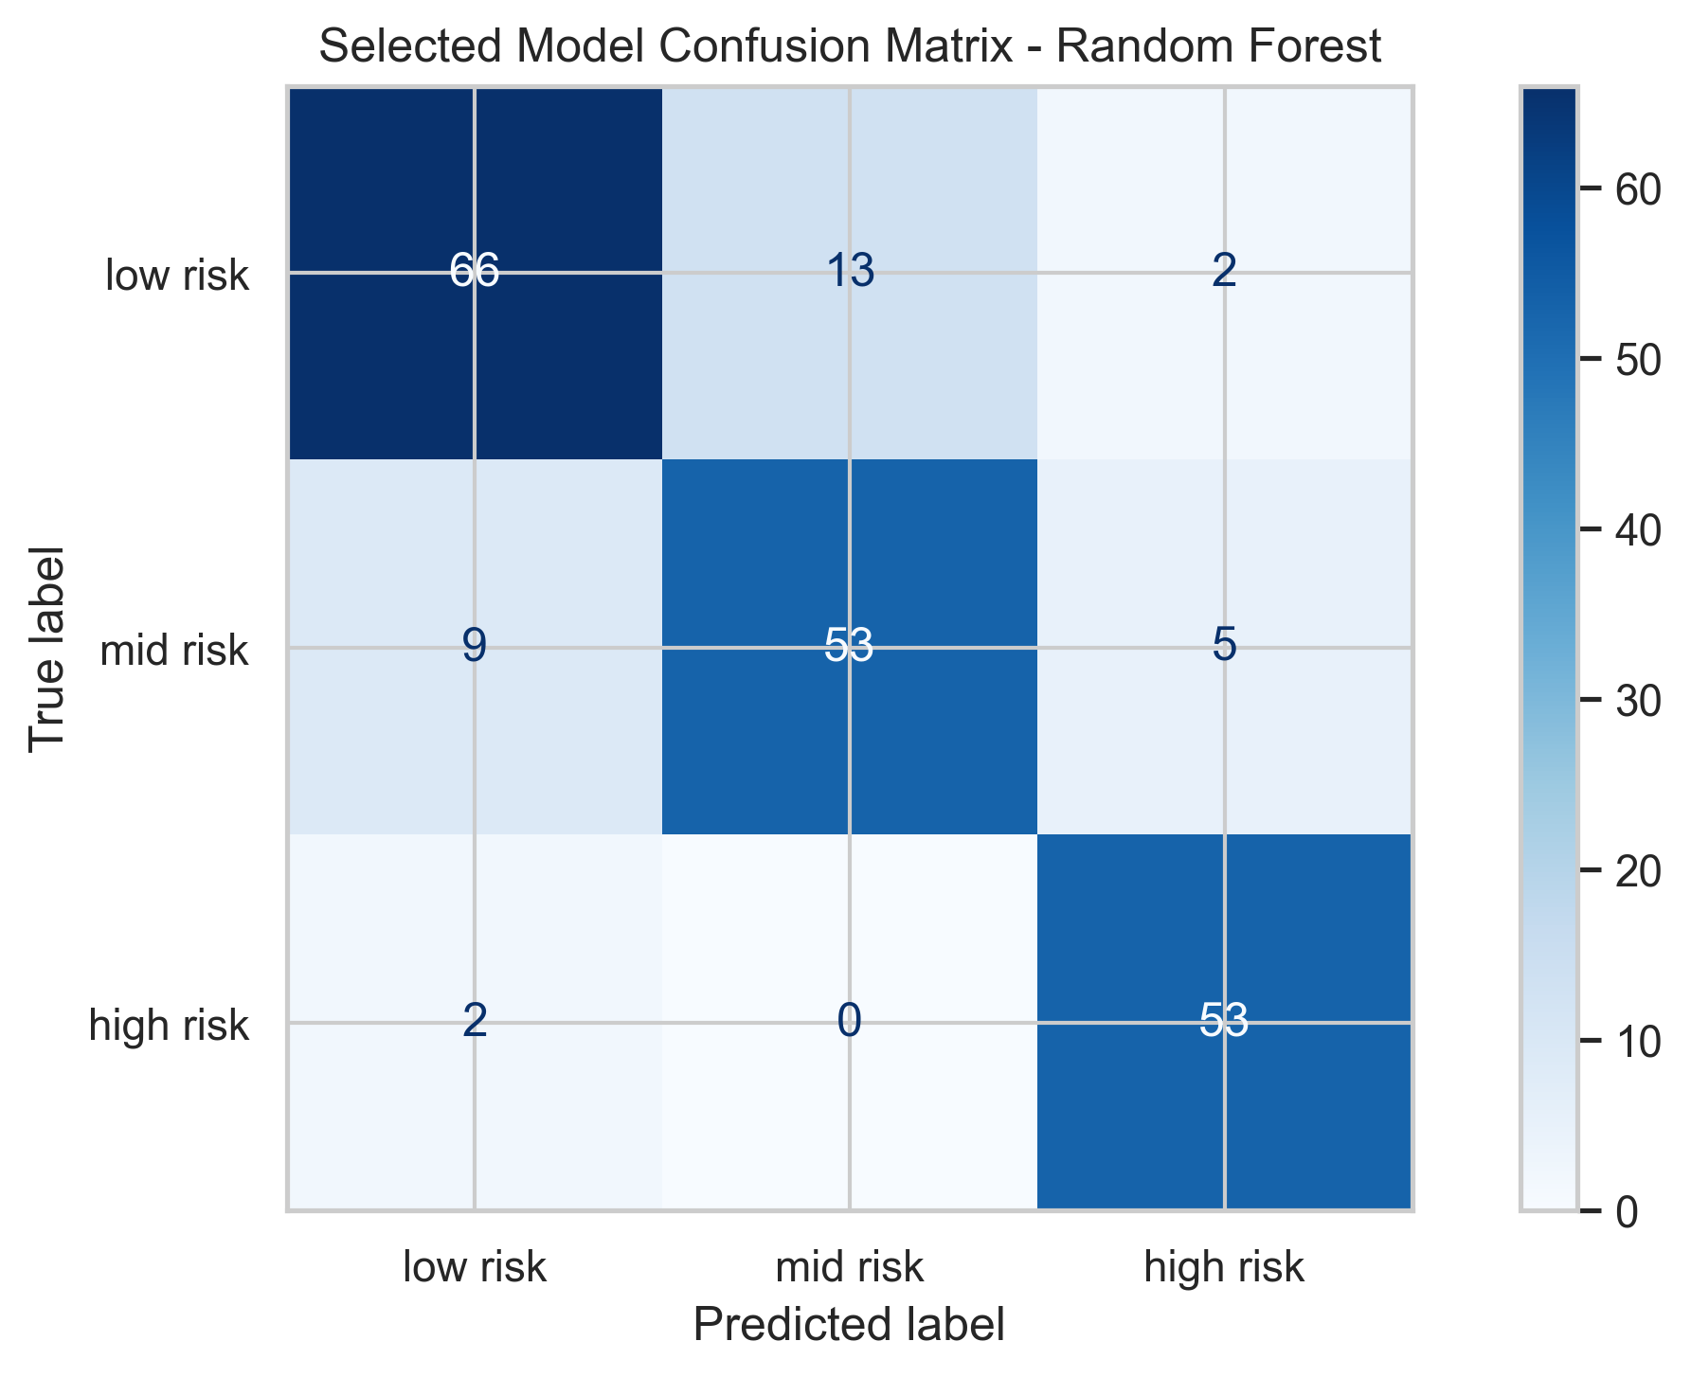
Figure 6: Confusion matrix and ROC curves for the selected model (Random Forest) on the held-out test set.
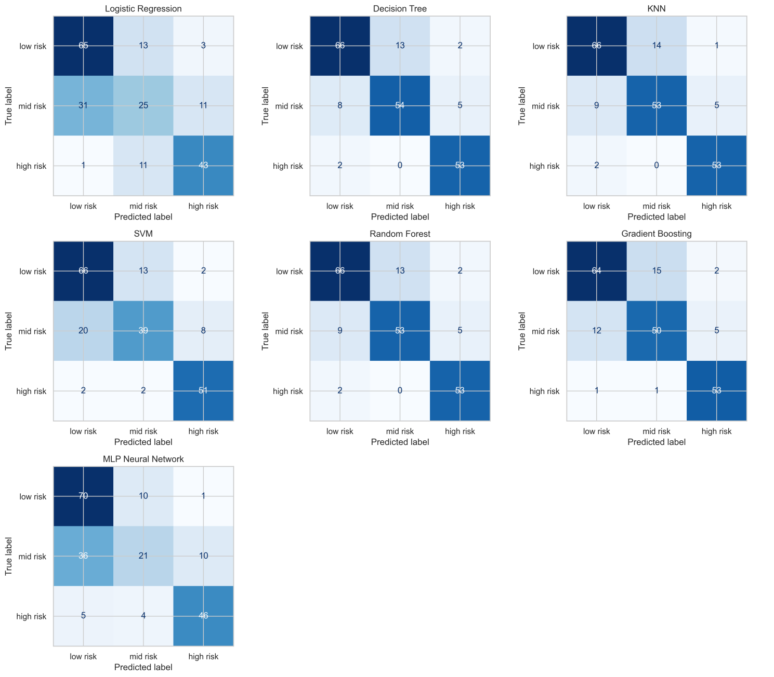
Figure 7: Confusion matrices for all seven tuned models, for side-by-side comparison.
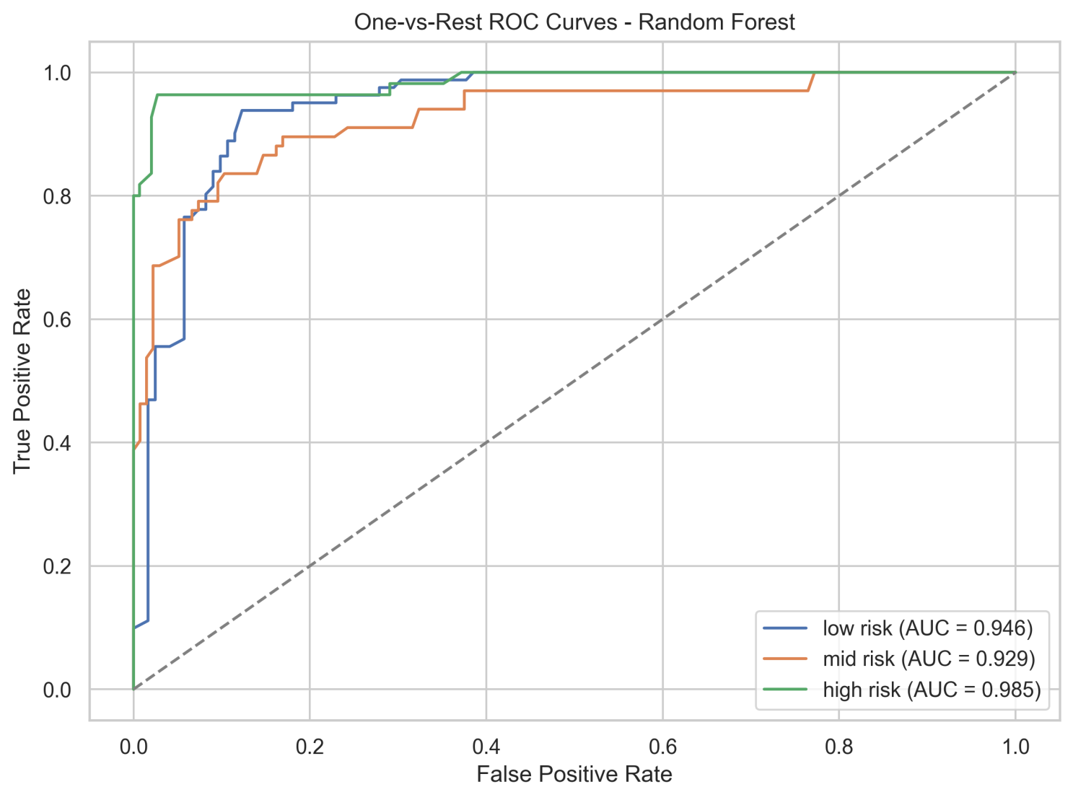
Figure 8: One-vs-rest ROC curves for the selected model, by class.
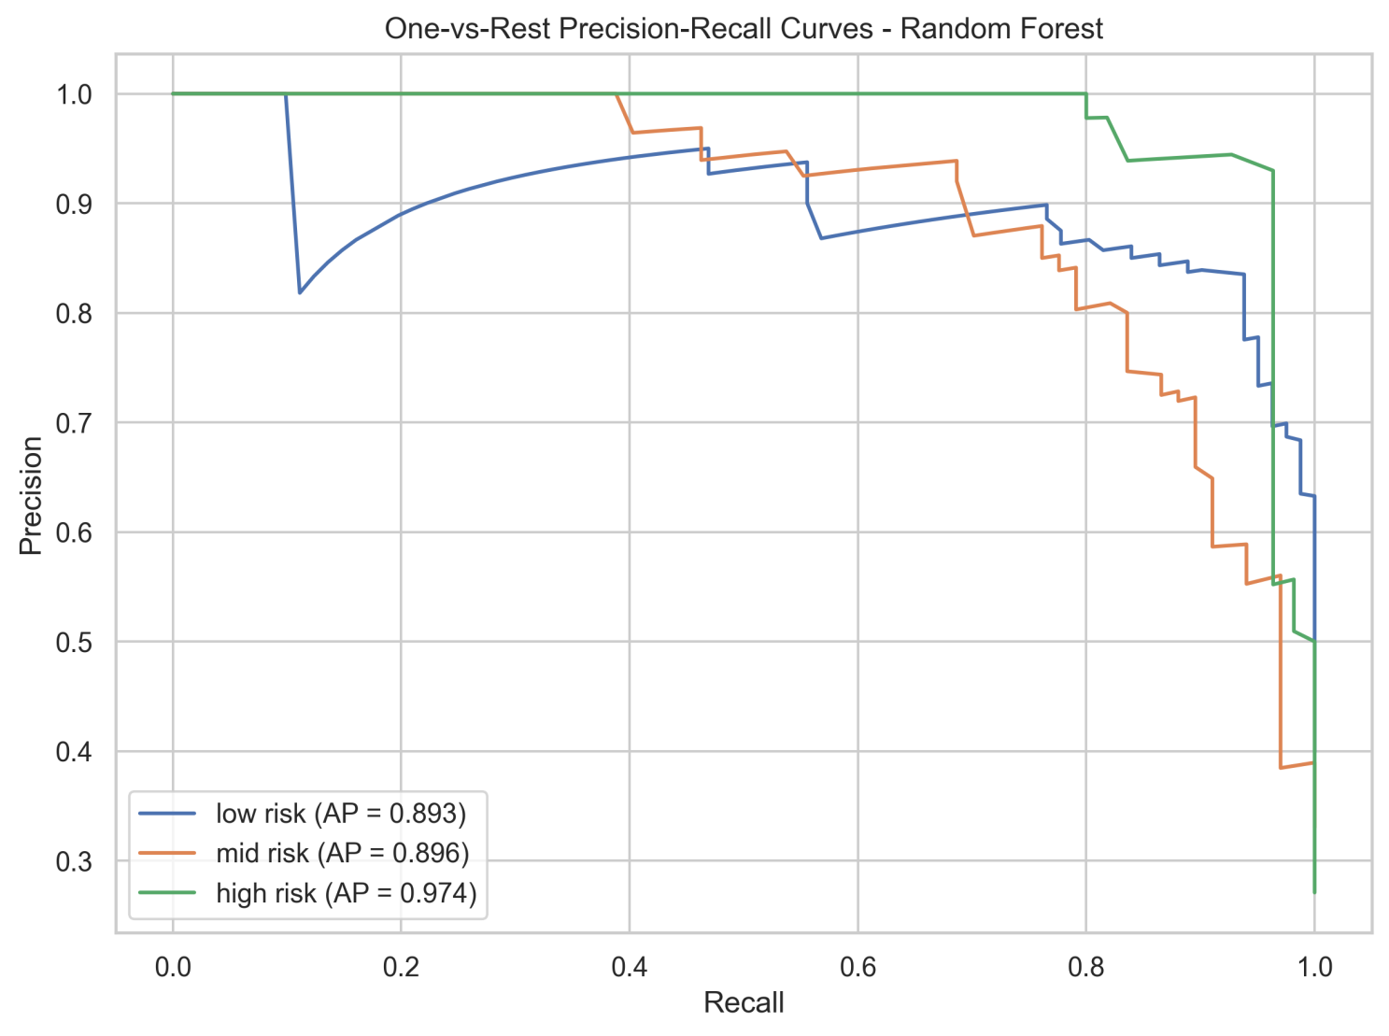
Figure 9: One-vs-rest precision-recall curves for the selected model, by class.

5.5 Per-Class Performance Across All Models
Recall for the mid-risk class was consistently the weakest across nearly every model, directly relevant to RQ3 (class imbalance): Logistic Regression achieved only 37.3% mid-risk recall and the MLP only 31.3%, while tree-based ensembles (Decision Tree, KNN, and Random Forest) each achieved 79-81% mid-risk recall nearly double the linear/neural baselines. Low-risk and high-risk classes were substantially easier for every model to separate, with the tree-based models achieving 96%+ recall on high-risk cases.
Model | Mid-Risk Precision | Mid-Risk Recall | Mid-Risk F1
Decision Tree | 0.8060 | 0.8060 | 0.8060
Random Forest | 0.8030 | 0.7910 | 0.7970
KNN | 0.7910 | 0.7910 | 0.7910
Gradient Boosting | 0.7576 | 0.7463 | 0.7519
SVM | 0.7222 | 0.5821 | 0.6446
MLP Neural Network | 0.6000 | 0.3134 | 0.4118
Logistic Regression | 0.5102 | 0.3731 | 0.4310
Table 9: Mid-risk class recall by model (the most difficult class to classify)

5.6 Statistical Significance of Model Differences
A Friedman test was applied to the matched, per-fold cross-validated macro F1 scores of all seven models (5 folds each), directly addressing RQ2.
Test | Statistic | p-value | Interpretation
Friedman | 27.2571 | 0.00013 | Significant at alpha = 0.05
Table 10: Friedman test result across all seven models' cross-validated macro F1 scores
With p = 0.00013, well below the alpha = 0.05 threshold, the null hypothesis that all seven models perform equivalently is rejected: at least one model's cross-validated performance differs significantly from the others. Combined with the tuning results in Table 6, this supports the conclusion that the results provide evidence that model performance differs significantly across the seven algorithms. The Friedman test provides evidence that cross-validated performance differs across the seven algorithms (p = 0.00013). However, because the hyperparameters were selected using the same cross-validation framework, this statistical comparison should be interpreted as supportive rather than as an independent confirmatory test.

5.7 Feature Importance (RQ4)
Two independent importance methods were used and cross-checked, since a single method (particularly impurity-based importance) can overstate the relevance of correlated or derived features.
Feature | Importance (mean) | Importance (std)
BS (blood glucose) | 0.2865 | 0.0254
SystolicBP | 0.0639 | 0.0136
BodyTemp | 0.0550 | 0.0134
Age | 0.0504 | 0.0129
HeartRate | 0.0054 | 0.0105
MeanArterialPressure | 0.0029 | 0.0087
AgeGroup_adult | -0.0011 | 0.0049
DiastolicBP | -0.0044 | 0.0039
AgeGroup_advanced_maternal_age | -0.0090 | 0.0031
SystolicDiastolicRatio | -0.0157 | 0.0040
PulsePressure | -0.0189 | 0.0070
Table 11: Permutation importance (held-out test set, selected model), ranked
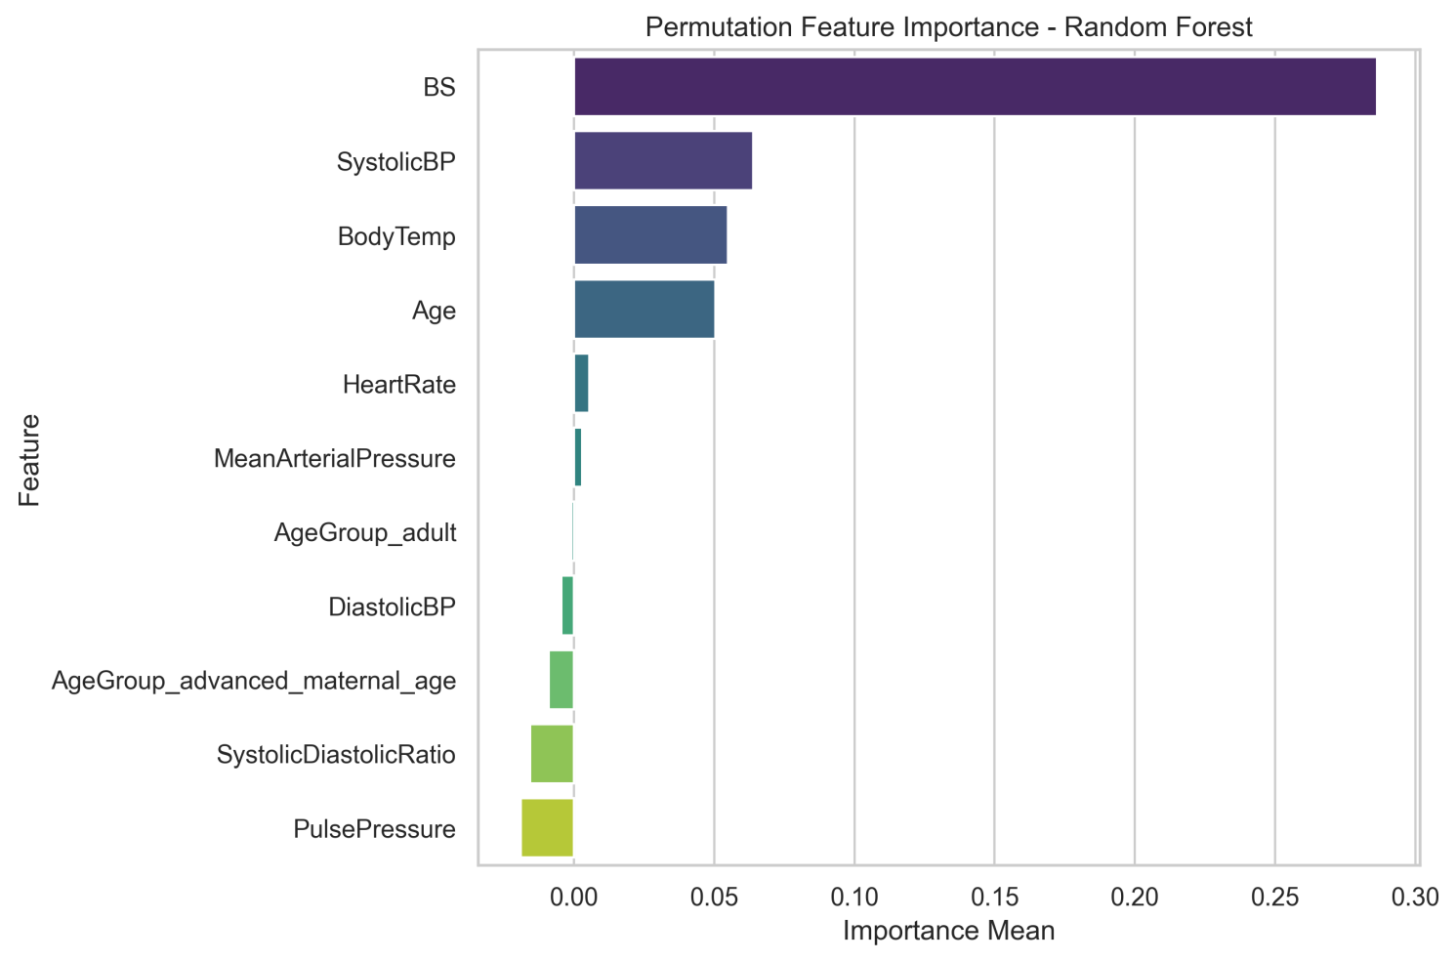
Figure 10: Permutation importance of all 11 features for the selected model, computed on the held-out test set.
Feature | Built-in Importance
BS (blood glucose) | 0.3388
Age | 0.1157
SystolicBP | 0.1037
MeanArterialPressure | 0.1007
HeartRate | 0.0735
SystolicDiastolicRatio | 0.0647
DiastolicBP | 0.0612
PulsePressure | 0.0569
BodyTemp | 0.0517
AgeGroup_adult | 0.0169
AgeGroup_advanced_maternal_age | 0.0162
Table 12: Built-in (impurity-based) feature importance, selected model (Random Forest)
Both methods agree strongly on blood glucose (BS) as the single most predictive feature by a wide margin, consistent with hyperglycemia being an established maternal risk factor. Age and SystolicBP also rank consistently high in both methods. However, the two methods disagree notably on the three engineered ratio/composite features: built-in importance ranks MeanArterialPressure, SystolicDiastolicRatio, and PulsePressure as moderately useful (ranked 4th, 6th, and 8th respectively), while permutation importance on the held-out test set assigns them near-zero or slightly negative importance. This is a meaningful finding for RQ4: impurity-based importance can overstate the value of features that are simple algebraic combinations of already-included raw features (SystolicBP and DiastolicBP), because the tree can use the derived feature as a convenient split threshold without it adding genuinely new information. Permutation importance, measured on unseen data, is the more trustworthy signal for generalization and suggests the raw vital signs (BS, SystolicBP, BodyTemp, Age) carry effectively all of the model's real predictive power.

5.8 Diagnostics for the MLP Neural Network
Property | Value
Hidden layer sizes | (64,)
Activation function | ReLU
Solver | Adam
Iterations run | 52
Final training loss | 0.6529
Table 13: Tuned MLP architecture and convergence
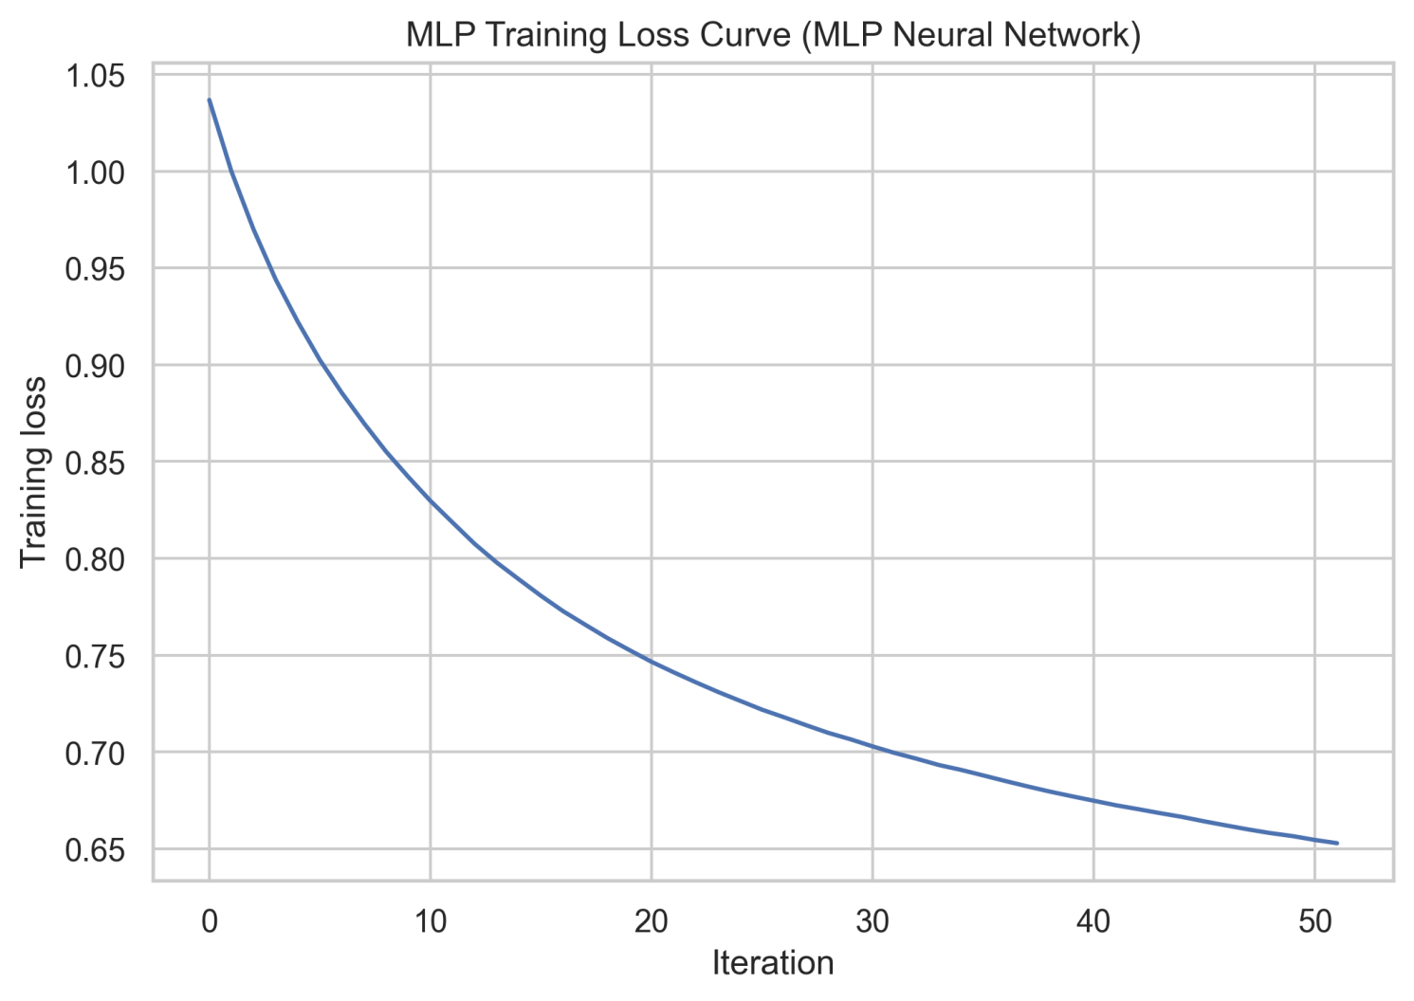
Figure 11: Training loss curve for the tuned MLP Neural Network.
The MLP's relatively high final training loss (0.6529, on a dataset with only 811 training records and 11 features) and comparatively weak test performance (macro F1 = 0.6541) together suggest the network did not fit this dataset as effectively as the tree-based models.Consistent with a well-known limitation of neural networks on small tabular datasets, where tree-based ensembles typically generalize better with far less data and no architecture search.

5.9 Generalization: Learning Curves (RQ5)
Learning curves were generated for the top three cross-validated models (Random Forest, Gradient Boosting, and Decision Tree) to examine whether performance is limited by high variance (overfitting), high bias (underfitting), or genuinely close to a data ceiling.
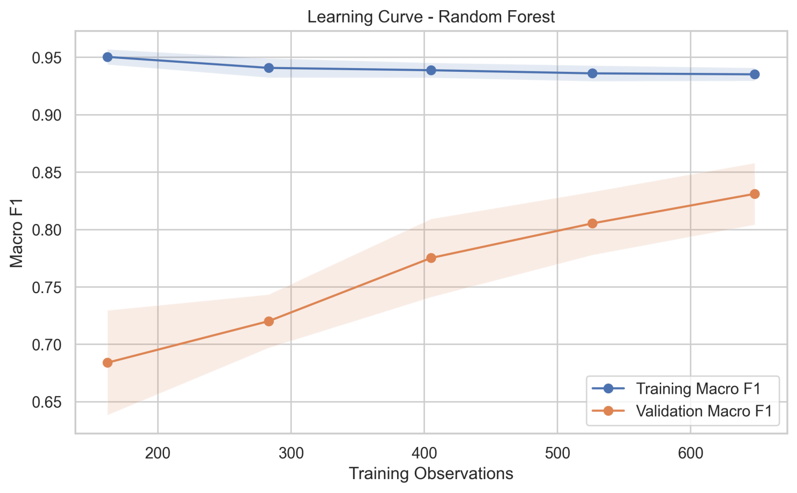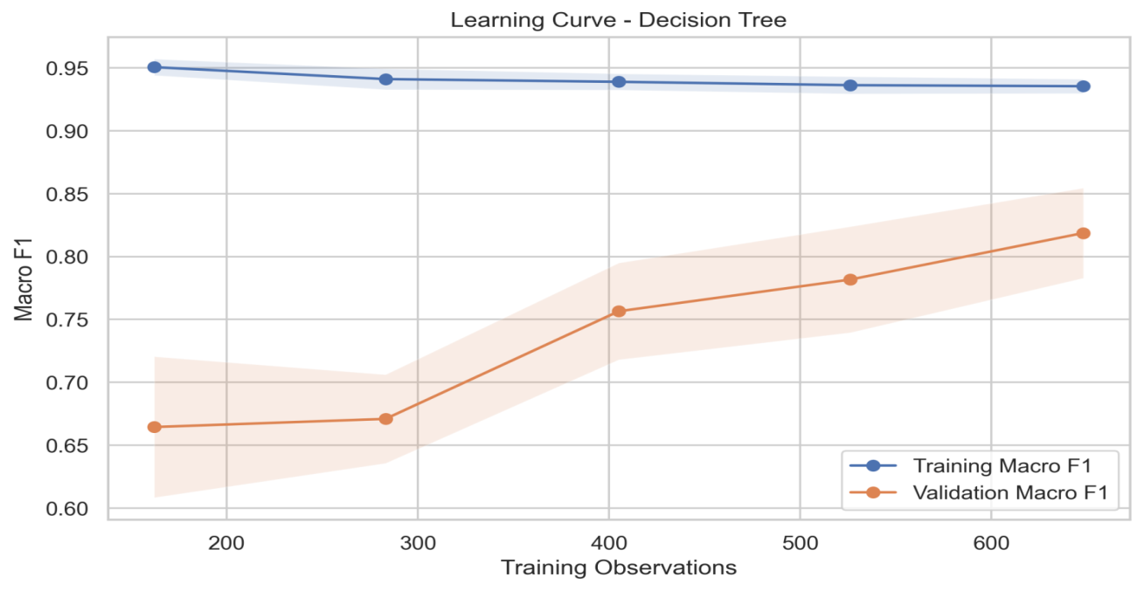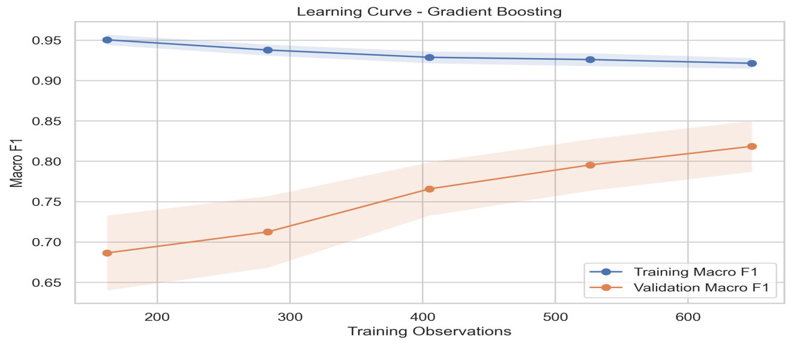
Figure 12: Learning curves for the three top cross-validated models: Random Forest, Gradient Boosting, and Decision Tree
A persistent, non-shrinking gap between training and validation score across all training-set sizes indicates variance (overfitting) that more data may not fully resolve; validation curves that plateau and converge closely with the training curve at larger sample sizes instead indicate the model is closer to a natural performance ceiling for the available features, and that more data would offer only modest further gains - this pattern should be read directly off the generated learning-curve figures and discussed against the CV-vs-test result reversal noted in Section 5.3.1.

5.10 Error Analysis
Of the 203 held-out test observations, 172 (84.7%) were classified correctly and 31 (15.3%) were misclassified by the selected model.
Actual \ Predicted | Low risk | Mid risk | High risk
Low risk | 66 | 13 | 2
Mid risk | 9 | 53 | 5
High risk | 2 | 0 | 53
Table 14: Confusion matrix for the selected model (Random Forest), held-out test set
The dominant confusion pattern is between low-risk and mid-risk cases (13 low-risk cases predicted as mid-risk, and 9 mid-risk cases predicted as low-risk together accounting for 22 of the 31 total errors, or 71%). This is clinically the least dangerous direction of error compared to confusing high-risk with a lower category: only 2 high-risk cases were misclassified (both as low-risk, none as mid-risk), and only 2 low-risk cases and 5 mid-risk cases were misclassified as high-risk. In a screening context, this error pattern is relatively favorable, since the model rarely fails to flag genuinely high-risk cases, though the 2 high-risk-to-low-risk errors represent the most clinically consequential mistake type and would need to be specifically addressed before any real-world use.

5.11 Descriptive/Unsupervised Analysis: PCA and K-Means
As a complementary descriptive analysis, Principal Component Analysis (PCA) was used to visualize the training data in two dimensions, and K-Means clustering (k=3, unsupervised, with no access to the true labels) was used to test whether the three risk levels form naturally separable clusters in feature space.
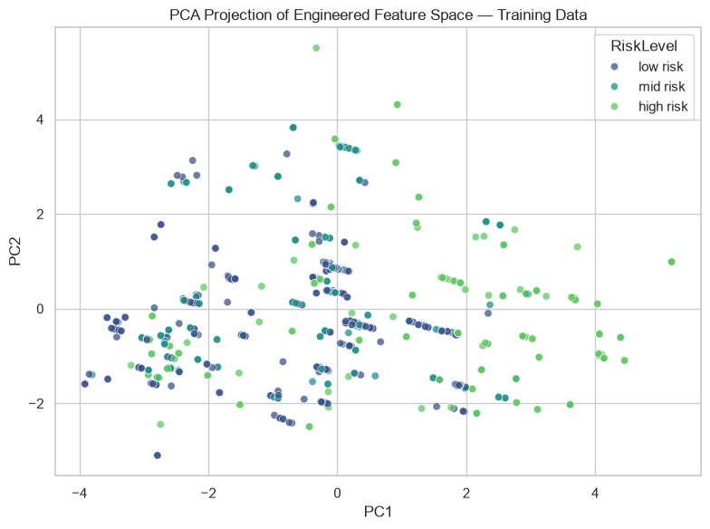
Figure 13: PCA projection of the training data, colored by true RiskLevel.
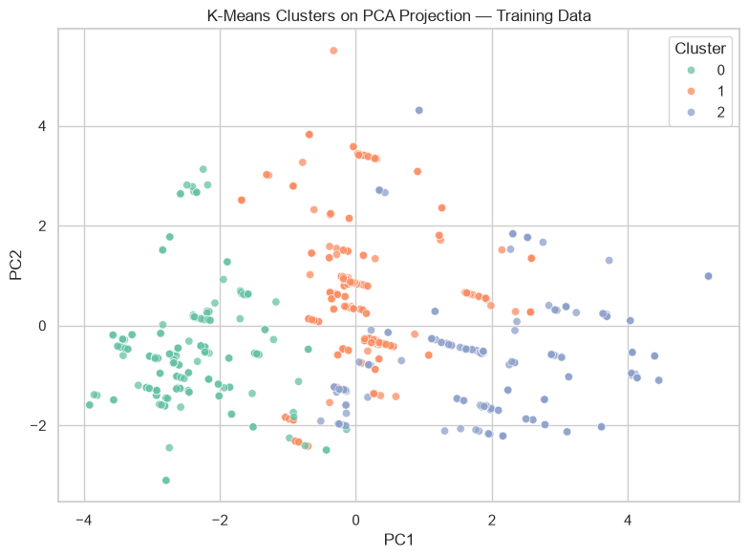
Figure 14: K-Means clustering (k=3) of the training data in PCA space.
True Risk Level | Cluster 0 | Cluster 1 | Cluster 2
Low risk | 119 | 136 | 70
Mid risk | 66 | 147 | 56
High risk | 42 | 58 | 117
Table 15: Cross-tabulation of true RiskLevel against unsupervised K-Means cluster assignment
High-risk cases concentrate disproportionately in Cluster 2, with 117 of 217 high-risk training observations (53.9%) assigned to this cluster, while low-risk and mid-risk cases are distributed more broadly across all three clusters. However, Cluster 2 also contains 70 low-risk and 56 mid-risk observations, indicating substantial overlap between the risk groups in the unsupervised feature space. Overall, the K-Means results suggest that high-risk cases have a partially distinct feature-space signature detectable without supervision, but that the separation between low- and mid-risk cases remains limited. This finding is consistent with the supervised error analysis in Section 5.10, where the low/mid boundary was the dominant source of classification error.

6. Concluding Remarks

6.1 Summary of Findings
This project developed and rigorously evaluated a seven-algorithm machine learning pipeline for three-class maternal health risk stratification. Model selection was based exclusively on stratified cross-validation using Macro F1, with the test set reserved for final evaluation. Random Forest achieved the strongest cross-validated performance and was therefore selected as the final model. On the held-out test set, it achieved an accuracy of 0.847, balanced accuracy of 0.857, Macro F1 of 0.851, and Macro ROC-AUC of 0.953.
Blood glucose (BS) was consistently identified as the dominant predictive feature by both native Random Forest importance and permutation importance. The error analysis showed that high-risk classification was particularly strong, with 96.4% recall, while most remaining errors occurred at the low/mid boundary. The PCA and K-Means analysis further indicated partial separation of high-risk observations in the unsupervised feature space, while substantial overlap remained between risk categories.
The findings directly address the six research questions introduced in Section 1.3.

6.1.1 Answers to the Research Questions
RQ1 Predictive accuracy: How accurately can the seven algorithms classify maternal risk level from six raw clinical/IoT features?
The seven candidate algorithms demonstrated substantially different predictive performance. Based on five-fold stratified cross-validation using Macro F1, Random Forest achieved the highest mean score of 0.834, followed by Gradient Boosting (0.821), Decision Tree (0.812), KNN (0.806), SVM (0.690), MLP (0.659), and Logistic Regression (0.618). The selected Random Forest achieved a held-out test Macro F1 of 0.851, accuracy of 0.847, and balanced accuracy of 0.857. These results show that the available clinical/IoT measurements contain substantial predictive information for three-class maternal risk stratification, while performance remains imperfect at the low/mid boundary.
RQ2 Model comparison: Which model performs best, and is the difference statistically significant or within noise?
Random Forest was the best model according to the pre-specified cross-validation model-selection criterion, achieving the highest mean Macro F1 (0.8338). The Friedman test indicated that cross-validated performance differed across the seven algorithms (p = 0.00013). However, because the hyperparameters were selected using the same cross-validation framework, this statistical comparison should be interpreted as supportive rather than independently confirmatory. Importantly, Random Forest was not the highest-performing model on every individual hold-out metric; the Decision Tree achieved a marginally higher test-set F1. The final model was therefore chosen according to the predefined CV procedure rather than by selecting the model that happened to perform best on the test set.
RQ3 Class imbalance: How does class imbalance across low/mid/high risk affect per-class recall, and does macro-averaging change the ranking versus plain accuracy?
The dataset contained 406 low-risk, 336 mid-risk, and 272 high-risk observations, creating a moderate class imbalance. The final Random Forest achieved recalls of 81.5% for low risk, 79.1% for mid risk, and 96.4% for high risk. The substantially stronger high-risk recall demonstrates that the model was particularly effective at identifying the most severe category, while mid-risk cases were more difficult to distinguish. Because plain accuracy can be influenced by class frequencies, Macro F1 and balanced accuracy were emphasized during model selection and evaluation. This provided a more balanced assessment of performance across the three risk categories.
RQ4 Feature contribution: Which raw and engineered features contribute most to predictions, and is this consistent across importance methods?
Blood glucose (BS) was the dominant predictive feature. It had the largest contribution under both native Random Forest feature importance and permutation importance, with approximate importance values of 0.339 and 0.287, respectively. The agreement between the two methods strengthens confidence that blood glucose is the most influential feature within this dataset and modeling pipeline. Engineered ratio features contributed less than initially expected, indicating that the original measurements contained much of the predictive signal captured by the model.
RQ5 Generalization: Do the learning curves and CV-vs-test comparison show overfitting, underfitting, or a model that would likely improve with more data?
The learning curves and comparison between cross-validation and held-out test performance do not indicate severe overfitting of the selected Random Forest. Its cross-validated Macro F1 (0.834) and held-out test Macro F1 (0.851) were broadly consistent, although the small difference should not be interpreted as proof of strong generalization. The learning-curve analysis also provides evidence that additional training data may still improve performance, particularly because the model has not clearly reached a completely flat performance plateau. However, the presence of 562 exact duplicate rows and the absence of patient-level identifiers introduce an important limitation: the record-level hold-out performance may be optimistic because identical observations can occur across the training and test partitions.
RQ6 Limitations and responsible use: What are the limitations of this dataset and model for real-world, low-resource clinical deployment, and what human oversight would be required?
The analysis demonstrates promising predictive performance but does not establish clinical readiness. The dataset contains only six raw clinical/IoT measurements, comes from a specific population and deployment context, contains 562 exact duplicate records, and lacks patient-level identifiers. There was also no external validation, prospective clinical validation, subgroup fairness analysis, or probability calibration assessment. Consequently, the reported performance should not be interpreted as evidence that the model is ready for autonomous clinical use. Before real-world deployment, the model would require larger and more diverse multi-site datasets, patient-level or grouped validation where appropriate, external and prospective validation, calibration and subgroup fairness assessment, and review by qualified clinicians. The appropriate role of such a model would be clinician-in-the-loop decision support, not autonomous diagnosis or treatment recommendation.
Overall, the six research questions are answered consistently by the analysis: the available measurements support useful three-class risk prediction; Random Forest provided the strongest cross-validated performance; class-specific evaluation revealed particularly strong high-risk detection but weaker low/mid separation; blood glucose was the most influential predictor; the selected model showed reasonably consistent cross-validation and hold-out performance while retaining potential to benefit from additional data; and substantial dataset, validation, fairness, calibration, and clinical limitations remain before any real-world deployment could be considered.

6.2 Major Strengths
- Methodological rigor: model selection was based strictly on cross-validated performance, never on the test set, avoiding a common and subtle form of leakage.
- All seven candidate models were exhaustively tuned (not just a pre-selected subset), avoiding selection bias against models with weak default configurations.
- Multiple independent interpretability methods (native importance, permutation importance) were cross-checked against each other, revealing that engineered ratio features contributed less than initially assumed.
- A formal statistical test (Friedman) was used to provide supportive evidence that cross-validated model performance differed across the seven algorithms.
- The data-cleaning decision to retain duplicate rows was made transparently and justified explicitly, rather than silently applying an unverifiable assumption.
- The full pipeline is reproducible: fixed random seeds, saved package versions, and a validation gate that halts execution if the dataset or class distribution does not match expectations.

6.3 Major Weaknesses and Limitations
- Dataset size and scope: 1,014 records (and only 452 truly unique records once duplicates are set aside) from a single country (Bangladesh), collected through a specific IoT deployment findings may not generalize to other populations or measurement conditions.
- Feature scope: only six raw vital signs are available, with no obstetric history, prior pregnancy complications, socioeconomic factors, or laboratory-confirmed diagnoses, which a real clinical risk model would typically incorporate.
- Because the dataset contains 562 exact duplicate measurement rows and lacks patient-level identifiers, random train/test splitting may place identical observations in both partitions. Consequently, although the test set was not used for model selection, the reported hold-out performance may still be optimistic because the dataset does not permit patient-level or duplicate-group separation. Future validation should use patient-level identifiers or grouped splitting where available.
- No external validation: the model has not been tested on data from a different hospital, region, or time period, so its reported performance may be optimistic relative to real-world deployment.
- No clinical validation: the model has not been reviewed or validated by medical professionals and has not been tested within an actual care pathway.
- The CV-selected best model (Random Forest) did not have the single highest test-set F1 score (Decision Tree was marginally higher); while this was handled with proper methodology, it highlights that model rankings at this dataset size carry real uncertainty.
- Fairness and calibration were not evaluated across subgroups (e.g., by age band), and predicted probabilities have not been calibration-tested.

6.4 Suggested Way Forward
- Collect a larger, multi-site dataset to validate whether Random Forest's advantage over Decision Tree and KNN holds at scale, and to enable proper external validation.
- Incorporate additional clinical features (obstetric history, prior complications, laboratory results) to improve mid-risk/low-risk separability, the model's weakest boundary.
- Conduct subgroup fairness analysis and probability calibration testing before any consideration of real-world use.
- Pursue clinician review and a prospective validation study, with the model positioned strictly as a clinician-in-the-loop decision-support aid rather than an autonomous classifier, consistent with the Academic and clinical notice stated at the start of this project.
- Investigate cost-sensitive learning to specifically penalize the clinically most dangerous error type (high-risk cases predicted as a lower risk level) more heavily than other error types.

References
[1] M. Ahmed, M. A. Kashem, M. Rahman, and S. Khatun, "Review and Analysis of Risk Factor of Maternal Health in Remote Area Using the Internet of Things (IoT)," in InECCE2019, Lecture Notes in Electrical Engineering, vol. 632, A. N. Kasruddin Nasir et al., Eds. Singapore: Springer, 2020, pp. 357-365, doi: 10.1007/978-981-15-2317-5_30.
[2] M. Ahmed and M. A. Kashem, "IoT Based Risk Level Prediction Model For Maternal Health Care In The Context Of Bangladesh," in 2020 2nd Int. Conf. Sustainable Technologies for Industry 4.0 (STI), Dhaka, Bangladesh, 2020, pp. 1-6, doi: 10.1109/STI50764.2020.9350320.
[3] T. O. Togunwa, A. O. Babatunde, and K.-R. Abdullah, "Deep hybrid model for maternal health risk classification in pregnancy: synergy of ANN and random forest," Frontiers in Artificial Intelligence, vol. 6, art. 1213436, 2023, doi: 10.3389/frai.2023.1213436.
[4] M. Assaduzzaman, A. Al Mamun, and M. Hasan, "Early Prediction of Maternal Health Risk Factors Using Machine Learning Techniques," in 2023 Int. Conf. for Advancement in Technology (ICONAT), Goa, India, 2023, doi: 10.1109/ICONAT57137.2023.10080700.
[5] M. Ahmed, "Maternal Health Risk," UCI Machine Learning Repository, 2020. [Online]. Available: https://doi.org/10.24432/C5DP5D
[6] F. Pedregosa et al., "Scikit-learn: Machine Learning in Python," Journal of Machine Learning Research, vol. 12, pp. 2825-2830, 2011.
[7] W. McKinney, "Data Structures for Statistical Computing in Python," in Proc. 9th Python in Science Conf. (SciPy), 2010, pp. 56-61.
[8] M. Friedman, "The Use of Ranks to Avoid the Assumption of Normality Implicit in the Analysis of Variance," Journal of the American Statistical Association, vol. 32, no. 200, pp. 675-701, 1937.

Annex

A1. Software Environment and Package Versions
Package | Version
numpy | 2.4.4
pandas | 3.0.2
scipy | 1.17.1
scikit-learn | 1.8.0
matplotlib | 3.10.8
seaborn | 0.13.2
joblib | 1.5.3
Python | 3.14.4

A2. Best Hyperparameters per Model
Model | Best Parameters
Random Forest | class_weight=None, max_depth=None, max_features=sqrt, min_samples_leaf=1, n_estimators=400
Gradient Boosting | learning_rate=0.1, max_depth=3, min_samples_leaf=1, n_estimators=200
Decision Tree | class_weight=balanced, max_depth=None, min_samples_leaf=1
KNN | n_neighbors=15, p=1, weights=distance
SVM | C=10, class_weight=balanced, gamma=scale
MLP Neural Network | activation=relu, alpha=0.0001, hidden_layer_sizes=(64,), learning_rate_init=0.001
Logistic Regression | C=1, class_weight=None

A3. Final Model Metadata
Property | Value
Selected model | Random Forest
Selection metric | f1_macro (cross-validated)
Best CV Macro F1 | 0.8338
Test Accuracy | 0.8473
Test Balanced Accuracy | 0.8565
Test Macro F1 | 0.8514
Test ROC-AUC (OvR macro) | 0.9533
Test Average Precision (macro) | 0.9211
Raw rows used for final refit | 1,014

A4. Final Pipeline Validation Checks
Check | Passed
Dataset file exists | True
Raw dataset has the expected row count (1,013-1,014) | True
All three target classes are present | True
Train split contains all classes | True
Test split contains all classes | True
Final model artifact saved | True
Final summary table saved | True

A5. Live Demonstration Example
The notebook includes a callable prediction function for live demonstration purposes. Example input (age=35, systolic BP=140, diastolic BP=95, blood sugar=8.5 mmol/L, body temp=98.6, heart rate=88) produced the following output using the final refit model:
Risk Level | Predicted Probability
High risk | 0.9489
Mid risk | 0.0261
Low risk | 0.0250
Predicted risk level: High risk (model: Random Forest).

A6. Data Dictionary
Column | Description
Age | Age of the woman in years
SystolicBP | Systolic blood pressure in mmHg
DiastolicBP | Diastolic blood pressure in mmHg
BS | Blood glucose concentration in mmol/L
BodyTemp | Body temperature
HeartRate | Resting heart rate in beats per minute
RiskLevel | Target variable: low risk, mid risk, high risk

A7. Complete Figure Index ( not only document but created by notebook also)
The following figures were generated by the notebook and saved to outputs_final/figures/.
- 01_target_distribution.png
- 02_feature_distributions.png
- 03_boxplots_by_risk.png
- 04_correlation_matrix.png
- 05_baseline_confusion_matrix.png
- 06_holdout_model_comparison.png
- 07_selected_model_confusion_matrix.png
- 08_all_model_confusion_matrices.png
- 09_selected_model_roc_curves.png
- 09b_mlp_loss_curve.png
- 10_selected_model_precision_recall_curves.png
- 11_permutation_feature_importance.png
- 12_decision_tree_structure.png
- 13_pca_projection.png
- 14_kmeans_clusters.png

