Cahier de Charge – DJMall

UML Class Diagram
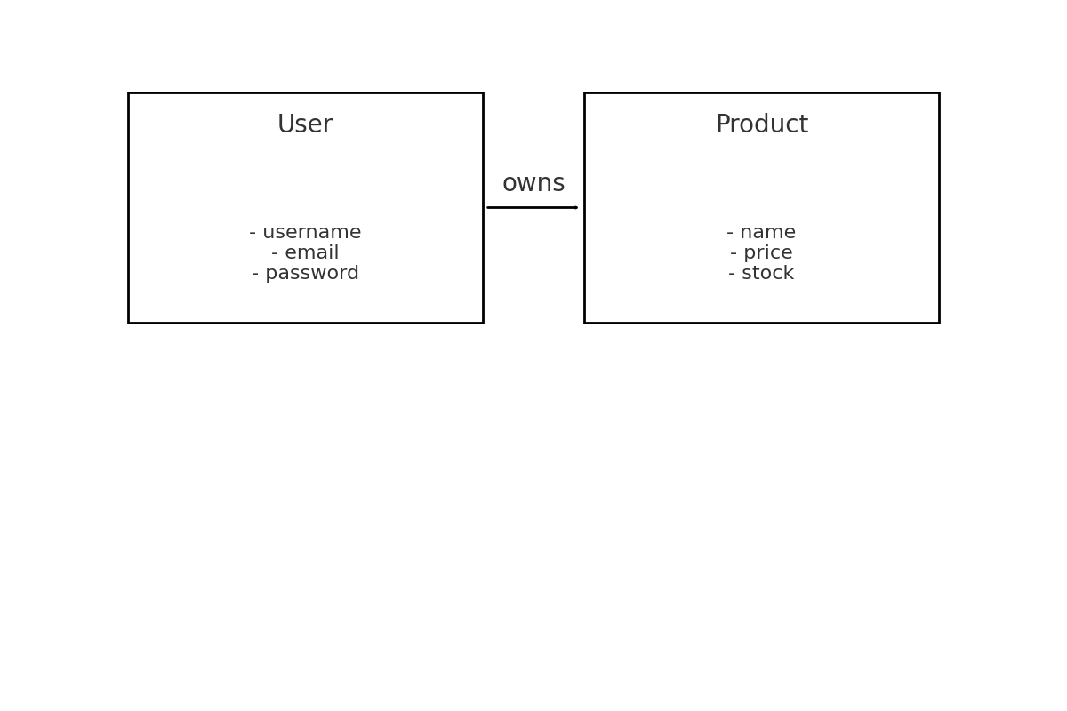

UML Use Case Diagram
