REGIONAL GEOGRAPHIC INTELLIGENCE ANALYSIS
Salt Lake County, Utah

Why did Salt Lake City and the surrounding Salt Lake County region develop where they did, and how do terrain, hydrology, population, transportation, and infrastructure explain the region's present spatial structure?
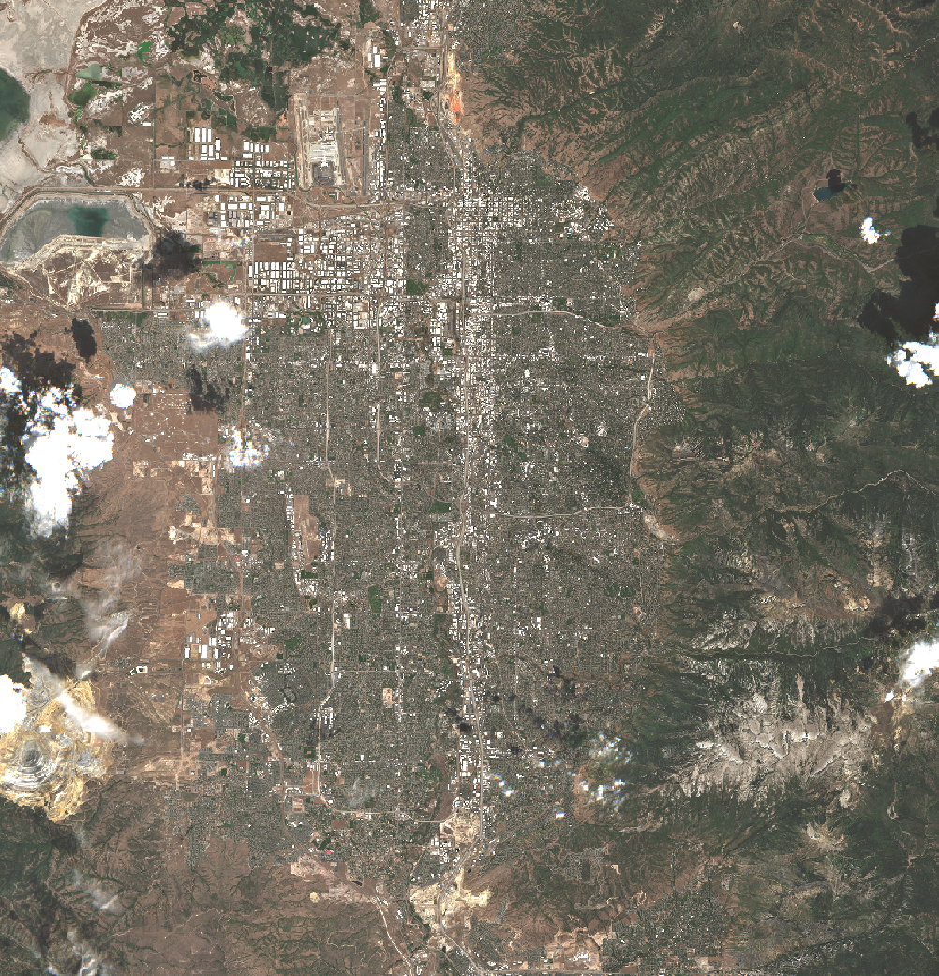
GEOINT | Student Portfolio Report
Study area: Salt Lake City and Salt Lake County, Utah, USA
Project CRS: NAD83 / UTM Zone 12N (EPSG:26912)
By: Yacine Ouhrouche

Primary tools | QGIS, Utah Open SGID, USGS 3DEP
Core evidence | Terrain, hydrology, population, land use, transportation, infrastructure, accessibility, network analysis
Primary data | 10 m DEM; 2020 Census block groups; Utah SGID vector layers
Overall confidence | High

1. Executive Summary
This project examines why Salt Lake City and the surrounding Salt Lake County region developed where they did by integrating terrain, hydrology, population, urban form, transportation, infrastructure, accessibility, and network evidence. The analysis uses a 10 m USGS 3DEP digital elevation model, 2020 Census block-group population data, and multiple Utah statewide GIS layers processed in QGIS within a common NAD83 / UTM Zone 12N coordinate system.
The strongest pattern is the contrast between the broad, relatively flat Salt Lake Valley and the steep Wasatch and Oquirrh mountain ranges. Urban development, population, roads, rail, public-service areas, and industrial/logistics activity are concentrated primarily on the valley floor, while steep and rugged terrain sharply reduces continuous development toward the mountain fronts. Major transportation routes therefore occupy the same low-gradient corridor as the densest settlement.
Hydrology adds a second set of geographic constraints. The Jordan River forms the main north-south drainage corridor through the developed valley, while the Great Salt Lake and its low-lying margins define a less continuously developed northwestern edge. Industrial and logistics activity is especially concentrated in the western and northwestern valley where flat terrain overlaps with highway, rail, airport, and urban-service access.
The main conclusion is that Salt Lake County's present spatial structure is best explained by the interaction of physical geography and human systems rather than by any single factor. Terrain establishes the broad framework of buildable land and constrained corridors; transportation and infrastructure reinforce development within that framework. Overall confidence is high for the major regional patterns, with more caution required for causal and historical claims.

2. Intelligence Question
Main question: Why did Salt Lake City and the surrounding Salt Lake County region develop where they did, and how do terrain, hydrology, population, transportation, and infrastructure explain the region's present spatial structure?
Supporting questions examine terrain constraints; elevation and slope differences between the valley and surrounding mountains; the Great Salt Lake, Jordan River, and drainage structure; population concentration; dominant road and rail corridors; constrained barrier crossings; industrial and logistics geography; accessibility; and the combined influence of the Wasatch Range, Oquirrh Mountains, Great Salt Lake, and valley geography on urban form.
The project remains a static geographic-intelligence analysis. Formal multi-date change detection, advanced remote sensing, OSINT investigation, database development, and web-dashboard development are outside scope. A single natural-color satellite image is reserved for visual geographic context only and is not treated as an analytical remote-sensing product.

3. Geographic Context
The area of interest covers the full Salt Lake County administrative boundary, including Salt Lake City and surrounding municipalities. The county spans approximately 60 km east-west by 57 km north-south and covers about 2,091 km² including land and water. The study area contains the Salt Lake Valley, the Wasatch Range to the east, the Oquirrh Mountains to the west, portions of the Great Salt Lake, the Jordan River, mountain canyons, dense urban and suburban development, major highways, rail corridors, industrial and logistics districts, and Salt Lake City International Airport.
The physical setting is dominated by a basin-and-range contrast. The Salt Lake Valley provides a broad low-gradient surface between two rugged mountain systems. The Wasatch front rises abruptly along the eastern side of the developed area, while the Oquirrh Mountains form a second major barrier to the west. Several canyons cut through the Wasatch Range and create a limited number of natural east-west passages.
Hydrologically, the Jordan River crosses the central valley and organizes much of the county's drainage. The northwestern county transitions toward the low-relief Great Salt Lake basin, where lake margins and flood-related areas reduce the continuity of urban development. Human settlement, transportation, and economic activity are concentrated overwhelmingly on the broader valley floor rather than on the steep mountain terrain.
Salt Lake County is therefore well suited to regional geographic-intelligence analysis because strong physical constraints can be compared directly with population, land-use, transportation, and infrastructure patterns.

4. Data Sources
Most vector layers were accessed through the Utah Geospatial Resource Center (UGRC) Open SGID, clipped or extracted to Salt Lake County, and standardized to EPSG:26912. The DEM was downloaded through Utah raster-data access using USGS 3DEP 10 m elevation data. The table summarizes the principal evidence used in the report.
Dataset | Publisher | Date / vintage | Resolution / scale | Contribution | Main limitation
Salt Lake County boundary | UGRC | Accessed 2026-09-01 | County polygon | AOI and clipping boundary | Administrative boundary, not a functional region
USGS 3DEP DEM | USGS / UGRC | Accessed 2026-09-01 | 10 m raster | Elevation, slope, hillshade, ruggedness, drainage support | Fine-scale landforms not resolved
Streams, lakes, watersheds, GSL flooding | UGRC / USGS | Accessed 2026-09-01 | Statewide vectors | Hydrology, drainage structure, lake-margin context | Minor/temporary drainage may be absent; flood layer is partial
2020 Census block groups + POP100 | U.S. Census / UGRC | 2020 | Block-group polygons | Population density and settlement pattern | Aggregation hides within-unit variation
Municipal boundaries | UGRC | Accessed 2026-09-01 | Municipal polygons | Settlement and jurisdiction context | Administrative, not morphological boundaries
Water-related land use | UGRC | Accessed 2026-09-01 | Generalized polygons | Urban morphology and broad land-use pattern | Not parcel zoning; broad categories
Roads | UGRC / UDOT / local sources | Accessed 2026-09-01 | Line network | Hierarchy, network length, shortest path, corridors | Functional class contains many blank/unclassified records
Railroads + airport locations | UGRC | Accessed 2026-09-01 | Line / point vectors | Multimodal transport and logistics context | Facility detail simplified
Culinary water service areas | UGRC | Accessed 2026-09-01 | Service-area polygons | Public-service coverage and urban infrastructure geography | Service boundaries do not represent all utilities
OpenStreetMap | OpenStreetMap contributors | Accessed 2026-09-01 | Web/context basemap | Visual geographic reference and place context | Variable completeness; not primary quantitative source

5. Methodology

5.1 Terrain processing
Two adjacent USGS 3DEP 10 m DEM tiles were loaded in QGIS in EPSG:26912 and treated as a continuous regional terrain surface. Elevation statistics were calculated from both tiles. Slope, aspect, hillshade, and terrain ruggedness index products were derived separately for each tile. The project used consistent display ranges so terrain differences were not created artificially by independent stretches.

5.2 Hydrology
Major streams, lakes, detailed watershed polygons, and Great Salt Lake flooding data were clipped to the county. HUC12 watershed polygons were dissolved to HUC10 for a cleaner regional view. A sink-filled DEM and a DEM-derived flow-direction raster were also produced. The hydrologic workflow was intentionally simplified; formal basin extraction and a full flow-accumulation drainage model were not completed.

5.3 Population and urban morphology
2020 census block groups containing POP100 population and HU100 housing fields were extracted for Salt Lake County and reprojected to EPSG:26912. Population density was calculated as POP100 divided by polygon area in square kilometers and mapped with a five-class Natural Breaks classification. Municipal boundaries and generalized water-related land-use polygons were then compared with the terrain and population pattern.

5.4 Transportation and infrastructure
Roads were clipped to the county and symbolized using DOT_FCLASS where available. Railroads and airport locations were extracted for the same AOI. Road geometry length was calculated in kilometers, producing approximately 8,266 km of mapped road centerlines. Culinary water service areas were used as a broad public-infrastructure layer, while industrial and logistics geography was interpreted from land use together with roads, rail, and airport access.

5.5 Accessibility and network analysis
Downtown Salt Lake City was represented by a reference point and four 5 km multi-ring buffers covering 0-5, 5-10, 10-15, and 15-20 km. These rings are a straight-line accessibility proxy rather than a travel-time model. A QGIS shortest-path point-to-point analysis was also run on the road network from Salt Lake City International Airport to downtown, yielding a modeled minimum network distance of approximately 13.75 km.
Network centrality and network-hub metrics were not calculated. Instead, network structure was evaluated through total road extent, the airport-to-downtown shortest path, and qualitative identification of major corridors and chokepoints including I-15, Parleys Canyon / I-80, Point of the Mountain, and the airport / western logistics gateway.

5.6 Analytical interpretation
Observations were recorded separately from interpretations. Major conclusions were retained when the same spatial pattern was visible in several independent layers. Alternative explanations such as planning policy, historical settlement, zoning, land ownership, land values, and infrastructure investment were considered before assigning confidence. No Python-derived analytical result is included in this report; the project focuses on QGIS-based raster, vector, accessibility, and network analysis, with programming reserved for the following geospatial phase.

6. Physical Geography Analysis

6.1 Elevation and relief
The two DEM tiles show a large regional elevation contrast. The overall minimum elevation is approximately 1,265 m and the overall maximum is approximately 3,580 m, producing roughly 2,315 m of total relief. The approximate combined mean elevation is 1,818 m. This range captures the transition from the low Salt Lake Valley and Great Salt Lake margins to high mountain terrain in the Wasatch and Oquirrh ranges.
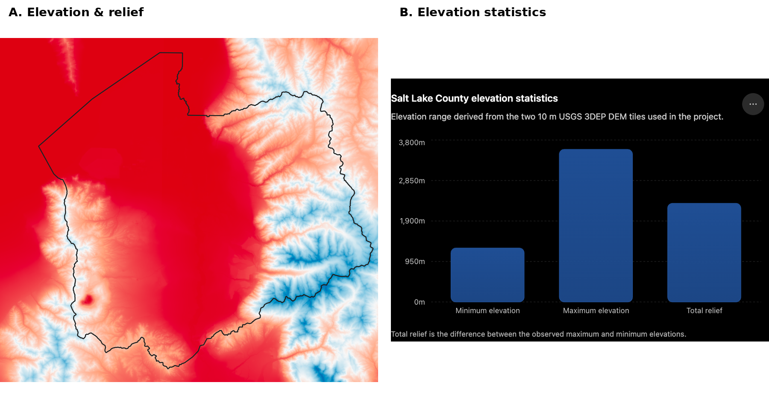
Figure 1. Elevation, relief, and summary statistics.
Interpretation. The broad central valley is much lower than the surrounding mountain terrain. The approximately 2,315 m total relief demonstrates why terrain is a central explanatory variable for development, transportation, and accessibility across the county.

6.2 Slope, landforms, and terrain constraints
Slope and hillshade products reveal three major terrain zones: the relatively flat Salt Lake Valley, the steep Wasatch Range to the east, and the rugged Oquirrh Mountains to the west. Transitional foothill benches and alluvial-fan surfaces occupy parts of the eastern valley margin. Several narrow canyons cut through the Wasatch front and provide a limited number of lower-gradient passages through otherwise steep terrain.

6.3 Hydrology and environmental constraints
The Jordan River forms the principal north-south drainage corridor through the developed valley. Major streams descend from mountain catchments toward the central valley and Great Salt Lake basin. The Great Salt Lake and its low-lying margins create a distinct northwestern geographic edge, while regional watershed boundaries show how the county is divided into multiple drainage systems.
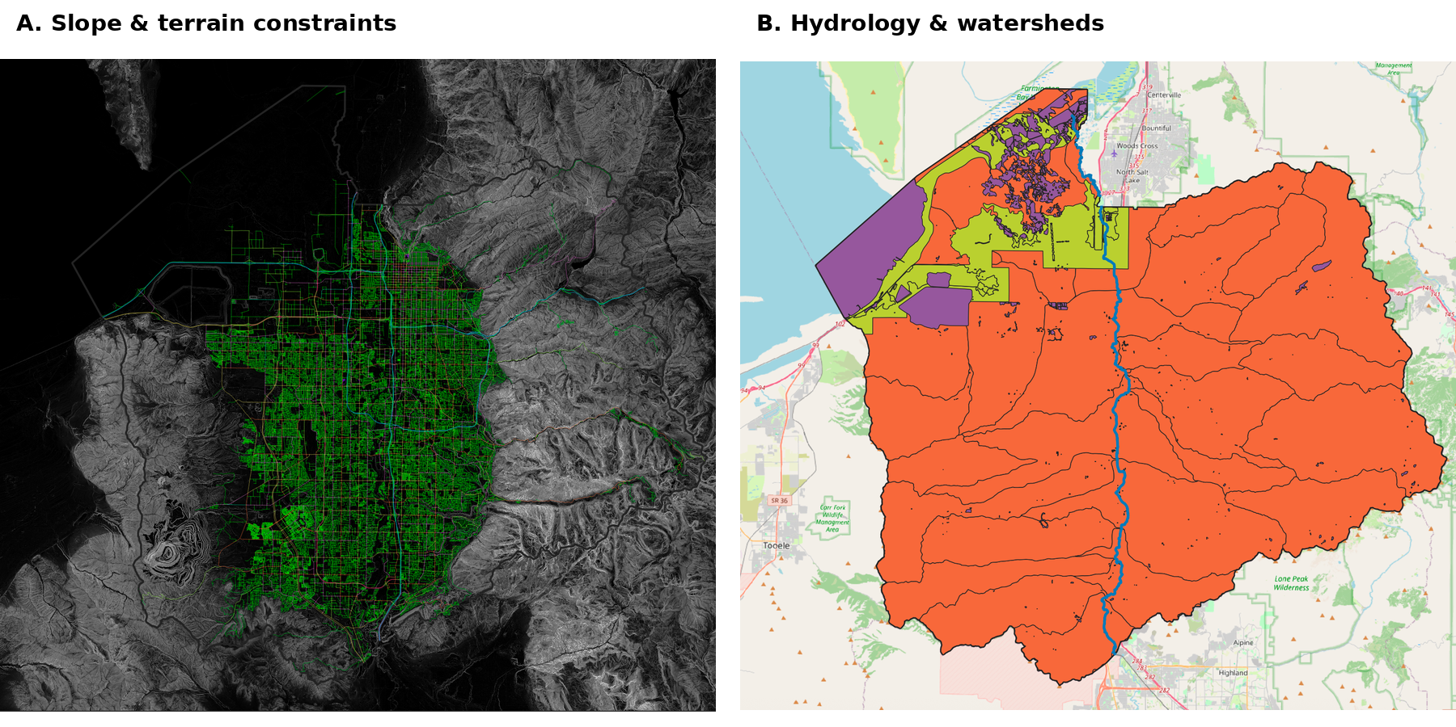
Figure 2. Slope constraints and hydrologic structure.
Interpretation. Panel A shows the sharp contrast between the low-gradient valley floor and rugged mountain terrain. Panel B shows the Jordan River, major drainage, watersheds, and lake-margin context. Together they show how terrain and water define the physical framework of the region.

7. Human Geography Analysis

7.1 Population and settlement
Population density is concentrated primarily on the Salt Lake Valley floor, especially through the continuous urban corridor around Salt Lake City and surrounding municipalities. Density decreases strongly toward the Wasatch Range, Oquirrh Mountains, and other rugged peripheral terrain. The population pattern therefore closely overlaps the region's lowest-gradient and most continuously accessible land.

7.2 Urban morphology and land use
Urban land use forms a broad and largely continuous developed corridor across the valley, while agricultural, open, riparian, wetland, and water-related categories become more prominent toward the margins. Development becomes less continuous near steep mountain fronts. Industrial and logistics uses are concentrated mainly in flatter western and northwestern portions of the valley where large parcels and multimodal transportation access coincide.
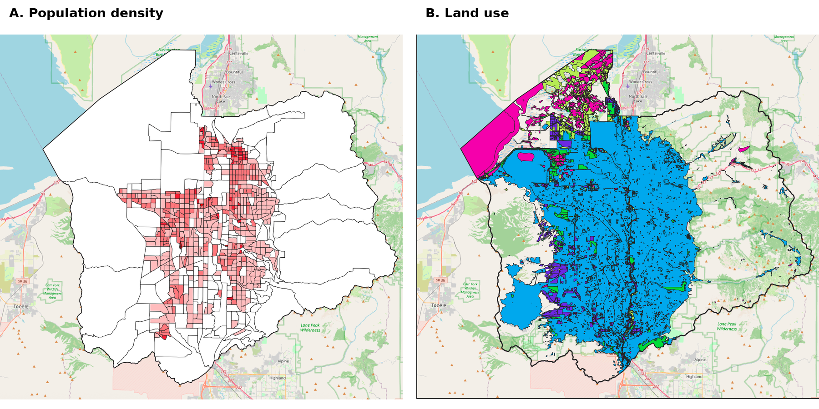
Figure 3. Population density and generalized land use.
Interpretation. Population and urban land use occupy the same broad valley-floor corridor. Mountain terrain and peripheral lake-margin areas contain much lower population density and less continuous development.

8. Transportation & Infrastructure Analysis

8.1 Roads, rail, and airport
The regional transportation network is strongly north-south in orientation. Interstate 15 and associated major arterials form the dominant central corridor through the Salt Lake Valley, and major rail lines occupy the same broad low-gradient terrain. East-west movement through the Wasatch Range is far more constrained and is concentrated into a limited set of natural corridors, especially Parleys Canyon and the Cottonwood canyon systems.
Salt Lake City International Airport is located on the relatively flat northwestern side of the valley and is closely connected to highways, rail infrastructure, and industrial/logistics land. This creates a strong multimodal concentration between the airport and the western urban-industrial corridor.

8.2 Infrastructure and economic geography
Culinary water service areas cover most of the developed and populated valley while becoming less extensive toward steep mountain terrain and sparsely developed peripheral areas. The strongest infrastructure concentration occurs where highways, rail corridors, airport access, urban service coverage, and industrial land uses overlap in the western and northwestern valley.
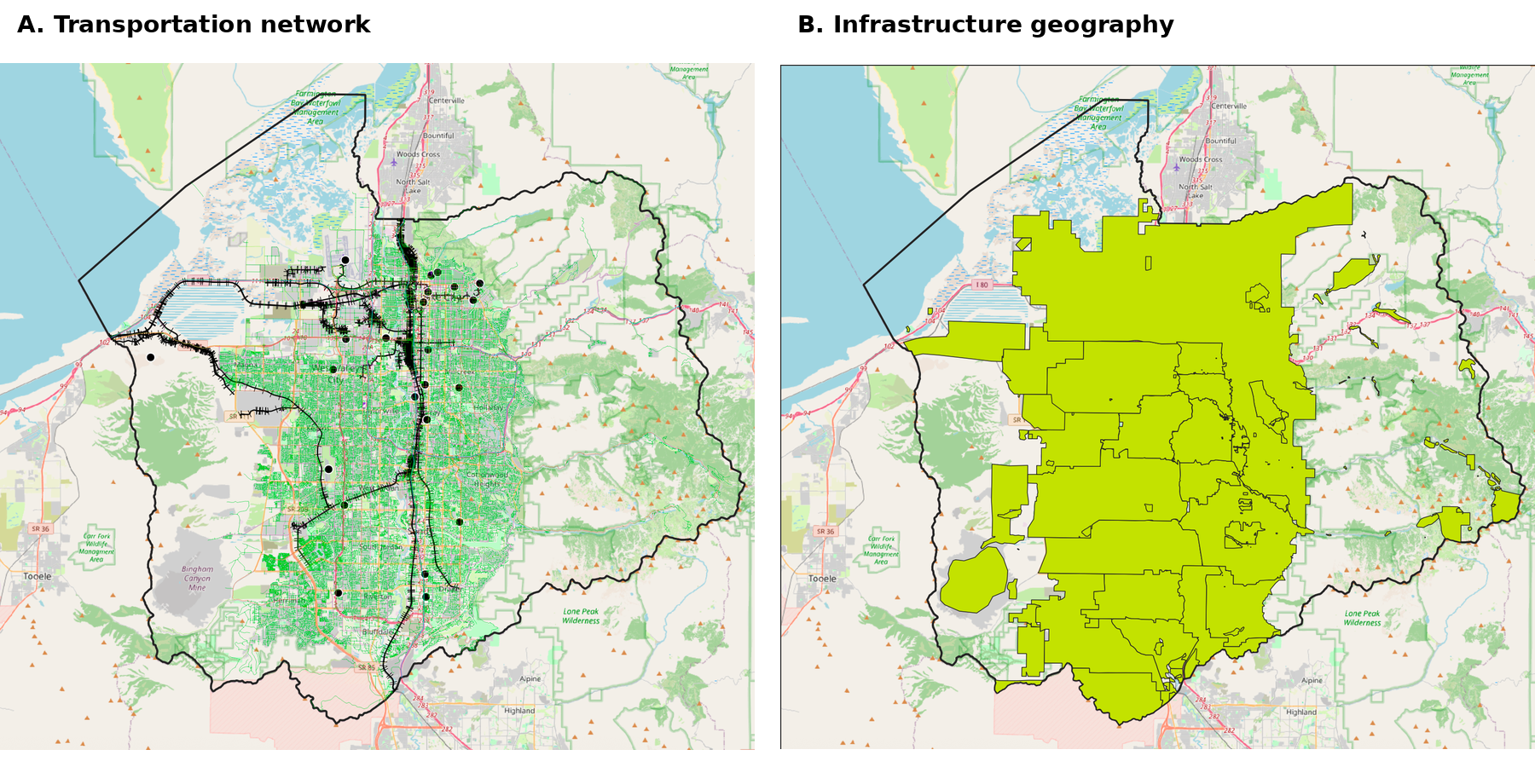
Figure 4. Transportation and infrastructure geography.
Interpretation. Panel A shows the dense road and rail network concentrated on the valley floor. Panel B shows public-service coverage and infrastructure concentration. Together they support the interpretation of a multimodal, serviced urban corridor.

9. Accessibility & Network Analysis

9.1 Downtown accessibility
The straight-line accessibility model places central Salt Lake Valley locations within the shortest distance bands around downtown. Southern and western portions of the county fall progressively farther from the urban core, while mountain areas extend beyond the practical interpretation of the ring model. The rings provide a simple geographic-distance reference rather than a true travel-time surface.

9.2 Road-network extent and shortest path
The Salt Lake County road dataset contains approximately 8,266 km of mapped road centerlines. A point-to-point shortest-path analysis from Salt Lake City International Airport to downtown Salt Lake City produced a minimum modeled network distance of 13,746.76 m, or approximately 13.75 km. The result supports the interpretation that the airport has relatively direct road-network access to the central urban core.
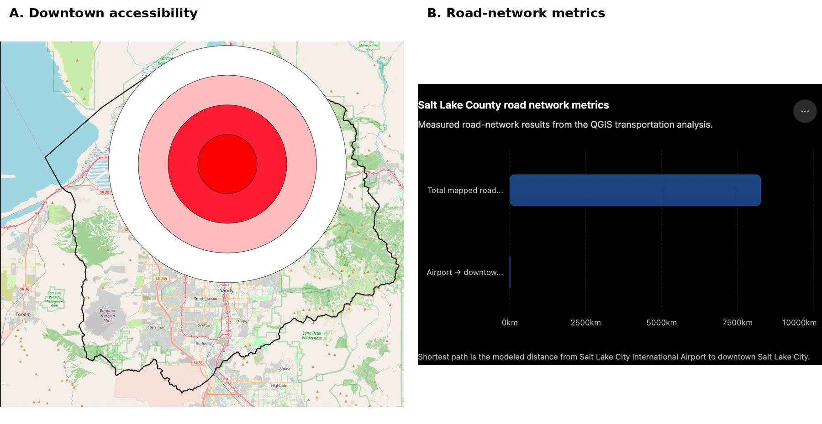
Figure 5. Accessibility and road-network metrics.
Interpretation. Panel A shows the 5 km straight-line accessibility rings around downtown; Panel B summarizes mapped road-network extent and the airport-to-downtown shortest path. The accessibility rings are not travel-time zones, while the shortest path minimizes distance only.

9.3 Terrain statistics and network chokepoints
The two DEM tiles differ substantially in mean elevation because they contain different proportions of valley and mountain terrain. Tile 1 has an approximate mean elevation of 2,074 m and reaches 3,580 m, while Tile 2 has an approximate mean of 1,563 m and reaches 3,361 m. Together they reinforce the strong elevation asymmetry across the county.
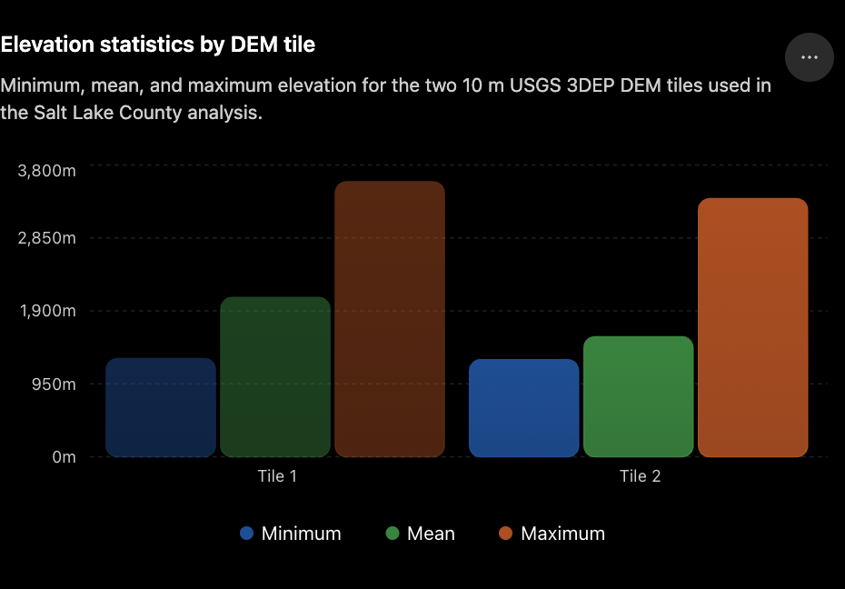
Figure 6. Elevation statistics by DEM tile.
Interpretation. The contrast between tile means reflects the uneven distribution of high mountain terrain and lower valley surfaces across the study area.
Four major geographic chokepoints or corridors were identified qualitatively. I-15 forms the dominant north-south central valley corridor. I-80 uses Parleys Canyon as one of the main east-west passages through the Wasatch Range. Point of the Mountain acts as a narrower southern gateway where regional movement is funneled through low-gradient terrain. The airport / western logistics gateway combines highway, rail, airport, industrial land, and flat terrain in a single multimodal zone.
These corridors demonstrate how topography does not merely limit development at the urban edge; it also reduces the number of practical regional movement paths. Local roads provide redundancy, but major regional flows remain concentrated in the same broad valley and canyon structures.

10. Integrated Geographic Interpretation
Terrain and development show the strongest regional relationship. Dense urban development occupies the relatively flat Salt Lake Valley floor, while continuous development decreases sharply toward the Wasatch and Oquirrh mountain ranges. Flat and gently sloping land provides more favorable conditions for dense settlement, road construction, and public infrastructure. Planning policy, land ownership, protected land, historical settlement patterns, and land values also contribute, so terrain should be understood as a major constraint rather than a single deterministic cause.
Terrain and transportation reinforce the same spatial framework. Major roads and railways occupy the broad low-gradient valley, while east-west routes through the Wasatch Range are concentrated into a few canyons. The I-15 corridor, Parleys Canyon / I-80, and Point of the Mountain are therefore understandable as geographic passages shaped by the interaction of topography and infrastructure investment.
Water adds a second physical structure. The Jordan River crosses the urbanized valley and organizes central drainage, while the Great Salt Lake and its low-lying margins form a less continuously developed northwestern edge. These relationships are meaningful, but environmental regulation, land ownership, and historical land-use decisions may also explain why lake-margin development differs from the central valley.
Population and transportation are spatially concentrated in the same central valley corridor. This pattern is mutually reinforcing: dense settlement supports transport demand, while transport accessibility supports continued urban concentration. Both also share the same underlying advantage of relatively flat terrain. Similar overlap is visible in industrial and logistics geography, where highway, rail, airport, and service infrastructure coincide in the western and northwestern valley.
Taken together, the evidence supports a basin-constrained urban form. Physical geography establishes the basic framework of buildable land, drainage, and limited cross-mountain passages. Human systems then intensify those advantages through roads, rail, airport access, service coverage, industrial land use, and concentrated settlement. The present spatial structure is therefore best understood as an interaction between geographic constraint and cumulative human investment.

11. Key Findings
1. Salt Lake County's urban development is strongly concentrated on the relatively flat Salt Lake Valley floor. The Wasatch Range to the east and the Oquirrh Mountains to the west form major terrain barriers that constrain outward development.
2. Major transportation infrastructure follows the geography of the valley. Interstate 15, major arterial roads, and rail corridors are concentrated on low-gradient terrain, while east-west movement through the Wasatch Range is channeled through a small number of natural corridors such as Parleys Canyon.
3. Population density and urban land use are concentrated in the same central valley corridor as the major transportation network. Steeper and more rugged areas generally contain much lower population densities and less continuous development.
4. Industrial and logistics activity is concentrated mainly in the western and northwestern Salt Lake Valley, where flat terrain overlaps with highway, rail, airport, and urban-service access. Salt Lake City International Airport forms an important part of this multimodal infrastructure concentration.
5. Hydrology also contributes to the region's spatial structure. The Jordan River forms the main drainage corridor through the developed valley, while the Great Salt Lake and its low-lying margins constrain development along the northwestern edge of the county.
6. Salt Lake County's present spatial structure is best explained by the combined interaction of terrain, hydrology, transportation, population, and infrastructure rather than by any single geographic factor. Physical geography establishes the main constraints and corridors, while human systems reinforce development within them.

12. Limitations
• The 10 m DEM is appropriate for regional analysis but cannot resolve very small landforms or fine elevation changes; derived terrain and hydrologic outputs inherit this limitation.
• 2020 Census block groups aggregate population within administrative units, so local variation inside individual polygons is not represented precisely.
• The land-use layer uses broad generalized categories rather than parcel-level zoning or detailed building-use information.
• Road functional-class attributes contain many blank or unclassified records, reducing the reliability of class-based road comparisons.
• The accessibility rings represent straight-line distance rather than travel time, and the shortest-path result minimizes distance only rather than congestion, speed, closures, or traveler behavior.
• Public infrastructure and hydrology datasets may be incomplete, simplified, or collected at different dates.
• Spatial coincidence does not prove causation. Historical development, planning, zoning, ownership, land value, policy, and economic factors may explain part of the same patterns.
• The project is static and cannot establish the historical sequence by which present-day relationships emerged.

13. Confidence
Overall confidence: High.
High-confidence conclusions include the concentration of urban development on the Salt Lake Valley floor, strong terrain constraints imposed by the Wasatch and Oquirrh ranges, the concentration of major transportation corridors on low-gradient valley terrain, the overlap between population and the developed valley corridor, and the association of industrial/logistics activity with highway, rail, and airport access.
Moderate-confidence conclusions include the degree to which hydrology directly shapes development, the extent to which public-service infrastructure reinforces economic concentration, and the interpretation of downtown accessibility using straight-line distance. Lower confidence applies to exact historical causal claims and to any argument that a single geographic factor independently caused the observed urban pattern.
Confidence would improve with historical land-use and transportation datasets, parcel-level zoning and development data, network travel-time data, more detailed infrastructure inventories, and multi-date evidence showing the sequence of urban expansion.

14. Conclusion
Salt Lake City and the surrounding Salt Lake County region developed primarily within a broad, relatively flat valley bounded by major physical constraints. The Wasatch Range and Oquirrh Mountains limit east-west expansion and channel transportation into the valley floor and a small number of canyon or pass corridors. The Great Salt Lake and Jordan River add drainage and low-lying constraints that further organize the regional landscape.
Within this physical framework, population, transportation, infrastructure, and economic activity reinforce one another. Dense settlement aligns with the central transportation corridor, rail follows low-gradient terrain, and industrial/logistics activity concentrates where flat land overlaps with highway, rail, airport, and public-service access. The modeled airport-to-downtown path further shows the close network relationship between the logistics gateway and the urban core.
The best answer to the intelligence question is therefore that Salt Lake County's present spatial structure reflects the combined influence of physical geography and cumulative human investment. Terrain and hydrology establish the major constraints and corridors; transportation, infrastructure, settlement, and economic activity intensify development within those geographically favorable areas. The resulting urban region is not simply located in the valley - it is spatially organized by the valley.

15. Sources and Reproducibility
Primary geospatial source: Utah Geospatial Resource Center (UGRC), Utah Open SGID. Most statewide vector datasets were accessed through the public Open SGID PostgreSQL service, then clipped or extracted to Salt Lake County and saved as project GeoPackages in NAD83 / UTM Zone 12N (EPSG:26912).
Terrain source: U.S. Geological Survey 3D Elevation Program (3DEP), approximately 10 m DEM, distributed through Utah raster-data access. Two adjacent GeoTIFF tiles were preserved as raw source data and used to derive slope, aspect, hillshade, ruggedness, and simplified hydrologic terrain products.
Population source: 2020 U.S. Census block groups distributed through UGRC, using POP100 total population and HU100 total housing fields. Population density was calculated in QGIS from POP100 and polygon area in square kilometers.
Contextual basemap: OpenStreetMap contributors. The basemap was used for place context and visual reference, not as the primary quantitative source for the main findings.
Access date for the primary project data: September 1, 2026. Core public portals: Utah GIS (https://gis.utah.gov/), Open SGID documentation (https://gis.utah.gov/documentation/sgid/open-sgid/), U.S. Census Bureau (https://www.census.gov/), and OpenStreetMap (https://www.openstreetmap.org/).
Satellite cover image: to be added. The planned image should be a single natural-color satellite view of the Salt Lake Valley used only for geographic context. Record the imagery provider, acquisition date, sensor/product, and access URL when it is added. It should not be presented as remote-sensing analysis unless additional spectral or quantitative interpretation is actually performed.

Reproducibility Notes
Project CRS: NAD83 / UTM Zone 12N (EPSG:26912). Processed vector data were stored as GeoPackages and raster derivatives as GeoTIFFs. The QGIS project contains the analytical layers used to generate the report figures. Key measured outputs include approximately 1,265-3,580 m elevation, about 2,315 m total relief, approximately 8,266 km of mapped road centerlines, and a 13.75 km modeled shortest road-network path from Salt Lake City International Airport to downtown Salt Lake City.
The report deliberately distinguishes measured observations from geographic interpretation. Where causal explanations are offered, alternative explanations and confidence are stated so that static spatial association is not treated as proof of historical causation.

