Software Requirements Specification
for
Git Going
Version 0.7 approved
Prepared by Michael Bloomquist, Sarah Ramazani, Travis Lamb, Christina Nguyen
Bellevue College
Date: 5/28/2021
Table of Contents
Table of Contents ii
Revision History ii
1. Introduction 1
1.1 Purpose 1
1.2 Product Scope 1
1.3 References 1
2. Overall Description 1
2.1 Product Perspective 1
2.2 Product Functions 1
2.3 User Classes and Characteristics 2
2.4 Design and Implementation Constraints 2
2.5 Assumptions and Dependencies 2
3. Specific Requirements 2
3.1 User Interfaces 2
3.2 Functional Requirements 2
3.3 Performance Requirements 3
3.4 Logical Database Requirements 3
3.5 Software Quality Attributes 3
Appendix B: Analysis Models 3
Appendix C: Requirement Tracibility Matrix (TBD) 4

Revision History
Name | Date | Reason For Changes | Version
Michael Bloomquist | 10/20/20 | Added first draft of changes for section 1, as well as sections 2.1 and 2.2 | 0.1
Michael Bloomquist | 10/26/20 | Added sections 2.3, 2.4, 2.5, 3.1, 3.2, 3.3, 3.5 | 0.2
Sarah Ramazani | 10/27/20 | Reviewed previous versions  Added section 3.4  Updated sections 3.2 (3.2.1 and 3.2.2) | 0.3
Travis Lamb | 10/27/20 | Minor revisions and editing. | 0.4
Christina Nguyen | 10/27/20 | Minor revisions and editing. | 0.5
Michael Bloomquist | 10/29/20 | Added the elusive initiate review requirement to the File Change System in 3.2.4 | 0.6

Introduction
Programming has become one of the largest professions in the world, employing tens of millions of people, and helping to provide services to nearly the entire planet today. A key component of the software development process is the assurance that updates can be vetted and applied to the codebase through peer review. Code review software makes this easier in a multitude of ways, but many systems are either internal to companies, limited in what platforms they support, or require extensive setup. Git Going looks to solve these issues with our web-based design, allowing users to easily review and approve code changes from any device, and any location!

Purpose
The purpose of this document is to provide a comprehensive list of features Git Going provides, and their importance to the user, as well as to provide clarity on the goal and scope of this project.

Product Scope
The goal of Git Going is to make it easier for developers to peer review code and we accomplish that in a few ways. First, we provide a web-based platform with a secure, two-factor authentication, user login system, which can be accessed from a multitude of devices; this platform allows users to upload new files or replace existing files, where replacing an existing file requires one or multiple approvals. When an update to a file is proposed, we give reviewers a compact and intuitive display of changes in the file from which they can leave comments, approve or decline changes.

Second, within that platform we provide the user with several features which help in facilitating collaboration and peer review. One of these features is the ability to organize these file structures as projects, which allow the project owner to tweak various settings which enforce requirements such as a required number of approvals. Additionally, we provide the user with a notification system for important project updates.

References
N/A

Overall Description

Product Perspective
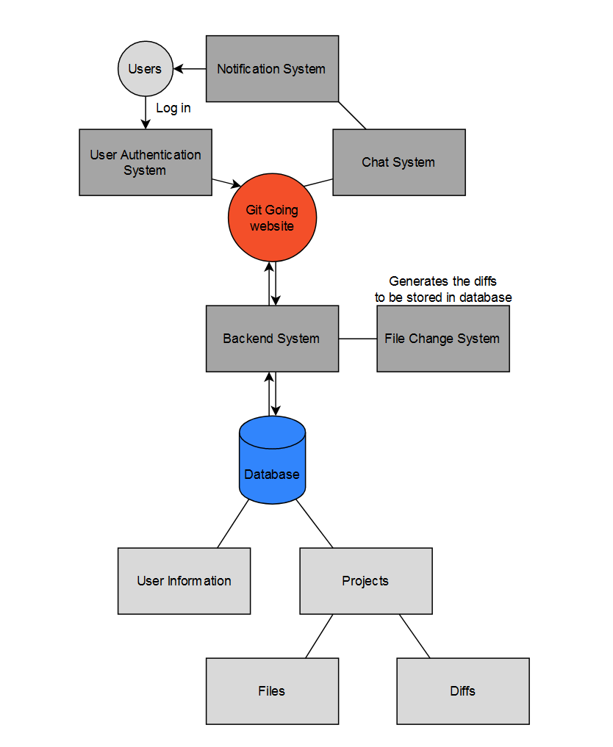

Product Functions
- Users can create, and login to an account
- Users can access, and adjust account settings
- Users can comment on, and approve/reject reviews
- Users can create and manage projects
- Project owners can invite other users to the project, and assign them to review file update requests
- Before-and-after file changes are displayed to the user
- Users are notified of project invites, collaborator invites, assigned reviews, approval/rejection of proposed file changes

User Classes and Characteristics
There will likely be many different kinds of users of Git Going; while Git and version control is often associated with programmers, and certainly important for those individuals, it can serve as a benefit to many more than that, and those users should be considered as well.

- Programmers:
Many of the users will be programmers in some way. It is proper practice for many programmers to manage and organize edits made to code and its versions. Features important to these users may include good inline commenting, good display of code diffs, and administrative tools which allow them extra control over the review process.
- Teachers:
Teachers may use Git Going for the purpose of teaching students about code review, but it could also be used between teachers. For example, if teachers wanted to share documents for a certain course, such as assignments or syllabi, they could require a review and approval of changes to those documents by several teachers.

- Students:

Students may use Git Going as an alternative to Github for programming classes where teachers want students to get used to using tools and resources from the industry they may one day work in. Students often need a method of version control, especially when many work in teams for school projects or work. Git Going’s user-friendly UI and intuitive design is perfect for users with little to no experience in code review.
- Designers:
Designers may be designing sensitive systems and would like to make sure changes to their documents are thoroughly vetted before approval as much as any programmer would. A problem that may particularly affect this group of users is the prevalence of document types such as .doc, .pdf, .ppt etc. These are examples of file types that may not produce meaningful git diffs to display.

- Authors:
Authors may work in collaboration on scripts and desire a review tool to make it easier to view changes to the script before implementing them. Authors may also particularly like the ability to leave inline comments and feedback. This user group may run into similar issues regarding document types not producing meaningful diffs such as .doc and .pdf files but being a mostly text-based profession gives this user group better options.
- Lawyers:
Similarly, lawyers may want a peer review process when changes are made to legal documents. Although this is largely a text-based profession as well, .doc and .pdf files are very common and may prove troublesome for this user group.

Design and Implementation Constraints
- Git diffs on certain file types:
As mentioned in the user classes section above, certain file types do not provide us with meaningful git diffs. .doc, .pdf, .ppt and image files are just some examples of files we cannot extract a meaningful git diff from (just open one of these file types in notepad and you’ll see what I mean, this is what we compare for diffs). This doesn’t necessarily eliminate any option for giving users some options for displaying changes to these files; however, for example, if the file could be embedded within the page, a before and after view could be shown rather than a diff.

Assumptions and Dependencies
- It is assumed that all users must register an account before using our services.
- It is assumed that our users do not have to pay for the services Git Going provides.
- It is assumed that users meet the minimum specs required to run our web app, and if these requirements are not met that unpredictable bugs and negative impacts on user experience may occur.
- It is assumed that users will be able to upload files to the website.
- It is assumed that the user must have an internet connection to use our services.
- It is assumed that database and server hosting services will be provided by third party (AWS).
- It is assumed that users will speak English, as other language support is unlikely to be implemented.

Specific Requirements

User Interfaces
Several user interfaces are required for different systems:

The user is first directed to a registration/login page, which will have information about the website, as well as a place for users to sign up for an account (or log in if they already have an account). After logging in, the user should be redirected to a hub where all features of Git Going can be accessed from. A universal navigation bar also makes it easy for users to navigate features.
The project page has user interfaces for project creation, as well as your current active projects. When the user accesses one of these projects, there are interface components for adding files, viewing files already in the project, and managing collaborators.
Upon viewing a review, the user is provided with a new interface from which they can approve or reject changes and make inline comments. For a review where a git diff is applicable, the diff is shown in an easy to digest format. For other file types such as PowerPoints or images, other methods such as a before/after view could be used.

Functional Requirements

User Registration and Login System

REQ-1: Register:
The user can register a new account for the system
Error cases:
User already exists in the Congito User Pool
User inputs already used email address
User does not meet password requirements
User does not correctly enter confirmation code

REQ-2: Email Confirmation
The user can receive and verify the email address after sign-up

Error cases:
User registered a non-existent email address and is unable to verify it
REQ-2: Login:
The user can login to the system
Error cases:
User inputs non-existent account
User inputs wrong username or password

REQ-3: Reset Password:
The user can reset their password given an existing account
Error cases:
User inputs non-existent account
User inputs invalid confirmation code

REQ-4: Logout:
The user can logout of the system
Error cases:
User is not logged out across multiple devices/connections

REQ-5: Security:
The users’ repos will be secured, unless public, and data on users will be held privately by the site.

Notification System
REQ-1: Notify review assignment
The user receives a visual and audible notification if they are assigned to review a change
REQ-2: Notify review approval
The user receives a visual and audible notification if a review they are assigned to, or a review they are managing is approved.
REQ-3: Notify review rejection
The user receives a visual and audible notification if a review they are assigned to, or a review they are managing is rejected.

REQ-4: Notify project invitation
The user receives a notification if a review they are invited to a project.

REQ-5: Notify project accept
The owner of a project receives a notification if an invitation they sent is accepted

REQ-6: Notify project decline
The owner of a project receives a notification if an invitation they sent is declined

File Change System
REQ-1: Initiate Review
The user can initiate a code review (pull request) for a file update
Error cases:
The user provides an invalid repository URL

REQ-2: Assign reviewer
The user can assign reviewers to a file change

REQ-3: Display diff
The user is displayed a window showing the diff between two file versions
Error cases:
The file format doesn’t produce a meaningful diff
REQ-4: Display before and after
The user is displayed a before and after view of the file in the case of file formats which don’t produce meaningful diffs
Error cases:
The file cannot be embedded
REQ-5: Leave inline comment
Users can leave inline comments on the review page

REQ-6: Leave document comment
Users can leave comments on the review page
REQ-7: Approve change
Users assigned to review a file change can approve changes
REQ-8: Reject change
Users assigned to review a file change can reject changes

Performance Requirements
- The app will be able to accommodate at least 10,000 users.
- Servers will require enough space to accommodate user account information, files, and git diff information
- Notifications, comments, approvals/rejections etc. should all perform in close to real-time – There should not be any perceptible sluggish behavior to the user

Logical Database Requirements
Git functionalities intervene in storing committed files under a directory on the server like GitGoing/username/repositoryname. Git Going uses MySQL database which is considered as the primary data storage.

Software Quality Attributes
Our system can be adapted beyond its “intended” use of code review and extends beyond the obvious user-base of programmers. Any person in any profession who can benefit from peer review of document changes can benefit from our system; this includes teachers, lawyers, writers and many more users.

Our system is also both flexible and portable, as our web-based approach allows Git Going to work identically on many devices. This frees users up to spend less time at an office computer and more time doing other things in their lives, while still being able to effectively review code and file changes on the go. Anywhere, any time.

Appendix B: Analysis Models
<Optionally, include any pertinent analysis models, such as data flow diagrams, class diagrams, state-transition diagrams, or entity-relationship diagrams.>
Appendix C: Requirement Traceability Matrix (TBD)
<Collect a numbered list of the TBD (to be determined) references that remain in the SRS so they can be tracked to closure.>

