1) GPA – numerical, actual GPA
2) Gender (1 – Female and 2 – Male)
3) Breakfast (the participants are shown the following pictures and asked which one of these pictures they associate with the word “breakfast), 1 – cereal option and 2 – donut option

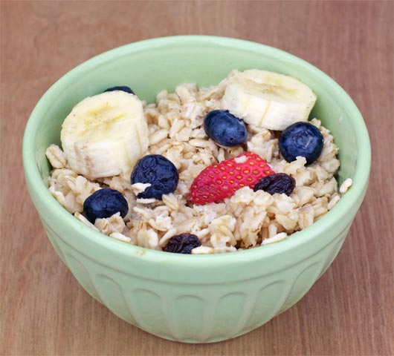

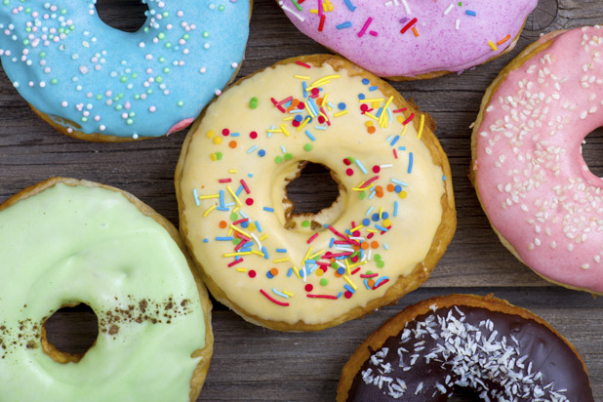

4) calories_chicken - guessing calories in chicken piadina:
1 - 265
2 - 430
3 - 610
4 – 720
(the variable shows the actual number of calories participants selected)

5) calories_day - Importance of consuming calories per day
1 - i dont know how many calories i should consume
2 - it is not at all important
3 - it is moderately important
4 - it is very important

6) calories_scone - Guessing calories in a scone from starbucks
1 - 107 cal
2 - 315 cal
3 - 420 cal
4 - 980 cal
(the variable shows the actual number of calories participants selected)

7) coffee – which of the two pictures you associate with the word coffee?
1 – creamy frapuccino
2 – espresso shown
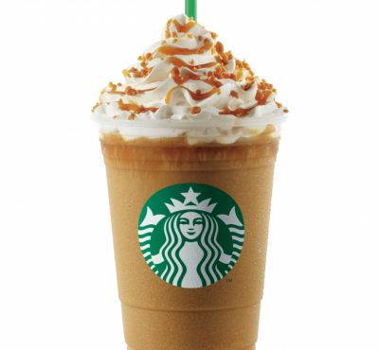



8) comfort_food - List 3-5 comfort foods that come to mind.
Open ended (perfect for NLP)

9) comfort_food_reasons - What are some of the reasons that make you eat comfort food? (i.e., anger, sadness, happiness, boredom, etc) - list up to three
Open ended (perfect for NLP)

10) comfort_food_reasons_coded
(the one mentioned first)

1 – stress
2 – boredom
3 – depression/sadness
4 – hunger
5 – laziness
6 – cold weather
7 – happiness
8- watching tv
9 – none

11) cook – how often do you cook?
1 - Every day
2 - A couple of times a week
3 - Whenever I can, but that is not very often
4 - I only help a little during holidays
5 - Never, I really do not know my way around a kitchen

12) cuisine – what type of cuisine did you eat growing up?
1 – American
2 – Mexican.Spanish
3 – Korean/Asian
4 – Indian
5 – American inspired international dishes
6 – other

(lots of cleaning needed for this variable)

13) diet_current – describe your current diet
open ended – ideal for NLP

14) diet_current_coded
(based on words used to describe the diet)

1 – healthy/balanced/moderated/
2 – unhealthy/cheap/too much/random/
3 – the same thing over and over
4 – unclear

15) which picture do you associate with the word “drink”?
1 – orange juice
2 – soda

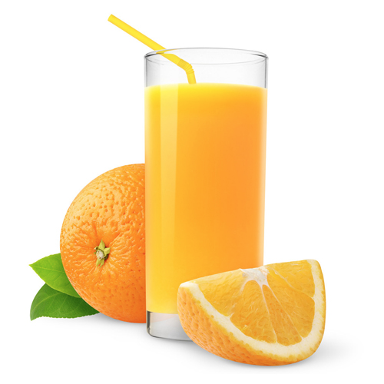
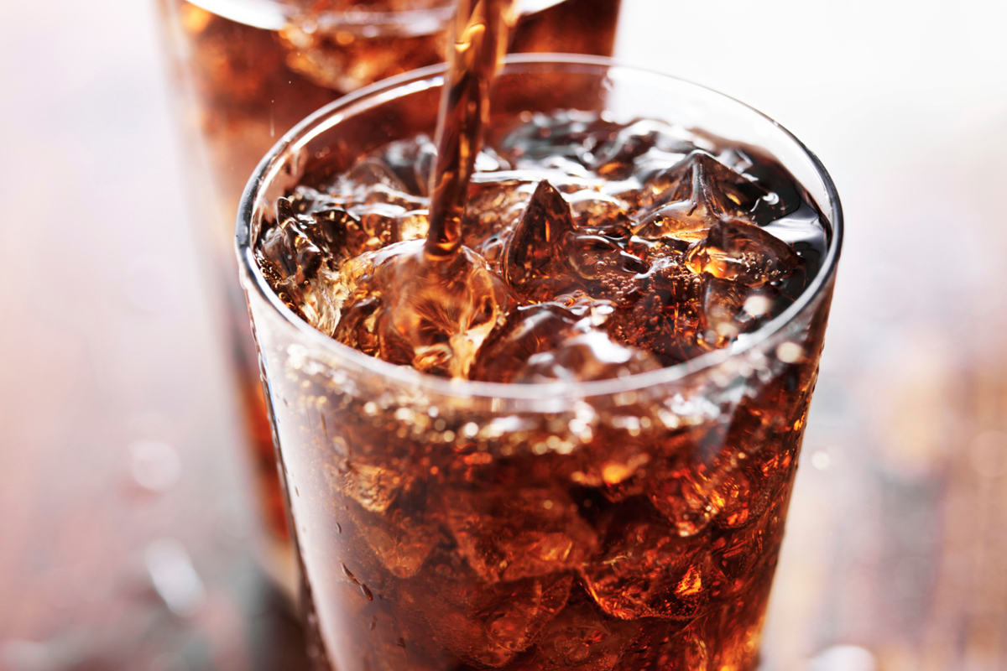

16) eating_changes - Describe your eating changes since the moment you got into college?
Open ended

17) eating_changes_coded

1 – worse
2 – better
3 – the same
4 – unclear

18) eating_changes_coded1
1 – eat faster
2 – bigger quantity
3 – worse quality
4 – same food
5 – healthier
6 – unclear
7 – drink coffee
8 – less food
9 – more sweets
10 – timing
11 – more carbs or snacking
12 – drink more water
13 – more variety

19) eating_out - frequency of eating out in a typical week
1 - Never
2 - 1-2 times
3 - 2-3 times
4 - 3-5 times
5 - every day

20) employment – do you work?
1 - yes full time
2 - yes part time
3 – no
4 - other

21) ethnic_food - How likely to eat ethnic food
1 - very unlikely
2 - unlikely
3 - neutral
4 - likely
5 - very likely

22) exercise – how often do you exercise in a regular week?
1 - Everyday
2 - Twice or three times per week
3 - Once a week
4 - Sometimes
5 – Never

23) father_education –
1 - less than high school
2 - high school degree
3 - some college degree
4 - college degree
5 - graduate degree

24) father_profession – what is your father profession?
Open ended

25) fav_cuisine - What is your favorite cuisine?
Open ended

26) fav_cuisine_coded

0-none
1 – Italian/French/greek
2 – Spanish/mexican
3 – Arabic/Turkish
4 – asian/chineses/thai/nepal
5 – American
6 – African
7 – Jamaican
8 – indian

27) fav_food - was your favorite food cooked at home or store bought?
1 - cooked at home
2 - store bought
3 - both bought at store and cooked at home

28) food_childhood – what was your favorite childhood food?
Open ended

29) which of these pictures you associate with word fries?
1 – Mcdonald’s fries
2 – home fries

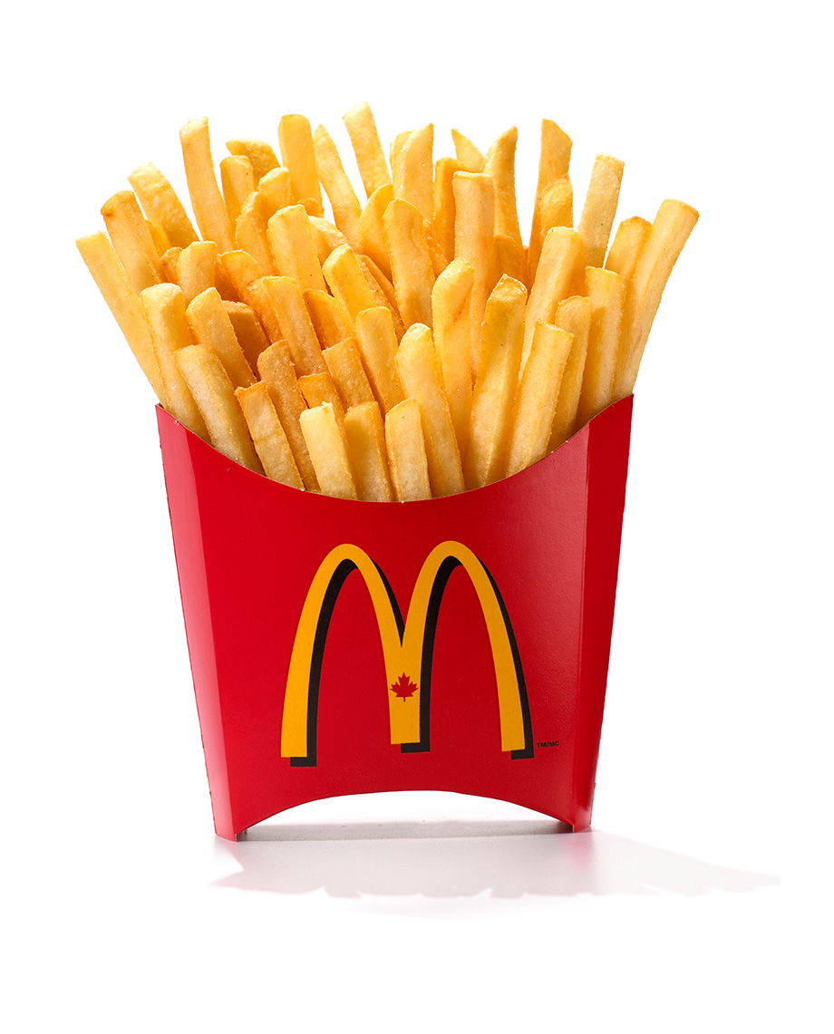
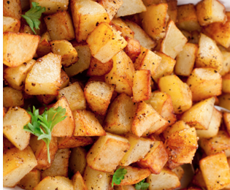

30) fruit_day - How likely to eat fruit in a regular day
1 - very unlikely
2 - unlikely
3 - neutral
4 - likely
5 - very likely

31) grade_level –
1 - freshman
2 -Sophomore
3 - Junior
4 - Senior

32) greek_food - How likely to eat greek food when available?
1 - very unlikely
2 - unlikely
3 - neutral
4 - likely
5 - very likely

33) healthy_feel – how likely are you to agree with the following statement: “I feel very healthy!” ?
1 to 10 where 1 is strongly agree and 10 is strongly disagree - scale

34) healthy_meal – what is a healthy meal? Describe in 2-3 sentences.
Open ended

35) ideal_diet – describe your ideal diet in 2-3 sentences
Open ended

36) Ideal_diet_coded

1 – portion control
2 – adding veggies/eating healthier food/adding fruit
3 – balance
4 – less sugar
5 – home cooked/organic
6 – current diet
7 – more protein
8 – unclear

37) income
1 - less than $15,000
2 - $15,001 to $30,000
3 - $30,001 to $50,000
4 - $50,001 to $70,000
5 - $70,001 to $100,000
6 - higher than $100,000

38) indian_food – how likely are you to eat indian food when available
1 - very unlikely
2 - unlikely
3 - neutral
4 - likely
5 - very likely

39) Italian_food – how likely are you to eat Italian food when available?

1 - very unlikely
2 - unlikely
3 - neutral
4 - likely
5 - very likely

40) life_rewarding – how likely are you to agree with the following statement: “I feel life is very rewarding!” ?
1 to 10 where 1 is strongly agree and 10 is strongly disagree - scale

41) marital_status
1 -Single
2 - In a relationship
3 - Cohabiting
4 - Married
5 - Divorced
6 - Widowed

42) meals_dinner_friend – What would you serve to a friend for dinner?
Open ended

43) mothers_education
1 - less than high school
2 - high school degree
3 - some college degree
4 - college degree
5 - graduate degree

44) mothers_profession – what is your mother’s profession?

45) nutritional_check - checking nutritional values frequency
1 - never
2 - on certain products only
3 - very rarely
4 - on most products
5 - on everything

46) on_off_campus – living situation
1 - On campus
2 - Rent out of campus
3 - Live with my parents and commute
4 - Own my own house

47) parents_cook - Approximately how many days a week did your parents cook?
1 - Almost everyday
2 - 2-3 times a week
3 - 1-2 times a week
4 - on holidays only
5 - never

48) pay_meal_out - How much would you pay for meal out?
1 - up to $5.00
2 - $5.01 to $10.00
3 - $10.01 to $20.00
4 - $20.01 to $30.00
5 - $30.01 to $40.00
6 - more than $40.01

49) Persian_food - How likely to eat persian food when available?
1 - very unlikely
2 - unlikely
3 - neutral
4 - likely
5 - very likely

50) self_perception_weight - self perception of weight
6 - i dont think myself in these terms
5 - overweight
4 - slightly overweight
3 - just right
2 - very fit
1 - slim

51) Which of the two pictures you associate with the word soup?
1 – veggie soup
2 – creamy soup

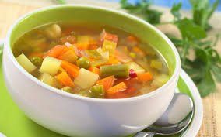

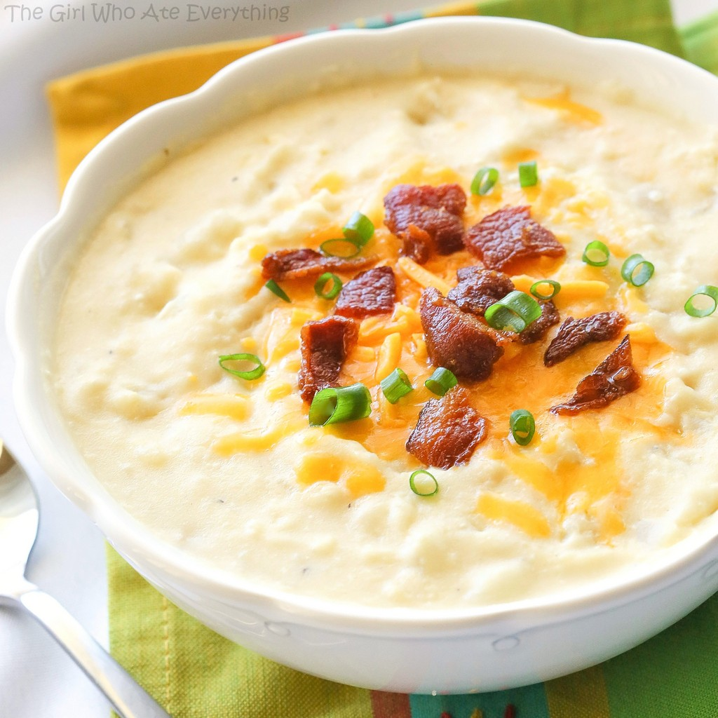

52) sports - sports – do you do any sporting activity?

1 - Yes
2 - No
99 – no answer

53) thai_food - How likely to eat thai food when available?
1 - very unlikely
2 - unlikely
3 - neutral
4 - likely
5 - very likely

54) tortilla_calories - guessing calories in a burrito sandwhich from Chipolte?

1 - 580
2 - 725
3 - 940
4 - 1165

55) turkey_calories - Can you guess how many calories are in the foods shown below? (Panera Bread Roasted Turkey and Avocado BLT)

1 - 345
2 - 500
3 - 690
4 - 850

56) type_sports – what type of sports are you involved?
Open-ended

57) veggies_day - How likely to eat veggies in a day?
1 - very unlikely
2 - unlikely
3 - neutral
4- likely
5 - very likely

58) vitamins – do you take any supplements or vitamins?
1 – yes
2 – no

59) waffle_calories - guessing calories in waffle potato sandwhich
1 - 575
2 - 760
3 - 900
4 - 1315

60) weight – what is your weight in pounds?

