HTML Practice

Darling, Jacob

CSD340

W1.2:A

15 August 2024

Link to GitHub repository:

<https://github.com/Yacobra/csd-340>

Screenshots:

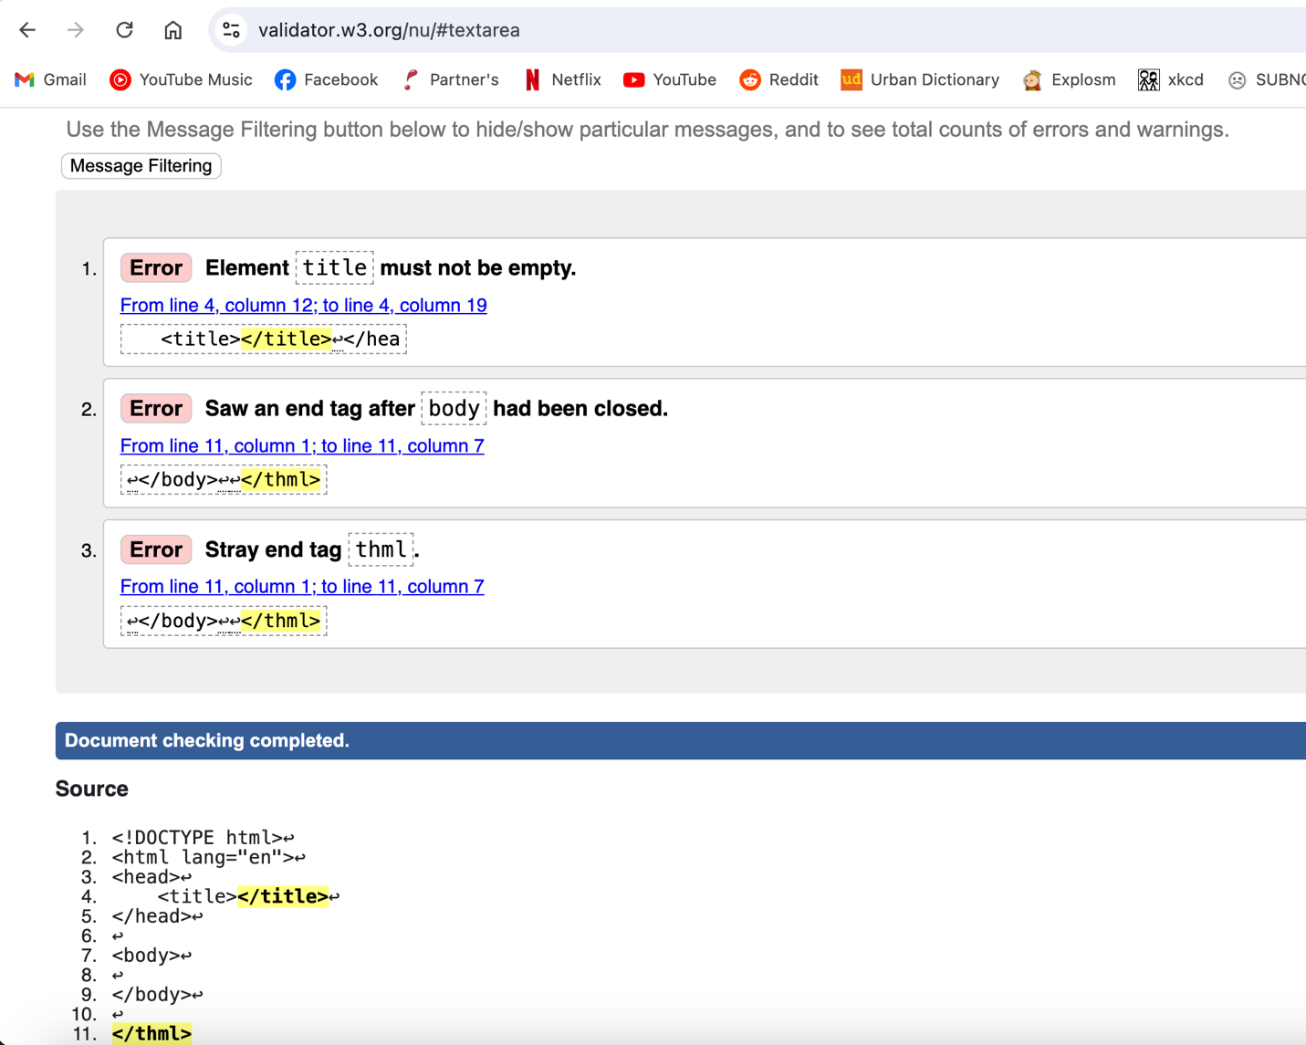

# References