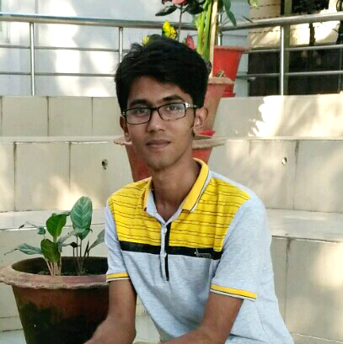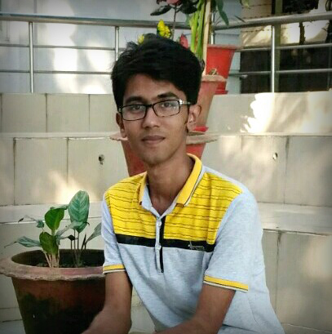

*29th Sep, 2019*

* *now*

­EDUCATION

**Invariant Telecom Bangladesh Limited**

Front-end Developer

<https://invarianttele.com>

|  |  |
| --- | --- |
| **Online Examination System** | / HTML5, CSS3, JavaScript,  PHP, AJAX,  MySQL |
| [https://github.com/Yadab-Sd/Online_Examination_System](https://github.com/Yadab-Sd/Image_To_ALTOXML_TXT_JSON) |
| <http://oe.yadab.us/> |

My Portfolio *-* <http://yadab.us/>

|  |  |
| --- | --- |
| **Combined Enterprise with Restaurant, Hotel, Community Center (inc. online services)** | / HTML5, CSS3, JavaScript,  PHP, AJAX,  MySQL |
| [https://github.com/Yadab-Sd/Combined-Enterprise-with-Restaurant-Hotel-Community-Center-](https://github.com/Yadab-Sd/Image_To_ALTOXML_TXT_JSON) |
| <http://enterprise.yadab.us/> , <http://restaurant.yadab.us/> |

|  |  |
| --- | --- |
| **Convert Multiple Image To Identical Formatted Text Document (ALTOXML, HOCR, JSON)** | /Python |
| <https://github.com/Yadab-Sd/Image_To_ALTOXML_TXT_JSON> |
|  |

PROJECTS

­EDUCATION

Higher Secondary

Certificate

**Science** *2010-2011*

Sonar Bangla College, Cumilla

*GPA: 5.00*

**Science** *2008-2009*

Bholachang High School, Brahmanbaria

*GPA: 4.19*

Secondary School Certificate

**Information & Communication Technology** *2012-2013*

Cumilla University, Cumilla

*CGPA: 3.40 (Approx.)*

Bachelor

Of Science

(Engg.)

ABOUT ME

A qualified and enthusiastic person, with worth of experience, currently searching for a challenging position to utilize my skill. I am a current technologist graduate. Excellent analytical and organizational skills. I am able to work under pressure, with team and self-motivated individual that can gives 100% in everything I do. Proven track record of successes.

SKILLS

|  |  |
| --- | --- |
| C, C++  JS (Angular, JQuery)  Python  PHP  MySQL  HTML5, CSS3  AJAX  Bootstrap | Photoshop  Illustrator  Atom  CodeBlocks  Visual Studio  Wordpress  JSON  Git |

CONTACT

|  |  |  |  |  |  |  |  |  |  |  |  |
| --- | --- | --- | --- | --- | --- | --- | --- | --- | --- | --- | --- |
| |  |  | | --- | --- | |  | +8801733267990 | |  | yadab.sd2013@gmail.com | |  | www.yadab.us | |  | [github.com/Yadab-Sd](https://github.com/Yadab-Sd) | |  | 10B2-Aziz Foyzunnesa Tower,  Police Line, Jhawtala, Cumilla. | |  | |

**YADAB SUTRADHAR**

|  |  |  |  |  |
| --- | --- | --- | --- | --- |
| ­PROGRAMMING CONTEST  **CoU CSE Fest** – 2016 ( $4^{th}$*)*  (Cumilla Regional) |  | PERSONAL INFO | | |
| Father’s Name  Date of Birth  Nationality  Marital Status  Religion  Gender  Language | :  :  :  :  :  :  : | Swapan Sutradhar  25.05.1994  Bangladeshi  Unmarried  Hinduism  Male  Bangla, English |
| Problem Solver at –  Hackerrank  Codeforces  URI  UVa |

Certificates

**5**

Awards

3

**30 +**

Projects

CERTIFICATION

* Learning & Earning Dev. Project
* SKT & Incubation (Webpers Ltd.)
* APTIS (English Test: Got C-92 )

**500 +**

Problems

**PERSONAL INTERESTS**

|  |  |  |  |
| --- | --- | --- | --- |
|  |  |  |  |

MY NUMBERS