**GUI Architecture**

In the “GUI-Base” there are some GUI’s elements that have their IDs, as in the red notation “xYY” being YY a number. Here is a documentation on how each element should behave.

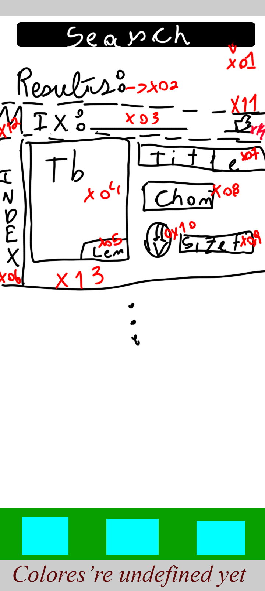

**x01**. This is a inputField that will receive the url of the playlist or video, this can be achieve using the pytube.YouTube() class on source/main.py, this activation needs to collect data for all the elements below.

**x02**. This is a simple label that will contain the string “results:” with x11 being a solid or non-solid line dividing the background.

**x03**. This is a Label saying “Mix:” and a inputField that will contain the string in which the IDE tag, TALB, that make it an automatic playlist on YTMusic. If the url input is a playlist the inputField will fill itself with the playlist title.

**x04**. I still need to search about images insertion on Kivy, but it should work with the same concept the “setCover()” uses.

**x05**. A label with bg with alpha < 200 that shows the length of the video in the formatting “%h:%m:%s” if the leftist value is 0 can be omitted.

**x06**. In case of a playlist, a label showing the music’s index in thou playlist.

**x07**. A label showing the music’s title.

**x08**. A label showing the channel which the music was uploaded.

**x09**. A label showing the size needed to download the music, this will be tricky because in the download process uses a double of this size, but at the end removes the MP4 file and only leaves the MP3, which is shorter than the MP4.

**x10**. A button with an image that triggers the download of the specified music.

**x11, x12, x13**. A visual separator with undefined aesthetic.

**x14**. A button with an image that tiggers the download of all the music’s in the playlist