**Integrated Test Range**

**Defense Research and Development Organization**

**Chandipur, Odisha (756025)**

**Summer Training (2019-2020)**

**Report on Orientation Program (Batch 2nd)**

**Name:** Anurag Yadav

**Roll No:** T018421/CS2016021021

**Application ID: -** 350

**Branch:** Computer Science and Engineering

**College Name:** Madan Mohan Malaviya University of Technology Gorakhpur,U.P.(273010)

TABLE OF CONTENTS

introduction 1

About drdo 1

about ITR 2

Genesis of leadership 3

range facilities 4

campus area network 2

introduction 1

resource sharing 2

types of network 3

network topology 4

internet 5

vlan 6

vrrp 7

Missile and test range 3

Types of missile based on trajectory 1

types of missile based on launch platform and target 2

major components of a missile 3

telemetry system 4

telemetry 1

telemetry system 2

Subsection 3.3.c

target system for test and evaluation 5

sensor 1

transducer 2

test against target 3

unmanned armed vehicle 4

Electro optics tracking system (eots) 6

objectives 1

advantages of eots over radar 2

eots system activities 3

power system in range 7

objective 1

linear load 2

non-linear load 3

main parameters to be monitored 4

key components of ups 5

lightening protection method 6

mission coordination 8

mission coordination 1

pre-flight 2

general teams involves 3

post mission analysis 4

range communication system 9

range communication system 1

modes of radar tracking 2

eots 3

positional advantages of nilgiri hills 4

need of real-time communication 5

computer data processing 10

introduction 1

components involves in data processing 2

rt display 3

multicast display 4

unicast display 5

Range instrumentation radar 11

introduction 1

modes of tracking 2

single/multiple target tracking system 3

radar sub system 4

types of radar 5

applications of radar 6

advantages of radar 7

range and flight safety 12

range safety 1

safety 2

telecommand system 13

introduction 1

ground system 2

spacecraft 3

environmental safety 14

introduction 1

references 15

**Introduction**

DRDO

The Defense Research and Development Organization (DRDO) is an [agency](https://en.wikipedia.org/wiki/Government_agency) of the [Government of India](https://en.wikipedia.org/wiki/Government_of_India), charged with the [military](https://en.wikipedia.org/wiki/Indian_Armed_Forces)'s [research and development](https://en.wikipedia.org/wiki/Research_and_development), headquartered in [New Delhi](https://en.wikipedia.org/wiki/New_Delhi), India. It was formed in 1958 by the merger of the Technical Development Establishment and the Directorate of Technical Development and Production with the Defense Science Organization. It is under the administrative control of the [Ministry of Defense](https://en.wikipedia.org/wiki/Ministry_of_Defence_(India)), [Government of India](https://en.wikipedia.org/wiki/Government_of_India).

ITR

Integrated Test Range was set up to provide safe and reliable launch facilities for performance evaluation of Rackets, Missiles and Air Borne weapon Systems. Starting in 1982 as a project under Integrated Guided Missiles Development Program (IGMDP), it has been graduated to perfection over the years and has reached the status of world class test range. Maiden Test launch of Intermediate Range Ballistic Missile, Agni AE 01 on 22nd May 1989 from this test range has put ITR has tested more than 1000 missions including 300 major missions of national importance.

All these tests are conducted at ITR, which is 200 km from two major cities of the country – Kolkata in the north and Bhubaneswar in the south. Strategically located along the Bay of Bengal, it has the advantage of safe corridor for short and medium range missile systems. The receding sea of Chandipur serves as a God-gifted testbed for weapons.

Genesis of Leadership:

Dr. APJ Abdul Kalam was the first Director of ITR.

He joined DRDO as Director of the Defense Research and Development Laboratory (DRDL), Hyderabad in 1982 and successfully piloted the Integrated Guided Missile Development Program (IGMDP) with total commitment. Dr. Kalam, a technocrat with great vision and imagination, has been decorated with many National Awards including Bharat Ratna for the unparallel services rendered to the nation.

# Range Facilities

* Launch Complexes
* Workshop
* Fire Fighting System
* Campus Area Network
* Knowledge Center
* Power Supply System
* VLSI Laboratory

**Campus Area Network**

**Introduction**

A campus area network also known as **campus network**, **corporate area network** or **CAN** is a computer network made up of an interconnection of local area networks within a limited geographical area. The networking equipment (switches and routers) and transmission media (optical fiber, cabling) are almost entirely owned by campus owner.

A campus area network is larger than a local area network but smaller than metropolitan area network or wide area network.

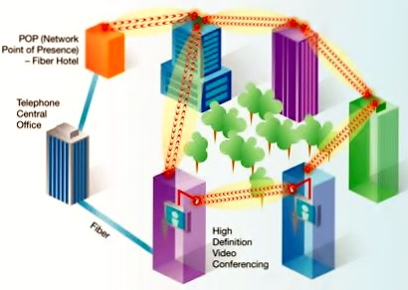

**Resource Sharing**

In networking, network share, is a computer resource made available from one host to other hosts on a network. Resource sharing involves sharing piece of information on a computer that can be remotely accessed from other computers either via local area network or intranet. Network sharing is made possible by inter-process communication over the network.

Examples- shared file, shared printer, shared scanner etc.

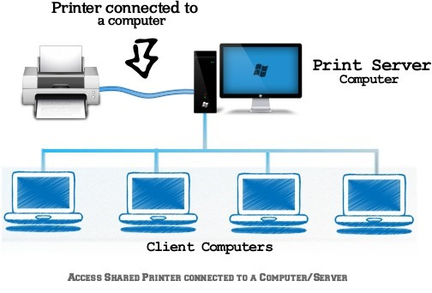

**Types of network**

1. **LAN**

A local area network is a computer network that interconnects computers within a limited area such as residence, school, laboratory, university campus or office building. Its range up to 10 kilometers.

1. 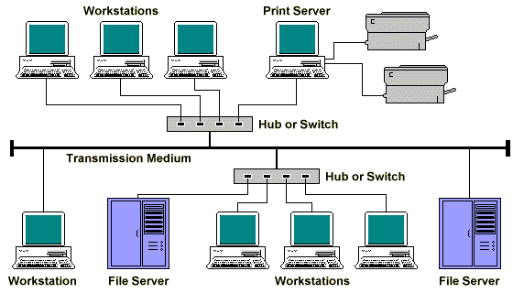
2. MAN

A metropolitan area network interconnects hosts with computer resources in geographic region of the size of a metropolitan area.

The term MAN is applied to the interconnection of LANs in a city into single larger network which may turn also offer efficient connection to wide area network. Its range up to 50 km.

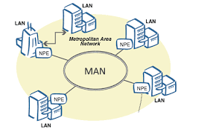

1. WAN

A wide area network is telecommunications network that extends over a large geographical distance for the primary purpose of computer networking. Wide area network is often established with leased telecommunication circuits. Its range is unlimited.

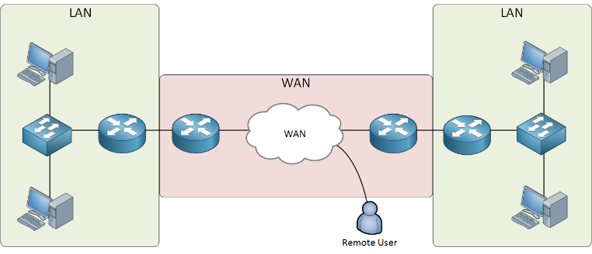

**Network Topology -**

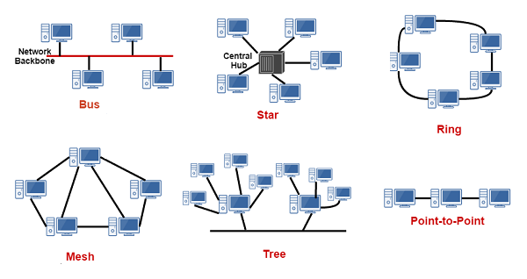

# Internet:

TheInternet([portmanteau](https://en.wikipedia.org/wiki/Portmanteau) ofinterconnected network) is the global system of interconnected [computer networks](https://en.wikipedia.org/wiki/Computer_network)that use the[Internet protocol suite](https://en.wikipedia.org/wiki/Internet_protocol_suite) (TCP/IP) to link devices worldwide.

# VLAN:

Virtual LAN (VLAN) is a concept in which we can divide the devices logically on layer 2 (data link layer). Generally, layer 3 devices divide broadcast domain, but broadcast domain can be divided by switches using the concept of VLAN.

# VRRP:

The Virtual Router Redundancy Protocol (VRRP) is a computer networking protocol that provides for automatic assignment of available [Internet Protocol](https://en.wikipedia.org/wiki/Internet_Protocol) (IP) routers to participating hosts. This increases the availability and reliability of routing paths via automatic [default gateway](https://en.wikipedia.org/wiki/Default_gateway) selections on an IP [sub network](https://en.wikipedia.org/wiki/Subnetwork).

**Missile & Test Range**

**Types of missile-**

Based on the type of trajectory-

* Cruise Missile-

A cruise missile is a [guided missile](https://en.wikipedia.org/wiki/Missile) used against terrestrial targets, that remains in the atmosphere and flies the major portion of its flight path at approximately constant speed. Cruise missiles are designed to deliver a large [warhead](https://en.wikipedia.org/wiki/Warhead) over long distances with high precision. Modern cruise missiles are capable of travelling at [supersonic](https://en.wikipedia.org/wiki/Supersonic_speed) or high [subsonic](https://en.wikipedia.org/wiki/Aerodynamics#Incompressible_aerodynamics) speeds, are self-navigating, and are able to fly on a non[-ballistic,](https://en.wikipedia.org/wiki/Ballistics) extremely low-altitude trajectory.

* Ballistic Missile-

A ballistic missile follows a [ballistic trajectory](https://en.wikipedia.org/wiki/Ballistic_trajectory) to deliver one or more [warheads](https://en.wikipedia.org/wiki/Warhead) on a predetermined target. These weapons are only guided during relatively brief periods of flight—most of their trajectory is unpowered, being governed by gravity and air resistance if in the atmosphere. Shorter range ballistic missiles stay within the [Earth's atmosphere,](https://en.wikipedia.org/wiki/Atmosphere_of_Earth) while longer-ranged [intercontinental ballistic missiles](https://en.wikipedia.org/wiki/Intercontinental_ballistic_missile) (ICBMs), are launched on a [sub-orbital flight](https://en.wikipedia.org/wiki/Sub-orbital_flight) trajectory and spend most of their flight out of the atmosphere.

Based on launch platform and target-

* Surface to surface
* Surface to air
* Air to air
* Air to surface

The major components of a missile-

* Airframe
* Propulsion System
* Flight control system
* Guidance System
* Warhead

**Telemetry System**

Telemetry

Telemetry is the automatic recording and transmission of data from remote or inaccessible sources to an IT system in a different location for monitoring and analysis.

It means remote measurement telemetry is used to make measurement at accessible or inconvenient or unsafe locations, like unmanned aircraft, nuclear reactor and space-bomb system, for human being and present in a remote location.

Telemetry System

Telemetry systems are an alternative method of transmitting data from the rotating assembly to the stationary [data acquisition system](https://www.sciencedirect.com/topics/engineering/data-acquisition-system).

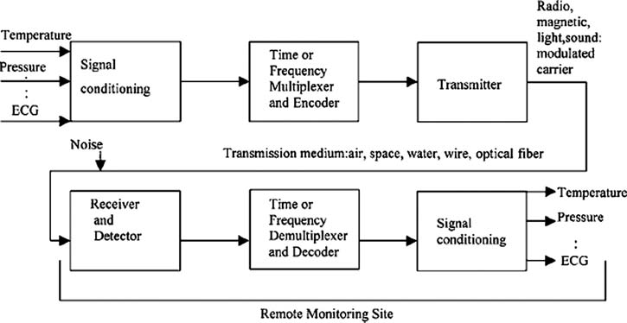

**Target System for Test & Evaluation**

**Sensor**

The [sensor is a device,](https://www.elprocus.com/sensor-based-electronics-projects/) that senses a physical quantity and converts it into an analogue quantity which can be measured electrically such as voltage, capacitance, inductance and ohmic resistance.

**Transducer**

The transducer is a device that is connected to sensor to convert the measured quantity into a standard electrical signal. The o/p of the transducer can be directly used by the system designer.

**Test against Target**

* Head on target
* Tail chasing target

**Unmanned Armed Vehicle**

An UAV is an aircraft without human pilot. It uses aerodynamic forces to provide vehicle lift, can be expandable or recoverable.

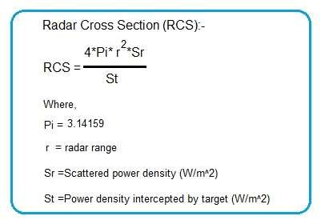

# Electro Optical Tracking System

EOTS stands for Electro Optical Tracking System. It is vehicle independent data collection system.

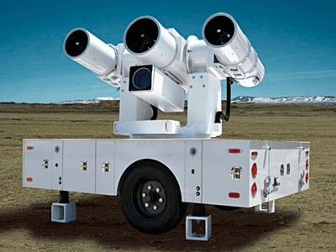

**Objectives of EOTS**

* Initial Trajectory
* Bias Estimation
* Range Estimation
* Vehicle Independent data
* Attitude Measurement
* Miss Distance Computation

**Advantage of EOTS over RADAR:**

* It can even track sea skimming missiles
* It is the most precise and accurate device

**EOTS System Activities:**

* Selection of site
* System deployment
* Calibration of System
* Voice timing and data collection
* Range validation

The image taken is binarized and the tracking object is maintaining in the middle portion of the image by proving position data in feedback and the pivot is moved accordingly. (normally using linear or non-li near regression).

**Power System**

**Objective**

Providing clean, regulated, un-interrupted, reliable and quality power supply to various instrumentation systems.

**Linear load** is a type of load which has constant impedance along a voltage cycle.

**Non-linear load** is a type of load which does not have constant impedance along a voltage cycle.

**Main parameters to be monitored:**

* Voltage
* Frequency
* Power
* Load
* Ground to neutral voltage
* Power quality

**Key components of UPS:**

* Rectifier
* Inverter
* Battery
* Static switch
* Monitoring and controlling network

**Lightning protection methods**

* Franklin rods
* Advanced lightning protection system (ESE)
* Mesh type
* Catenary type

**Mission Coordination**

**Mission Coordination**

There are 4 parts of mission co-ordination which include:

a) Pre-Flight

b) On-flight

c) Post-flight

d) Non-Mission tasks generally involves the following:

a) Receipt of data for range requirement

b) Allotment of range

c) Receipt of data for Project:

* Flight Test Plan
* Nominal Trajectory

d) Discussion of Joint Co-ordination Committee regarding launch

e) Helicopter Sortie (Non- mission) and Link checks

f) Conduct of Range Integration checks

g) Display validation

h) Test and Evaluation

Then launch is conducted. Then, follows Post Mission Analysis in which: a) Collection of data is done from various sensors and radars. B) Conduct of PMA is done.

c) Customer feedback is taken.

Hence, the above sequence of procedures is followed during a mission to ensure safe and proper coordination and carry out of a successful mission.

**Range Communication System**

For proper tracking of a flight, three parameters are required to locate a projectile in space which is basically acquired through a communication system of **Radars and EOTS.**

These parameters are: **Azimuth, Look angle and Range.**

The monitoring of on-board parameters, viz. temperature, pressure, vibrations etc. is done through **Telemetry** system.

Two modes of **Tracking through RADAR** are:

**a) Skin Mode of tracking:** The time interval between transmission and reception of a pulse is utilized to calculate the position of a flight.

**b) Transponder based tracking:** Electronics onboard are utilized to transmit back signals on reception from earth-based antennae.

**EOTS:** The major contribution of EOTS system is it helps in tracking during take on and take off conditions. It can help in starting the timer during flight tracking.

The various nodes of the network are connected through fiber optic cables as well as satellite links to establish a redundant link to provide alternate routes for communication if one route fails.

**Positional advantage of Nilgiri Hills in the range communication system:**

The presence of a high hill for installing a Radar system for flight tracking gives the natural advantage of a long Line of Sight distance.

**Need of Real Time Communication:**

The need of real time communication is to work with minimum time delay in a mission which poses risk of huge loss if there is no instantaneous response from the concerned authorities. **Circuit switching and packet switching** technologies are deployed for real time and non-real- time communication.

The satellites from Inmarsat (group of commercial satellites) are used for communicating the data from central computers to the stationed ships in the deep Indian Ocean for target acquisition.

**Computer Data Processing**

Data processing, Manipulation of data by a [computer.](https://www.britannica.com/technology/computer) It includes the conversion of raw data to machine-readable form, flow of data through the [CPU](https://www.britannica.com/technology/central-processing-unit) and memory to output devices, and formatting or transformation of output. Any use of computers to perform defined operations on data can be included under data processing. In the commercial world, data processing refers to the processing of data required to run organizations and businesses.

Components involved in data processing-

* Central Processing Unit (CPU)
* Memory (RAM & ROM)
* Data Bus
* Ports
* Motherboard
* Hard disk
* Input devices
* Output devices

RT display –

* Multicast display
* Unicast display

Multicast display –

* CDP display
* XY display
* Multicast trajectory display
* Integrated display

Unicast display –

* MD display
* Unicast Trajectory display
* LRTR-MFCR display

**Range Instrumentation Radar**

RADAR stands for Radio Direction and Ranging.

Frequency bands used by the RADARs in the range are in the S-band, C-band and X-Band ranging over frequencies of (2-6) GHz. Ultra-High Frequencies are used so that the antennae Size is practically realizable.

Basically, 2 modes of tracking are used which are:

**Skin based:** depends on the rays reflected by the missile to track it.

**Transponder based:** Electronic circuits are deployed in the missile to transmit signals to the RADAR.

For tracking highly maneuvering targets, beams are focused by using **switching antennae** and **simultaneous lobbing technologies.**

One issue which arises while calculating position of missile is determining the exact timing difference of received and transmitted pulses which is termed as Resolution error. The data are calculated while optimizing the errors.

**Single/Multiple Target Tracking System**

For multiple target tracking system, one part of the transmitter arrays is used to track one interceptor missile and another part is used for tracking another missile.

**RADAR Sub System:**

The sub system basically involves:

a) Transmitter, b) Duplexer, c) Antennae, d) Signal Processor, e) Receiver.

The signals received are transmitted to the display in the control center.

**Types of radar:**

* Continuous
* Pulse

Range calculation for pulse radar:

R = CT/2

R = Range

T = time of propagation

C = speed of light

**Applications:**

* Air traffic control
* Navigation
* Ship safety
* Remote sensing
* Law enforcement
* Military
* Space application

**Advantages of RADAR:**

* Complete data obtained at a single station.
* All weather operation
* Tracking on cooperative and non-cooperative targets

# Range & Flight Safety

**Range Safety**

* Facility for flight-testing of weapon systems.
* Sensor base for tracking and telemetry.
* Provision of communication, command and safety to the user of the range.

**Flight Safety**

* Notification of range volume.
* Flight termination in adverse situation.

**Telecommand System**

It involves generation and transmission of signal.

A Telecommand is a command sent to control a remote system or systems not directly connected (e.g. via wires) to the place from which the Telecommand is sent. The Telecommand can be done in [real time](https://en.wikipedia.org/wiki/Real-time_Control_System) or not depending on the circumstances.

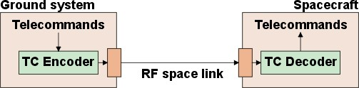

**Environmental Safety**

Environmental safety is the practice of policies and procedures that ensure that a surrounding environment, including work areas, laboratories or facilities, is free of dangers that could cause harm to a person working in those areas. A safe place to work is the key element of environmental safety.



**References**

1. https://wikipedia.org
2. https://tutorialspoint.com
3. https://geeksforgeeks.org
4. https://drdo.gov.in