**Defence Research and Development Organization, Chandipur,Odisha**

Report On

**Orientation Program**

**SUBMITTED BY: DEEPAK PATEL**

**Roll No**: 2016021034

**Branch**: Computer Science & Engineering

**College**: Madan Mohan Malaviya University Of Technology, Gorakhpur

**Batch**: 2nd (15 May to 14 June)

|  |  |
| --- | --- |
| 1 | INTRODUCTION |
| 2 | TELEMETRY SYSTEM |
| 3 | RADAR SYSTEM |
| 4 | POWER SYSTEM |
| 5 | EOTS |
| 6 | CAN & DATA CENTER |
| 7 | MISSION COORDINATION |
| 8 | TARGET SYSTEM FOR TEST AND EVALUATION |

**INTRODUCTION**

DRDO: The Defense Research and Development Organisation (DRDO) is an [agency](https://en.wikipedia.org/wiki/Government_agency) of the [Government of India](https://en.wikipedia.org/wiki/Government_of_India), charged with the [military](https://en.wikipedia.org/wiki/Indian_Armed_Forces)'s [research and development](https://en.wikipedia.org/wiki/Research_and_development), headquartered in [New Delhi](https://en.wikipedia.org/wiki/New_Delhi), India. It was formed in 1958 by the merger of the Technical Development Establishment and the Directorate of Technical Development and Production with the Defence Science Organisation. It is under the administrative control of the [Ministry of Defence](https://en.wikipedia.org/wiki/Ministry_of_Defence_(India)), [Government of India](https://en.wikipedia.org/wiki/Government_of_India).

ITR: Integrated Test Range was set up to provide safe and reliable launch facilities for performance evaluation of Rackets, Missiles and Air Borne weapon Systems. Starting in 1982 as a project under Integrated Guided Missiles Development Program (IGMDP), it has been graduated to perfection over the years and has reached the status of world class test range. Maiden Test launch of Intermediate Range Ballistic Missile, Agni AE 01 on 22nd May, 1989 from this test range has put ITR has tested more than 1000 missions including 300 major missions of national importance. All these tests are conducted at ITR, which is 200 km from two major cities of the country – Kolkata in the north and Bhubaneswar in the south. Strategically located along the Bay of Bengal, it has the advantage of safe corridor for short and medium range missile systems. The receding sea of Chandipur serves as a God-gifted test-bed for weapons.

Genesis of Leadership: Dr. APJ Abdul Kalam was the first Director of ITR.

He joined DRDO as Director of the Defence Research and Development Laboratory (DRDL), Hyderabad in 1982 and successfully piloted the Integrated Guided Missile Development Program (IGMDP) with total commitment. Dr. Kalam, a technocrat with great vision and imagination, has been decorated with many National Awards including Bharat Ratna for the unparallel services rendered to the nation.

# Range Facilities

* Launch Complexes
* Workshop
* Fire Fighting System
* Campus Area Network
* Knowledge Center
* Power Supply System
* VLSI Laboratory

# Types of Missiles:

* Cruise Missiles

A cruise missile is an unmanned self propelled guided vehicle that sustains through aerodynamic lift for most of its flight path and whose primary mission is to place an ordnance or special payload on a target.

Ex- Brahmos

* Ballistic Missiles

A ballistic missile is a missile that has a ballistic trajectory over most of its flight path, regardless of whether or not it is a weapon-delivery vehicle. Ex- Agni-I, Prithvi

**TELEMETRY SYSTEM**

Telemetry: Telemetry is the automatic recording and transmission of data from remote or inaccessible sources to an IT system in a different location for monitoring and analysis.

It means remote measurement telemetry is used to make measurement at accessible or inconvenient or unsafe locations, like unmanned aircraft, nuclear reactor and space-bomb system, for human being and present in a remote location.

Telemetry System: Telemetry systems are an alternative method of transmitting data from the rotating assembly to the stationary [data acquisition system](https://www.sciencedirect.com/topics/engineering/data-acquisition-system).

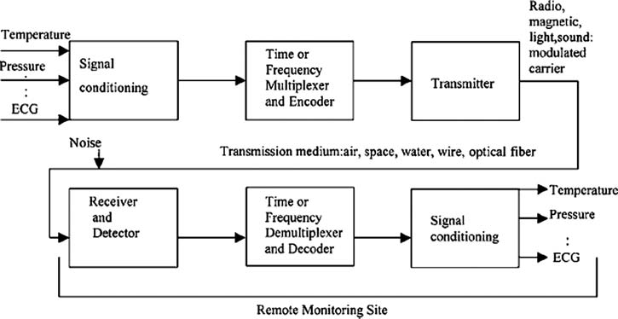

**RADAR SYSTEM**

RADAR stands for Radio Detection And Ranging. It is an electromagnetic system for the detection and location of objects. It gives vehicle independent data.

**Types of radar:**

* Continuous
* Pulse

Range calculation for pulse radar:

R = CT/2

R = Range

T = time of propagation

C = speed of light

**Applications:**

* Air traffic control
* Navigation
* Ship safety
* Remote sensing
* Law enforcement
* Military
* Space application

**Advantages of RADAR:**

* Complete data obtained at a single station.
* All weather operation
* Tracking on cooperative and non-cooperative targets

**MODES OF OPERATION**:

1. Range mode

* Auto
* Auto detection
* Manual
* Memory

1. Angle mode

* Manual
* Automatic

**POWER SYSTEM**

**Objective:**  Providing clean, regulated, un-interrupted, reliable and quality power supply to various instrumentation systems.

**Linear load** is a type of load which has constant impedance along a voltage cycle. **Non-linear load** is a type of load which does not have constant impedance along a voltage cycle.

**Main parameters to be monitored:**

* Voltage
* Frequency
* Power
* Load
* Ground to neutral voltage
* Power quality

**Key components of UPS:**

* Rectifier
* Inverter
* Battery
* Static switch
* Monitoring and controlling network

**Lightning protection methods:**

* Franklin rods
* Advanced lightning protection system (ESE)
* Mesh type
* Catenary type

# EOTS

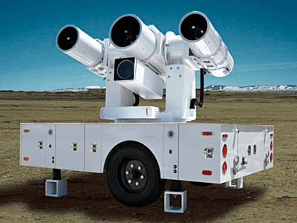

EOTS stands for Electro Optical Tracking System. It is vehicle independent data collection system.

**Objectives of EOTS:**

* Initial Trajectory
* Bias Estimation
* Range Estimation
* Vehicle Independent data
* Attitude Measurement
* Miss Distance Computation

**Advantage of EOTS over RADAR:**

* It can even track sea skimming missiles
* It is the most precise and accurate device

**EOTS System Activities:**

* Selection of site
* System deployment
* Calibration Of System
* Voice timing and data collection
* Range validation

The image taken is binarized and the tracking object is maintain in the middle portion of the image by proving position data in feedback and the pivot is moved accordingly.(normally using linear or non-li near regression)

# CAN & Data Center

# Computer Network:

Collection of computers connected with each other and has the ability to communicate.

# Types Of Computer Network:

* LAN
* MAN
* WAN

# LAN:

Small geographical connection that ranges over few meters

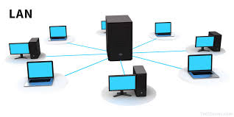

# MAN:

Medium geographical connection that ranges over few ten’s of km.

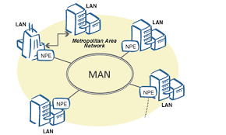

WAN:

It has no range limitation. It covers whole world.

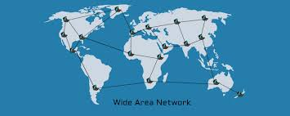

# Network Topology:

# network-topology.png

# Internet:

TheInternet([portmanteau](https://en.wikipedia.org/wiki/Portmanteau) ofinterconnected network) is the global system of interconnected [computer networks](https://en.wikipedia.org/wiki/Computer_network)that use the[Internet protocol suite](https://en.wikipedia.org/wiki/Internet_protocol_suite) (TCP/IP) to link devices worldwide.

# VLAN:

Virtual LAN (VLAN) is a concept in which we can divide the devices logically on layer 2 (data link layer). Generally, layer 3 devices divides broadcast domain but broadcast domain can be divided by switches using the concept of VLAN.

# VRRP:

The Virtual Router Redundancy Protocol (VRRP) is a computer networking protocol that provides for automatic assignment of available [Internet Protocol](https://en.wikipedia.org/wiki/Internet_Protocol) (IP) routers to participating hosts. This increases the availability and reliability of routing paths via automatic [default gateway](https://en.wikipedia.org/wiki/Default_gateway) selections on an IP [sub network](https://en.wikipedia.org/wiki/Subnetwork)

**Mission Coordination**

**Mission Coordination:-** There are 4 parts of mission co-ordination which include:

a) Pre-Flight

b) On-flight

c) Post-flight

d) Non-Mission tasks generally involves the following:

a) Receipt of data for range requirement

b) Allotment of range

c) Receipt of data for Project:

* Flight Test Plan
* Nominal Trajectory

d) Discussion of Joint Co-ordination Committee regarding launch

e) Helicopter Sortie (Non- mission) and Link checks

f) Conduct of Range Integration checks

g) Display validation

h) Test and Evaluation

Then launch is conducted. Then, follows Post Mission Analysis in which: a) Collection of data is done from various sensors and radars. b) Conduct of PMA is done.

c) Customer feedback is taken.

Hence, the above sequence of procedures is followed during a mission to ensure safe and proper coordination and carry out of a successful mission. Range Communication System:- For proper tracking of a flight, three parameters are required to locate a projectile in space which is basically acquired through a communication system of Radars and EOTS . These parameters are: Azimuth, Look angle and Range. The monitoring of on board parameters, viz. temperature, pressure, vibrations etc. is done through Telemetry system. Two modes of Tracking through RADAR are: a) **Skin Mode of tracking**: The time interval between transmission and reception of a pulse is utilized to calculate the position of a flight. b**)Transponder based tracking**: Electronics onboard are utilized to transmit back signals on reception from earth based antennae. EOTS: The major contribution of EOTS system is it helps in tracking during take on and take off conditions. It can help in starting the timer during flight tracking. The various nodes of the network are connected through fiber optic cables as well as satellite links to establish a redundant link to provide alternate routes for communication if one route fails. Positional advantage of Nilgiri Hills in the range communication system: The presence of a high hill for installing a Radar system for flight tracking gives the natural advantage of a long Line Of Sight distance. Need of Real Time Communication: The need of real time communication is to work with minimum time delay in a mission which poses risk of huge loss if there is no instantaneous response from the concerned authorities. Circuit switching and packet switching technologies are deployed for real time and non real- time communication.

The satellites from Inmarsat (group of commercial satellites) are used for communicating the data from central computers to the stationed ships in the deep Indian Ocean for target acquisition.

**Target System For Test & Evaluation**

Sensor- The sensor is a device, that senses a physical quantity and converts it into an analogue quantity which can be measured electrically such as voltage, capacitance, inductance and ohmic resistance. Transducer- The transducer is a device that is connected to sensor to convert the measured quantity into a standard electrical signal. The o/p of the transducer can be directly used by the system designer. Test against Target-

* **Head on target**
* **Tail chasing target**
* **Unmanned Armed Vehicle**- A UAV is an aircraft without human pilot. It uses aerodynamic forces to provide vehicle lift, can be expandable or recoverable.

**Defense Research and Development Organization, Chandipur, Odisha**

Report On

**Orientation Program**

**SUBMITTED BY: S VISWANATHAN**

**Roll No:** 311616106172

**Branch:** *Electronics and Communication Engineering*

**College:** *MNM Jain Engg. College (Affiliated to Anna University)*

**Batch:** 2nd ( 15 May to 14 June)