**Project Proposal**

1. **Project name:** Krishak (Bhartiya Kisan Portal)
2. **Department and University Name:** Computer Science and Engineering, Madan Mohan Malaviya University of Technology, Gorakhpur U.P. - 273010.
3. **Project Guide:** Rohit Kumar Tiwari
4. **Project Members:**

|  |  |
| --- | --- |
| Shivam Sahu | Roll no. 2016021078 |
| Anurag Yadav | Roll no. 2016021021 |
| Panne Lal | Roll no. 2016021110 |

1. **Keywords:** Farmer, Krishak, E-commerce, Crop
2. **Introduction**

Nowadays there is an alarming increase in the suicide rate among Indian farmers. If we took a close eye on the above problem, there are two main issues. First is the crop failure due to climate change, pests and lack of advance farming method. The second is the absence of marketing facility to sell crop yields. A farmer depends on middleman for selling their produce who took most of the profits.

The Krishak portal requires only mobile phone and internet to access its services. In the modern scenario, everyone owns a mobile phone and Government of India is also connecting villages through Digital India, which aims to connect all the 6,25,000 villages by December 2020.  So, there is no constraint in use of portal. As the Krishak portal will provide a lot of services to increase the revenue of farmers by providing them maximum benefit. Thus, it will definitely prove to be a boon for Indian farmers.

1. **How it relates to modern trends in the industry?**

With the proliferation of the internet and technology, the e-commerce sector has completely revolutionized the principles of buying and selling. Thousands of businesses rely on e-commerce as it decreases investment and increases the convenience of the customers. With a whopping amount of $2.8 billion in the last year, retail e-commerce sales are expected to reach $4.88 billion by 2021.

Our final year project Krishak is a web application that is dedicated to the farmers to overcome the above problems with the help of modern technologies. It will help farmers to get knowledge of the latest farming methods, agro technology and will provide solutions to the problem faced by them through fellow farmers. It will also provide weather reports to minimize their loss due to climate change. Our project will provide an integrated platform to know the tentative price of their crop and will connect the farmer to the end-user by eliminating the role of a middleman.

So, it provides an e-commerce platform for farmers to sell their crops. Overall, it will help the farmers to increase their profit by getting a reasonable price of their crop and minimizing the loss.

1. **How the project is novel and unique?**

Still, e-commerce businesses are very less popular in small towns and villages due to a lack of trust and familiarity with digital technologies. Due to the availability of cheap internet and initiatives are taken by the government to promoting Digital India most of the peoples are connecting with digitalization, and that's what we are digesting.

Still, there is not a single platform provided for farmers to sell their crops directly to customers. There is neither a dedicated discussion forum for farmers to discuss their problems, nor they are practicing the modern agro-farming methods.

Our project is unique in the following ways -

* 1. Providing an e-commerce platform to connect the farmers directly to the end consumers. And providing a cashless system for selling and buying of crops through the payment gateway and connect them to the digital India program.
  2. To provide weather forecasting reports to minimize crop loss due to weather.
  3. To provide a discussion forum to share and know the cure of various plant diseases and methodology for crop sowing/harvesting/ technology from fellow farmers.

1. **Why the project is chosen and how it relates to the learnings?**

Project is chosen because-

The project solves the major problem of poverty prevailing among farmers. The project aims at providing a fair price to farmers. The farmers are unaware of the solution to problems like crop diseases, fog, seeds, etc. so connecting them with fellow farmers will help them know about the ways to get rid of it by following the advance method of agriculture. Although access to the platform will be free to farmers, a small amount of money can be charged from the end-user on the transaction made. Other sources of revenue will be from the advertisement shown on the application.

Learnings from the project-

We are using MVC (Model-View-Controller) architecture to build the project. Figure 1 shows the architecture of Krishak. We are using trending MERN stack technology to develop the web app, and Machine Learning, using TensorFlow for weather forecasting. Technologies are being selected to make project scalable and maintainable after going through the latest developments-

Client Program

(View)

Rest API

(Controller)

Request

Response

Response

DBMS

(Model)

* 1. DBMS: Database management system used for the Krishak is MongoDB. It is an advanced No-SQL database server, which is available on a wide range of platforms. It has an enviable reputation for performance, stability, and a wide range of advanced features.
  2. Rest API: The rest services of the system will be written in Nodejs. The main purpose of writing REST services for the system is that a variety of applications and websites can be developed using the same rest services.
  3. User-interface: User interface will consist of a website for computers as well as mobile browsers. This will increase the reach on the system.

1. **What strength each does member provide to the project?**

The team consists of three members, and description of their role in the development of the project is as follows-

* 1. Anurag Yadav-

He is strong in front-end development and web app designing. He is working on designing the User Interface, calling of REST API using ReactJS which is an opensource, lightweight JavaScript library.

* 1. Panne Lal -

He is responsible for the development of the back end of the web app, writing the REST API and modeling the database schemas. The back end is being developed using NodeJS and MongoDB for the database.

* 1. Shivam Sahu-

We are using machine learning for Weather Forecasting and developing the recommendation system for consumers. He is developing machine learning models using Google's opensource library TensorFlow.

1. **Clarity and intent of the project:**

The Krishak web application will be divided into three parts-

* 1. Farmer Panel
  2. Consumer Panel
  3. Admin Panel

Farmer panel will include the features of registering them with the platform, recommendation system to update them about the weather report, discussion forum, crops in demand and their selling price as well as a platform to sell their crops. Consumer panel will include the features of registration of consumers, showing them about the

crops and their process as well as various filtering options for select the crops to be purchased. Admin panel to manage the farmers and consumers on the Krishak platform. It will also help to control the unauthorized activity on the portal.

Krishak Portal will surely set a milestone in reshaping agriculture as a lucrative opportunity for farmers. It provides a platform for farmers to connect with end-user directly to sell their products eliminating the role of middleman. It also gives them information about the advanced method of farming provided on the platform and connects them with fellow farmers. Overall it will help the farmers to get out of poverty by connecting them with present-day technology.

1. **High-level design and flow charts:**

Following figure-2 represents the application architecture while figure-3 represents various use cases of the Krishak portal by different users. Figure-4 shows the object-relational mapping of the proposed system.

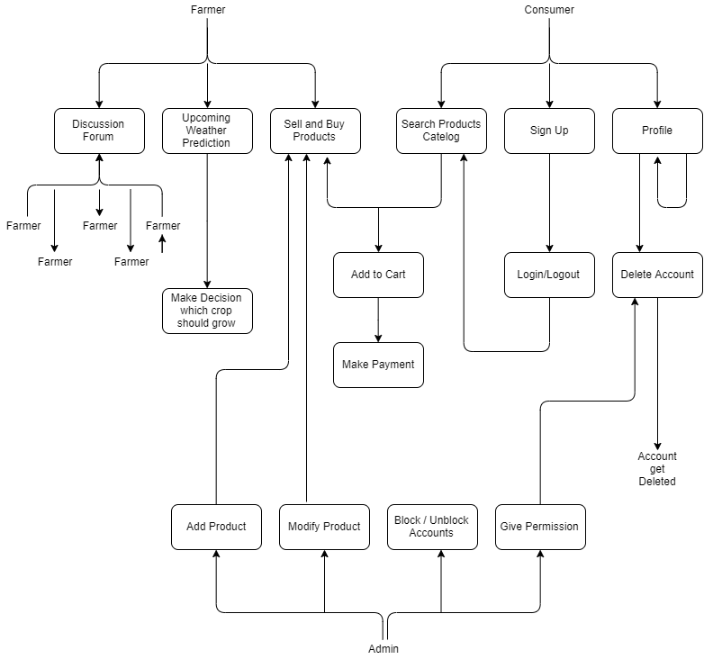

Fig. - 2 Application Architecture

Fig. - 3 Use Case Diagram

Fig. - 4 Object Relation Mapping