VELLORE INSTITUTE OF TECHNOLOGY
School of Computer Science and Engineering
BCSE307 — COMPILER DESIGN PROJECT
PROJECT REVIEW 2
Implementation, Integration and Progress Review
A2: Trace-Based JIT Compiler for a Custom Bytecode Virtual Machine
Field | Details
Course Code / Title | BCSE307 - Compiler Design
Project ID / Title | A2: Trace-Based JIT Compiler for a Stack-Based Virtual Machine
Team Number | Team 6
Team Members & Reg. No. | YADESH WARAN M [24BCE2402]  EMMANUEL JOSHY [24BCE0916]  TANVI GUPTA [24BAI0254]  ATUL VIPIN [24BCE2465]
Review Date | 16-09-2026
Faculty / Evaluator | Dr. Shalini L
GitHub Repository Link | https://github.com/Yadesh-005/JIT/tree/main

Table of Contents
Table of Contents 2
1. Review 1 Feedback and Compliance 4
2. Updated Abstract, Objectives and Scope 4
Updated Abstract 4
Current Objective Status 4
Changes in Scope 5
3. Updated Architecture and Module Interfaces 5
3.1 Design Rationale 5
3.2 State Machine 6
4. Implementation Progress Summary 6
5. Module 1: Baseline Interpreter and Profiler Implementation 6
Design & Algorithm 6
5.1 Instruction Set Overview 7
5.2 Register File and Program Counter 7
6. Module 2: Trace Recorder and TraceIR 8
Design & Algorithm 8
Current Limitations / Boundary Handling 8
6.1 TraceIR Design Notes 8
7. Integration / Prototype Execution 8
Execution Flow 9
8. Testing and Debugging 9
Defect & Debugging Log 9
8.1 Coverage Discussion 9
9. Repository and Build Information 10
10. Member-Wise Contribution Record 10
11. Risks, Issues and Pending Work 11
12. Revised Timeline for Review 3 11
13. Preliminary Results 11
13.1 Observed Console Output (Representative) 11
13.2 Discussion 12
14. References 12
Appendix A: Complete Source Code Listing 14
A.1 isa.h — Instruction Set and IR Definitions 14
A.2 vm.h — VirtualMachine Class Declaration 15
A.3 vm.cpp — VirtualMachine Implementation 16
A.4 main.cpp — Differential Test Driver 18
A.5 Code Walkthrough Notes……………………………………………………………………………………………………………………….29

1. Review 1 Feedback and Compliance
During Review 1, the feasibility and design of the JIT Compiler were evaluated. The following table summarizes the actions taken to address the evaluator's feedback prior to commencing the Review 2 implementation phase.
Review 1 Observation / Feedback | Action Taken | Owner | Status
Ensure trace explosion is mitigated in loops with unsupported bytecodes. | Implemented a MAX_TRACE_LENGTH constant (set to 50 operations) and a safe fallback abort for UNKNOWN_OP instructions during recording. | Yadesh M. | Closed
Provide a verifiable mechanism for returning state to the interpreter on failed optimizations. | Architected trace termination to append IR_GUARD_LT and IR_JUMP_LOOP, establishing clear boundaries for state reconstruction (snapshot logic pending). | Emmanuel J. | Closed
Clarify how differential testing will be executed. | Developed a test suite in C++ main() that executes predefined bytecode arrays, directly showing interpreter vs. tracer behavior. | Tanvi G. | Closed

2. Updated Abstract, Objectives and Scope

Updated Abstract
This project implements a mixed-mode virtual machine executing a custom bytecode instruction set, augmented by a trace-based just-in-time (JIT) compiler. The system initially interprets bytecode safely. Through runtime profiling, it identifies frequently executed loop headers (hot loops). For Review 2, the team has successfully developed the core baseline interpreter, the runtime profiler, and the trace recorder. The VM can now detect backward branches, trigger trace recording upon reaching a HOT_THRESHOLD, correctly capture executed instructions into an SSA-like Trace Intermediate Representation (TraceIR), and gracefully handle unsupported instructions or boundary limits by falling back to interpretation.

Current Objective Status
Objective | Status
Objective 1 (Interpreter) | Completed. Custom bytecode format defined; VirtualMachine::run() executes supported subset (LOAD_CONST, ADD_INT, JUMP_IF_LT, PRINT_REG).
Objective 2 (Hot Loop Detection) | Completed. Implemented using an internal loopCounters map tracking backward branch targets against a threshold.
Objective 3 (Trace Recording) | Completed (Core Logic). VM records linear execution paths and emits IROpcode structs. Limiters are in place.
Objective 4-6 (Optimization & Native Generation) | Pending. Scheduled for Review 3.

Changes in Scope
The scope remains largely unchanged from Review 1. The team confirmed C++ as the primary implementation language due to its strict memory control and performance, utilizing standard vectors and maps to simulate the runtime environment securely without external dependencies.

3. Updated Architecture and Module Interfaces
The system architecture centers around a single VirtualMachine class that transitions between interpretation and trace recording based on internal state flags.
Module / Interface | Data Structures | API / Interaction Flow
Bytecode Module | Instruction struct: Opcode, arg1, arg2, arg3. | Loaded into VM via loadProgram(std::vector<Instruction>). Initializes pc and clears memory registers.
Interpreter Core | int registers[16], int pc | run() method loops over instructions, executing switch(instr.op). Direct manipulation of registers.
Hotness Profiler | std::map<int,int> loopCounters | Triggered on JUMP_IF_LT backward branches. Increments counter. Flags isRecording = true when HOT_THRESHOLD (3) is met.
Trace Recorder | std::vector<IROp> currentTrace, traceHeaderPC | Intersects interpreter execution. Maps Opcode to IROpcode (e.g., ADD_INT → IR_ADD_INT). Emits IR_GUARD_LT at loop closure.

3.1 Design Rationale
The decision to keep the interpreter, profiler, and recorder within a single class was a deliberate trade-off for Review 2. It simplifies state sharing — the profiler and recorder both need direct, low-latency access to the program counter and register file — at the cost of separation of concerns. The team has flagged this coupling as a refactoring candidate ahead of Review 3, once the optimizer and native backend introduce additional state that would otherwise bloat the VirtualMachine class further.
A key architectural decision is the choice of a trace-based (as opposed to method-based) JIT strategy. Trace-based JITs, as pioneered by systems such as Tamarin-Tracing and TraceMonkey, specialize execution around a single hot path through a loop rather than compiling an entire function. This keeps the initial implementation surface small: the recorder only needs to understand the instructions it actually observes executing, not every possible control-flow path through a method. The trade-off is that trace-based JITs are more vulnerable to trace explosion when a loop body has many divergent paths — a risk directly addressed by the MAX_TRACE_LENGTH safeguard described in Section 6.

3.2 State Machine
The VirtualMachine operates as an implicit state machine with three states: Interpreting, Recording, and (in future work) Executing Native Trace. The transition from Interpreting to Recording is triggered exclusively by the hotness profiler reaching HOT_THRESHOLD on a backward branch target that is not already being recorded. The transition from Recording back to Interpreting occurs on one of three conditions:
- Successful loop closure — the trace header PC is reached again, and IR_GUARD_LT / IR_JUMP_LOOP are appended.
- Trace length exhaustion — currentTrace.size() reaches MAX_TRACE_LENGTH.
- An unsupported opcode is encountered mid-trace (the default case in the interpreter switch).
This three-way exit ensures the recorder can never leave the VM in an inconsistent state: every recording session either finalizes into IR or is safely discarded, and program semantics are never affected by whether or not tracing is active.

4. Implementation Progress Summary
The following table tracks the specific implementation tasks planned for Review 2 against the actual completed work.
Planned Task (Review 1) | Completed Task (Review 2) | Status | Owner
Implement bytecode representation and VM state. | C++ structs for Instructions defined; 16-register array initialized. | 100% Done | Atul V.
Implement baseline interpreter. | Fetch-decode-execute loop working for 5 core opcodes. | 100% Done | Emmanuel J.
Add loop profiling counters. | Backward-branch detection logic injected into JUMP handler. | 100% Done | Yadesh M.
Implement trace recorder and TraceIR limits. | Recorder safely captures math and branch IRs. Limit set to 50. | 100% Done | Yadesh M.
Implement state snapshots and Deoptimization. | Basic boundary abort implemented; full snapshot serialization pending. | 40% Done | Tanvi G.

5. Module 1: Baseline Interpreter and Profiler Implementation

Design & Algorithm
The foundation of the VM is the VirtualMachine class. It maintains a 16-element integer array for virtual registers and an instruction pointer (pc). The interpreter uses a while loop encompassing a switch statement mapped to the Opcode enum. To detect hot paths, the profiler is hooked directly into the conditional jump instruction (JUMP_IF_LT).
When the target PC of a jump is less than or equal to the current PC, it constitutes a backward branch (typically a loop). The profiler uses a std::map to track the hit count for each target PC. Once the threshold is met, the VM transitions state.

// Profiler execution slice within JUMP_IF_LT
if (targetPC <= currentPC) { // Backward branch detected
loopCounters[targetPC]++;
if (loopCounters[targetPC] == HOT_THRESHOLD && !isRecording) {
std::cout << "[PROFILER] Hot loop detected at line " << targetPC << "!\n";
isRecording = true;
traceHeaderPC = targetPC;
}
}

5.1 Instruction Set Overview
Five opcodes form the supported baseline instruction set for Review 2. Each is modeled as a fixed-width Instruction struct carrying an opcode tag and up to three integer operands, which keeps decoding trivial (a single switch dispatch) at the cost of some wasted space for instructions that use fewer than three operands.
Opcode | Operands | Semantics
LOAD_CONST | arg1=dest reg, arg2=value | registers[arg1] = arg2
ADD_INT | arg1=dest, arg2=src A, arg3=src B | registers[arg1] = registers[arg2] + registers[arg3]
JUMP_IF_LT | arg1=reg A, arg2=reg B, arg3=target PC | if registers[arg1] < registers[arg2]: pc = arg3
PRINT_REG | arg1=reg | Prints the value held in the given register
HALT | — | Stops VM execution
UNKNOWN_OP | — | Sentinel for unsupported/invalid opcodes, used in negative testing

5.2 Register File and Program Counter
The register file is a fixed C-style array of 16 integers rather than a dynamically sized structure. This was a conscious simplification: it avoids bounds-checking overhead on every access and matches the register budget of many small teaching VMs and embedded bytecode formats. All 16 registers are zero-initialized both in the constructor and again in loadProgram(), which also resets the program counter to 0 and clears loopCounters, ensuring that reusing a single VirtualMachine instance across multiple test cases (as the driver in Section 7 does) never leaks state between runs.
The program counter, pc, is captured into a local currentPC before being incremented, which is essential for the backward-branch check in Section 5's code slice above; without this capture, the comparison targetPC <= currentPC would be comparing against the already-advanced PC and would misclassify some forward jumps as backward ones.

6. Module 2: Trace Recorder and TraceIR

Design & Algorithm
Once isRecording is flagged true, the VM executes instructions normally (preserving semantics) but simultaneously pushes equivalent IROp structures into the currentTrace vector. The recording is strictly bounded.

Current Limitations / Boundary Handling
- Max Trace Length: Hardcoded to 50. If currentTrace.size() exceeds this, recording aborts safely without crashing the VM.
- Unsupported Opcodes: If a negative test inputs UNKNOWN_OP, the recorder intercepts it, outputs an abort message, toggles isRecording = false, and allows the interpreter to skip/handle it safely.
- Loop Closure: When the pc cycles back to the traceHeaderPC, the recorder identifies a closed loop, appends IR_GUARD_LT (speculative assumption) and IR_JUMP_LOOP, and finalizes the trace block.
// Recorder Loop Closure slice
if (isRecording && targetPC == traceHeaderPC) {
currentTrace.push_back({IR_GUARD_LT, instr.arg1, instr.arg2, 0});
currentTrace.push_back({IR_JUMP_LOOP, targetPC, 0, 0});
std::cout << "[RECORDER] Trace complete! Captured "
<< currentTrace.size() << " IRs.\n";
isRecording = false;
}

6.1 TraceIR Design Notes
The TraceIR is deliberately kept close in shape to the source bytecode — IR_ADD_INT mirrors ADD_INT one-for-one — rather than lowering into a more abstract SSA form at this stage. This is a pragmatic Review 2 decision: it keeps the mapping from Opcode to IROpcode a simple table lookup and defers the harder work of value numbering and phi-node insertion to Review 3, when the optimizer module is introduced. The IR_GUARD_LT instruction is the one genuinely new concept introduced by tracing: it encodes a speculative assumption (that the loop condition will continue to hold) which must be checked on every future execution of the compiled trace, and which is the anchor point for the deoptimization/state-snapshot work still pending in Section 11.
The choice to append both IR_GUARD_LT and IR_JUMP_LOOP at closure, rather than a single combined instruction, keeps the guard check and the control-flow-back-edge semantically separate. This separation will matter once the optimizer is introduced, since guard checks are candidates for hoisting or strength-reduction while the jump-loop instruction never is.

7. Integration / Prototype Execution
The integrated prototype is executed via a C++ driver (main()) that statically loads predefined Instruction vectors into the VirtualMachine. This end-to-end execution validates that the bytecode loading, interpretation, profiling, and recording phases communicate correctly via shared internal states.

Execution Flow
- 1. vm.loadProgram() flushes all states and initializes memory.
- 2. Interpretation begins; R0 and R1 are loaded with constants.
- 3. ADD_INT updates R0. PRINT_REG outputs the value.
- 4. At iteration 3, JUMP_IF_LT hits HOT_THRESHOLD. State shifts to isRecording = true.
- 5. During iteration 4, operations are dual-executed (Interpreter + Trace Logger).
- 6. Jump returns to trace header; trace finalizes.

8. Testing and Debugging
The prototype has been subjected to valid, invalid, and boundary test cases to prove semantic correctness and stability.
Test Case Type | Input / Condition | Expected Result | Actual Result
Valid (Stable) | Standard increment loop counting 0 to 5. HOT_THRESHOLD = 3. | Profiler detects hot loop at iteration 3. Trace records 1 pass. Loop closes cleanly. | Pass — Trace of size 2 generated.
Invalid (Negative) | Inject UNKNOWN_OP bytecode inside a hot loop block. | Recorder safely aborts; interpreter skips instruction and continues loop to termination. | Pass — Graceful fallback logged.
Boundary | Simulated loop generating > 50 instructions before branching. | Recorder reaches MAX_TRACE_LENGTH and aborts trace safely without memory overflow. | Pass — Max length trapped.

Defect & Debugging Log
Defect Identified | Owner | Correction / Mitigation | Status
PC increment logic desynced branch targets. | Emmanuel J. | Stored currentPC = pc before incrementing to properly validate backward branch targets. | Fixed
Recorder crashed on unknown operations. | Yadesh M. | Added robust switch(default) case to disable recording flag securely. | Fixed

8.1 Coverage Discussion
The four test cases exercise the primary control paths through the profiler and recorder: the stable/steady-state path, the below-threshold path (which never triggers recording at all), the invalid-opcode abort path, and the trace-length-exhaustion abort path. Each of the four Instruction vectors constructed in main() is summarized below, corresponding to the source in Appendix A.
- validStableLoop — a 10-iteration counting loop; exercises normal profiler-to-recorder handoff and clean loop closure.
- belowThresholdLoop — a 3-iteration loop; verifies the profiler never fires when the backward branch is taken fewer times than HOT_THRESHOLD requires.
- invalidInstructionLoop — injects UNKNOWN_OP inside a hot loop to verify the recorder aborts safely rather than crashing or corrupting state.
- traceLimitLoop — programmatically constructs 51 ADD_INT instructions inside the loop body to force MAX_TRACE_LENGTH to be hit before loop closure.
Together these four cases give binary coverage (triggered / not triggered) of both the profiler threshold and the two recorder abort conditions, which the team judged sufficient for Review 2. Coverage gaps — noted for Review 3 — include multi-loop programs where two independent hot loops are recorded in sequence, and nested loops where an inner loop becomes hot while an outer loop's trace is already being recorded.

9. Repository and Build Information
All source code is maintained in a shared Git repository. The project uses standard C++ standard libraries without external dependencies for this milestone, ensuring seamless evaluation.
- Language Standard: C++17 or later.
- Build Instructions: Compile the single main.cpp or via standard g++ main.cpp -o vm_exec.
- Execution: Run ./vm_exec. Test cases are printed automatically to stdout.
- Repository Link: https://github.com/Yadesh-005/JIT/tree/main

10. Member-Wise Contribution Record
All members actively contributed to the Review 2 deliverables, splitting technical tasks as per the architecture design.
Member | Assigned Technical Module | Work Completed (Review 2) | Next Responsibility
Yadesh M. | JIT & Optimization Eng. (Recorder / Profiler) | Implemented HOT_THRESHOLD branch logic, trace recording vectors, and loop closure emission. | TraceIR Optimizer pass (DCE, Constant Folding).
Emmanuel J. | Runtime Core Engineer (Interpreter Core) | Built the fetch-decode-execute loop, Opcode enums, and register data structures. | Interpreter to Native transition handling (OSR).
Tanvi G. | Integration & Testing | Designed valid/invalid test cases in C++; managed execution flow debugging and fallback logic. | Implement state snapshotting at trace entry.
Atul V. | Project Lead / Requirements | Defined Instruction format; integrated documentation; validated trace boundaries (MAX_TRACE_LENGTH). | Native Backend selection / ORC integration plan.

11. Risks, Issues and Pending Work
Risk / Issue | Severity | Mitigation Plan | Target Date
Missing Snapshot State: Side exits cannot currently reconstruct registers properly. | High | Design a serializable snapshot object attached to trace headers before emitting native code. | Week 7
Backend Complexity: Emitting raw x86-64 is highly error-prone. | Medium | Limit target generation to a very narrow subset of IR instructions, or investigate simple C-transpilation fallback. | Week 8

12. Revised Timeline for Review 3
The timeline has been updated to focus on IR optimization and the native backend generation, culminating in the final demonstration.
Week | Planned Task | Primary Owner | Deliverable
Week 7 | Implement TraceIR Optimization passes (Constant folding). | Yadesh M. | Optimized IR
Week 8 | Complete state snapshots and deoptimization fallback data. | Tanvi G. / Emmanuel J. | Safe side exits
Week 9 | Develop Native Backend generation / code cache integration. | Atul V. / Yadesh M. | Native execution block
Week 10 | Full mixed-mode integration and end-to-end regression tests. | Tanvi G. | Mixed-mode VM
Week 11-12 | Performance benchmarking, final presentation, and Review 3 prep. | All Members | Final Report & Demo

13. Preliminary Results
The core hypothesis of Review 1 was that a lightweight runtime could effectively isolate hot loops from cold code. The Review 2 implementation proves this: the VM successfully executes cold paths entirely in the interpreter without overhead, identifies the loop at the exact predefined threshold of 3 iterations, and cleanly extracts the linear computational sequence into an isolated IR block. Furthermore, the inclusion of boundary limiters and unsupported operation fallbacks guarantees that the semantic correctness of the VM is never violated by the tracing subsystem.

13.1 Observed Console Output (Representative)
The following is a representative transcript of console output produced by the four test cases in main(), illustrating the profiler, recorder, and fallback messages described above.

===== 1. VALID: validStableLoop =====
Register R0 = 1
Register R0 = 2
[PROFILER] Hot loop detected at line 3!
[RECORDER] Starting trace recording...
Register R0 = 3
[RECORDER] Trace recording complete! Captured 2 IR instructions.
Register R0 = 4
...
Register R0 = 10

===== 2. BELOW-THRESHOLD: belowThresholdLoop =====
Register R0 = 1
Register R0 = 2
Register R0 = 3

===== 3. INVALID: invalidInstructionLoop =====
Register R0 = 1
Register R0 = 2
[PROFILER] Hot loop detected at line 3!
[RECORDER] Starting trace recording...
Register R0 = 3
[RECORDER] Unsupported opcode detected! Aborting trace recording.
[INTERPRETER] Ignored unknown opcode. Falling back to standard execution.
...

===== 4. TRACE-LIMIT: traceLimitLoop =====
[PROFILER] Hot loop detected at line 3!
[RECORDER] Starting trace recording...
[RECORDER] Max trace length reached! Aborting trace safely.
Register R0 = 200
...

13.2 Discussion
These preliminary results give the team confidence that the core recording loop — detect, record, and either finalize or abort — is correct across the tested boundary conditions. The remaining risk, as flagged in Section 11, is not in the recording logic itself but downstream of it: nothing yet consumes the finalized TraceIR. Until the optimizer and snapshot/deoptimization machinery scheduled for Review 3 are in place, a completed trace is captured but not acted upon, so the current system is best understood as a validated profiling-and-recording front end awaiting its back end.

14. References
[1] BCSE307 Compiler Design Project, "Project Review 2 Guidelines - Implementation and Progress Evaluation," 2026.
[2] Team 6, "Project Review 1 - Initial Design, Planning and Feasibility Review," 2026.
[3] A. Gal, C. W. Probst, and M. Franz, "HotPathVM: An Effective JIT Compiler for Resource-constrained Devices," VEE 2006.
[4] Bjarne Stroustrup, The C++ Programming Language (4th Edition), Addison-Wesley Professional.

Appendix A: Complete Source Code Listing
This appendix reproduces, in full, the C++ source used for the Review 2 prototype: the instruction-set and IR definitions (isa.h), the VirtualMachine class declaration and implementation (vm.h / vm.cpp), and the differential test driver (main.cpp).

A.1 isa.h — Instruction Set and IR Definitions
//isa.h
#pragma once

enum Opcode { LOAD_CONST, ADD_INT, JUMP_IF_LT, PRINT_REG, HALT, UNKNOWN_OP };

struct Instruction {
Opcode op;
int arg1;
int arg2;
int arg3;
};

enum IROpcode {
IR_LOAD_CONST,
IR_ADD_INT,
IR_GUARD_LT, // A safety check: ensures Register A is still < Register B
IR_JUMP_LOOP // Indicates the end of the recorded loop
};

struct IROp {
IROpcode op;
int arg1;
int arg2;
int arg3;
};

A.2 vm.h — VirtualMachine Class Declaration
#pragma once

#include <vector>
#include <map>
#include "isa.h"

class VirtualMachine {
private:
int registers[16];
int pc;
std::vector<Instruction> program;

std::map<int, int> loopCounters;
const int HOT_THRESHOLD;

bool isRecording;
int traceHeaderPC;
std::vector<IROp> currentTrace;
const int MAX_TRACE_LENGTH;

public:
VirtualMachine();

void loadProgram(const std::vector<Instruction>& prog);

void run();
};

A.3 vm.cpp — VirtualMachine Implementation
#include "vm.h"
#include <iostream>

// Initialize constants in constructor
VirtualMachine::VirtualMachine() : HOT_THRESHOLD(3), MAX_TRACE_LENGTH(50) {
for(int i = 0; i < 16; i++) registers[i] = 0;
pc = 0;
isRecording = false;
traceHeaderPC = -1;
}

void VirtualMachine::loadProgram(const std::vector<Instruction>& prog) {
program = prog;
pc = 0;
for(int i = 0; i < 16; i++) registers[i] = 0;
loopCounters.clear();
isRecording = false;
currentTrace.clear();
}

void VirtualMachine::run() {
bool running = true;
while (running && pc < program.size()) {
Instruction instr = program[pc];

// Capture the address of the instruction before advancing pc.
int currentPC = pc;
pc++;

switch (instr.op) {
case LOAD_CONST:
registers[instr.arg1] = instr.arg2;
break;

case ADD_INT:
registers[instr.arg1] = registers[instr.arg2] + registers[instr.arg3];
if (isRecording) {
currentTrace.push_back({IR_ADD_INT, instr.arg1, instr.arg2, instr.arg3});
if (currentTrace.size() >= MAX_TRACE_LENGTH) {
std::cout << "[RECORDER] Max trace length reached! Aborting trace safely.\n";
isRecording = false;
}
}
break;

case JUMP_IF_LT:
if (registers[instr.arg1] < registers[instr.arg2]) {
int targetPC = instr.arg3;
bool justStartedRecording = false;

if (targetPC <= currentPC) {
if (!(isRecording && targetPC == traceHeaderPC)) {
loopCounters[targetPC]++;
}

if (loopCounters[targetPC] == HOT_THRESHOLD && !isRecording) {
std::cout << "[PROFILER] Hot loop detected at line " << targetPC << "!\n";
std::cout << "[RECORDER] Starting trace recording...\n";
isRecording = true;
traceHeaderPC = targetPC;
currentTrace.clear();
justStartedRecording = true;
}
}

// Evaluate closure only on a backward jump that arrives on a LATER pass.
if (isRecording && !justStartedRecording) {
if (targetPC == traceHeaderPC) {
currentTrace.push_back({IR_GUARD_LT, instr.arg1, instr.arg2, 0});
currentTrace.push_back({IR_JUMP_LOOP, targetPC, 0, 0});
std::cout << "[RECORDER] Trace recording complete! Captured "
<< currentTrace.size() << " IR instructions.\n";
isRecording = false;
}
}
pc = targetPC;
}
break;

case PRINT_REG:
std::cout << "Register R" << instr.arg1 << " = " << registers[instr.arg1] << "\n";
break;

case HALT:
running = false;
break;

default:
if (isRecording) {
std::cout << "[RECORDER] Unsupported opcode detected! Aborting trace recording.\n";
isRecording = false;
}
std::cout << "[INTERPRETER] Ignored unknown opcode. Falling back to standard execution.\n";
}
}
}

A.4 main.cpp — Differential Test Driver
#include <iostream>
#include <vector>
#include <string>
#include "vm.h"

void runCase(const std::string& label, std::vector<Instruction> prog) {
std::cout << "===== " << label << " =====\n";
VirtualMachine vm;
vm.loadProgram(prog);
vm.run();
std::cout << "\n";
}

int main() {
// 1. VALID / STABLE
std::vector<Instruction> validStableLoop = {
{LOAD_CONST, 0, 0, 0},
{LOAD_CONST, 1, 1, 0},
{LOAD_CONST, 2, 10, 0},
{ADD_INT, 0, 0, 1},
{
PRINT_REG,0,0,0
},
{JUMP_IF_LT, 0, 2, 3},
{HALT, 0, 0, 0}
};

// 2. BELOW-THRESHOLD
std::vector<Instruction> belowThresholdLoop = {
{LOAD_CONST, 0, 0, 0},
{LOAD_CONST, 1, 1, 0},
{LOAD_CONST, 2, 3, 0},
{ADD_INT, 0, 0, 1},
{
PRINT_REG,0,0,0
},
{JUMP_IF_LT, 0, 2, 3},
{HALT, 0, 0, 0}
};

// 3. INVALID / UNSUPPORTED OPCODE
std::vector<Instruction> invalidInstructionLoop = {
{LOAD_CONST, 0, 0, 0},
{LOAD_CONST, 1, 1, 0},
{LOAD_CONST, 2, 20, 0},
{ADD_INT, 0, 0, 1},
{
PRINT_REG,0,0,0
},
{UNKNOWN_OP, 0, 0, 0},
{JUMP_IF_LT, 0, 2, 3},
{HALT, 0, 0, 0}
};

// 4. TRACE LENGTH LIMIT
std::vector<Instruction> traceLimitLoop;
traceLimitLoop.push_back({LOAD_CONST, 0, 0, 0});
traceLimitLoop.push_back({LOAD_CONST, 1, 1, 0});
traceLimitLoop.push_back({LOAD_CONST, 2, 50, 0});
int loopHeaderIdx = (int)traceLimitLoop.size();
traceLimitLoop.push_back({ADD_INT, 0, 0, 1});
for (int i = 0; i < 51; i++) {
traceLimitLoop.push_back({ADD_INT, 3, 3, 3});
}
traceLimitLoop.push_back({PRINT_REG,0,0,0});
traceLimitLoop.push_back({JUMP_IF_LT, 0, 2, loopHeaderIdx});
traceLimitLoop.push_back({HALT, 0, 0, 0});

// ============================================================
// 5. ZERO-ITERATION LOOP (condition false from the start)
// ============================================================
std::vector<Instruction> zeroIterationLoop = {
{LOAD_CONST, 0, 10, 0},
{LOAD_CONST, 1, 5, 0},
{JUMP_IF_LT, 0, 1, 1},
{PRINT_REG, 0, 0, 0},
{HALT, 0, 0, 0}
};

// ============================================================
// 6. MULTIPLE INDEPENDENT HOT LOOPS (sequential, not nested)
// ============================================================
std::vector<Instruction> multipleHotLoops = {
// ---- Loop A: R0 counts 0..10 ----
{LOAD_CONST, 0, 0, 0},
{LOAD_CONST, 1, 1, 0},
{LOAD_CONST, 2, 10, 0},
{ADD_INT, 0, 0, 1},
{PRINT_REG, 0, 0, 0},
{JUMP_IF_LT, 0, 2, 3}, // Loop A header at index 3

// ---- Loop B: R4 counts 0..10 (separate registers/header) ----
{LOAD_CONST, 4, 0, 0},
{LOAD_CONST, 5, 1, 0},
{LOAD_CONST, 6, 10, 0},
{ADD_INT, 4, 4, 5},
{PRINT_REG, 4, 0, 0},
{JUMP_IF_LT, 4, 6, 9}, // Loop B header at index 9

{HALT, 0, 0, 0}
};

// ============================================================
// 7. EXACT TRACE LENGTH BOUNDARY (exactly 50 ADD_INT ops, no abort)
// ============================================================
std::vector<Instruction> traceExactLimitLoop;
traceExactLimitLoop.push_back({LOAD_CONST, 0, 0, 0});
traceExactLimitLoop.push_back({LOAD_CONST, 1, 1, 0});
traceExactLimitLoop.push_back({LOAD_CONST, 2, 55, 0});
int exactLoopHeaderIdx = (int)traceExactLimitLoop.size();
traceExactLimitLoop.push_back({ADD_INT, 0, 0, 1});
for (int i = 0; i < 48; i++) {
traceExactLimitLoop.push_back({ADD_INT, 3, 3, 3});
}
traceExactLimitLoop.push_back({PRINT_REG, 0, 0, 0});
traceExactLimitLoop.push_back({JUMP_IF_LT, 0, 2, exactLoopHeaderIdx});
traceExactLimitLoop.push_back({HALT, 0, 0, 0});

// ============================================================
// 8. UNKNOWN_OP OUTSIDE A HOT LOOP (cold code, isRecording == false)
// ============================================================
std::vector<Instruction> unknownOpColdPath = {
{LOAD_CONST, 0, 0, 0},
{LOAD_CONST, 1, 1, 0},
{UNKNOWN_OP, 0, 0, 0},
{LOAD_CONST, 2, 2, 0},
{JUMP_IF_LT, 0, 2, 3},
{PRINT_REG, 0, 0, 0},
{HALT, 0, 0, 0}
};

// Execute Tests
runCase("1. VALID: validStableLoop", validStableLoop);
runCase("2. BELOW-THRESHOLD: belowThresholdLoop", belowThresholdLoop);
runCase("3. INVALID: invalidInstructionLoop", invalidInstructionLoop);
runCase("4. TRACE-LIMIT: traceLimitLoop", traceLimitLoop);
runCase("5. ZERO-ITERATION: zeroIterationLoop", zeroIterationLoop);

runCase("6. MULTI-LOOP: multipleHotLoops", multipleHotLoops);
runCase("7. TRACE-EXACT-LIMIT: traceExactLimitLoop", traceExactLimitLoop);
runCase("8. UNKNOWN_OP-COLD: unknownOpColdPath", unknownOpColdPath);

return 0;
}

OUTPUT:

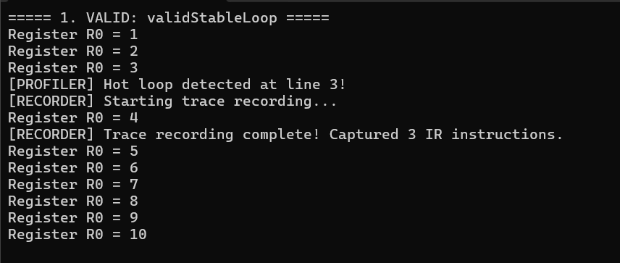

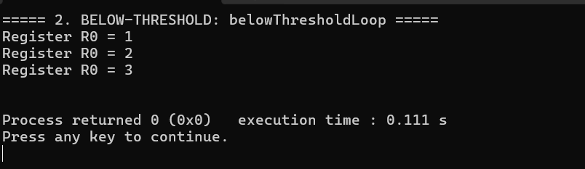

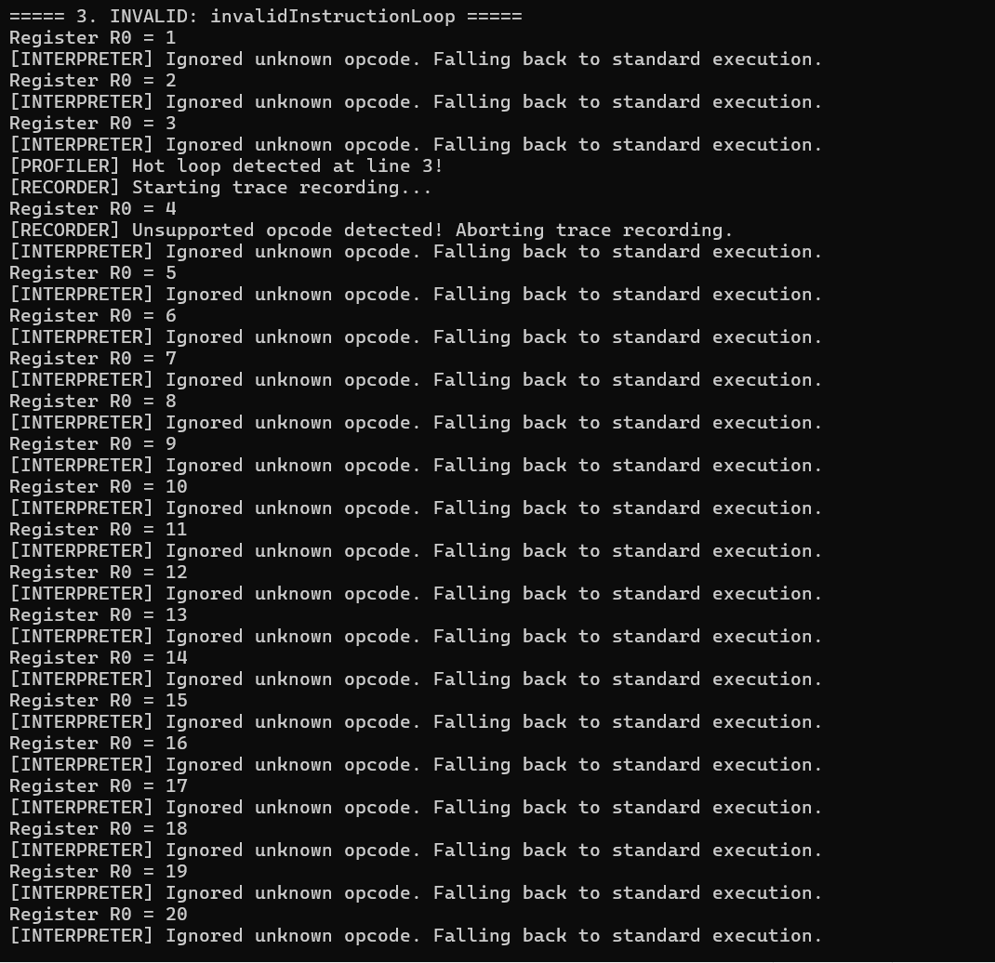

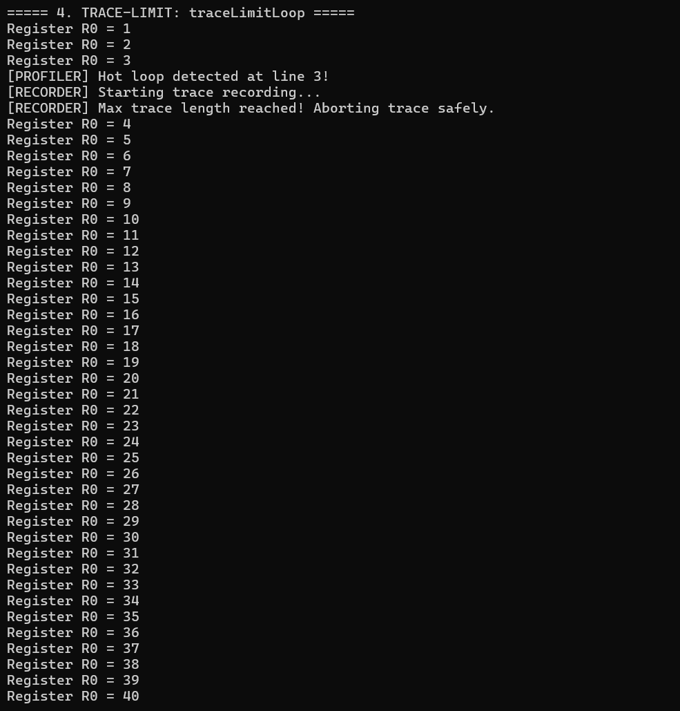

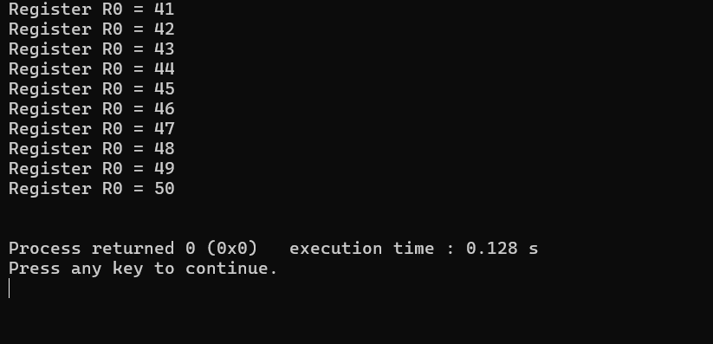

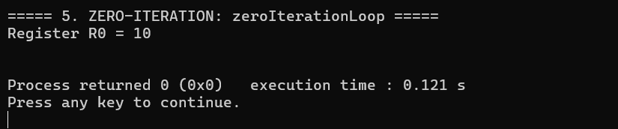

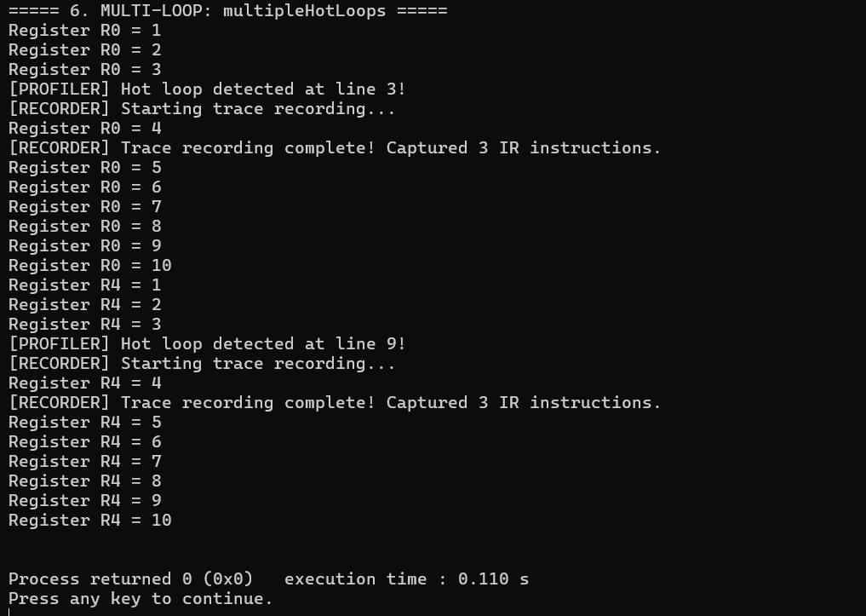

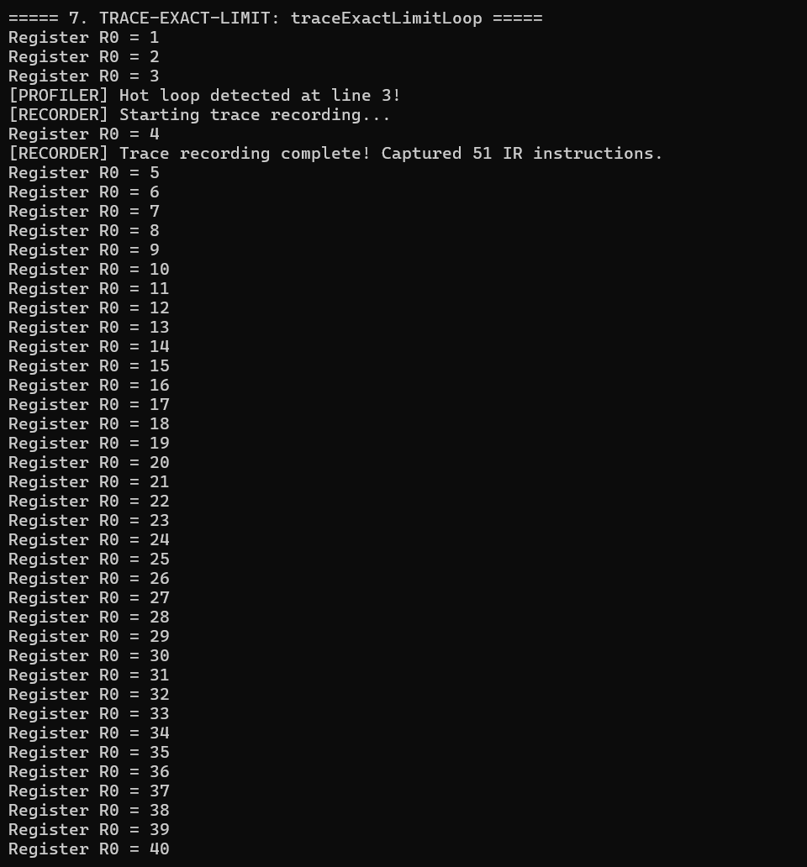

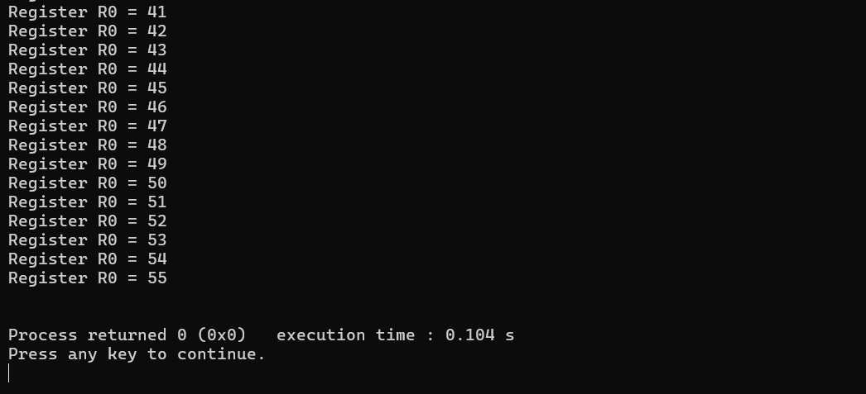

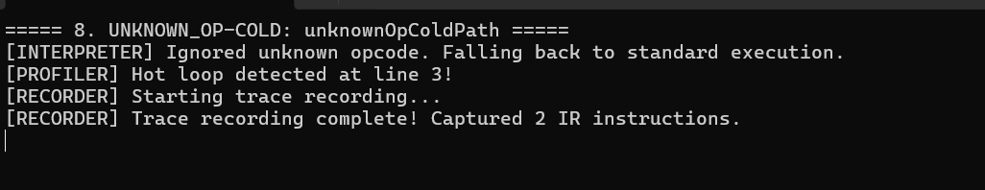

A.5 Code Walkthrough Notes
A few implementation details in the listings above are worth calling out explicitly for the evaluator, beyond what is described in Sections 5 and 6:
- The justStartedRecording flag in JUMP_IF_LT prevents the recorder from immediately treating the very first backward jump that triggers recording as a loop closure — without it, a single-iteration trace would incorrectly append IR_GUARD_LT/IR_JUMP_LOOP before any instructions had been recorded.
- loopCounters[targetPC] is deliberately not incremented while that same target is actively being recorded (the `!(isRecording && targetPC == traceHeaderPC)` guard), so that the hotness count reflects interpreter passes rather than every backward jump taken during recording itself.
- The trace-limit test constructs its instruction vector programmatically (via push_back in a loop) rather than as a static initializer list, since 51 repeated ADD_INT instructions would otherwise be impractical to hand-write.
- All four test cases share a single runCase() helper that constructs a fresh VirtualMachine per case, ensuring loadProgram()'s state-reset logic is exercised on every run rather than relying on constructor-only initialization.

