Experiment – 1 Date: 11/11/2024

Fibonacci series using recursion.

Aim: Write a program to print the Fibonacci series using recursion.

pseudocode :

1.Function fibonacci(n):
a.If n is less than or equal to 0:
Return 0
b.Else if n is equal to 1:
Return 1
c.Else:
Return fibonacci(n - 1) + fibonacci(n - 2)
2.Input n_terms as an integer
3.Print "Fibonacci series:"
4.For i from 0 to n_terms - 1:
i. Print fibonacci(i), with a space after it
5. Print a newline
Source code:

def fibonacci(n):
if n <= 0:
return 0
elif n == 1:
return 1
else:
return fibonacci(n - 1) + fibonacci(n - 2)
n_terms = int(input("enter number:"))
print("Fibonacci series:")
for i in range(n_terms):
print(fibonacci(i), end=" ")
print("\n")

Output:

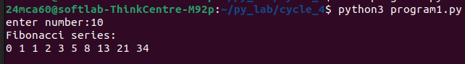

Experiment – 2 Date: 11/11/2024

Menu-driven calculator

Aim: Write the to implement a menu-driven calculator. Use separate functions for the
different operations..

pseudocode :

1.Function add(x, y): Return x + y
2.Function subtract(x, y): Return x - y
3.Function multiply(x, y): Return x * y
4.Function divide(x, y): Return "Cannot divide by zero!" if y is 0, else x / y
5.Loop:
a.Print "Menu: 1. Add 2. Subtract 3. Multiply 4. Divide 5. Exit"
b.Input choice
c.If choice is 5: Print "Exit", Break

d.Print "Select two numbers from list:"
e.For i in range of numbers: Print i, numbers[i]

f.Input index1, index2
g.Set num1 to numbers[index1], num2 to numbers[index2]

h. If choice is 1: Print "Result:", add(num1, num2)
i. Else if choice is 2: Print "Result:", subtract(num1, num2)
j. Else if choice is 3: Print "Result:", multiply(num1, num2)
k.Else if choice is 4: Print "Result:", divide(num1, num2)
l. Else: Print "Invalid input"
Source code:

def add(x, y):
return x + y
def subtract(x, y):
return x - y
def multiply(x, y):
return x * y
def divide(x, y):
if y == 0:
return "Cannot divide by zero!"
return x / y
while (True):
print("\nMenu:")
print("1. Add")

print("2. Subtract")
print("3. Multiply")
print("4. Divide")
print("5. Exit")

choice = int(input("Enter choice (1/2/3/4): "))
if choice == 5:
print("Exit")
break
num1 = float(input("Enter first number: "))
num2 = float(input("Enter second number: "))
if choice == 1:
print(f"Result: {add(num1, num2)}")
elif choice == 2:
print(f"Result: {subtract(num1, num2)}")
elif choice == 3:
print(f"Result: {multiply(num1, num2)}")
elif choice == 4:

print(f"Result: {divide(num1, num2)}")

else:
print("Invalid input")

Output:

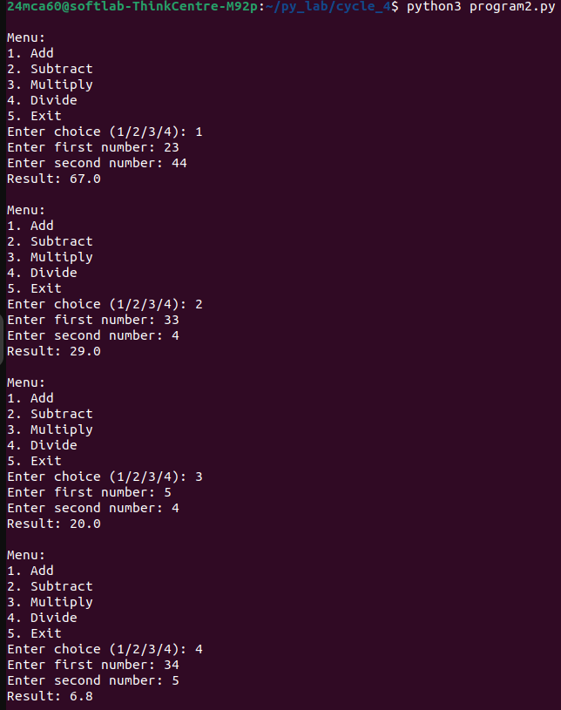

Experiment – 3 Date: 11/11/2024

Print the nth prime number.

Aim: Write a program to print the nth prime number.
[Use function to check whether a number is prime or not]

pseudocode :

1. Function is_prime(num):
1.If num is less than or equal to 1
Return False
2.For i from 2 to square root of num (inclusive):
a.If num is divisible by i:
b.Return False
3Return True

2. Function nth_prime(n):
3. Set count to 0
4. Set num to 2
5. While True:
a. If num is prime:
i. Increment count
ii. If count equals n:
1. Return num
b.Increment num

6. Input n as the position of the prime number
7. Print "The n-th prime number is:" and call nth_prime(n)
Source code:

def is_prime(num):
if num <= 1:
return False
for i in range(2, int(num ** 0.5) + 1):
if num % i == 0:
return False
return True

def nth_prime(n):
count = 0
num = 2
while True:
if is_prime(num):
count += 1
if count == n:
return num

num += 1
n = int(input("enter postion Number"))
print(f"\nThe {n}th prime number is: {nth_prime(n)}")

Output:

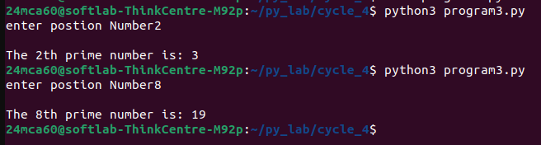

Experiment – 4 Date: 11/11/2024

Area using lambda function

Aim: Write lambda functions to find the area of square, rectangle and triangle.

pseudocode :

1. Function area_square(side):
Return side * side

2. Function area_rectangle(length, width):
Return length * width
3. Function area_triangle(a, b, c, s):
Return area: round(s * (s - a) * (s - b) * (s - c))^0.5 to 2 decimal places

4. Print "Area of square (side=4):", area_square(4)
5. Print "Area of rectangle (length=5, width=3):", area_rectangle(5, 3)
6. Set a = 20, b = 34, c = 30
7. Calculate the semi-perimeter s = (a + b + c) / 2
8. Print "Area of triangle (a=20, b=34, c=30):", area_triangle(a, b, c, s)
Source code:

area_square = lambda side: side * side
area_rectangle = lambda length, width: length * width
area_triangle = lambda a,b,c,s:round(((s*(s-a)*(s-b)*(s-c))**0.5),2)
print(f"\nArea of square (side=4): {area_square(4)}")
print(f"Area of rectangle (length=5, width=3): {area_rectangle(5, 3)}")
a,b,c=20,34,30
s=(a+b+c)/2
print(f"Area of triangle (base=6, height=4): {area_triangle(a,b,c,s)}")

Output:

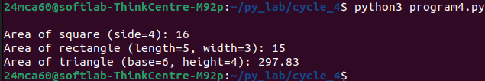

Experiment – 5 Date: 11/11/2024

Powers of 2 using anonymous function.

Aim: Write a program to display powers of 2 using anonymous function. [ Hint use map and lambda function)

pseudocode :

1. List exponents = [0, 1, 2, 3, 4, 5]
2. List powers_of_2 = []
3. For each x in exponents:
1. Calculate 2 raised to the power of x (2^x)
2. Add the result to powers_of_2

4. Print "Powers of 2:", powers_of_2
Source code:

exponents = [0, 1, 2, 3, 4, 5]
powers_of_2 = list(map(lambda x: 2 ** x, exponents))

print(f"\nPowers of 2: {powers_of_2}")

Output:

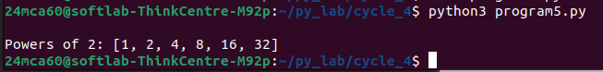

Experiment – 6 Date: 11/11/2024

Sum the series 1/1! + 4/2! + 27/3! + ….. + n

Aim: Write a program to sum the series 1/1! + 4/2! + 27/3! + ….. + nth term. [ Hint
Use a function to find the factorial of a number]

pseudocode :

1. Function factorial(n):
a. If n is 0 or 1:
Return 1
b. Else:
Return n * factorial(n - 1)

2. Function series_sum(n):
a. Set total to 0
b. For i from 1 to n:
i. Add (i^i) / factorial(i) to total
ii. Return total

3. Input n as the limit of terms
4. Calculate the sum of the series up to n terms using series_sum(n)
5.Print the result rounded to 2 decimal places
Source code:

def factorial(n):
if n == 0 or n == 1:
return 1
else:
return n * factorial(n - 1)

def series_sum(n):
total = 0
for i in range(1, n + 1):
total += (i ** i) / factorial(i)
return total

n = int(input("enter limit:"))
print(f"\nSum of the series up to {n} terms: {round(series_sum(n),2)}")

Output:

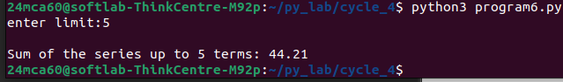

Experiment – 7 Date: 11/11/2024

Compare two strings

Aim: Write a function called compare which takes two strings S1 and S2 and an integer n as arguments. The function should return True if the first n characters of both the strings
are the same else the function should return False.

pseudocode :

exponents = [0, 1, 2, 3, 4, 5]
powers_of_2 = list(map(lambda x: 2 ** x, exponents))

print(f"\nPowers of 2: {powers_of_2}")
Source code:

def compare(s1, s2, n):
return s1[:n] == s2[:n]

s1 = "hello"
s2 = "helicopter"
n = 3
print(f"\nComparison result: {compare(s1, s2, n)}")

Output:

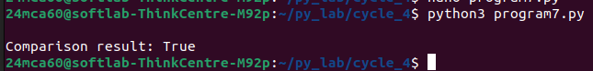

Experiment – 8 Date: 11/11/2024

Implementation of permutations and combinations

Aim: Write a program using functions to implement these formulae for permutations and
combinations. The Number of permutations of n objects taken r at a time:
p(n, r) = n!/(n − r)!.The Number of combinations of n objects taken r at a time is:
c(n, r) = n!/(r! ∗ (n − r)!)

pseudocode :

exponents = [0, 1, 2, 3, 4, 5]
powers_of_2 = list(map(lambda x: 2 ** x, exponents))

print(f"\nPowers of 2: {powers_of_2}")
Source code:

def factorial(n):
if n == 0 or n == 1:
return 1
else:
return n * factorial(n - 1)

def permutations(n, r):
return factorial(n) // factorial(n - r)

def combinations(n, r):
return factorial(n) // (factorial(r) * factorial(n - r))

n, r = 5, 3
print(f"\nPermutations (5, 3): {permutations(n, r)}")
print(f"Combinations (5, 3): {combinations(n, r)}")

Output:

