**TOURISM**

**MANAGEMENT SYSTEM**

**Abstract**

Tourism Management System is a complete tourist fully integrated tourism web site. The website covers all the areas required for an including tourism, This project is developed to manage the tourist in the tourism management web site. The main module in this project are login,package creation,billing etc.

**Introduction**

Tourism management system is used to book a tour from anywhere in the world by a single dynamic website which will help the user to know all about the places and tour details in a single website. The manager can add packages to the website from a certain travel agents and hotels .Then the users can sign in and book each project, they can be confirmed by the admin in their manage booking page. The user can see the confirmation in their my booking page. It is a easiest platform for all travelers which can be easily booked and know the all details.The objective of the project is to develop a system that automates the processes and activities of a travel and. The purpose is to design a system using which one can perform all operations related to traveling.

**General Use Case Diagram**

Manage and create account

**USER**

Book packages/cancel packages

**Manager**

**Admin**

Manage client

Manage managers

Manage packages

**Process Diagram**

Payment

Packages

Hotel

Activty

Billings

Exit

start

Splash screen

Login

**yes**

Home

**No**

Registration

**Home Page**

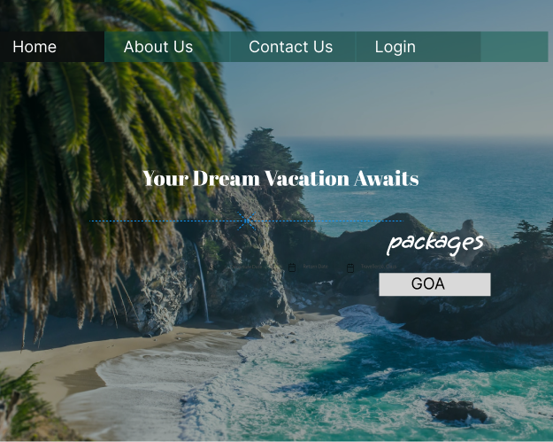

**Registration Form**

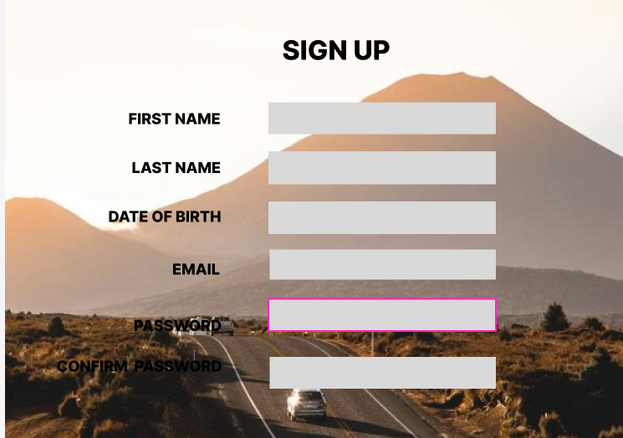

**Login**

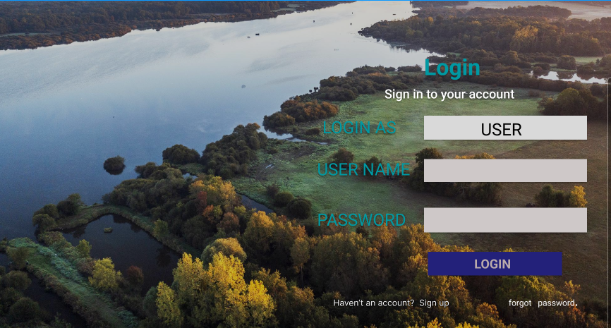

**Packages**

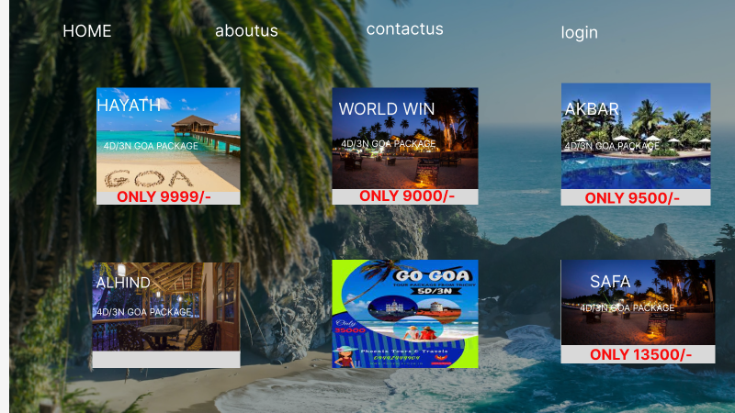

**Billings**

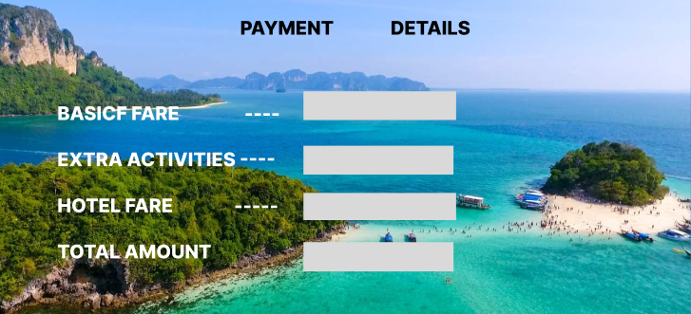

**ER Diagram**

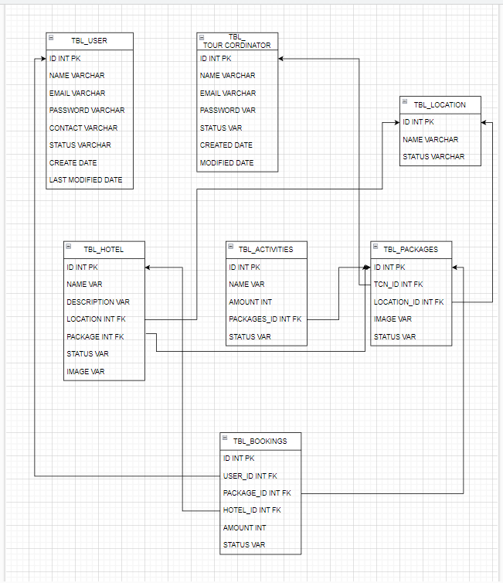

**Functional Requirements**

This section provides requirement overview of the system. Various functional modules that can be implemented by the system will be

**1. Registration**

If customer wants to buy the product then he/she must be registered, unregistered user can’t go to the shopping cart.

**2. Login**

Customer logins to the system by entering valid user id and password for the shopping.

**3. Booking Packages**

Customer chooses the packages,hotel activity as per his/her wish

**4. Payment**

In this system we are dealing the mode of net banking.

**5. Logout**

After ordering or surfing for the packages customer has to logout.

**User Interface Specification**

1) Login Page

2) Registration Form

3) There will be a screen displaying information about Packages.

4) If the customer selects the packages then customer can find his packages in another screen called billings.

**Non Functional Requirement**

• Secure access to consumer’s confidential data and 24X7 availability.

**References**

Make My Trip

Other Travel and Tourism Management Apps

Wikipedia