KUBERNETES INTRODUCTION
Fundamentals • Cluster Architecture • Cluster Types

1. What is Kubernetes?
Kubernetes is an open-source container orchestration tool that helps automate the deployment, scaling, and management of containerized applications.
Kubernetes is used for maintaining containers.

2. Advantages of Kubernetes
- Autoscaling: If the load increases, the number of containers can increase automatically. If the load decreases, the number of containers can decrease automatically.
- Rollback: Roll back to any version.
- No downtime: Supports deployments designed to avoid downtime.
- Scheduling: Containers can be scheduled to run where required.
- High security.

3. What is a Pod?
A Pod is a group of containers. Pods are short-lived objects, and a Pod acts as a single instance for an application.

4. Core Architecture of a Kubernetes Cluster
A Kubernetes cluster consists of two main parts: the Control Plane (the brain) and Worker Nodes (the muscle).
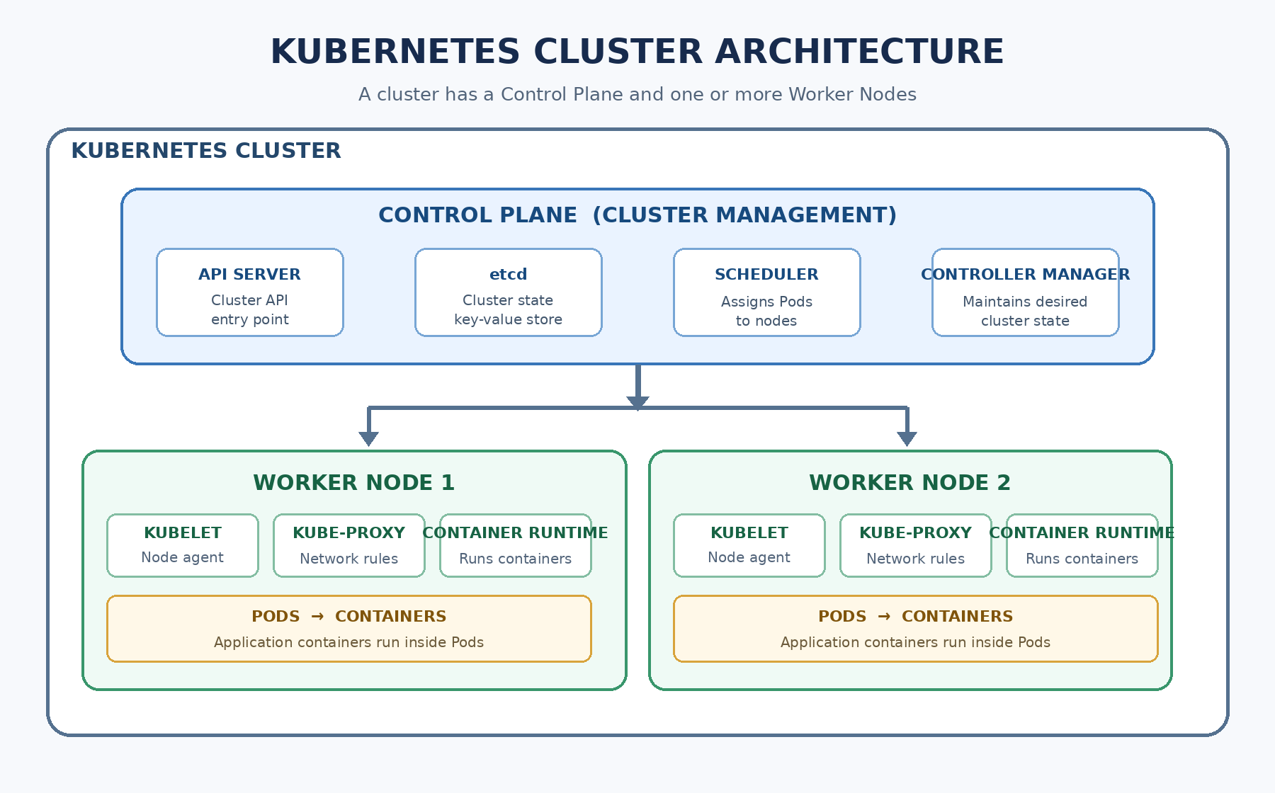
Figure 1. Kubernetes cluster architecture

4.1 Control Plane (Master Node)
The Control Plane makes global decisions about the cluster (for example, scheduling), and detects and responds to cluster events. Its key components include:

API Server
The front end of the Control Plane. All administrative commands and internal communications go through it.

etcd
A consistent and highly available key-value store used as Kubernetes' backing store for all cluster data.

Scheduler
Watches for newly created Pods with no assigned node and selects a node for them to run on.

Controller Manager
Runs controller processes that regulate the state of the cluster.
Controller types mentioned in the source:
- Replication Controller: Ensures the correct number of Pods are running; if not, it creates Pods.
- Node Controller: The source notes that if a server crashes or is deleted, it will automatically create a server.
- Service Controller: The source notes that if a service crashes or is deleted, it will automatically create the service.

4.2 Worker Nodes
Worker Nodes are the machines (physical servers or virtual machines) that actually run applications. Their components include:

Kubelet
An agent that runs on each node to ensure containers are running inside a Pod.

Kube-proxy
A network proxy that maintains network rules on nodes, enabling network communication to Pods from inside or outside the cluster.

Container Runtime
The software responsible for running containers (for example, containerd or CRI-O).

5. Types of Kubernetes Clusters

5.1 Self-managed Cluster
Everything is managed by us.
- Minikube
- kOps
- kubeadm
- k3d
- kind

5.2 Cloud-managed Cluster
The Control Plane is managed by the cloud provider, while Worker Nodes are managed by us (as stated in the source).
- AWS: EKS (Elastic Kubernetes Service)
- Azure: AKS (Azure Kubernetes Service)
- Google Cloud: GKE

