
PCET’S PIMPRI CHINCHWAD COLLEGE OF ENGINEERING
An Autonomous Institute, Pune
Department of Computer Engineering-Regional Language
MINI PROJECT REPORT
ON
VEHICLE REPAIR MANAGEMENT SYSTEM
Object Models, System Architecture and Repair Workflow Design
Submitted in partial fulfilment of the requirements for the subject
OBJECT ORIENTED MODELING AND SYSTEM DESIGN (OOMSD)
Submitted by
Anushka Misal | PRN: 123B1D027
Yadnesh Patil | PRN: 123B1D034
Abhay Bormale | PRN: 123B1D057
Under the guidance of
MS.SHALU MAHAJAN
Academic Year 2026–2027
CERTIFICATE
This is to certify that the mini project report entitled “Vehicle Repair Management System” is submitted by Anushka Misal (PRN: 123B1D027), Yadnesh Patil (PRN: 123B1D034) and Abhay Bormale (PRN: 123B1D057) for the subject Object Oriented Modeling and System Design (OOMSD) at PCET’s Pimpri Chinchwad College of Engineering, Pune.
The report presents the requirements, object model, system architecture, repair workflow, implementation structure and evaluation plan of a Django-based vehicle service portal.
Guide’s Name: MS. SHALU MAHAJAN
Date:23-10-2026 Place: Pune
DECLARATION
We declare that this report has been prepared for academic study using the supplied Vehicle Repair Management System repository and associated design diagrams. Existing code, conceptual models and proposed enhancements are identified separately. We acknowledge the upstream project and interface credits; this report does not claim that all repository code was originally authored by us.
Anushka Misal
Yadnesh Patil
Abhay Bormale
ACKNOWLEDGEMENT
We thank our OOMSD project guide and the Department of Computer Engineering-Regional Language at PCET’s Pimpri Chinchwad College of Engineering for the opportunity to study object-oriented modelling and system design through a practical workshop management application.
We acknowledge Sumit Kumar / LazyCoder for the upstream vehicle service project and Tran Anh Tuat for the dashboard interface, as credited in the repository README. We also acknowledge the maintainers of Python, Django, SQLite, Pillow and diagrams.net.
ABSTRACT
Vehicle repair workshops coordinate customers, service enquiries, mechanic assignments, progress updates and repair costs. Maintaining these records in separate registers or informal messages makes it difficult to identify the current repair status or retrieve previous service details.
The Vehicle Repair Management System provides a browser-based portal with Customer, Admin and Mechanic roles. Customers submit vehicle information and repair problems, track requests, view bills and send feedback. Administrators approve requests, assign mechanics, set costs and manage staff records. Mechanics review assigned work and update repair progress. The repository uses Python, Django, server-rendered HTML templates and SQLite.
This report examines the system from an OOMSD perspective: it maps requirements to objects, associations, persistence, workflow and interactions, explains the Django Model–Template–View structure, and evaluates suitable design patterns. Factory, Singleton, Adapter, Observer and Strategy are proposed refactorings, not implemented classes. Source review identifies incomplete object-level permissions, unrestricted status transitions and numeric registration numbers. Testing scenarios are documented without claiming unperformed execution results.
Keywords: OOMSD, object modelling, Django, MTV, repair workflow, relational database, design patterns, role-based portal.
TABLE OF CONTENTS
Sr. No. | Contents | Page No.
1 | Introduction | 5
2 | Literature Review and Existing Systems | 5
3 | Requirements Specification | 6
4 | System Analysis and Design | 7
5 | Implementation Details | 10
6 | Testing and Evaluation | 11
7 | Results and Discussion | 12
8 | Limitations, Ethics and Future Scope | 12
9 | Conclusion | 13
10 | References | 13
11 | Appendix A – Run Instructions | 13
12 | Appendix B – Demonstration Checklist | 13
13 | Appendix C – AI Use Disclosure | 13

LIST OF ABBREVIATIONS
Term | Meaning
OOMSD | Object Oriented Modeling and System Design
UML | Unified Modeling Language
MTV | Model–Template–View
ORM | Object–Relational Mapping
ERD | Entity–Relationship Diagram
API / REST | Application Programming Interface / Representational State Transfer
ADR | Architecture Decision Record
WSGI | Web Server Gateway Interface
PRN | Permanent Registration Number

1. INTRODUCTION

1.1 Background
A workshop needs a consistent link between a customer, a repair enquiry, the assigned mechanic and the resulting service cost. A central portal makes these responsibilities visible and reduces repeated manual entry. The application organises these activities through three role-specific interfaces.

1.2 Problem Statement
Design and analyse a system that records vehicle repair requests, supports mechanic assignment and repair progress, and presents service costs to customers. The design must explain object responsibilities and associations while identifying access-control and data-integrity requirements.

1.3 Objectives
- Identify actors, functional requirements and quality requirements.
- Model Customer, Mechanic, Request, Attendance and Feedback with their associations.
- Explain the repair lifecycle and the browser-to-database interaction.
- Relate object-oriented principles and design patterns to maintainable extensions.
- Document existing functionality, limitations and a practical test plan.

1.4 Scope and Intended Users
The scope is an academic, role-based workshop portal. Customers request services; administrators coordinate work and staff; mechanics update assigned repairs. Payment processing, inventory, spare-part tracking, a mobile API and production deployment are outside the implemented scope.

1.5 Organisation of the Report
Chapters 2–3 introduce design concepts and requirements. Chapter 4 develops the models and architecture. Chapters 5–7 describe implementation, verification plans and source-based findings. Chapters 8–9 discuss improvements and conclusions.

2. LITERATURE REVIEW AND EXISTING SYSTEMS

2.1 Object-Oriented Modelling and Architecture
Object modelling groups related data and responsibilities into domain concepts. Here, Customer and Mechanic are role profiles, Request is a repair enquiry, and Attendance and Feedback are supporting records. Django models supply persistence behaviour, while much of the workflow logic remains in view functions. The application is a layered Django monolith: MTV separates persistent models, HTML templates and request handlers, which suits the present scope because it avoids distributed deployment.

2.2 Existing and Proposed System
Approach | Strength | Limitation / design lesson
Paper registers / spreadsheets | Simple initial recording | Separate records make status and ownership unclear.
Role-based web portal | Shared records, visible responsibilities | Role and object checks must be enforced on the server.
Django monolith | Integrated forms, ORM and templates | Large view modules can mix workflow and presentation.
SOA / microservices | Explicit contracts, independent services | Operational complexity unless a measured need exists.

The proposal retains the monolith, extracts workflow services, strengthens permissions and adds stricter state rules. A REST API and asynchronous notifications can be introduced later.

2.3 Gap Addressed
The project brings repair-related records into one application. The OOMSD contribution is a clear mapping from actors and use cases to model relationships, interactions, database tables and architectural decisions. This is a conceptual review, not an experimental comparison with commercial products.

3. REQUIREMENTS SPECIFICATION

3.1 Functional Requirements
ID | Requirement | Expected behaviour
FR-01 | Accounts and roles | Customers register; mechanics apply; users enter the appropriate portal.
FR-02 | Repair enquiry | Customer enters vehicle details, category and problem description.
FR-03 | Approval and assignment | Admin selects a mechanic, sets cost and updates the request.
FR-04 | Progress tracking | Customer views status; mechanic updates assigned repair progress.
FR-05 | Bills and service costs | Display costs derived from Request records.
FR-06 | Staff administration | Admin manages mechanic approval, salary and attendance.
FR-07 | Profiles and feedback | Customers and mechanics edit profiles and submit feedback.
FR-08 | Cancellation rule | Only an owner’s pending request should be cancellable; server enforcement needs improvement.

3.2 Non-Functional Requirements
Quality | Requirement
Usability | Clear navigation and consistent labels for each role.
Security | Authenticate users; enforce role, ownership and assignment checks.
Integrity | Validate costs, registration identifiers and permitted state transitions.
Maintainability | Separate workflow services from request and presentation logic.
Performance / Reliability | Avoid repeated related-object queries; provide backups, clear errors and durable history.

3.3 Hardware and Software Requirements
Component | Project requirement
Hardware | Standard laptop/desktop with a browser; 4 GB RAM or more recommended (planning figure, not benchmarked).
Language / Framework | Python compatible with the dependencies; Django (requirements.txt specifies Django>=4.2).
Supporting packages | django-widget-tweaks, Pillow, asgiref, sqlparse and tzdata.
Database / Frontend | SQLite (local); Django templates, HTML, CSS and JavaScript.
Tools | Terminal, code editor, modern browser and diagrams.net for editable models.

3.4 Constraints and Assumptions
- Single Django deployment with local SQLite storage; uploaded images need persistent storage.
- The dependency file uses lower bounds rather than a fully pinned environment.
- No external SMS, online payment or versioned REST API is implemented; production security and performance need further testing.

4. SYSTEM ANALYSIS AND DESIGN

4.1 High-Level Architecture
A browser sends an HTTP request to Django URL routing. A view validates form input, performs workflow operations and accesses model records through the ORM. A template renders the response. These are logical responsibilities within one application, not independently deployed services.
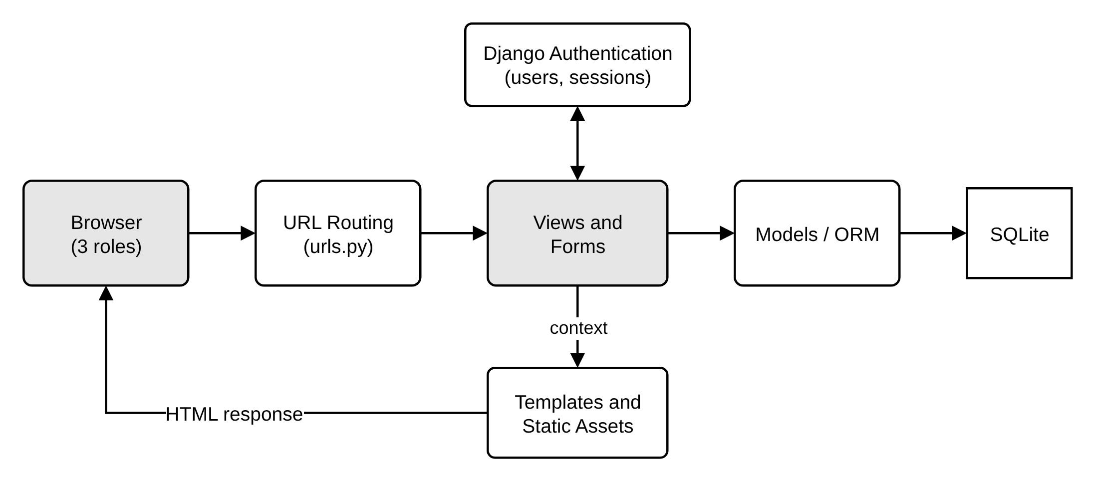
Figure 4.1: Current layered Django architecture

4.2 Use-Case Model
The Customer registers, requests service, tracks status, views bills and gives feedback. The Admin approves mechanics and repairs, assigns work, sets costs and manages staff. The Mechanic views assigned work, updates progress and views salary and attendance.
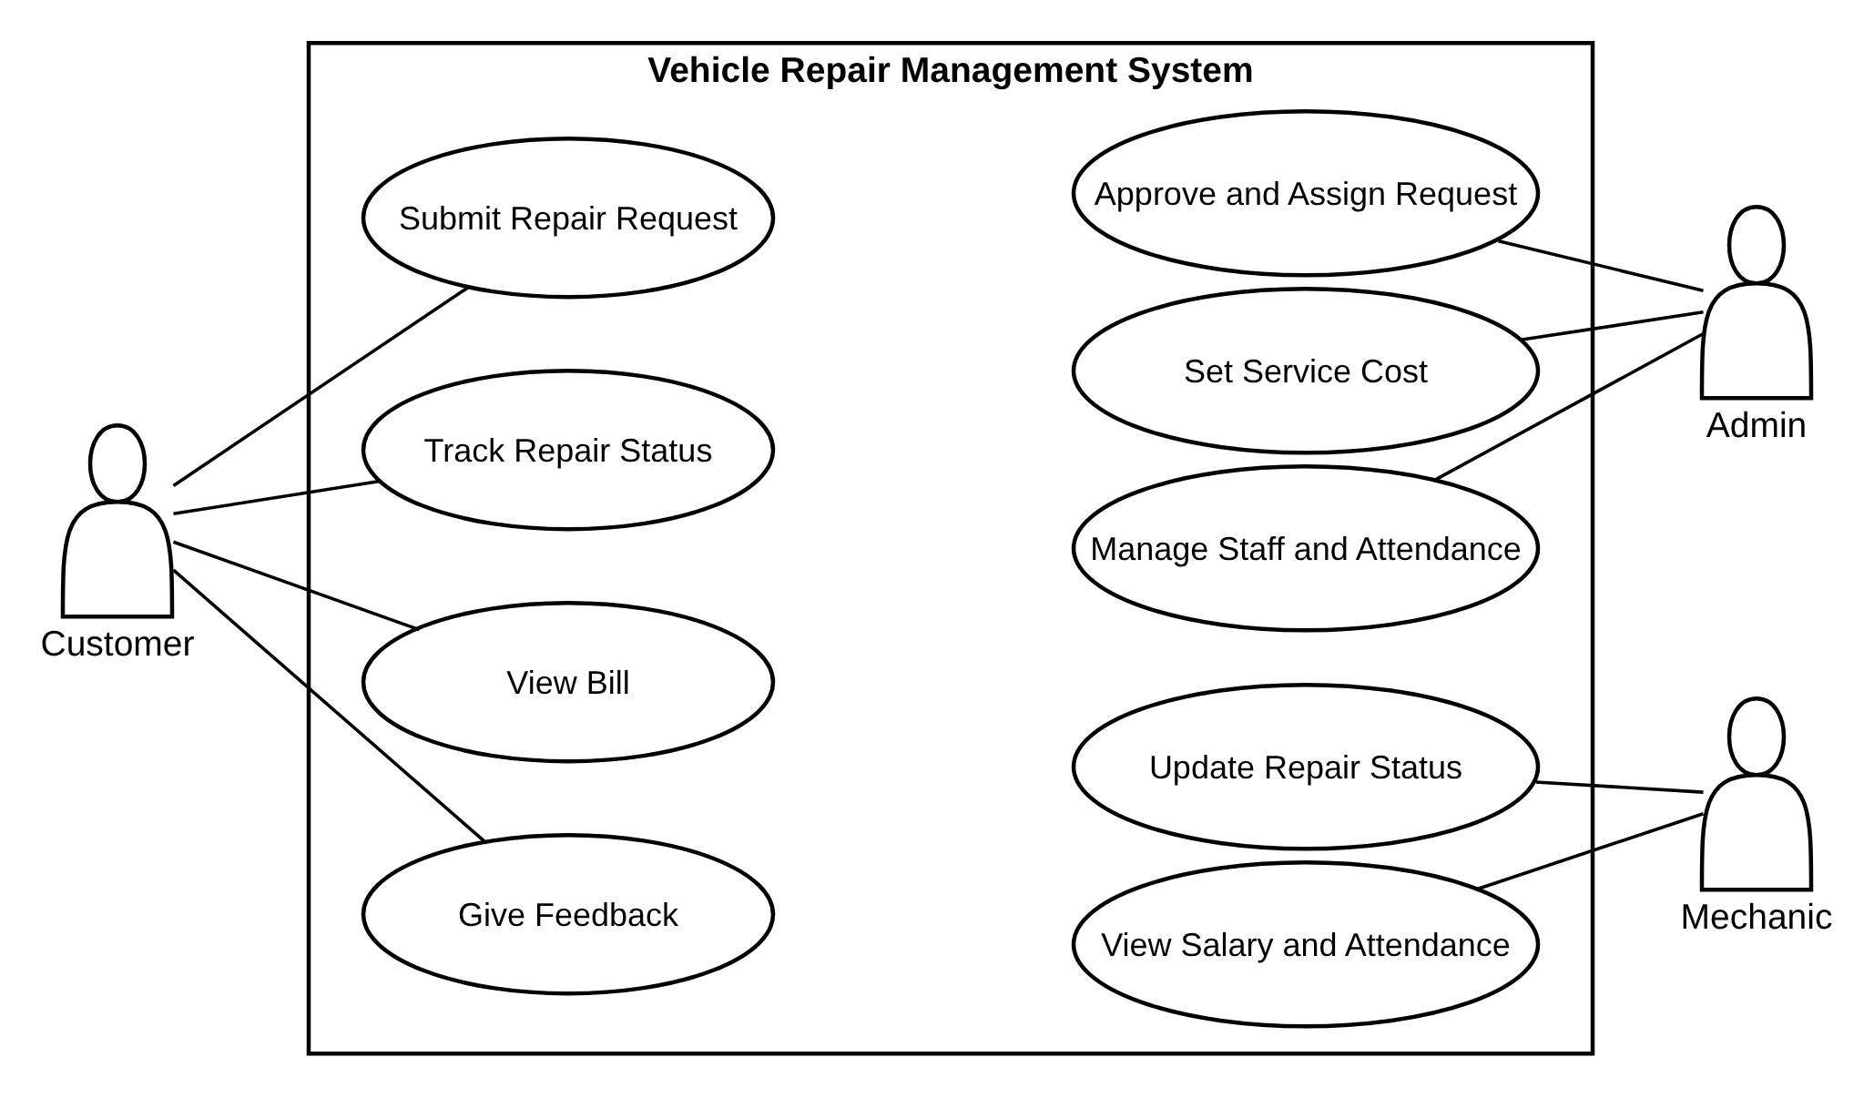
Figure 4.2: Use-case diagram
Element | Use case: Submit Repair Request
Primary actor | Authenticated Customer.
Main flow | Open request form → enter details → submit → validate → associate Customer → save Request → redirect.
Alternative flow | Invalid fields should display errors without saving a record.
Postcondition | A Request exists with the default Pending status; identity comes from the session.

In Approve and Assign, the administrator reviews a pending request, chooses a mechanic, enters the estimated cost and records approval; the request then appears in the mechanic’s list. The target design must check privileges and mechanic eligibility and reject invalid costs or transitions.

4.3 Object Model and Associations
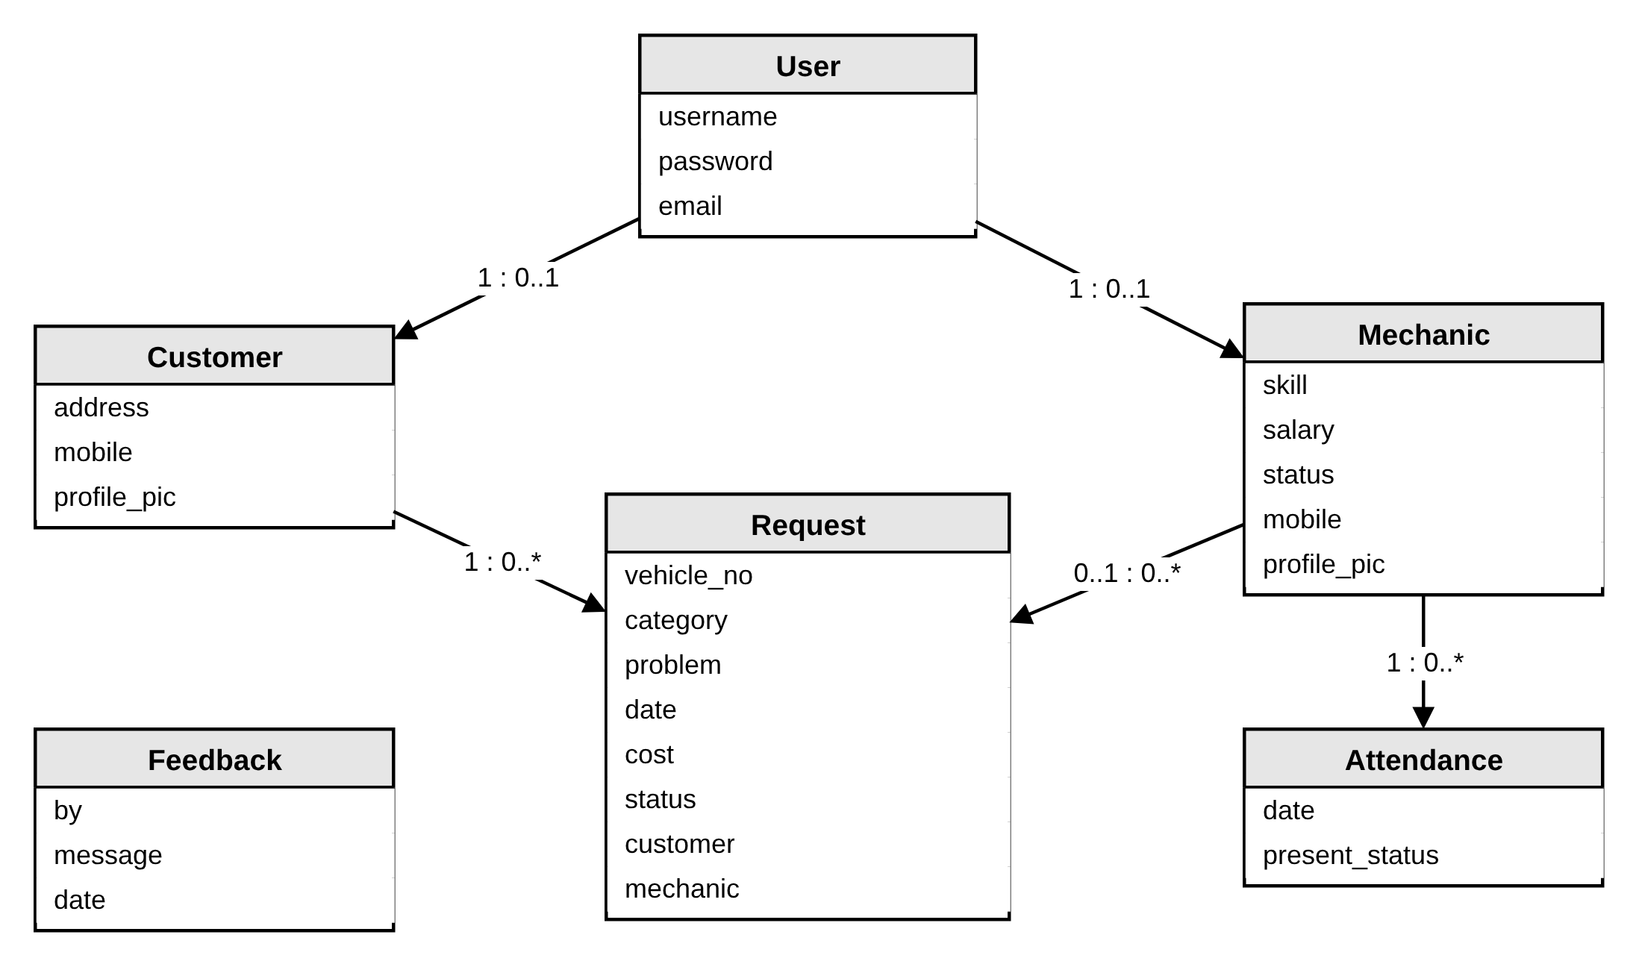
Figure 4.3: Existing domain object model
Customer and Mechanic each use a one-to-one association with User; they are not subclasses of User. Django model inheritance supplies ORM behaviour, but custom pricing polymorphism is not implemented. Encapsulation is partial because many business operations are performed directly in views.

4.4 Relational Database Design
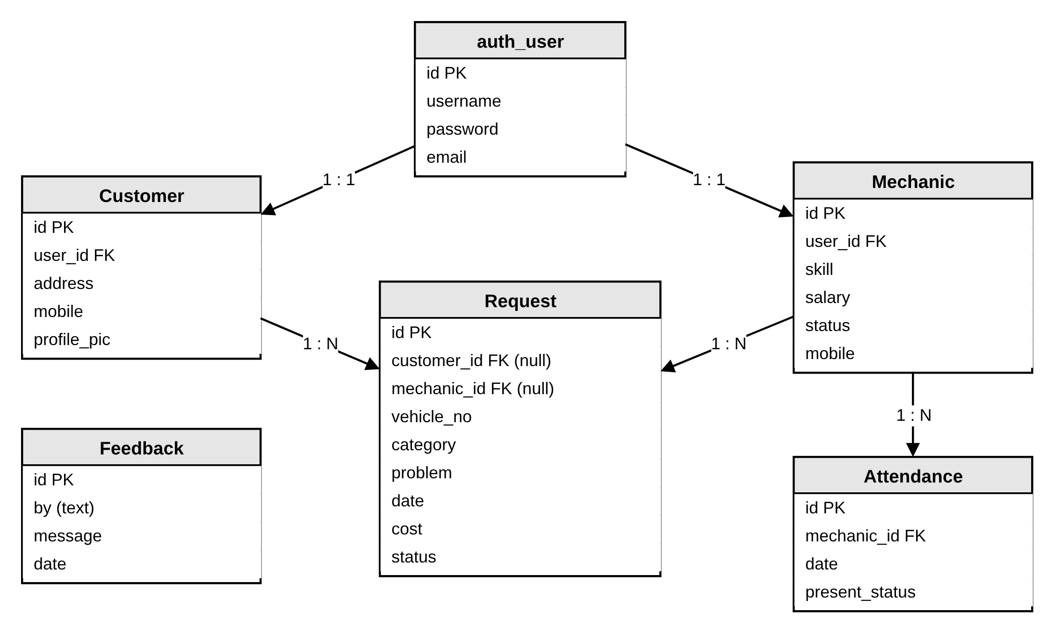
Figure 4.4: Database relationships derived from current models
One Customer can relate to many Requests; one Mechanic can relate to many Requests and Attendance rows. Request.customer and Request.mechanic allow null, so a request can be unassigned. Feedback.by is a text field without a foreign key. There is no separate Vehicle or Invoice table. Integrity review findings:
- vehicle_no is numeric; a text identifier would support normal registration formats.
- cost and salary are positive integers; decimals would represent currency better.
- Request.date uses auto_now; separate created_at and updated_at fields would clarify history.
- CASCADE deletion can remove linked repair records; a retention policy is needed.

4.5 Repair State Model
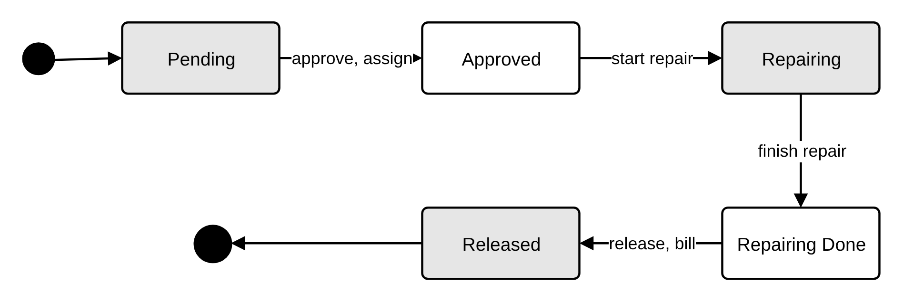
Figure 4.5: Intended repair lifecycle
The intended progression is Pending → Approved → Repairing → Repairing Done → Released. The stored choices represent these labels, but the application does not implement a strict state machine. Transition guards should check actor role, current state and assignment before saving.

4.6 Request Interaction Model
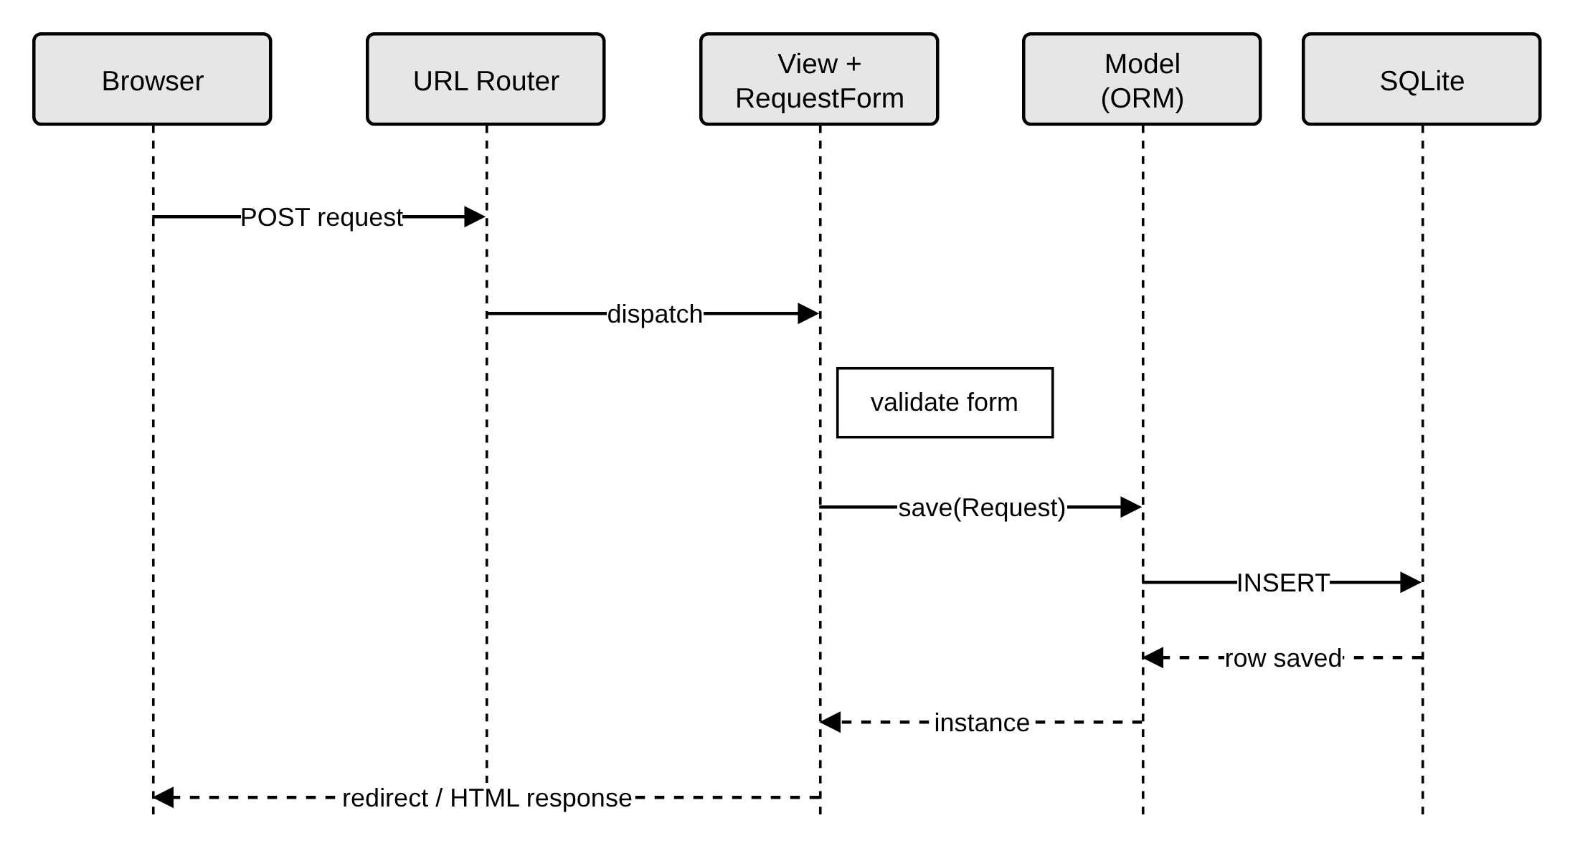
Figure 4.6: Ordered browser-to-database request interaction
The figure is a simplified ordered flow. A repair submission passes through routing, view/form validation and the ORM before a response is returned. Failed validation should preserve the user’s input and display field errors; current submission handling redirects even after invalid input, so this needs improvement.

4.7 Design Patterns
Pattern | Repair-domain application | Status
MVC / MTV | Models store records; templates display; views/routing handle requests. | Implemented
Factory | Create a vehicle-category-specific estimator. | Proposed
Singleton | Read-only configuration holder once per process. | Conceptual
Adapter | Wrap an SMS or payment provider behind a stable interface. | Proposed
Observer | React to a committed repair-status change. | Proposed
Strategy | Interchange two-wheeler and four-wheeler pricing rules. | Proposed

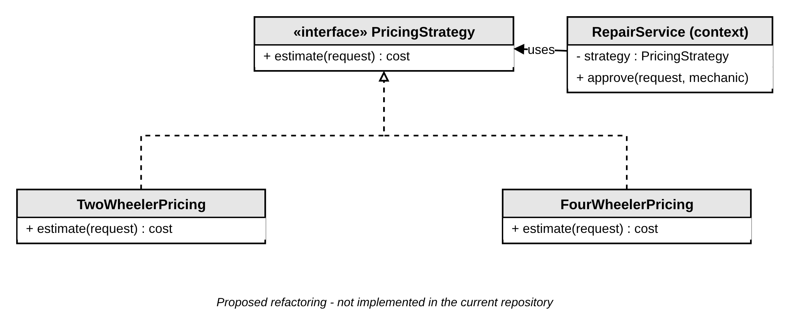
Figure 4.7: Proposed Strategy pattern for repair pricing
These extensions should be introduced only when they simplify a concrete requirement; a service function can centralise approval and transition rules first.

4.8 API, Events and Deployment
Current endpoints render HTML or process forms. A proposed /api/v1/repair-requests/ API could use GET for reads, POST for creation and PATCH for status updates, with authentication, ownership and transition rules enforced on the server. A future RepairCompleted event could trigger asynchronous notifications after a committed update. Local execution uses runserver and SQLite; the proposed deployment uses an HTTPS proxy, a production WSGI server, persistent database and media storage, and optional shared cache.
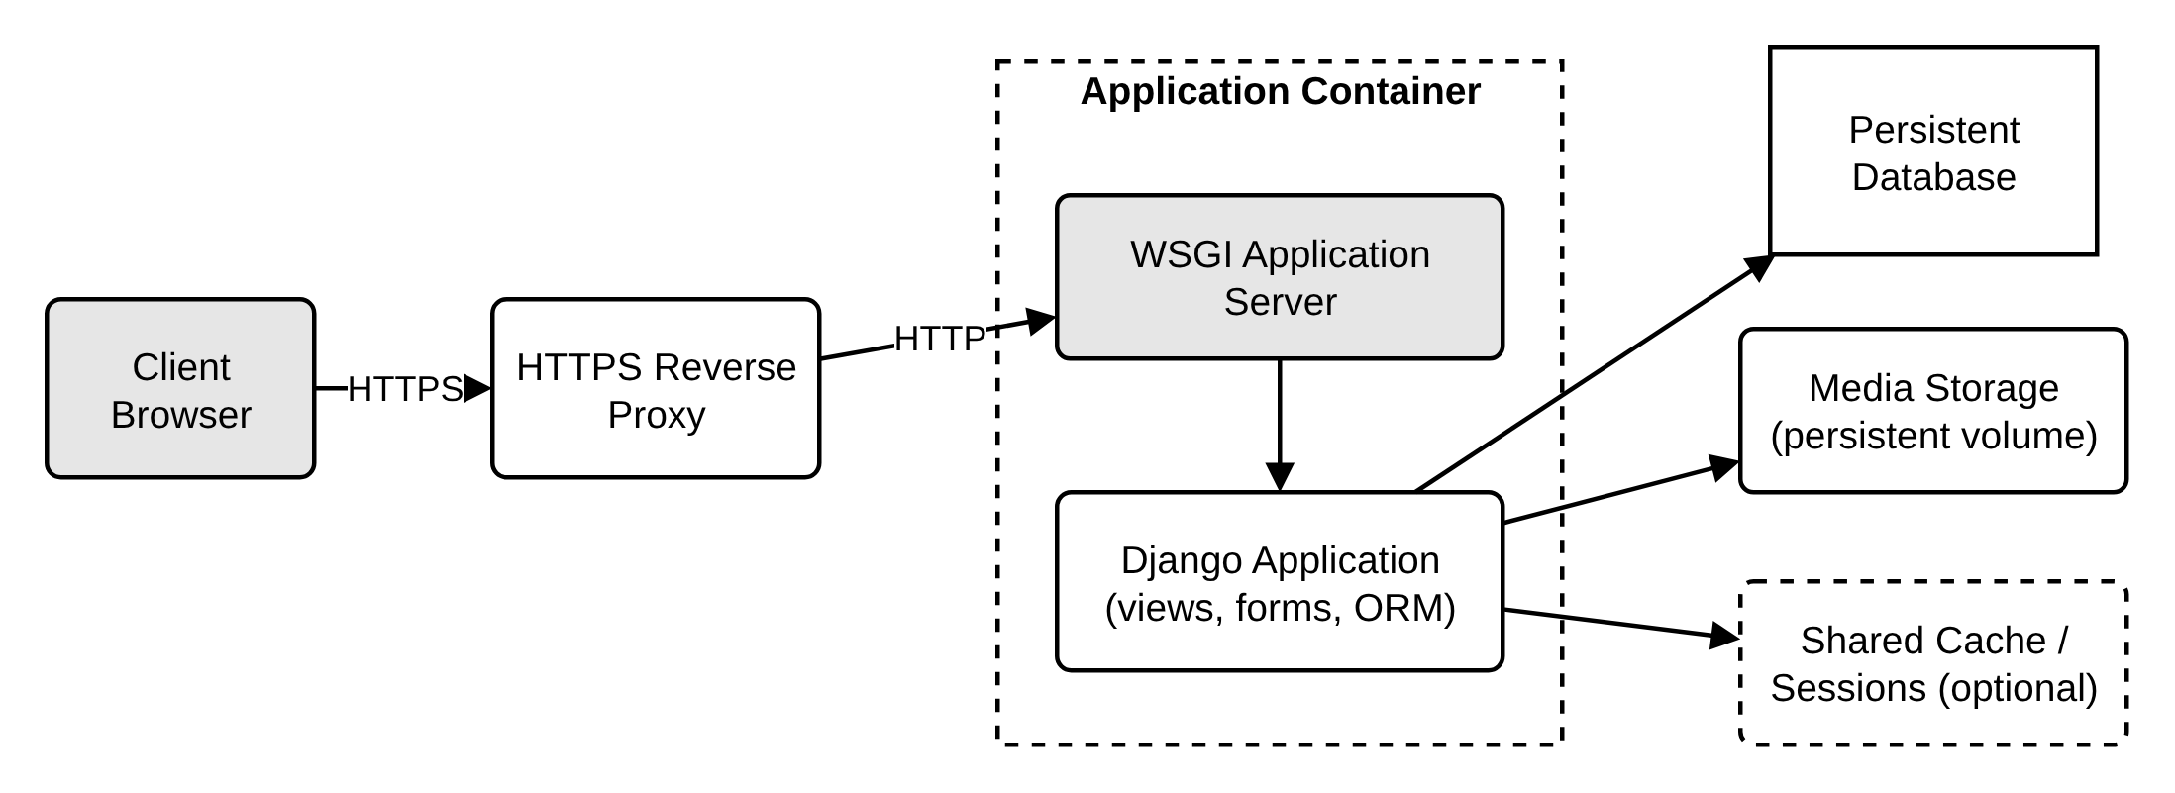
Figure 4.8: Proposed production deployment

5. IMPLEMENTATION DETAILS

5.1 Project Structure
Path | Purpose
manage.py | Django management entry point.
vehicleservicemanagement/ | Project settings, URL routing and WSGI configuration.
vehicle/models.py | Customer, Mechanic, Request, Attendance and Feedback models.
vehicle/forms.py | Registration, repair, approval, salary and status forms.
vehicle/views.py | Role-based pages and application workflow handlers.
templates/, static/ | HTML pages with role-specific bases; styles, scripts and images.

5.2 Modules
Customer: customer_add_request_view associates validated form data with the logged-in Customer and saves a Request; other views show pending and approved requests, invoices, profiles and feedback. Admin: handlers manage customers and mechanics, approve assignments, update costs and record attendance. Mechanic: handlers list assigned requests and update status. Many admin handlers check login without an explicit administrator-role guard, and some Request lookups use only the submitted identifier, so object-level permission checks are a priority.

5.3 Workflow Mapping
Operation | Relevant implementation
Create repair enquiry | customer_add_request_view; RequestForm; Request.
Assign repair and cost | approve_request_view; AdminApproveRequestForm.
Update repair status | mechanic_update_status_view; MechanicUpdateStatusForm.
Display customer bill | customer_invoice_view; customer_view_approved_request_invoice_view.
Attendance and salary | Attendance; admin_take_attendance_view; mechanic_salary_view.

Proposed workflow: authenticate actor → authorise role and record → validate current state → validate mechanic and cost → save atomically → schedule post-commit side effects. This is a recommendation; no service layer was added for this report.

5.4 Technology Rationale and Source Evidence
Python and Django offer forms, authentication and persistence in one framework; SQLite suits a local demonstration; HTML templates keep the interface close to server validation. Feature descriptions were checked against models.py, forms.py, views.py, the URL configuration, requirements.txt and README.md. No transactions or user accounts were modified.

6. TESTING AND EVALUATION

6.1 Testing Approach
Use model/form tests for validation, request tests for role and object permissions, and browser scenarios for the end-to-end repair process. The cases below are a recommended plan; they were not executed during report preparation.
ID | Scenario | Expected result | Status
TC-01 | Customer registers and signs in | Account and profile created; correct portal opens. | Not executed
TC-02 | Submit a complete repair form | Pending Request belongs to the signed-in customer. | Not executed
TC-03 | Submit missing/invalid fields | No record saved; field errors visible. | Not executed
TC-04 | Admin assigns mechanic and cost | Assignment and cost persist; mechanic sees work. | Not executed
TC-05 | Mechanic updates own assignment | Permitted progress update is stored. | Not executed
TC-06 | Access another customer’s request | Server denies read/mutation by URL identifier. | Not executed
TC-07 | Mechanic changes another assignment | Server rejects unauthorised mutation. | Not executed
TC-08 | Cancel a non-pending request | Server rejects cancellation. | Not executed
TC-09 | Customer opens bill | Amount matches eligible Request costs. | Not executed
TC-10 | Non-admin requests admin page | Access denied by explicit role policy. | Not executed

6.2 Acceptance Criteria
- The complete repair flow persists the correct customer, mechanic, status and cost.
- Unauthorised users cannot access or change another user’s records.
- Invalid forms and invalid transitions give useful errors without changing records.

7. RESULTS AND DISCUSSION

7.1 Implemented Application Areas
Repository inspection confirms models, forms, routes and templates for customer requests, mechanic assignment, repair progress, invoice display, feedback, profiles, salary and attendance. These are source-based findings, not claims of successful end-to-end execution or production readiness.

7.2 OOMSD Discussion
The object model provides clear records and useful associations, but domain behaviour is spread across view functions. A workflow service would create a single place for approval, ownership and state rules. Separate Vehicle and Invoice entities could be added if service history, itemised billing or payment tracking becomes a requirement.

7.3 Architecture Decision Record: ADR-001
Field | Decision draft
Context | Small role-based academic workshop portal.
Decision | Retain the Django monolith and server-rendered HTML.
Alternatives | React plus REST API; independently deployed services.
Consequences | Simpler deployment; application components scale together.
Revisit trigger | Mobile clients, measured load growth or need for independent service ownership.

8. LIMITATIONS, ETHICS AND FUTURE SCOPE

8.1 Current Limitations
- Administrator checks and direct object lookups require stronger authorisation.
- The pending-only cancellation rule is not enforced in the deletion handler inspected.
- State labels exist without strict transition guards.
- Numeric vehicle registration; money and date fields need richer semantics.
- SQLite/local storage and cascade deletion need review for shared production use; no billing entity, payment integration or notification service.

8.2 Privacy and Responsible Use
Customer contact details, profile pictures and repair records should be visible only to authorised users. Use retention rules and backups; do not publish private invoices, expose credentials or include real customer data in AI prompts. Follow the project’s licence and attribution requirements.

8.3 Future Enhancements
- Extract workflow services and add role, ownership and transition tests.
- Introduce Vehicle and itemised Invoice models; support text registration numbers and decimal currency.
- Add a versioned REST API and optional HTMx/React enhancements; publish repair events through an Adapter.
- Evaluate PostgreSQL, caching, pagination and deployment using measured workload.

9. CONCLUSION
The Vehicle Repair Management System connects customers, administrators and mechanics through a shared repair workflow. Its Django models and role-specific interfaces provide a practical basis for studying object modelling, associations, persistence and system architecture.
The OOMSD analysis maps requirements to domain records, database relationships, behaviour and interactions, and presents design patterns and integration options as future extensions. The immediate priority is a maintainable workflow boundary with consistent authorisation and validation, followed by execution of the documented test plan.

REFERENCES
[1] Local repository: vehicle/models.py, forms.py, views.py, vehicleservicemanagement/urls.py, requirements.txt and README.md.
[2] Sumit Kumar / LazyCoder. Vehicle Service Management upstream project. https://github.com/sumitkumar1503/vehicleservicemanagement
[3] Tran Anh Tuat. Dashboard UI attribution in the project README.
[4] Django Software Foundation. Django documentation. https://docs.djangoproject.com/
[5] Python Software Foundation. Python documentation. https://docs.python.org/3/
[6] SQLite. SQLite documentation. https://www.sqlite.org/docs.html
[7] diagrams.net. Diagram editor and documentation. https://www.drawio.com/doc/
[8] Object Management Group. Unified Modeling Language specification. https://www.omg.org/spec/UML/

APPENDIX A – RUN INSTRUCTIONS
Local demonstration procedure (commands were not run for this report):
- Open a terminal in the project root.
- Create an environment: python -m venv .venv
- Activate in PowerShell: .\.venv\Scripts\Activate.ps1
- Install dependencies: python -m pip install -r requirements.txt
- Apply migrations: python manage.py migrate
- Create the admin account: python manage.py createsuperuser
- Start locally: python manage.py runserver, then open http://127.0.0.1:8000/
Use test accounts and synthetic data. Do not use runserver as the production application server.

APPENDIX B – DEMONSTRATION CHECKLIST
- Register a customer and create a repair enquiry.
- Register a mechanic and approve the mechanic account through admin.
- Approve the request, assign the mechanic and set the service cost.
- Sign in as the mechanic, show the assigned request and update its status.
- Return to the customer view to show status and bill; record negative permission tests separately.

APPENDIX C – AI USE DISCLOSURE
AI assisted in structuring this report, mapping source-code observations to OOMSD concepts and preparing documentation. Implementation claims were checked against the supplied local files; AI-generated design suggestions require human review. No automated test execution, runtime benchmark, external guide approval or certification is implied. All figures are draw.io (diagrams.net) diagrams.

