TATA TECHNOLOGIES LTD. | TECH PULSE FY-26
Final Submission Declarations
Project: AUTOSAR HLD Document Analysis Assistant (Case Study CS1)
Institute / University | Pimpri Chinchwad College of Engineering (PCCOE), Pune
Programme / Batch | Computer Engineering-Regional Language 2023-2027
Student name | Yadnesh Patil
PRN | 123B1D034

1. Student Declaration
I confirm that:
☐ The work submitted represents my own understanding and contribution. I can explain every significant part of the code, the data, the implementation decisions, the evaluation results and the limitations.
☐ The submitted version follows the approved synopsis. Any change of scope, methodology or approach was approved by my faculty before it was made.
☐ Only approved or synthetic data was used. The knowledge base was generated by Code/scripts/generate_synthetic_data.py and contains no confidential, customer, OEM or licensed standards content.
☐ All results in the report were produced by the submitted code (Evaluation_Results/) and failures are reported honestly.
☐ AI tools used for assistance are listed completely in Section 2 and I have checked, run and understood the output they produced.

Student name: | Yadnesh Patil | PRN: | 123B1D034
Signature: | 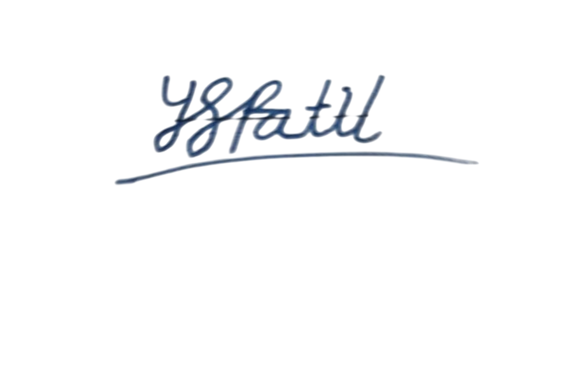 | Date: | 13-10-2026

2. AI-Tool Usage Declaration
Complete the last column yourself after you have read, run and understood the artifact (write Y or N).
AI tool / model | Purpose | Artifact affected | Verified by student (Y/N)
Claude | Coding assistant: scaffolding of application modules, web user interface, unit tests, synthetic data generator | Code/, Input_Data generator, Evaluation_Results | Yes
Chatgpt | Drafting of synopsis, technical report, README | Synopsis/, Documentation/, README.md | Yes
The submitted application itself does not call any AI service by default. The optional local model (Ollama, llama3.2) runs on the student's own computer.

Student name: | Yadnesh Patil | PRN: | 123B1D034
Signature: |  | Date: | 13-10-2026

3. Internet and External API Dependency Declaration
Runtime of the application (demo and evaluation):
- No internet connection and no external API is needed. The server listens on 127.0.0.1 only and makes no outgoing network calls in the default configuration.
- Default models: none downloaded (offline hashing embeddings, extractive answers).
One-time installation (before the demo):
- pip install numpy pypdf (and reportlab only to regenerate the synthetic PDFs) from the Python Package Index.
- Optional, not used for the reported results: sentence-transformers and faiss-cpu (BGE embeddings download model weights once); Ollama and the llama3.2 model for a local LLM.
Fallback if the live demonstration fails: the submitted demonstration video in the Video folder.

Student name: | Yadnesh Patil | PRN: | 123B1D034
Signature: |  | Date: | 13-10-2026

4. Faculty Approval Record
Synopsis reviewed and approved. (Print the synopsis pages and obtain the faculty signature as required by the TechPulse guidelines.)
Faculty name
Designation / Department
Date of approval
Remarks / approved changes
Faculty signature

